

NATIONAL UNIVERSITY
Computer Science Program

CSC 480B
Professor Jeffery Appel, Ph.D.

Software Requirements Specification:
Retro Fix Inventory Manager v1.0
January 11, 2016

Prepared for:
Retro Fix Video Games

Prepared by:
Kevin Powell
Eric Bergren
Daniel LaVergne
Eric Sweeten

Approvals

Title | Printed Name | Signature | Date
Client Representative | Rudy Treadwell |  | 1/11/2016
Project Manager | Dr. Jeffrey Appel |  | 1/11/2016
Project Leader | Kevin Powell |  | 1/11/2016
Software Engineering | Eric Sweeten |  | 1/11/2016
Document Control | Daniel LaVergne |  | 1/11/2016
Quality Manager | Eric Bergren |  | 1/11/2016

Revision Change Record
Revision No. | Date | ECO No. | Description | Name | Approval
1 | 1/3/2016 | 0001 | Preliminary Outline | K. Powell
2 | 1/10/2016 | 0002 | Second Draft | K. Powell
3 | 1/11/2016 | 0003 | Third Draft | K. Powell | Dr. Appel
4 | 1/31/2016 | 0004 | Fourth Draft | K. Powell | Dr. Appel

Table of Contents
1 Introduction 5
1.1 Purpose 5
1.2 Scope 5
1.3 Definitions, Acronyms, and Abbreviations 5
1.4 References 6
1.5 Overview 6
2 Overall Description 7
2.1 Product Perspective 7
2.1.1 System Interfaces 7
2.1.2 Memory Constraints 8
2.1.3 Operations 8
2.1.4 Site Adaptation Requirements 8
2.2 Product Functions 9
2.3 User Characteristics 9
2.4 Constraints 10
2.5 Assumptions and Dependencies 10
2.6 Apportioning of Requirements 10
3 Specific Requirements 10
3.1 External Interfaces 10
Login 10
Database Information 11
3.1.1 User Interfaces 12
3.1.2 Hardware Interfaces 12
3.1.3 Software Interfaces 12
3.1.4 Communication Interfaces 13
3.2 Functions 13
3.3 Functional Requirements 16
3.4 Performance Requirements 17
3.5 Design Constraints 17
3.5.1 Standards Compliance 17
3.5.2 Logical Database Requirements 17
3.6 Software System Attributes 18
3.6.1 Reliability 18
3.6.2 Availability 18
3.6.3 Security 18
3.6.4 Maintainability 18
3.6.5 Portability 19
3.6.6 Usability 19
3.6.7 Testability 19
3.6.8 Modifiability 19
3.6.9 Performance 19

List of Figures
Figure 2.1: Two-tiered System 7
Figure 2.1.1: System Interface 8
Figure 2.2: System function with user and database 9

List of Tables
Table 1.3.1: Definitions 5
Table 1.3.2: Acronyms 6
Table 1.3.3: Abbreviations 6

1 Introduction
The Software Requirements Specifications (SRS) is a managed source document that is used in conjunction with the development of Retro Fix Inventory Manager v1.0. This software program created by Team Retro Fix is designed to provide superior convenience and security as compared to the client’s existing system of Microsoft Excel documents. The Retro Fix Inventory Manager program will provide easy management and storage of database files containing all information relevant to the inventory of the business.

1.1 Purpose
This particular document will provide an outline for the overall requirements and specifications of Retro Fix Inventory Manager v1.0. The intended audience for this document is the client and owner of Retro Fix Video Games, Mr. Rudy Treadwell as well as the team members of Team Retro Fix as well. Any and all modifications, additions, or deletions made in the future to this document will be determined by the project leader.

1.2 Scope
The program Retro Fix Inventory Manager v 1.0 can be broken down into a few different components. The software deals with the interface involved in inventory management and stock information, the saving and loading of database files, and the password protection of database files and information. Retro Fix Inventory Manager v 1.0 will keep track of the quantity, condition, and completeness of video games and other inventory currently in stock at Retro Fix Video Games. The user will be able to add, subtract and otherwise edit any of the information in the program. All games will have to be added manually, but duplicates of a game can be easily added with the click of a button. Sections and the content within the sections will be able to alphabetized. The user will be able to choose from 13 different colors to customize the background.

1.3 Definitions, acronyms, and abbreviations

Table 1.3.1: Definitions
Terminology | Definition
Operational Concept Document | A document describing the characteristics of a proposed system from the viewpoint of a user of that system.
Software Project Management Plan | A document describing the execution plan for the proposed software application.
Table 1.3.2: Acronyms
GUI | Graphical User Interface
OCD | Operational Concept Document
JRE | Java Runtime Environment
JVM | Java Virtual Machine
Table 1.3.3: Abbreviations
I/O | Input/Output

1.4 References

Powell K., Bergren E., LaVergne D., Sweeten E. (2015). Operational Concept Document. Unpublished Manuscript, CSC 480A Computer Science Project I, National University, United States.

Powell K., Bergren E., LaVergne D., Sweeten E. (2015). Software Project Management Plan. Unpublished Manuscript, CSC 480A Computer Science Project I, National University, United States.

Pressman, R. (2010). Software engineering: A practitioner's approach (7th ed.). New York: McGraw-Hill Higher Education.

1.5 Overview
This SRS document is divided into 3 main sections and a variety of subsections. The three main sections are 1. Introduction, 2. Overall Description, and 3. Specification Requirements. The overall description describes the overall factors in general that will affect the product as well as its requirement. These constituents include the product perspective, product functions, user characteristics, constraints, assumptions and dependencies, and requirements subsets. The Specifications Requirements will cover in detail the specifications required for the design and testing of the product itself. The specific requirements include the external interfaces, functional requirements, performance requirements, logical database requirements, design constraints and software system attributes.

2 Overall Description

2.1 Product Perspective
The Retro Fix Inventory Manager v1.0 is a two-tier program: the client tier and the information tier.

Figure 2.1 Two-tiered system
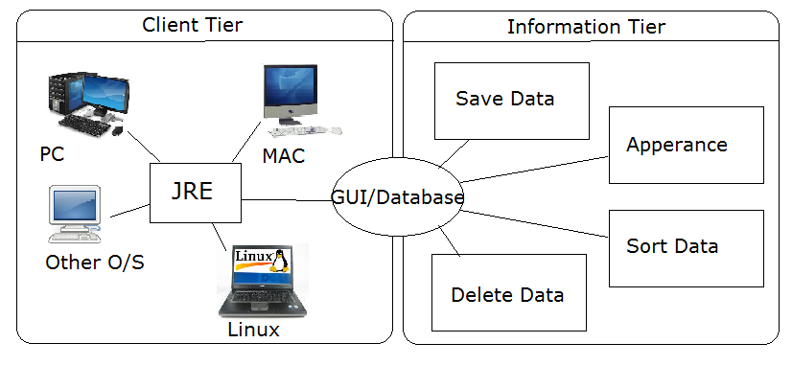

The client tier uses the Java Runtime Environment (JRE) and the Java Virtual Machine (JVM) which is included with a free Java software download and installation. Java can be run on most, if not all, operating systems including, but not limited to, Windows, Mac OS, and Linux.
The information tier is the database stored on the user’s machine. Retro Fix Inventory Manager v1.0 will have one database that includes the entirety of the inventory.

2.1.1 System Interfaces
The Retro Fix Inventory Manager v1.0 is a completely self-contained program and it will not interact with other programs or networks. The program functions independently on the computer system to which it is installed. No connection to the Internet or any other server is required for the operation of the program.

Figure 2.1.1 System Interface
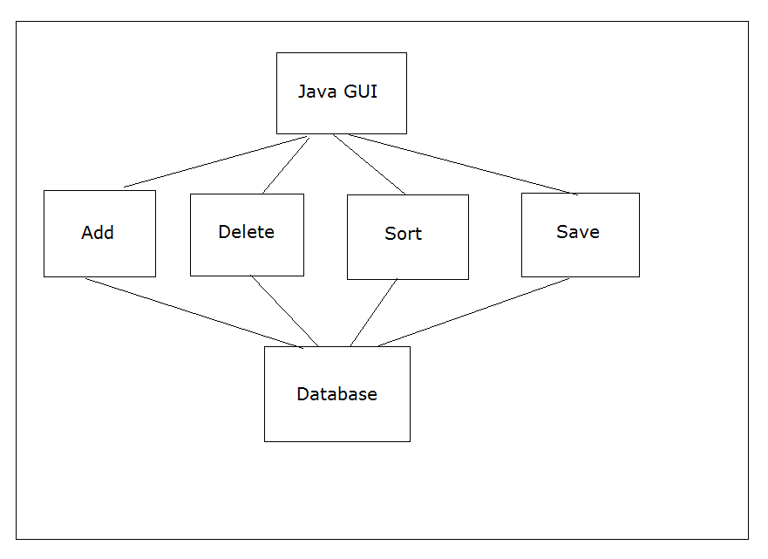

2.1.2 Memory Constraints
The amount of physical memory that is required to run Retro Fix Inventory Manager v1.0 is minimal and can be supported by most if not all modern computer systems. All of the data and information necessary to run the Retro Fix Inventory Manager v1.0 program will be contained in less than 1 gigabyte of overall physical memory. The settings and database files saved by the program will consist of less than a few megabytes of physical memory on the system drive

2.1.3 Operations
Retro Fix Inventory Manager v1.0 is both self-contained and independently designed. It can be run as much or as little as the user requires; neither will effect the program. It is recommended to backup the data weekly, although that is a decision the user will have to make for themselves. Anytime the user makes large changes to the data, it is recommended they save and backup the database.

2.1.4 Site Adaptation Requirements
Retro Fix Inventory Manager v1.0 does not need to be modified to adapt to any software. The machine running the program must have Java installed and enough storage and memory to run the program, totaling less than one gigabyte.
2.2 Product Functions
Retro Fix Inventory Manager v1.0 serves the ultimate purpose of tracking the inventory of Retro Fix Video Games. It does this through the use of several functions: add, delete, and save of inventory items. The add and delete functions are for adding and deleting products into the entries. The database should be saved on a regular basis using the save function. While these are the main functions, there are more cosmetic functions. One function can change the background to a solid color or any picture loaded from the machine running the program. The user can also select from 13 different colors for the text and background color. Similarly, the user can choose a border color to make the borders distinctive. Another function can alphabetize the sections or the contents within a section.
Figure 2.2 System function with user and database
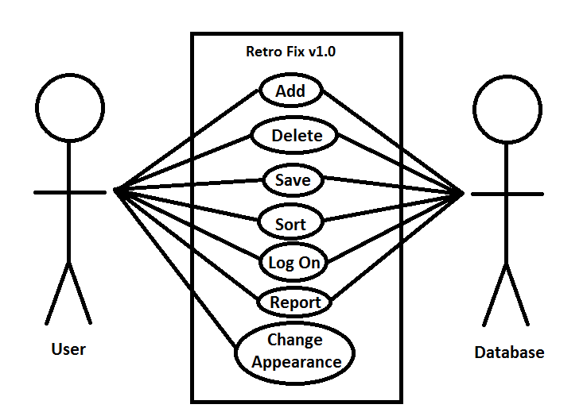

2.3 User Characteristics
The system owner or administrator needs to have a competent background in basic computer usage. This skill set will be focused on the ability to adequately navigate through a windowed GUI, as well as the interaction with standard input and output devices related to the computers being used. The administrator may need a short demonstration on how to use the Retro Fix Inventory Manager program and interact with the necessary interfaces within the program. The client or administrator also needs to understand the basics of saving and loading the appropriate database files for use with the program. The administrator will have to learn the ability to store the database files from the program and then access and modify them accordingly to accommodate the needs of the owner/administrator.

2.4 Constraints
The Retro Fix Inventory Manager v1.0 program communicates solely with the operating system, the only constraint it has will be memory-related, which is the responsibility of the user. The user can make the inventory as large or small as needed, but the machine running the Retro Fix Inventory Manager v1.0 needs to have enough memory and storage to hold the database. A standard personal computer system will have plenty of memory and hard drive storage space to sufficiently run the program and store all of the relevant files required for operation of the program.
2.5 Assumptions and Dependencies
The computer system of the user is assumed to have a fully functional operating system installed on it whether it be Microsoft, Mac, or Linux. The computer has sufficient memory and hard drive space in order to sufficiently run the Retro Fix Inventory Manager v1.0 program. The computer system being used is required to have the Java Runtime Environment properly installed on it. The program does not need to interface with any other networks or servers and no connection to the Internet is required assuming that the JRE has already been previously downloaded and installed.

2.6 Apportioning of Requirements
The requirements of this overall endeavor will be assigned to particular modules that can be identified individually by the software designer. The modules for Retro Fix Inventory Manager v1.0 can be broken down as 1.) GUI design, 2.) Interface Design, 3.) database design, 4.) security design. These specific requirements are broken down obviously with the division of the requirements section. In the enhance version of the program there may be the ability to interface with an online pricing website. The program would then monitor the fluctuating market of the prices of video games as they change over time and can be accessed and related to the current stock and item inventory of the Retro Fix Video Games store.

3 Specific Requirements

3.1 External Interfaces
The Retro Fix Inventory Manager v1.0 program is a self-contained piece of software created in Java and will rely on Java being installed on the computer it’s ran on. There is a secure password protected login in order to access previously saved database files and load them from the hard drive.

Login
- Login
- The login allows the user to password-protect the database storing their inventory information.
- The user will input the password using a keyboard.
- The password must match the password stored within the file or the database is inaccessible. In the prototype version there will be no way to retrieve a forgotten password. The password will have a minimum and maximum number of characters, yet to be determined.
- The password will take in any information able to be entered into the JTextField and read in Java. This includes all standard inputs from the keyboard, such as A-Z, a-z, 0-9, and special characters.
- There are no timing constraints.
- The previously saved databases will be inaccessible unless the correct password is entered, unless it was made to be unsecured (requiring no password).
- The screen format will be a data grid. The data elements will be Title, Loose, Complete, New, Box, Manual, Condition, Notes, and Value.
- The window will occupy a portion of the screen and will be able to be adjusted, maximized, or minimized (to a point) to meet the user’s needs and preferences.
- The program saves data for the settings and database in a stored binary file format on the disk the program is being ran on, such as the hard disk or a thumb drive.
- The commands executed in the program will add, delete, modify, or alphabetize inventory items that will be stored in the database file of the program. It can also add, delete, and modify sections.
- “Thank you for using Retro Fix Inventory Manager v1.0”

Database Information
- Database Information
- The purpose is to display the information from the database for the user.
- When a database is loaded from a saved database file, the information in the database is taken from that file and loaded into active memory. As database elements are added, modified, and deleted (as the database is being edited), the information is modified within active memory. The information is displayed on the monitor in the grid as this happens.
- The accuracy of the database file is important to ensure that the user will have the correct information loaded into all of the fields when they resume the program from a previous session. The range was originally 600 elements per section. However the limit restriction has been removed and now each section can have an unlimited number of sections. An example of this is one section called “Nintendo” and another section called “Nintendo (#2)”. There is no tolerance for error with the database information.
- There are 30 database entries shown on the screen. There are 20 pages for each section that can be flipped through as entries fill up those pages. This allows for 30 x 20 = 600 entries per section. There is no limit to the number of sections. When the report is generated, totals are counted for each section, as well as grand totals of all sections. There is no limit to the size of the file, because there is no upper limit to the size of the database, aside from the available disk space available.
- There are no timing constraints.
- The database information can be added, deleted, or otherwise altered by the user.
- The screen format will be a data grid. The data elements will be Title, Loose, Complete, New, Box, Manual, Condition, Notes, and Value.
- The window will occupy a portion of the screen and will be able to be adjusted, maximized, or minimized (to a point) to meet the user’s needs and preferences.
- The program saves data for the settings and database in a stored binary file format on the disk the program is being ran on, such as the hard disk or a thumb drive.
- The commands executed in the program will add, delete, modify, or alphabetize inventory items that will be stored in the database file of the program. It can also add, delete, and modify sections.
- “The database has been successfully saved and stored.”

3.1.1 User Interfaces
In order to use Retro Fix Inventory Manager, any basic monitor that’s able to run a newer version of Windows, Apple OS, or Linux and that can handle Java and run Java apps will be able to use the application. The application will be able to be navigated using just a standard keyboard, or just a mouse, or most effectively, with a combination of the two. When just equipped with a mouse, the user will have to have access to an on-screen keyboard, which is provided by a lot of GUI operating systems, such as Windows.
The GUI components will be laid out on each panel in an order that will be able to be tabulated through from top-left to bottom-right, in a format as though you’re reading it. There will be a robust help menu that will explain every part of how to use the application in detail. The application itself will be made as user-friendly as possible, with the least amount of confusion as necessary. It will also be made to be efficient, so there may be a little bit of a clash between ease of use and efficiency. At this time Team Retro Fix are considering including “Tool Tips”, but are not yet sure if that will be necessary.
3.1.2 Hardware Interfaces
The hardware required for the operation of Retro Fix Inventory Manager v1.0 is minimal and the program can be executed on a variety of different platforms. Any machine and operating system capable of running Java will be able to run Retro Fix Inventory Manager v1.0. This includes, but is not limited to, Windows, Mac OS, and Linux. The machine will need enough memory and storage to store and load the database, which will depend on the size of the inventory. Almost any modern laptop or desktop should suffice.

3.1.3 Software Interfaces
The Retro Fix Inventory Manager v1.0 will use the Java Runtime Environment (JRE) to handle all interfacing with the operating system. The JRE comes with Java software and uses a Java Virtual Machine (JVM). The JRE allows the code to run on all operating systems. Any computer system with the JRE for the Java programming language installed on it can execute and run the program. The Java programming language is an object oriented language and utilizes the concepts and constructs specific to the paradigm.

3.1.4 Communication Interfaces
Retro Fit Inventory Manager v1.0 will not need to communicate with any networks. It is a self-contained program that will be able to run without any need for a connection to the Internet or any other network or computer.

3.2 Functions
Add:
- The application shall allow the user to add games to the database.
- The application shall allow the user to add merchandise to the database.

Delete:
- The application shall allow the user to remove games to the database.
- The application shall allow the user to remove merchandise to the database.

Log on:
- Shall allow the user to log on with the appropriate password.
- Shall allow the user to change the password.
- Shall allow the administrative user to manage users.

Sort:
- Shall allow the user to pull up and sort all games in the database by price.
- Shall allow the user to pull up and sort all games in the database alphabetically.
- Shall allow the user to pull up and sort all games in the database condition.
- Shall allow the user to sort merchandise by price.
- Shall allow the user to sort merchandise alphabetically.

Report:
- The report function shall allow the user to copy and print the states of all data in each section.

User management:
- Shall allow the addition, modification, and deletion of users by the administrator
- Shall allow the modification of user’s permissions by the administrator, including the ability to add items, modify items, delete items, add sections, modify sections, delete sections, and order items
Change appearance:
- The change appearance function shall allow the user to change the background color of the program window.
- The change appearance function shall allow the user to change the font color of fields.
- The change appearance function shall allow the user to change the border color of fields.
- The change appearance function shall allow the user to change the background to an image of their choice in the program window.
- “Restore Defaults” option allows the restoration of defaults for these properties, including white text color, white border color, black background color, and no background image.
Supporting Functions:
- Validity checks on the inputs
- The password must match the password stored in the database file in order to access a stored database, if the user chose to make it password protected.
- When a password is created for a database, it will be asked once and then asked again to confirm. Both must match.
- For loose price, complete price, new price, and value, if a proper numerical value is not entered, the opacity of the JTextField is set to true, in order to highlight to the user that the value in the field is not valid.
- For a new inventory entry, the name cannot be blank, or else it will not allow the addition of the inventory item.
- For the addition or modification of a section, the new section cannot be a blank name.
- For the addition or modification of a section, the new section cannot have the same name as any other previous sections.
- The application will not allow less than one section.
- Exact sequence of operations
- The program loads and a blank database is shown.
- The settings are loaded. If there is no settings file or the settings file is corrupted, the default settings are set, which is a black background, white text, white borders, and no background picture.
- Throughout the use of the application, at any time, these settings may be changed, and once changed, they will automatically save.
- In order to create a new database, the user may start adding entries.
- After entries or added, entries may me modified, deleted, and duplicated.
- Sections may be added, modified, and deleted (no less than one section).
- The database may be saved, and a password may be chosen, if the user wishes to password-protect the database.
- At any time, the user may choose to create a new database, which will close the existing, currently open one. If the currently open one is not saved, the user will be prompted.
- If the user opens a database, a password may be prompted, which the user must enter correctly. If the password is forgotten, the database is inaccessible.
- This should cover everything. Throughout the user of the application, inventory items may be added, deleted, modified, and alphabetized; sections may be added, deleted, and modified, as long as there is at least one section; settings may be modified; and databases may be saved and loaded, with passwords that may be changed.

- Responses to abnormal situations, including
  - Overflow
The application will not allow more than 600 entries for section. If this happens, there will be a prompt explaining the maximum number of entries has been reached, and a new section must be created to add more entries.
  - Communication facilities
There will be no networking in our initial prototype version. The only kind of communication problems there may be is potential miscommunication, mainly in the GUI, when it comes to using Java on different platforms. If our customer decides to change from a PC to an Apple OS or Linux, there can potentially be miscommunication in the way GUI elements are displayed. Layout managers are used, which greatly reduce the chance of this happening, but I hear it’s still possible. This would only affect aesthetics and not the functionality of the program.
  - Error handling and recovery
There is file I/O when it comes to the settings file, background image file, and database files. When there are file I/O or other errors with the settings file, a new file is created with default settings. If there continues to be errors, the settings simply won’t save. If the background image file has errors loading, it simply will not load. It is tedious and unnecessary to prompt the user every time the background image or settings file is having issues.

- Effect of parameters
- At this time, Team Retro Fix is not planning to deal with any parameters for the program. Making the use of parameters is something we can do in an enhanced version. One thing we can do is allow for the automatic opening of a particular database file when running the application, with a parameter such as “-load [database file]”. We can also allow parameters for custom settings, that will ignore the settings file, in case multiple people use the inventory manager application and have different preferences.

- Relationship of outputs to inputs. including
  - Input/Output sequences
The inputs and outputs correspond to one another when it comes to file I/O and other operations. With the settings file (at this time), three color options are saved, one File object, and one boolean on whether or not to load the background image. The loading happens in the same order, to make things consistent. Many Java GUI elements are used to transfer data. The toString() and setText() methods are used often to retrieve and set texts within JTextFields.
  - Formulas for input/output conversion
The only real mathematical formulas in the program, aside from some simple math done to arrange GUI elements and other small, technical things, is the math required to total the values of loose price, complete price, new price, and value, and to come up with overall totals for each sections, and grand totals of all sections.

It may be appropriate to partition the functional requirements into sub-functions or sub-processes. This does not imply that the software design will also be partitioned that way.
3.3 Functional Requirements (System Mode)
In Retro Fix Inventory Manager, there are two main modes - one that displays Video Game inventory, and the other that displays Generic Item inventory. The Generic Item inventory display has the same text fields as Video Game display except for loose price, complete price, new price, box, and manual. There are different menus throughout the program, such as adding, modifying, and deleting sections; the main JMenus to modify settings and load and save databases; the adding and modifying inventory items GUI; and the report GUI that shows the totals.

Functional Requirements
Mode 1: Video game inventory portion of the program, includes more categories
- Each and every element shall have 9 attributes
- Invalid numbers shall be shown to be invalid if the appropriate settings checkbox is marked, which is telling the user the numbers are invalid
Mode 2: Generic inventory only, less attributes overall
- Each and every element shall have 5 attributes
- Shall have same invalid numbers option
Mode 3: Adding, modifying, and deleting sections
- Can add section, but shall not be the same name as a previous section
- Can delete section, but shall be at least one section remaining
- Can modify a section, but shall not name it one that already exists
- Shall have unlimited sections are allowed
- As sections are added, they shall be automatically alphabetized
Mode 4: The main JMenus to modify settings and load and save database files
- When loading a database, you shall enter the correct password if it’s setup to be password protected
- As soon as a setting is changed, the settings file shall automatically saved
Mode 5: The adding and modifying inventory items GUI
- Inventory items shall be required to have a name, or else they cannot be added
- An inventory item shall never be modified to having no name
- It shall be allowed to have zero inventory items for a particular section
- If a section has zero inventory items, then you shall be on the first page
- There shall be no limit for how many items can reside in each section. The user can create another section if necessary as many times as needed.
Mode 6: Report GUI that shows the totals of each section and grand totals of all sections
- If all sections are generic items, there shall be no grand totals for loose price, complete price, and new price.

3.4 Performance Requirements
The Retro Fix Inventory Manager v1.0 program only supports one terminal at a time that it is installed on. The program is designed to be run on a single machine with only a single user at any given time. A variable of data type double can hold a floating point number of 8 bytes (64 bits) and will be used for prices. A variable of data type string can hold a string of characters. This data type will be used for non-numerical entries such as titles, notes, and condition.
All transactions within the Retro Fix Inventory Manager v1.0 can be completed in less than 1 second.
3.5 Design Constraints
Retro Fix Inventory Manager v1.0 under its current construction is designed primarily for all standard desktop and notebook computers. It is not the intention of Team Retro Fix to construct a program that is usable on tablets or mobile devices however that functionality is not out of the question for a future iteration of the program. For the first version of the program it will not necessarily designed to be portable to tablets and mobile devices but portability is an inherent feature of the Java programming language and it may be relatively easy to eventually fully support such a feature. The future development of Retro Fix Inventory Manager v1.0 will be confined to the evolution of the design concepts through the implementation of the Java programming language.

3.5.1 Standards Compliance
The Retro Fix Inventory Manager v1.0 program has a report feature that totals the loose, complete, new, and value and displays the overall sum. The program will calculate and display the grand totals of all of the sections. For the generic items other than video games the report feature only tallies the total value for all items. The data naming convention for the program are applied for the save files. The default settings files are saved as settings.dat and a user selected name followed by the files extension .inv for the inventory save files. The basic accounting features are covered by the report feature that is built into the program. Due to the nature of the program and its intended functionality, the inventory files will only store and keep track of current values and it does not keep a record of prior values or quantities.

3.5.2 Logical Database Requirements
The database for the Retro Fix Inventory Manager v1.0 will contain any data entered by the user as well as login information. The login information will be accessed any time the program is started. After the user has logged in, the rest of the information will be made accessible. The data will be retained in the database until modified or deleted by the user. The user should maintain a regular backup of the data in case of hardware or software damage.

3.6 Software System Attributes

3.6.1 Reliability
The reliability of Retro Fix Inventory Manager v1.0 involves observing particular areas concerning program availability, average time between any failure, average time to make a repair, and the overall accuracy of the program. The program will have an inherently high degree of reliability given that it is a basic Java program with minimal demand on the system. The program also does not rely on any external programs or servers and therefore is unlikely to fail.

3.6.2 Availability
The program Retro Fix Inventory Manager v1.0 is required to meet an availability of 95%. The higher availability is required because the owner of the store Retro Fix Video Games, Rudy Treadwell, relies on the software to be operational in order to run his business through making transactions and tracking all of the relevant information in the Retro Fix Inventory Manager v1.0 database file. No redundant systems are required to ensure that Mr. Treadwell’s are always online. In the event that the program does go down or becomes inaccessible, Mr. Treadwell can temporarily keep track of transactions using a pen and paper and then enter the data to the program accordingly once it is fully operational again. The program reaches the equivalent of a checkpoint every time that the database file is saved because it updates the relevant data and information fields. As long as the binary database file for the Retro Fix Inventory Manager v1.0 program is stored on the hard drive of the computer in use recovery will be a simple process. The program can be restarted by exiting the program and then launching it again from the computer system currently being used.

3.6.3 Security
Retro Fix Inventory Manager v1.0 utilizes basic security features that can be readily taken advantage of by the store owner who is the primary user of the program. The owner of Retro Fix Video Games, Mr. Rudy Treadwell will be taking advantage of the built in security features while using the program. The settings and database files for the program will be password protected so that unwanted or unauthorized users will not be able to access or modify any of the settings or database information saved from the program. The settings and database save files will also be stored in a binary format so that they cannot be opened with a text reading program and accessed or read at all in that matter. The system times associated with each file that is stored on the hard drive will be noted and attached to the save files, so the owner would know if the files have been modified without their consent.

3.6.4 Maintainability
The owner and user of the Retro Fix Inventory Manager v1.0 program, Rudy Treadwell, will be indirectly responsible for the maintenance. As long as the program is running then the maintainability of the program is continuous. As soon as the owner encounters a problem that is stopping him from using the program the software engineer will need to be contacted. The acting software engineer from Team Retro Fix will be the representative for the program and work on fixing any errors or inconsistencies that are contributing to the issue. There is no need for routine maintenance checks due to the high reliability of the software so specific issues will be addressed as they are uncovered by the user.

3.6.5 Portability
The Retro Fix Inventory Manager v1.0 program is fully developed in the highly portable programming language of Java. The program is portable to all different platforms and operating systems that support the Java programming language, which is most if not all in existence. The program will be able to run on Microsoft Windows, Mac, and Linux operating systems. This versatility of the program and the language it is developed in makes it inherently portable. All of the code for the program and its components are stored and run on the local machine that is being utilized. The computer system that is running the program is considered the host and therefore all of the code relevant to the program is dependant on the one host machine in use.

3.6.6 Usability
The operation of Retro Fix Inventory Manager v1.0 is relatively simple and will require minimal training or instruction for the primary user to be able to fully operate the program. The owner of Retro Fix Video Games is already familiar with basic computer systems and GUI interface formats. The program is designed in a user friendly manner which keeps the operation and navigation of the program and its interface simple and easy to follow. The execution of the program will be similar to a variety of programs that the owner already has prior experience with and will not take much time to familiarize with the new program being provided. The saving and loading of the settings and database files relevant to the program will behave and interact in the same manner as programs previously used by the owner.

3.6.7 Testability
It is possible to debug Retro Fix Inventory Manager v1.0 using the integrated development environment that the program is being developed with. Through rigorous testing and combing through the program for errors, bugs and mistakes in the code can be detected. The program itself can be ran on different machines and tested by all the members of Team Retro Fix. Multiple people testing the program at the same time can help reveal any bugs or errors more readily. While running the program it can be manipulated in any way that is desired which will reveal any underlying bugs or issues with the code that can then be addressed and fixed.

3.6.8 Modifiability
The owner and primary user of the program has the ability to customize the software to their own personal taste. The Retro Fix Inventory Manager v1.0 program includes the functionality to allow the user to select the background and text colors from a selection of 13 different colors. The background can also contain a customized picture or be blank. The user can also alphabetize sections and the content within the sections.

3.6.9 Performance
The performance of the Retro Fix Inventory Manager v1.0 program will be efficient and only incur very short response times from the computer system it is being run on. Due to the minimal memory and hardware requirements of the program, it is expected that there will not be any noticeable slowing of the operation of the program due to the lack of system resources. The program does not rely on any other outside interfaces or networks and all of the response time is contained within the computer system that it is installed on.

