**[Etsy Profitability and Material Loss Report](https://github.com/DanielLevenstein/Product_Profitability_Study)**

This report was used to optimize the pricing and material loss calculations used by a local Etsy store.

* The numbers in this study were pulled from a client selling handmade goods on Etsy.
* The details about the orders have been removed from this analysis but the numbers used were real.
* This project was posted on GitHub with permission from a client.

**Features**

* Generates synthetic data for test analysis using Panda DataFrames.
* Calculates profit and material loss from order length and width.
* Compares different pricing structure for product and calculates margins for each.
* Generates an HTML report for a client using Jupyter notebook.

**Findings**

**Material Loss vs Num Colors**

* As num colors went up material loss went up.
* Material loss did not go up evenly for all orders.

[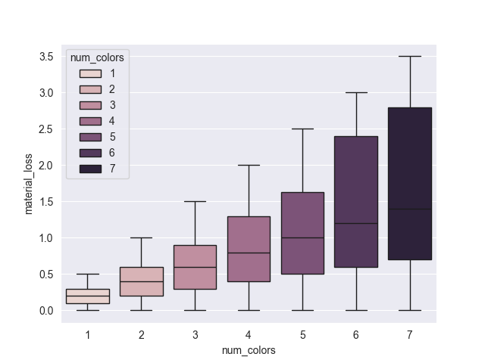](https://github.com/DanielLevenstein/Product_Profitability_Study/blob/main/images/material_loss_vs_num_colors.png)

**Profit Chart**

Four pricing structures were suggested in this report.

[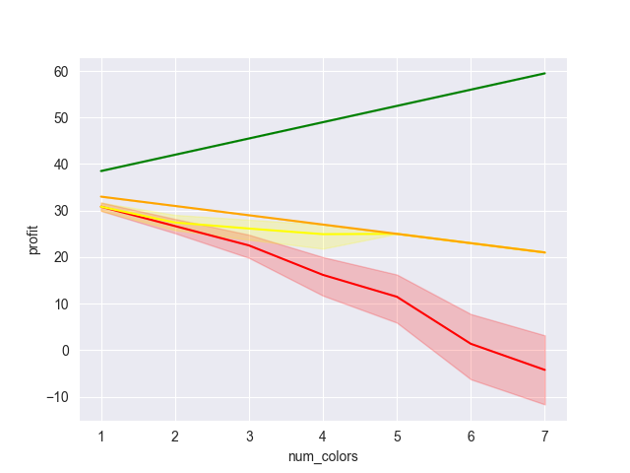](https://github.com/DanielLevenstein/Product_Profitability_Study/blob/main/images/profit_chart_comparison.png)

**Price Ratings**

* Red Line: color surcharge = $5 with no limits on order dimensions. (Price1)
* Yellow Line: color surcharge = $5 and material loss < 1 unit (Price2)
* Orange Line: color surcharge = $5 and length and width add up to 19 (Price3)
* Green Line: color surcharge = $7 and length and width add up to 19 (Price4)

**Observations**

* Of these three pricing schemes, prices 2, price 3, and price 4 are profitable while price 1 is not.
* Price structure 4 has the highest profit margin.
* Pricing structures 2 and 3 are very similar, but price 3 is easier to calculate.

**Suggestions**

* Client should charge $40 per item with a $5 - $7 surcharge per additional color
* Client should limit orders to ones whose length and width <=19

**Final Pricing Chart**

| **Name** | **Min Profit** | **Max Profit** | **Mean Profit** | **Median Profit** | **Size** |
| --- | --- | --- | --- | --- | --- |
| Price 1 | -28.0 | 33.0 | 17.31 | 25.0 | 3190 |
| Price 2 | -1.0 | 33.0 | 26.83 | 29.0 | 2230 |
| Price 3 | 21.0 | 33.0 | 28.30 | 29.0 | 1540 |
| Price 4 | 38.5 | 59.5 | 46.73 | 45.5 | 1540 |

**Frameworks Versions at (09/16/2025)**

* python: 3.13
* pandas: 2.3.2
* numpy: 2.3.2
* seaborn: 0.13.2
* jupyterlab: 4.4.7
* jupyter_client: 8.6.3
* jupyter_core: 5.8.1
* jupyter_server: 2.17.0

**Project**

* Product Profitability Report
* Daniel Levenstein
* Date: 09/16/2025