**BL 1110 Lab 2b: Library research (5 pts)**

Due the week of 09/20 (submit on Canvas)

**Introduction**

Primary literature refers to written work, usually published in scientific journals, that present original research. This is one of the most common ways to communicate current research to the scientific community. It allows us to build upon the research that others have done and give context to our own.

University libraries usually have databases of scientific journals where you can find peer-reviewed articles. Students and faculty have free and open access to these databases. However, the library is not the only place where you can access such databases; PubMed, Web of Science, and to some extent, Google Scholar, are some examples of other sites where you can access peer-reviewed articles. Beware that access to journals is not always free on these other sites! As a student, you should never pay for an article. If you find an article that you like and is relevant to your chosen topic but is not free, then contact the MTU library to figure out how to get access.

To search for articles, you must first decide on the right **keywords** to use to narrow down your results. Knowing which keywords to use takes practice, and overtime, you will become more familiar with the most common ones used in your field. In addition to keywords, using the search operators **AND, OR,** and **NOT** will help refine your searches.

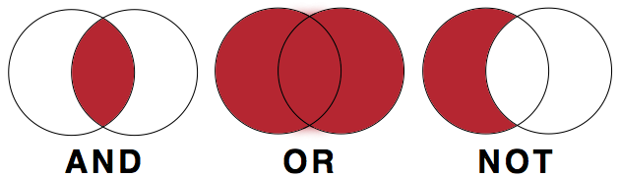

Source: Choosing & Using Sources: A Guide to Academic Research. **Authored by**: Teaching & Learning, Ohio State University Libraries. **Provided by**: The Ohio State University. **Located at**: **https://osu.pb.unizin.org/choosingsources/**. **License**: ***CC BY: Attribution***

When to use certain search operations:

**AND** – If the topic or idea has 2 or more topics/ideas related, then use the AND operation to combine them. 1

**OR** – If there are several synonyms for the topic or main idea, then use the OR operation to combine them. 1

**NOT** – If there is a common use of the topic or main idea and you don’t want to include them, then use the NOT operation. 1

In this lab exercise, you will:

* Practice searching for peer-reviewed, scientific journal articles through MTU’s library
* Practice writing proper reference list citations

**Instructions:**

1. Navigate to MTU’s library home page (<https://www.mtu.edu/library/>)
2. Find the search bar and type in the keyword “biodiversity”
3. Hit enter or click on the search button Icon

   Description automatically generated with medium confidence
4. Make note of the number of results
5. On the left side column, you can narrow down your choices that better match what you are looking for. Find the column on the left side of your screen. Check the box next to “Peer-reviewed Journals” and click “APPLY FILTERS”
6. Make note of the number of results
7. In the search bar, use the AND operation to add another keyword to “biodiversity”
8. On the left side column, check “Peer-reviewed Journals” and “Articles” under Resource Type and click “APPLY FILTERS”
9. Choose an article that looks interesting and click on it
10. Make note if the full article (text) is online for free
11. Write a reference list citation for the article using APA style

**Questions:**

1. How many results showed up when you searched “biodiversity”? **(1pt)**
2. How many results showed after step 5? **(1pt)**
3. What was the title of the article that you chose? **(1pt)**
4. Was the full article (text) available online for free (yes/no)? **(1pt)**
5. Write the citation in the correct format here: **(1pt)**