**Daniel M. Jones**

**Rice Data Analytics BootCamp**

Homework Unit #6

API

**You must include a written description of three observable trends based on the data.**

1. The hottest max temperature of cities tends to cluster between -20 and 40 degrees of latitude based on a random sample of greater than 500 cities. As the distance becomes farther away from either -20 or 40 degrees, the max temperature of the cities also decreases.

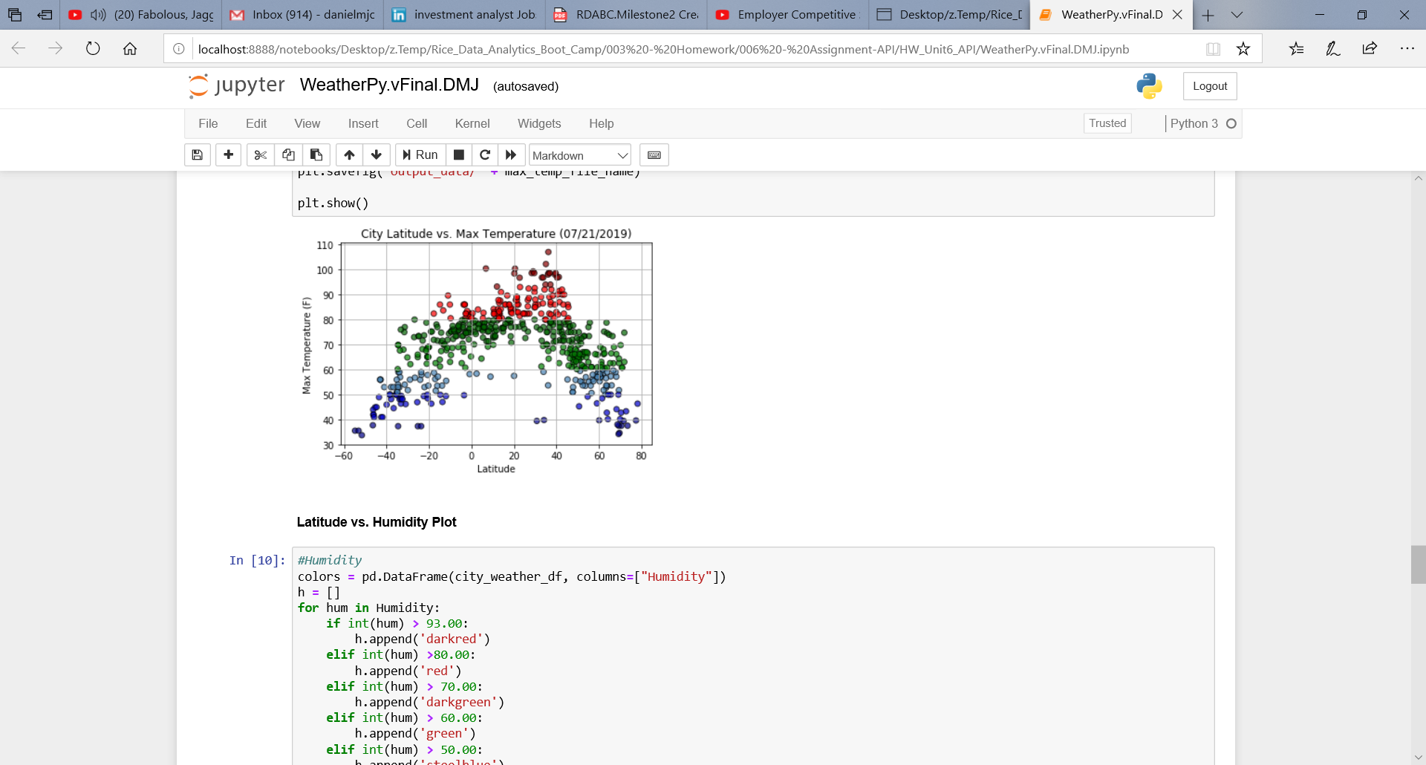

1. Varying percentages of humidity in cities seems to be well distributed across latitudes. In other words, latitude is not necessarily a predictor of a city’s humidity.

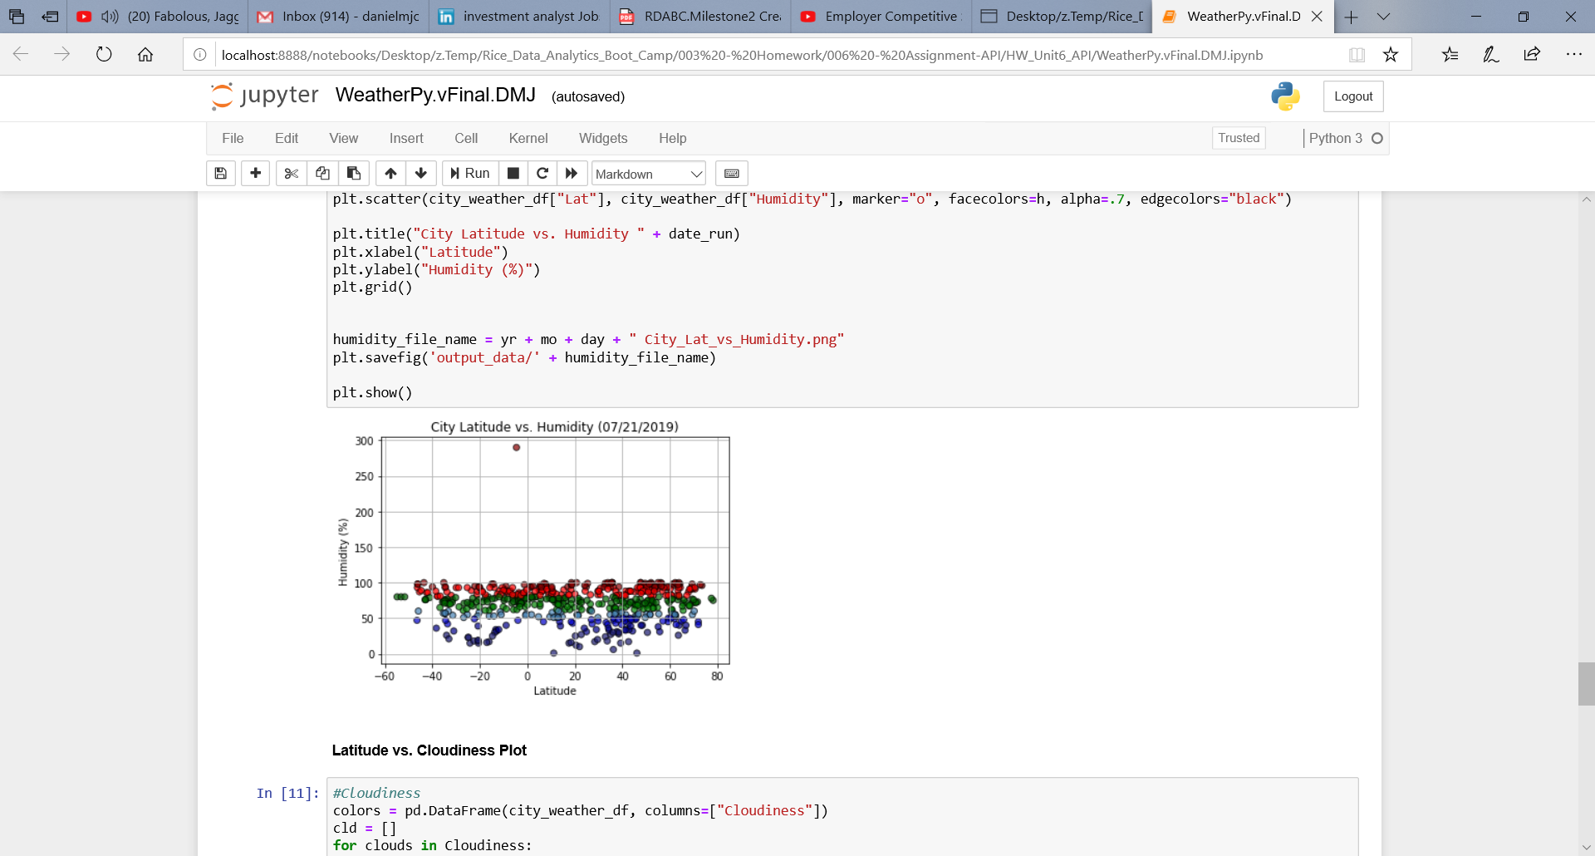

1. While wind speed also seems to be well distributed across latitudes, the average wind speed is 8.35 mph and the median wind speed is 6.93 mph. The standard deviation is 5.7 mph.

Average Wind Speed: 8.35

Median Wind Speed:6.93

Standard Deviation Wind Speed:5.7

