**Part A**

**I**

**A**

**B**

**C**

**D**

**E**

**F**

**G**

**Objective** : Name and decribe each component

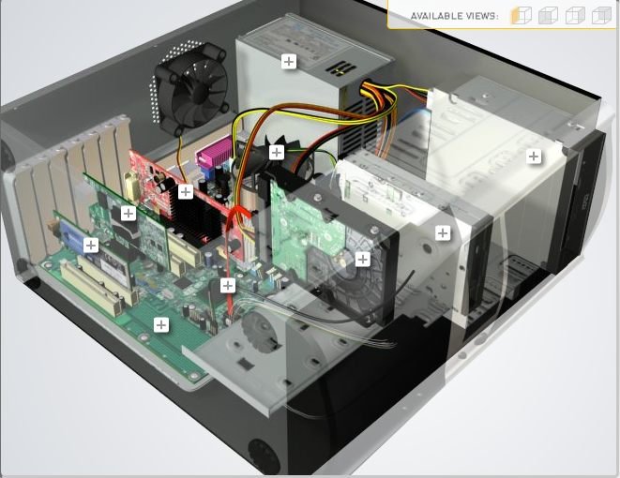

**H**

|  |  |  |
| --- | --- | --- |
| Download [**http://tinyurl.com/CW208-CAG-SIM**](http://tinyurl.com/CW208-CAG-SIM) PC Build Simulator.  Go through steps of building a PC, as you complete the simulation find and describe in detail components A to I. To run simulator first install <http://www.swffileplayer.com/> and open ***RootMovie.swf*** using SWF player. Alternatively install [Macromedia Flashplayer](https://fpdownload.macromedia.com/pub/flashplayer/updaters/32/flashplayer_32_sa.exe) . Ideally use a simulator as listed in class. | | |
| Label | Name each component | Description |
| A | Ram | It holds the short term data that the pc will use and operate properly |
| B | Graphics card | Electronic circuit that helps the pc create and render images faster |
| C | Case cooler | It cools down the pc by replacing the hot air and replace it with cold outside |
| D | Power supply | Provides the pc with a high voltage current which allows all the parts to run |
| E | Dvd driver | It allows the pc to be able to play cds to play and watch movies |
| F | Usb and speaker reader | It allows the pc to take usbs for more storage and speaker to play audio |
| G | motherboard | The circuit board that connect all hardware to the proccesors. |
| H | Processor | A processing logic circuit that responds and processes instructions on the computer |
| I | Network card | Allows all devices and this device to connect to the internet |

**Part B**

**Objective**

Compare a pre-assembled system and the components that could be assembled to build a comparable system. After completing this practical, you should be able to:

1. Identify the components of a pre-assembled system
2. Locate prices for components needed to assemble a comparable system
3. Compare the cost of a pre-assembled system and a self-assembled system.

If you can’t find exact match for components, find the closest possible substitute. Use the Internet and available computer-related publications as your sources for information. Examples of websites for computer parts [www.komplett.ie](http://www.komplett.ie), [www.dell.ie](http://www.dell.ie), [www.custompc.ie](http://www.custompc.ie) [www.amazon.de](http://www.amazon.de)

MAKE SURE TO INCLUDE VALID LINKS TO WEB REFERENCES

|  |  |  |
| --- | --- | --- |
|  | **Pre-Assembled Computer Package** | **Computer Package**  **Components** |
| **CPU** | Intel core i7-9700k 3 | Intel core i7 11700 |
| **Storage / Memory** | | |
| |  | | --- | |  | | RAM | | Hard Drive | |  | | |  | | --- | |  | | 16gb ddr4 | |  | |  |   1tb pci | 16gb  960GB ssd |
| **Input/Output** | | |
| |  | | --- | | Keyboard | | Pointing Device | | Monitor | | Speakers | | Network Adapter | |  | |  | | 7.1 channel keyboard  7.1 channel mouse  Acer 68.6m 27inch gaming lcd  802.11ac wifi audio  Rj-45 network ethernet | Ps/2  Ps/2  Acer 59.9 cm (23.6 Inch) Gaming LCD Monitor LED Kg241Qsbiip  PC speakers, USB computer speakers 10W stereo gaming speaker system with colorful LED lighting  RJ45 Network Ethernet 10/100/1000 | 300Mbps 802.11n Wi-Fi |
| **Bundled Software**  (Including Operating System) | Windows 10 | Windows 10 |
| **Total Cost** | 3000.90 | 1854.40 |

**Part C**

**Objective**

You have been asked by a family friend to assist them with a computer purchase. They’re unfamiliar with technology and the terms used and have presented you with two alternatives machine choices. They would like to be able to write word documents, surf internet and play Minecraft © Mojang and Half-Life © Valve Software. They are considering playing Fortnight but are not sure yet, as it depends on machine cost and if they can extract some money from their Bitcoin wallet.

Compare Personal Computer Option A and B in relation to each of the side headings and recommend a system and any alterations.

|  |  |  |
| --- | --- | --- |
|  | Personal Computer  Option A | Personal Computer  Option B |
| CPU | 2.2 GHz Intel Celeron 450 | 3.2 GHz Intel Core i5 |
| Memory |  |  |
| |  | | --- | | Cache | | RAM | | Hard Drive | | CD-ROM/DVD | | |  | | --- | | 512 KB Cache | | 4 GB RAM | | 320 GB Hard Drive | | DVD+/-RW drive | | |  | | --- | | 4 MB Cache | | 8 GB RAM | | 1 TB Hard Drive | | DVD+/-RW drive | |
| Input/Output |  |  |
| |  | | --- | | Keyboard | | Pointing Device | | Screen | | Speakers | | Network Adapter | | |  | | --- | | USB multifunction keyboard | | USB optical mouse | | 20’’ HD flatscreen monitor | | Multimedia Speaker System | | Integrated 10/100/1000 Ethernet | | |  | | --- | | wireless multifunction keyboard | | wireless optical mouse | | 25’’ HD flatscreen monitor | | Dolby Surround Sound Speakers | | Integrated 10/100/1000 Ethernet | |

|  |
| --- |
| **Recommendations** |
| The second pc option would be better as the amount of memory it holds is a lot more the processor is faster and the monitors are bigger and better for gaming with a lounder and more in dept sound coming from the speackers. |

**Your Recommend System**

|  |  |
| --- | --- |
|  | Personal Computer  Recommendation |
| **CPU** | Intel i7 11th gen |
| **Memory** | |
| |  | | --- | |  | | RAM | | Hard Drive | | SSD Drive | | |  | | --- | | 16 gb | | 1tb | | 240gb | |  | |
| **Input/Output** | |
| |  | | --- | | Keyboard | | Pointing Device | | Screen | | Speakers | | Network Adapter  GPU | | |  | | --- | | Gaming Keyboard White Shark GK-1923 Gladiator  Wired Gaming Mouse 19 Buttons Game Mice Backlight  **1.** LG 27GN950-B | | Speakers smalody computer speakers wired usb powered pc speakers stereo multimedia volume control gaming | | PNY VCX NVIDIA Quadro T600 4GB GDDR6 GPU Graphics Card | |  | |  | |

Hand up this practical report at the end of session and ensure it has been checked

|  |  |  |  |
| --- | --- | --- | --- |
| **Student Name** | **Daniel mooney** | **Student Number** | **C00263423** |
| **Date** | **27/10/21** | **Checked** |  |
| **Group** | **A / B** |  |  |