NOTE: Use of internet is not permitted, calculators are permitted and your answers must include worked solutions. If you require extra sheet(s) please write your name and student number at the top of each additional sheet.

**Objective**

Complete exam questions d, e, and f below

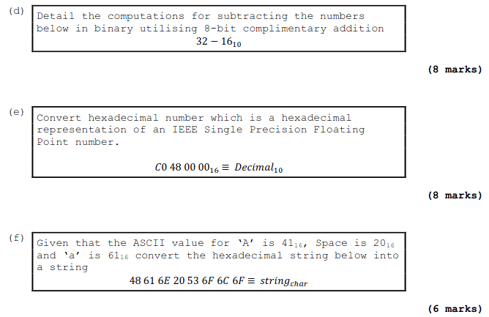

D) 32 in binary is 0010 0000 and 16 base10 is 10000 in binary and 0010000 – 100000 = 0

E) C0 48 00 00 16 to decimal is 32252944064

F) 48 61 6E 20 53 6F 6C 6F

48 = H 61 = A 6E = N 20 = SPACE 53 = S 6F = l 6f =o

String = HAN Slo

Hand up this practical report at the end of session and ensure it has been checked

|  |  |  |  |
| --- | --- | --- | --- |
| **Student Name** |  | **Student Number** |  |
| **Date** |  | **Checked** |  |
| **Group** | **A / B** |  |  |