Urban Sound Classification: CNN vs. SVM
Performance and Noise Robustness on UrbanSound8K
Duy Nguyen
Department of Electrical and Computer Engineering
PID: A18513063 | ECE 176 — Introduction to Deep Learning | UC San Diego | March 2026

Abstract
This project compares a Convolutional Neural Network (CNN) trained on log-mel spectrograms against a Support Vector Machine (SVM) trained on MFCC features for urban sound classification on the UrbanSound8K dataset [1]. Both models are evaluated using the official 10-fold cross-validation protocol. The CNN achieves 73.29% ± 5.19% mean accuracy, outperforming the SVM at 66.10% ± 5.03% by about 7 percentage points. The novel contribution is a post-hoc noise robustness analysis: additive Gaussian noise is injected at five SNR levels (20 to −5 dB) without retraining either model. The CNN degrades far more gracefully — at −5 dB SNR, where noise is louder than the signal, it still reaches 56.7% while the SVM collapses to 19.4%, barely above random for a 10-class problem. The advantage gap grows from +7.2 pp on clean audio to +37.2 pp under extreme noise, which has real implications for deploying these systems in the field.

1 Introduction

1.1 Problem Statement
Urban sound classification is the task of assigning a short audio clip to one of several categories of urban noise — sirens, drilling, car horns, and so on. The core challenge is that audio clips share overlapping frequency content, vary in recording quality, and, in real deployments, are captured in noisy environments rather than controlled lab settings. A model that performs well on clean test audio may fail badly when background noise is present, yet most published benchmarks only evaluate on clean data.

1.2 Motivation
Two things motivated this project. First, there's a practical gap: the two most common approaches to audio classification — hand-crafted MFCC features with an SVM, and CNN on mel spectrograms — have never been directly compared under controlled noise conditions on UrbanSound8K. We know the CNN is more accurate on clean data [2], but we don't know how that gap behaves when noise enters the picture. Second, understanding noise robustness matters for real applications. Smart city monitoring, autonomous vehicle perception, and public safety systems all operate outdoors. If one approach degrades gracefully and the other collapses, that's a deployment-critical distinction.

1.3 Approach
The project trains a CNN (UrbanCNN, ~8.8M parameters) on log-mel spectrogram images and an SVM on 80-dimensional MFCC feature vectors, both following the official UrbanSound8K 10-fold cross-validation protocol. After training on clean audio, both models are tested under five levels of additive Gaussian noise (20 dB down to −5 dB SNR) without any retraining. The goal is a clean empirical answer to: which representation — spatially-rich spectrograms or compact MFCC statistics — holds up better as noise increases?

2 Dataset
UrbanSound8K [1] is a curated collection of 8,732 labeled audio clips drawn from Freesound.org, covering 10 urban sound classes: air conditioner, car horn, children playing, dog bark, drilling, engine idling, gunshot, jackhammer, siren, and street music. Clips are at most 4 seconds long and sampled at various rates. All audio in this project is resampled to 22,050 Hz and zero-padded or trimmed to exactly 4 seconds before any feature extraction.
The dataset ships with a predefined 10-fold split where folds are grouped by recording source rather than randomly. This is intentional — Salamon et al. [1] showed that random splits inflate reported accuracy by 5–10% because clips from the same field recording end up in both train and test sets, creating a form of data leakage. All experiments here use the official fold assignments strictly. Fold 5 is a known outlier: its test clips come from recording sources that are acoustically similar to the training data, so accuracy on that fold tends to run ~10 pp above average for both models.

3 Method

3.1 Feature Extraction
For the CNN, each 4-second waveform is converted to a log-mel spectrogram using a 2,048-point FFT with a 512-sample hop length and 128 mel-spaced frequency bins up to 8,000 Hz. The result is a 128×128 time-frequency image, normalized to [0, 1] per clip to keep the model focused on spectrotemporal texture rather than absolute amplitude.
For the SVM, 40 MFCC coefficients are computed per frame, then summarized as mean and standard deviation across all frames in the clip — yielding an 80-dimensional feature vector. This captures the overall timbral character of the clip without preserving temporal detail. A StandardScaler is fit on the training fold only and applied to the test fold to prevent leakage.

3.2 Model Architectures
UrbanCNN uses four convolutional blocks, each with Conv2d(3×3) → BatchNorm → ReLU → MaxPool(2×2), with channel depth growing 1→32→64→128→256. After four pooling steps, the 128×128 input is reduced to a 256×8×8 feature map, which is flattened to 16,384 values and passed through a fully-connected layer (16,384→512) with Dropout(0.5), then a 10-class output. The FC layer dominates the parameter budget at ~8.4M, giving ~8.8M total. Full details are in Table 3.
Table 3. UrbanCNN architecture.
Layer | Operation | Output Shape | Approx. Params
Input | Log-mel spectrogram | (1, 128, 128) | —
ConvBlock 1 | Conv2d 3×3 → BN → ReLU → Pool | (32, 64, 64) | ~0.4K
ConvBlock 2 | Conv2d 3×3 → BN → ReLU → Pool | (64, 32, 32) | ~18.6K
ConvBlock 3 | Conv2d 3×3 → BN → ReLU → Pool | (128, 16, 16) | ~74.1K
ConvBlock 4 | Conv2d 3×3 → BN → ReLU → Pool | (256, 8, 8) | ~295.7K
Flatten | — | (16,384) | —
FC1 + Dropout | Linear(16384→512) + ReLU + Dropout(0.5) | (512) | ~8.4M
Output | Linear(512→10) | (10) | ~5.1K
Total | — | — | ~8.8M
Training uses Adam (lr = 1e-3, weight_decay = 1e-4) with cosine annealing over 60 epochs. Data augmentation applies random temporal shift (±10%) and small Gaussian jitter (σ = 0.005) to the waveform. Best-checkpoint selection tracks validation accuracy every 5 epochs and saves the best weights rather than the final epoch — important because some folds begin overfitting well before epoch 60.
The SVM uses an RBF kernel with C = 10 and gamma = 'scale'. The scale setting lets the kernel bandwidth adapt to the feature variance of each fold, which works better than a fixed gamma for MFCC vectors that shift across folds.

3.3 Noise Robustness Experiment
After training on clean audio, additive white Gaussian noise (AWGN) is injected into each test-set clip before feature extraction. Five SNR levels are tested: 20, 10, 5, 0, and −5 dB. Noise power is set per-clip relative to its own signal power:
P_noise = P_signal / 10^(SNR/10)
Neither model is retrained. This simulates a production deployment scenario: a model trained in the lab, deployed in a noisy environment. Any robustness advantage must come from the representation, not noise augmentation at training time. Results are the 10-fold mean ± standard deviation.

4 Results

4.1 Clean-Data Performance
Table 1 and Figure 1 show the per-fold results on clean audio. The CNN averages 73.29% ± 5.19%, beating the SVM at 66.10% ± 5.03% by 7.19 pp. Notably, both models have nearly the same standard deviation — the fold-to-fold spread is a dataset property, not a model property. It comes from how the recording-source grouping creates test sets of varying difficulty.
Table 1. Per-fold accuracy on UrbanSound8K (clean audio, 10-fold CV).
Fold | CNN Acc. | SVM Acc. | Notes
1 | 72.85% | 60.02%
2 | 67.68% | 65.77%
3 | 66.81% | 60.54%
4 | 72.53% | 65.45%
5 | 83.87% | 75.53% | Recording-source outlier (~+10.6 pp above mean)
6 | 75.70% | 59.90%
7 | 68.14% | 70.88%
8 | 69.98% | 63.40% | Overfitting: train acc. 98.6%, val peaked ~70%
9 | 78.31% | 69.36%
10 | 77.06% | 70.13%
Mean | 73.29% ± 5.19% | 66.10% ± 5.03% | CNN advantage: +7.19 pp
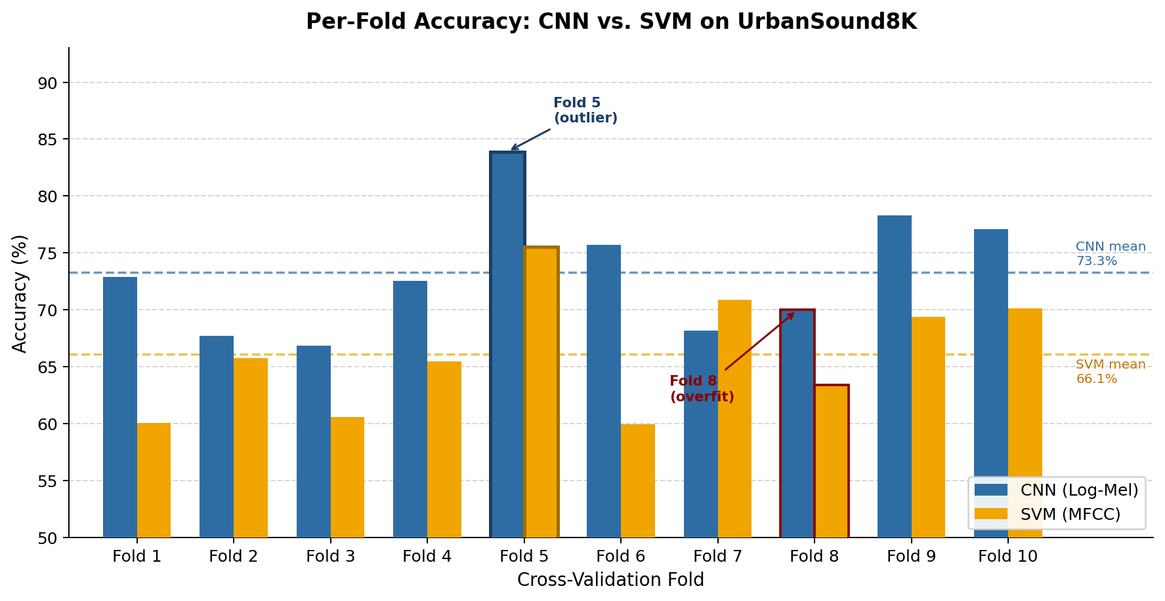
Figure 1. Per-fold accuracy for CNN (blue) and SVM (orange). Dashed lines show 10-fold means. Fold 5 is a clear outlier driven by recording-source similarity; Fold 8 shows overfitting (red border).
Fold 5 stands out at 83.87%, about 10.6 pp above the next-best fold for the CNN. This is expected — it's a well-documented UrbanSound8K property [1, 2] where that fold's test clips happen to come from recordings acoustically similar to the training set. It's not leakage; it's just the dataset's structure.
Fold 8 shows the clearest overfitting: training accuracy hit 98.6% while validation peaked around 70% and then declined. Best-checkpoint selection recovered part of this (reported accuracy is 69.98% from the best validation epoch), but the fold still lands below average. With roughly 790 training clips per class per fold, a model with ~8.8M parameters has plenty of capacity to memorize when training diversity is limited.

4.2 Noise Robustness
Table 2 and Figure 2 show how both models degrade as noise increases. The CNN holds up substantially better at every tested SNR level.
Table 2. Mean accuracy (10-fold) under AWGN. SVM Drop = change relative to clean baseline.
SNR Level | CNN Accuracy | SVM Accuracy | CNN Adv. | SVM Drop vs. Clean
Clean | 73.3% ± 5.2% | 66.1% ± 5.0% | +7.2 pp | —
20 dB | 75.5% ± 5.1% | 59.8% ± 5.3% | +15.7 pp | −6.3 pp
10 dB | 73.2% ± 6.0% | 52.8% ± 5.6% | +20.4 pp | −13.3 pp
5 dB | 70.6% ± 6.1% | 43.2% ± 5.1% | +27.4 pp | −22.9 pp
0 dB | 66.2% ± 6.3% | 29.3% ± 4.5% | +36.9 pp | −36.8 pp
−5 dB | 56.7% ± 4.6% | 19.4% ± 3.1% | +37.2 pp | −46.7 pp
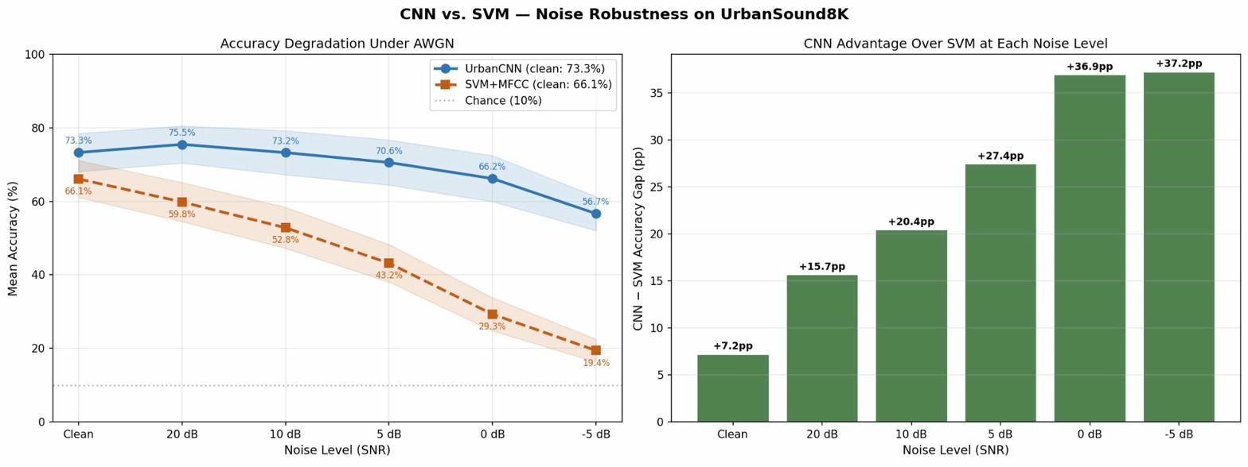
Figure 2. Accuracy vs. SNR for CNN and SVM. The gap widens from +7.2 pp at clean to +37.2 pp at −5 dB as the SVM collapses while the CNN degrades gradually.
At 20 dB SNR (mild noise), the CNN accuracy actually ticks up to 75.5%, a +2.2 pp gain over clean. This is consistent with mild noise acting as implicit regularization — the model is nudged away from exact waveform memorization toward more general spectral features. The SVM already drops 6.3 pp at 20 dB, which suggests that MFCC statistics are sensitive to even mild broadband perturbation from the start.
The divergence becomes severe at 0 dB — where noise power equals signal power. The CNN holds at 66.2% while the SVM collapses to 29.3%, barely above what a majority-class predictor would achieve. At −5 dB (noise louder than the signal), the SVM bottoms out at 19.4% — essentially random for 10 classes — while the CNN still achieves 56.7%. The spatial structure of the mel spectrogram apparently retains enough class-discriminative texture even when noise visually floods the image.
Figure 3 breaks down per-class accuracy at −5 dB. The CNN wins on 9 of 10 classes. The one exception is drilling (SVM 67%, CNN 41%). Drilling has a very regular periodic impulsive structure — its temporal periodicity partially survives in MFCC variance statistics even under severe noise, while the noisy mel spectrogram loses the clean vertical-stripe texture the CNN learned to rely on. For anyone specifically targeting drilling detection in noisy conditions, this result suggests the SVM may be the better practical choice.
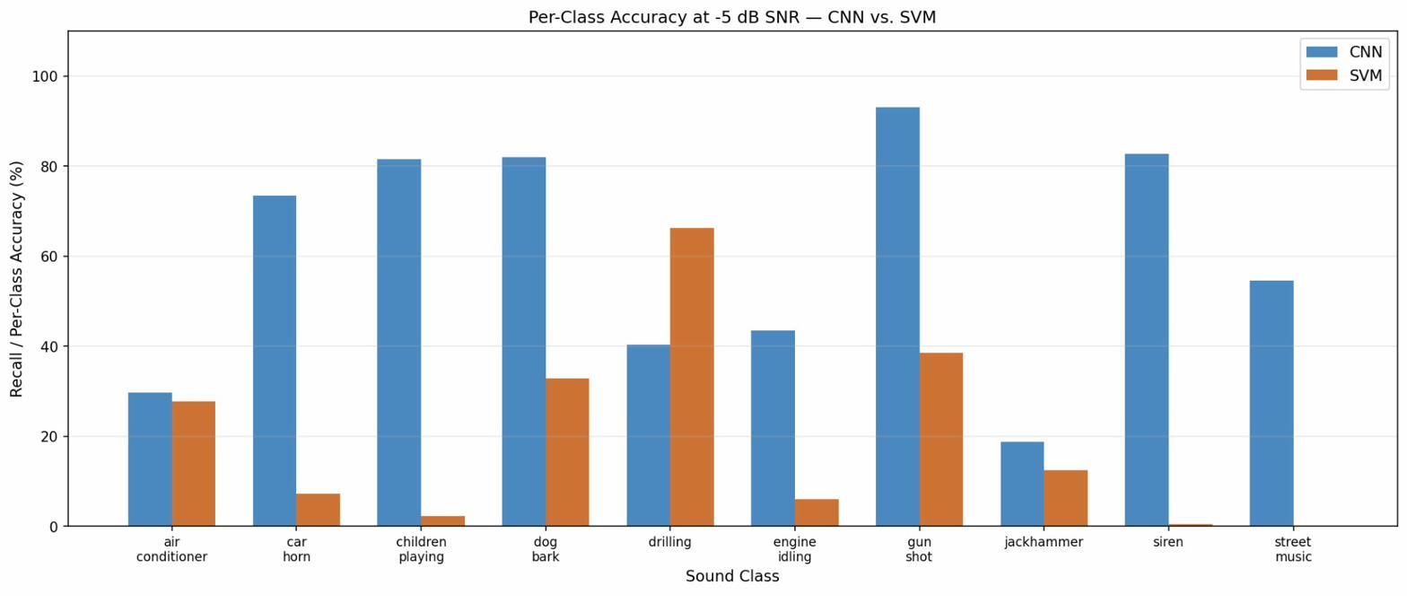
Figure 3. Per-class recall at −5 dB SNR. CNN dominates 9 of 10 classes; SVM retains advantage only on drilling due to its periodic impulsive structure.

4.3 Confusion Analysis (Clean Audio)
Figure 4 shows the confusion matrix aggregated over all 10 folds on clean audio (8,732 clips total). The heaviest confusion clusters are among drilling, jackhammer, and engine idling — all continuous broadband sounds with overlapping frequency profiles. Air conditioner is frequently misclassified as engine idling, which makes sense: both produce a steady low-frequency drone. Gunshot (95.7% recall) and car horn (85.5%) are the cleanest classes, both having sharp, distinctive spectrotemporal shapes that stand out from typical urban backgrounds.
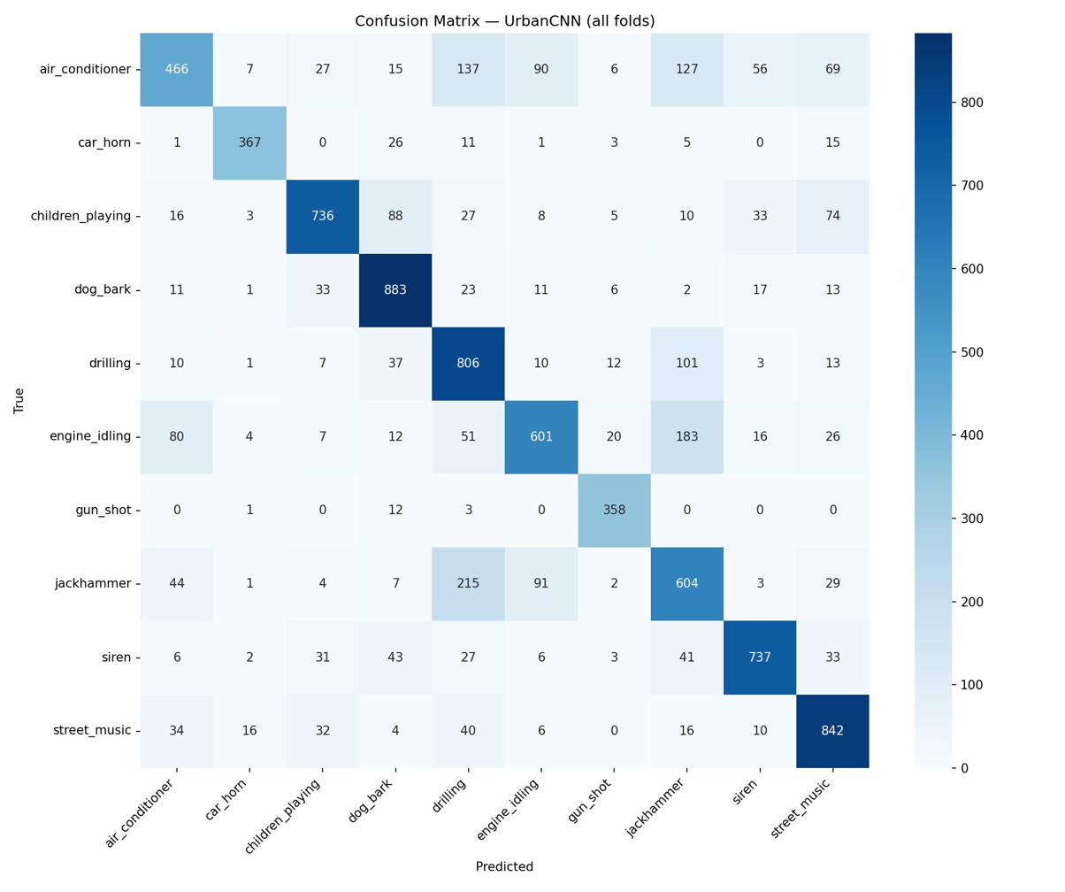
Figure 4. Confusion matrix for UrbanCNN across all 10 test folds. Strongest errors concentrate in the drilling/jackhammer/engine-idling cluster — all continuous broadband sounds.

5 Discussion
The main finding is clear: the CNN's advantage over the SVM grows with noise, not shrinks. On clean data the gap is a modest 7.2 pp. Under extreme noise (−5 dB) the gap expands to 37.2 pp, with the SVM essentially non-functional and the CNN still producing meaningful output. This pattern makes intuitive sense — the mel spectrogram preserves the full time-frequency structure of the audio, and even a noise-corrupted spectrogram retains some spatial patterns the CNN can use. The MFCC summary statistics, by contrast, lose discriminative information quickly once noise begins corrupting the per-frame coefficient values.
The mild-noise CNN bump (+2.2 pp at 20 dB) is an interesting side result. It suggests the model was slightly over-relying on exact waveform details on clean audio, and mild perturbation actually improves generalization. This lines up with the general observation that noise augmentation during training can improve CNN robustness [3].
The drilling exception is a useful caveat. The SVM's MFCC representation accidentally encodes the periodic impulsive structure of drilling in a way that survives Gaussian noise, even though it doesn't help much for other classes. This is a reminder that "better overall" doesn't mean "better on every class."
Looking ahead, the most obvious next steps are: retraining both models with noise augmentation to see how much of the robustness gap closes; testing with real noise types (traffic babble, rain) instead of synthetic AWGN; and using an AudioSet-pretrained feature extractor [4] as a stronger CNN starting point.

6 Supplementary Material
All code, trained fold checkpoints, and result files are available on GitHub: https://github.com/DanielNg520/Urbansound8k-spectrogram-CNN
The repo includes the annotated Colab notebook (with per-cell design notes), the noise robustness experiment script, and JSON result files (cnn_results.json, svm_results.json, noise_results.json). A video walkthrough is submitted separately via Gradescope.
Implementation: PyTorch 2.10 / CUDA 12.8 on an NVIDIA T4 GPU (Google Colab Pro). The final clean training run across all 10 folds and the noise robustness experiment together took approximately 4–5 hours of GPU time.
All results are single-run — the reported fold variance reflects dataset structure, not run-to-run randomness.

References
[1] J. Salamon, C. Jacoby, and J. P. Bello, "A Dataset and Taxonomy for Urban Sound Research," in Proc. 22nd ACM Int. Conf. on Multimedia, Orlando, FL, 2014, pp. 1041–1044.
[2] K. J. Piczak, "Environmental Sound Classification with Convolutional Neural Networks," in Proc. IEEE 25th Int. Workshop on Machine Learning for Signal Processing (MLSP), Boston, MA, 2015.
[3] J. Salamon and J. P. Bello, "Deep Convolutional Neural Networks and Data Augmentation for Environmental Sound Classification," IEEE Signal Processing Letters, vol. 24, no. 3, pp. 279–283, Mar. 2017.
[4] S. Hershey et al., "CNN Architectures for Large-Scale Audio Classification," in Proc. IEEE ICASSP, New Orleans, LA, 2017, pp. 131–135.

Total GPU compute consumed across the full project: approximately 164 hours (195 Colab Pro compute units at 1.19 units/hour). This includes all development, debugging, failed runs, and iterative experimentation. The final clean training run (10 folds to convergence) and the noise robustness experiment together account for roughly 4–5 hours of that total.

