Simply Rugby

User manual

Daniel Niven

# Introduction

This document (the user guide) will assist in the understanding of how to use the Simply Rugby application. Screenshots will also help to create a better understanding of how to go about this app.

This document will provide key information on:

* Navigation between pages within this application
* Creating new record
* Viewing details of particular record
* Updating record
* Deleting record

# Navigation between pages within this application

Navigation throughout the application is straightforward and easy to grasp, so much so that the tabs have been specifically designed to give titles of the page you are wishing to direct to. There are 6 buttons within the navigation tab of the application. These are buttons linking you to:

* “Simply Rugby” – Index page
* “Home” – Index Page
* “Juniors” – Index Page within juniors
* “Results” – Index Page within Results
* “Trainings” – Index Page within Trainings
* “Seniors” – Index Page within Seniors

Navigation buttons. These remain for all pages within the site, and will link you to the correct page. Even when new page is created

An example of these are shown below:

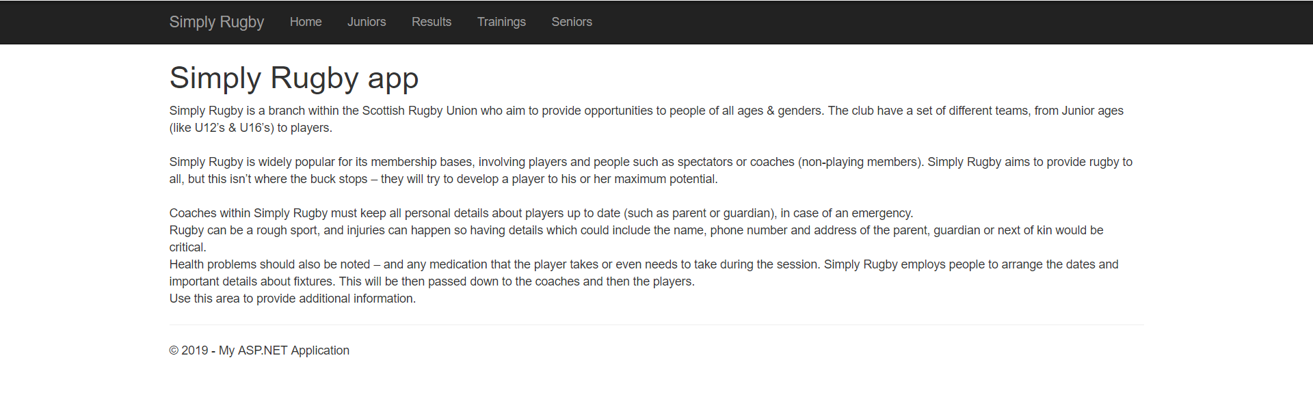

# Creating new record

First of all we need to navigate to the respective field you wish to enter data in to. Whether than be Juniors or seniors – they are both very similar.

Buttons to link to relative section for creating a new record



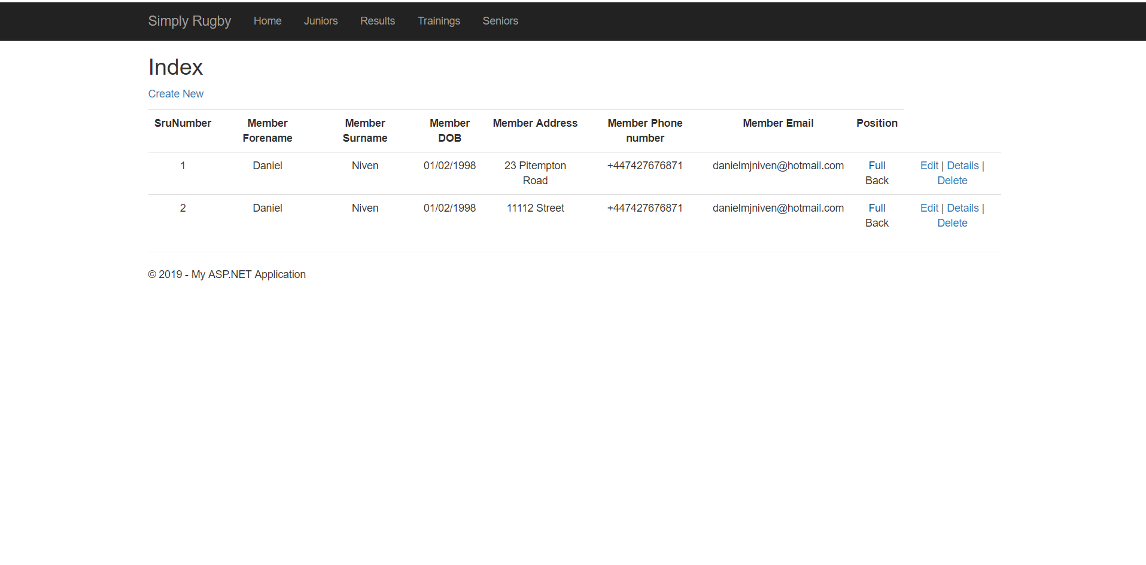Then we need to click on “Create new”.

You will then be taken to the following form:

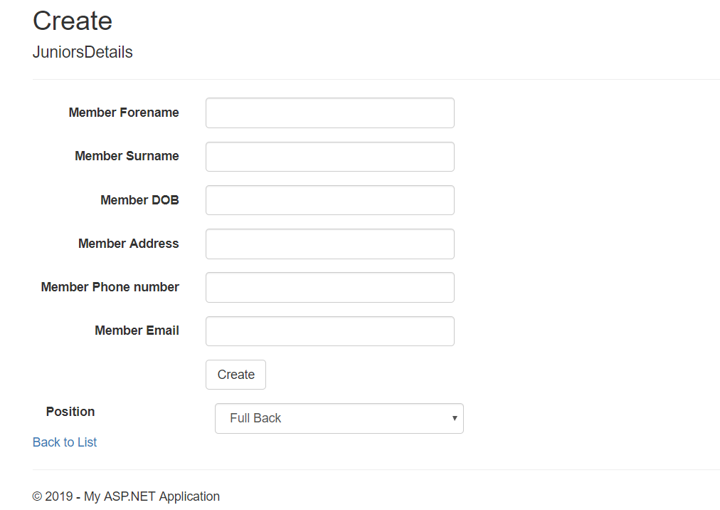

This is for junior details but works very similarly for Seniors. Simply Enter data into the fields and hit create when finished.

If you navigated to the juniors view, you will also be required to fill out parent details. This works in the sane way.

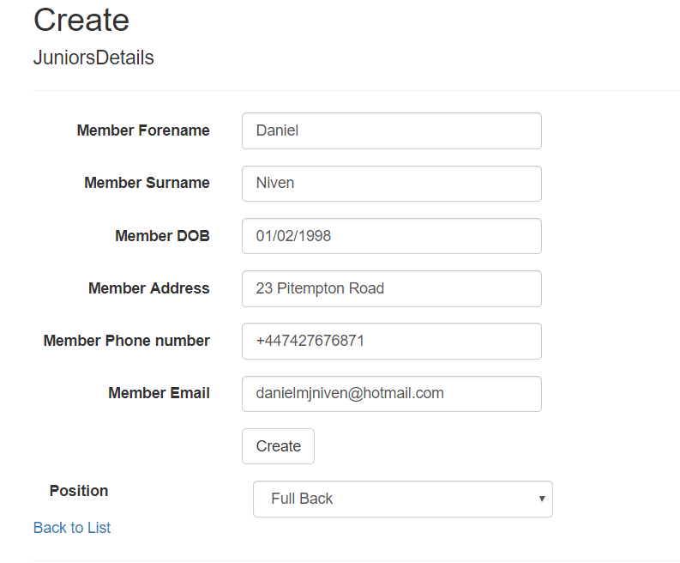

Sample data

Create button

# Viewing details of particular record

Buttons to link to relative section for Edit a new record

Like before we need to navigate to Juniors/Seniors view

You will then be directed to the following page:

Click on details.



You should then be taken to a page displaying something along the lines of this.

# https://i.gyazo.com/cfc1fafc5afff25f8f8433b6741e0def.png

# Updating record(edit)

First of all, we need to go to the respective view like before.

Buttons to link to relative section for Edit a new record



But this time, we click on edit within record.

*Note: records must be created first before editing them, as editing a blank record would be impossible. You will then be directed to the following form:

Unlike before, when you get to the Juniors/Seniors index page, we need to click on “Edit” within a record.

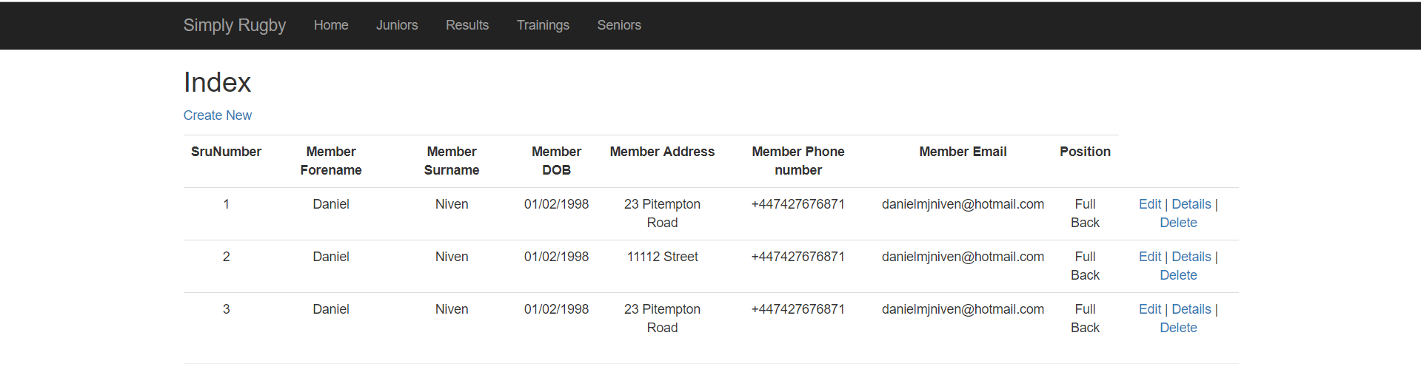*Ignore the data, this is only for sample data purposes only.

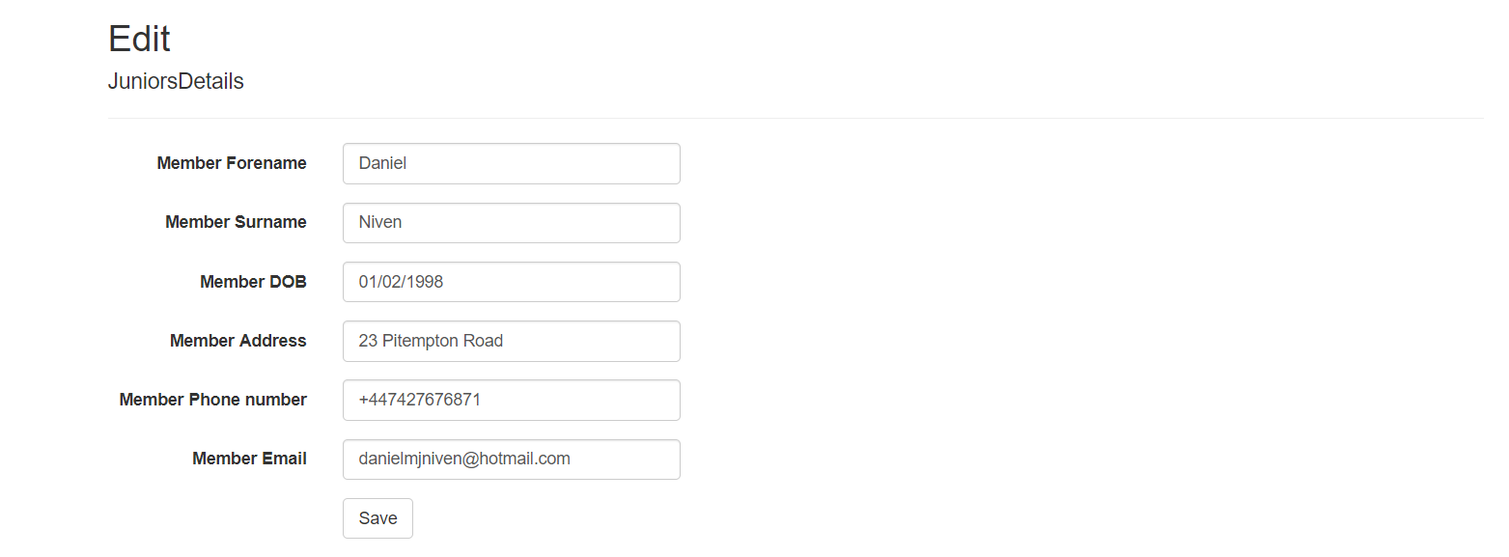

Once you’ve edited data in whatever fields you wish to change, click “Save”.

# Deleting record

Like before we need to navigate to Juniors/Seniors view.



Buttons to link to relative section for creating a new record

You will then be directed to the following page:

Click on delete.

You will then be taken to the following view:

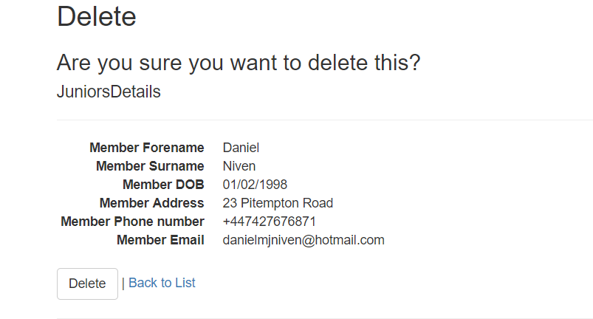

Click on Delete and you should then be redirected to index page. The record you’ve deleted should no longer show in the respective details page.

# Conclusion

Hopefully you should now have a better understanding of how this application works. It is still a work in progress and is subject to change at any time, thus, this user guide may become outdated.