Daniel Oh

CSCI 165

1.

1. let sum = 0

2. loop 10 times

1. ask for grade scores (input)

2. add scores to sum

3. Divide the sum by 10

2.

1. Correspond a letter to a number (ASCII)

2. Convert each letter into ASCII

3. Add 5 to each number

4. If the number x is greater than 122 then find the difference between the number x and 122 and add the found difference by 96

5. Convert each ASCII code back into letters and print them

3.

1. Correspond a letter to a number (ASCII)

2. Convert each letter into ASCII

3. Loop every possible shift (1 - 25) by adding the ASCII code by the number of shifts

1. If the number x is greater than 122 then find the difference between the number x and 122 and add the found difference by 96

2. Convert each ASCII code back into letters

3. Print the “message:” + message + “number of shifts:” + shift

4. Find the readable message: puzzles are fun

4.

1. Start n = 0 and counter = 0 and let given homework grade be “score”

2. Loop

1. Ask for a grade input

2. Add “score” to n

3. Increase the counter by 1

4. print (n divided by counter)

5.

15, 46, 23, 70, 35, 106, 53, 160, 80, 40, 20, 10, 5, 16, 8, 4, 2, 1

6.

6, 3, 10, 5, 16, 8, 4, 2, 1

7.

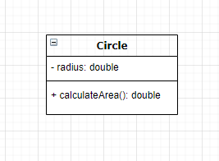

8.

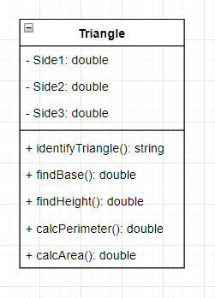

10.

