Lab2

Derrick Alders, Daniel Longo, and Michael Wholey

**Videos, Code, and Dashboard Links**

[Lab2 Video](https://www.youtube.com/watch?v=GGQjaBL506M&feature=youtu.be)

[Arduino Code](https://github.com/DanielPLongo/DanielLongoIOT/blob/master/Lab2/Lab2.ino)

[Node-Red Code](https://github.com/DanielPLongo/DanielLongoIOT/blob/master/Lab2/Lab2_Node-Red_Flow.txt)

**Introduction**

IOT is extremely useful in the home and as an always on device. In this lab we integrate two different sensors into one device to monitor conditions within the home. However, instead of most of our programming taking place on the board, we split up the code so that some of it runs on board and some of it runs off, on a connected computer.

**Objectives**

In this lab we were to create an end to end system for visualizing sensor data using node-red. That meant we were to take an arduino and augment it with two sensors and an additional virtual sensor if interested. Then we were to connect the arduino to node-red, create a node-red flow which handled our data properly and displayed it on a dashboard as well as posting it to social media.

**Approaches/Methods**

Since the objective of Lab2 is principally integration, the approach to the software and hardware build was to combine the various sensor types that might be found in an integrated environment; local connections, remote connections, and virtual connections.

With future development in mind, the method focused on how these sensor types could be used in a robotics platform in the home. While the sensors themselves may or may not be exactly what is used, they are representative of the type of data collection that would occur. Programatic decisions would reasonably be made from the discrete circuitry within the device locally, which could then be compared to data off-site or sent off site for analysis and returned as new data that would instruct the theoretical device on what to do next, or virtual data both remote and local that could be used to help troubleshoot the device or improve its performance.

As such, the Arduino was constructed to simulate the local device and the Node-Red dashboard serves as the user interface. To this end, audio annunciations were integrated into the project to better represent an interactive device. This simulates audible messages that could be played for the user which could interpret data in a more understandable manner, rather than just gauges and graphs. The closer the data can be brought to human language the better.

**Node-Red Dashboard.**

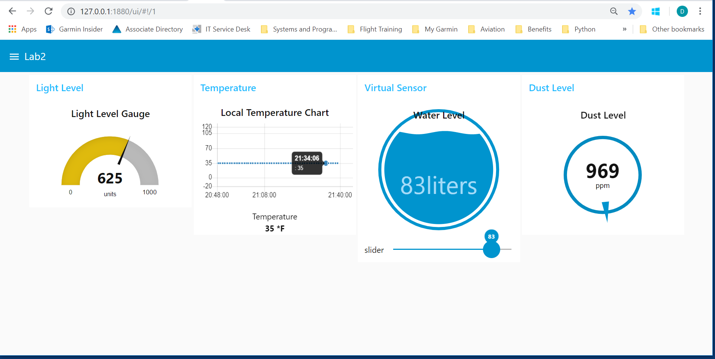

**Workflow**

Learning lessons from the previous lab and the other ICPs, we took each component of the Lab separately to verify operability and then combined them. The first test was a simple test of the Arduino ports to make sure we had a working board before we dove in. A simple script was written to blink an LED. Similarly, we tested a known flow from a previous exercise to make sure the Node-Red paths were correct.

Next, a single flow using the Arduino Standard Firmata to send and receive data from the board to Node-Red was used in conjunction with the light sensor. It was quick to see the ease of using the Arduino nodes on the pallet to convert the readings into a message for the flow. The data was monitored in the Node-Red flow output window. Once the flow of data was observed to be correct at the output node, the same data was sent to a gauge node and on to the Node-Red Dashboard- these nodes having been loaded in a previous exercise. With the light sensor working, the dust sensor was then integrated, tested, and added to the Dashboard using a compass-type graph.

Next, the http flow simulating a remote sensor was integrated. The flow was edited from one used in a previous exercise. Likewise, it was tested and deployed to the Dashboard.

Lastly, the virtual sensor flow was built, tested, and deployed successfully. At this point the audio annunciations were created using text files and the audio node's pick of voices. All nodes were then deployed and verified in the Dashboard.

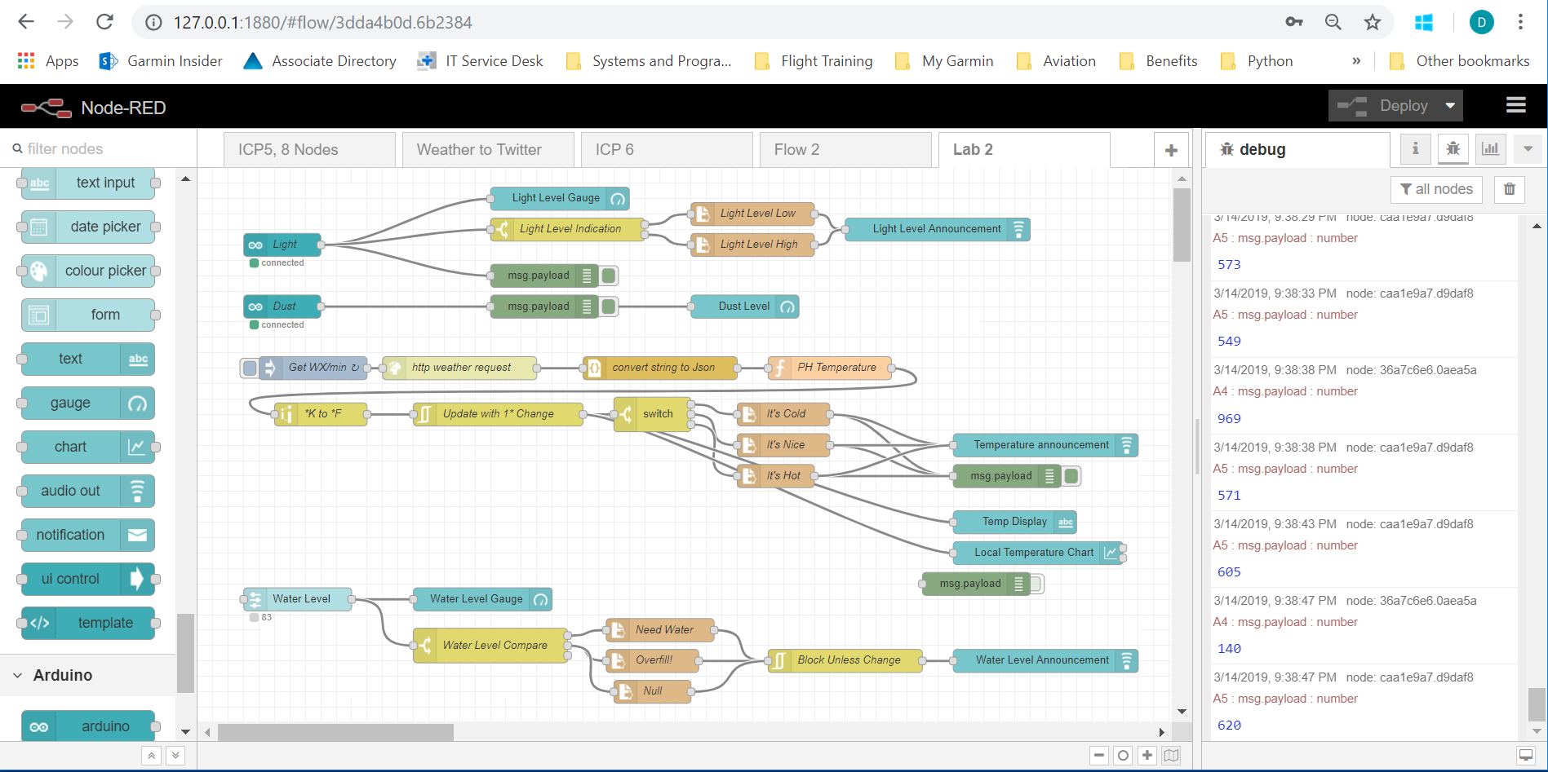###Node-Red flow showing the two Arduino mounted sensors, the http request, and the virtual sensor

**Circuit Diagram**

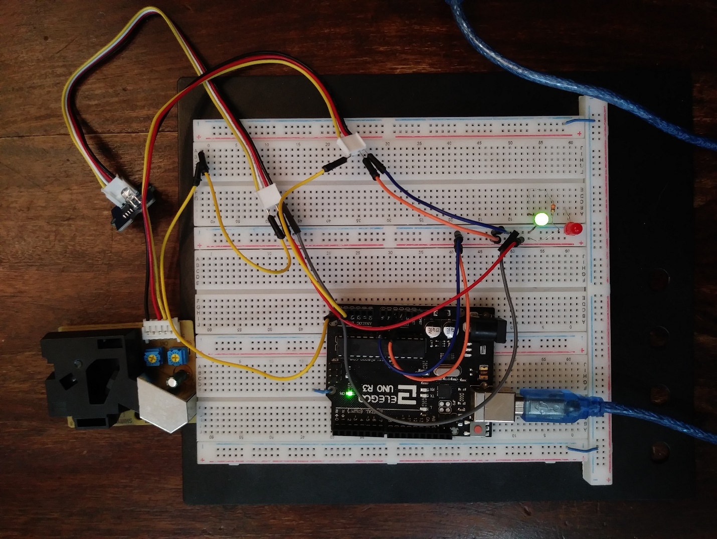

**Parameters**

We used an Arduino Uno, a light sensor and a dust sensor with wires and a breadboard to connect everything. Then we used a cable to connect that Arduino to a computer running node-red.

**Evaluation & Discussion**

This was a great way to bring all the tools used to-date into a single exercise. The ease-of-use with regard to Node-Red was very apparent in this Lab. It is hard to quantify the amount of time it would have taken to write custom script to accomplish all of the several tasks, not to mention the time in development for all of the artwork in creating the Dashboard.

**Conclusion**

The real power of Node-Red is the ability to integrate many sources of data into a common framework. Looking ahead, with a little more sophistication in flow architecture and the selection of the proper hardware platform, it is easy to see how a very robust application can be built for all of the mature IOT devices that have been discussed thus far in class. This is outstanding technology!