Sentencia de creación de la base de datos airports.
CREATE DATABASE airports;
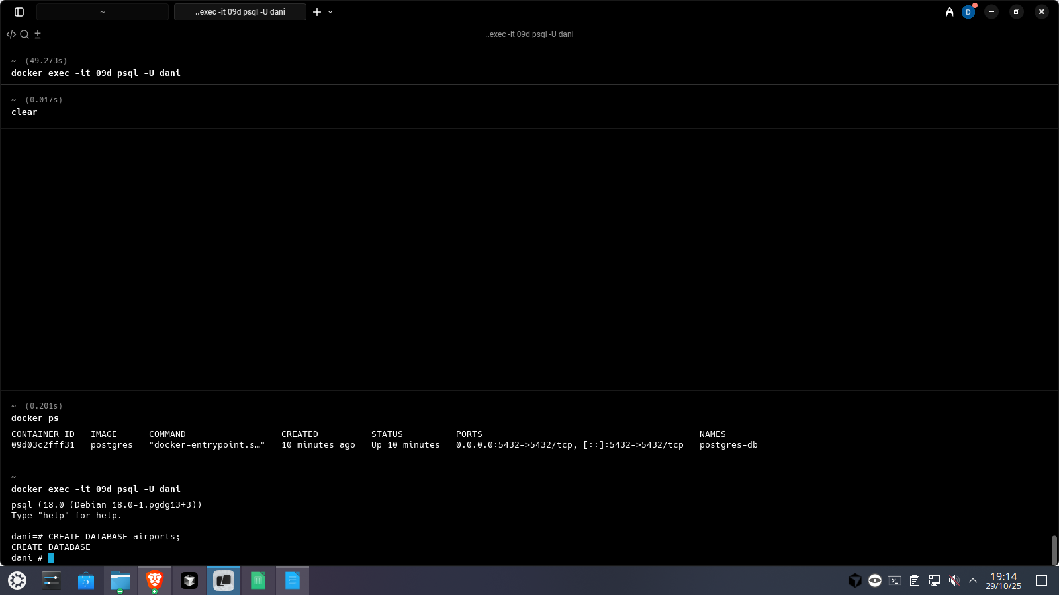

Sentencias de creación de las tablas.
CREATE TABLE Airports (
airport_id VARCHAR(10) PRIMARY KEY,
airport_name VARCHAR(100) NOT NULL,
country VARCHAR(50) NOT NULL
);

CREATE TABLE Airplanes (
airplane_id VARCHAR(10) PRIMARY KEY,
model VARCHAR(50) NOT NULL,
capacity INT NOT NULL,
year INT
);

CREATE TABLE Airlines (
airline_id VARCHAR(10) PRIMARY KEY,
airline_name VARCHAR(100) NOT NULL
);

CREATE TABLE Passengers (
passenger_id VARCHAR(10) PRIMARY KEY,
passenger_name VARCHAR(100) NOT NULL
);

CREATE TABLE Flights (
flight_id VARCHAR(10) PRIMARY KEY,
departure_datetime TIMESTAMP NOT NULL,
arrival_datetime TIMESTAMP NOT NULL,
origin_airport_id VARCHAR(10) NOT NULL,
destination_airport_id VARCHAR(10) NOT NULL,
airplane_id VARCHAR(10) NOT NULL,
airline_id VARCHAR(10) NOT NULL,
FOREIGN KEY (origin_airport_id) REFERENCES Airports(airport_id),
FOREIGN KEY (destination_airport_id) REFERENCES Airports(airport_id),
FOREIGN KEY (airplane_id) REFERENCES Airplanes(airplane_id),
FOREIGN KEY (airline_id) REFERENCES Airlines(airline_id)
);

CREATE TABLE Flight_Passengers (
flight_id VARCHAR(10) NOT NULL,
passenger_id VARCHAR(10) NOT NULL,
seat VARCHAR(5) NOT NULL,
PRIMARY KEY (flight_id, passenger_id),
FOREIGN KEY (flight_id) REFERENCES Flights(flight_id),
FOREIGN KEY (passenger_id) REFERENCES Passengers(passenger_id)
);

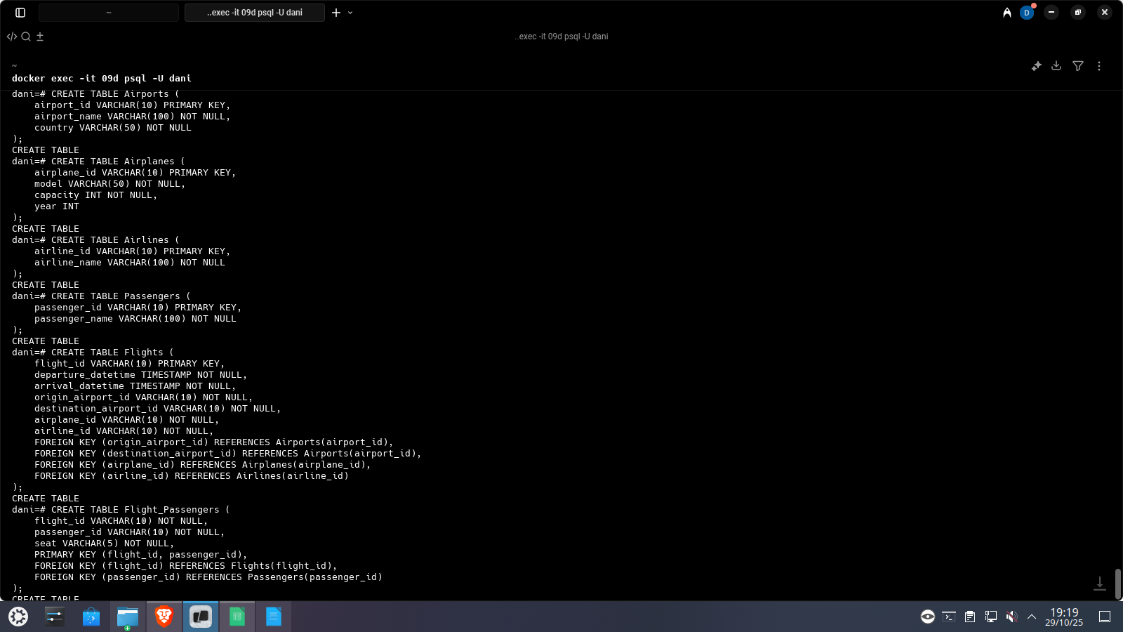

Sentencias de inserción de los datos hasta ahora almacenados en EXCEL , teniendo en cuenta que la información ha de estar siempre bien relacionada.

Airports
INSERT INTO Airports (airport_id, airport_name, country) VALUES
('AP01', 'John F. Kennedy Intl', 'USA'),
('AP02', 'Los Angeles Intl', 'USA'),
('AP03', 'Heathrow', 'UK'),
('AP04', 'Barajas', 'Spain'),
('AP05', 'Charles de Gaulle', 'France'),
('AP06', 'Berlin Brandenburg', 'Germany'),
('AP07', 'Tokyo Haneda', 'Japan'),
('AP08', 'Toronto Pearson', 'Canada'),
('AP09', 'Roma Fiumicino', 'Italy'),
('AP10', 'O''Hare Intl', 'USA'),
('AP11', 'Frankfurt Intl', 'Germany'),
('AP12', 'Sydney Kingsford', 'Australia'),
('AP13', 'Miami Intl', 'USA'),
('AP14', 'Vancouver Intl', 'Canada');
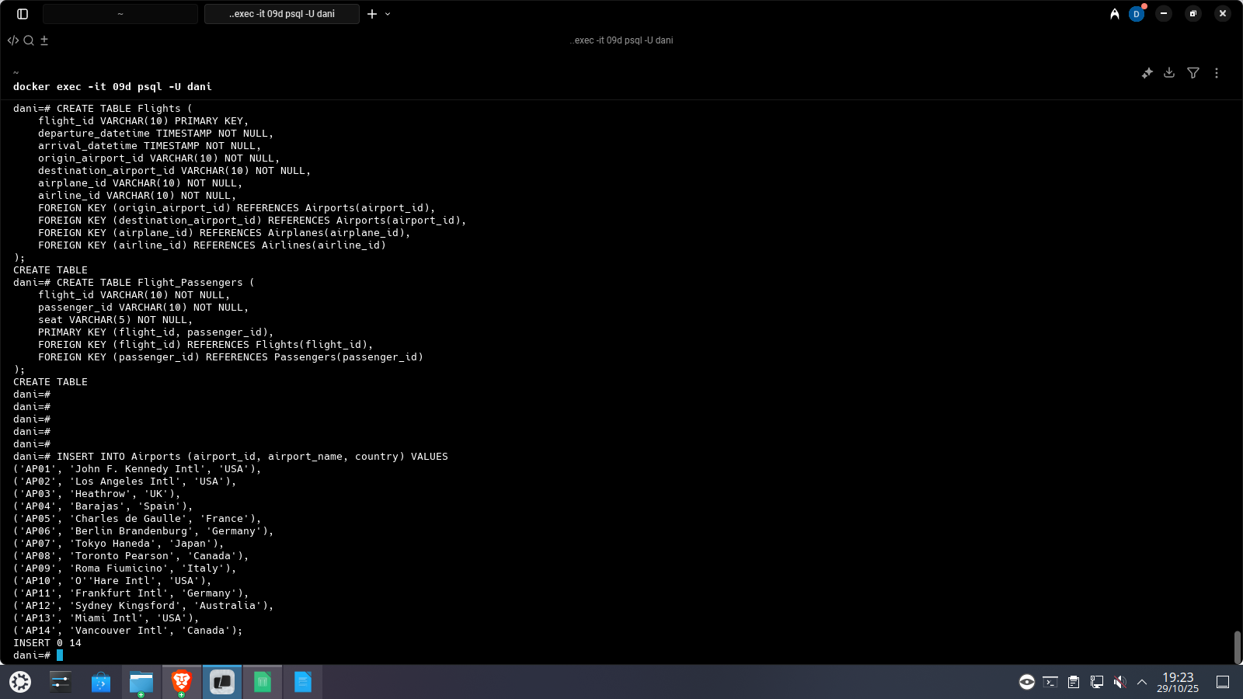

Airplanes
INSERT INTO Airplanes (airplane_id, model, capacity, year) VALUES
('PL001', 'Boeing 737', 180, 2018),
('PL002', 'Airbus A320', 160, 2019),
('PL003', 'Airbus A330', 250, 2020),
('PL004', 'Boeing 777', 300, 2016),
('PL005', 'Boeing 787', 240, 2021),
('PL006', 'Boeing 737 MAX', 190, 2022),
('PL007', 'Boeing 777X', 320, 2023),
('PL008', 'Airbus A321', 185, 2020),
('PL009', 'Airbus A350', 280, 2021),
('PL010', 'Boeing 737', 170, 2017);
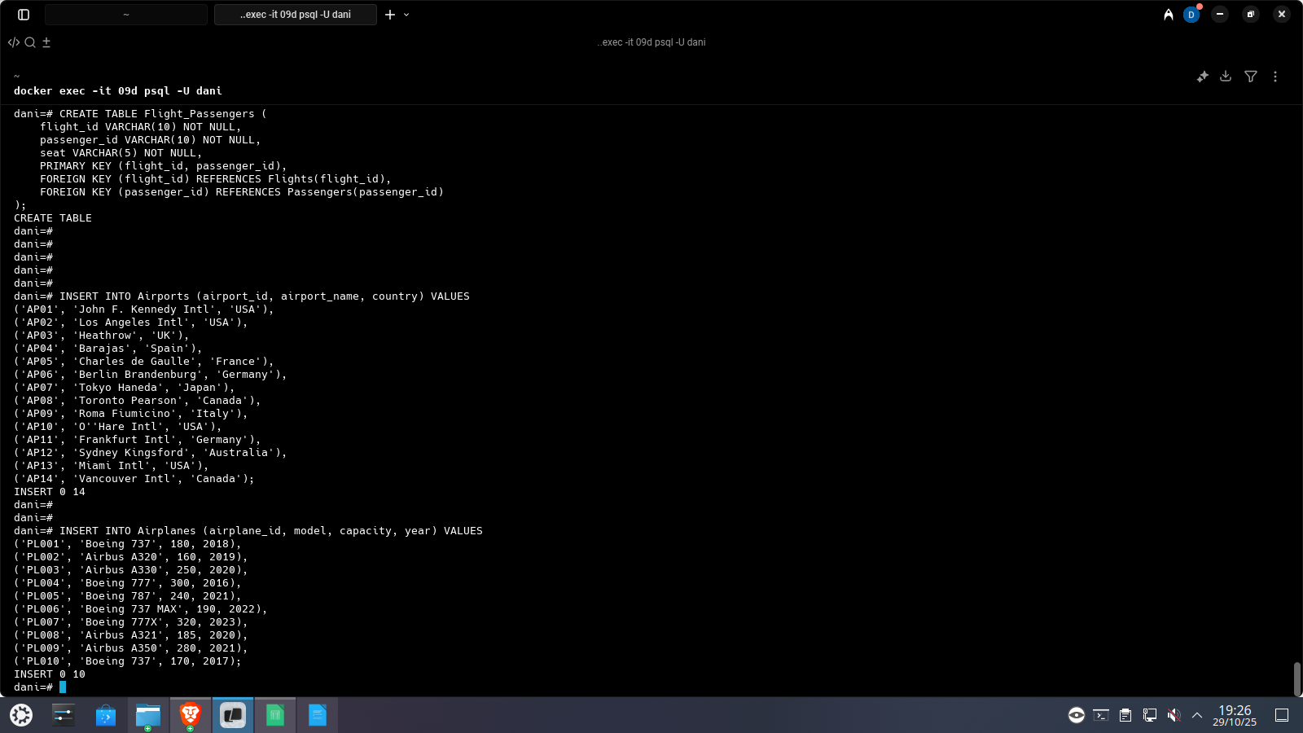

Airlines
INSERT INTO Airlines (airline_id, airline_name) VALUES
('AL01', 'American Airlines'),
('AL02', 'British Airways'),
('AL03', 'Iberia'),
('AL04', 'Air France'),
('AL05', 'Delta Airlines'),
('AL06', 'Air Canada'),
('AL07', 'Qantas');
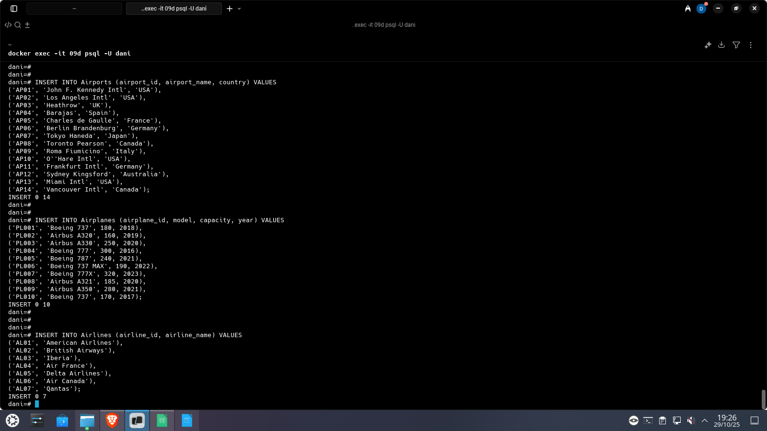

Passengers
INSERT INTO Passengers (passenger_id, passenger_name) VALUES
('PS001', 'Ana Gómez'),
('PS002', 'Carlos Ruiz'),
('PS003', 'Lucía Martínez'),
('PS004', 'Diego López'),
('PS005', 'Sofía Torres'),
('PS006', 'Pedro Fernández'),
('PS007', 'Elena Navarro'),
('PS008', 'Marco Álvarez'),
('PS009', 'Valeria Pérez'),
('PS010', 'Mario Conti'),
('PS011', 'Andrea Silva'),
('PS012', 'Clara Jiménez'),
('PS013', 'Noa Ramírez'),
('PS014', 'Santiago Ibarra'),
('PS015', 'Renata Duarte'),
('PS016', 'Emilio García');
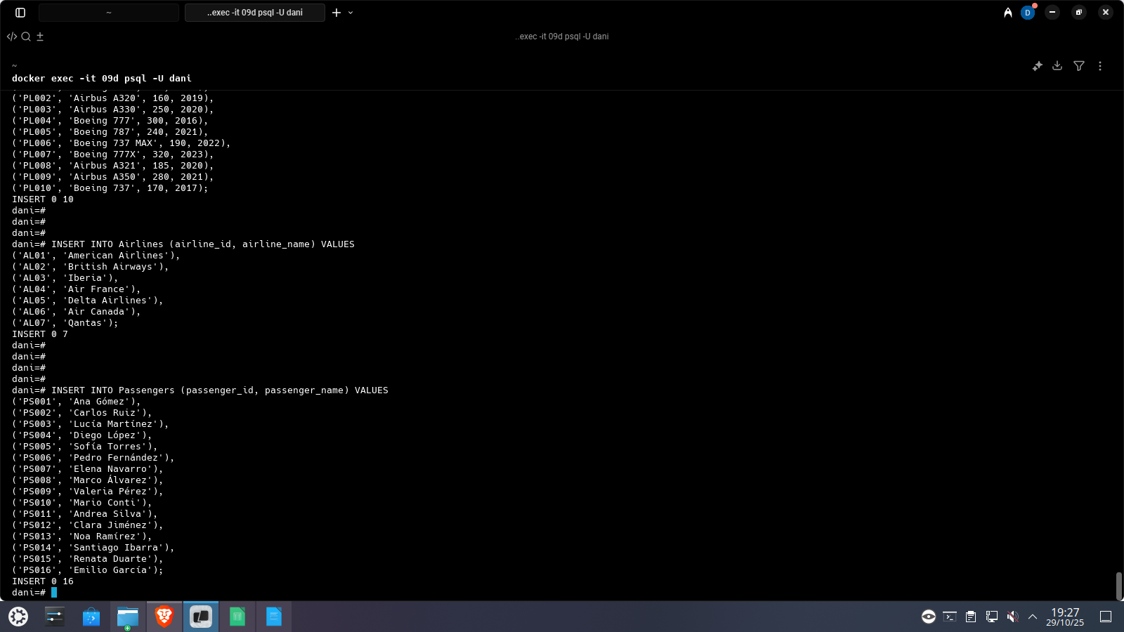

Flights
INSERT INTO Flights (flight_id, departure_datetime, arrival_datetime, origin_airport_id, destination_airport_id, airplane_id, airline_id) VALUES
('FL001', '2025-09-01 08:00:00', '2025-09-01 10:30:00', 'AP01', 'AP02', 'PL001', 'AL01'),
('FL002', '2025-09-01 14:00:00', '2025-09-01 18:30:00', 'AP03', 'AP04', 'PL002', 'AL02'),
('FL003', '2025-09-02 06:45:00', '2025-09-02 09:00:00', 'AP02', 'AP01', 'PL001', 'AL01'),
('FL004', '2025-09-02 11:00:00', '2025-09-02 14:15:00', 'AP04', 'AP05', 'PL003', 'AL03'),
('FL005', '2025-09-02 17:20:00', '2025-09-02 21:00:00', 'AP05', 'AP06', 'PL004', 'AL04'),
('FL006', '2025-09-03 09:15:00', '2025-09-03 11:00:00', 'AP06', 'AP04', 'PL002', 'AL02'),
('FL007', '2025-09-03 13:30:00', '2025-09-03 17:00:00', 'AP02', 'AP07', 'PL005', 'AL05'),
('FL008', '2025-09-03 22:10:00', '2025-09-04 02:45:00', 'AP07', 'AP02', 'PL005', 'AL05'),
('FL009', '2025-09-04 10:00:00', '2025-09-04 12:30:00', 'AP01', 'AP08', 'PL006', 'AL06'),
('FL010', '2025-09-04 16:45:00', '2025-09-04 19:15:00', 'AP08', 'AP01', 'PL006', 'AL06'),
('FL011', '2025-09-05 07:30:00', '2025-09-05 10:00:00', 'AP04', 'AP09', 'PL003', 'AL03'),
('FL012', '2025-09-05 13:20:00', '2025-09-05 16:30:00', 'AP09', 'AP04', 'PL003', 'AL03'),
('FL013', '2025-09-06 06:00:00', '2025-09-06 09:00:00', 'AP02', 'AP10', 'PL001', 'AL01'),
('FL014', '2025-09-06 11:00:00', '2025-09-06 14:10:00', 'AP10', 'AP01', 'PL001', 'AL01'),
('FL015', '2025-09-06 18:30:00', '2025-09-06 21:00:00', 'AP04', 'AP11', 'PL004', 'AL04'),
('FL016', '2025-09-07 08:15:00', '2025-09-07 11:45:00', 'AP11', 'AP05', 'PL004', 'AL04'),
('FL017', '2025-09-07 14:00:00', '2025-09-07 18:30:00', 'AP07', 'AP12', 'PL007', 'AL07'),
('FL018', '2025-09-08 08:00:00', '2025-09-08 12:00:00', 'AP12', 'AP07', 'PL007', 'AL07'),
('FL019', '2025-09-08 15:45:00', '2025-09-08 18:00:00', 'AP01', 'AP13', 'PL008', 'AL01'),
('FL020', '2025-09-09 07:30:00', '2025-09-09 10:10:00', 'AP13', 'AP01', 'PL008', 'AL01'),
('FL021', '2025-09-09 12:30:00', '2025-09-09 15:45:00', 'AP03', 'AP11', 'PL009', 'AL02'),
('FL022', '2025-09-10 09:00:00', '2025-09-10 12:30:00', 'AP11', 'AP03', 'PL009', 'AL02'),
('FL023', '2025-09-10 18:10:00', '2025-09-10 21:00:00', 'AP08', 'AP14', 'PL010', 'AL06');
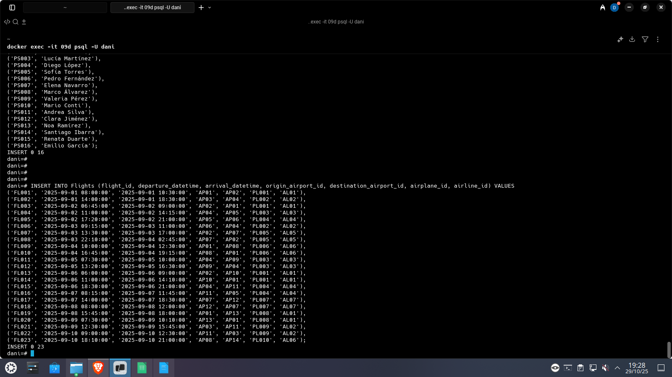

Flight Passengers
INSERT INTO Flight_Passengers (flight_id, passenger_id, seat) VALUES
('FL001', 'PS001', '12A'),
('FL001', 'PS002', '12B'),
('FL002', 'PS003', '22C'),
('FL002', 'PS001', '22D'),
('FL003', 'PS004', '15A'),
('FL004', 'PS005', '18F'),
('FL005', 'PS006', '6C'),
('FL006', 'PS007', '20A'),
('FL007', 'PS008', '30B'),
('FL008', 'PS002', '30C'),
('FL009', 'PS009', '14B'),
('FL010', 'PS003', '14C'),
('FL011', 'PS010', '19D'),
('FL012', 'PS001', '19E'),
('FL013', 'PS011', '8A'),
('FL014', 'PS011', '8B'),
('FL015', 'PS012', '10C'),
('FL016', 'PS004', '10D'),
('FL017', 'PS013', '2A'),
('FL018', 'PS014', '2B'),
('FL019', 'PS002', '21A'),
('FL020', 'PS015', '21B'),
('FL021', 'PS006', '5D'),
('FL022', 'PS009', '5E'),
('FL023', 'PS016', '13C');
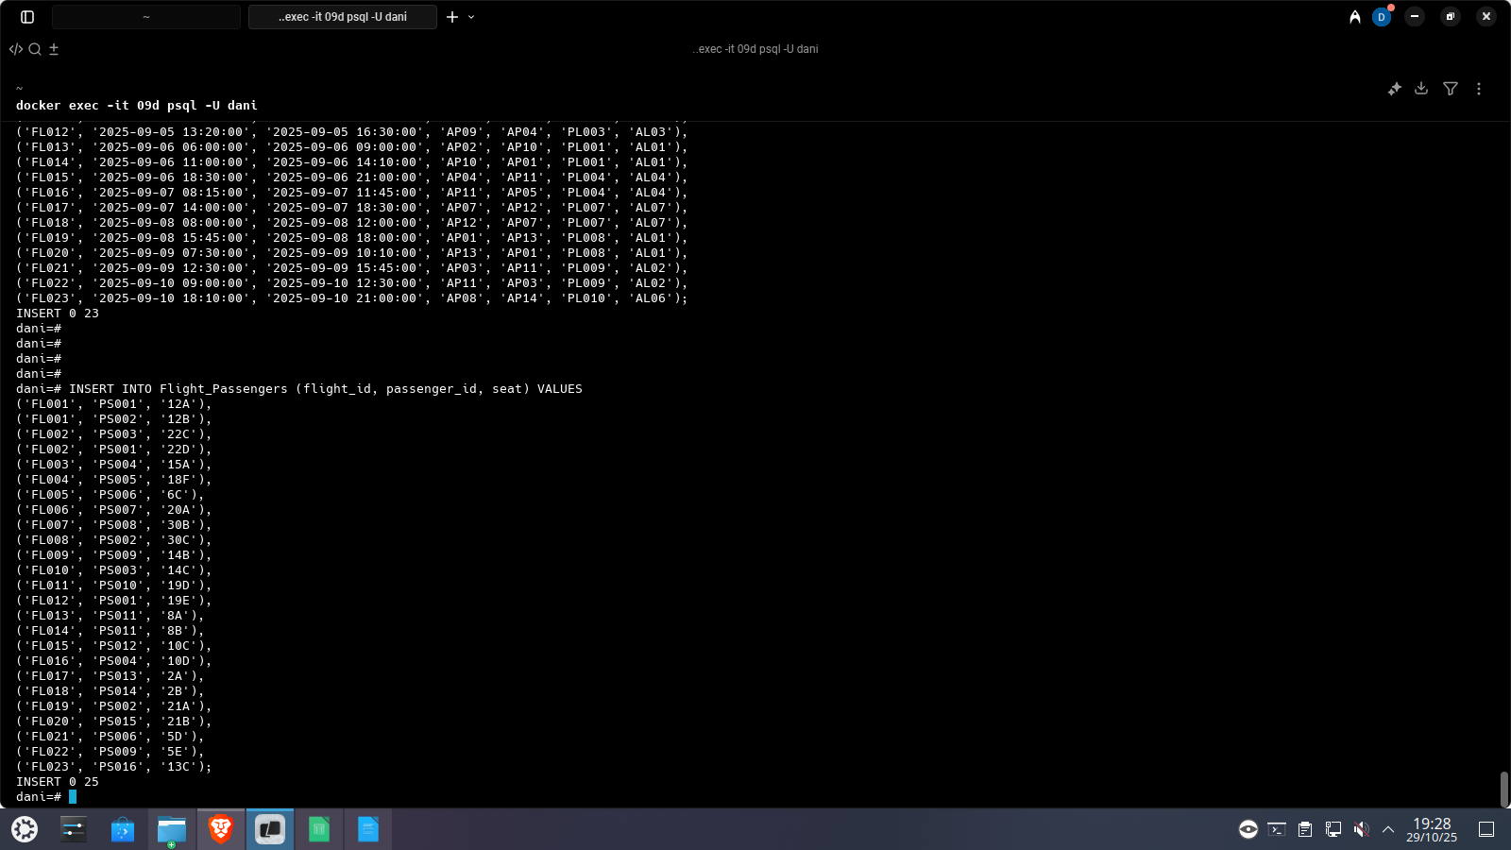

Consultas:

Vuelos y su número de pasajeros, ordenado de mayor a menor
SELECT
flight_id,
COUNT(passenger_id) AS num_passengers
FROM
Flight_Passengers
GROUP BY
flight_id
ORDER BY
num_passengers DESC;
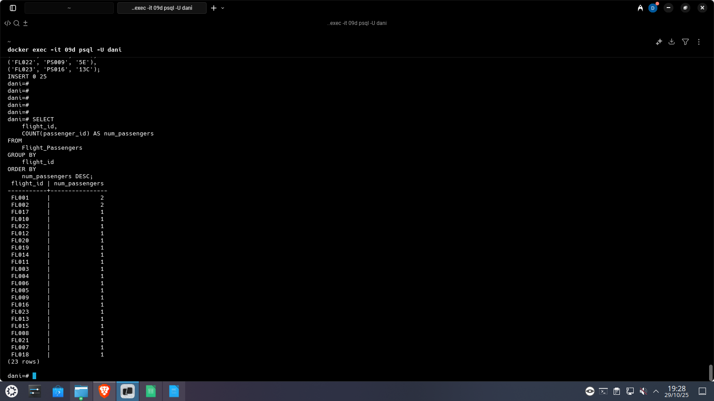

Identificador de los vuelos, con los identificadores de los aeropuertos
SELECT
flight_id,
origin_airport_id,
destination_airport_id
FROM
Flights;
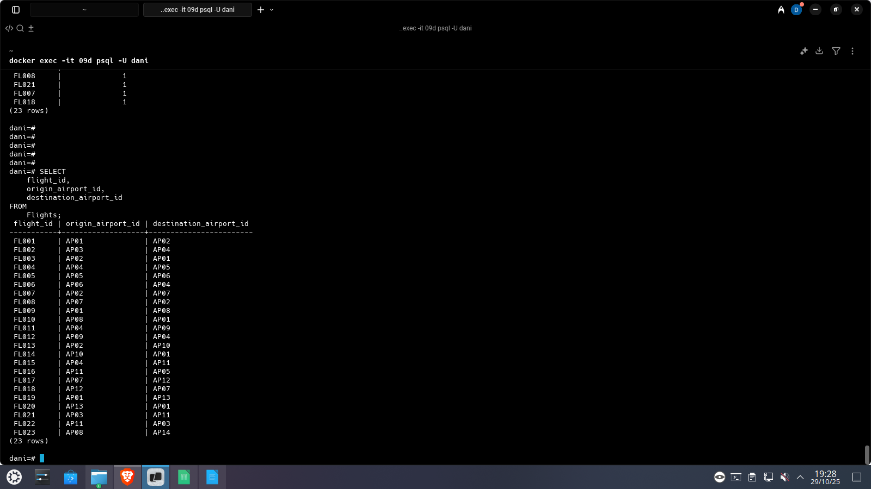

Combinaciones distintas de aeropuertos de origen y destino
SELECT DISTINCT
f.origin_airport_id,
o.airport_name AS origin_name,
f.destination_airport_id,
d.airport_name AS destination_name
FROM
Flights AS f
JOIN
Airports AS o ON f.origin_airport_id = o.airport_id
JOIN
Airports AS d ON f.destination_airport_id = d.airport_id;
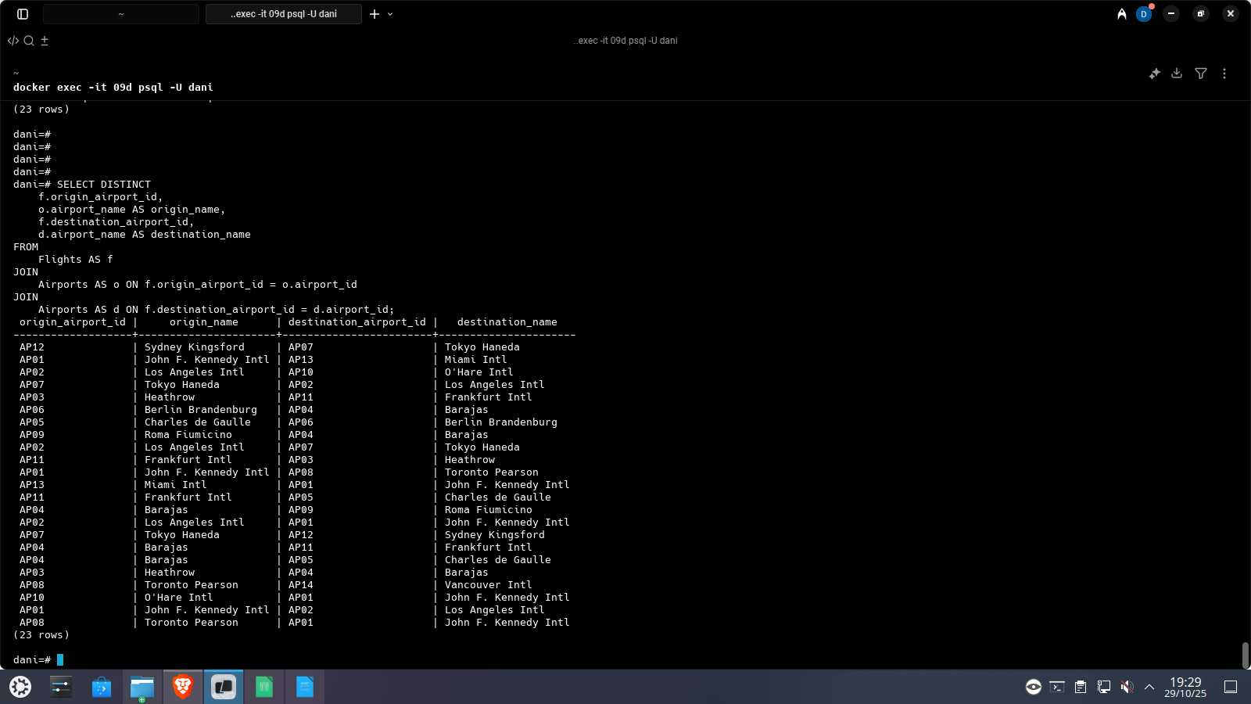

Número de vuelos por avión
SELECT
a.model,
a.airplane_id,
COUNT(f.flight_id) AS num_flights
FROM
Flights AS f
JOIN
Airplanes AS a ON f.airplane_id = a.airplane_id
GROUP BY
a.airplane_id, a.model
ORDER BY
num_flights DESC;
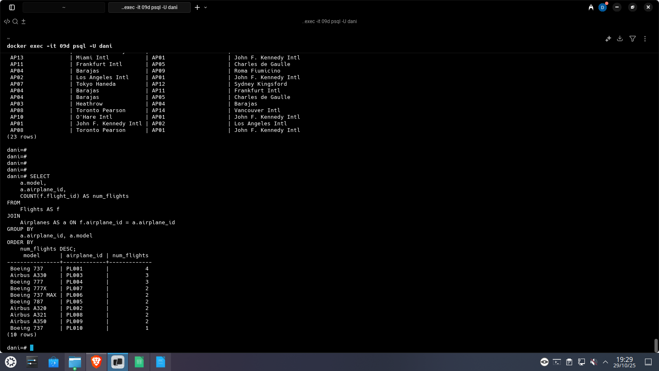

Suma total de pasajeros por aeropuerto, un pasajero puede pasar más de una vez por el mismo aeropuerto, se deben tener en cuenta aeropuertos de origen y destino
WITH AirportTraffic AS (
SELECT
f.origin_airport_id AS airport_id,
COUNT(fp.passenger_id) AS passenger_count
FROM
Flights AS f
JOIN
Flight_Passengers AS fp ON f.flight_id = fp.flight_id
GROUP BY
f.origin_airport_id

UNION ALL

SELECT
f.destination_airport_id AS airport_id,
COUNT(fp.passenger_id) AS passenger_count
FROM
Flights AS f
JOIN
Flight_Passengers AS fp ON f.flight_id = fp.flight_id
GROUP BY
f.destination_airport_id
)

SELECT
a.airport_name,
t.airport_id,
SUM(t.passenger_count) AS total_passenger_traffic
FROM
AirportTraffic AS t
JOIN
Airports AS a ON t.airport_id = a.airport_id
GROUP BY
t.airport_id, a.airport_name
ORDER BY
total_passenger_traffic DESC;

