# Advanced Programming Design

## UML (I have included the Visio file in the .zip incase this is difficult to read)



## Design Rational – Explanation of Separation of Concerns

I understand that the separation of concerns yields many benefits such as the code is separated into partitions based on behavior, by doing so allows us to edit the code in a partition and not affect the other partitions. It also means that new developers can change the system and the way it works without knowing how to implement the entire system making code more flexible. In my system I have separated my concerns with two interfaces, one being where we read the data in and the other displaying it. I have separated my concerns though separating the object classes and the list classes behind them. A further example would be how I first started my build. I hardcoded my constituencies and had 5 lists within 1 report. To tidy this in separation of concerns terms I made 2 functions, the first simply reading the constituencies dynamically, the second using the constituency.id of function 1 which meant I could match the constituencies and display the candidates based upon user selection. This is great because it means I have gotten rid of the code within my forms based UI that doesn’t relate. Now the code is within the candidate list where it belongs because we are querying the data in this class and not in formsbasedUI.

## Screen cast: this is available in the folder structure.

## User Guide

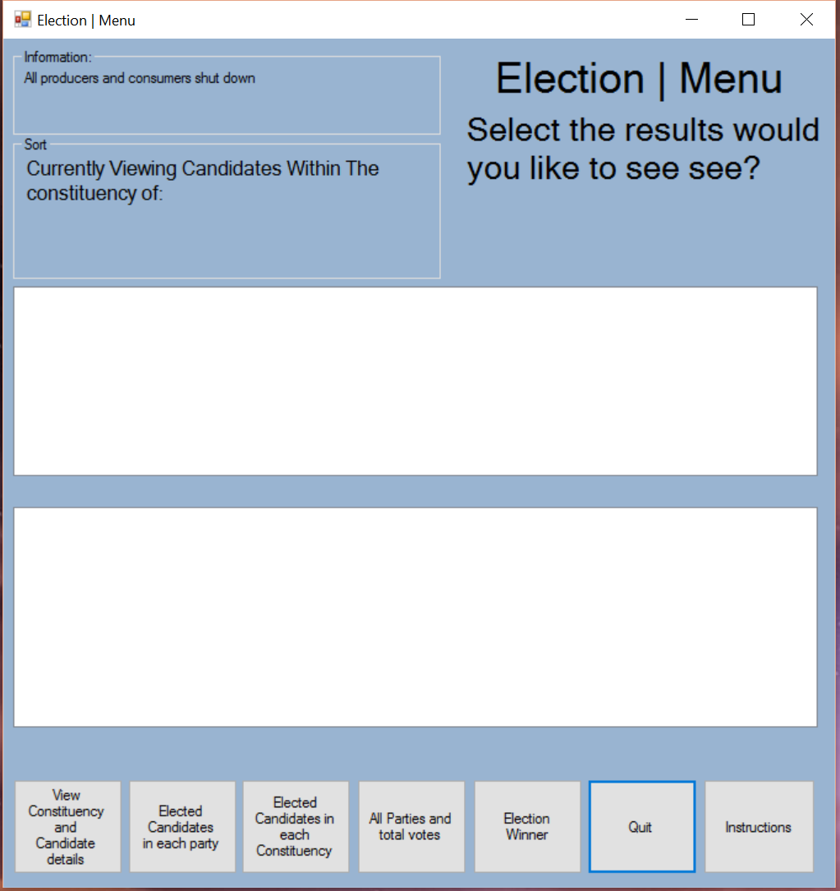

1. Once the system opens you will see the above screenshot

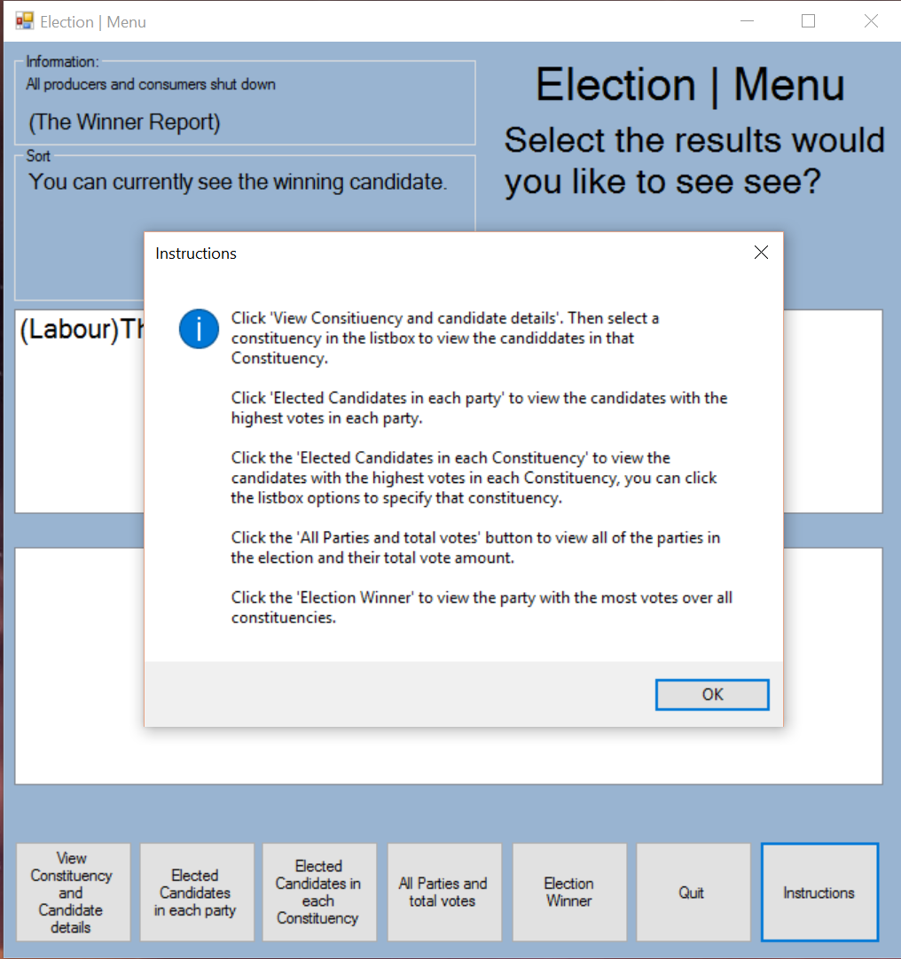

1. You can see all instructions by clicking the instructions button.

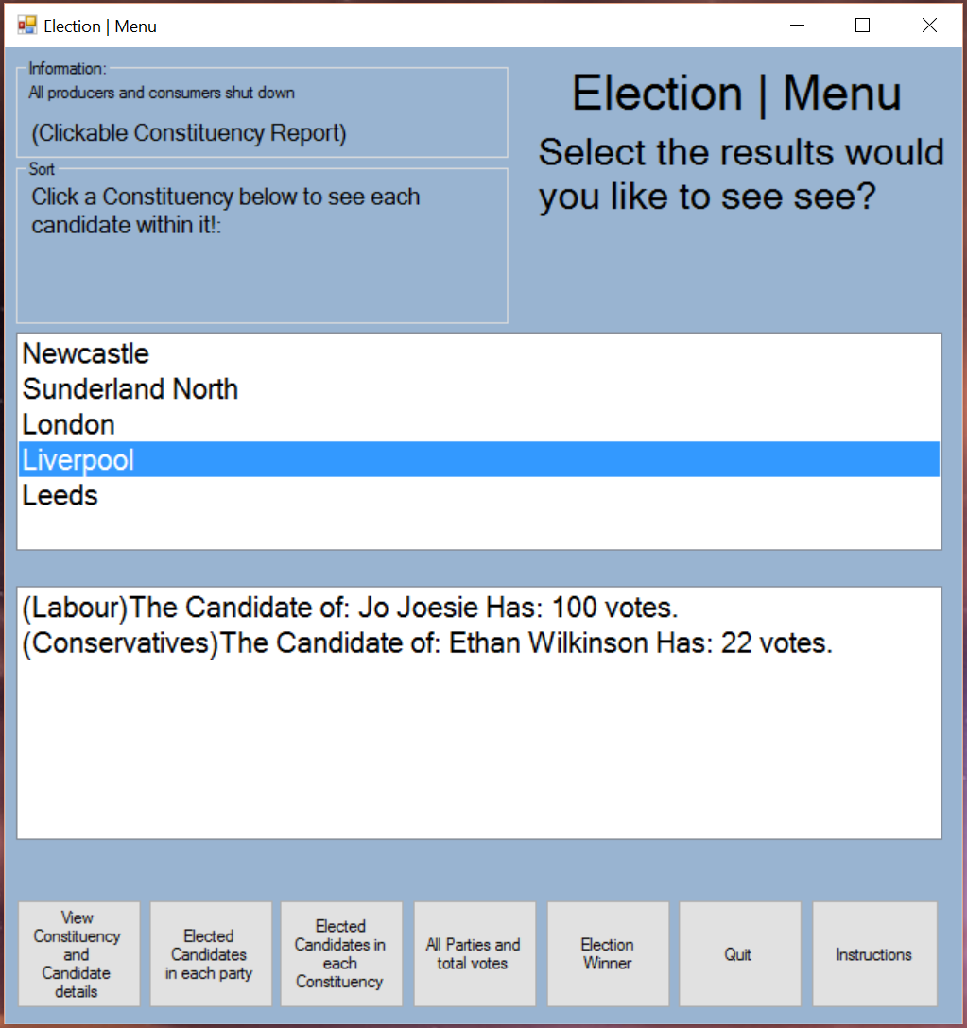

1. If you have clicked “View Constituency and candidate details” you will see a list of constituencies in the top list box and once you have selected one the details of each candidate member in that constituency will be displayed.

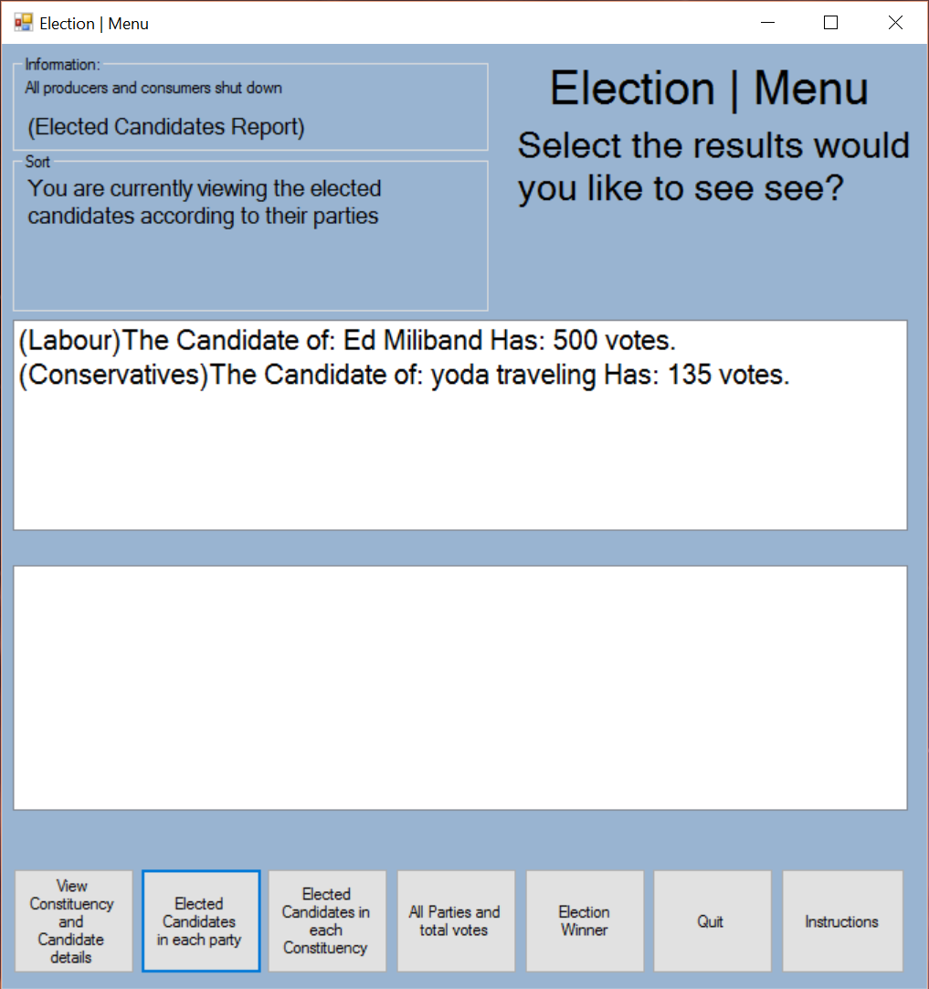

1. If you have clicked “Elected Candidate in each party” you will be viewing the highest voted member of each party.

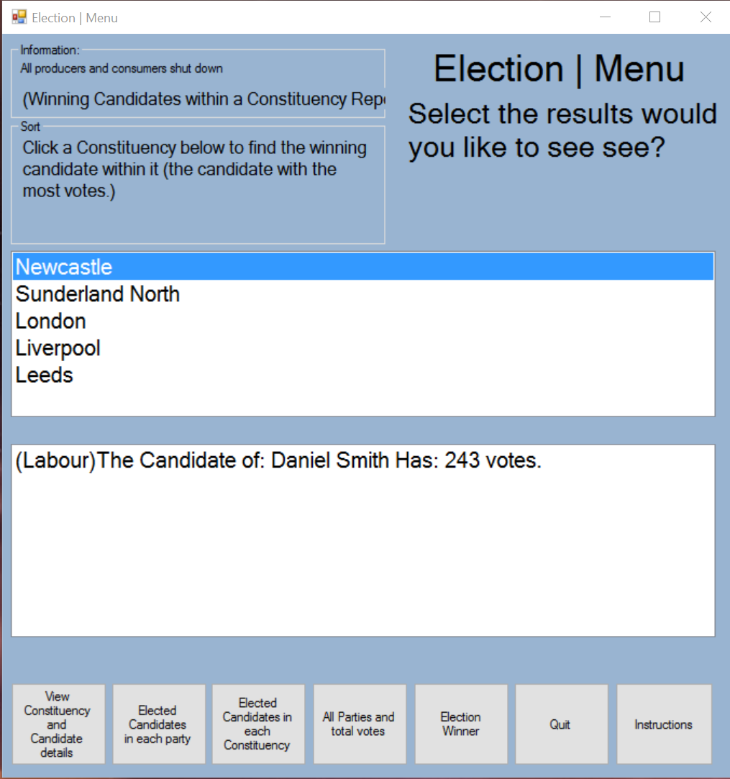

1. If you have clicked “Elected Candidate in each constituency” you will be looking at the top list box which displays constituencies, select one to view the winner of that selected constituency.

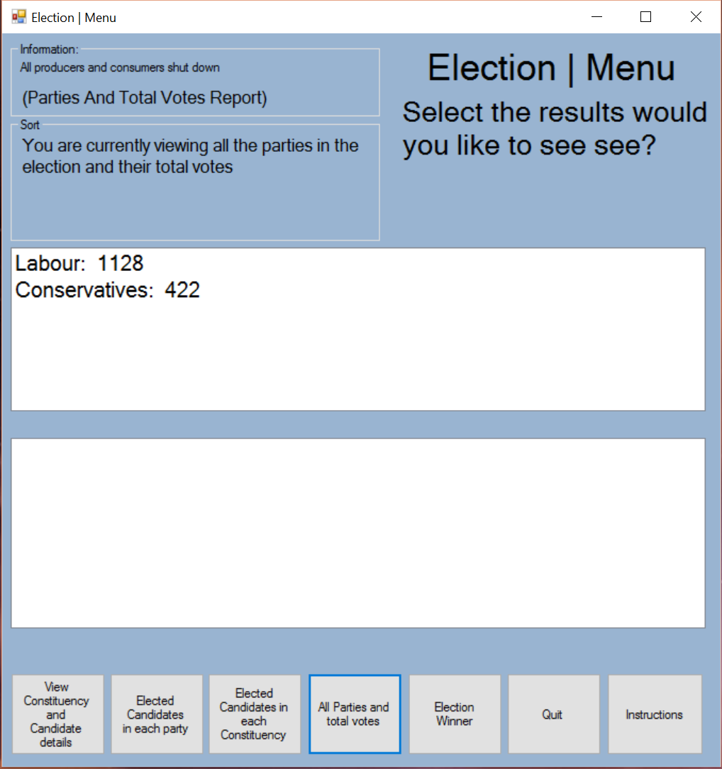

1. If you have clicked “All Parties and total votes” you will see a list of parties and a sum of all their votes.

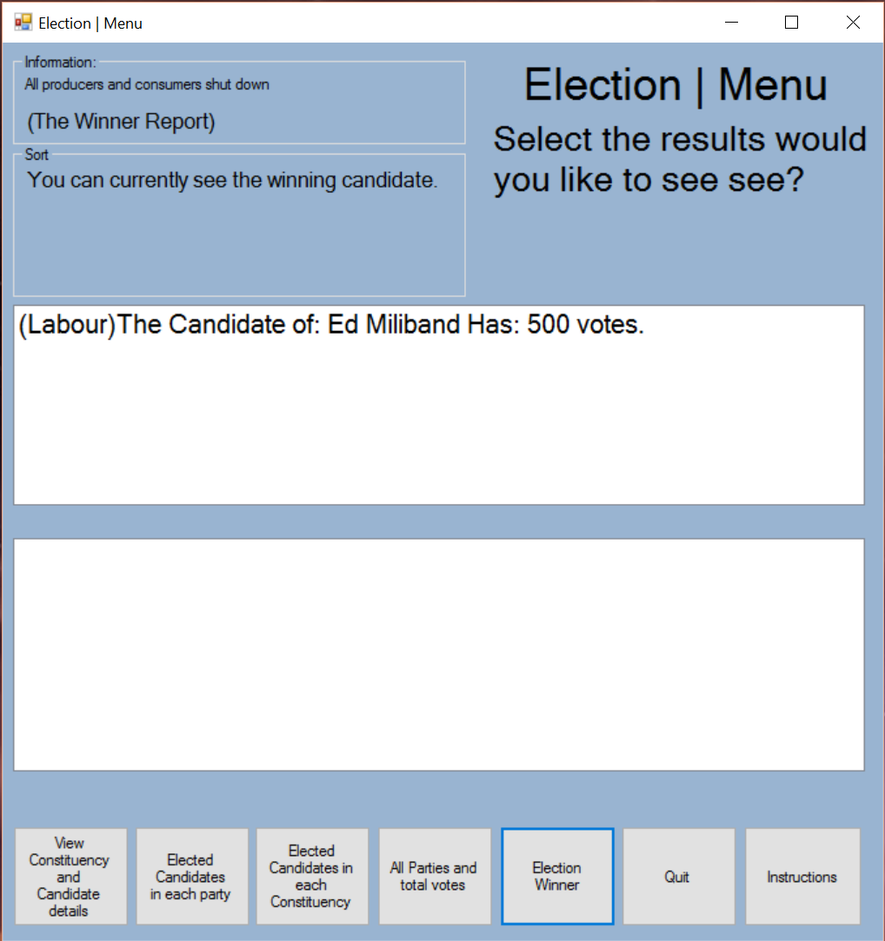

1. If you have clicked “Election winner you will see the winner of the election with their total votes.”
2. You can quit the system anytime by clicking “Quit” or the X in the top right.