סיכום מחקר bash

סרטונים שבעזרתם חקרנו:
https://www.youtube.com/watch?v=PNhq_4d-5ek

משחקים שבעזרתם חקרנו:
https://arcade.redhat.com/bash/index.html?extIdCarryOver=true&sc_cid=701f2000001OH79AAG?extIdCarryOver=true&sc_cid=701f2000001OH79AAG

אתרים שעזרו לנו לחקור:
https://devdocs.io/bash/

פקודות ב- Linux שלמדנו שרלוונטיות לנו לפרוייקט:
Sudo - נותנת הרשאה להפוך ל ROOT.
למדנו בנוסף איך ליצור ולהשתמש במערכים בBASH כדי שזה יעזור לנו בבניית הסביבה המבודדת.
https://www.w3schools.com/bash/bash_arrays.php

סיכום מחקר Capabilities ו- Seccomp

capabilities:

אתרים שעזרו לנו לחקור:
https://earthly.dev/blog/intro-to-Linux-capabilities/
https://nhimg.org/glossary/linux-capabilities/

Linux capabilities are a kernel-level privilege model that breaks the all-or-nothing nature of root into discrete units of authority. Instead of giving a process full administrative power, an administrator can assign only the specific capability it needs, such as opening a privileged network port or adjusting selected system settings. In practice, this makes Linux capabilities a core least-privilege mechanism for services, daemons, containers, and other workloads that must perform a narrow privileged action without inheriting unrestricted root access.

Implementing Linux capabilities rigorously often introduces configuration complexity, requiring organisations to weigh tighter privilege boundaries against deployment simplicity and troubleshooting effort.
- A web server can be granted the ability to bind to port 80 or 443 without running as root, limiting the blast radius if the service is compromised.
- A network tool may receive only the capability needed to capture or inspect packets, rather than full administrative control over the host.
- A containerised workload can be launched with a reduced capability set so the application can function while the runtime blocks unnecessary kernel-level privileges.
- An operations team can replace a setuid-root helper with a narrowly scoped capability assignment, improving reviewability during hardening and patching.
- Security teams can compare requested capabilities against documented function to identify over-privileged services during audit or control mapping exercises.
אפשר גם לגשת לCPABILITIES בעזרת bash
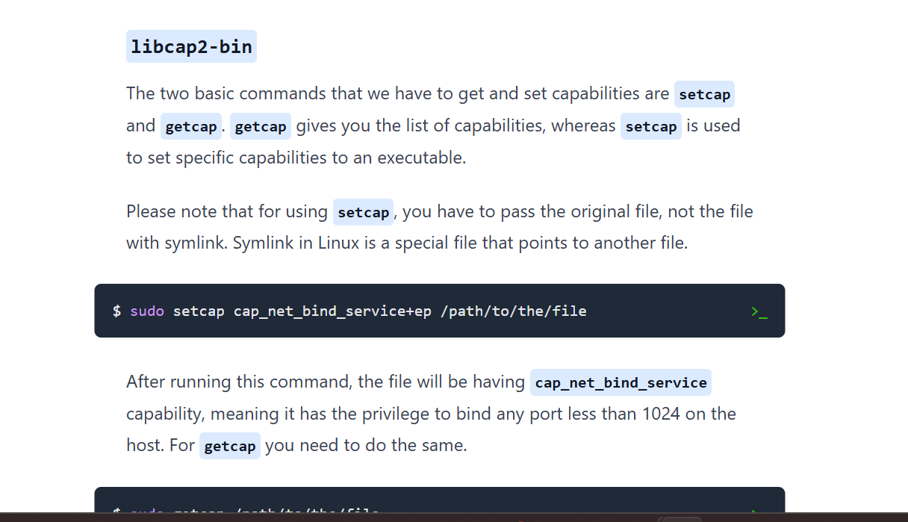

סוגי capabilities:
https://man7.org/linux/man-pages/man7/capabilities.7.html

Seccomp:
פונקצית System call ב-C שמגבילה את שאר הSysCalls.

The seccomp() system call operates on the Secure Computing
(seccomp) state of the calling process.

מאמרים שעזרו לנו לחקור:
https://www.armosec.io/blog/seccomp-internals-part-1/
https://lwn.net/Articles/656307/
https://medium.com/@veyselsahin/understanding-seccomp-restricting-system-calls-for-security-3985fae97df8

סוגי seccomp:
https://man7.org/linux/man-pages/man2/seccomp.2.html

What actually happens when you set seccomp?
You are probably asking yourself, how is seccomp even implemented from the operating system perspective? Well, the answer lies in the task_struct. Let’s dive into some kernel code in order to really understand what is going on.
If we take a look at the task_struct we can see a field of type struct seccomp, this field contains the seccomp related data of the task. Remember seccomp policies are defined per task. The fact that seccomp is defined per task, raises another question, what happens when a new thread (aka task) starts? Does it inherit the parent’s seccomp settings? Keep that question in mind, we will answer it later in this blog.

