ADDIS MCDA Tutorial 1

## Background

The Multicriteria Decision Analysis (MCDA) process is a quantitative approach to benefit-risk analysis which is useful whenever consensus needs to be reached about the comparative value of several alternatives, e.g. medical treatments. Without such an approach reaching consensus is often difficult, because different people may attach different importance to treatments' effects. Such preferential differences become an obstacle to meaningful and constructive discussion if they are left unquantified. In contrast, if someone has reached a different conclusion than you but has quantified their preferences, you can immediately see what underlies their conclusion, and how large the difference to your preferences is. This yields common, concrete grounds for discussion and makes clear where disagreements originate.

Examples of situations where MCDA can be of great value are the regulatory process, HTA agencies and even doctors and patients that have specific requirements for a treatment.

For more theoretical background on MCDA benefit-risk analysis, see https://mcda.drugis.org/manual.html#mcda-benefit-risk-analysis

This tutorial will cover the basics of the ADDIS MCDA tool.

## Subjects covered

- Creating a new workspace based on an example dataset

- Exploring different methods for preference elicitation, that is, quantifying how important (side-) effects of treatments are to you

- Seeing how these preferences impact the relative value of the alternatives offered

## Prerequisites

- You need a Google account. We only use this to identify you as a user, and do not share any data with Google.

- You need an up to date web browser. ADDIS is tested and stable on recent versions Mozilla Firefox, Google Chrome and Microsoft Edge. Microsoft Internet Explorer 11 also works, but errors may occur.

## Tutorial

👉 Open your browser of choice and navigate to [https://mcda.drugis.org](https://mcda.drugis.org/). Use your Google account to log in.

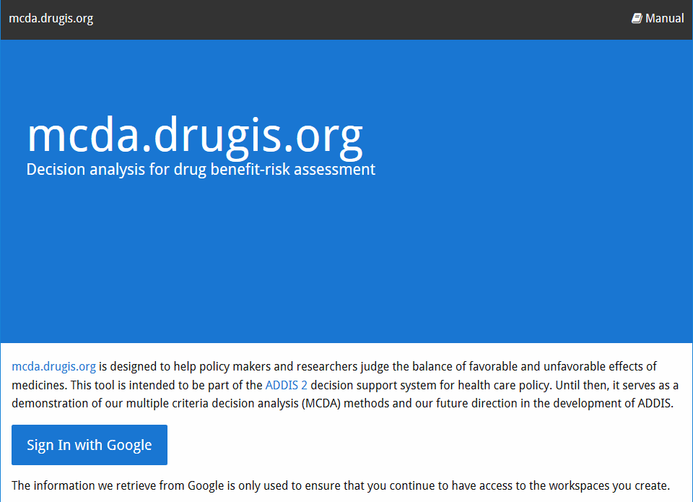  
Figure 1: The MCDA welcome screen

👉 After signing in, click the ‘Create workspace’ button. In the dialog that appears, choose the ‘Zinbryta initial assessment simplified’ option. You should now be on the Overview screen of a fresh workspace, like on Figure 3.

The overview screen shows you the criteria and their data sources and characteristics, the alternatives and the effects table. Note that many elements in the interface have a contextual help icon that you can click for explanation and links to the relevant section in the manual.

  
Figure 2: Contextual help icon (outlined in red)

  
Figure 3: Overview screen of a workspace

The example concerns a simplified version of the [Zinbryta assessment](https://www.ema.europa.eu/en/medicines/human/EPAR/zinbryta" \l "authorisation-details-section). The criteria are the primary endpoint (Annualised Relapse Rate) and several adverse events. Only data from the 205MS301 study are included, as can be seen in the effects table. The references column contains links to the clinicaltrials.gov registry version of this study in case you want to look at the source data.

👉 Take a moment to look at the effects table at the bottom of the overview tab. Do you have a clear preference for one of the two alternatives? What makes this alternative better?

We are now going to quantify your preferences in several ways to see whether your intuitive answer in the previous step matches the outcome of MCDA.

👉 Go to the ‘Preferences’ tab. At the top are the partial value functions, which indicate how the desirability of a criterion’s outcome varies with its value. Below this is the weights section which is the main concern of this tutorial. First let’s see how the criteria compare if we only give an ordinal ranking, with efficacy as the most important.

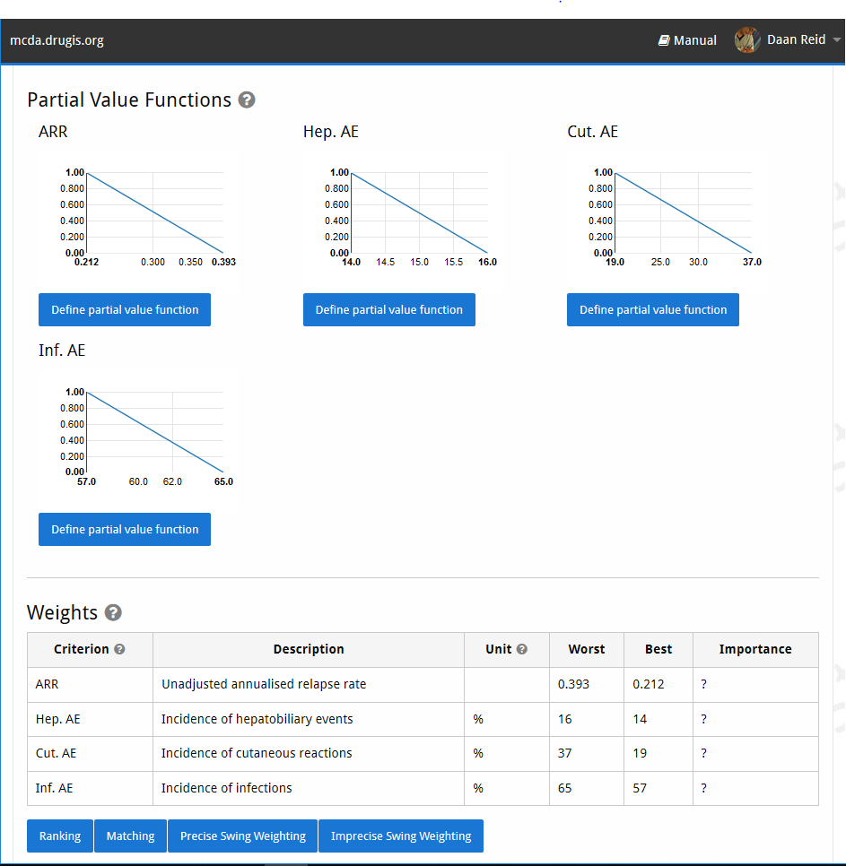  
Figure 4: Partial value functions and preferences

👉 Click the ‘Ranking’ button below the weights table, then indicate that ARR is the most important criterion, followed by Hep. AE, then Inf. AE. Then click on the ‘Deterministic results’ tab. Here, you see the effects table again, but the values can be changed to do sensitivity analysis (subject of a later tutorial). Below this are the representative weights, showing which weights the system has based the value profiles on. Because we did not supply direct numerical weights but did ordinal ranking instead, the system has calculated a default ordinal set of weights which is shown in the table.

The total value indicates how good a criterion is according to the weights you supplied and the data in the effects table. The value profile plot below the total value table shows how the value of each criterion is composed (see Figure 5). In the current situation, we can see that Daclizumab is much better at reducing the relapse rate, while the other treatment is better as far as all the adverse events goes. Because we have indicated that ARR is much more important than the adverse events, it follows that we should prefer Daclizumab.

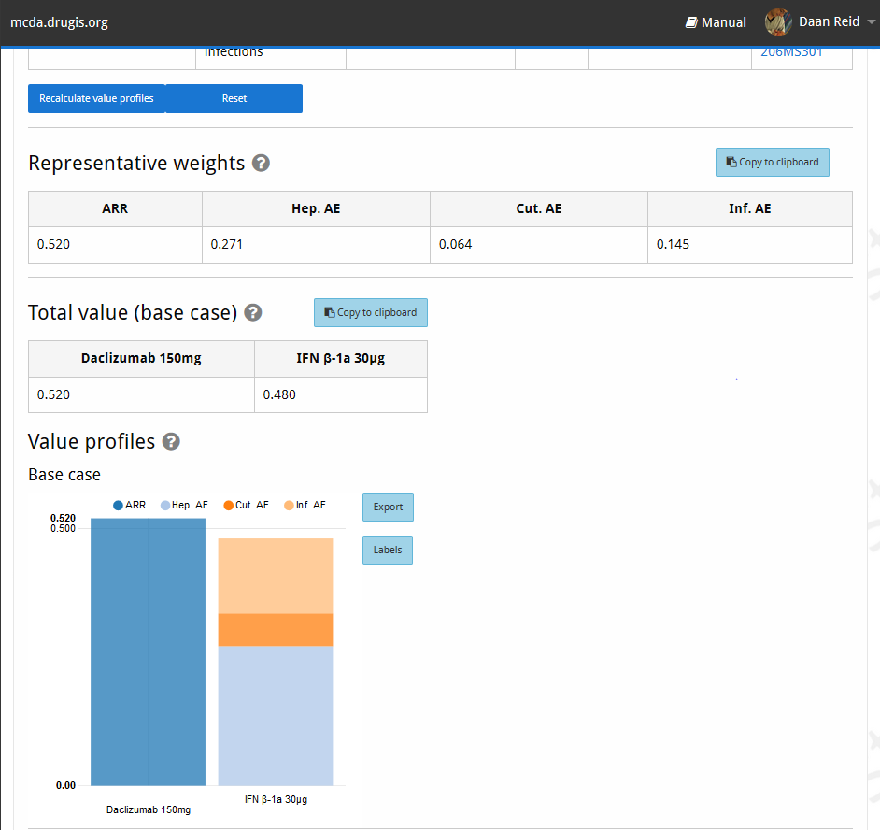  
Figure 5: Representative weights and value profile

Let’s see how the picture changes if we weight all criteria equally.

👉 Go back to the ‘Preferences’ tab, and click the copy icon next to the scenario dropdown (Figure 6). Give the new scenario an intuitive name like ‘Equal weights.’

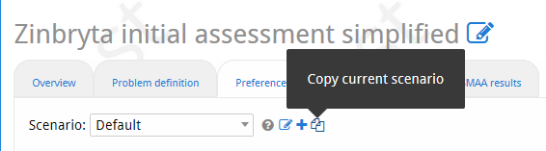  
Figure 6: Copy scenario button

👉 Click the ‘Precise Swing weighting’ button below the weights table, indicate that ARR is the most important, and then leave all the sliders at 100% and click ‘Save’. Now navigate to the ‘Deterministic results’ tab again, and the picture should be quite different. The representative weights are 0.25 for each criterion, and IFN β-1a 30µg is now better than Daclizumab. Because there are simply more adverse event criteria, they together outweigh the higher effectiveness of Daclizumab.

You can switch between scenarios using the dropdown at the top of the tab, and the results will reload.

Also explain Matching weighting here? Seems maybe too complicated?

There is no uncertainty in this simplified scenario, meaning that the stochastic component of our MCDA tool is not relevant and the ‘SMAA’ tab should be ignored. It is the subject of a later tutorial.

We hope that this tutorial has demonstrated adequately how assigning different importance to criteria can drastically change the relative value judgment of treatments. We’ve also shown how quantifying these importances makes it easy to see where these differences originate. Finally, we’ve shown that in the MCDA interface it is easy to input different preference scenarios and switch between them.