Group report

Group C

Callum Edwards, Laura Haddy, Daniel Richards

Word count: 5604

Contents

Introduction 3

Background information 3

Our client 3

Our project 3

Requirement engineering 4

Sprints & agile methodologies 4

User stories 4

Project Backlog 4

Code reviews 5

Diagrams 5

Problems occurred and solved 5

Design and implementation: 5

How our software met our user stories 5

Patient Application: 6

Doctor application: 6

Proposed solution – How the group have met it 7

Usability report and how the group have responded 8

Examples of improvements 8

How the group have implemented security 9

Testing 9

How the group have tested the project 9

Legal and Ethical considerations 10

Project management 10

Evidence of deliverables 11

Who did what? 11

Managing the client 11

Evaluation 12

Appendix 1: User Stories & Requirements list 14

Appendix 2: Client Feedback 15

Appendix 3: Backlog 18

Appendix 4: Encryption 19

Appendix 5: Client requirement agreement 20

Appendix 6: Diagrams 21

State machine 21

Use Case 22

Class Diagram 23

Exported SQL Server Management Diagram 24

Appendix 7: Normalisation 25

Appendix 8: Usability report 26

Group development 26

Gaining feedback 26

Feedback gained 26

Client feedback: 26

Group feedback: 27

Other feedback: 27

Summary of feedback and development 28

Appendix 10: Proof of concept document 29

# Introduction

Within this report, displays and explains the implemented work completed by PRDC251 Group C, consisting of Callum Edwards, Laura Haddy and Daniel Richards; who have collaborated with a client to develop two web applications. Throughout the course of this report, the group will explain in detail about their client, who they are and what they do, the requirements and analysis of the application, the development process, as well as how the group have tested the prototype and how they have worked and made progress together to produce the end product. The group have worked accordingly to produce a functional, professional prototype for the client. The group have worked via agile methodologies throughout, to complete the project, which has proven extremely successful for the team.

# Background information

## Our client

The group’s client is Gabriel Esteban Aguiar Noury, who is a researcher in Human Robotics at the University of Plymouth. Originally, the group were going to be working with EPIC (E-health Productivity and Innovation in Cornwall), the company the client works with. Unfortunately, this fell through as the company did not attend any of the initial meetings to devise a project.

As a result of this, Gabriel stood in and became the group’s client, and the group have been liaising with Gabriel in order to construct and develop this project, whilst acting to industry standards and conducting meetings and communication in a professional manner.

## Our project

The groups project has been derived of what EPIC’s intended project for us initially was supposed to be; A health monitoring application known as “HealthApp”, this application has two different types of users, Doctors and Patients.

The purpose of the application is, as a doctor, to monitor and track the health for a variety of patients. This will be achieved through the creation of surveys with medical questions for the patients to answer, and will be assisted through a private messaging service between a doctor and their corresponding patients, the doctor will be able to check a patient answer history for the questions they have sent out. Finally, if a patient has been consistently scoring low answers on questions, or inactive on the application for a certain amount of time, the doctor will receive an alert and be given the option to message the patient.

As a patient, the goal of the application will be to track their own health by keeping a track on their application, this will be done through answering survey questions tailored to them by the doctor in accordance with the health issues they are suffering from, which will be specified to the specific patient, there will also be the option to message their doctor directly if they need to seek help.

The aim of both patient and doctor applications is to enable both users to be able to communicate and frequently track health through using a web application, rather than making an appointment to see a doctor or having to travel.

# Requirement engineering

## Sprints & agile methodologies

To manage and organise the workload, the group have worked through regular sprints, over the course of every two weeks. The group decide what needs to be done in each sprint to reach the minimal viable product, and then delegate specific tasks to members, which are recorded through the project backlog on GitHub, as well as in the sprint plan. Working through sprints has also allowed members of the group to be able to swap and alternate the tasks they work on, when planning a new sprint – which allows members of the group to gain a wider understanding on all parts of the application.

Working via two week sprints has been a successful aspect for the group; the sprints have been aided by sprint plans, every two weeks – to be able to record and plan what the group are going to do over the following two weeks. And then finalised by sprint reviews, every two weeks. Documenting a sprint review has enabled the group to see what has been successful, and what still needs working on in the following sprint. The tasks allocated from the sprint plans, have been recorded in the project backlog.

With the group doing sprints every two weeks, it has allowed members of the group to produce the minimal viable product within that time, yet also allowing work to be improved on in the following sprint. It also poses a deadline to what an individual is working on, which results in the group working at a sustainable pace, yet they are still able to manage the workload from the client in an orderly manner. Developing a project through using sprints, has allowed the group to work in a professional, yet well-paced environment throughout the development of the project.

## User stories

The group have developed user stories based on the application that is being developed, patient and doctor user stories have been created; the user stories include the individual tasks that the user will be carrying out whilst using the web applications.

Throughout the development of the project, the group have considered and developed the application based around the user stories created. The group have done this to ensure that the project is a user-centred prototype, which will work accordingly for any type of user.

The group have also considered the user stories when delegating tasks to group members in the backlog; doing this, the group have referred to the user story first, and then how the individual is going to implement features-based on the user story, and how the user would be using the feature created. This has ensured that each member of the group has the end user in mind, and what they would be doing on the application whilst developing the prototype, which then has made it easier for the group to consider HCI concepts whilst developing.

With the application changing throughout the development process (due to extra aspects being implemented), so have the requirements and the user stories; the user stories can be found in Appendix 1.

## Project Backlog

In order to organise the sprints and delegated tasks effectively, the group have created a project backlog to organise the tasks during each sprint. The group have organised the tables, into two-weekly sprints; so the group are able to clearly see what each member is doing for that sprint, and how long the sprint lasts. Typically, members of the group have chosen what they want to work on during each sprint – which has allowed members of the group to gain knowledge on a variety of aspects during the project, e.g. C# back end, front-end, database etc. Using the backlog has proved to be effective for the group, as it provides a clear vision of what everyone must do within each two-week sprint. The backlog has allowed the group to be able to prioritise essential tasks that need to be completed to be able to achieve the MVP for each sprint, as well as ensuring that nothing is forgotten. The project backlog can be viewed on GitHub, as well as Appendix 3.

## Code reviews

As part of using agile methodologies within the project, the code have conducted code reviews every two weeks. Doing a code review has allowed the group to be able to review the code which was created by a group member, and aim to optimise the quality of it. This was done every two weeks, alongside the sprint review. The write up for the code review can be found in the sprint review document on GitHub. Undertaking code reviews has enabled the group to be able to understand what a group member has written, allowed the group to minimise the chance of bugs within the project, as well as finally being able to produce a high quality project.

## Diagrams

In order to process the requirements of the client, the group have developed several diagrams which can be found in Appendix 6. The diagrams created, display how the group have analysed the project. Due to elements of the application being changed throughout the process of developing the product, the diagrams have also slightly altered and have been updated to match the end application. The diagrams created include state machine diagram, use case, class diagram and ERD. These diagrams represent and display how the group have structured and gone onto implement the health application prototype. Alternately, the diagrams can be found on the documents folder on GitHub.

## Problems occurred and solved

With the group initially being fairly unfamiliar with ASP.net technologies, developing the application was certainly challenging for all members. Whilst implementing functionality during the development process, there has been minor issues which have occurred for the group, however they have been easily resolved. With members of the group working individually on certain tasks, team members have come across aspects which they are unsure about. Despite this, members have reached out to the group, and the group have been able to help each other and resolve the issue quickly, with no significant impact for the project.

Some members of the group initially had issues with using and committing to GitHub, – however this was soon resolved through the help of Dan, who was more familiar with using GitHub. With the whole group using GitHub, it has allowed the group to work and develop using several branches, as well as being able to have appropriate version control on the project – just in case there were ever any issues.

# Design and implementation:

## How our software met our user stories

When implementing and developing the project, the group have often referred to the user stories to ensure that the minimal viable product is user-centred, and that all aspects relate to the end user of the system. Through this, the group have aimed to be able to achieve all the user stories within our prototype.

Appendix 1 displays the user stories which the group created at the early stages of the project. Some user stories have been added due to the alteration and additional features that the project has inherited throughout the development process. Some user stores the group have been unable to achieve due to time restraints as well as commitment and efforts from group members. Below specifies the user story, and if and how the group have been able to implement in into the health application.

### Patient Application:

* **As a patient, I want to be able to log into my account and answer questions from my doctor.**

The log in page is the first page the user is greeted with; the group have been able to implement the system so a patient is able to log in via their code given to them by their doctor. Alternately, the patient is also able to log in through the use of their email address and password. When the patient successfully logs into the application, they are then taken to the patient dashboard. When the patient is sent a survey from their allocated doctor, they are able to answer the questions and then submit their answers. Currently, the answers do not go anywhere.

* **As a patient, I want to be able to update my personal details, such as email address.**

Whilst logged in, a patient is able to go to their ‘My profile’ page, and update their first name, last name, email address or account password. When ‘Save changes’ is clicked, the changes committed from the patient is then updated to the database. This is based on their Session ID when they first log into the system.

* **As a patient, I want to be able to reply to messages from my doctor.**

The patient is able to view messages from their doctor on the ‘Messages’ page on the patient application. The patient would then be able to reply to their doctor. The layout for the message page has been made simple for the user – so they are able to understand what to do in order to reply to their doctor. The patient is only able to view and reply to messages, whilst both doctor and patient are online.

* **As a patient, I want to be able to see any notifications on the dashboard when I first log in.**

Due to the way the messaging service was implemented through SignalR, and the chat service only working if both patient and doctor are online, the group were unable to push message notifications to the dashboard of the patient app. The group would aim to employ this if we implemented messaging through SMS style, rather than SignalR.

* **As a patient, I would like to be able to answer questions from my doctor.**

The patient is able to answer questions when asked to by the doctor. When a doctor sends a patient questions to answer, the patient will be able to answer by either text input or drop down choices, which they then send back to their doctor.

### Doctor application:

* **As a doctor, I want to be able to ask question to my patients so I can check on them.**
* **As a doctor, I want to be able to set up template questions for patients as well as specific questions depending on the patient.**

A doctor, when logged in, can create a survey for a patient – consisting of however many questions they wish – they are able to use template questions, or alternatively create new questions, perhaps depending on a patients conditions. The doctor is also able to decide upon the frequency that the questions is sent to the patient – e.g. once, daily. Once the survey is created, the doctor then can send it to the patient.

* **As a doctor, I want to be able to log into my account and view patients answers to questions.**
* **As a doctor, I want to be able to receive alerts depending on a patients answers to questions.**

The doctor is able to log into their account through their email and password. Unfortunately, the implementation of the alerts page for the application was unable to be implemented. However, the group have developed an html page to provide a visual representation to what the page would have looked like.

* **As a Doctor, I want to be able to message a patient and have a conversation with them.**

When logged in, the doctor is able to message a specific patient and have a chat with them privately.

The initial user stories created, mostly meet what the group have implemented. Referring to the user stories has allowed the group keep the user in mind, as well as ensuring that all of the user stories are implemented into the prototype. The group have prioritised tasks within the backlog to ensure that both users are primarily able to complete the main functions of the application.

## Proposed solution – How the group have met it

The proposed solution slightly differs to the group’s final solution. The group have produced the best possible outcome and have worked through sprints to achieve the outcome. The group have been able to meet the proposed solution through delegating tasks to specific members and ensuring that they are complete and functioning by the deadlines set by the group.

The proposed solution: The Patient and Doctor should be able to login to their account, through a code a doctor has given them, or by email address and password. The doctor should then be able to send questions to a patient through sending them a survey – these questions should have an option to be sent once, or daily. Based on the patient’s responses to these questions, the doctor should receive alerts – the doctor should only see notifications if the answer to their question is below a certain amount – or the patient is inactive. The doctor should have the option to message a patient through a private chat.

The patient should be able to receive questions from their doctor, and also be able to message their Doctor.

The group have been able to implement the login system for both applications. The doctor can log in through their email and password. The patient can log into their application, given they have received a code from their doctor, or they can use their email and password.

The group have used SignalR to implement the messaging service for the patient and doctor, the patient and doctor can communicate via messaging when both users are online. If the group had more time, the group would work on allowing the patient and doctor to message whilst offline, and for message history to be stored.

The proposed solution also included ‘The doctor, asking a patient specific question, once, or daily.’ The group have implemented this feature through a survey the doctor creates. The Doctor can choose the frequency of how many times the question is asked, and decide an option to how the patient replies, e.g.: Text, multiple choice etc. This implementation has been successful, the group have been able to ensure that the patient and doctor are able to communicate through questions. The patient is able to answer the questions, there is not a way of being able to view the answers on the doctor application.

The proposed solution was to make the application scalable for a mobile, the group implemented this through using bootstrap.

## Usability report and how the group have responded

*Please find the usability report in* *Appendix 8**.*

The usability report provided the group with valuable feedback which was greatly considered. The group were able to gain feedback from several perspectives which were greatly appreciated and have influenced the development.

Gaining feedback on the wireframes at the beginning of the development was a positive move for the group. Gaining feedback before the group had started implementing the prototype was ideal, the client was able to suggest any major alterations on specific pages or design elements, especially before the group began developing functionality. Appendix 2 shows the feedback the group received from the client. This feedback influenced the development of the system and was dependant on key features such as functionality and what pages were compulsory within the application. Gathering client feedback on a regular basis has influenced improvements as big as page changes, to user interface aspects, changing the content of the pages, as well as general functionality.

The group have gained feedback from various other users. Due to a considerable number of patients using this application, it could possibly be users with a variety of capabilities with technology, therefore the group have used this opportunity to be able to gain feedback on the application from a several users – some whom are not familiar with technology. Doing this, has enabled the group to be able to gather comments based on what could be visually improved, as well as looking at the ease of use.

Employing HCI concepts for this application has been a priority for the group; as a website with which is ascetically pleasing is one a user will continue to use. Making sure that the web application is easy to use, was majorly important to the group. Hence, why the group have aimed to gather feedback based on what the application looks like. HCI concepts and the interface of the prototype was mentioned in the user feedback, therefore has been an aspect that the group have closely focused on. Due to this, the group have created a very simplistic, yet easy to use application.

### Examples of improvements

#### Design

Most of the feedback gained from the HCI report consisted of design elements which the group could improve on, one comment was ensuring that the buttons are clear when a user is clicking on them. The group have responded to this creating a hover element, so when a user hovers over a button, it goes darker. Also, the mouse cursor now points when over a button, rather than staying the same – this has improved the quality of the application for the user, and enabled them to have a positive experience on the application. Examples of this can be found on the application, looking at buttons such as ‘Logout’.

There were comments made about the colour of the application and how it is a bit dull – this has been changed, so now the application is more user-friendly and appealing.

#### Functionality

Due to the feedback gathered for the HCI report being at the middle of the development stage, not all functionality was operating as it should have been at that point; this was something which was picked up in the user feedback. The group have improved on the functionality of the application, and the application has developed considerably since, making it useable for a user to complete the tasks in order to get full use of the application.

The functionality of the project has changed throughout the module, the feedback the group received at the point of the HCI report was primarily about the functionality – which has improved.

Conducting usability tests throughout the development of the project has had a positive impact on the project. Testing the project at several stages of the development, has certainly been useful for the project – and has risen issues as well as design concepts which the group could improve on. The usability testing has made a significant impact on the end result of the application and is an aspect which has been carried out till the end of the project. The group have responded to the feedback received positively, and have made changes based on the feedback provide to produce a well-functioning, user-friendly application. The feedback received throughout the development of the project has been acted upon and considered when developing the prototype. The feedback has been useful and has helped the group can create a functioning prototype which is fully user-centred.

## How the group have implemented security

The group have employed verification within the log in, so checking the email, passwords, and ID codes for patients match the credentials currently in the database.

Within the groups log in system for both patient and doctor, the group have attempted to implement encryption through hashing. Unfortunately, this is not currently working, the attempt of this can be found in the application under the encryption folder, or alternatively within Appendix 4.

If a malicious user without an account wanted access to the application past the login page, they could potentially do so via searching for a page within the URL if they knew what they were looking for. However the group have prevented this through using the login session, and including it on each page. Over every page there is a login validation if statement, when a user logs in they are given a session – without this session they are automatically redirected into the login page. By placing this on every page, it ensures that no user is able to access pages without going through the login process.

# Testing

## How the group have tested the project

Throughout the process of development, the group have tested the project through using various methods. For example, throughout the process of the usability testing, the product was tested by various users, and the group were able to gain feedback based from an end users' view.

The group have repeated usability tests using alternative criteria, to test the functionality of the project, as well as looking at the user interface aspects, and how the group could improve this. Doing this has enabled the group to continually gather feedback on the product throughout different development stages.

Throughout the course of developing and especially when finalising the project, the group have tested the project through attempting to enact each created user story. This has enabled the group to find out if the user, patient or doctor, will be able to complete tasks they need to in order to have successful use of the application. This has enabled the group to fully test the project, checking for errors, as well as ensuring that the user is able to complete a task within the application.

Come the end of the development, the group have fully tested both the doctor and patient application, to ensure the project is fully functional – and operates as it should without significant errors which disable both applications from working. The team have also met with the client to test the product, and to ensure that the client is satisfied with the product.

## Legal and Ethical considerations

Due to the sensitive nature of the information contained within the group’s project, which is the personal details of both the doctor and patient, it was important to keep this information protected in order to keep in accordance with doctor and patient confidentiality. It was also important not just from an ethical standpoint but a legal standpoint as well as the information we could store within our project must only be used within the context of the project and we also must take steps to secure this information to keep it safe, in this way we are obeying the law and keeping with Data Protection Act (1998).

An example of the group making ethical considerations was the implementation of the private messaging service as opposed to the global public chat, this was deemed the correct methodology of messaging as it kept the sensitive information that could be potentially being exchanged over the messaging service safe and protected from external users or user’s the messages were not intended for.

# Project management

Creating the requirements of the project has defined the development process for the group and has clarified how the product should operate. Working through agile two-week sprints and allocated tasks on the project backlog on GitHub, has enable the team to keep up to date on the progress of the project, as well as being able to keep the client updated.

With the project team meeting weekly, as well as every two weeks with the client, the group have been able to resolve issues as well as being able to clarify anything. To ensure that all work items have been completed, the group have allocated tasks to members in each sprint, to prioritise aspects.

Meeting minutes and sprint plans and reviews were an important aspect of the project, they can be found in the documents folder on GitHub.

Throughout the entire project, group members contributes to several stages of the project. The group worked together to produce the requirements and the user stories for the client. This was a good start to then be able to start the project development wise. The group planned and wrote the team bid together, as well as meeting regularly which aided the project to develop.

Callum was the main point of contact for the client, he was able to email and arrange meeting when required by the group. Callum covered sections of the project from initial requirements to the development aspect of the project. Callum covered creating wireframes for the doctor application, and then he went to go on to implement functionality within the login for both patient and doctor user. Callum also created one of the main parts of the project, which was the messaging functionality – which was used between the patient and the doctor user.

Laura took part in several stages of the PRDC251 module. She contributed greatly to the requirements process, which included the user stories, requirements list, normalisation and diagrams. Laura attended every client and group meeting, in these meeting she was wrote the minutes for. She then went on to create the patient wireframes for the application, and following this, create the HTML pages for the patient side of the app. Laura created the My Profile page within the application, which allowed the patient user to edit and save their details on the app. Laura recorded the sprint plans and reviews each sprint, as well as posting allocated tasks to the project backlog. In the middle of the project, Laura created and wrote the entire HCI report, which was submitted on the DLE. Laura was able to get a full understanding of the project – due to undertaking tasks from the requirements process to the development of the application.

Daniel also participated greatly to the project. Daniel was able to devise requirements and user stories alongside the group, as well as creating the state machine diagram. Daniel then went on to create the database and provide test data into the tables which he created. Later, Daniel created the HTML pages for the doctor application. Daniel participated greatly in making the application functional – this included making the dashboard functional as well as the survey aspect of the project.

All members of the team participated in group meetings; the whole team was able to communicate to each other given there were any issues at any point. The whole group participated in testing the project come the end, to ensure there were little errors within the app. All of the team thoroughly prepared for the final presentation to ensure all the group members felt confident about the application the group had created.

## Evidence of deliverables

The Health Application provided, contains both the patient and doctor web applications. The group have worked together to achieve the overall outcome, they also have individually worked on tasks to achieve the outcome. Below, gives an in-depth exclamation to what each member contributed to the project and how their contribution has impacted the end result. Please see the ‘Health App’ on GitHub to view the full project.

## Who did what?

The group worked together to produce a successful prototype for the client, examples of who did what specific task, can be found in the ‘Mark sign off’ sheet which was submitted individually by each group member.

## Managing the client

The group have been in constant communication with the client; the client has been able to provide the group with a ‘proof of concept’ document (Appendix 10), which outlines the requirements which are to be displayed in the presentation.

At the initiation stage, the group met with the client to discuss the minimal viable product; the group then proposed a document of requirements as the MVP. The group decided to do this based on the client changing the requirements of the project, which began to make the requirements process complicated for the group. This document was signed and agreed to by the client. The document displaying the agreed requirements is within **Appendix 5.**

Callum has been the main point of contact with the client, and has been emailing Gabriel throughout, to arrange meetings – which all of the group have attended.

The group have had consistent meetings with the client, from the beginning of the project, analysing requirements, to preparing for the final group presentation with the client. The client has provided the group with in-depth details of what both applications are required to do. With the group having constant contact with the client, it has enabled the group to create a well analysed and appropriate solution, matching what has been specified by the client.

# Evaluation

From concept through to development, the project team conducted a thorough and detailed analysis of the project, to ensure the creation of product met the user requirements. The group are pleased that a professional, yet useable solution has been made for the client, which appropriately works alongside the requirements and user stories.

Although some aspects of the project have been challenging for the group, it has allowed the group to be able to develop their skills on MVC and ASP.NET, which will be useful in the future for further projects. Using skills such as requirement analysis has been more in-depth than previous projects, due to the scope of the project that the group have worked with. Working with a client for PRDC251 module has allowed the group to gain an insight on the business aspects of the project, as well as the front and back-end development.

The group have primarily focused on making the project functional and working before focusing on design aspects of the web applications; the group have centralised their process of development based on the user stories, which focus on the tasks that the users of the web application should be able to carry out.

If the opportunity of more time arisen for the group, the group would take the opportunity to improve the messaging service for both the doctor and patient application; enabling the doctor and patient to see the messaging history exchanged between both users. The group would also work to enforce offline messaging between the doctor and patient. Due to unforeseen circumstances, there are elements of the project which have been uncompleted, such as the alerts page – this is an element that the group would aim to begin to functionalise. The survey element of the application would also be an aspect the group would ideally like to improve on; despite the doctor being able to create a survey for a patient, the group are not yet able to gather the answers from the patients – this is an aspect of the project that the group would like to finalise.

Despite it not being one of the client’s prioritised requirements, a histogram is something that the group also would like to implement into the web application. This would be based upon the patient survey answers, and would display the patients answer alongside to the date and time which they answered the question. This graph would give the doctor a visual opportunity to view how the patient is doing on a day to day (or other frequency) basis.

The group are pleased that they have worked together to achieve the best prototype possible for the client, whilst closely monitoring the end-user, as well as the user requirements for the Health Application.

# Appendix 1: User Stories & Requirements list

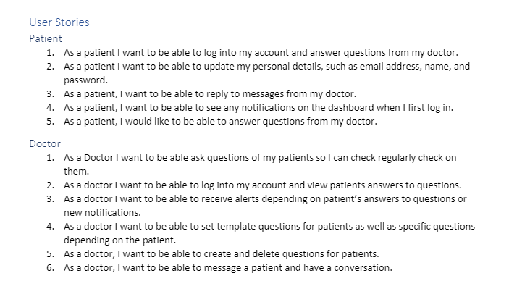

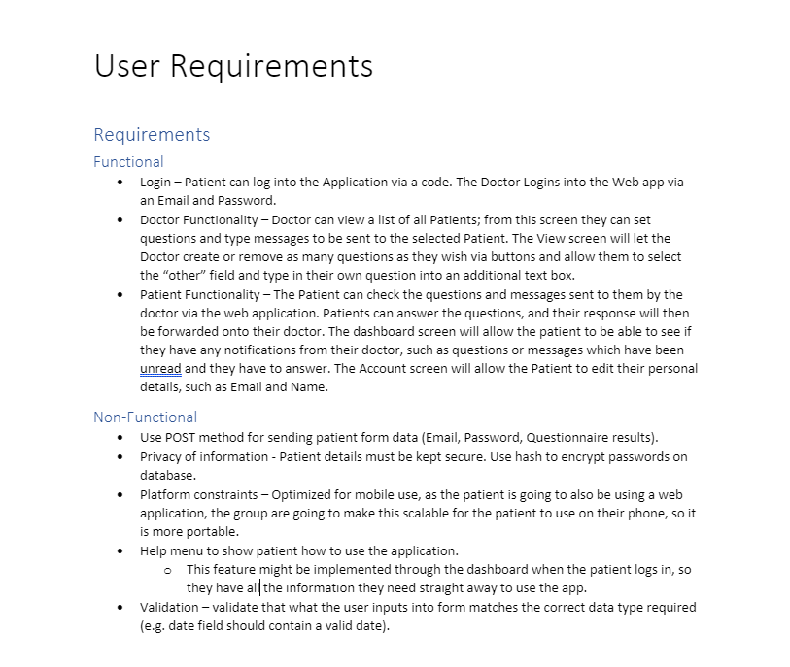

# Appendix 2: Client Feedback

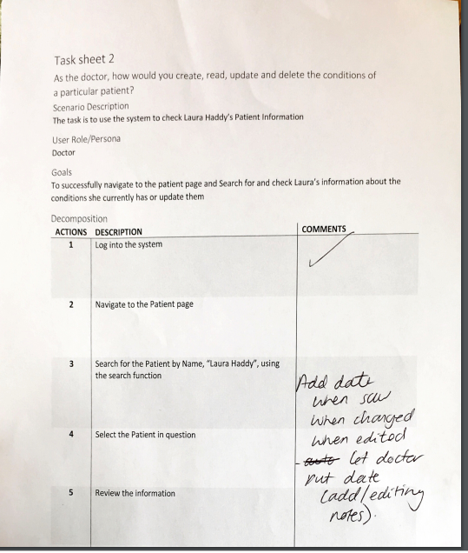

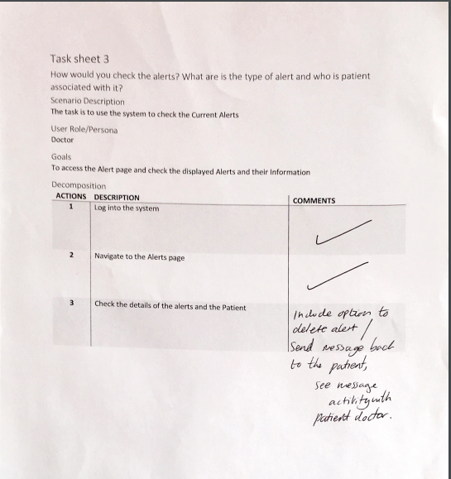

# Appendix 3: Backlog

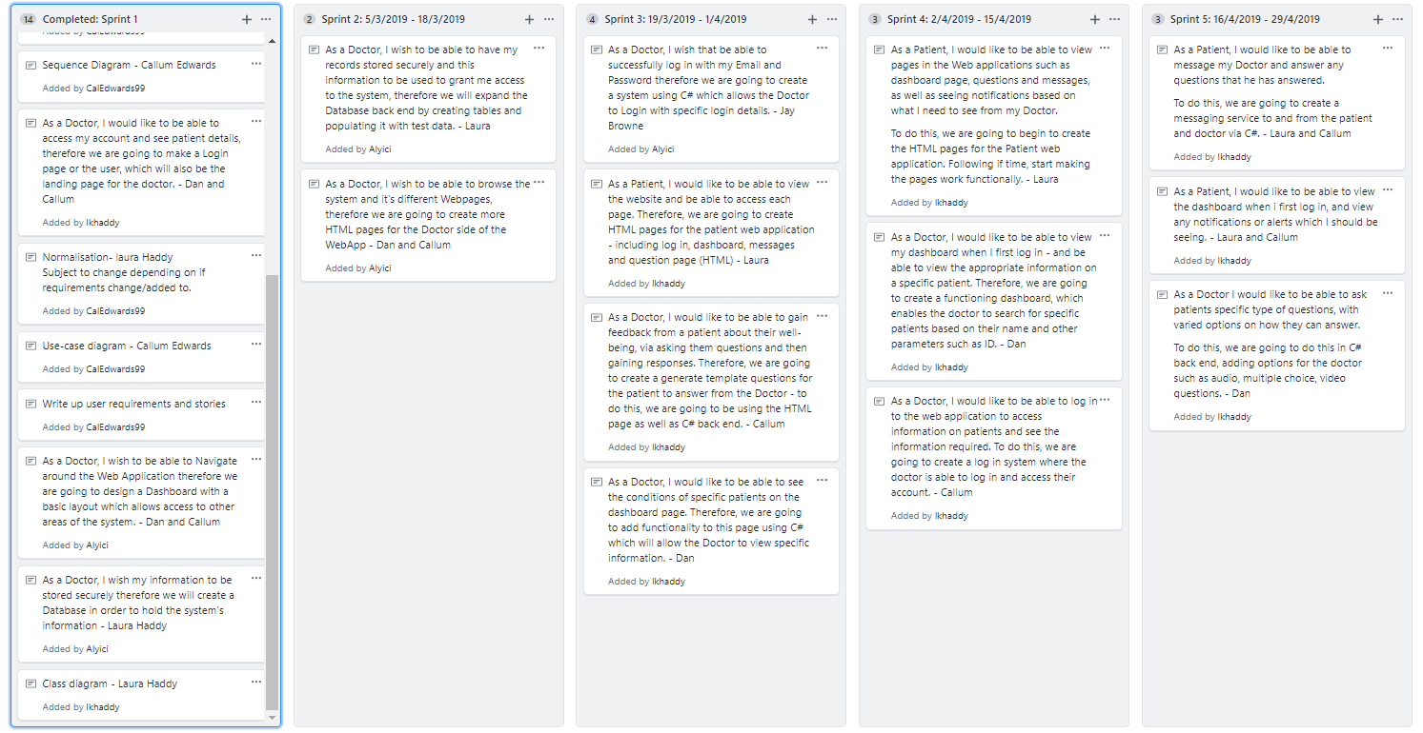

# Appendix 4: Encryption

# Appendix 5: Client requirement agreement

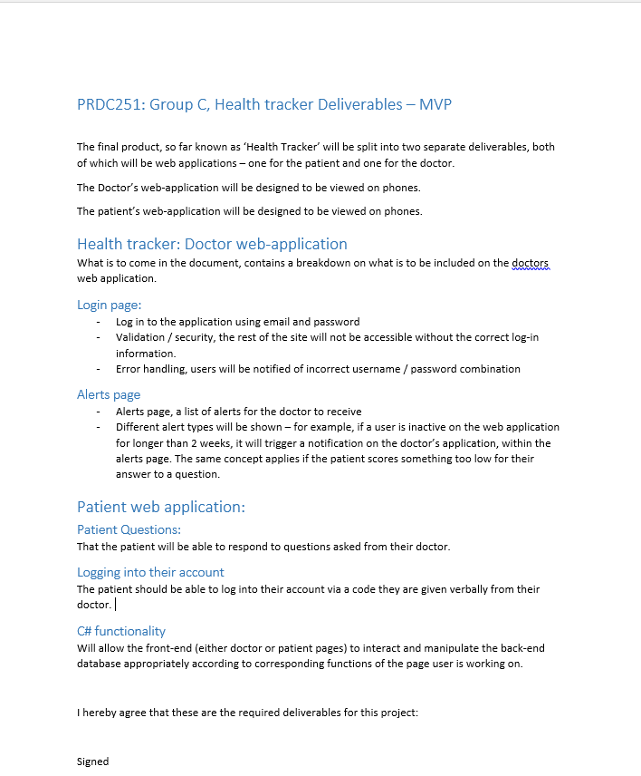

# Appendix 6: Diagrams

## State machine

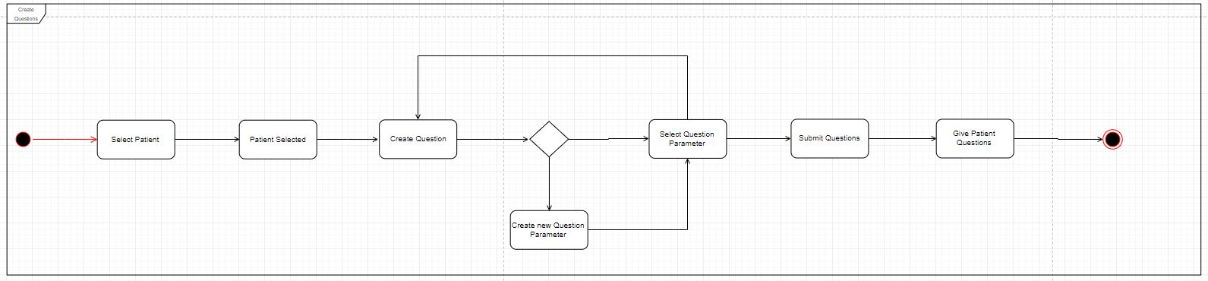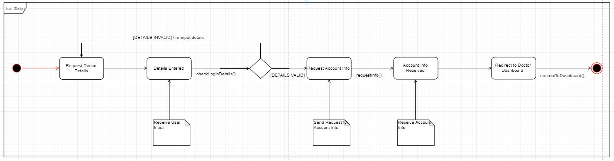*Created by Daniel Richards*

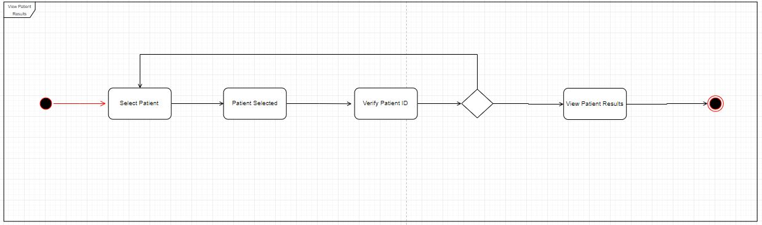

## Use Case

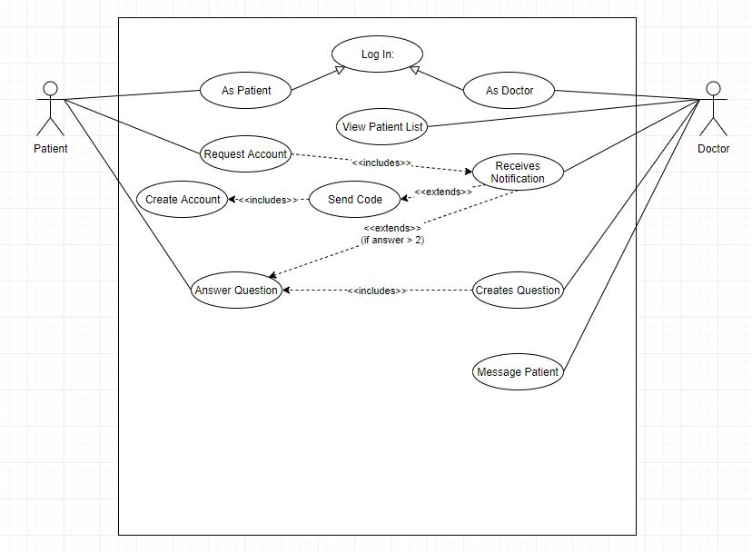C*reated by Callum Edwards*

## Class Diagram

*Created by Laura Haddy*

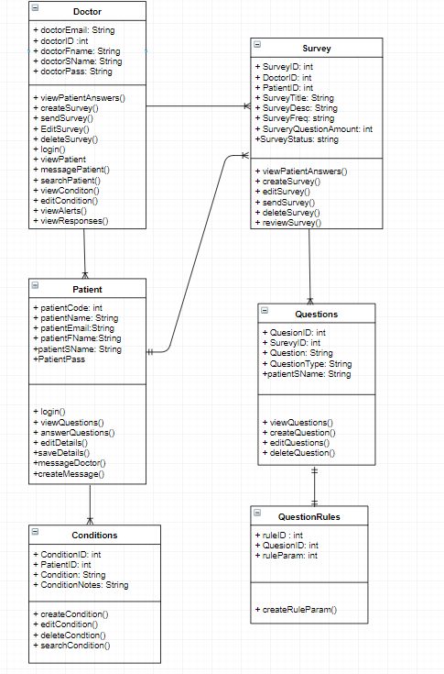

## Exported SQL Server Management Diagram

*Diagram of the final database, showing the table structure and relationship scheme.*

# Appendix 7: Normalisation

# Appendix 8: Usability report

*Below details the usability report submitted. For the purposes of the report the group have pasted the report into this report, and referenced sections within. For the full report, please see GitHub, or alternatively, the link below. The full report consists of the report with the appendix’.*

https://liveplymouthac-my.sharepoint.com/:w:/g/personal/daniel_richards-8_students_plymouth_ac_uk/EcBkT0PMktdBgOt7fb1WV5UB1Ce3V1j6Ff1MWjLMn4ITFA?e=42mUAI

## Group development

Throughout the course of the development of the product for the client, the group have focused and considered HCI concepts when developing the web-application system, for both doctor and patient. To do this, we have become attentive to the end user of the system, and have always considered them when making decisions, specifically about the design aspects of both applications.

With the group’s current knowledge of HCI concepts, the design of HTML pages has been implemented using bootstrap, to make the application look as pleasing as possible for the user, as well as making the application as easy to use for the users.

## Gaining feedback

To gain a further understating on the user interface of the applications, the group have gained feedback from several perspectives throughout the development process to see how we can change and enhance the application to make it a more positive experience for users. To do this, we have allowed several users to navigate their way through our system, to gain feedback on the design perspective of the project; which will then allow the group to develop the system, whilst considering all the feedback we have gained.

The group have decided to gain feedback through different stages of the development, as well as from a variety of users – so we can gain a better understanding of how we can develop the product to become more beneficial and easier for the users to use.

The group have created a document (Appendix C) with a list of tasks for the user to do, and whilst they do this, we will gain feedback on their decision process as well as their comments on the design of the system, and how it could look better and be a more successful system someone to use.

**Due to gaining feedback throughout the development of the project, the functionality of the system was not always working, therefore the user has simply navigated through HTML pages, or wireframes depending on the stage of the project. However, from this, the group were still able to gain an understanding on what could be done better and how we can develop the design of the web applications to be more usable for the user. The group plan to continue to gain feedback throughout the process of developing both applications.**

## Feedback gained

### Client feedback:

#### **Doctor Application -**

Throughout the start of the development process, the group have met with the client to go through the wireframes provided (Appendix D) – this was to see if the client was able to navigate their way through the system, page by page. During this, the group provided a document (Appendix A) with specified tasks to see if there were any problems that the client would come across. Through the process of this, the group have gained an understanding on what the client wanted to be changed on each page of the doctor application. From doing this user feedback with the client relatively early, using the wireframes created, the group have been able to develop the project, according to the feedback given.

Please see Appendix B to see the written feedback and brief comments on how the client has advised to improve the development of the application. Due to the application not being developed enough at the time to gain feedback on the HTML pages, the group decided to use the wireframe approach to gain feedback on the product. This approach tested the usability of the system as if everything was working, as well as gaining feedback on design aspects.

#### **Patient application**

Due to the Patient web-application being developed after the Doctor web-application, the group are currently unable to test this application in terms of usability. Due to this, the group have created wireframes (Appendix D) of what the application will look like and used this to gain feedback from the client on how the application looks in terms of design and HCI concepts. At each stage of the development of the project, the group are going to continue to undertake usability test to evaluate and gain feedback on how the application can be best suited to the end user. From gaining feedback on the wireframes, the group have gathered some in-depth feedback from the client on how the client would like the pages to be designed, as well as extra features added to certain pages. The feedback from the client based on the wireframes can be found in Appendix D. The client has responded via altering the wireframes Appendix D, as well as giving verbal feedback.

### Group feedback:

As part of the usability process, the group have decided to test the system. As the group are developing the application, we are familiar with the development of it; however, the group thought it would be useful to look at the project from an end user point of view, as if we were using the applications – to gain a broader perspective of the whole project. To do this, each individual member of the group have also completed the feedback document (Appendix C) , to evaluate and gather thoughts and feedback on the project from the group , and how we gain improve it based on HCI concepts and design. The results from the usability feedback testing can be found in Appendix C, group feedback.

The groups feedback on the application so far (Appendix C), was overall positive. There were comments on how the log out button is clear and able to see for users, as well as the navigation bar being in the standard position for users.

There were also comments on how the buttons on the navigation bar could be highlighted when hovered over or shown more defined when a user is on a specific page. This is something that would improve the usability of the system, as well as being able to see a curser point when hovering over a button.

### Other feedback:

Aside from the client and group feedback, the group have also looked to seek other feedback from users. The group have done this to gain a more in-depth understanding on what users find pleasing on a page in terms of the way it is designed, as well as the functionality of it and where everything is placed on a page. The group have provided the user with Appendix C, to gain several perspectives on the same questions. The feedback for these user tests can be found in other feedback.

## Summary of feedback and development

Though the course of developing the system and gaining feedback, the group have been able to develop the web-based applications according to the feedback we have been given so far. The feedback on the usability of the system has been a positive experience for the group; the group have been able to change and develop the project based on critical feedback we have received from several users. As the group are still developing the project, the group are going to continue to gain feedback at each step of the development process. By doing this, we will ensure that the system we create will be best fitted to any type of user.

With the group looking at the system from an end user’s perspective, it has enabled us to look at the system from another point of view, and comment on how the group would like the system to improve. Testing the usability of the system frequently will enable the group to act on feedback given and develop the best possible prototype system.

# 

# Appendix 10: Proof of concept document

