Task 1 – 8-Puzzle with A* Search
Documentation
Introduction to Artificial Intelligence and Data Science, WS 26/27
Group members: Dominik Barat, Daniel Rosenthal, Fabian Sefranek, Benjamin Suskic

1. Task description
The objective of this task is to implement an A* search algorithm in Python to solve the 8-puzzle and compare the performance of two heuristic functions: Hamming distance and Manhattan distance.
The 8-puzzle consists of a 3×3 board containing eight numbered tiles and one blank space. A move consists of sliding a tile adjacent to the blank into the empty position, with each move having a cost of 1. The goal is to reach the ordered state
0 1 2
3 4 5
6 7 8
using as few moves as possible.
The implementation generates random start states, checks their solvability, and solves them using A* with both heuristic functions. To evaluate their performance, the same 100 solvable start states are tested with each heuristic. The number of expanded nodes and execution time are recorded, and their mean and standard deviation are calculated.
Finally, the documentation discusses the time and space complexity of the heuristics and compares their performance based on the experimental results.
The program optionally exports the individual measurements to a CSV file for further analysis.

How to run it
The script needs only the Python standard library (Python 3.8 or newer).
Command | Effect
python puzzle8.py | 100 random puzzles with seed 42, including the example solution
python puzzle8.py --n 50 --seed 7 | Runs 50 puzzles using a different, reproducible random sequence
python puzzle8.py --csv results.csv | Also writes the raw measurements per puzzle

2. Software architecture
The program is organized into seven logical components (modules), each responsible for a specific part of the solution process. The Main component coordinates these components and controls the overall execution.
First, the puzzle model generates the goal state and random starting states. Each starting state is checked for solvability before it is included in the experiment. The experiment then solves each valid starting state twice: once using the Hamming heuristic and once using the Manhattan heuristic.
During each search, A* explores possible puzzle states and uses the selected heuristic to estimate how far each state is from the goal. The algorithm returns a solution path and the number of expanded nodes. The experiment also measures the execution time of each search.
Finally, the statistics component summarizes the collected measurements by calculating the mean and standard deviation for each heuristic. The results are printed in a report.
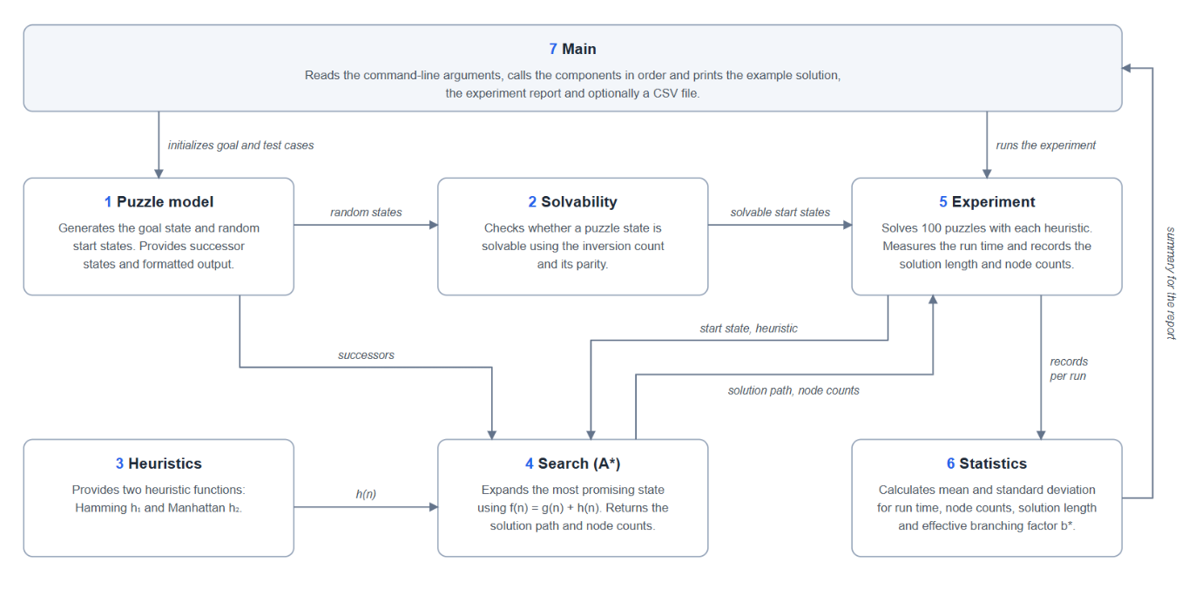

3. Modules and interfaces
The implementation is contained in a single Python file, puzzle8.py, organized into seven logical components. A puzzle state is represented as a tuple of nine integers with 0 representing the blank space.
Component | Responsibility | Input | Output
1. Puzzle model | Defines the goal state, generates random states and legal successors, and formats puzzle states. | Puzzle state, random generator | Goal state, start states, successor states, formatted output
2. Solvability | Decides whether the goal is reachable. | Start state, goal state | Boolean (True or False)
3. Heuristics | Estimates the remaining distance to the goal using Hamming or Manhattan distance. | Goal state to initialize the heuristic.  Puzzle state for evaluation | Integer estimate h(n)
4. Search (A*) | Finds an optimal solution using the selected heuristic. | Start state, goal state, heuristic function | Solution path, number of moves, node counts
5. Experiment | Runs both heuristics on the same solvable start states and measures performance. | Start states, goal state, heuristic functions | Individual measurements for each run
6. Statistics | Summarizes the measurements. | Experiment records | Mean and standard deviation per measure, effective branching factor
7. Main | Processes command-line arguments, coordinates execution and displays results. | Command-line arguments | Console output, optional CSV file

The components interact through function calls. For example, the A* search receives a heuristic function as a parameter, allowing both heuristics to use the same search implementation. The experiment collects the search results, which are then processed by the statistics component.

Example output of a solution
For the example state the script prints every move and the resulting board. The first two and the last of 23 steps with seed 42:
Start:
2 5 7
8 6 1
4 _ 3

Step 1 of 23: tile 6 moves down
2 5 7
8 _ 1
4 6 3

Step 2 of 23: tile 8 moves right
2 5 7
_ 8 1
4 6 3
...
Step 23 of 23: tile 1 moves right
_ 1 2
3 4 5
6 7 8

Goal reached after 23 moves.

4. Design decisions
The implementation was designed to make the search efficient, the comparison between the two heuristics fair, and the results easy to verify. The following sections explain the main design decisions and why they were made.
1. Representing puzzle states as tuples.
Each puzzle state is stored as a tuple of nine integers instead of a two-dimensional list. For example, the goal state is represented as (0, 1, 2, 3, 4, 5, 6, 7, 8). The tuple represents the board row by row, with 0 representing the blank space. Tuples cannot be changed after creation and can be used as keys in dictionaries or stored in sets. This makes it easier for A* to recognize states that have already been encountered and avoid unnecessary repeated work.
2. Precomputing frequently used information.
Some information is needed repeatedly during the search. For example, the program needs to know which positions the blank can move to and how far each tile is from its goal position. Instead of calculating this information every time, the program stores it in tables before the search begins. The algorithm can then look up the required information quickly, reducing repeated calculations.
3. Checking solvability before searching.
Not every possible arrangement of the puzzle can reach the goal state. The program therefore counts inversions, which occur when a larger numbered tile appears before a smaller one in the row-by-row sequence. For a 3×3 puzzle, the parity (whether the count is even or odd) determines whether the state can reach the configured goal. The program compares the inversion parity of the start state with that of the goal state. This check prevents the search from wasting time on impossible puzzles.
4. Generating random but solvable test cases.
To create test cases, the program randomly shuffles the nine puzzle elements and checks whether each resulting state is solvable. Unsolvable states are discarded until the required number of solvable states has been collected. This approach allows the experiment to use randomly selected solvable states rather than only states created by moving a few steps away from the goal. It also ensures that both heuristics are tested on the same set of puzzles.
5. Using two interchangeable heuristic functions.
The program implements Hamming distance and Manhattan distance to estimate how far a puzzle state is from the goal. Hamming distance counts the numbered tiles that are in the wrong position. Manhattan distance adds up how many horizontal and vertical steps each numbered tile is away from its goal position.
Both heuristics are implemented as separate functions and passed to the same A* algorithm. This means the search algorithm does not need to be rewritten to test a different heuristic. The two functions also allow the program to compare how different estimates affect search performance.
6. Choosing A and avoiding unnecessary repeated searches.*
A* evaluates each state using (f(n) = g(n) + h(n)). Here, (g(n)) is the number of moves made so far, while (h(n)) estimates the number of moves remaining to reach the goal. The algorithm prioritizes states with the lowest estimated total cost.
Both implemented heuristics are admissible, meaning they never estimate a remaining cost higher than the true minimum. Consequently, A* can find an optimal solution with either heuristic. Manhattan distance also dominates Hamming distance because its estimate is always at least as large and is often more informative. This generally helps A* explore fewer states.
To manage the search efficiently, the program uses a priority queue to select the next state and stores the best known path cost for each encountered state. A separate set tracks states that have already been expanded. These structures help avoid expanding the same state repeatedly when it does not need to be revisited.
7. Ensuring a fair and reproducible comparison.
Both heuristics are tested on the same 100 solvable start states. This is important because otherwise differences in difficulty between randomly generated puzzles could influence the results. A fixed random seed makes the sequence of generated states reproducible when the same program and settings are used again.
The program measures execution time using Python's time.perf_counter(). It also records expanded nodes, generated nodes and states stored in memory. These measurements provide different perspectives on search effort: execution time measures how long a search takes, while node counts help explain how much work the algorithm performs.
8. Verifying and presenting the results.
The program includes a self-check that compares the solution lengths returned by the two heuristics for each puzzle. Since both heuristics are admissible, the solutions should have the same optimal length. Any difference is therefore a reason to investigate the implementation.
In addition, the program prints the solution to one example puzzle step by step, including the board after each move. This makes it possible to inspect the solution and verify that the goal state is reached. The individual measurements can also be exported to a CSV file for further analysis.

5. Results and complexity
Manhattan needs about one sixteenth of the nodes and one twentieth of the run time of Hamming, at identical solution lengths.

Complexity estimate
The 8-puzzle has 9! = 362,880 arrangements, of which half, 181,440, can be reached from a given state. The blank has 2, 3 or 4 possible moves, so the branching factor b is about 3. The hardest instances need 31 moves; a random instance needs about 22.
Quantity | Estimate
Uninformed tree search to depth 22 | About 3^22 ≈ 3.1 × 10^10 nodes
A* time, worst case | O(b^d), exponential in the solution length d
A* space, worst case | O(b^d), because every generated node is kept in memory
A* with a heuristic | About (b*)^d nodes, where b* is the effective branching factor
Upper bound with duplicate detection | 181,440 states, the size of the reachable state space
Work per expanded node | At most 4 successors, each with one heuristic call (9 look-ups) and one heap push, O(log n)
Solvability check | 28 comparisons, constant

A better heuristic does not change the exponential form. It lowers the base b*, and because the exponent is around 22, a small change of the base has a large effect.

Measured comparison
Values are mean ± sample standard deviation over 100 random solvable puzzles (seed 42). Each puzzle was solved once with each heuristic.
Measure | Hamming | Manhattan
Expanded nodes (memory effort) | 13,316 ± 12,942 | 835 ± 831
Generated nodes | 19,753 ± 18,326 | 1,334 ± 1,308
States stored in memory | 19,668 ± 18,226 | 1,308 ± 1,279
Run time [ms] | 75.97 ± 85.06 | 3.77 ± 4.46
Solution length [moves] | 22.47 ± 3.41 | 22.47 ± 3.41
Effective branching factor b* | 1.43 ± 0.02 | 1.25 ± 0.04

To collect 100 solvable puzzles, 92 unsolvable random states were discarded, which fits the expected share of one half. In all 100 puzzles both heuristics returned the same solution length.
The run times were measured in a Linux cloud container with Python 3 and depend on the computer. The node counts are the same on every computer for the same seed.

Reading the numbers
- Space. Hamming expands 15.9 times as many nodes as Manhattan and keeps about 15 times as many states in memory.
- Time. Hamming takes 20.1 times as long. The time per expanded node is similar, about 5.7 µs against 4.5 µs, so run time follows the node count.
- Spread. The standard deviation is about as large as the mean for nodes and time. The effort grows exponentially with the solution length, so a few long puzzles dominate.
- Branching factor. b* drops from 1.43 to 1.25. Both are far below the raw branching factor of about 3.

6. Discussion and conclusions
The choice of heuristic matters more than any detail of the implementation: with the same A* code, Manhattan solves a random 8-puzzle in about 4 ms and Hamming in about 76 ms.

Conclusions
Both heuristics find optimal solutions. Hamming and Manhattan distance are admissible, so A* returned a shortest solution in all 100 puzzles. The two heuristics only differ in the effort, not in the result.

Manhattan is clearly better. Its estimate is never smaller than Hamming’s and usually much closer to the real number of moves (19 against 8 in the example state, with 23 actual moves). As a result, A* expanded about 16 times fewer nodes and was about 20 times faster. The time per node is about the same for both, so the run time depends almost only on the number of nodes.

Memory is the main limit of A*. All generated states stay in memory. This is no problem for the 8-puzzle with its 181,440 reachable states. (For larger puzzles, a method like IDA* would be needed.)

Experience

Before this task, we knew A* mostly from the lecture. Implementing it ourselves showed us how much the heuristic matters. We expected Manhattan to be better, but seeing it need about 16 times fewer nodes made the idea of a “more informed” heuristic much clearer.

We also learned that a correct result is not enough to trust an implementation. Checking that both heuristics return the same solution length turned out to be a simple but reliable test. Using a fixed random seed helped as well, because we could repeat a run and compare the results after every change.

Finally, the measurements taught us to look beyond average values. Some puzzles needed far more effort than others, so the standard deviation was almost as large as the mean. Looking at the individual results helped us understand where these differences come from.

Possible improvements
Improvement | Expected effect
Linear conflict added to Manhattan | Stronger admissible heuristic, fewer expanded nodes
Pattern database heuristic | Much stronger estimate, at the cost of precomputation and memory
IDA* instead of A* | Memory linear in the solution length; needed for the 15-puzzle
Incremental heuristic update | Only the moved tile changes, so h can be updated in constant time
State packed into one integer | Less memory per stored state, faster hashing
Repeated timing per puzzle | Less noise in the run time measurement
Diagrams from the CSV data | Nodes over solution length shows the exponential growth directly
Generalisation to N×N boards | Solvability rule must then include the blank row for even widths

