Library Books

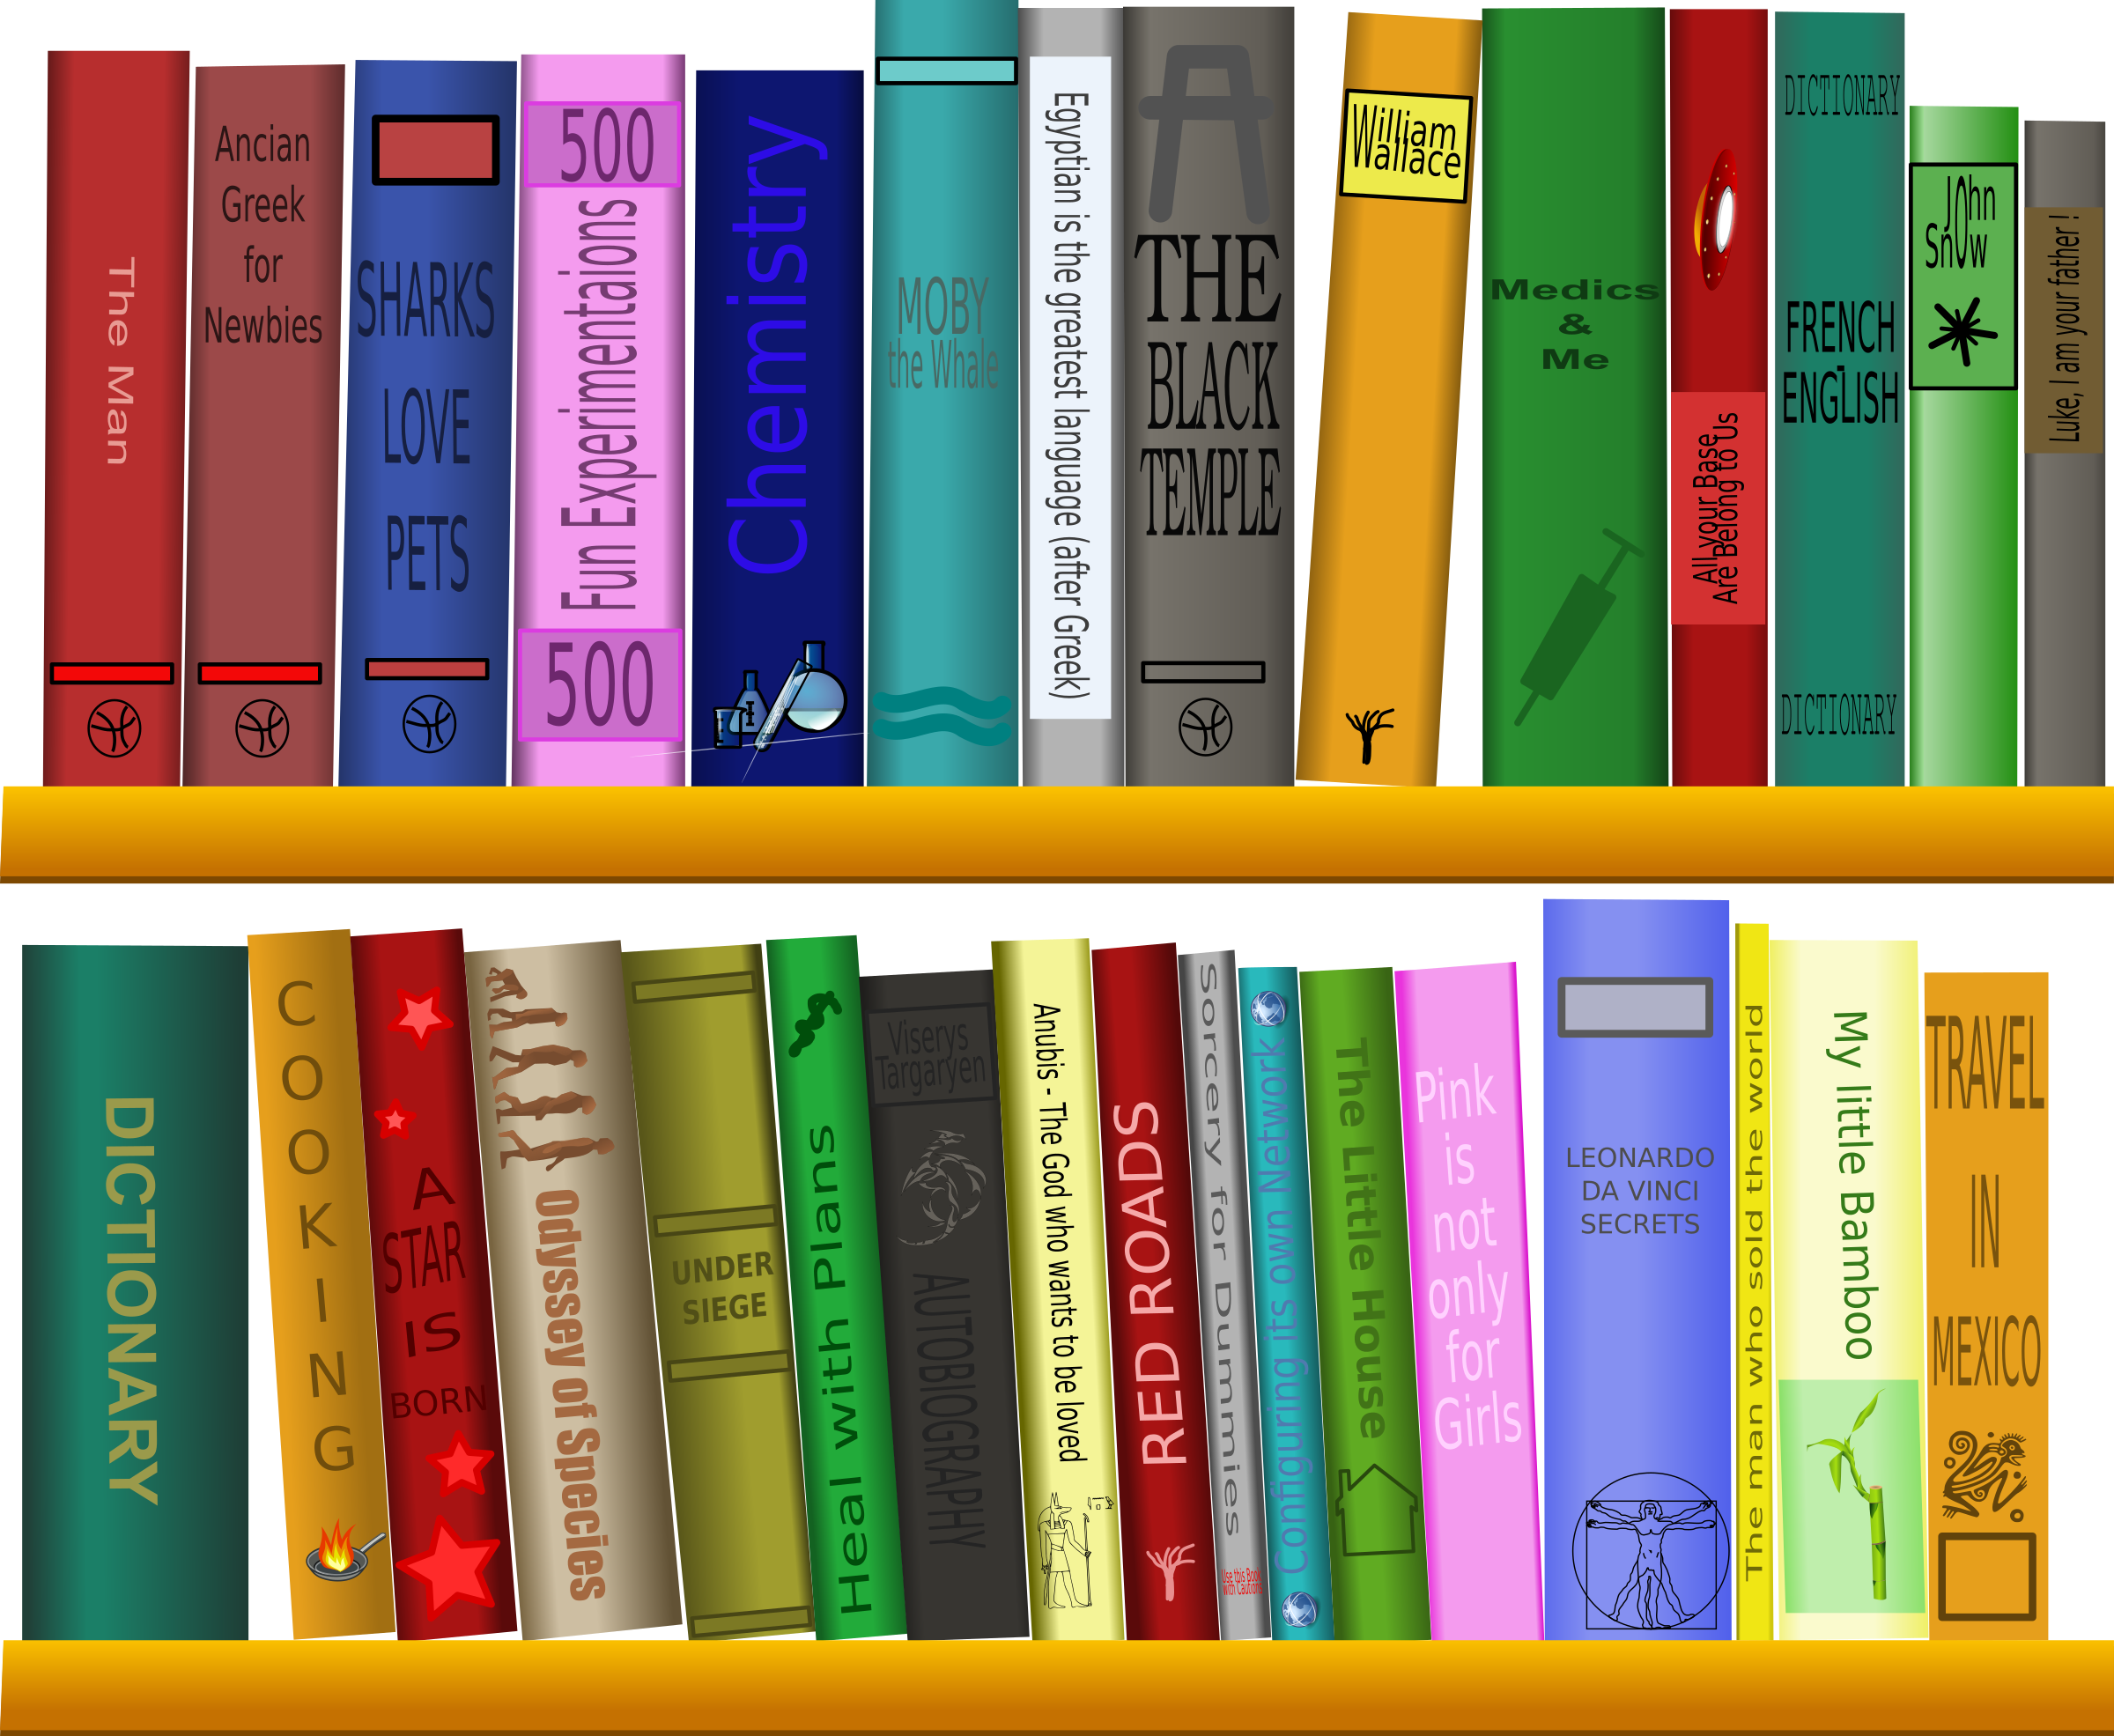

Library - Bibliothèque by cyberscooty found at https://openclipart.org/detail/171438/library-bibliotha%C2%A8que and is licensed under Creative Commons (CC0 by 1.0) Public Domain https://creativecommons.org/publicdomain/zero/1.0/

Directions: Create a system of storing library books with two hash numbers each, one for the author name and one for the title. Note that collisions are possible since the same author has likely written more than one book. Likewise it is possible for two authors to have a book of the same title.

The goal is to create a set of two numbers for each book that will allow the user to look up quickly to see if a given book (author and title strings) is stored in the library or not.

Here is an example:

The book ("David Copperfield", "Charles Dickens") might translate to:

(3423490, 2349008)

You then store these numbers in a database. If someone is looking for
("David Copperfield", "Charles Dickens"), you would search your database and quickly determine that the book is present.

Look up on the internet to try to find a good way to hash Strings.

In order to receive full credit for this assignment, you must first create an encryption algorithm for the author and titles, then store the names of 15 books.

This is assignment is from https://csab373.appspot.com/first/unit?unit=14&lesson=51 which has the following license: https://creativecommons.org/licenses/by-nc-sa/4.0/.

