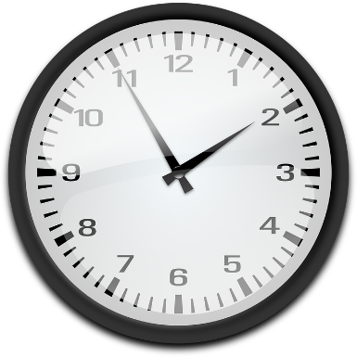
Minutes and Hours

In this program, the goal is to convert an input of minutes to days, hours and/or minutes.

Remember:
- minutes can never be greater than 59.

Image source: Clock by OpenClipart-Vectors/27454 and is available at https://pixabay.com/en/clock-analog-time-watch-147257/ and is licensed under Creative Commons (CC0 by 1.0) Public Domain https://creativecommons.org/publicdomain/zero/1.0/

Here is an example:
If the minutes is 145, the printout should be 2 hours and 25 minutes or something similar.

Statements Required: decision making, keyboard input
Sample Output:
Input: 336
Output: 5 hours 36 minutes

Input: 1500
Output: 1 day 1 hours 0 minutes

Input: 2433
Output: 1 day 16 hours 33 minutes

Input: 6789
Output: 4 days 17 hours 9 minutes

