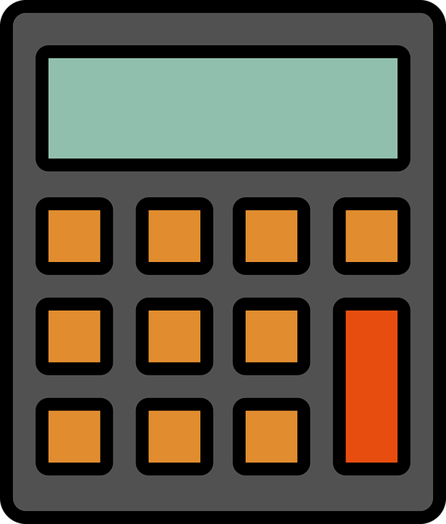

Cost of Items

Program Description: Below you have the cost of a set of items. Find the total cost and average cost the items in the file. The last number in the data will be zero and should not be processed. Print the costs in a column as they are read in. Print the total cost, number of items, and average cost using appropriate output prompt labels.

This program requires reading an external file. First you must download the data file to the same subdirectory where your program (.java file) is located.

Statements required: file input, properly formatted output, efficient use of loop control (use a while loop), correctly formatted output

Data location: M6L1.in

Sample output:

Item Costs
$14.99
$39.99
$69.95
$74.95
$59.95
$49.95
$75.50
$14.50
$29.95
$29.95

The sum of the cost= $450.23
The number of costs = 10
The average cost = $45.02

