CSCT Masters Project
Similarity Mapping on Symbolic Music

Daniel Sean Brown
24043720
Word Count: 5940
Abstract:
This project aimed to produce a track similarity tool with which a user could visualise and explore song similarity. This was done with, and as such is limited to, the Lakh MIDI dataset where musical features were extracted from each track and then combined into a vector representation. Feature weightings were explored and the most ideal one was selected by evaluating against hand annotated similarity song triplets. Properly weighted embeddings were indexed using FAISS to enable efficient similarity search with cosine similarity used for scoring. The index can be navigated using the produced tool which gives the option to explore track neighbourhoods, use custom weights and find the shortest path between any two songs. All of these options were provided with both text and graph visualisations. The project gave insight into which feature groups were the most useful in mapping similarity across the MIDI dataset as well as produce a tool which to current knowledge has not yet been publicly available.

Table of Contents
I. Introduction 1
A. Context 1
B. Rationale 1
1) Research 1
2) Recommender Systems 1
C. Problem Statement 1
D. Project Scope 1
1) In Scope 1
2) Out of Scope 1
E. Aims and Objectives 1
F. Report Structure 2
1) Introduction 2
2) Reaserch 2
3) Proposed Soloution 2
4) Soloution Evaluation 2
5) Conclusion 2
6) Appendix 2
II. Reaserch 2
A. Literature Review 2
B. User Needs 3
III. Proposed Solution 3
A. Proposed Artefact 3
B. Evaluation 3
C. Methodology 3
1) MIDI and Metadata Downloading 3
2) Feature Processing 3
3) Vector Embedding 5
4) Feature Group Weighting and Evaluation 6
5) FAISS Index 8
6) Music Explorer 8
7) Backend 8
8) Frontend 8
D. Ethical Considerations 11
IV. Soloution Evaluation 11
A. Discussion of the Extent to which the aims and objectives have been met 11
B. Discussion of the Extent to which the problem addressed has been solved 11
C. Soloution Limitations 11
V. Conclusion 11
A. Summary of Project and Results 11
B. Future Work 11
VI. Appendix 12
A. On AI use 12
B. Record of meetings with supervisor 12
C. Ethical Approval Form 12
D. Bibliography 13

Introduction

Context
This project sits in the field of MIR (Music Information Retrieval), an area of research which focuses on extracting information from and analysing musical data (Downey, 2003). Within this field, multiple published works have focused on mapping similarities between genres (Corrêa, 2016), artists (Georges and Nguyen, 2019) and tracks. And although publicly available tools exist for exploring the first two (Crauwels, 2022; McDonald, 2014), the latter has comparatively few where tracks can be quantitatively compared. Though Pampalk et al. (2002) had produced a system for mapping musical similarity for raw audio, their system: cannot handle MIDI, is unavailable and gives no quantitative insight into track-by-track similarity. This project is concerned with producing a tool that can bridge this gap.

A publicly available audio repository specifically for MIR research utilised for this project is the Lakh MIDI dataset (Raffel, 2016) which provides a large body of songs represented in MIDI format with metadata from the MSD (Million Song Dataset) (Bertin-Mahieux, 2011). This gives a substantial body of data that can be used as the foundation for a track similarity tool.

On MIDI (Musical Instrument Digital Interface), this is a method of storing music where a file contains digital instructions rather than audio recordings (The MIDI Association, 2016). These files are typically much smaller, easier and faster to process than their recorded audio file counterparts.

As such, this sets up the project for working with a satisfactory amount of data, in a format that lends itself well for producing a similarity mapping on a single song scale.

Rationale
There are two main applications for a tool like this:

Research
A similarity mapping tool could be used to aid further research. There is substantial interest in the computational representations of music, evidenced by the existence of MIR as a field, and a tool like this could be utilised to help explore a variety of research directions. From how different musical features contribute to a sense of similarity to perhaps how genres are defined by their quantitative musical makeup. Regardless, this tool could help lay ground for substantial future work.

Recommender Systems
There can be huge commercial value in recommender systems (Downie, 2003) and indeed companies like Spotify or YouTube use them to drive user engagement (Covington, 2016; Spotify Engineering, 2020). As an asset, these systems are private and unavailable for personal use.

A publicly available system could be used by individuals who want more control over their music discovery, which a more commercial system may not offer. Moreover, any individual or entity is then also welcome to build off the system and make use of it the way private enterprises do.

Problem Statement
The problem, or rather gap, this project aims to address is the lack of a musical exploration tool focusing on specifically on track similarity.

Project Scope

In Scope
- The production of a song exploration tool with quantitative signals on similarity and interactive elements aiding the discovery of similar tracks.
- A method for the extraction of musical features from MIDI for representing a track in a similarity space.
- Evaluation of similarity metrics to give credence to the tool’s validity.
- A feature weighting option for optimising similarity scoring as well as giving the user the option to explore similarity by their own custom agenda.

Out of Scope
- Perform track similarity mapping on raw audio data. This project is limited to MIDI.
- Perform track similarity mapping using lyrics. The project is aimed at mapping musical similarity.
- Performing user surveys to gauge an idea of similarity. Unfortunately it is outside the time and budget constraints of this project to perform this in a way that would generate meaningful data.
- Draw conclusions on which features drive musical similarity. Thouh the tool can be used for this and through the process of development an idea of this may start to form, this direction will not be explored in depth.

Aims and Objectives
In broad strokes, the aims of this project can be listed in two points:
- Produce a model which can accurately measure the musical similarities between two songs.

- Using the output of the model, produce a map which showcases these similarities in a quantitative and explorable way.

On aim 1 please see below for more granular objectives. For aim 2, the same expansion into required objectives can be seen under User Needs as those goals are more relevant to that section.
  - A method needs to be devised/selected for scoring similarity between songs.
    - The method needs to be assessed for accuracy with proof of performance.
    - The method is ideally time feasible for a large dataset.
  - A retrieval system needs to be devised/selected for finding the closest K neighbours of any given track.

Report Structure

Introduction
This section introduces the project with its surrounding context and presents its goals.

Reaserch
This section contains the literature review part of the report where surrounding and supporting literature is discussed in aid of the work. User needs are also discussed here.

Proposed Soloution
This section outlines the method used to achieve the goals listed in the introduction chapter. The tools development and method of operation are documented. It also includes evaluation performed on the tool’s similarity metrics, as well as a short section on the ethical implications of the project and methods used.

Soloution Evaluation
This section contains evaluation against project aims, objectives and the problem statement. Solution limitations are also discussed here.

Conclusion
This section contains a summary of the project and results as well as discussion on future work.

Appendix
The appendix holds the project supporting sections. These include the bibliography, a declaration on the use of AI, ethical approval form and a record of supervisor meetings.

Reaserch

Literature Review
Immediate issues around the project arise from attempting to define musical similarity. Though most of us may have an innate idea of how two songs may feel similar, translating this to quantitative musical features can be challenging. Especially when there are no pre-existing ground truths to refer to beyond metadata like artist or genre where a grouping is likely to be similar. As such, initial research was focused here.

Returning to a similar project, the method used by Pampalk et al. (2002) is a good example of track level visualisation. However, their approach relied on psychoacoustic models, which made use of acoustic signals from MP3 files. This method unfortunately cannot be directly applied to MIDI.

More applicable existing literature focuses on extracting musical features in relatively similar categories with Downie (2003) arguing that music similarity can be captured through 7 categories: pitch, temporal, harmonic, timbral, editorial, textual and bibliographic.

In a more recent papers, similar feature groupings were highlighted under rhythm, melody, chroma, pitch and harmony (Deldjoo, 2024; Corrêa, 2016). Specific variations exist where Deldjoo (2024) argued for the use of an onion model with multiple support layers including user generated content such as reviews and professionally produced annotations.

In the context of this project, bibliographic and textual are not applicable as metadata and lyrics will not be used for similarity. Also on timbre, though this is captured well by raw audio files, it is not directly encoded in MIDI. However, other features can be extracted from MIDI with relative ease, as demonstrated by Corrêa (2016).

On methods of similarity comparisons, Lijffijt et al. (2010) had demonstrated the efficacy of using DTW (Dynamic Time Warping) whilst Raffel (2016) did the same with neural networks. Though DTW would provide a way to overcome the issue of no ground truth, since the algorithm is designed to produce an innate similarity score, at O(n²) it is too computationally expensive to perform on a large, effectively k-complete dataset (Keogh and Ratanamahatana 2005). Conversely, neural networks would require substantial ground truth with the dataset also likely not large enough for meaningful training.

A perhaps more realistic approach is explained in Manning et al. (2008). Here cosine similarity is used for comparison in a unit vector space. With track features converted to vectors and normalised, cosine similarity could be used as a self-evident similarity score like DTW while also being computationally cheap.

As the size of the dataset and dimensionality of similarity features are both substantial, exhaustive comparison to retrieve a similarity mapping becomes computationally expensive. Moreover, the curse of dimensionality can cause point distances to become meaningless (Weber et al., 1998). As such ANN (Approximate Nearest Neighbour) methods were researched to use as an efficient yet accurate method of retrieval.

The three techniques considered were FAISS (Facebook AI Similarity Search), ANNOY (Approximate Nearest Neighbour Oh Yeah) and HNSW (Hierarchical Small Worlds).

They perform ANN with varying approaches where FAISS uses cluster centroids to compare vector embeddings (Douze et al., 2024), whilst ANNOY (Bernhardsson, n.d.) constructs indexes using forests and HNSW functions using hierarchical graphs. Though Aumüller et al. (2020) concludes HNSW (Malkov et al., 2018) can perform the best, this is dependent on dataset and a high recall count. Moreover, performance was still comparable across the three techniques and FAISS outperformed on a low recall count. The use of vector embeddings may lend itself best to this project’s context.

User Needs
As observed from a review of similar tools (Crauwels, 2022; McDonald, 2014) and also identified gap, user needs are set out below:

The tool needs to provide the following functions:

  - Query the nearest neighbourhood of any song in the dataset.
    - Be able to amend the number of neighbours displayed.
    - Visualise the neighbourhood as a graph with labelled edges.
    - Give the option to select any neighbour to observe their neighbourhood, thus giving any easy and smooth exploration experience.
  - Query the shortest path between any two songs in the dataset.
    - Visualise the path as a graph.
  - Be able to customise the perspective of similarity. That is, the user should be able select by which metrics similarity is being mapped.

- The tool needs to be easy to navigate and straightforward to use.
  - The tool should have an obvious flow, with actions and buttons being self-explanatory.
  - The tool should include a user guide.

Proposed Solution

Proposed Artefact
To overcome the identified gap and meet the identified user needs, a track similarity exploration tool is proposed with the features as identified under User Needs. Evidence and discussion of how this meets project aims can be seen under methodology. For accessing the tool, please see my GitHub page: DanielSeanBrown/music-representation-learning.

Evaluation
It had been identified first at the project’s proposal, and then again with my supervisor, that evaluating the accuracy of the produced similarity mapping might prove tricky with no true, pre-existing similarity marker to evaluate against. A variety of methods had been discussed and considered. These included ideas such as:

- Scoring how (un)expected the results of random walks were on the mapping.
- Using agentic AI as a source of low cost, high-speed feedback on similarity results. This then working as a proxy for surveying a large volume of participants music taste.

However, a simpler method was ultimately chosen. I hand annotated the first 360 songs into truth triplets to produce an evaluation table. Here each row has a root song, an expected closer neighbour and an expected further neighbour. Then on any mapping it can be checked if this convention holds with roughly 100 rows to evaluate against.

This method was chosen for its relative ease and control over capturing the feal of similarity. Only triplets where an obvious and immediate closer/further pairing is present was selected, meaning edge cases were ignored. This aimed to minimise the truth table containing any personal taste in similarity by selecting “undeniable” triplets. This method was also favoured for somewhat capturing the elusive idea of two songs feeling similar.

However, it does have its limitations. At 100 rows, the table is admittedly limited compared to the total 27,579. This is because of the slow and laborious nature of hand annotation and perhaps this would be an area for improvement with more time allowed in the future. A more comprehensive evaluation system, as well as a more gamified user orientated one, is talked about under the future work section.

Methodology
The structure and flow of the entire artefact is outlined below with explanations of the tools and techniques used as well as the rationale for choices made.

MIDI and Metadata Downloading
The Lakh MIDI Dataset consists of 176,581 MIDI files where 45,129 are matched to metadata from the Million Song Dataset. Links are provided on the webpage for downloading the MIDI files and metadata as separate zip files. A script was written to perform this. On unzipping, it can be observed that track ID’s in the h5 metadata files point to respective MIDI files locations so for example:

Track “TRAAJSX128F4275A1D” is located at
“midi_files/A/A/J/TRAAJSX128F4275A1D/”

As such, a metadata index was produced to navigate and pair up MIDI files with their respective titles. It was also discovered at this stage that although the matched subset of the Lakh dataset has 45,129 MIDI files, some songs have more than one MIDI representation meaning that the number of unique songs represented here is fewer at 31,034.

Feature Processing
Next files were processed to produce tabular features by which similarity could be scored for each respective track. Features were extracted along 6 categories identified from the literature review. These were selected to best capture track similarity from multiple approaches.

Basic Descriptive:
These features hold descriptive statistics about each track. They are not expected to be the most decisive on mapping similarity, but their assistance could be useful and certainly can help differentiate between dense and sparse songs.

Chroma:
These features relate to the distribution of notes across the 12 pitch classes of the Western chromatic scale (Krumhansl, 1990). They contain 7 features for low, mid, high and total with each as 12-dimensional normalised vectors and 3 features relating to the tracks key. The idea behind these is to capture harmonic content and similarity.

Entropy:
These features aim to capture the degree of randomness or rather repetition within a song. The idea here is that some genres might score higher such as Jazz where pitch use might be more diverse and distributed than in a genre which tends to have more repetition like Trance or Techno.

Melody:
These features aim to describe the tracks melodic content. This done by taking note pitches pre-processed into low, middle, high and “melody” ranges and then producing interval lists as well as 3-word n-grams. With this common repeating melodic lines and pitch patterns can be captured across multiple ranges of the track.

Rhythm:
These features aim to capture a tracks rhythm. With these slow and fast tracks can be easily distinguished as well as allow distinguishing syncopated rhythms. This done using inter onset interval histograms and density measure for total, notes, bass, melody and drums.

Structure:
Finally, the structure feature group aimed to capture more overarching aspects of songs that can pick up on how similarly tracks are put together. Whilst a classical piece might have multiple parts, a pop song might be more verse-chorus dominated. This is done by separating tracks into segments and measuring change across these.

With this it was believed that song similarity could be approached with depth safe redundancy on some features if they proved to be not useful.

It is also noted here that on feature extraction was discovered some songs are duplicated in the dataset. After a second cleaning, the number of songs is at 27,579.

For a completeness, an overview of all the extracted features is provided below. This is an exact copy of the feature dictionary put together for the project GitHub repository and as such it is also available there.

Feature Name | Description | Data Type | Category
note_count | Total number of notes in the song. | int64 | Basic Descriptive
mean_pitch | Mean pitch of the notes in the song. | float64 | Basic Descriptive
std_pitch | Standard deviation of the pitches in the song. | float64 | Basic Descriptive
pitch_range | Range of pitches (max - min) in the song. | int64 | Basic Descriptive
mean_duration | Mean duration of the notes in the song. | float64 | Basic Descriptive
std_duration | Standard deviation of the durations in the song. | float64 | Basic Descriptive
mean_velocity | Mean velocity of the notes in the song. | float64 | Basic Descriptive
std_velocity | Standard deviation of the velocities in the song. | float64 | Basic Descriptive
num_files | Number of files in the song. | int64 | Basic Descriptive
mean_instruments | Mean number of instruments used across the files in the song. | float64 | Basic Descriptive
low_chroma | 12D normalised chroma vector for low pitches | list | Chroma
mid_chroma | 12D normalised chroma vector for mid pitches | list | Chroma
high_chroma | 12D normalised chroma vector for high pitches | list | Chroma
total_chroma | 12D normalised chroma vector for all pitches | list | Chroma
key | Estimated key of the song using a simple Krumhansl-Schmuckler-style correlation method (Krumhansl, 1990) | string | Chroma
key_distance | Cyclical encoding of the key | list | Chroma
key_strength | Strength of the estimated key (correlation score) | float | Chroma
pitch_entropy | Shannon entropy of the pitch distribution (histogram) | float | Entropy
duration_entropy | Shannon entropy of the duration distribution (histogram) | float | Entropy
ioi_entropy | Shannon entropy of the inter-onset interval distribution (histogram) | float | Entropy
melody_intervals | Intervals of the melody | list | Melody
melody_ngrams | N-grams of the melody intervals | dict | Melody
low_intervals | Intervals of the low part | list | Melody
low_ngrams | N-grams of the low part | dict | Melody
mid_intervals | Intervals of the mid part | list | Melody
mid_ngrams | N-grams of the mid part | dict | Melody
high_intervals | Intervals of the high part | list | Melody
high_ngrams | N-grams of the high part | dict | Melody
ioi_hist | Histogram of inter-onset intervals | list | Rhythm
duration_hist | Histogram of note durations | list | Rhythm
drum_ioi_hist | Histogram of drum inter-onset intervals | list | Rhythm
bass_ioi_hist | Histogram of bass inter-onset intervals | list | Rhythm
melody_ioi_hist | Histogram of melody inter-onset intervals | list | Rhythm
density | Density of notes per unit time | float | Rhythm
drum_density | Density of drum notes per unit time | float | Rhythm
bass_density | Density of bass notes per unit time | float | Rhythm
melody_density | Density of melody notes per unit time | float | Rhythm
segment_chroma | Chroma vectors for each segment | list | Structure
chord_progression | Most prominent pitch class in each segment | list | Structure
harmonic_rhythm | Proportion of segments where the chord root changes | float | Structure
segment_variation | Average variation between consecutive segments | float | Structure
Table. 1 Dictionary of Features Extracted from MIDI Files

Vector Embedding
Following this, the feature set was transformed into vector embeddings on a group-by-group basis giving control to not let features with high dimensionality dominate smaller ones.

This was relatively straightforward for scaler features and arrays. In the case of n-grams however, a vocabulary was produced to track every possible n-gram. Then their index could be used to produce a fixed-length vector where each dimension counted the occurrences of the specific n-gram respective to that index.

Once each song could be represented as a single, scaled vector, feature grouping weights were applied. At this stage these were a default multiplication by 1.0.

Finally, resulting vectors were L2-normalised. This is important because it meant all song vectors were now unit vectors, meaning their position in the resultant vector space was influenced by direction rather than magnitude. This also made using cosine similarity easier since:

Cosine similarity for two vectors x and y can be calculated as:
$$\text{cosine similarity}\left(x,y\right)=\frac{x⋅y}{\left\|x\right\|\left\|y\right\|}$$

But because song vectors were normalised as:
$$\overset{ˆ}{x}=\frac{x}{\left\|x\right\|}$$

Where:
$$\left\|x\right\|=\sqrt{x_{1}^{2}+x_{2}^{2}+…+x_{n}^{2}}$$

Then:
$$\overset{ˆ}{x}=\frac{x}{\left\|x\right\|}⟹\left\|\overset{ˆ}{x}\right\|=1$$
Means:
$$\begin{aligned}\text{cosine similarity}\left(\overset{ˆ}{x},\overset{ˆ}{y}\right)&=\frac{\overset{ˆ}{x}⋅\overset{ˆ}{y}}{1×1} \\ &=\overset{ˆ}{x}⋅\overset{ˆ}{y}\end{aligned}$$

Therefore it is enough to take the dot product between any two songs to get an immediate similarity score.

Feature Group Weighting and Evaluation
In the previous section it was mentioned that feature groupings were multiplied by 1.0. This was done as a placeholder action to produce an unweighted embedding space before selecting optimal weights to account for not all feature groupings being equally useful and to potentially compensate for some feature groupings having a larger dimension count.

To produce these weights, 20,000 weight configurations were sampled using uniform random distribution between 0 and 5 and a further 19,683 were produced from performing a grid search over the weight options (0, 2.5, 5). For understanding these weights, if two groupings are weighted at 0.1 and 5 then one is 50 times more impactful on similarity comparison.

The unnormalised vector space was then weighted with the respective configuration, normalised and then scored with cosine similarity (dot product) against my hand annotated truth table. The performance metrics on accuracy and margin of decision were extracted and recorded. The results of these simulations were discussed in depth in the “weighting_evaluation.ipynb” notebook. The figures below are from there. As the focus on the project was more on the development of the tool rather than uncovering the exactly how features drive musical similarity, analysis of the results here in the report are short. I recommend looking over the notebook for more detailed analysis and this is another area left open for future work (with the hope and intention that the tool may be used for this).

An initial boxplot of results showed accuracy scores cluster around 0.6 with standout results above 0.7. But perhaps more interestingly, some configurations scored under 0.5 indicating a worse performance than random guessing. (Though this could just be limited because of the 100 truth points for evaluation). This indicated that good and bad weight configurations do exist, with very few even being counterproductive. Also, scores around 0.7 gave confidence in good performance whilst likely not overfitting.
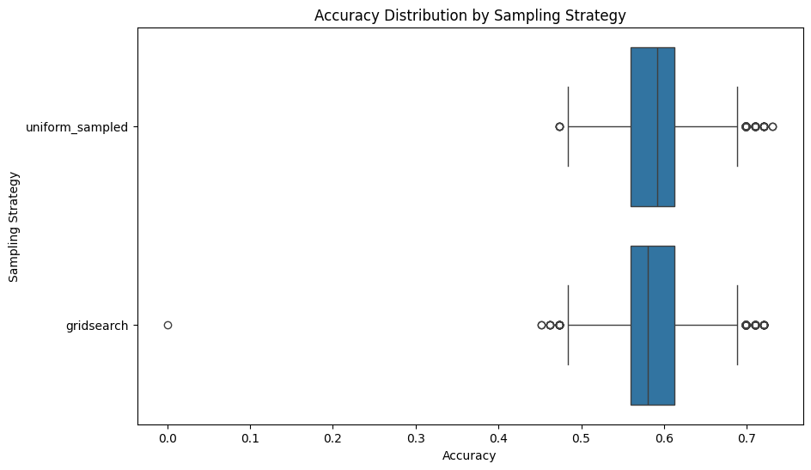

Fig. 1 Boxplot of Accuracy Scores for The Two Methods of Weight Simulation

The correlation plot below showed a few things. As expected, weights have no correlation with each other due to being artificially produced. But more importantly, melody and structure weights had a negative correlation with accuracy whilst the other register n-grams correlated well with the high register having the best at 0.5. This gave valuable insight into which features might be the best for capturing similarity.

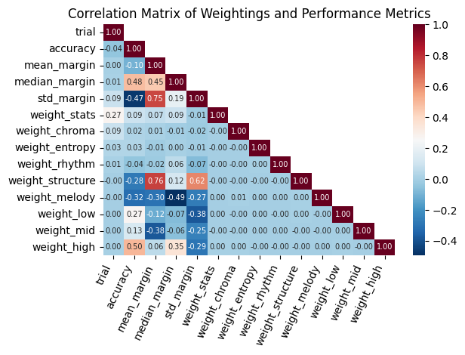
Fig. 2 Correlation Matrix for Features in Weight Simulation Results

Then analysis was shifted to the best performing configurations and here dispersion was calculated. Expected values for the whole population of weights is broken down below.

For range $R$ and standard deviation $σ$, dispersion is defined as:

$$D=\frac{σ}{R}​$$

Then for random uniform distribution:

$$X∼U\left(a,b\right)$$

Standard deviation is as follows:

$$σ=\frac{b-a}{\sqrt{12}}$$

Therefore an expected dispersion value would be:

$$D=\frac{\frac{b-a}{\sqrt{12}}}{b-a}=\frac{1}{\sqrt{12}}≈0.29$$

This is important as stats (which is otherwise known as basic descriptive), chroma and entropy weights had comparable dispersion values. This indicates the value of weights for these feature groupings has not become more consistent than the original random sampling. Which in the context of their no correlation with accuracy, it would seem that these have little impact on accurately scoring similarity overall.
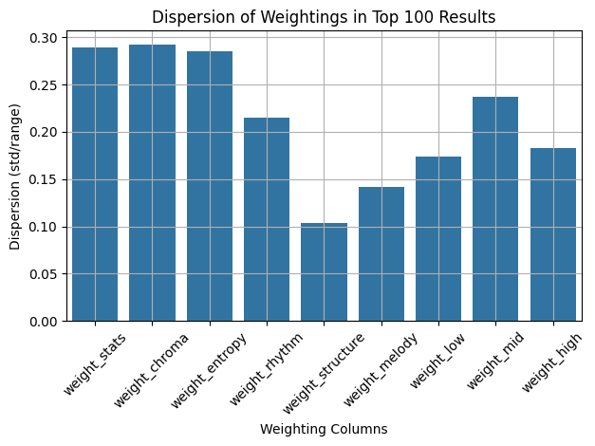
Fig. 3 Bar Graph of Dispersion Values for Top 100 Weight Configurations

The distribution of features within the top 100 was observed through histograms and again the aforementioned three features seem to have a rough uniform random distribution shape. Whilst features with low dispersion are more normally distributed and often exhibit skew with the two most important to highlight being melody and high register. These see strong skew in accordance with their respective corelations with accuracy.
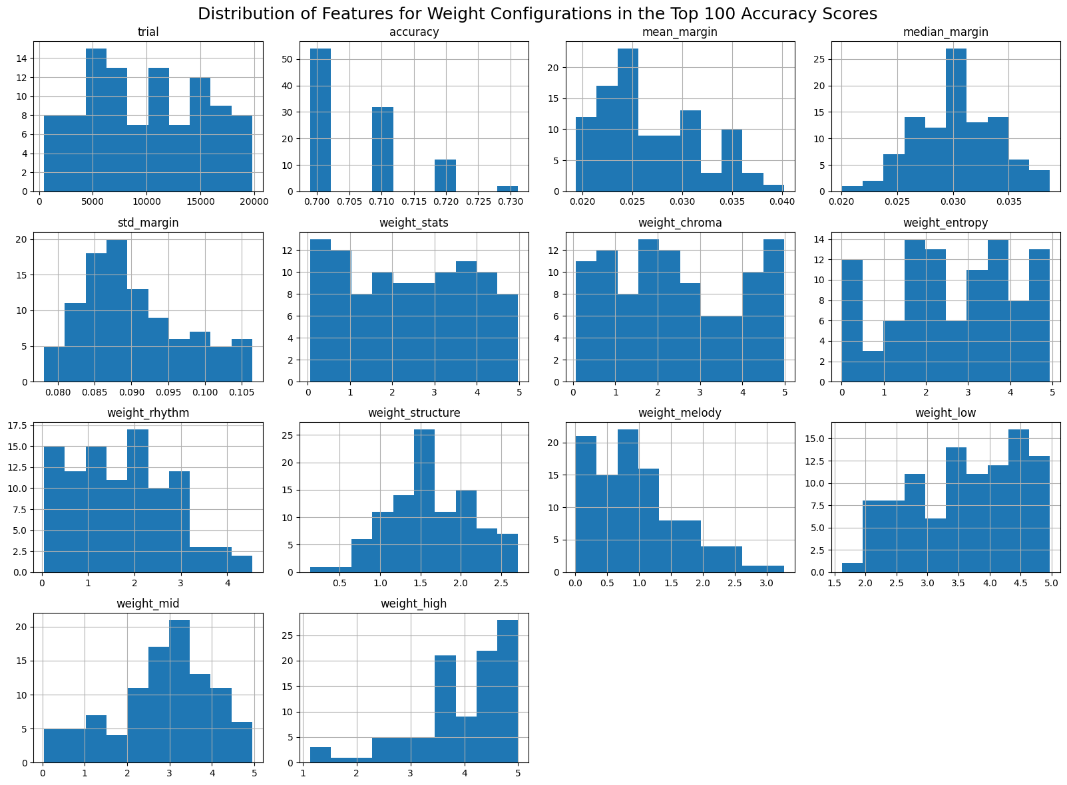
Fig. 4 Histograms of Feature Distributions for Top 100 Weight Configurations

The importance of these distributions, dispersion and correlation plots is not just to uncover relationships, and as said this is not the main focus of the project, but to become sure that a viable weight configuration was selected. The occurrence of patterns, correlations and normal distributions from original uniform random distributions is significant in that it shows the best selected weight does not perform well at random but is rather part of an explainable trend.

The bar graph below illustrates the weight values for the best selected configuration. See here the extreme lows and highs for melody and the high register features. Note also, this configuration scored 0.73.

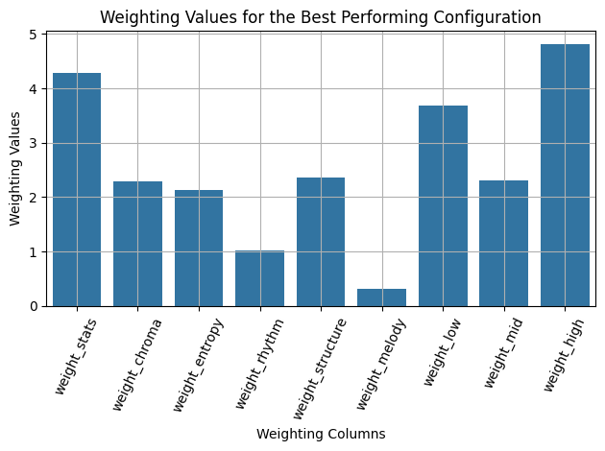
Fig. 5 Bar Graph of Best Performing Weight Configuration

Following this, it is right to question whether the features found less impactful should be excluded. The decision was made to keep them in as these scores were calculated against my ideas of similarity. One of the features of the tool is the use of custom weights. The user may choose to not just be interested in total similarity but, for example, only in how similar songs are in their entropy. In this case it is vital these features groups are not excluded.

FAISS Index
Once the optimal weights had been found, the embeddings were reproduced with these and indexed using FAISS, which was selected for use due to its advantages uncovered in the literature review.

It is important to note that at roughly 27,000 tracks, FAISS is optimised enough to make use of its direct comparison index without performance drop instead of its ANN solution. As such, accuracy does not need to be traded off for performance. However, were more tracks to be added to the tool, the switch over would only require changing one line of code. With the index constructed and tested, the mapping had been completed.

At this stage in the methodology a figure is provided below outlining the stages and steps creating the similarity mapping. Squares indicate setup scripts, required to execute only on the installation whilst ellipses indicate scripts used to operate the completed system.

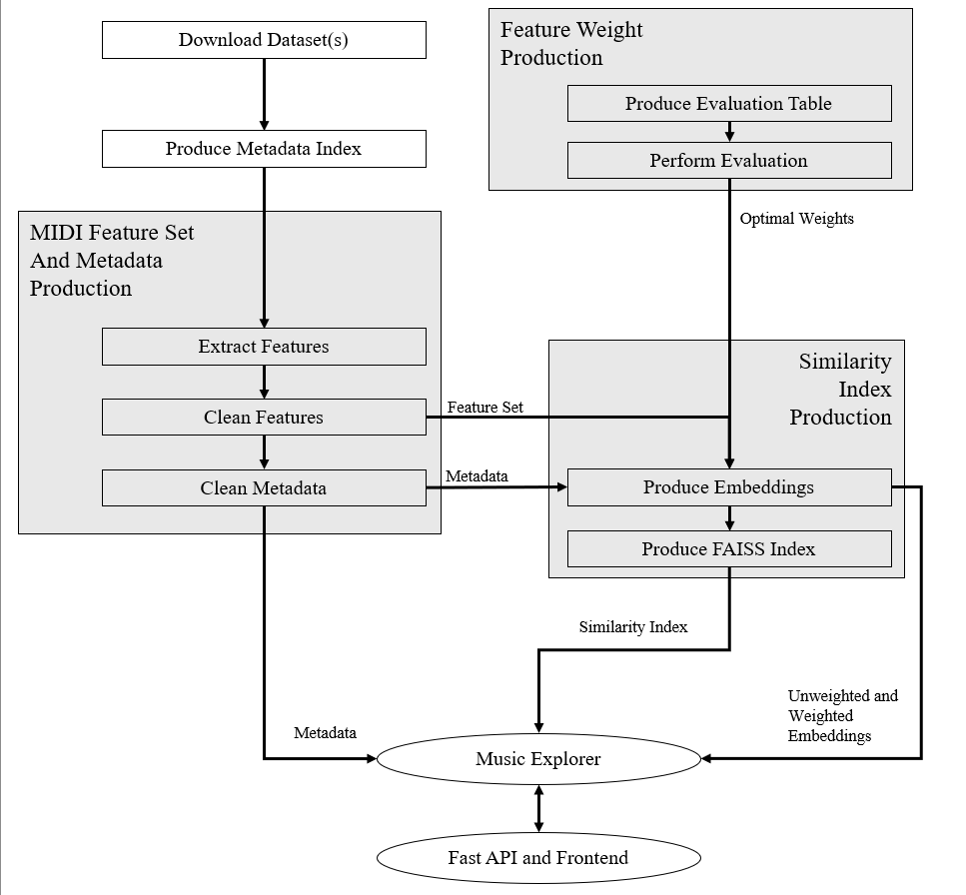
Fig. 6 Project Script Structure

Music Explorer
For performing the tasks outlined under the user needs and objectives, a class was created call Music Explorer. This class object interacts with metadata, FAISS index and embeddings to perform the following tasks:
- Neighbourhood retrieval using the similarity mapping for any track in the dataset.
- Production of a graph representing a songs similarity neighbourhood, including the neighbours’ neighbours.
- Find the shortest path between any two tracks in the dataset using Dijkstra’s algorithm (Dijkstra 1959)
- Production of a custom similarity index using user defined weights

There are other helper functions, some of which are key for interacting with the API and frontend and for making the tasks above possible. These can be observed in the project’s repository.

Backend
The FastAPI backend provides a method of communication between the user who interacts with the React frontend and the music explorer class. This is done by creating HTTP endpoints where the frontend can submit queries. These queries line up with the tasks explained above but also include searching for songs by track title or artist. FastAPI was chosen because it provides an easy and lightweight interface between python and the more web based React.

Frontend
Finally, an interactive frontend is produced using React. Unlike the rest of the project which was scripted in Python, this section was completed with JavaScript XML and CSS files. The visual display for graphs was handled using Cytoscape due to its relative ease of use and interactive capabilities. Here the user can navigate and explore all features of the tool as specified.

Extra controls are provided such as:
- Querying by tracks title or artist
- Changing the number of neighbours to display in the similarity query
- Changing the number of neighbours to consider at each step of the shortest path search.

Further exploration functionality is included by making track textual displays and nodes in graphs clickable for querying the next song’s similarity neighbourhood. As part of easing navigation, a history section is also included to help users keep track of their tool use.

A guide is also included explaining how to use the tool.

Screenshots below document these functionalities.

See below the start page of the tool with example track selection query. Here the search box for querying tracks by title or artist can be seen as well as the buttons in the top right-hand corner for opening the user guide and for switching to custom weights.

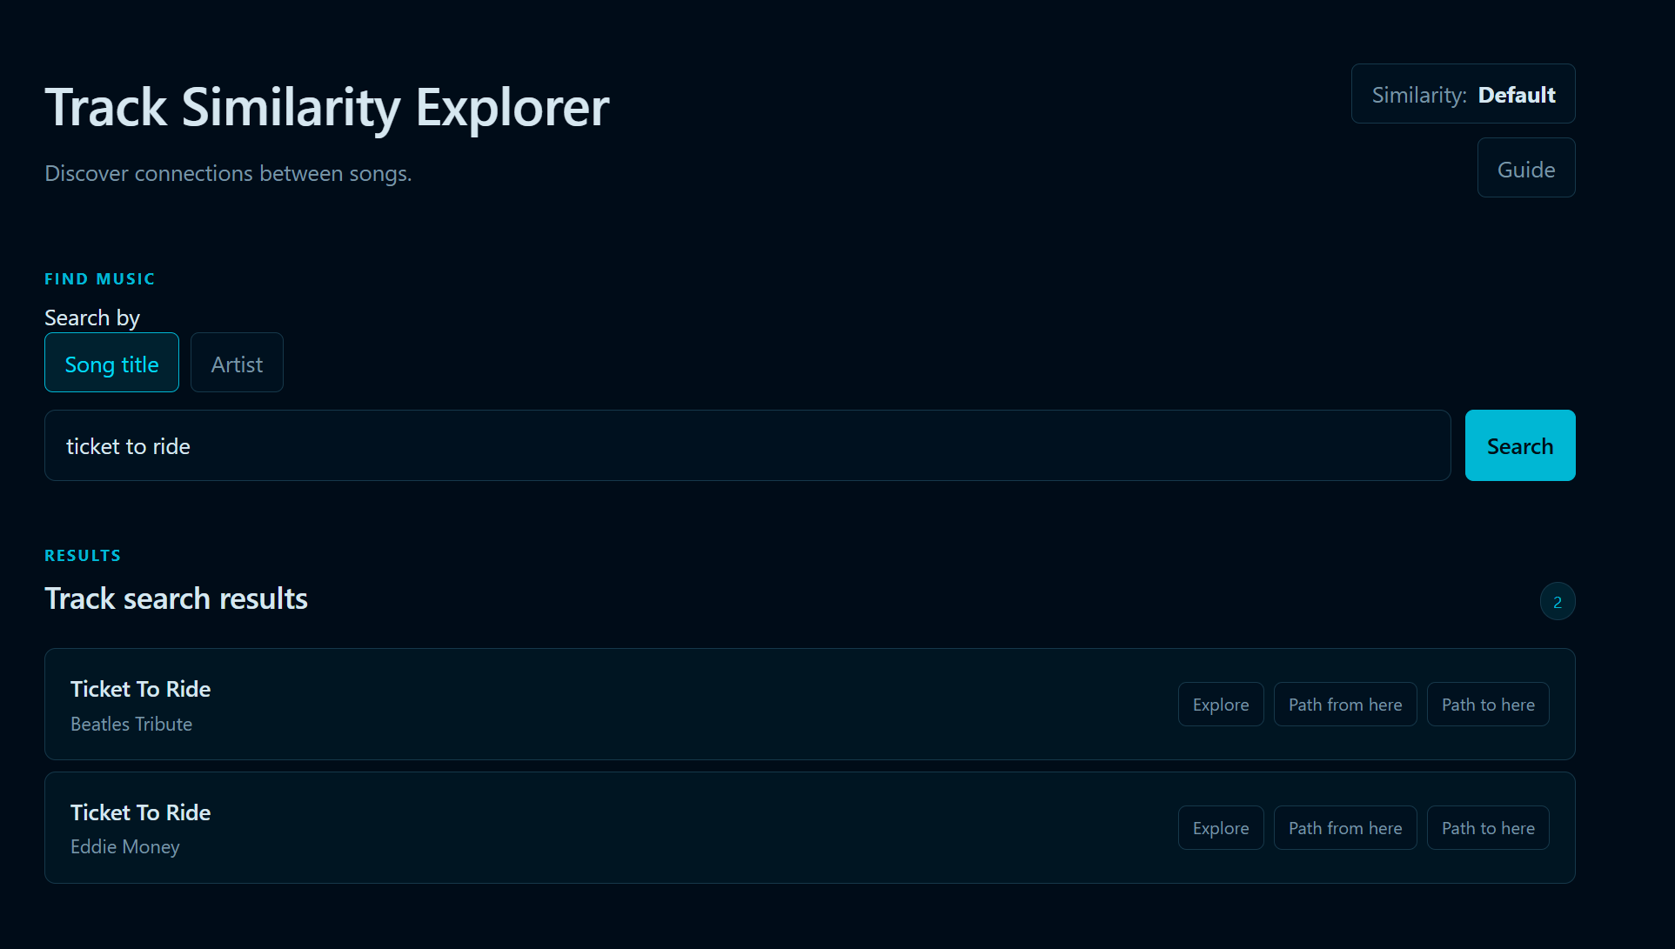
Fig. 7 Screenshot of Track Similarity Tool Home Page with Example Track Selection Query

For showcasing a neighbourhood search, the song “Ticket to Ride” is used with the default neighbour count of 5. Please see the arrangement of closest neighbours in text and row format with scores shown on the right. Buttons there also serve to explore neighbours or indeed select any track as a start or end point of a shortest path search.

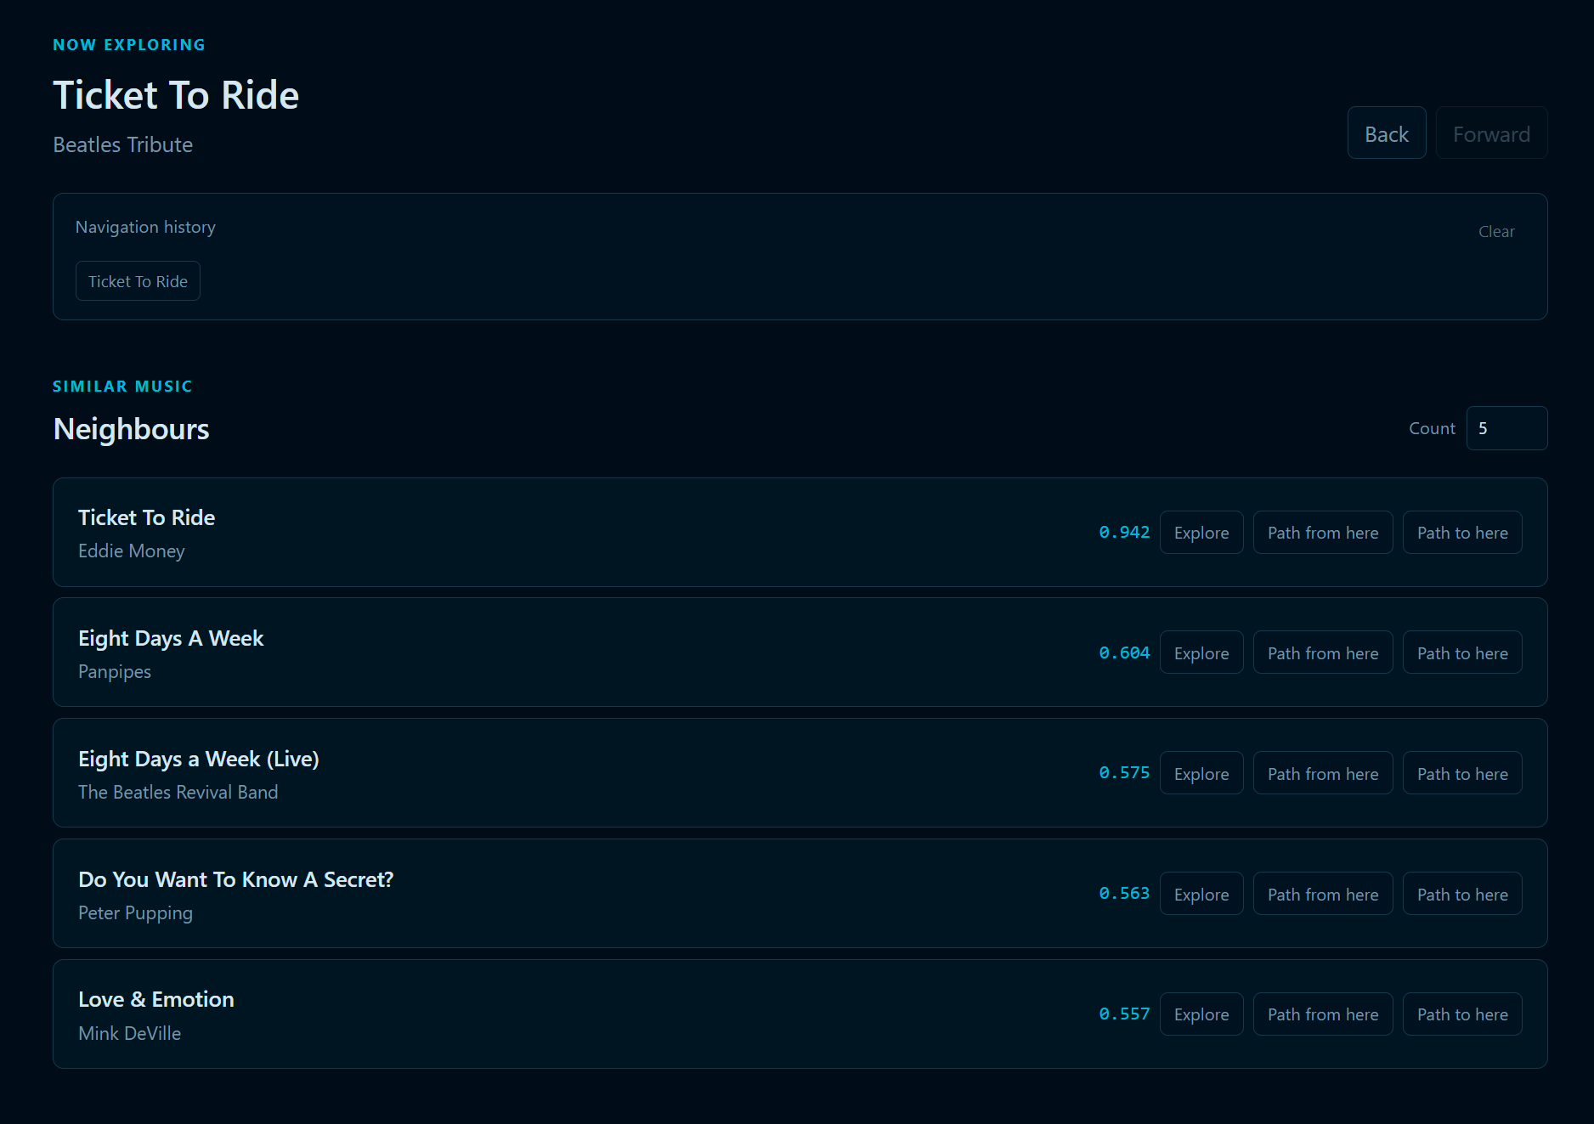
Fig. 8 Screenshot of Example Track Similarity Query

Next, if the user scrolls down, they will see the query displayed as a similarity graph with two rings of neighbours. The inner ring shows immediate neighbours while shows the neighbours’ neighbours. Here edges represent neighbour relationships and are labelled with their similarity score whilst nodes are labelled with the track and artist names.

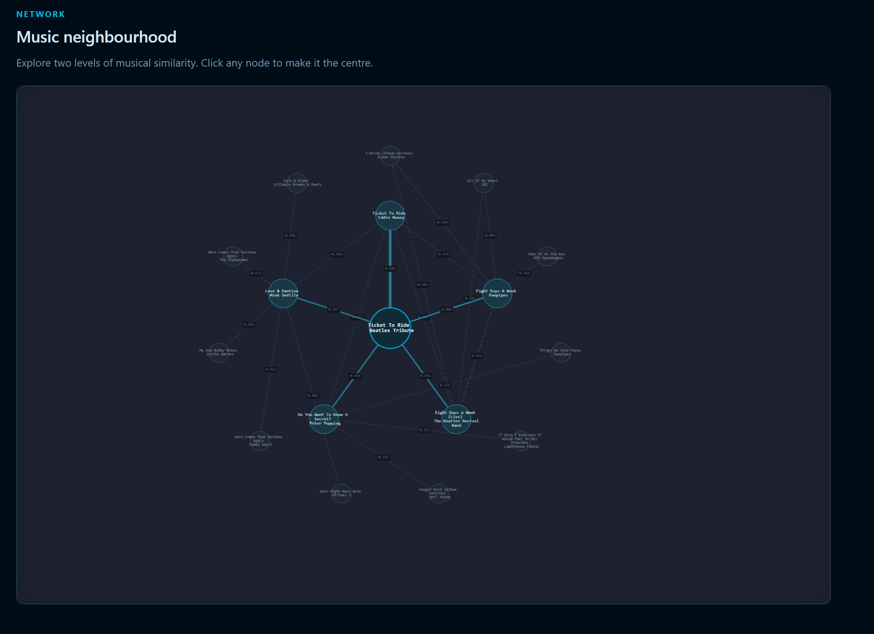
Fig. 9 Screenshot of Respective Example Query Graph Neighbourhood

A zoomed in and rearranged version is included for better visibility and to showcase how the graph can be rearranged.

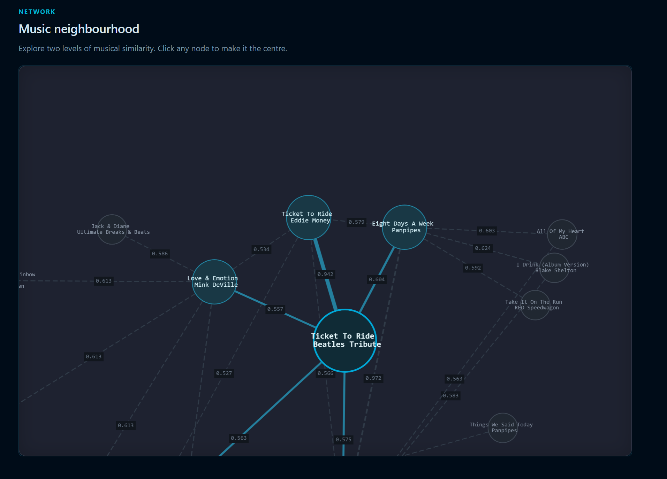
Fig. 10 Screenshot of Manipulated Graph for Better Visibility and Showcase of Graphs Interactive Capabilities

The next screenshot shows the custom similarity settings where sliders can be used to submit new feature group weightings. As an example here, rhythm and low register are weighted high with other groups reduced with the idea of exploring similarity on bass and rhythm sections of tracks.

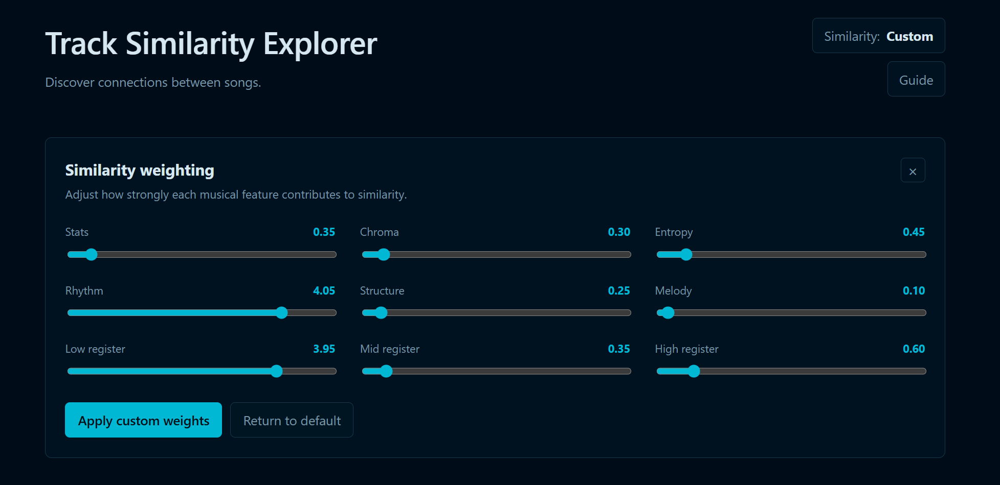
Fig. 11 Screenshot of Custom Weight Settings

And now, the same query is shown again but with the custom weightings. Notice here scores have changed, as have some of the neighbours.


Fig. 12 Screenshot Showcasing the Same Example Track Query with Custom Weightings

A shortest path query result is also showcased. I would warn here that the shortest path query can take a while to execute.

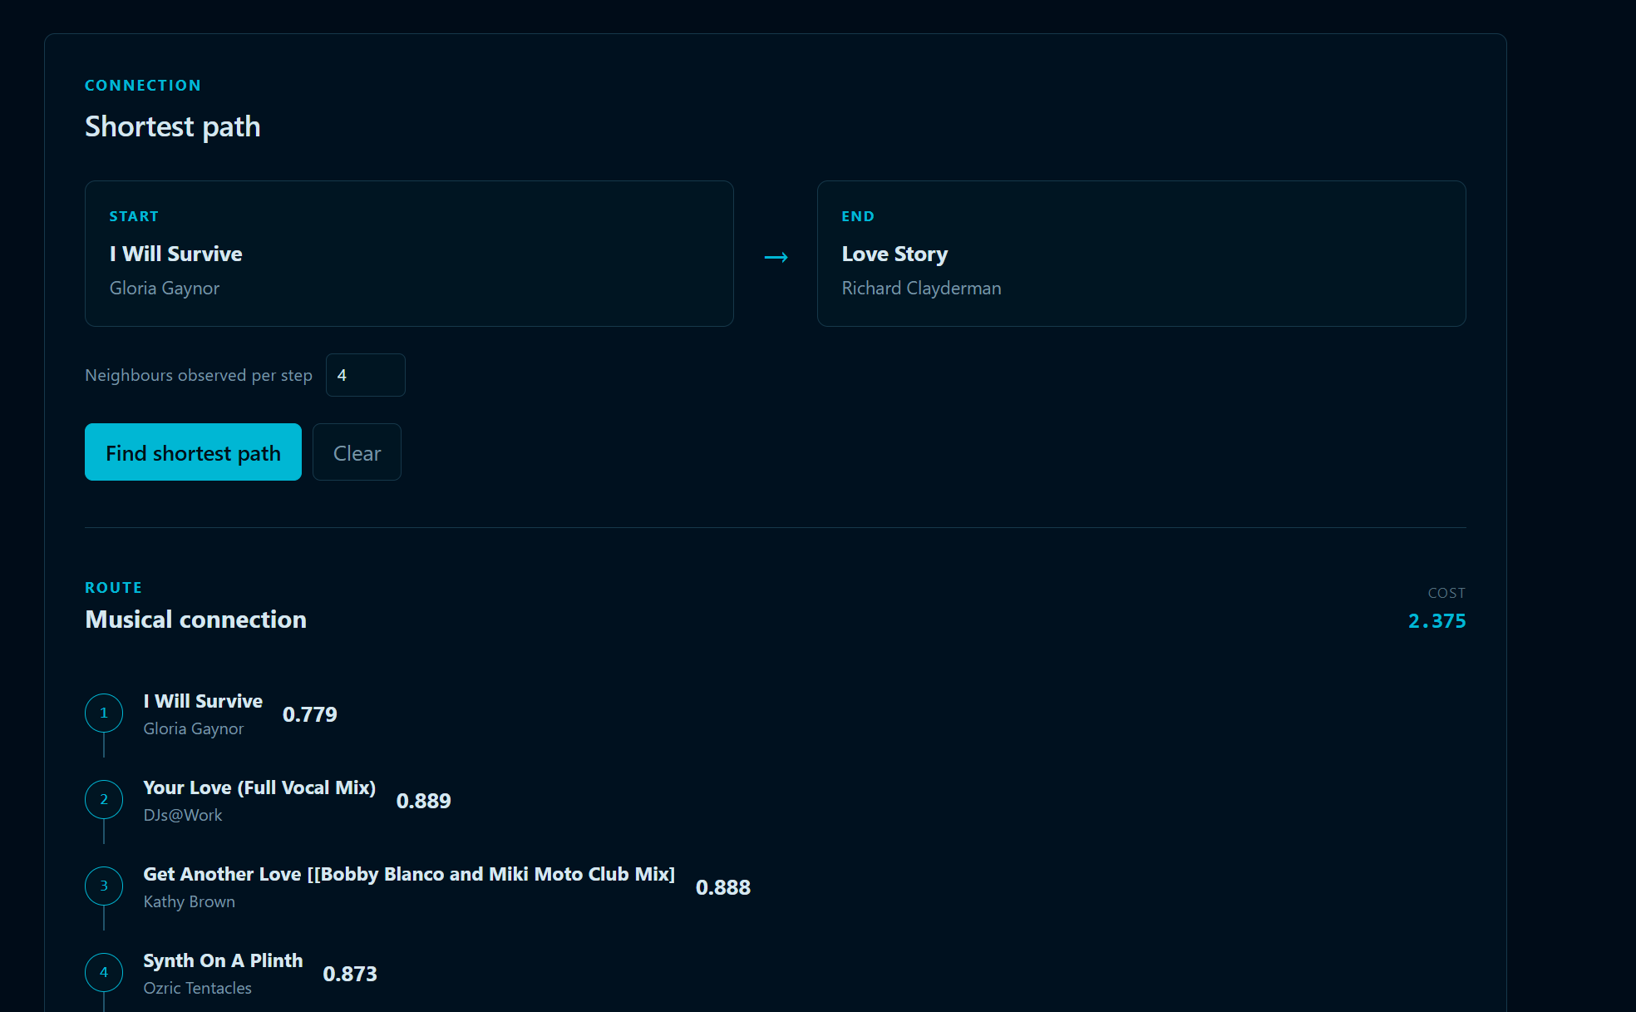
Fig. 13 Screenshot of Text Display of Shortest Path found

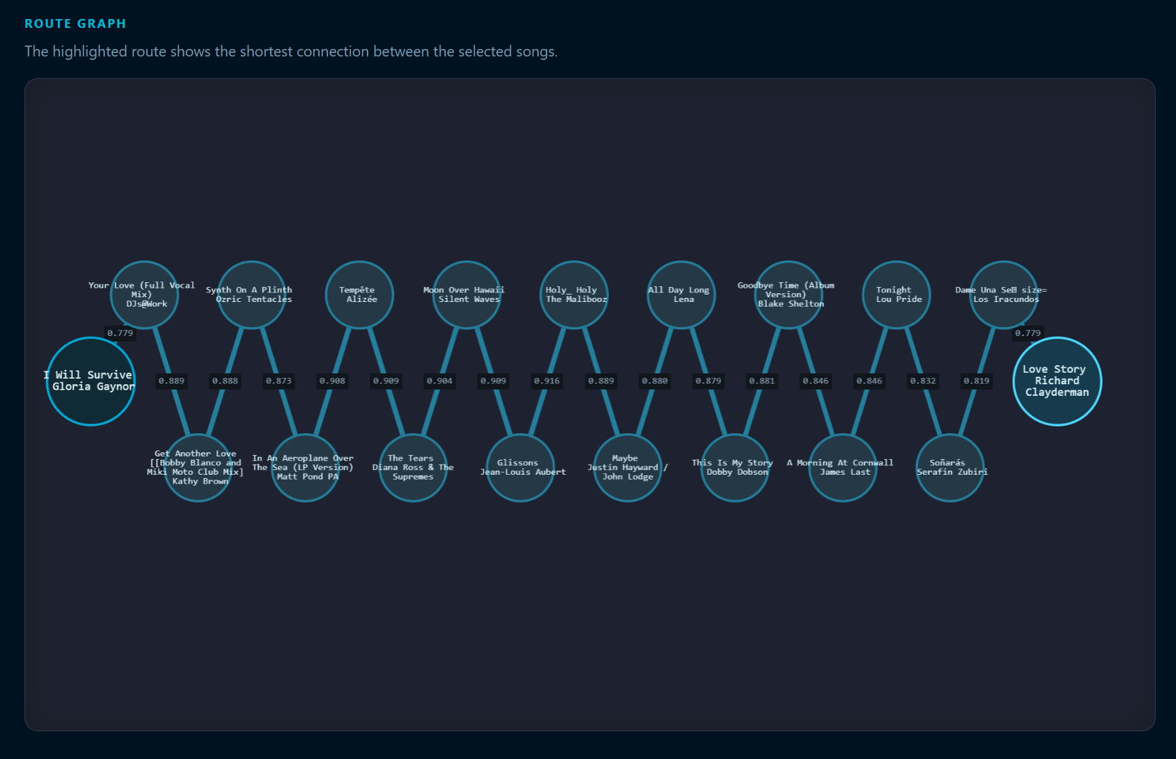
Fig. 14 Screenshot of Shortest Path Graph Display

Finally, though cropped due to length, the guide is also showcase below.


Fig. 15 Screenshot of User Guide

Ethical Considerations
Main issues around ethical considerations in this project could have risen from the downloading and processing of sound files breaking copyright laws, data containing personal information and from surveying participants.
The Lakh MIDI datasets author gives open use if they are properly referenced as per their instructions on the dataset’s webpage (Raffel, 2016). However, it is important to note that though MIDI files are usually not the original songs, this does not make them copyright free. As such, the project relies on the licensing and conditions of the Lakh MIDI dataset.
As discussed earlier, a truth table with song triplets was used for evaluation in the end instead of participant survey which avoids this issue. In other words, as the evaluation method involved only the author, no participant data was collected.
I would also state here, as the use of AI on coding assistance and debugging is declared in the appendix, that AI was not used to fabricate data or results in a way that would falsify project.

Soloution Evaluation

Discussion of the Extent to which the aims and objectives have been met
On the first aim, to produce a model which is capable of mapping musical similarities on a track level, this was achieved through the production of a feature-based vector representation of tracks where a weighted similarity model could be indexed with FAISS. As demonstrated, the model can successfully retrieve song neighbourhoods to map similarity.

The best performing weight configuration scored an accuracy of 0.73 against my hand annotated song triplets. Although this gives evidence of the model capturing a meaningful sense of similarity, the method of evaluation (and score) mean that the results should not be taken as objective truth. As discussed, the evaluation method has its limitations and as such serves more to assure that similarity is more meaningful rather than not.

On remaining objectives, the produced FAISS index recalls a tracks similarity neighbourhood in near instantaneous time and can recall a k-neighbourhood for a variable value of k. As such, these requirements were met.

On the second aim, to produce an interactive map for exploration, this was fully achieved through the completed artefact. As evidenced by the supplied screenshots, the tool allows for interactive exploration of musical similarity through both textual and graph displays. Multiple avenues of exploration were implemented as specified under User Needs. With this, principal limitations of the tool arise from the dataset and evaluation methodology. That is not to say, however, that the tool could not have more features and for this it is advised to observe the Future Work section.

Discussion of the Extent to which the problem addressed has been solved
The problem as stated, a lack of a publicly available track similarity, has been substantially addressed through the production of the MIDI similarity mapping tool. The tool is available for use from the authors GitHub repository.

The problem however cannot be considered completely solved as the tool is constrained by dataset size, song representation in MIDI and limitations in evaluation method.

Soloution Limitations
Certain cultural limitations in the way features are extracted mean that tracks that do not use a Western scale may be misrepresented (Downey, 2003). As such, similarity comparison on these songs might be somewhat skewed.

Also, at roughly 27,000 track a system has been produced for mapping similarity on a large dataset. However, this is still a small track count in comparison to the total amount of music in the world. Spotify for instance has over 100 million tracks (Spotify, 2026). As such, any song in the dataset may have a much closer neighbourhood in truth than what is available here.

The final, and perhaps largest, limitation discussed is on the mapping’s evaluation method. The implications of the truth tables have been explained previously, but it is important to mention again as a limitation of the project. Beyond its comparatively limited size, it’s distribution across genres is not guaranteed. With no extra metadata scrapped and used, this was unfortunately not possible. Therefore it should be remembered that the default weightings produced for the tool do not necessarily map best across all genres.

Conclusion

Summary of Project and Results
In summary, the project set out to bridge a gap in research by producing a publicly available music similarity tool that focused specifically on individual track similarity. This was achieved using contemporary techniques and accuracy of the mapping was evaluated by simulating weight configurations, with the best selected one performing at 0.73. The aims and objectives of the project were met with all required functionalities of the tool fulfilled.

Future Work
As mentioned under limitations, immediate future work could focus on extending the dataset to include more songs and metadata. With the possible extension of the truth table, the manufactured ground truth could be stratified to represent the respective genres in the dataset.

Moreover, an extra feature of the tool could be an option to recalibrate weights to the user’s taste by including a gamified data annotation feature. In this sense, the lack of ground truth can be circumnavigated, and the tool can become even more geared towards personalised recommendation.

On a small ergonomic note, in its current form to launch the tool the user must clone the GitHub repository and then follow the command prompt instructions. Ideally, the tool would be polished into an executable with a straightforward download link to make its use more accessible.

Further extension of the tool could come from production of currently out of scope features. Lyrical data could scrapped and analysed. Then lyrical content and semantics of tracks could be analysed with or against their musical similarity. This of course could also extend to more metadata, where the user could see comparisons filtered to or highlighted on genre, artist, release year and region.

Appendix

On AI use
For transparency and in accordance with university policies, this short section outlines how and where AI was used during the project (OpenAI, 2026). AI was used to assist in debugging and assisting code and in the case of producing the tools frontend, to help understand how JavaScript XML and CSS work and assist in their writing.

Where AI was used to assist in coding, as mentioned above, I would like to stress that this was done in an iterative, engaged way. That is to say, generative AI was not used to blindly produce entire scripts of code.

Record of meetings with supervisor
1st Meeting: 26th May
On initial meeting the project was discussed with aims, scope and plan outlined. Issues around evaluation were picked out as one of the main challenges from the onset. A variety of methods were discussed including a user survey, random walks and the use of agentic AI as a proxy for surveying people.

2nd Meeting: 7th July
The second meeting served to update my supervisor on progress and go over evaluation options again. The meeting was relatively short with most of the work to do being clearly understood. This stage of the project was mainly spent on finalising scripts for extracting features and producing embeddings.

3rd Meeting: 25th August
This meeting focused mainly on report structure and clearing up any queries on expectation.

The use and proper disclosure of AI use was discussed to ensure that no academic offense is committed, even by accident.

The final evaluation method used was discussed with evaluating similarity mapping being a recurring point across the project. Benefits and drawbacks of this approach were weighed up with shortcomings laying space for future work.

Expectations on the literature review were clarified due to some slight confusion over weather an annotated literature review is sufficient (, as was the case on the Interdisciplinary Group Project,) or if a more classic, academic review was required.

Further questions around report structure such as column formatting, referencing JupyterLab notebooks and repository URL helped clear up any remaining queries.

4th Meeting: 1st September
The final meeting of the project concluded questions on report sections. There was some confusion over weather separate reference list and bibliography were required.

Issues around dataset size were discussed. I had wondered weather it is acceptable to submit repository without processed datasets, since these exceed GitHubs repository limit. This would not impede the artifacts functionality; it just significantly increases time for markers to reproduce results. My supervisor assured that this is not a major concern.

The rest of the meeting focused on the project viva. Here presentation structure, time limit and artefact demonstration were discussed along with marking criteria. Viable dates and timeslots were also agreed on.

Ethical Approval Form
As discussed with my supervisor, below is a receipt of the ethical approval form for this project.
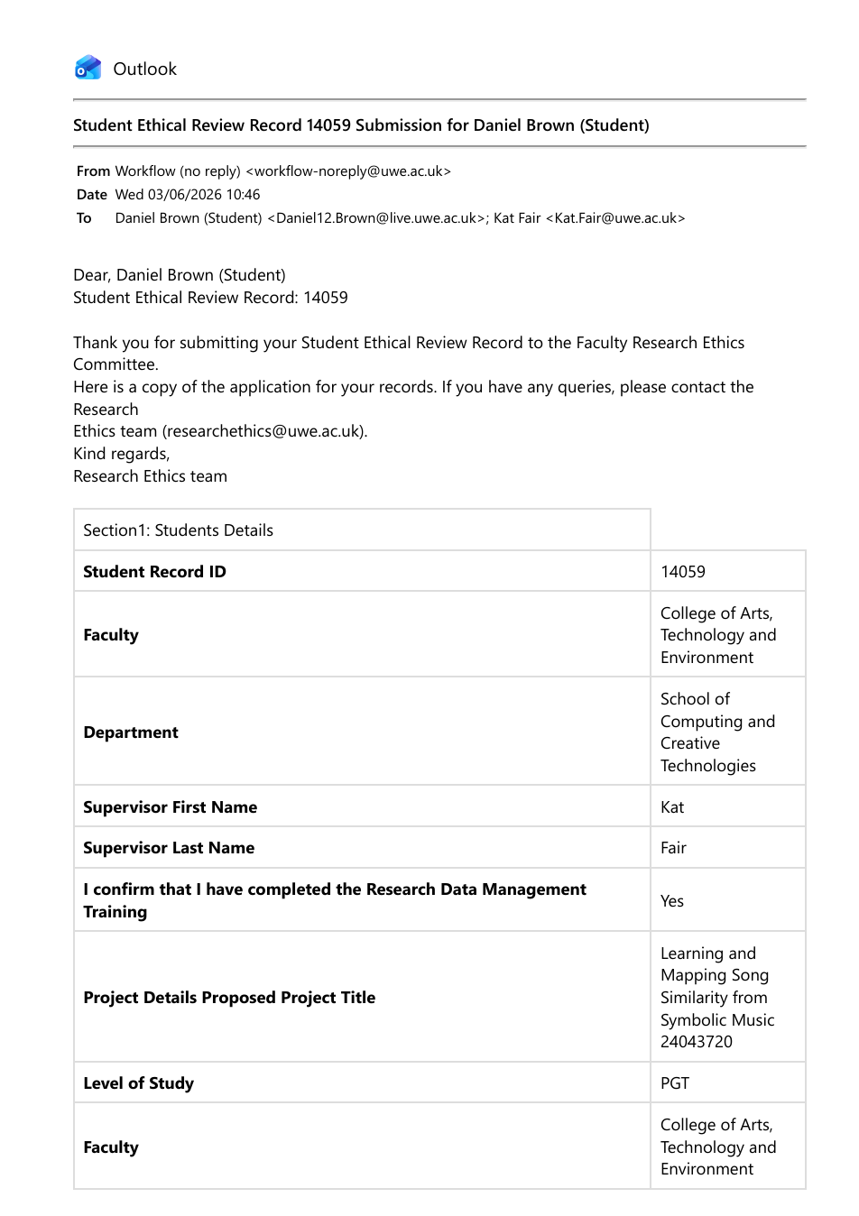

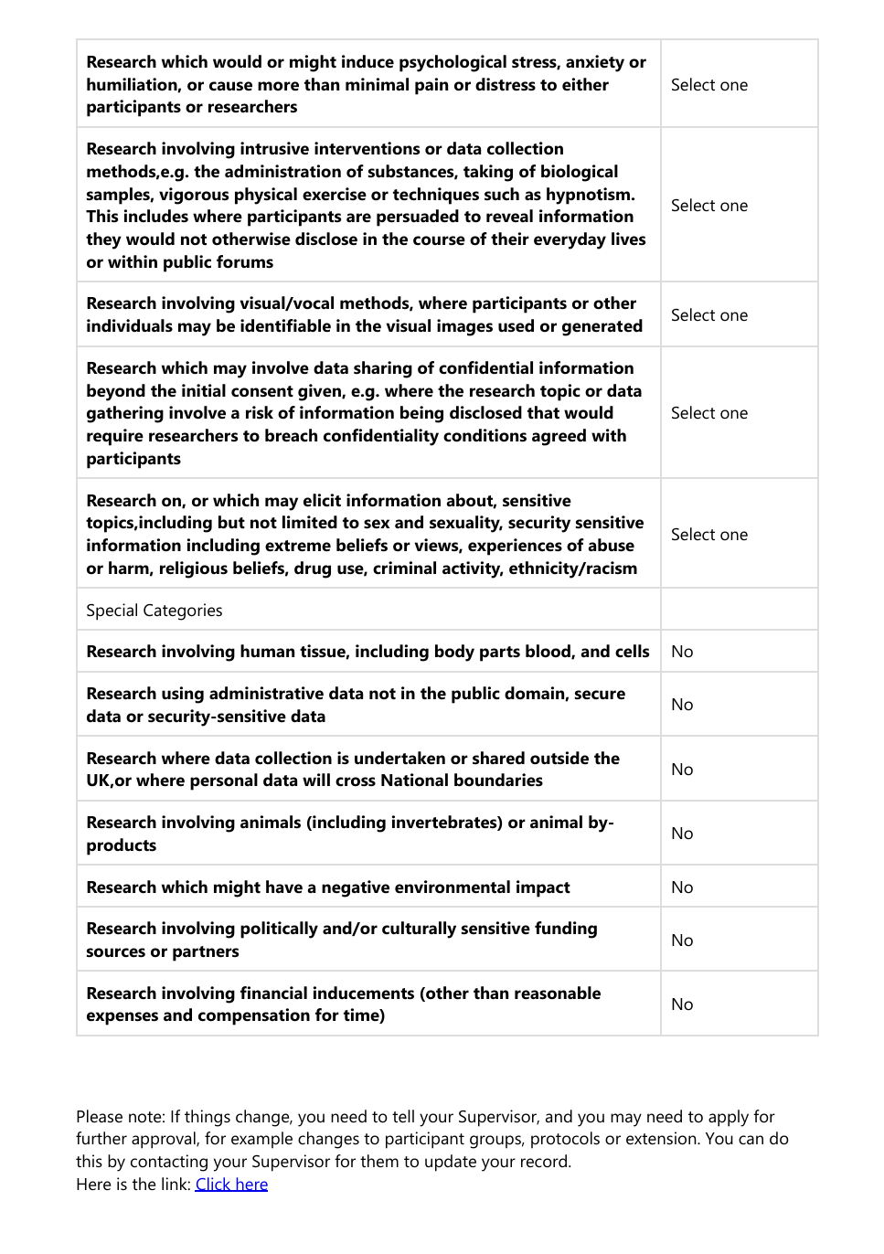


Bibliography

Aumüller, M., Bernhardsson, E. and Faithfull, A. (2020) ‘ANN-Benchmarks: A benchmarking tool for approximate nearest neighbor algorithms’, Available from https://ann-benchmarks.com/sisap19/index.html [Accessed 21 June 2026]

Bernhardsson, E. (n.d.) Annoy: Approximate Nearest Neighbors in C++/Python. GitHub. Available from https://github.com/spotify/annoy [Accessed 21 June 2026]

Bertin-Mahieux, T., Ellis, D.P.W., Whitman, B. and Lamere, P. (2011) ‘The Million Song Dataset’, in Proceedings of the 12th International Society for Music Information Retrieval Conference (ISMIR 2011). Available from http://millionsongdataset.com [Accessed: 5 February]

Corrêa, D. C. and Rodrigues, F. A. (2016) ‘A survey on symbolic data-based music genre classification’, Expert Systems with Applications, Available from https://www.sciencedirect.com/science/article/pii/S095741741630166X [Accessed 15 June 2026]

Covington, P., Adams, J. and Sargin, E. (2016) ‘Deep neural networks for recommendations’, Proceedings of the 10th ACM Conference on Recommender Systems, Available from https://dl.acm.org/doi/10.1145/2959100.2959190 [Accessed 15 May 2026]

Crauwels, K. (2022) MusicMap version 1.2.0. Available from https://musicmap.info [Accessed 1 March 2026]

Deldjoo, Y., Schedl, M. & Knees, P. (2024). Content-driven music recommendation: Evolution, state of the art, and challenges. Computer Science Review, 51, 100618. Available from https://www.sciencedirect.com/science/article/pii/S1574013724000029?via%3Dihub#d1e1425 [Accessed 15 June 2026]

Dijkstra, E.W. A note on two problems in connexion with graphs. Numer. Math. 1, 269–271 (1959). Available from https://link.springer.com/article/10.1007/BF01386390 [Accessed August 23]

Douze, M., Guzhva, A., Deng, C., Johnson, J., Szilvasy, G., Mazaré, P.-E., Lomeli, M., Hosseini, L. and Jégou, H. (2024) ‘The Faiss library’. arXiv. Available from https://arxiv.org/abs/2401.08281 [Accessed 20 June 2026]

Downie, J.S. (2003), Music information retrieval. Ann. Rev. Info. Sci. Tech., 37: 295-340. Available from https://asistdl.onlinelibrary.wiley.com/doi/10.1002/aris.1440370108 [Accessed 12 June 2026]

Georges, P. and Nguyen, N. (2019) ‘Visualizing music similarity: clustering and mapping 500 classical music composers’ Scientometrics 120, pp. 975–1003 Available from https://www.researchgate.net/publication/334406188_Visualizing_music_similarity_clustering_and_mapping_500_classical_music_composers#full-text [Accessed 23 February 2026]

Keogh, E., Ratanamahatana, C. (2005) Exact indexing of dynamic time warping. Knowl Inf Syst 7, 358–386. Available from https://link.springer.com/article/10.1007/s10115-004-0154-9 [Accessed 25 February 2026]

Krumhansl, C.L. (1990) Cognitive Foundations of Musical Pitch. New York: Oxford University Press. Available from https://www.researchgate.net/publication/269487773_Cognitive_Foundations_of_Musical_Pitch_Carol_L_Krumhansl [Accessed 8 June 2026]

Lijffijt, J., Papapetrou, P., Hollmén, J. and Athitsos, V. (2010) ‘Benchmarking dynamic time warping for music retrieval’ ACM International Conference Proceeding Series. Available from: https://www.researchgate.net/publication/221410471_Benchmarking_Dynamic_Time_Warping_for_Music_Retrieval#full-text [Accessed 17 February 2026]
Malkov, Y.A. and Yashunin, D.A. (2018) ‘Efficient and robust approximate nearest neighbor search using Hierarchical Navigable Small World graphs’ IEEE Transactions on Pattern Analysis and Machine Intelligence, Available from https://ieeexplore.ieee.org/document/8594636 [Accessed 21 June 2026]

Manning, C.D., Raghavan, P. and Schütze, H. (2008) Introduction to Information Retrieval. Cambridge: Cambridge University Press. Available from https://nlp.stanford.edu/IR-book/ [Accessed 13 June 2026]

Mcdonald G (2014) Every Noise at Once – Genre Map. Available from https://everynoise.com/engenremap.html [Accessed 3 March 2026]

OpenAI (2026) ChatGPT [Large language model]. Available from https://chatgpt.com/ [Accessed 13 August 2026]

Pampalk, E., Rauber, A. and Merkl, D. (2002) ‘Content-based organization and visualization of music archives’ in Proceedings of ACM Multimedia 2002, pp. 570–579. Available from https://www.researchgate.net/publication/221573225_Content-based_Organization_and_Visualization_of_Music_Archives#full-text [Accessed 25 February 2026]

Raffel, C. (2016) ‘Learning-based methods for comparing sequences, with applications to audio-to-MIDI alignment and matching’ PhD Thesis, Columbia University. Available from https://colinraffel.com/projects/lmd [Accessed: 5 February 2026]

Spotify (2026) ‘About Spotify’, Spotify Newsroom. Available from https://newsroom.spotify.com/company-info/ [Accessed 12 August 2026]

Spotify Engineering (2020) ‘For Your Ears Only: Personalizing Spotify Home with Machine Learning’, Spotify Engineering, 16 January. Available from https://engineering.atspotify.com/2020/1/for-your-ears-only-personalizing-spotify-home-with-machine-learning [Accessed 15 May 2026]

The MIDI Association (n.d.) ‘Standard MIDI Files’, MIDI.org. Available from https://midi.org/standard-midi-files [Accessed 10 February 2026]

Weber, R., Schek, H.-J. and Blott, S. (1998) ‘A quantitative analysis and performance study for similarity-search methods in high-dimensional spaces’, Proceedings of the 24th International Conference on Very Large Data Bases (VLDB), Available from https://www.vldb.org/conf/1998/p194.pdf [Accessed 21 June 2026]

Still to Do:

- Clean repo- write READMEs
- Clean up code, comment, docstring where missing etc
- Look over run code, commit zip, make sure marler can easily get app up
- Spellcheck weight exploration notebook
- Final testing on new machine???

