Pathology Recognition Based on Conjugacy Criteria with Subspaces of Reference Images

Vladislav I. Korshikov*, Vladimir A. Fursov
Samara University, 34, Moskovskoye shosse, Samara, 443086, Russian Federation,
*e-mail: vlad73453@gmail.com
Abstract. This paper addresses the problem of recognizing pathologies in medical magnetic resonance imaging (MRI) images of the brain. The use of convolutional neural networks for image recognition requires a large number of images for training, which are not always available. In this paper, we propose a recognition technique with partitioning vector class spaces into subspaces and further classification based on the conjugacy criteria. The advantage of the proposed technology is that the selection of reference subspaces is possible on a small number of images and the classification model can be adjusted depending on the classes to be defined. The paper describes the mathematical formulas used to determine the conjugacy criteria. In addition, a description of the datasets used in the work and a detailed description of the image preprocessing processes are given. The experiments revealed the optimal number of subspaces for each set and the probability of correct image recognition depending on the number of subspaces.
Keywords: brain MRI; pathology recognition; conjugacy criteria

Introduction
One of the most important factors in the effective treatment of cancerous brain tumors is their timely and correct detection. Currently, magnetic resonance imaging (MRI) has found wide application in the diagnosis of brain tumors, as it allows radiologists to obtain a large amount of information about the tumor [1]. However, with the proliferation of this tool, the issue of interpreting the data to determine the specific type of tumor is of particular relevance. The most common tumor types are: glial tumors (gliomas), meningiomas, and pituitary tumors [2].
Manual visual inspection of MRI images by a specialized specialist is a labor-intensive and time-consuming process, which is hampered by a significant flow of patients [3]. The problem of data interpretation is associated, on the one hand, with a large variability of data, on the other hand, with small differences between images of different pathologies. Attempts to form a feature system from sets of geometric figures are unfortunately too labor-intensive and often do not lead to a good result. We propose a recognition technology with partitioning of vector class spaces into subspaces based on the determination of proximity to these subspaces by the contiguity criteria.

Related Work
Many works have been devoted to the automatic detection of cancerous tumors, and their proposed methods of its implementation have certain advantages and disadvantages.
Ahmaad et al. [4] in a review article emphasizes three approaches that are superior to traditional image processing methods in pneumonia detection tasks: convolutional neural networks (CNNs), hybrid approaches and ensemble techniques.
Converged neural networks require a large volume of images for training and may be susceptible to overtraining. In addition, the neural network models must be trained for processing in order to be trained. Ozkaraca et al. [5] is limited to converting to the size of the input layer of the neural network, Gupta et al. [6], in addition, compensate for the lack of number of images by randomly generating new images based on existing ones according to a given rule, but how well the resulting images correspond to real medical images remains questionable.
Arunachalam and Savarimuthu [7] used linear Gabor filter and other linear filters for image preprocessing, however, many studies use separate models for preprocessing, that is hybrid approaches are used.
Hybrid approach involves using separate models for extracting useful features and for classification, with the output layer of the first model being the input layer of the second. Pashaei et al. [8] in their work use two machine learning models: convolutional neural network extracts useful features KELM model (kernel extreme learning machine) performs classification, in their work this method is called KE-CNN. Khairandish et al. [9] proposes to use a combination of CNN and SVM to extract useful features and perform classification respectively.
Hybrid approaches also include radiomics, which allows a large number of biomarkers to be extracted from diagnostic images. Ilyasova et al. showed that the analysis of standard MRI data based on radiomics shows a better outcome in the differential diagnosis compared to visual assessment [10].
Although hybrid approaches help to extract useful features, huge data sets are still needed to train convolutional neural networks.
Ensemble methods involve training multiple models independently on one or more datasets and making a decision based on combining the decisions of the participating models. Anantharajan et al. [11] proposed to perform abnormal tissue detection using Ensemble Deep Neural Support Vector Machine. However, to train the models used, large amounts of trained data are also required.
The contiguity criterion has not been previously used for cancer detection, but has performed well in automated image analysis tasks.
Zakharov and Fursov [12] consider the problem of color image recognition using the contiguity criterion. In order to overcome the problem related to the strong difference of vectors of one class from each other, it proposes clustering of separate classes into subclasses, which will be used within the framework of this paper. The algorithm described in this paper has been successfully applied to solve a number of highly specialized problems.
Zherdev et al. [13] apply the conjugacy criterion to recognize objects from their scattering diagrams. Kozin and Fursov [14] use it for face recognition in invariant space.
The novelty of this work consists in the application of the conjugacy criterion to the problem of tumor detection from MRI images, as well as in its original practical implementation, which differs from the previously proposed ones.

Problem Definition
It is assumed that pre-processing of images is performed, in particular, centering and shaping (bringing to the same dimensions). A vector of dimension $N×1$ is assigned to each image (by row sweep), and almost linearly dependent vectors are excluded from the set of reference vectors.
The set of $N$-vectors formed from the reference images of each class (recognized pathology) forms a vector subspace defined in the form of $N×m$ -matrix $X=[x_{1}, x_{2},…,x_{m}]$ (for certainty, we assume that the number of reference vectors in each class is $m$).
The conjugacy index $R(x_{k})$ of $N×1$-vector $x_{k}$ with the vector space given in the form of matrix $X$ is defined as follows
$R(x_{k})=\frac{x_{k}^{T}X{[X^{T}X]}^{-1}X^{T}x_{k}}{x_{k}^{T}x_{k}}$. (1)
The contiguity criteria (1) is a measure of the closeness of the vector $x_{k}$ representing the recognized image to the space of reference vectors of the class. The convenience is that all the class reference vectors can be included in the matrix, and the proximity indices $R(x_{k})$ are scalar features. In [15], a method to improve recognition accuracy by iteratively partitioning classes into two subclasses to achieve the desired number of even subclasses was considered.
We aim to develop a method based on the application of conjugacy indices for partitioning the space formed by vectors of each class into any (including odd) number of subspaces.

Data Preprocessing
In the first step of data handling, data preprocessing must be performed. Brian Tumor Classification (MRI) and Brain Tumor MRI Dataset containing images of glial tumors, meningiomas and pituitary tumors are used in this work, as shown in Fig. 1.
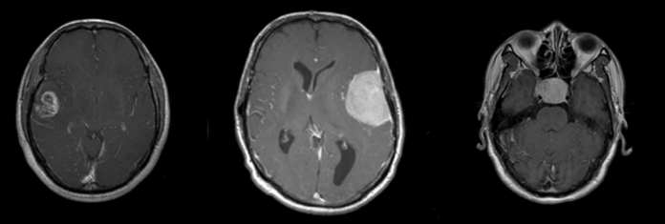
- Examples of glioma, meningioma, and pituitary tumor images from the Brian Tumor Classification (MRI) Ыset.
The first step was to bring the images to the same scale, so that the vectors obtained on their basis contained the same number of elements. The proposed technology can work with images of any size, but to ensure the algorithm's fast work with the presented information, downsampling (image resolution reduction) to a resolution of 256 by 256 pixels is performed. Pathology on the obtained images remains visually distinguishable, further downsampling may result in loss of significant information.
There is free space at the edges of the images and the brain may be slightly displaced relative to the center, which can create difficulties in image processing, therefore, the next step is to align the area of pixels that make up the image of the brain directly in the center of the image. At the same time, the empty space at the edges is not removed because it contains useful information about the relative size of the brain area compared to the rest (the larger the area occupied in the section, the less empty space and vice versa), which is important for correct image analysis.
The dataset contains images in three projections: axial (slice in the transverse plane), sagittal (slice in the longitudinal plane) and coronal projection (slice in the frontal plane), which is illustrated in Fig. 2. A cancerous tumor may be indistinguishable in any one projection, so the diagnosis is made after analyzing all three projections.
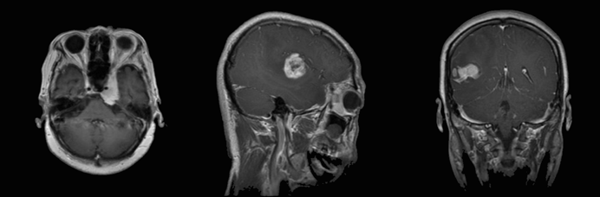
- Axial, sagittal, and coronal projections, respectively, taken from the Brain Tumor MRI Dataset.
To perform the task of automatic image projection detection, binarization is applied to abstract the specific features of the image and extract the essential elements, improving the detection accuracy, which is illustrated in Fig. 3 [16].
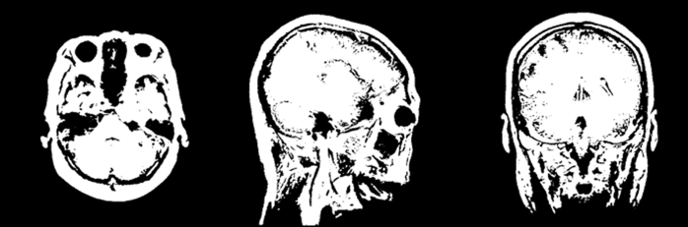
- MR images in different projections after binarization.
Since it is not possible to set the threshold of image separation in advance due to their differences in brightness, the Otsu method is used for binarization, which allows to divide the whole set of pixels into two classes: useful and background. For their distribution, a binarization threshold is calculated such that the inter-class variance is minimized, which is also equivalent to maximizing the inter-class variance [17]. In this paper, the useful pixels are white and the background pixels are black, although this algorithm allows for the reverse situation. The weighted sum of the variance of two classes is found by the formula 2
$σ_{ω}^{2}\left(t\right)=ω_{1}\left(t\right)σ_{1}^{2}\left(t\right)+ ω_{2}\left(t\right)σ_{2}^{2}\left(t\right)$. (2)
For more clarity, we can visualize the image as a histogram of pixel brightness values, and the separation threshold as a red dashed line, above which is the area of white pixels and below which is the area of black pixels, as in Fig. 4.
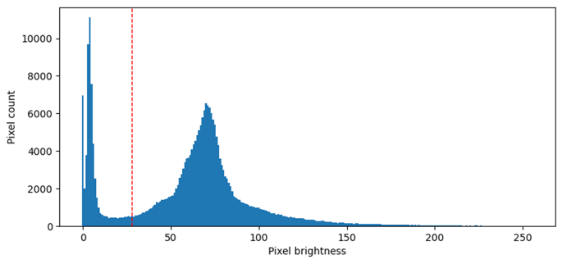
- Distribution of pixels by brightness in one of the images of the set.
For the task of tumor type detection in projection distributed images, binarization is not performed because it requires knowing the specific brightness of the image segments for accurate detection.
To obtain a vector, a transformation procedure (vectorization) is performed over the original image [18]. The image is expanded horizontally, each element of the vector is equated to the brightness of a pixel, where 0 is a black pixel and 255 is a white pixel. Each vector obtained contains 65536 elements.
For the projection detection task, 100 images of each projection are extracted from the set and 50 images are added to the test set. For tumor type detection in axial, sagital and coronal projection, independent sets containing 300, 375 and 450 images were generated. Each set was divided into samples: 80% training sample and 20% test sample.

Description of the Clustering Method
In the present technique, first the subclass centers are determined step by step by the criterion of minimum contiguity (maximum distance) with the space formed by the vector centers selected in the previous steps. Then, other reference vectors are incrementally joined to the found subclass centers by the criterion of maximum contiguity (closeness), forming subspaces. This completes the clustering of the training sample and we can proceed to classification.
At the first step of determining the subclass centers, a pair of vectors with the smallest cosine similarity index is searched in the training set of each class. By cosine similarity in this paper we mean the similarity coefficient, which is the cosine of the angle between vectors normalized by the value of their lengths. Since all elements of the presented vectors are greater than or equal to zero, the cosine criterion in this case can take values from 0 (vectors are maximally different) to 1 (vectors are maximally similar) [19]. It is calculated by the formula 3
$r(x_{i},x_{j})=(x_{i}^{T}x_{j})/({||x}_{i}||×||x_{j}||)$. (3)
These two vectors are recognized as the centers of the first two subclasses. The next center of the (third) subclass is defined as the vector having minimum conjugacy, (in the sense of formula (1)) with the subspace formed by the two vectors found. When defining the third subclass center, the matrix has dimension $N×2$ , for defining the fourth center - N×3 and so on until the required number of subclass center vectors is reached.
Now the reference vectors remaining free in this class are successively joined to them. The maximum value of criterion (2) is used to join one (first) vector to each center. As a result, a subspace of two vectors is formed based on each center. In the next step, one (third) vector from the free vectors of the class is attached to these subspaces formed by the first two vectors by the maximum conjugacy criterion. The matrices $X$ of the subspaces will have dimension $N×2$ . At the third step of joining the fourth vector is $N×3$ and so on until the distribution of all free vectors is completed. It is possible that some number of reference vectors will remain unallocated.
The number of subclasses of subclass centers for each class within the same problem may vary. We can represent some class $A$ as a set of vectors forming spaces $a$, $b$, and so on. In mathematical form, the class representation is written in formula 4
$A=[\left[a_{1}, a_{2}, a_{3}…\right],\left[b_{1}, b_{2}, b_{3…}\right]…]$. (4)
The training sample for each class is formed separately, due to which, when working with the test sample, it is possible to choose in which classes it is necessary to distribute images, and also to exclude the unclaimed ones. For example, in one set there is a class of images that do not contain tumor at all (notumor), and the test sample is formed on the basis of the set that does not contain this class. For such cases, the program implementation provides a possibility to disable separate classes.
Since subspaces are a set of vectors combined into subspaces, all the information required to detect class objects is written to a separate file, which can be read by the module performing classification of the test sample. In addition, vectors from these files can be reconstructed into images, which allows to visually evaluate the content of the created subclasses without the need to refer to the training set of images. Since the correct operation of the algorithm requires that subspaces contain the same number of vectors, when the number of vectors in subspaces of different classes differs, only the first n elements corresponding to the number of vectors of the smallest space are taken for each vector.
At the classification stage, the image is assigned to the space with which the contiguity criterion will be the largest, however, the determination of the belonging of the next image at this stage no longer takes into account new observations assigned to any space. This helps to ensure that the spaces are of the same size and are not “cluttered”. Attributing an object to a space means attributing it to the class that this subspace includes.

Analysis of Experimental Results
Brain images in different projections are very different from each other, therefore, before starting to classify tumors, it is necessary to distribute images across projections and only then to perform classification within each specific projection. Due to the versatility of the proposed algorithm, it can be used for this task.
The purpose of the first experiment is to determine the image projection from binary images generated from MRI images for further classification of the tumor type. The use of binary images is due to the fact that through binarization, images of one projection with different affected areas become more similar, while differing significantly in contour from images in other projections.
Nevertheless, images of different brain regions in the same projection have significant differences between them, which accounts for the separation of several subclasses within each class. As mentioned earlier, for each individual class, the number of subspaces on which the highest detection accuracy is achieved can vary significantly. The presented graph shows the detection accuracy of objects of each class as a function of the number of subspaces, which is shown in Fig. 5.
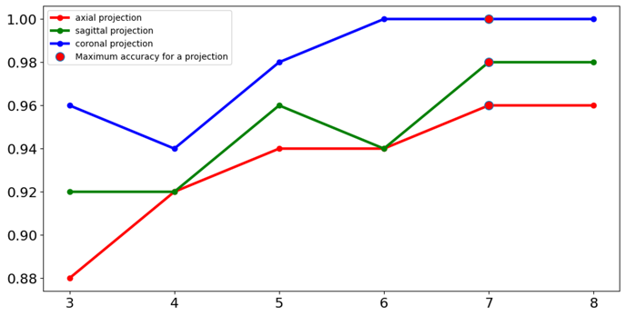
- Graph of dependence of projection definition accuracy depending on the number of subclasses.
According to the data presented in the graph, we can conclude that the proposed technology allows us to achieve high accuracy in determining the projection of images, which up to a certain point increases with the growth of the number of spaces, but after reaching a certain accuracy, the growth stops.
Analyzing the program errors, it can be observed that there are some number of images that are classified incorrectly on any number of subclasses because they have little in common with the rest of the images of the containing set. Such images are represented in the set in small numbers and cannot form their own subclass within the training sample. In this experiment, some images located at the boundary of the study area are erroneously assigned to another class due to the fuzzy contour, however, since they affect only a small area of the brain, they have low enough informativeness and can be excluded from the sample at the discretion of the expert at the preprocessing stage, as exemplified by Fig. 6.
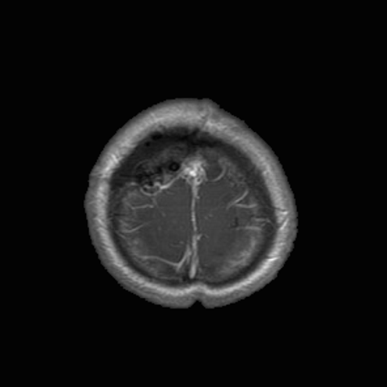
- Axial MRI image misclassified as a sagittal image.
In order to improve accuracy in the above case, it is possible to add to the training sample examples of relatively rare representatives of the selected class, which may occur during practical application of the algorithm.
In addition to distinguishing objects of classes that are quite different from each other by contour, the presented algorithm allows distinguishing quite similar objects. For example, classification of different types of tumors in one projection is complicated by the fact that images are similar in contour, but different types are characterized by specific clusters of brighter pixels in different parts of the image. The presented technology is capable of solving such problems as well.
The aim of the second experiment is to determine the tumor type on MRI images acquired in axial projection on datasets of different sizes.
The experiment compared the classification accuracy of the test sample on datasets of different sizes. For each set, the number of subspaces at which the highest accuracy was achieved was identified, as can be seen in Fig. 7.
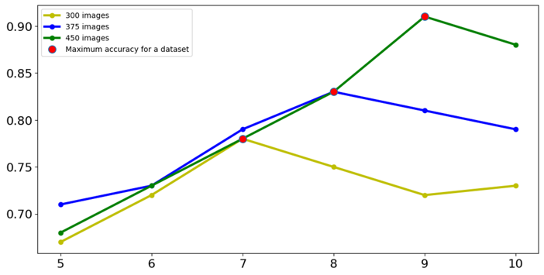
- Graph of the dependence of classification accuracy on the number of subclasses for sets of different sizes.
As can be seen from the graph presented, as the number of images in the set increases, the number of subspaces at which the highest accuracy is achieved also increases. As can be seen from the results presented in Table I, as the number of evaluation objects increases, the probability of recognizing them correctly increases.

- Comparison of the best classification accuracy for each set in axial projection
 | Sample size | Recognition probability
 |  | glioma | meningioma | pituitary | mean
300 |  | 0,8 | 0,75 | 0,8 | 0,78
375 |  | 0,72 | 0,84 | 0,92 | 0,83
450 |  | 0,87 | 0,9 | 0,97 | 0,91

When analyzing the results of the second experiment, the images affecting only a small area of the brain and having low informativeness show low recognition rate, therefore, it is necessary to filter these images.
For this purpose, in the third experiment, an additional step is added during preprocessing, during which images with the number of white pixels less than 50% of the average number of white pixels in the images of the set are cut off. The results in Table 2 show that the classification accuracy has increased.

- Comparison of the best classification accuracy for each set in axial projection after adding the additional preprocessing step
Sample size | Recognition probability
Sample size | glioma | meningioma | pituitary | mean
300 | 0,83 | 0,78 | 0,83 | 0,81
375 | 0,75 | 0,87 | 0,92 | 0,85
450 | 0,9 | 0,92 | 0,97 | 0,93

The fourth experiment performed the same analysis for the sagital and coronal projection images, respectively. To keep the results of the experiments comparable, the number of images and the partitioning of the set remains the same as in the axial projection analysis, as can be seen in Table 3.

- Comparison of the best classification accuracy for each set in sagittal and coronal projection after adding the additional preprocessing step
Projection type | Sample size | Recognition probability
Projection type | Sample size | glioma | meningioma | pituitary | mean
sagittal | 300 | 0,75 | 0,80 | 0,85 | 0,8
sagittal | 375 | 0,78 | 0,87 | 0,87 | 0,84
sagittal | 450 | 0,82 | 0,95 | 0,92 | 0,9
coronal | 300 | 0,82 | 0,78 | 0,8 | 0,8
coronal | 375 | 0,88 | 0,83 | 0,85 | 0,85
coronal | 450 | 0,96 | 0,89 | 0,9 | 0,92

The results obtained confirmed the conclusions drawn from the second experiment. The average classification accuracy increases as the set increases, as does the number of subclasses at which the highest accuracy is achieved [20].
It should be noted that a significant increase in the number of subclasses can reduce the classification accuracy, since the most distant centers of subclasses can join the standards from adjacent classes. In order to achieve high accuracy, a tuning that provides a compromise between the number of reference images used and the number of subclasses in each class is necessary.
When considering this program, it is important to note that it is capable of performing sequential classification. The first step involves the identification of the essential feature, and the second step involves the classification of objects for which this feature is matched. In other words, it allows you to first determine the projection of the image, and then to determine the presence of a tumor and its specific type. At the same time, the result obtained at the previous stage of classification becomes a set of data for the next stage.
This process should not be confused with hybrid solutions based on convolutional neural networks (CNNs), where processing is performed by several neural network models sequentially and the output of one model is the input data for another [21]. In contrast to the above method, the proposed technology allows to obtain human-readable useful features at each processing stage and makes it possible to rearrange the order of image processing at any time when the conditions of the task change. At the same time, it should be remembered that both approaches are justified only if the classification accuracy at the first levels remains high enough, otherwise a constantly growing “snowball” of errors may form, making the classification results at subsequent levels practically inapplicable.

Conclusions
This paper is the first to apply the conjugacy criterion in the task of medical image recognition. Experimental results confirmed that, given a sufficient number of reference images, the method based on the calculation of conjugacy indices when dividing classes into subclasses can provide good classification accuracy on a relatively small set of training images, and also allows increasing the classification accuracy when adding new observations. The increase in accuracy is due to new observations that can form new subclasses that cover previously unrepresented situations. The advantages of this method include robustness to changes in perspective and ease of technology customization. When new reference images appear, they are simply incorporated into the matrices of the corresponding classes.

Disclosures
All authors declare that there is no conflict of interest in this paper.

Funding Statement
The authors did not receive support from any organization for the submitted work.

References
- M. Huang, W. Yang, Y.Wu, J. Jang, W. Chen, and Q. Feng “Brain tumor segmentation based on local independent projection-based classification,” IEEE transactions on biomedical engineering, vol. 10, pp. 2633-2645, 2014.
- M. K. H. Wiedmann, C. Brunborg, A. Di leva, K. Lindemann, T. B. Johannesen, L. Vatten, E. Helseth, and J. A. Zwart “Overweight, obesity and height as risk factors for meningioma, glioma, pituitary adenoma and nerve sheath tumor: a large population-based prospective cohort study,” Acta oncologica, vol. 56, pp. 1302-1309, 2017.
- K. Popuri, D. Cobzas, A. Murtha, and M. Jagersand, “3D variational brain tumor segmentation using Dirichlet priors on a cluster feature set,” International journal of computer assisted radiology and surgery, vol. 7, pp. 493-506, 2012.
- M. A. Alam, A. Sahel, K. M. Hasan, and I. Ahmad “Advancing Brain Tumor Detection Using Machine Learning And Artificial Intelligence: A Systematic Literature Review Of Predictive Models And Diagnostic Accuracy,” Strategic Data Management and Innovation, vol. 1, pp. 37-55, 2024.
- O. Ozkaraca, O. I. Bagriacik, H. Guruler, F. Khan, J. Hussain, J. Khan, and U. e Laila “Multiple brain tumor classification with dense CNN architecture using brain MRI images,” Life, vol. 13, p. 349, 2023.
- B. B. Gupta, A. Gaurav, and V. Arya “Deep CNN based brain tumor detection in intelligent systems,” International Journal of Intelligent Networks, vol. 5, pp. 30-37, 2024.
- M. Arunachalam and S. R. Savarimuthu, “An efficient and automatic glioblastoma brain tumor detection using shift-invariant shearlet transform and neural networks,” International Journal of Imaging Systems and Technology, vol. 27, pp. 216-226, 2017.
- A. Pashaei, H. Sajedi, and N. Jazayeri “Brain tumor classification via convolutional neural network and extreme learning machines,” 8th International conference on computer and knowledge engineering (ICCKE), pp. 314-319, 2018.
- M. O. Khairandish, M. Sharma, V. Jain, J. M. Chatterjee, and N. Z. Jhanjhi “A hybrid CNN-SVM threshold segmentation approach for tumor detection and classification of MRI brain images,” Irbm, vol. 43, pp. 290-299, 2022.
- N. Y. Ilyasova, N.S. Demin, E. N. Surovcev, and A. V. Kapishnikov “Possibilities of MRI Texture Analysis of Brain Images in Differential Diagnosis of Primary Extra-Axial Tumors,” Journal of Biomedical Photonics & Engineering, vol. 9(4), pp. 68-76, 2023.
- S. Anantharajan, S. Gunasekaran, T. Subramanian, and R. Venkatesh “MRI brain tumor detection using deep learning and machine learning approaches”, Measurement: Sensors, vol. 31, p. 101026, 2024.
- R. K. Zaharov and V. A. Fursov “Computational technology for color image recognition using conjugacy criteria,” Parallel computing technologies, pp. 684-687, 2011.
- D. A. Zherdev, N. L. Kazansky, and V. A. Fursov “Object recognition from electromagnetic radiation scattering diagrams based on the method of reference subspaces,” Computer optics, vol. 38(3), pp. 503-510, 2014.
- N. E. Kozin and V. A. Fursov “Face recognition by conjugacy criteria in the space of summation invariants,” Computer optics, vol. 32, pp. 400-402, 2008.
- D. A. Zherdev, N. L. Kazansky and V. A. Fursov “Object recognition on radar images using conjugacy criteria and reference subspaces” Computer optics, vol. 39(2), pp. 255-264, 2015.
- R. Saini “Document image binarization techniques, developments and related issues: a review,” International Journal of Computer Applications, vol. 116, pp. 41-44, 2015.
- S. L. Bangare, A. A. Dubal, P. S. Bangare, and S. T. Patil “Reviewing Otsu’s method for image thresholding,” International Journal of Applied Engineering Research, vol. 10, pp. 21777-21783, 2015.
- М. Dziuba, I. Jarsky, V. Efimova, and A. Filchenkov “Image vectorization: a review,” Journal of Mathematical Sciences, vol. 285, pp. 155-168, 2024.
- A. R. Lahitani, A. E. Permanasari, and N. A. Setiawan “Cosine similarity to determine similarity measure: Study case in online essay assessment,” 2016 4th International conference on cyber and IT service management, pp. 1-6, 2016.
- V. A. Fursov, S. A. Bibikov, and O. A. Baida “Thematic classification of hyperspectral images by conjugacy criteria,” Computer optics 38(1), pp. 154-158, 2014.
- M. Wageh, K. Amin, A. D. Algarni, A. A. Hamad, and M. Ibrahim “Brain Tumor Detection Based on Deep Features Concatenation and Machine Learning Classifiers with Genetic Selection,” IEEE Access 12, pp. 114923-114939, 2024.

