The Rohingya Migrant Crisis

Author: [Eleanor Albert](http://www.cfr.org/experts/world/eleanor-albert/b20300), Online Writer/Editor  
Updated: September 19, 2016

*Soe Zeya Tun/Reuters*

* [Share](http://www.cfr.org/burmamyanmar/rohingya-migrant-crisis/p36651#share)
* [Tweet](http://www.cfr.org/burmamyanmar/rohingya-migrant-crisis/p36651#share)
* [Post](http://www.cfr.org/burmamyanmar/rohingya-migrant-crisis/p36651#share)
* [Email](http://www.cfr.org/burmamyanmar/rohingya-migrant-crisis/p36651#share)
* [Print](http://www.cfr.org/burmamyanmar/rohingya-migrant-crisis/p36651#share)
* [Cite](http://www.cfr.org/burmamyanmar/rohingya-migrant-crisis/p36651)

Introduction

Thousands of Muslim Rohingya have fled Myanmar, many taking to the sea to try to reach Indonesia, Malaysia, and Thailand. The latest surge in refugees was prompted by a long-building crisis: the discriminatory policies of the Myanmar government in Rakhine state, which have caused hundreds of thousands of Rohingya to flee since the late 1970s. Their plight has been compounded by the responses of many of Myanmar’s neighbors, which have been slow to take in refugees for fear of a migrant influx they feel incapable of handling.

Who are the Rohingya?

The Rohingya are an ethnic Muslim minority group living primarily in Myanmar’s western Rakhine state; they practice a Sufi-inflected variation of Sunni Islam. The estimated one million Rohingya in Myanmar account for nearly a third of Rakhine’s population. The Rohingya differ from Myanmar’s dominant Buddhist groups ethnically, linguistically, and religiously.

The Rohingya trace their origins in the region to the fifteenth century when thousands of Muslims came to the former [Arakan Kingdom](http://www.economist.com/news/asia/21654124-myanmars-muslim-minority-have-been-attacked-impunity-stripped-vote-and-driven). Many others arrived during the nineteenth and early twentieth centuries when Bengal and the Rakhine territory were governed by colonial rule as part of British India. Since independence in 1948, successive governments in Burma, renamed Myanmar in 1989, have refuted the Rohingya’s historical claims and denied the group recognition as one of the country’s [135 ethnic groups](http://www.embassyofmyanmar.be/ABOUT/ethnicgroups.htm). The Rohingya are largely identified as illegal Bengali immigrants, despite the fact that many Rohingya have resided in Myanmar for centuries.

Both the Myanmar government and the Rakhine state’s dominant ethnic Buddhist group, known as the Rakhine, reject the use of the label “Rohingya,” a [self-identifying term (PDF)](http://www.crisisgroup.org/~/media/Files/asia/south-east-asia/burma-myanmar/261-myanmar-the-politics-of-rakhine-state.pdf) that surfaced in the 1950s and that experts say provides the group with a collective, political identity. Though the etymological root of the word is disputed, the most widely accepted origin is that “Rohang” is a derivation of the word “Arakan” in the Rohingya dialect and the “ga” or “gya” means “from.” By identifying as Rohingya, the ethnic Muslim group asserts its ties to land that was once under the control of the Arakan Kingdom, according to Chris Lewa, director of the Arakan Project, a Thailand-based advocacy group.

[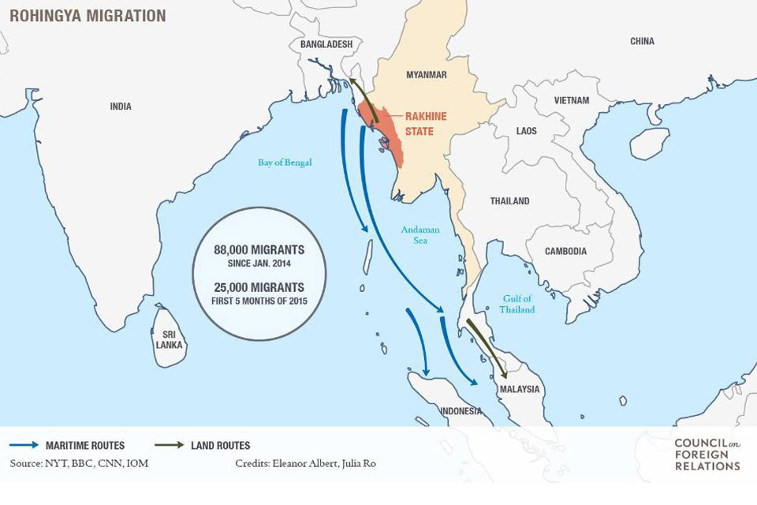](http://www.cfr.org/content/publications/Rohingya-Migration-Map-BGR.jpg)

What is the legal status of the Rohingya?

The Myanmar government refuses to grant the Rohingya citizenship status, and as a result the vast majority of the group’s members have no legal documentation, effectively making them [stateless](http://thediplomat.com/2014/10/interview-the-stateless-rohingya/). Though Myanmar’s 1948 citizenship law was already[exclusionary](http://www.irinnews.org/report/97966/activists-call-for-review-of-myanmar-s-citizenship-law), the military junta introduced a citizenship law in 1982 whose strict provisions stripped the Rohingya of access to full citizenship. Until recently, the Rohingya have been able to register as temporary residents with identification cards, known as “white cards,” which Myanmar’s regime began issuing to many Muslims (both Rohingya and non-Rohingya) in the 1990s. The white cards [conferred (PDF)](http://www.crisisgroup.org/~/media/Files/asia/south-east-asia/burma-myanmar/261-myanmar-the-politics-of-rakhine-state.pdf) some limited rights but were not recognized as proof of citizenship. Although the temporary cards held no legal value, Lewa says that the IDs did represent some minimal recognition of temporary stay for the Rohingya in Myanmar.

In 2014 the government held a UN-backed [national census](http://www.aljazeera.com/indepth/inpictures/2014/04/pictures-myanmar-census-bars-r-2014413114633189492.html)—its first in thirty years. The Muslim minority group was initially permitted to self-identify as “Rohingya,” but after Buddhist nationalists threatened to boycott the census, the government decided the Rohingya could only register if they identified as Bengali.

Similarly, under pressure from Buddhist nationalists protesting the Rohingya’s right to vote in a 2015 constitutional referendum, then-President Thein Sein [cancelled](http://www.mmtimes.com/index.php/national-news/13106-president-backtracks-on-white-cards.html) the temporary ID cards in February 2015, effectively revoking their newly gained right to vote—white card holders had been [allowed to vote](http://www.irrawaddy.org/burma/revoking-white-card-holder-voting-rights-counter-reconciliation-us-official.html) in Myanmar’s 2008 constitutional referendum and 2010 general elections. In the 2015 elections, which were widely touted as being free and fair by international monitors, [no parliamentary candidate](https://www.theguardian.com/world/2015/nov/03/no-vote-no-candidates-myanmars-muslims-barred-from-their-own-election) was of the Muslim faith. “Country-wide [anti-Muslim sentiment (PDF)](http://www.crisisgroup.org/~/media/Files/asia/south-east-asia/burma-myanmar/261-myanmar-the-politics-of-rakhine-state.pdf) makes it politically difficult for the [central] government to take steps seen as supportive of Muslim rights,” writes the International Crisis Group.

Despite the documentation by rights groups and researchers of systematic[disenfranchisement](https://www.amazon.com/Rohingyas-Inside-Myanmars-Hidden-Genocide/dp/1849046239), violence, and instances of [anti-Muslim campaigns (PDF)](http://www.ushmm.org/m/pdfs/20150505-Burma-Report.pdf), Muslim minorities continue to “consolidate under one Rohingya identity” says Lewa.

Why are the Rohingya fleeing Myanmar?

Government policies, including [restrictions (PDF)](http://www.hrw.org/sites/default/files/reports/burma0413webwcover_0.pdf) on marriage, family planning, employment, education, religious choice, and freedom of movement have institutionalized systemic discrimination against the ethnic group. The Association of Southeast Asian Nations (ASEAN) Parliamentarians for Human Rights wrote in April 2015 that “the longstanding persecution of Rohingya has led to the [highest outflow](http://www.burmapartnership.org/2015/04/open-letter-to-asean-heads-of-state/) of asylum seekers by sea [in the region] since the U.S. war in Vietnam.”

Rakhine state is also Myanmar’s least developed state, with more than [78 percent](https://www.iom.int/appeal/iom-appeal-myanmar-rakhine-state-april-2016-april-2018) of households living below the poverty threshold, according to World Bank estimates. Widespread poverty, weak infrastructure, and a lack of employment opportunities exacerbate the cleavage between Buddhists and Muslim Rohingya. This tension is deepened by religious differences that have at times erupted into conflict.

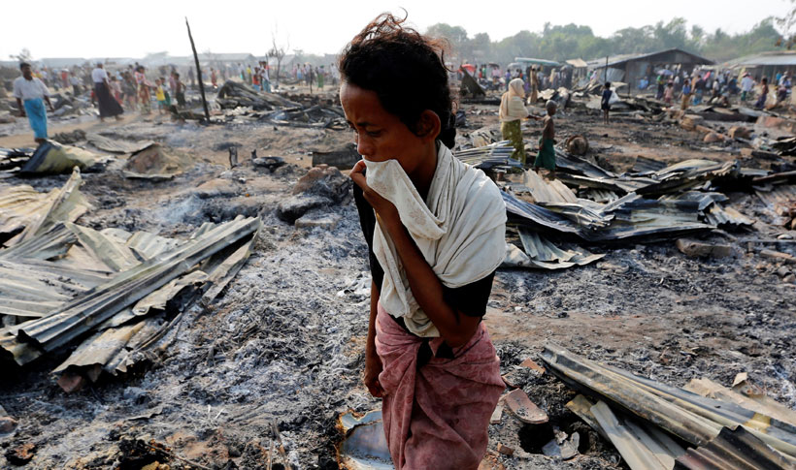A woman walks among debris after fire destroyed shelters at a camp for internally displaced Rohingya Muslims in the western Rakhine State near Sittwe, Myanmar May 3, 2016. (Photo: Soe Zeya Tun/Reuters)

Violence broke out in 2012, when a group of Rohingya men were accused of raping and killing a Buddhist woman. Groups of Buddhist nationalists burned Rohingya homes and [killed](http://america.aljazeera.com/articles/2015/5/12/up-to-6000-rohingya-bangladeshi-migrants-stranded-at-sea.html) more than 280 people, displacing tens of thousands of people. Human Rights Watch described the anti-Rohingya violence as amounting to [crimes against humanity (PDF)](http://www.hrw.org/sites/default/files/reports/burma0413webwcover_0.pdf) carried out as part of a “campaign of ethnic cleansing.” Since 2012, the region’s displaced population has been forced to take shelter in squalid refugee camps. More than [120,000 Muslims](http://www.fortifyrights.org/jointstatement-20160808.html), predominantly Rohingya, are still housed in more than forty internment camps, according to regional rights organization Fortify Rights.

Many Rohingya have turned to smugglers, choosing to pay for transport out of Myanmar to escape persecution. “The fact that thousands of Rohingya prefer a dangerous boat journey they may not survive to staying in Myanmar [speaks volumes](http://www.amnesty.org.au/news/comments/37179/) about the conditions they face there,” says Amnesty International’s Kate Schuetze. Fleeing repression and extreme poverty, more than eighty-eight thousand migrants [took to sea](http://www.iom.int/infographics/southeast-asia-migration-routes-19-may-2015) from the Bay of Bengal between January 2014 and May 2015, according to the International Organization for Migration (IOM). The flow of migrants slowed in the second half of 2015 after thousands were abandoned at sea. Though [volume (PDF)](http://reporting.unhcr.org/sites/default/files/UNHCR%20-%20Mixed%20Maritime%20Movements%20in%20South-East%20Asia%20-%202015.pdf) of migration has abated and the crisis has fallen from international view, little has been done to address the status quo for Rohingya in Myanmar and for those who brave the maritime journey.

*“An international response that consists primarily of assigning blame for this humanitarian tragedy is no longer tenable. It is time for the international community to organize a realistic, workable solution.”— Priscilla Clapp, senior advisor at the United States Institute of Peace and former U.S. mission chief in Myanmar.*

Where are they migrating?

* **Bangladesh**: Many Rohingya have sought refuge in nearby Bangladesh, which [hosts (PDF)](http://reporting.unhcr.org/sites/default/files/UNHCR%20Bangladesh%20Factsheet%20-%20MAR16.pdf) more than thirty-two thousand registered refugees; more than two hundred thousand additional unregistered Rohingya refugees are believed to live in the country, according to UN High Commissioner for Refugees estimates. However, conditions in most of the country’s refugee camps are [dire (PDF)](http://www.hrw.org/sites/default/files/reports/burma0413webwcover_0.pdf), driving many to risk a perilous voyage across the Bay of Bengal.
* **Malaysia**: As of June 2016, more than [90 percent](http://news.trust.org/item/20160830030159-t1h1q/) of Malaysia's 150,700 registered refugees are from Myanmar, including tens of thousands of Rohingya, according the UN. Rohingya who have arrived safely in Malaysia have [no legal status](http://www.aljazeera.com/indepth/inpictures/2016/06/rohingya-children-malaysia-undocumented-life-160620042659161.html) and are [unable to work](http://www.nytimes.com/2016/07/06/world/asia/rohingya-malaysia-myanmar.html), leaving their families cut off from access to education and healthcare.
* **Thailand**: Thailand is a hub for regional human smuggling and trafficking activities and serves as a common transit point for Rohingya. Migrants often arrive by boat from Bangladesh or Myanmar before moving on foot to Malaysia or continuing by boat to Indonesia or Malaysia. A 2013 Reuters report [found](http://uk.reuters.com/article/2013/12/05/uk-thailand-rohingya-special-report-idUKBRE9B400920131205) that some Thai authorities were colluding with smuggling and trafficking networks in the exploitation of detained Rohingya. In its [2016 Trafficking in Persons report (PDF)](http://www.state.gov/documents/organization/258876.pdf), the U.S. State Department upgraded Thailand to Tier 2 Watch List, from the bottom Tier 3 ranking, after having been identified as a source, destination, and transit country for men, women, and children who are subject to trafficking. (In 2016, Indonesia ranked as Tier 2, Malaysia as Tier 2 Watch List, and Myanmar was downgraded to Tier 3.) Since taking power in 2014, the military-led government in Bangkok has [prioritized](http://www.nationmultimedia.com/politics/Trafficking-fight-national-priority-30257406.html) a crackdown on smuggling and trafficking rings after the discovery of mass graves in alleged detention camps. But some experts say that new punitive measures directed at traffickers were responsible for the uptick in abandoned vessels at sea—a development that worsened the humanitarian crisis.
* **Indonesia**: The Rohingya have also sought refuge in Indonesia, although the number of refugees there remains relatively modest. During the spring 2015 migration surge, Indonesia’s military chief expressed concerns that easing immigration restrictions would [spark an influx](http://www.npr.org/sections/thetwo-way/2015/05/15/407048785/why-no-one-wants-the-rohingyas) of people. Amid international pressure, Indonesia admitted one thousand Rohingya and provided them with [emergency assistance](http://reporting.unhcr.org/node/10335?y=2016#year) and protection.

At the height of the migration crisis in May 2015, international pressure peaked and Indonesia and Malaysia offered [temporary shelter](http://www.nytimes.com/2015/05/21/world/asia/indonesia-malaysia-rohingya-bangladeshi-migrants-agreement.html) to thousands of migrants, Malaysia [launched](http://www.cnn.com/2015/05/21/asia/malaysia-migrants-rescue/index.html) search-and-rescue missions for stranded migrant boats stranded, and Thailand agreed [to halt push backs](http://www.channelnewsasia.com/news/asiapacific/thailand-won-t-push-back/1860500.html). Myanmar’s navy also conducted initial [rescue missions](http://www.scmp.com/news/asia/southeast-asia/article/1806944/myanmar-conducts-first-rescue-migrant-boat-208-people) at the end of the month. Joe Lowry, the Asia spokesman for the IOM, characterized the ad hoc regional response to the crisis as, “a game of [maritime ping-pong](http://www.nytimes.com/2015/05/15/world/asia/burmese-rohingya-bangladeshi-migrants-andaman-sea.html).”

*“The two major communities have to move beyond decades of mistrust and find ways to embrace shared values of justice, fairness, and equity.”—Kofi Annan, former UN Secretary General*

What is being done to address the migration crisis?

Myanmar’s first civilian government—led by Aung San Suu Kyi’s opposition National League for Democracy (NLD) party—won in [landslide elections](https://www.theguardian.com/world/2015/nov/13/aung-san-suu-kyi-wins-myanmar-landmark-election) in November 2015. While the cabinet ministers include a mix of political and ethnic representatives, critics say the NLD has been reluctant to advocate for the Rohingya and other Muslims because of the party’s need to cultivate support from Buddhist nationalists. Nevertheless, Aung San Suu Kyi, who has long vowed to push for national peace and reconciliation, established a [nine-person commission](http://www.voanews.com/a/kofi-annan-to-lead-comission-on-myanmar-s-rakhine-state/3478917.html) in August 2016, led by former UN Secretary-General Kofi Annan, to discuss options for resolving the ethnic strife in Rakhine state. The advisory committee, whose final report is expected by the end of August 2017, is intended to make recommendations to reduce communal tension and support much-needed development efforts in the impoverished state. “To build the future, the two major communities have to move beyond decades of mistrust and find ways to [embrace shared values](http://www.aljazeera.com/news/2016/09/kofi-annan-vows-stay-impartial-leading-commision-160907074315313.html) of justice, fairness, and equity,” Annan said on his first visit to Sittwe, the capital of Rakhine.

Some analysts are skeptical that the democratic election of a civilian government will do anything to change the fate of the Rohingya, while others have said the creation of the new advisory body offers a rare glimmer of hope for resolving the problem.

Regionally, no unified or coordinated ASEAN response has been proposed to address the deepening crisis. States in Southeast Asia [lack established legal frameworks](http://www.unhcr.org/pages/49e4884c6.html) to provide for the protection of rights for refugees.

Indonesia, Malaysia, Myanmar, and Thailand—all ASEAN members—have yet to ratify the UN Refugee Convention and its Protocol. ASEAN itself has been silent on the plight of the Rohingya and on the growing numbers of asylum-seekers in member countries largely because of the organization’s commitment to the [fundamental principle](http://www.asean.org/asean/about-asean/overview) of noninterference in the internal affairs of member-states. Lilianne Fan of the London-based Overseas Development Institute says that while ASEAN has the capacity to manage this crisis, member states lack the [political will](http://www.irrawaddy.org/asia/boat-people-crisis-a-test-for-aseans-humanitarian-resolve.html) to resolve it.

Advocacy groups like Human Rights Watch, the Arakan Project, and Fortify Rights, a Southeast Asia-based advocacy group, continue to appeal to major international players to exert pressure on Myanmar’s government. Some, like *New York Times*columnist Nicholas Kristof, argue that the United States should not have [normal relations](http://www.nytimes.com/2015/05/14/opinion/nicholas-kristof-crisis-at-sea.html) with the country until its persecution of the Rohingya ends and that investment and aid should be linked to progress on the protection of minority rights. Others, like senior advisor at the United States Institute of Peace and former U.S. mission chief in Myanmar Priscilla Clapp, say that placing sole blame on Myanmar [oversimplifies](http://www.rfa.org/english/commentaries/rohingya-08032012124109.html) and misrepresents the complexities of the country’s historical ethnic diversity. “An international response that consists primarily of [assigning blame](http://www.usip.org/olivebranch/2015/05/27/se-asian-migrant-emergency-cries-global-solution) for this humanitarian tragedy is no longer tenable. It is time for the international community to organize a realistic, workable solution,” writes Clapp.

To date, the United States and other global powers have [urged the central government](http://www.reuters.com/article/us-myanmar-usa-rohingya-idUSKCN0IY0VN20141114) in Myanmar to do more to protect ethnic minority groups from persecution. Still, experts say more must be done to address the plight of the Muslim minority to prevent it becoming “a flashpoint for further social and religious destabilization,” as Clapp writes in a [March 2016 CFR report](http://www.cfr.org/burmamyanmar/securing-democratic-future-myanmar/p37681). She argues that Washington should assist economic development and conflict mediation in Rakhine state: “The United States should be leading an international effort to find a humane solution to their plight, not only in Myanmar but in other countries as well.”