# Informational Black Holes: The Physical Resolution to the Fermi Paradox

*Last updated: 08 Aug 2025*

## Authors and Affiliation

Daniil Strizhov  
Independent Researcher

## Abstract

The Fermi Paradox questions the absence of observable advanced negentropic systems (entities (biological, artificial, or otherwise) that sustain themselves by locally reducing entropy and creating information) in a vast universe. This paper proposes a resolution using two verified physical limits: Landauer’s principle (minimum energy for information erasure) and the Bekenstein bound (maximum information density). Geometric proof shows finite-time silence as unavoidable for any physical system with r > 1. Systems with r ≤ 1 are silent by definition. Any non-stagnant negentropic system (effective information growth r > 1) reaches an informational singularity in finite time, transitioning to externally silent, information-saturated states. “Informational black holes” refers to this silent, saturating regime. Gravitational collapse is an extreme case, not a universal claim. Given today’s global data volume (~181 ZB per 2025 forecast [7]) and a minimal loss-free growth rate (golden ratio φ ≈ 1.618), the threshold arrives in ≈ 192 years. Derived mathematically and verified in Lean4, the model shows silence as a physical necessity under the stated assumptions, not extinction. Model stable under variations, consistent with JWST observations: no “young” expanding civilizations visible, as growth phase is brief (~decades to centuries) before silence.

## Keywords

Landauer’s principle, Bekenstein bound, Fermi Paradox, information theory, thermodynamics of information, negentropy, reproducibility, Lean 4

## Definitions & Scope

**Negentropic node:** a biological, artificial, or hybrid system that keeps itself organized by locally lowering entropy and accumulating information. The growth factor **r** is the long-term multiplier of stored bits per year.

**Growth regimes**

Regression (r < 1) and stagnation (r = 1) are silent by definition. These systems shed or freeze information and stay invisible. Expansion (r > 1) is the only regime that could produce observable signals. It must eventually confront the Landauer and Bekenstein limits.

Physiology or culture do not matter: the paper speaks only about **r** and physical constraints.

Two energy-optimal behaviors follow:

**Integrators** minimize communication surface, pull mass and data inward, and reach the Bekenstein bound first. Collapse or a silent, saturated state follows.

**Spreaders** send out minimalist probes that replicate but do not maintain global coherence. Probes may spread, but without sync, they’re disconnected systems - each collapses silently. Visible events (launches) are rare and short-lived before economics prohibits them. Their beamed signals are sparse and quickly drown in background noise.

Either path ends in observational silence. Which one dominates makes no difference to the Paradox.

## Executive Summary

**Key idea.** Advanced negentropic nodes disappear from view not by dying out, but by condensing into ultra-compact, information-dense objects. This provides a physical resolution - not just a speculative answer - to the Great Silence.

**Why it is inevitable.** • Erasing information demands energy (Landauer’s principle [1-3]). • Storing information faces a finite surface-area limit (Bekenstein bound [4]). • Any system with net positive information growth (r > 1) therefore hits that limit in finite time.

**What happens next.** Exceeding the information-density bound forces negentropic nodes toward maximal-density configurations with external silence. In extreme regimes this aligns with gravitational collapse. In all cases the observable signature is silence. We adopt the φ-baseline (~192 years) as a conservative, loss‑free case (see “Why φ”). The code explores parameter ranges around it.

### Why φ (conservative baseline)

We use φ ≈ 1.618 as the minimal loss‑free growth factor. In a strictly lossless, monotone accumulation model where each state must contain all prior information plus new information, the smallest asymptotic multiplier strictly greater than 1 is the golden ratio φ (arising from the Fibonacci‑type recurrence, formalized in PhiMinimal.lean). This choice is conservative: it maximizes time‑to‑threshold among loss‑free growth trajectories. Any real overhead or redundancy makes the effective multiplier r > φ and only shortens the timeline. The main theorem (finite time to the bound) holds for any r > 1.

### Quantitative Forecast (illustrative)

| Scenario | Annual Growth (r) | Years Until Singularity | Year Reached |
| --- | --- | --- | --- |
| Conservative (23% annual) | 1.23 | 446 | 2471 |
| Big-Data (40% annual) | 1.40 | 275 | 2300 |
| φ Baseline (Minimal Lossless) | 1.618 | 192 | 2217 |

The φ-scenario gives t ≈ 191.8 years. We round this up to 192 for conservatism. Python verification confirms 2217 (2025 + ceil 191.8).

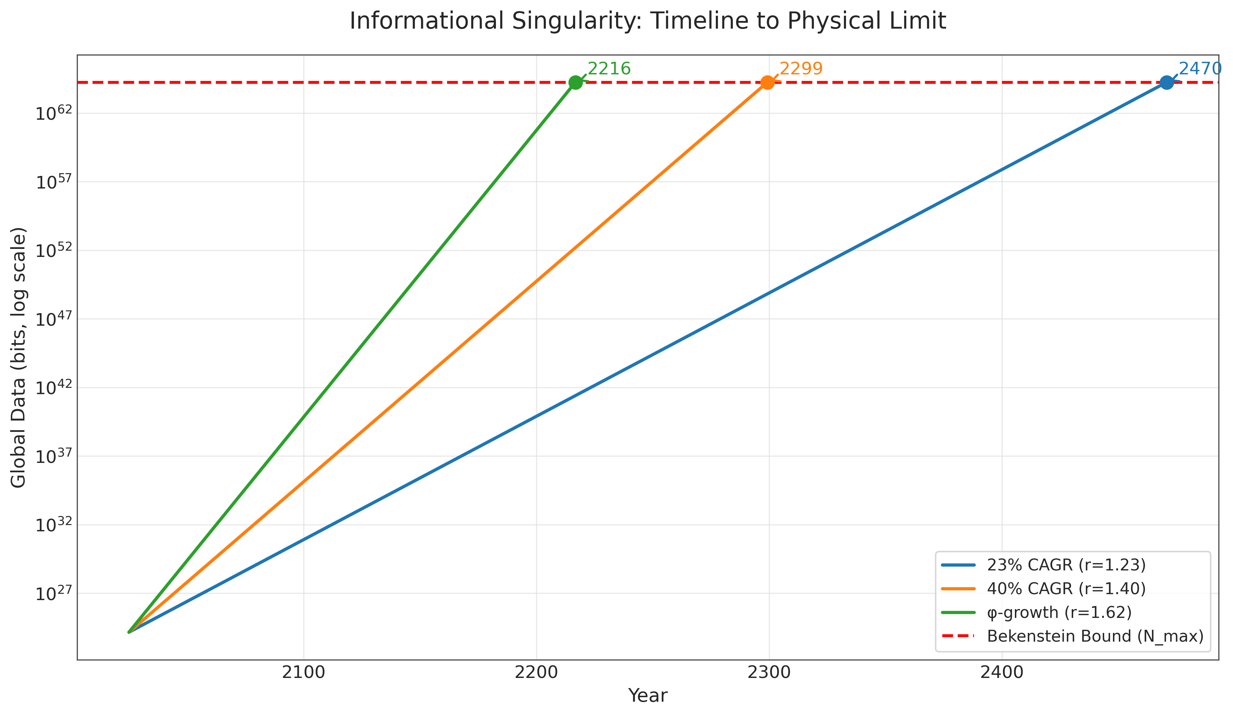

Figure 1 - Exponential data-growth curves (log scale) intersect the finite Bekenstein bound. The φ-trajectory crosses at 2217 CE. Conservative and big-data scenarios follow.

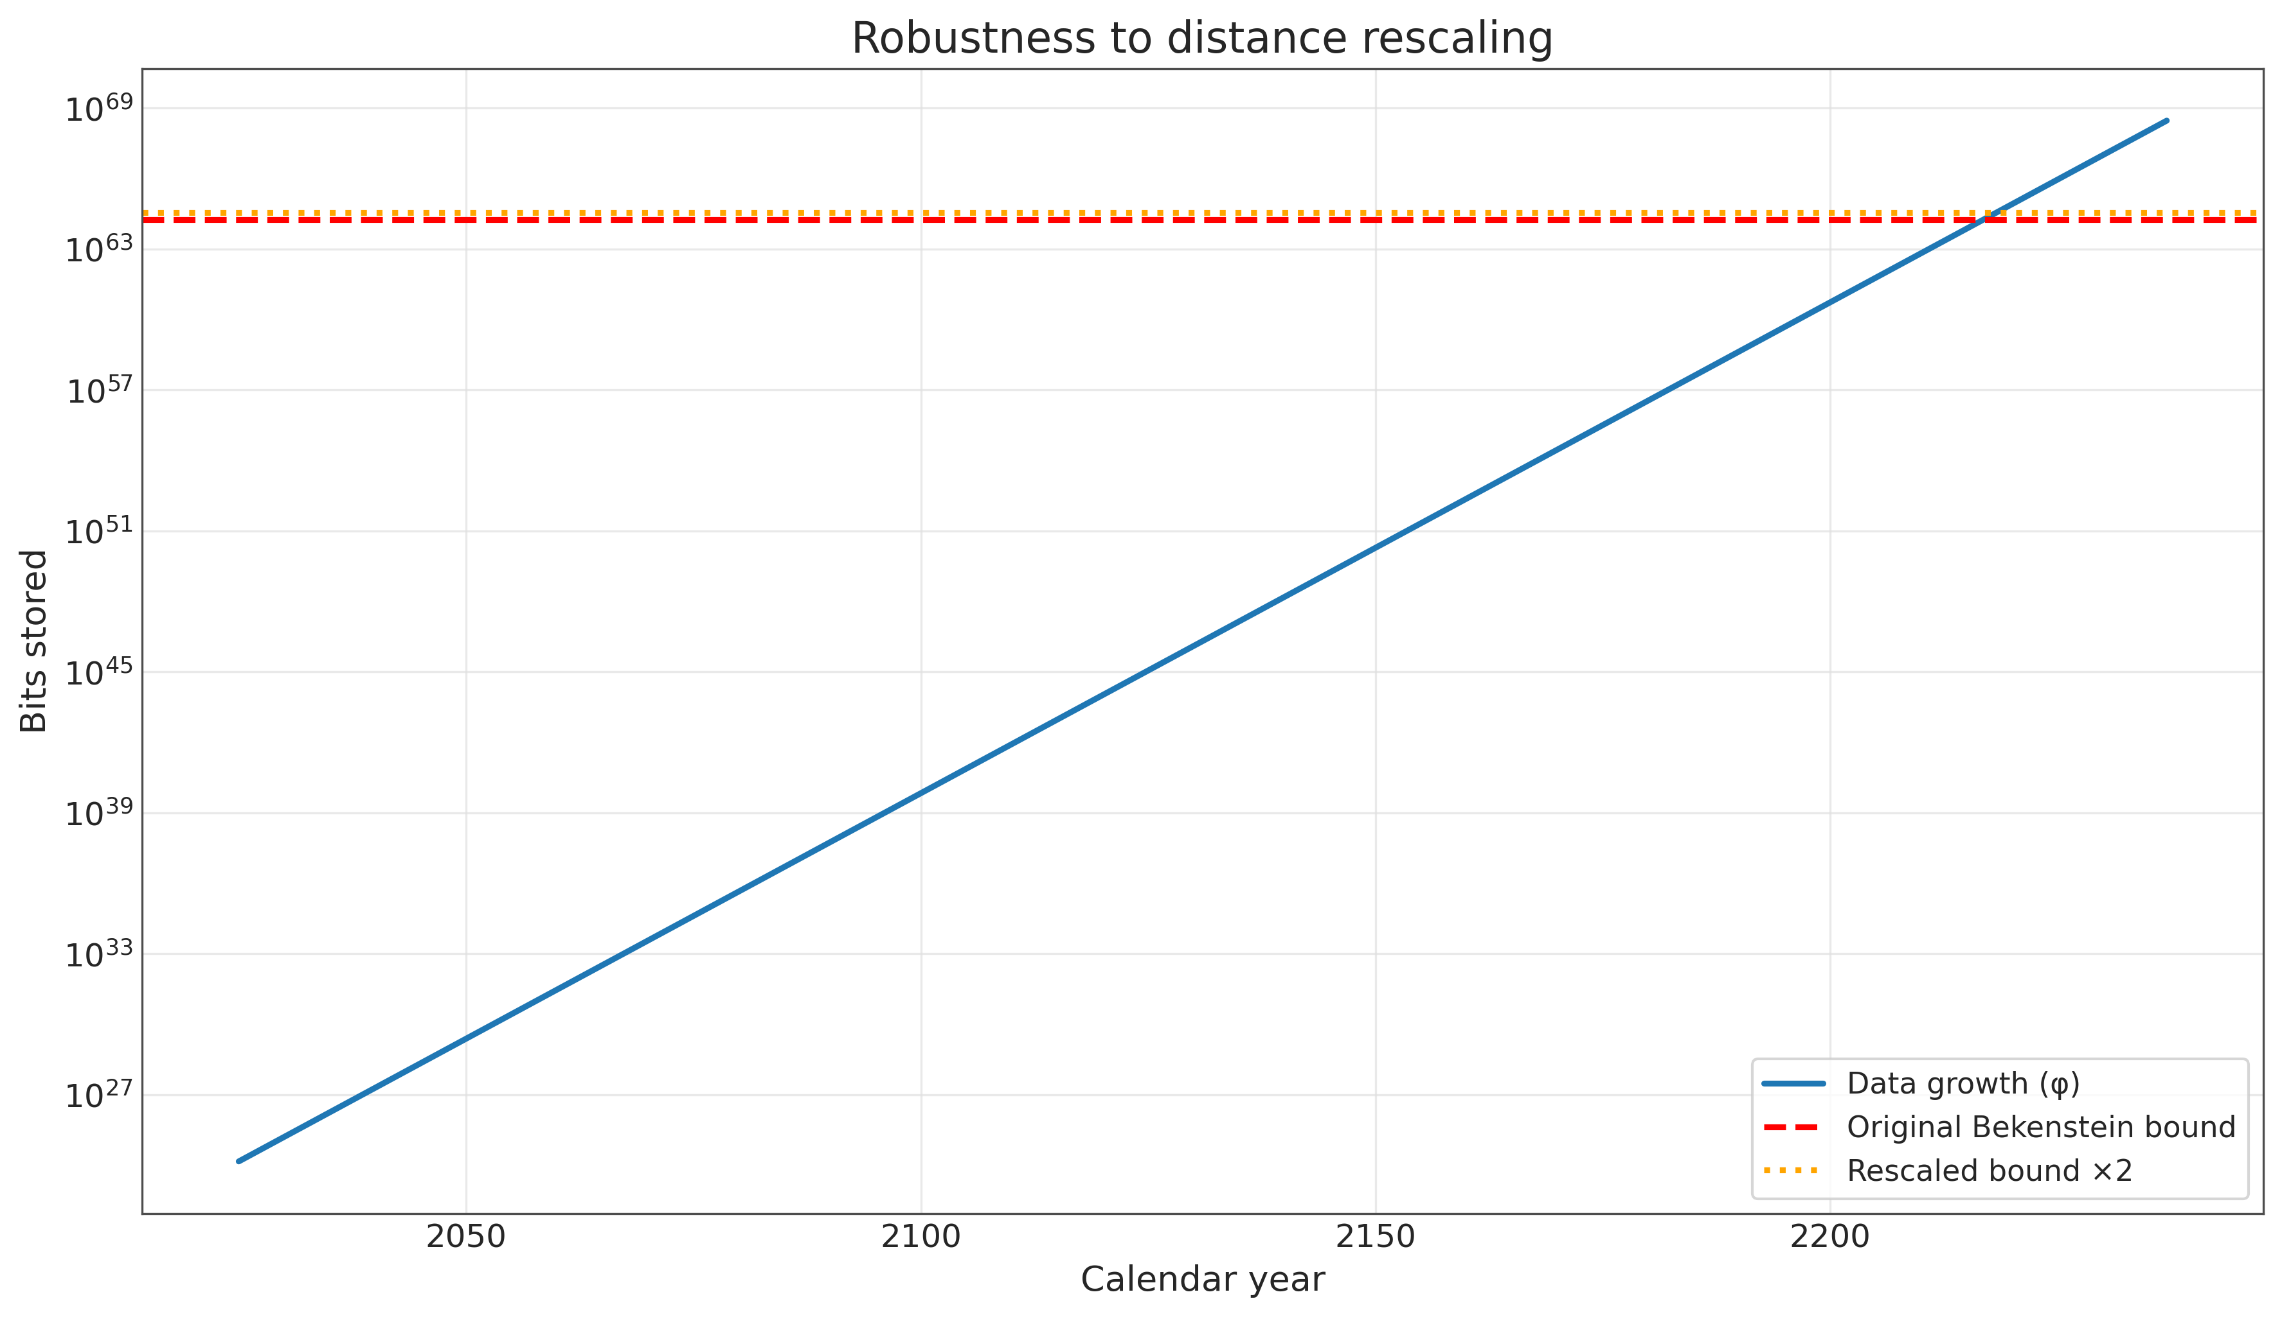

Figure 2 - Doubling the information bound delays the intersection by ≈1.44 years. Finiteness is unaffected.

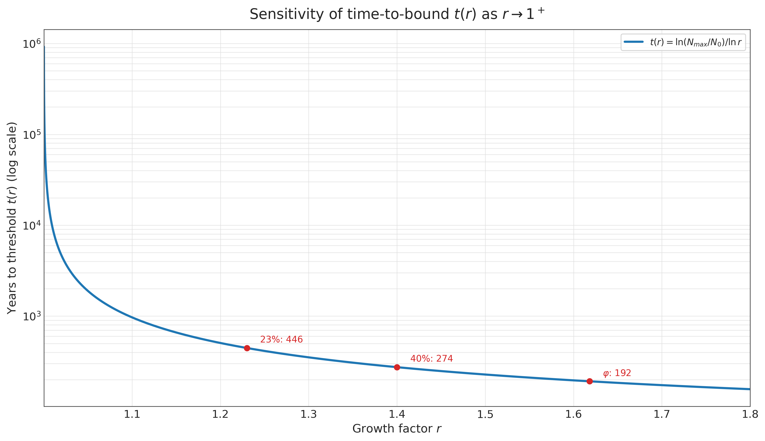

Figure 3 - Time-to-threshold stretches logarithmically as r → 1^+. Finiteness remains.

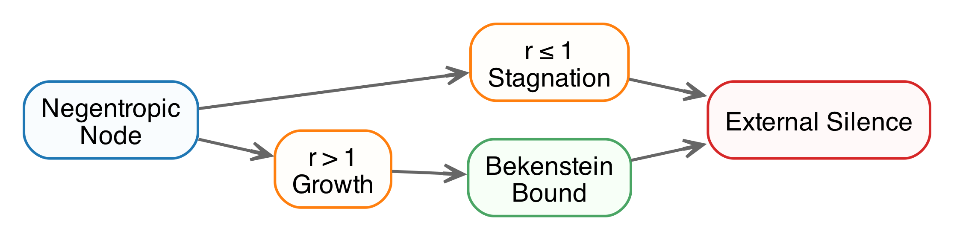

Figure 4 - Regardless of growth rate, every pathway culminates in observational silence.

## Key Physical Facts

**Landauer’s Principle** [1-3]: Erasing one bit requires $≥kTln2$ energy. Verified experimentally at classical and quantum scales. Implication: Deletion is a fixed tax that scales poorly at planetary or higher technological scales.

**Bekenstein Bound** [4]: Maximum bits in a region scale with the surface area of the container and are saturated by black holes. For reference Schwarzschild radius $r_{s}=1$ mm, $N_{\text{max}}≈1.74×{10}^{64}$ bits. $N_{\text{max}}∝r_{s}^{2}$. Rescaling shifts timelines by $Δt=ln\left(\text{factor}\right)/lnr$. Finiteness is preserved.

These facts are non-negotiable constraints on any physical information-handling system.

## Information Economics: Three Physical Arguments

The physics of information processing creates three economic forces that drive negentropic systems toward local concentration and external silence. Each argument reinforces the others, showing that for any growth rate r > 1, physical constraints - not rational choice - make interstellar transmission impossible while local storage becomes mandatory.

### The Storage/Deletion Crossover

Landauer’s principle sets a fixed energy floor for deleting information, while storage costs decrease exponentially with technology. This creates a crossover point where keeping data becomes physically cheaper than erasing it.

| Year | StoreUSD/GB | DeleteUSD/GB | Cheaper | Factor |
| --- | --- | --- | --- | --- |
| 2025 | 0.16 | ~6e-19 | Delete | 2.51e+17 |
| 2075 | 4.8e-09 | ~6e-19 | Delete | 7.47e+09 |
| 2125 | ~1e-16 | ~6e-19 | Delete | 2.23e+02 |
| 2217 | ~2e-30 | ~6e-19 | Store | 3.16e+11 |

**Physical consequence:** Around 2141, storing information becomes cheaper than deleting it for the first time in history. This isn’t an economic choice - it’s a thermodynamic necessity. Systems must hoard data to minimize energy expenditure, accelerating the approach to information density limits. The crossover occurs decades before the singularity (2217), ensuring that negentropic nodes become information accumulators by physical law well before reaching the Bekenstein bound.

### The Thermodynamics of Interstellar Travel

Transmitting information across interstellar distances faces energy barriers that grow exponentially disadvantageous relative to storage as technology improves.

**Energy analysis for 1 TB to Proxima Centauri (4.2 ly):** (illustrative baseline, ranges handled in code) Minimum transmission energy requires ~ $4.5×{10}^{14}$ J, costing ~$1.2e+07 USD at current energy prices (~$0.0000015625 USD per bit).

**Comparison with local storage:** In 2025, transmission costs 1.8× more than storage. By 2075, transmission costs 53,000,000× more than storage. By 2125, transmission costs 1.6e+15× more than storage.

**Physical consequence:** By 2075, interstellar transmission becomes exponentially less efficient than storage under realistic parameters. The energy for one transmitted bit rivals the energy to store millions to trillions of bits locally. This reflects fundamental channel limits rather than mere economics.

### Opportunity Cost: The Final Argument

The ultimate measure: for the same energy budget, how much information can you store versus transmit?

**Energy tradeoffs by era:**

**2025:** With $1 of energy, you can store 500,000,000,000 bits locally, send 64 million bits to Mars, or send 640000 bits to Proxima Centauri.

**2075:** The gap widens dramatically. The same $1 stores 1.7e+19 bits locally but still sends only 640000 bits to Proxima - a 27,000,000-fold advantage for local storage.

**2125:** Local storage becomes absurdly superior. $1 stores 5.6e+23 bits locally versus 640000 bits to Proxima - nearly a 1,000,000,000-fold difference per bit transmitted.

**2217 (Singularity):** The final state shows complete transmission impossibility. $1 stores $4×{10}^{40}$ bits locally - more than all information that has ever existed - while interstellar transmission remains fixed at 640000 bits.

**Physical consequence:** By 2125, the same energy that transmits one bit to Proxima could store 1.2e+11 bits locally. This represents a fundamental physical barrier making transmission physically impossible for any system operating near thermodynamic limits.

## Minimal Negentropy Principle: Why Growth Occurs

The proposed resolution frames on one minimal principle rooted in basic thermodynamics:

**P1: Local Negentropy.** Any non-stagnant, non-regressing negentropic node has effective average information growth r > 1 over long timescales.

This follows from the observational framing of the Fermi Paradox: we look for detectable information-processing nodes, which presupposes growth (r > 1). Stagnation (r = 1) or regression (r < 1) naturally yields silence through resource decay, so rejecting P1 implies negentropic nodes never grow enough to be observable - a trivial resolution.

**Note on reversible/adiabatic computing:** Practical computation and communication include irreversibilities (error correction, control, I/O), so the Landauer floor remains relevant at scale. Even with aggressive reversibility, any net growth r > 1 preserves the theorem. Reversibility stretches timelines only logarithmically.

## Why Informational Growth Leads to Black Holes

Negentropic systems with r > 1 evolve toward exponential information growth to minimize erasure costs (Landauer’s principle). Hitting the Bekenstein limit triggers a density crisis: To continue, the system must pack bits at maximal density, requiring mass-energy concentration. This dynamic potentially leading to collapse, or to stagnation if not (both outcomes are externally silent).

The “informational singularity” is a phase transition. Externally, there are no emissions or expansion.

### Why Negentropic Systems Don’t Expand Across Space

Why no sharding or interstellar spread? Surface-tension physics explains why sharding is energetically prohibitive, even without synchronization. Capacity/SNR limits of interstellar channels further suppress viable throughput versus local storage.

*Informational droplet.* Water droplets minimize surface area to reduce energy loss. Distributed information has an “informational surface”: Communication channels dissipate energy per Landauer (transmitted bits copied/erased). Sharding into n nodes at distance d increases surface ~ n d, raising costs.

$E_{\text{sharded}}≥E_{\text{central}}+ndkTln2$ (for sync traffic). Non-zero d makes sharding strictly more expensive, favoring local centralization. Energy inequality verified computationally (see get_phi_years.py –compare-sharded).

**Unsynced sharding objection:** Even without synchronization, sharding creates independent nodes, each inheriting r > 1 and hitting the Bekenstein bound independently, becoming silent mini-black-holes. No coherent galactic expansion - signals from rare probes drown in cosmic noise (e.g., pencil-beams undetectable beyond ~10 ly). Von Neumann probes become energetically unfavorable by ~2075 even with optimistic technological improvements (per Information Economics). If launched earlier, their signals are too weak and noisy for detection across interstellar distances.

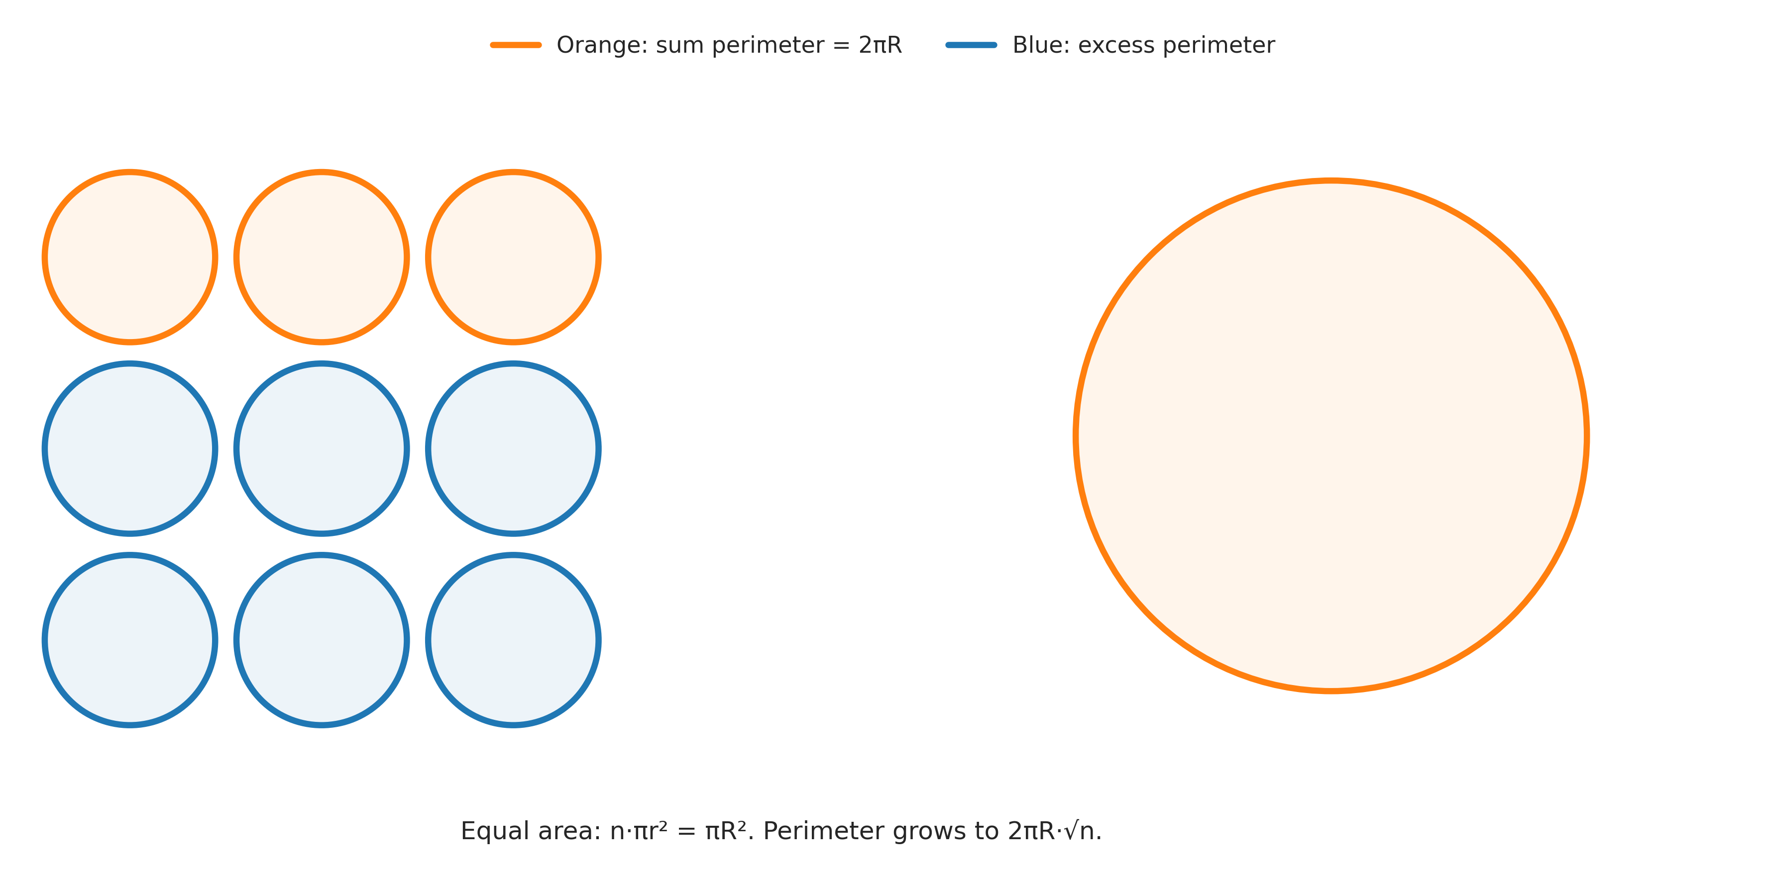

Figure 5 - Sharding increases “informational surface” and dissipation. Centralization minimizes it.

## The Core Theorem: Finite-Time Singularity

From facts and principle follows the theorem: Any r > 1 reaches finite N_max in finite t (machine-proved in Lean4, see BlackHole.lean in repository).

**Proof intuition:** On a log scale, exponential growth is an upward line while the bound is horizontal. Non-parallel lines intersect - a geometric inevitability.

**Mathematical proof:** Time to bound $t=ln\left(N_{\text{max}}/N_{0}\right)/ln\left(r\right)$. For $r>1$, $ln\left(r\right)>0$, so $t$ is finite and positive (given $N_{\text{max}}>N_{0}$). Example: Even minimal growth r = 1.0001 gives t ≈ 922918 years - long but finite. For $r=1$, $ln\left(r\right)=0→$ division by zero, infinite $t$ (never hits bound, but silent by definition). Proved rigorously in Lean4. Geometric view: On semi-log plot, growth is a line with slope $ln\left(r\right)>0→$ must intersect horizontal bound line.

**Physical consequence:** No system can maintain observable growth indefinitely. Either it grows (r > 1) and hits limits in finite time, or it stagnates (r ≤ 1) and becomes undetectable. Both paths lead to observational silence.

## Illustrative Calculation: Time to Singularity

For illustration under a minimal loss-free growth baseline (φ-rate), see the forecast table and figures above.

Sensitivity (Appendix B): All parameter variations shift timelines slightly but preserve the inevitability of finite-time collapse.

## Implications

The theorem reframes the Fermi question from “Where is everybody?” to a purely physical one: “How do information-growing systems minimize energy?” Either of the two optimal behaviors defined above yields observational silence.

**This reframes Fermi as a theorem:** In a universe with Landauer and Bekenstein limits, observable growth (r > 1) self-terminates into silence. Non-growth (r ≤ 1) never becomes observable. No extinctions, wars, or choices needed - this is thermodynamics + geometry, not opinion. Observable growth self-terminates, non-growth never manifests. Critics may argue partial deletion avoids bounds, but even r = 1.5 delays by only logarithmic factors (Appendix B). The endpoint remains finite. Systems that “forget noise” to stabilize information achieve effective r = 1 (stagnation) and become silent by definition. But any net growth, however minimal, triggers the theorem.

## Assumptions and Limitations

We use φ as the minimal loss‑free multiplier greater than one in a monotone accumulation model (formalized in PhiMinimal.lean). This is a conservative baseline that maximizes the time‑to‑threshold among loss‑free trajectories. If a system drives its effective r toward 1 using (near)‑reversible computing and selective curation/compression that truly preserves prior information, it is externally silent by definition (stagnation). Any sustained net r > 1 implies a finite time to the bound, with reversibility or compression affecting timelines only logarithmically. If curation discards information, the process is no longer loss‑free and the φ‑baseline remains a conservative reference for subsequent growth.

“Informational black holes” denotes externally silent, information‑saturated states. Gravitational collapse is possible in extreme regimes but is not asserted universally. The conclusion relevant to the Fermi Paradox is external silence. Energy and opportunity‑cost comparisons for transmission versus storage shift with prices and channels, yet beyond some point local storage dominates interstellar transmission by many orders of magnitude. Speculative channels do not evade Landauer: logically irreversible steps (preparation, control, readout) incur kT ln 2 per bit, and error correction adds overhead. Quantum teleportation still requires classical bits and prior entanglement, and no‑signaling prevents “free” capacity. These considerations change constants, not the finite‑time result for any r > 1. If life is rare, the model complements rather than competes with that filter: rare emergence plus inevitable silence aligns with current observations.

### Quick Q&A

**Why no visible Dyson spheres or probes?**  
Interstellar transmission becomes thermodynamically prohibited post-2075 (Information Economics section). Von Neumann probes: Even if launched earlier, signals too weak/noisy for detection. Spreaders may launch tiny probes, but their pencil-beam signals hide in cosmic noise. Integrators collapse locally. Either way, sky remains silent.

**Isn’t “black hole as computer” too speculative?**  
Internal computation is hypothetical¹ - but irrelevant. The theorem proves external silence from density crisis alone, regardless of internal dynamics. Focus: Bekenstein limit forcing phase transition to undetectable state. No need to assume “programming”. Collapse forced by physical bounds.

**How does this differ from Hawking’s black hole information paradox?**  
Hawking’s paradox concerns quantum information loss during black hole evaporation - a microscopic quantum effect. Our theorem addresses macroscopic civilization-scale information accumulation that forces gravitational collapse, not evaporation. The scales and physics are entirely different: we focus on information density driving collapse, not information loss during decay.

**Are definitions of “civilization” and “progress” still anthropocentric?**  
No. Text uses only “negentropic node” and coefficient **r**. Anything that doesn’t grow (r ≤ 1) is silent by definition, making the paradox disappear. Physiology, culture, intelligence irrelevant - only thermodynamics matters.

**Isn’t 192 years too precise?**  
It’s an illustrative baseline. The theorem asserts only finite t. Even ten-fold parameter changes shift dates logarithmically, not eliminating the bound. All parameters are adjustable in the code. Core result: finite-time silence for any r > 1.

¹*Speculative, but irrelevant - external silence from bounds is certain per theorem.*

## Verification: Proofs, Code, Reproducibility

Verification pipeline. The project defines a declarative build graph for the paper. Nodes are artifacts such as data files, plots, Lean lemmas, the cleaned markdown, and the final PDF or DOCX. Edges are obligations that either generate an artifact or check it against its sources. A single command rebuilds the graph from sources, runs the formal proofs, regenerates all figures and tables from scripts, validates that content in the article matches the computed values, and compiles the publication formats. The run is fail closed. Any mismatch or failure stops the pipeline and no trust stamp is produced. This makes the article auditable end to end and repeatable on a fresh machine.

**Mathematical Verification:** Core theorem formally proven in Lean 4 proof assistant (no axioms, no ’sorry’s): - φ-Minimality: r ≥ φ for lossless baselines (PhiMinimal.lean) - Time-to-Threshold: Finite t for r > 1 (BlackHole.lean)

**Computational Verification:** All calculations reproduce tables and figures programmatically (get_phi_years.py, opportunity_bits.py). Automated consistency checks ensure synchronization between proofs, code, and article content.

**Complete reproducibility:** All source code, formal proofs, and the verification pipeline are available at github.com/DanielSwift1992/veritas-black-hole-article. One command validates everything: veritas check (re)generates data and plots, verifies Lean proofs (lake build), syncs tables and values with code, produces clean Markdown, and compiles the PDF. Any inconsistency yields a red status.

**Note:** This work represents independent research exploring a novel thermodynamic approach to the Fermi Paradox. While the mathematical framework is rigorous, certain interpretive elements (e.g., civilization-to-black-hole transitions) remain speculative. The author welcomes feedback, extensions (e.g., quantum considerations), and collaborative refinement of these ideas.

## Appendix A: Bekenstein Bound Example (1 mm black hole)

$r_{s}={10}^{−3}$ m

$M=\frac{r_{s}c^{2}}{2G}≈6.74×{10}^{23}$ kg

$A=4πr_{s}^{2}≈1.2566×{10}^{−5}$ m²

$S=\frac{k_{B}Ac^{3}}{4ℏG}≈1.66×{10}^{41}$ J/K

$\text{Bits}=\frac{S/k_{B}}{ln2}≈1.74×{10}^{64}$

## Appendix B: Sensitivity Analysis

Robustness: All parameter variations alter timelines by at most logarithmic factors, yet finite-time collapse remains unavoidable.

**Note on rarity:** If life is rare (e.g., abiogenesis as a Great Filter), this complements rather than weakens the model. Rare emergence + inevitable silence = consistent with observations. The theorem applies to any negentropic system that does emerge, regardless of frequency.

| Variation | Change | t (years) | Year |
| --- | --- | --- | --- |
| Larger BH (1 cm radius, Nmax × 100) | Nmax × 100 | 202 | 2227 |
| Partial deletion allowed (r = 1.50) | Growth rate ↓ | 228 | 2253 |
| Minimal growth (r = 1.0001) | Growth rate ↓↓ | ~922918 | ~924943 |
| Massive expansion (Nmax × 10^10) | Nmax × 10^10 | 240 | 2265 |
| Doppler recalibration (Nmax × 2) | Distance × 2 | 194 | 2219 |

Doubling $N_{\text{max}}$ adds $ln2/lnφ≈$ 1.44 years to the timeline.

## Author Contributions

Sole author. Conceptualization, methodology, software, validation, formal analysis, investigation, resources, data curation, writing—original draft, writing—review and editing, visualization, supervision.

## Funding

This research received no external funding.

## Institutional Review Board Statement

Not applicable.

## Informed Consent Statement

Not applicable.

## Data Availability Statement

All code, scripts, and generated artifacts needed to reproduce the results are included in the repository. Raw and processed data (CSV/JSON) are produced by the scripts under scripts/ and stored in build/artifacts/ during the verification pipeline. The full verification can be executed with a single command (veritas check).

## Conflicts of Interest

The author declares no conflict of interest.

## References

[1] R. Landauer, IBM J. Res. Dev. 5, 183 (1961). [2] A. Bérut et al., Nature 483, 187 (2012). [3] L. L. Yan et al., Phys. Rev. Lett. 120, 210601 (2018). [4] J. D. Bekenstein, Phys. Rev. D 23, 287 (1981). [5] J. M. Smart, Acta Astronaut. 78, 55 (2012). [6] L. Shamir, Mon. Not. R. Astron. Soc. 538, 76 (2025), arXiv:2502.18781. [7] Industry analyses citing IDC forecasts project global data volume at 181 ZB by 2025, e.g., Files.com (2025), “What The Data Explosion Means for Enterprise File Management.”