Tried Running the project

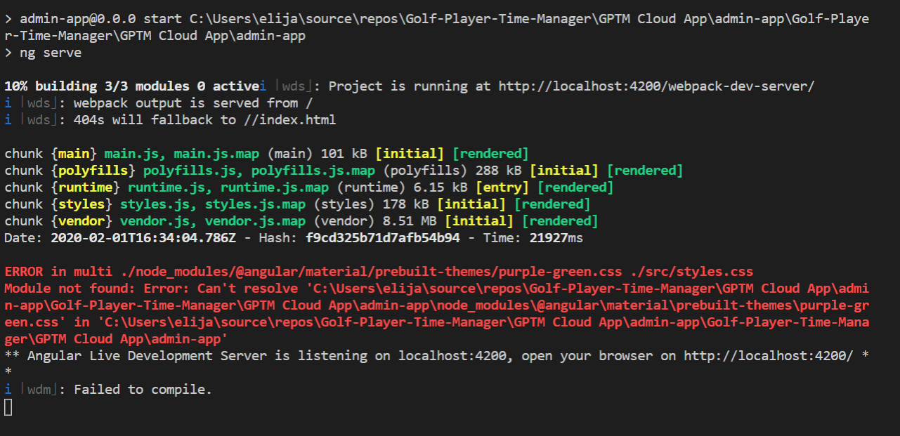

<https://stackoverflow.com/questions/51035096/error-in-multi-styles-css-in-angular-6/53941175>

<https://stackoverflow.com/questions/40025762/angular2-cli-gives-multi-styles-error>

**RUN npm install to fix this!**