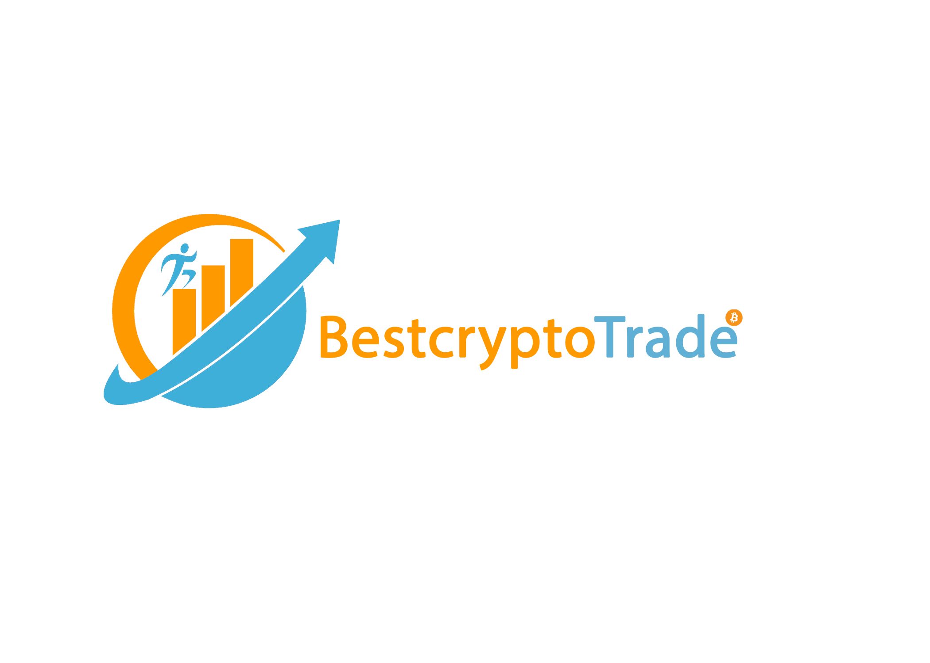

**General Business Information**

* Company Name; Bestcryptotrade
* Head Office; 124 Jug Hill Rd Milton Mills, New Hampshire (NH), 03852. USA
* Phone Number ; +1 (626) 988-2984 ( WhatsApp)
* Website Address; https://bestcryptotrade.io
* Scope of Registration; Bitcoin/ Etherium/ Bitcoin cash Investment Company.
* Contact Information of the CEO (GERMAN GREY, +1 (626) 988-2984, Admin@bestcryptotrade.com)

**Business Details**

* Date of Creation; 26 March 2013
* Main Areas of Activities of Business; USA
* Main Services; Crypto Investment Services, Basically on Trading & mining

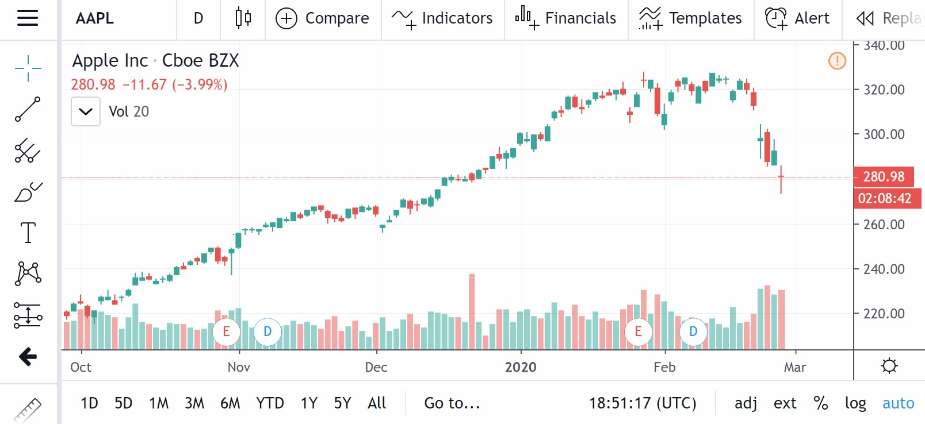

**ANTMINER**

**AntMiner is** a brand name for bitcoin mining ASIC hardware. **ANTMINER** S1 **is** a Bitcoin mining rig with a speed of 180 GH/s. **AntMiner** U1 Spec: Default hash rate: 1.6 GH/s, over clock by command.

Bestcryptotrade Uses an Antminer which is a mining machine, which is being generally linked to every of our investors account being able to generate 100% of their investment profits depending on the plan the investor make a deposit to.

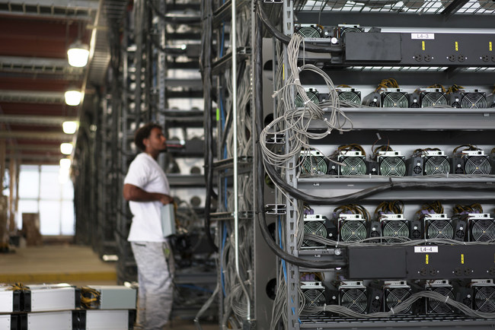

Bestcryptotrade Acquires over Eight Million USD Worth of Bitmain Antminer S19 and S19 Pro Mining Hardware, which is being linked to all their investors account.

**©Address: 124 Jug Hill Rd Milton Mills, New Hampshire (NH), 03852. USA**

©Phone number: +1 (306) 992-7324

* Principal Customer Industries and Geographies

**Business Capacity**

**Human Resources**

* Business Organization
* Number of Employees

**Financial**

* Financial Circumstances of Business (Optional)

**Technical**

* Company Capacity for the Project in Terms of Qualifications and Certifications.

**Other**

* References or Success Stories in a Similar Project

**Bestcryptotrade Profile**