Comp 369 - Assignment 2

HardLine Design Document

Professor: Dr. Walter Ridgewell

# Name: Daniel Tran

# ID: 3339325

# 

# General Overview of the Game

HardLine is an arcade style game that features a moving unit, called a cursor, and a target. The cursor moved along a horizontal line, where the player must hit the space key when the cursor is in contact with the target. If the user presses space prematurely such that the cursor will miss the target, the game will end. As well, if the player is late on pressing space and the cursor passes the target, then the player loses as well. As the user continues to play the game, it will get more difficult, as the cursor will move faster with each level.

HardLine is a game based on reflexes and speed. It requires concentration and focus to progress through the levels. Although the player requires speed, they also require patience, as any misstep would lead to a lost game! The game is endless and it can only increase in difficulty as the game continues. The game is inspired by a couple of mobile games: Pop the Lock and Flappy Bird. The gameplay style is similar to Pop the Lock, but in a straight line fashion. As well, the game was pushing to create a frustrating but addictive atmosphere, similar to Flappy Bird.

# Target System and Requirements

The target system for this game is for Windows, OS X, and Linux, utilizing a device with the capability of handling a screen size of 640 x 480 pixels.

# Game goals

The goal of the game is to get the highest score possible. There are different levels of difficulty to challenge the player if they believe that the game is too simple. In order to progress to the next level, the player must score 5 points before an automatic transition to the next level. As the levels increase, the game gets more difficult and it is the player’s goal to last as long as possible and get as high of a score as they can.

# All the rules defined

There are a couple rules to the game:

1. Do not press SPACE when the cursor is not over the target or you lose the game.
2. Do not let the cursor pass the target or you lose the game.
3. Press SPACE when the cursor is touching the target at any point to gain a score.

# Interaction of the player and the game

The player will navigate through the game by interfacing with a keyboard. Transitioning out of the Welcome screen and the Instructions screen can be done using the ENTER KEY. The difficulty can be chosen using the 1, 2, or 3 number keys. In the game, it’s as simple as using the SPACE button to play the game, using the rules defined in the “All the Rules Defined” section. Every time the player moves up a level, there is the games mascot, Sonic, who runs across the screen, denoting that the game will be “moving faster!”. On the ending, or Game Over screen, the game can be restarted using the ENTER key, or exited with the ESC key. During gameplay as well, the game can be exited using the ESC key. Background music and sound effects can be toggled using the key combination CTRL + m. As well, a Help menu can be displayed using the key combination CTRL + h.

## Player Interaction Flow Chart

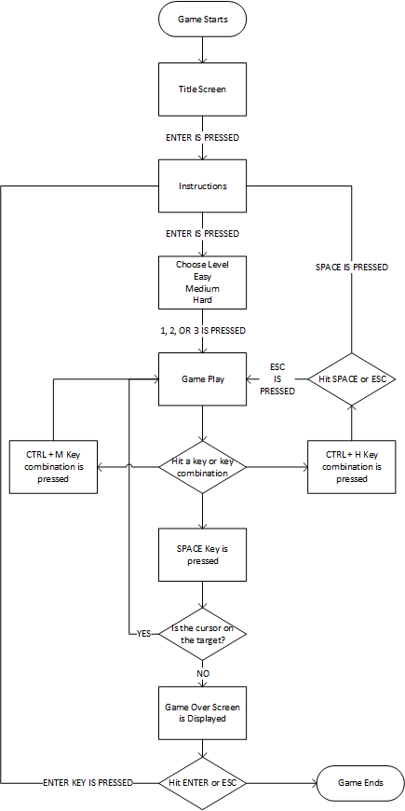

# Menu layout and style and all game options

HardLine uses bright, grass themed backgrounds, as they are bright, simplistic, and provide a nice consistent color theme. This theme matches the theme that the game uses, which is archery themed. The cursor is an arrow and the target is, well, a target. Thus, the grassy theme was chosen as a theme that generally correlates with archery. The blurring effect added to the backgrounds emphasizes the focus on the game, rather than on the background. All screens in the game (except the help menu) have this theme for a background. There are several menus throughout the game. The starting screen, or the first screen that the user sees, introduces the game’s title, and allows the user to move onto the instructions screen. The instructions screen describes the how the game is played, what the user should expect from the game, and the controls in the game. After this is the difficulty selection screen, where the user can select their level of difficulty. The difficulties are easy, medium, and hard. The progression to from less difficult to more difficult has a progressively smaller line, along with an increase in starting speed for the cursor. In the main gameplay, the layout is simple, where there is a bar at the top that describes the user’s current stats, while the rest of the screen is dedicated to the background and gameplay. Figure 1 is a visualization of the layout.

Figure 1. Visualization of gameplay layout

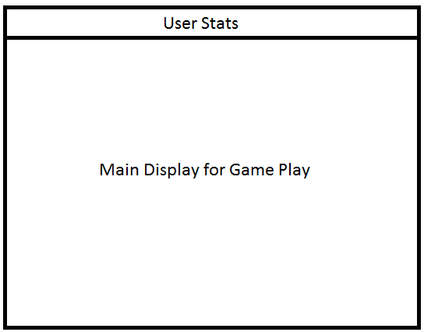

On this screen, the user can press the key combination CTRL + H to display the help screen. The screen describes more of the player’s interaction with the game, and can display the instructions screen again if the user chooses to do so. When the user loses the game, the game over screen is shown. This screen displays the player’s score as well as their highest score from multiple plays. The user then has the option to replay the game and choose their difficulty again, or exit the game.

# Music and Sound Description

The music in the game consists of an upbeat soundtrack to help increase the adrenaline of the user to create a feeling of excitement and thrill to keep the player hooked to the game. For the sound effects, they are sounds taken from the Sonic and Mario franchise of games. They are rustic and iconic sounds that are provide a pleasant and reminiscent feeling of old school arcade style gaming, which adds a bit of familiarity to the game. The sound effects match their the purpose in the game, such as the ring collecting sound from the Sonic games to indicate that the target was hit and the player’s score increased, or the mushroom power up sound in Mario that plays when the user moves up a level and the game becomes more difficult. There is also a sound effect for losing the game, which is the same sound as Sonic getting hit. The pause sound is the 1-Up sound from Mario, which has a fitting tune for a pop-up pause menu. As well, when the player increases levels, there is the power up sound effect from Mario, which is a suitable sound effect, as it denotes the player’s increase in level and difficulty.

# Future Improvements

There are many improvements that could be implemented into the game, and here are a couple that I have brainstormed through the development of the game. The first improvement was a menu that allows the player to choose different sprites for the cursor, target, or line. There would be sprites that are unlockable depending on the player’s difficulty and highest achieved score. There would also be a save file that would store the user’s highest scores so these sprites would be unlocked upon a fresh launch of the game. Another improvement would be to change the orientation of the line, rather than have it strictly horizontal. This change could be applied per level change to make the game to add another level of difficult. An additional enhancement to the game would be to add a mode where the target moved as well, so there would be a moving cursor and a moving sprite, which would make the game a lot more entertaining and challenging.

To add to this section, another idea surfaced in my imagination through the development of this game, which was to animate the cursor moving forward and actually hitting the target (the cursor would be further down than it currently is in the game), but this idea was scrapped due to the fact that such an animation would ruin the flow of the gameplay. My belief is that gameplay should not be sacrificed for aesthetics, which is why this was not implemented in the game.

An improvement to the code would be to package all of the sprites into a spritehandler class, when there are more sprites in the game. Since there are currently only 3 sprites existing at any one moment, it was redundant to use a spritehandler in this case, but with some of the improvements and enhancements specified above, this implementation would definitely result in more clean code. I have included the code for the spritehandler for future use.

A timer could be implemented in the future to control the frame rate of the game, but was excluded in this version due to the fact that the the game requires a high amount of accuracy. Installing a timer into the game would introduce delays that could interfere with the game by calling the rest function to slow up the game at the wrong moment and interrupt the player’s inputs. It may be possible to create a timing function that is intelligent enough to avoid this interruption, thus making the timer a possibility in the game.

# Sources

## Background images

http://wp.production.patheos.com/blogs/daylightatheism/files/2014/02/GreenFields.jpg

http://www.powerpointhintergrund.com/uploads/2017/05/grass-background-wallpapers-win10-themes-33.jpeg

https://img15.deviantart.net/42c2/i/2013/154/5/b/grassy_field_stage_by_chocosunday-d67r3o0.png

https://cdn.pixabay.com/photo/2013/11/25/17/27/grass-218186_960_720.jpg

http://www.cothr.org.uk/content/pages/uploaded_images/32.jpg

http://www.misucell.com/data/out/1/IMG_17250.jpg

http://www.misucell.com/data/out/1/IMG_17255.jpg

## Sound Effects

Mario Sound Effects

http://themushroomkingdom.net/media/smw/wav

### Sonic Sound Effects

https://www.sounds-resource.com/genesis_32x_scd/sonic1/sound/2626/

“Mr Lange

My name on Sonic Retro and Sonic Fan Games HQ is also Mr Lange.

shortfactor@hotmail.com

Youtube: shortfactor

Newgrounds: Short-Factor”

## Sprites

Target

https://www.spriters-resource.com/nintendo_64/ssb/sheet/37006/

Cursor

https://s3.envato.com/files/171719892/weaponpackprev/2000x2000/arrow1b.png

Sonic

http://spritedatabase.net/file/5695

# Conclusion

In conclusion, HardLine is a fast-paced arcade style game that pushes the player’s reflexes to the limits. The increasing cursor movement speed adds speed to the game, while the randomly spawning target adds unpredictability which requires the user to be able to react quickly if the target spawns near the cursor’s position. The UI of the game is simple and designed with backgrounds that do not detract the user from the gameplay. The game progresses by increasing the difficulty as the player advances through the levels. The music in the game is upbeat and exciting, to keep the player’s adrenaline going and frustration down. Along with the background music, there are also sound effects in the game that correspond with different scenarios that the player can go through. These sound effects are reminiscent of older action arcade games, taken from Mario and Sonic. They provide a sense of familiarity and entertainment for the player. In the coding perspective, each component of the game was developed modularly to allow for better code maintainability and easier implementation of future features.