Cinema Web App


Final Project Demonstration
Before we start building the application, your lecturer will show you a quick demonstration of the final version of the Cinema Web Application.
This short preview will help you understand what the complete project will look like and what features you’ll be working on.
You don’t need to take notes during the demo — just focus on getting a general idea of the functionality.
Once the demonstration is over, we’ll begin step by step from scratch.

Create a New MVC Project in an ASP.NET Core
Open Visual Studio 2022. You will see the start screen with various options to get started.
Select [Create a new project] from the list of options. This will initiate the process of creating a new project from scratch.
On the next step, choose [ASP.NET Core Web App (Model-View-Controller)] as a project template. The steps are shown below:
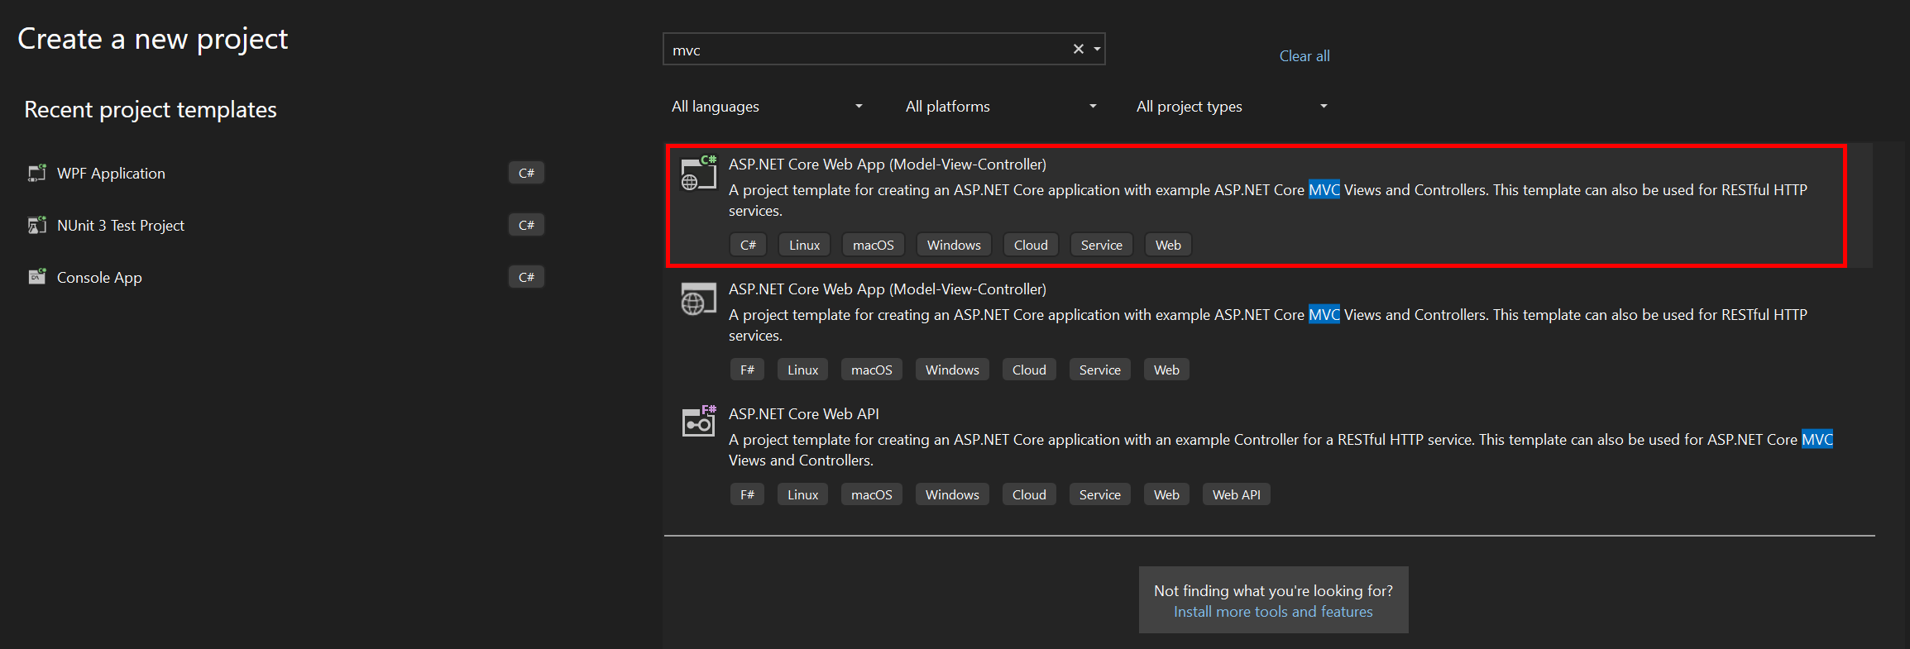
Give a name to your project and solution:
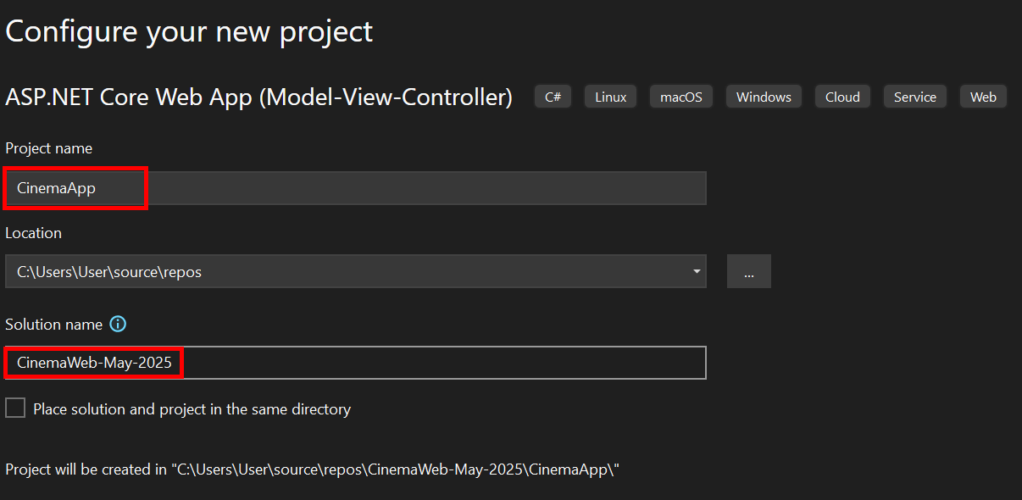
On the next step you should choose your target frameworok and authentication type.
After that click on the [Create] button:
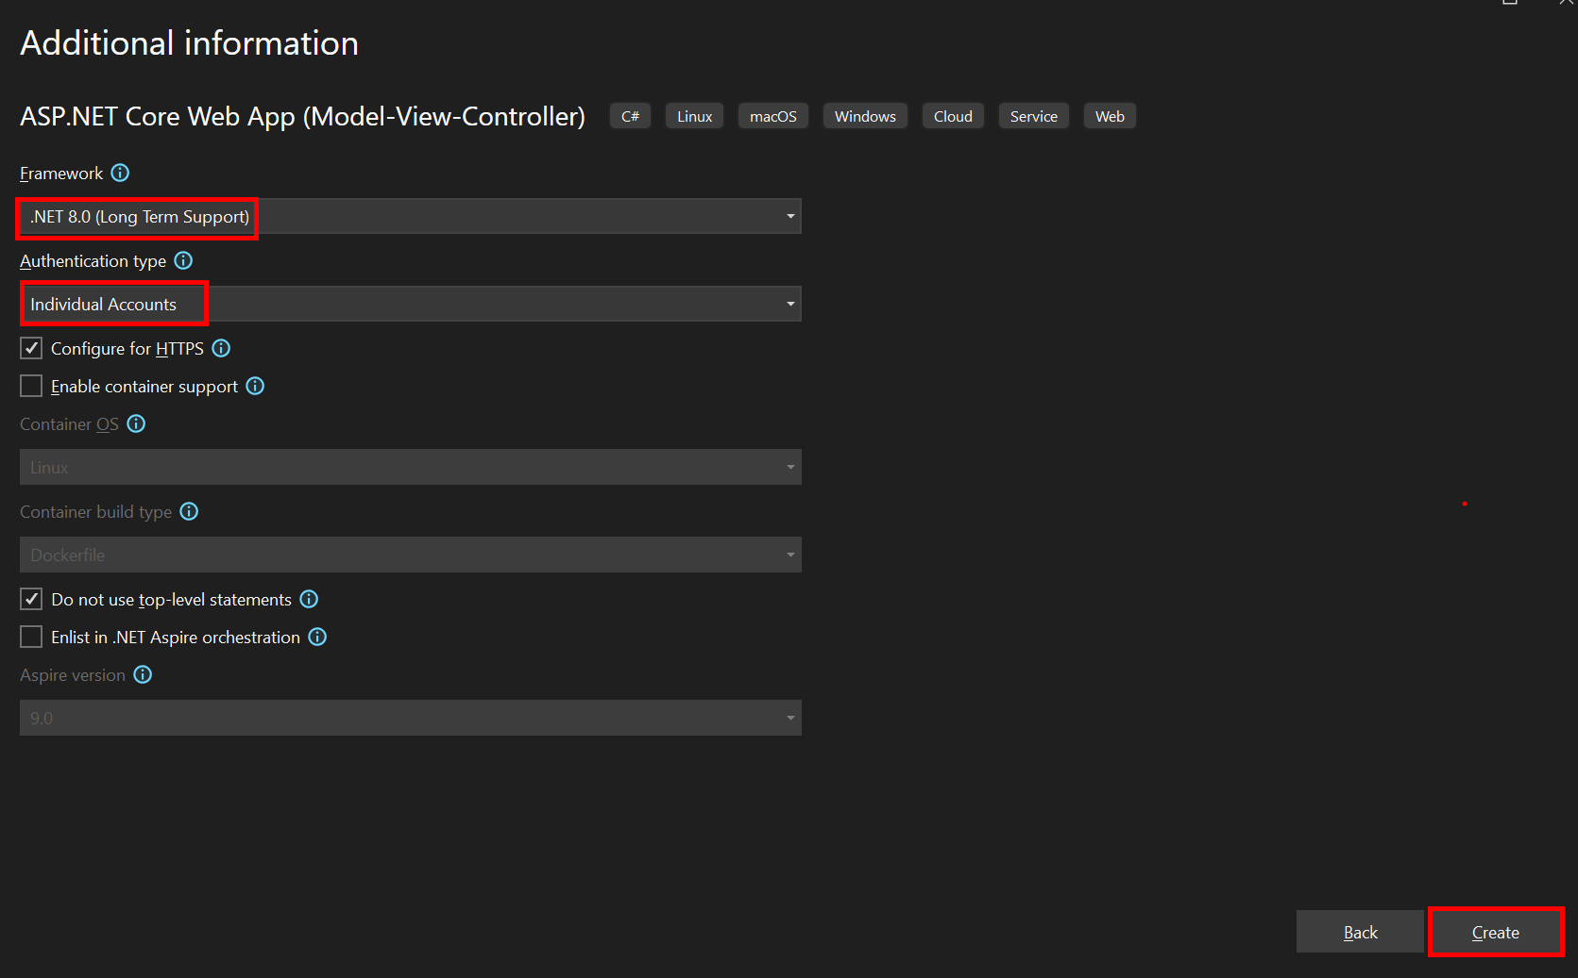
Important:
We will not use Identity at the beginning of this course.
You don't need to worry about login, registration, or authentication for now.
However, it's important to enable Identity from the start to avoid complicated setup later.
We will come back to Identity in a dedicated section later in the course.
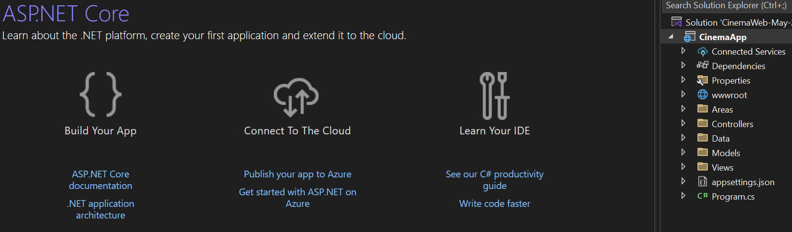
Now your app is created and looks as shown below. Note that it has folders for controllers, models and views because of the template we chose:
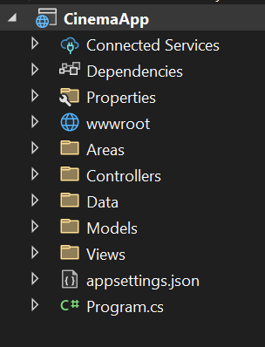
If you run the app, you will see the default "Home" page, which is served by the HomeController in the app:
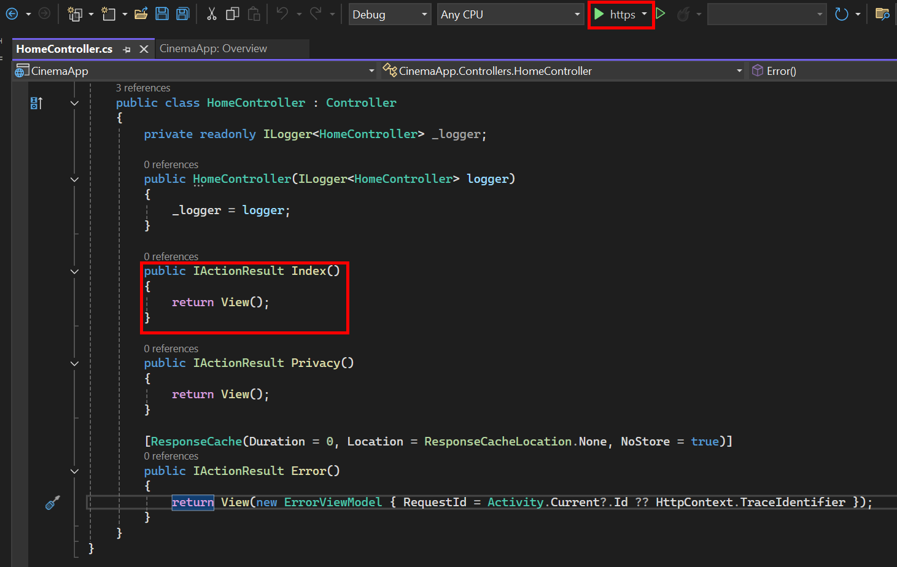
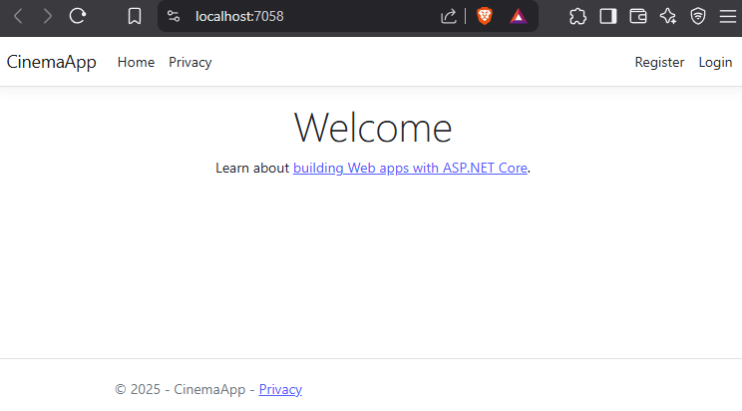

Understanding the Layout

What is _Layout.cshtml?
In ASP.NET Core MVC, the file _Layout.cshtml defines the overall layout (structure) of your website.
It contains parts that are shared across all pages, like:
- The <head> section (with title, meta, CSS)
- The navbar at the top
- The footer at the bottom
- The @RenderBody() placeholder where each page loads its unique content
You can think of _Layout.cshtml as a master template.

Where to find _Layout.cshtml?
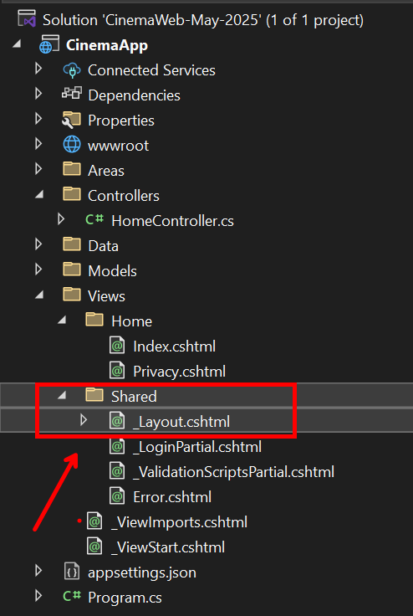

Transition to the Modern Architecture Skeleton

From This Point Forward…
Until now, you’ve been creating your application step by step to understand how ASP.NET Core MVC works.
Starting now, we will work on a professional template architecture that is pre-built and ready for development. It will save you time, let you focus on building real features, and teach you how grade applications are structured.

What Is the Skeleton Project?
We’re switching to a pre-created layered solution that includes everything you need:
- A structured architecture
- All required Razor Views
- Identity integration
- Layer separation (Data, Services, Web, ViewModels, etc.)

Feel Free to Use It for Your Graduate Project
This architecture will be shared with you as a GitHub repository:
- https://github.com/KrIsKa7a/ASP.NET-Core-Arch-Template/tree/main

Please Take Time to Explore
Students, we strongly encourage you to:
- Open the repository and explore each project/folder
- Read the code, structure, and documentation
- Try to understand why it is built this way
- Follow how each layer communicates with others
- Think about how this will help your graduation project later
This is more than just a coding exercise — it’s an opportunity to learn how professional applications are built

What You’ll Do from Now On
You will no longer write views or layout code from scratch. Instead:
- Use the predefined views and UI
- Implement the controllers and services
- Bind logic to the views
- Learn advanced practices through real implementation

What We’ve Used So Far?
Until now, we worked in a single-project solution with folders like:
- 📁 Controllers/
- 📁 Models/
- 📁 Views/
- 📁 Data/
- 📄 Program.cs
This was useful for learning the basics — how MVC works, how views connect with controllers, how models are created, etc.
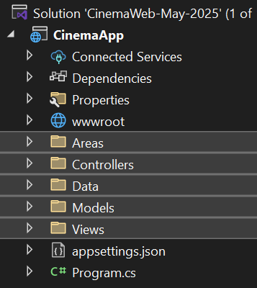

We Will Make Transition To
The solution you just opened may look big — and that’s on purpose! It’s designed to be scalable, testable and professional. But don’t worry: you will not work on everything at once.
The solution includes the following layers:
- CinemaApp.Data
- CinemaApp.Data.Common
- CinemaApp.Data.Models
- CinemaApp.Services.AutoMapping
- CinemaApp.Services.Common
- CinemaApp.Services.Core
- CinemaApp.IntegrationTests
- CinemaApp.Services.Core.Tests
- CinemaApp.Web.Tests
- CinemaApp.Web
- CinemaApp.Web.Infrastructure
- CinemaApp.Web.ViewModels
- CinemaApp.GCommon

Summary of Transition
From | To (Modern Architecture)
One MVC project (CinemaApp) | Multi-project solution (Data, Services, Web)
Mixed folders | Organized layers per concern
Manual view creation | Pre-built views, waiting for logic
Local logic in controller | Separated logic in services and ViewModels

Understanding the Role of the Software Architect
In every professional software project, there is a key person responsible for designing the big picture —
the Software Architect

What Does a Software Architect Do?
A Software Architect defines how the entire system is structured. This includes:
- Deciding how the code is split into layers and modules
- Ensuring scalability, maintainability, and performance
- Designing how data flows between components
- Making decisions about patterns, conventions, and technology
Their work ensures that the developers can focus on implementing logic in a clean, consistent, and efficient way.

Why We Provide the Architecture in This Course?
This course is not focused on teaching software architecture.
It is focused on helping you grow as a developer — someone who writes code, builds features, and implements functionality.

You Still Learn Architecture — by Using It
While the course does not train you to be an architect, you gain valuable knowledge by working inside a proper architecture.

Starting the CinemaApp Project
In this phase, we will begin our CinemaApp project with a simple and focused approach. The goal is to help you understand the core components of an ASP.NET Core MVC application and how to implement basic functionality before we scale the project further.

Initial Functionality Overview
- Use the IdentityUser from the pre-configured Individual Accounts authentication
- Create the Movie model with basic properties
- Implement full CRUD operations (Create, Read, Update, Delete) for movies
- Introduce a simple Watchlist feature, where users can mark movies they want to watch later

Simplified Project Structure
To keep the development process simple and focused, we will begin by working only with the essential layers of the solution. While the original solution includes multiple projects and architectural components, we will remove all unnecessary projects from the solution for now. They are not deleted, only removed to reduce distractions during this early phase.

Active Projects in This Stage
- Data Layer
  - CinemaApp.Data
  - CinemaApp.Data.Models
  - CinemaApp.Data.Common
- Web Layer
  - CinemaApp.Web
  - CinemaApp.Web.ViewModels

Cleaning Up the Solution for Now
To keep our project focused and easy to manage in the early stages, we will remove all the projects we don't currently need. This will help us avoid confusion and keep the solution lightweight. Don't worry — we are not deleting anything from your computer, just removing the projects from the solution view in Visual Studio.
- Open Visual Studio and make sure your solution is loaded.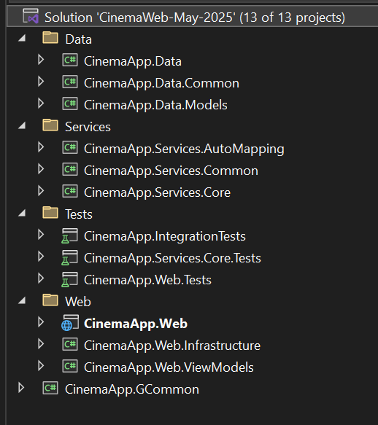
- In the Solution Explorer, right-click on each of the projects one by one
- Choose "Remove" from the context menu
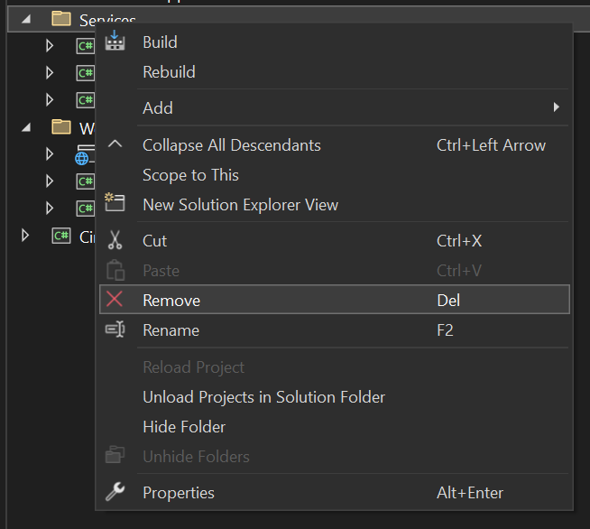
- When prompted, confirm that you want to remove the project from the solution

Result
You should now see only the following projects remaining in your solution:
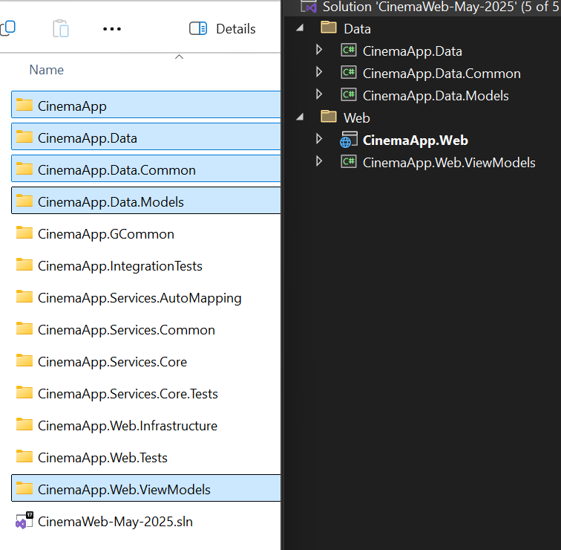
This is all we need to build our first version of the application — with Movies, basic CRUD, authorization, authentication, and Watchlist

Identity Setup – Ready but Not Used Yet
Since we selected Individual Accounts during project creation, ASP.NET Core automatically set up the default Identity system for us. This means that registration and login functionalities are already available and fully functional. You can run the project and try to register a new user or log in with existing credentials.
- However, for now, we won’t use Identity features in the application logic. Our focus at this stage is on building core functionality without any restrictions or authentication checks.
During the ASP.NET Fundamentals course, we will dive deeper into Identity. We’ll scaffold and customize the Identity views and implement proper authentication and authorization logic. Until then, just keep in mind that Identity is set up and working behind the scenes.
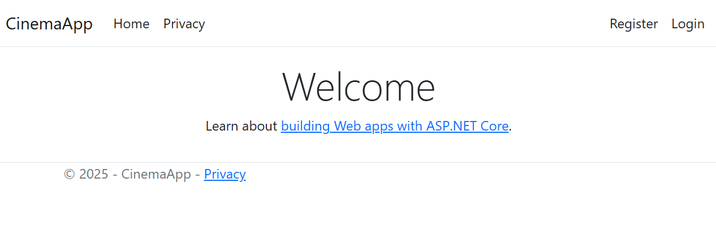
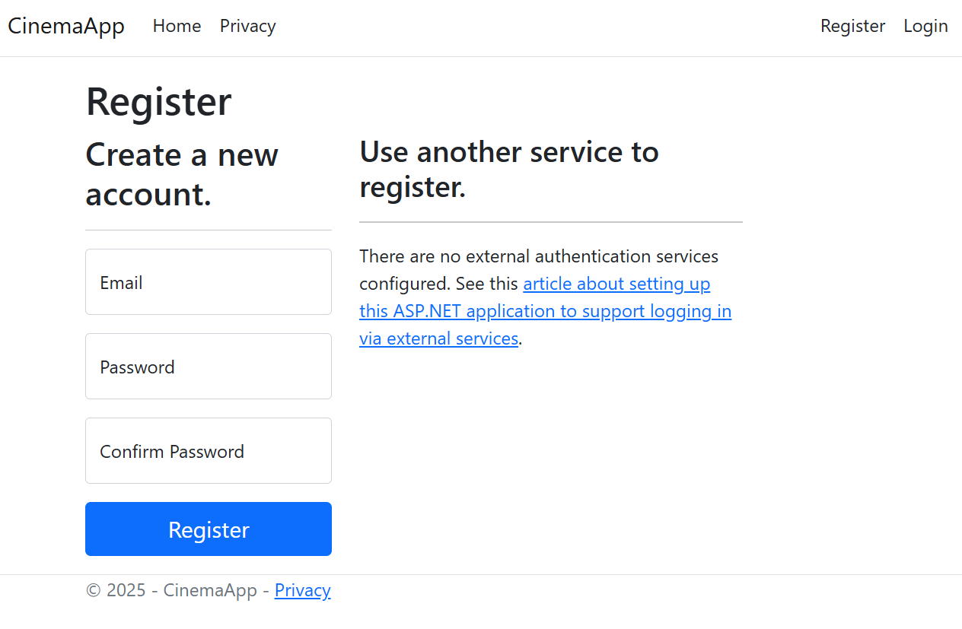
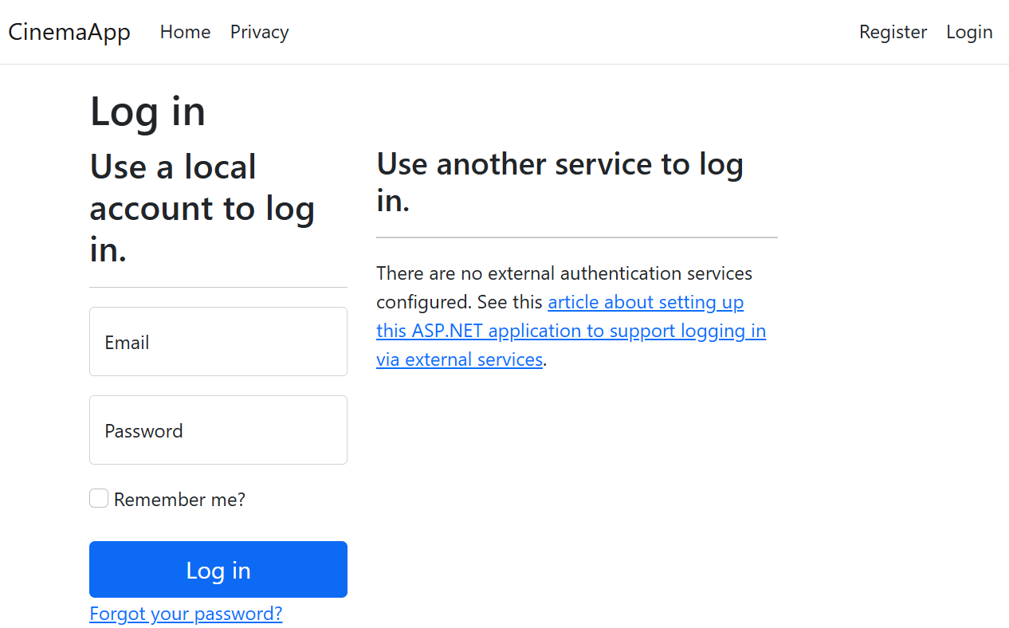

Connecting the Project to SQL Server
Before we can work with data in our CinemaApp project, we need to connect the application to a database. This happens through a configuration file called appsettings.json
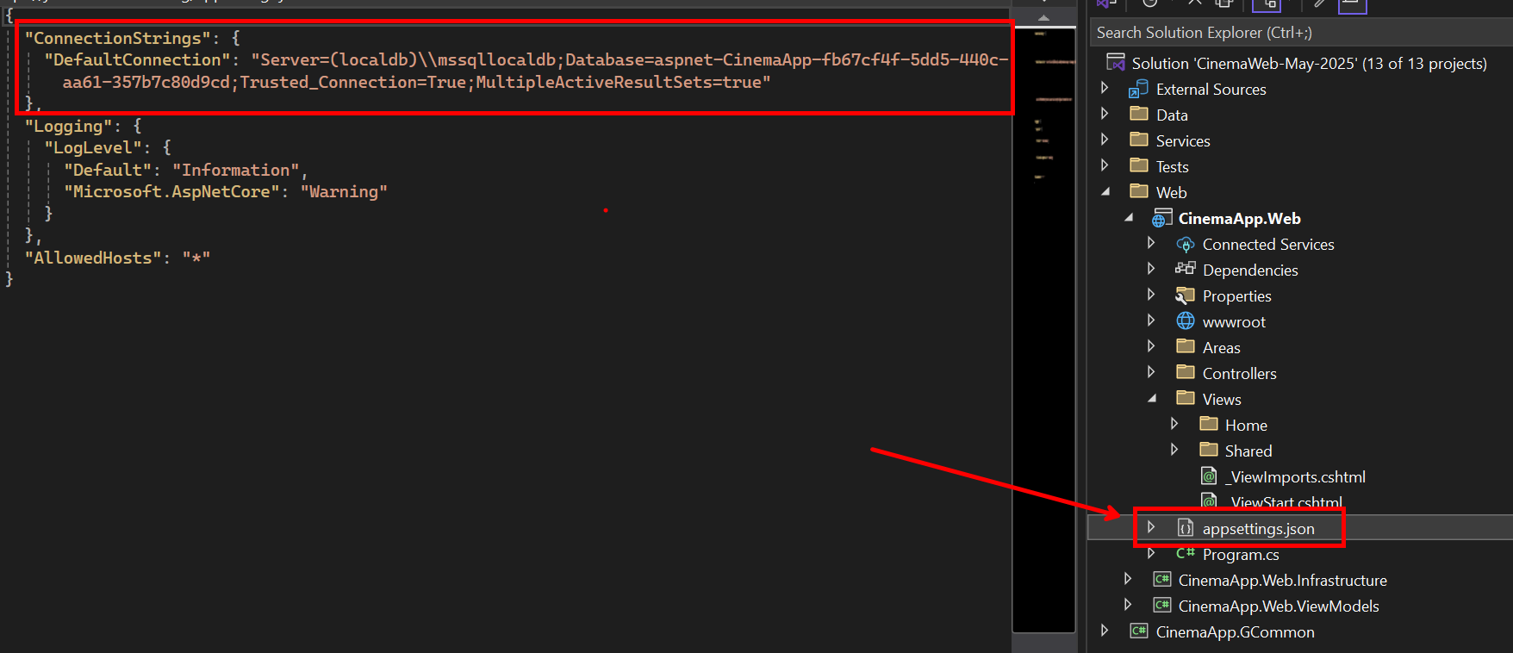

Connection String
- In the CinemaApp.Web project, locate the appsettings.json file. This is where we store settings like our connection string — which tells the application where to find the database
- Replace the default "DefaultConnection" value with your own SQL Server connection string
- If you're unsure how to format your connection string based on your SQL Server version, authentication type, or other settings, we recommend this helpful resource:
https://www.connectionstrings.com/sql-server/
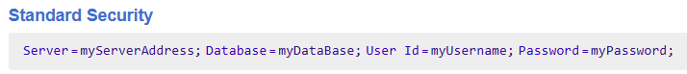


Creating the Initial Migration
Now that we’ve connected the application to a database through appsettings.json,
it’s time to create our first migration.
Even though we haven’t created any custom models yet, this step is still important because:
- Our project uses Identity
- The Identity system includes several built-in tables (like AspNetUsers, AspNetRoles, etc.) that need to be created in the database
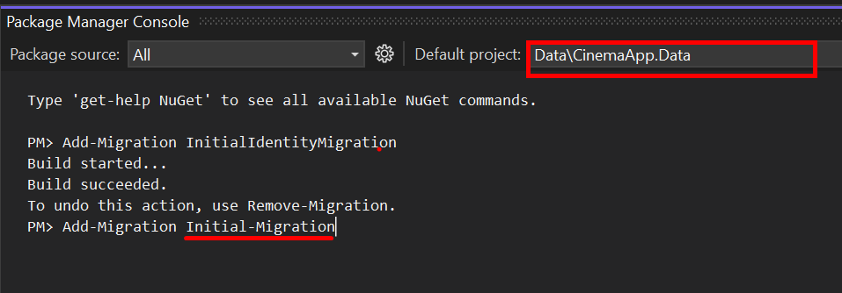
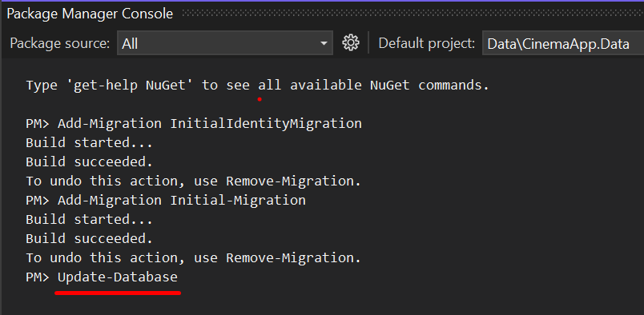

Database is Successfully Created
You should be able to see a new database (e.g., CinemaApp-May-2025) in SQL Server Management Studio (SSMS)
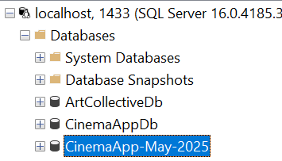
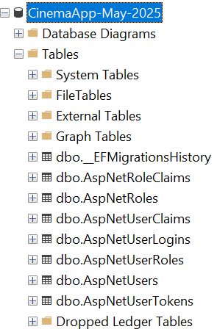

Applying a Custom Appearance
When we create a new ASP.NET Core MVC project, the application includes only a basic appearance using the default Bootstrap layout and a site.css file.
In this section, we will improve the visual look of our CinemaApp by creating and applying custom style files. This will make our application look cleaner and more personalized from the beginning.

Add CSS Files
Create two new CSS files inside the wwwroot/css/ folder:
- cinema-styles.css
- user.css
You can create them directly from Visual Studio:
- Right-click on the css folder → Add → New Item → Style Sheet
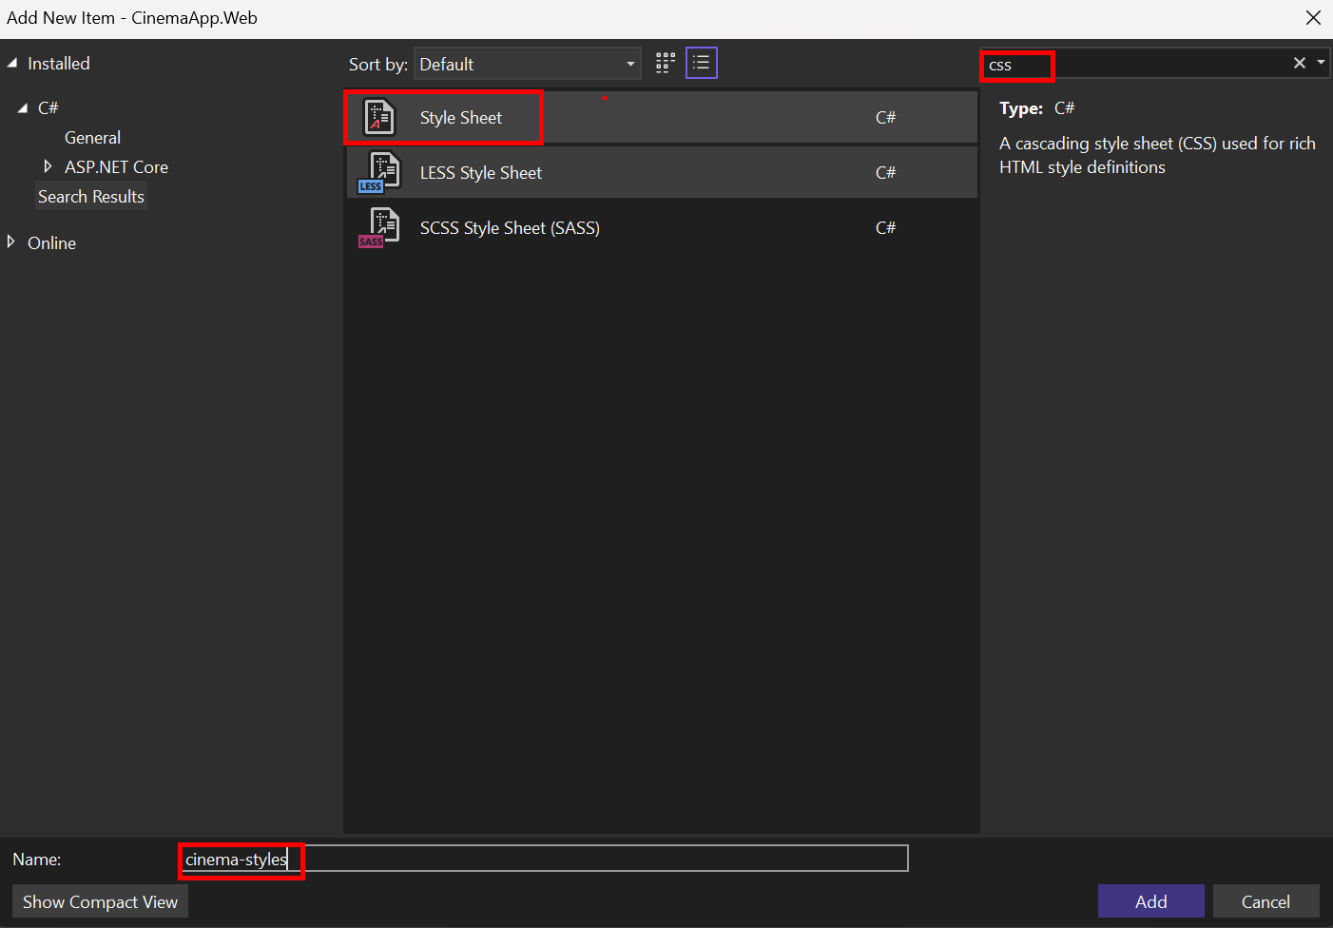

Link the CSS Files in the _Layout.cshtml
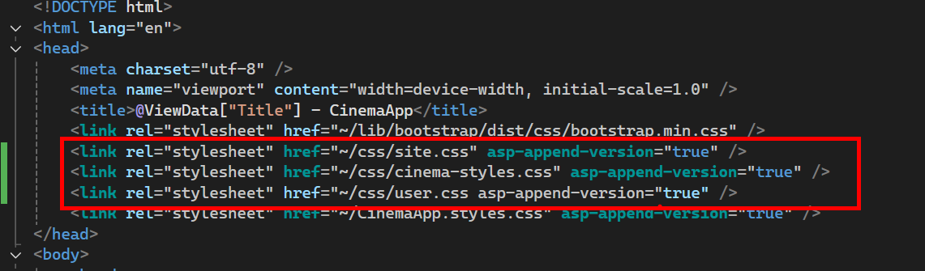

Replacing the Default Layout with a Custom Cinema _Layout.cshtml
In the previous section, we created and linked custom CSS files to define the look of our CinemaApp. Now we will complete the appearance upgrade by replacing the default layout:
- A custom navigation bar with icons and role-specific links
- A footer with a dynamic year
- All the necessary scripts and stylesheets to support Bootstrap and interactivity

Updating the _LoginPartial View
The _LoginPartial.cshtml file controls the right-hand side of the navigation bar. It displays either:
- A Register and Login button for anonymous users
- A Logout button and user info when logged in
We’ll now replace the default version with a cleaner version styled with Bootstrap,
so it matches our CinemaApp layout and icon set.
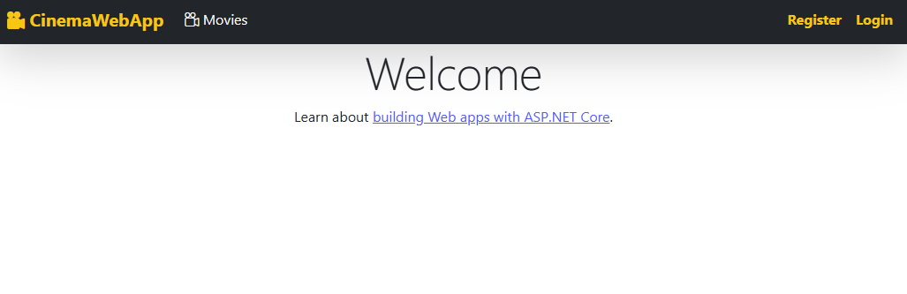
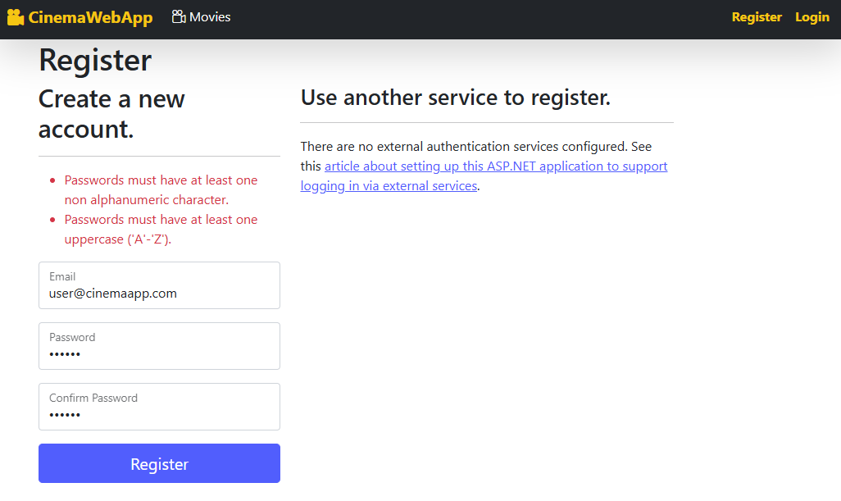

Simplifying Password Requirements
To make development and testing easier, we will reduce the default password complexity rules. This will allow us to register users with simpler passwords, such as 123456.
By default, ASP.NET Core Identity enforces strong password rules like requiring:
- Uppercase letters, Lowercase letters, Digits, Non-alphanumeric characters, Minimum length of 6

Open Program.cs
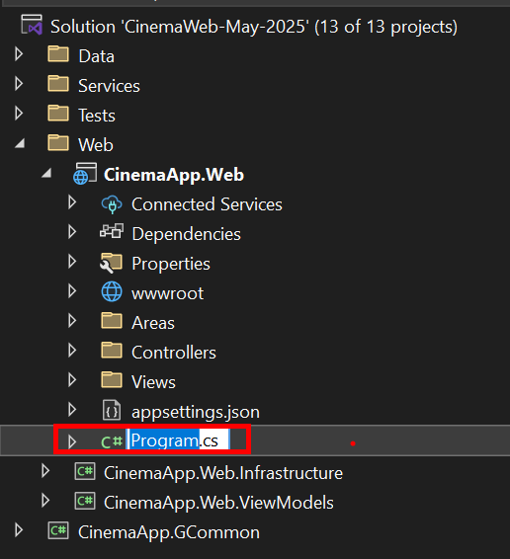

Update Identity Configuration
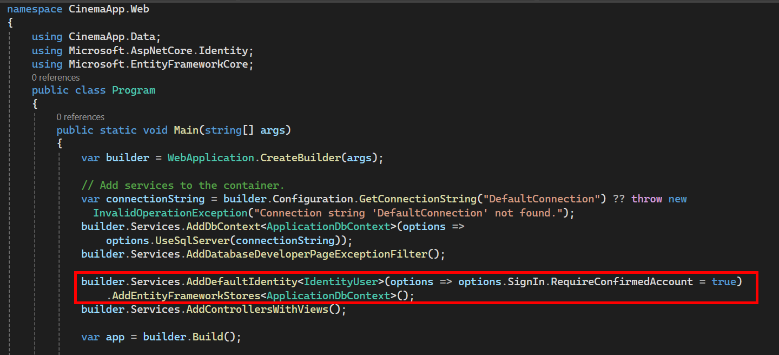
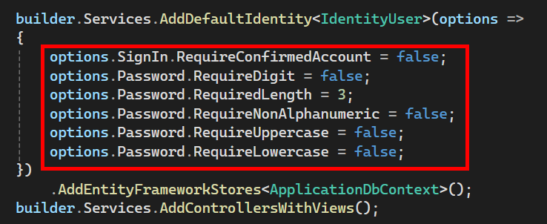

Visual Feedback After Login – Navbar Changes
After registering and logging in successfully, users will see immediate changes in the navigation bar, thanks to the role-aware layout and _LoginPartial.cshtml
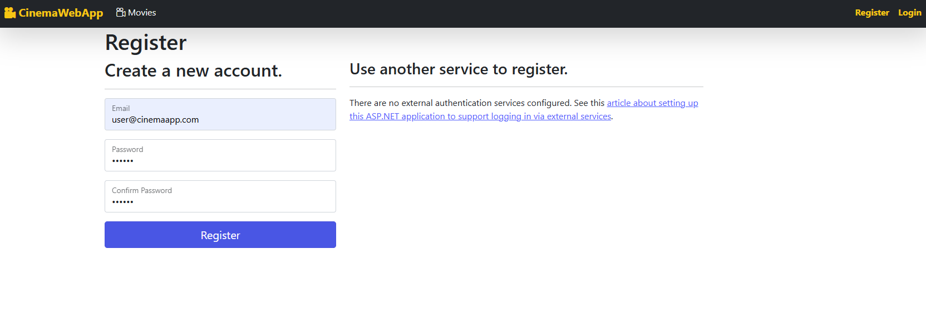
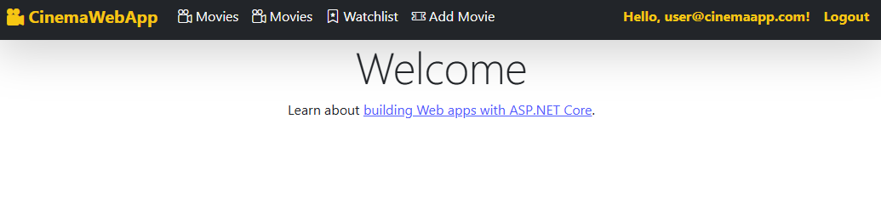

Viewing Registered Users in SQL Server
Now that registration is functional, it’s important to understand where user data is stored and how to view it.
ASP.NET Core Identity stores user accounts in a table called AspNetUsers in your database.
- Open SQL Server Management Studio (SSMS)
- Connect to your local SQL Server instance (e.g., localhost)
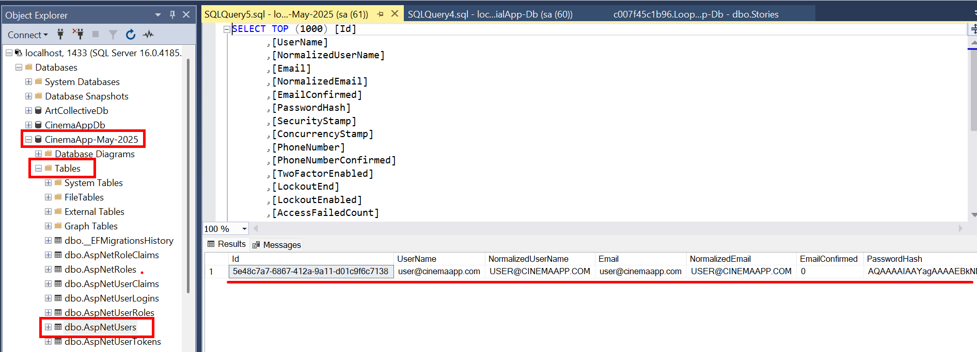

Customizing the Identity Views (Login & Register)
By default, the Login and Register pages are not visible in your project — they are embedded in the Identity library.
In this section, we will scaffold the Identity UI to make these views editable, and then simplify them by removing unnecessary fields and elements.

Add the Identity UI Scaffold
Right-click on the Areas folder in your CinemaApp.Web project
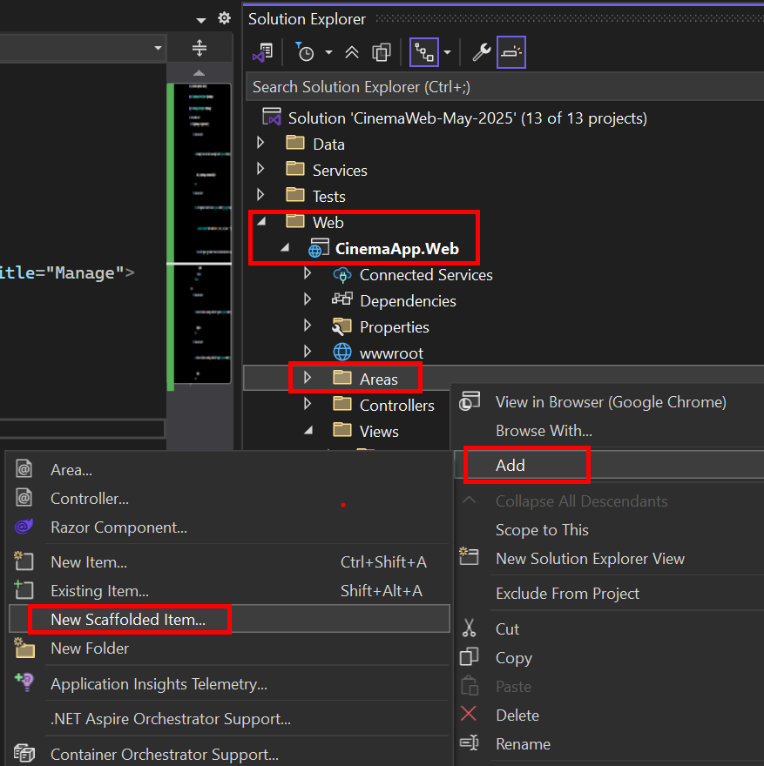
Choose Identity -> Add
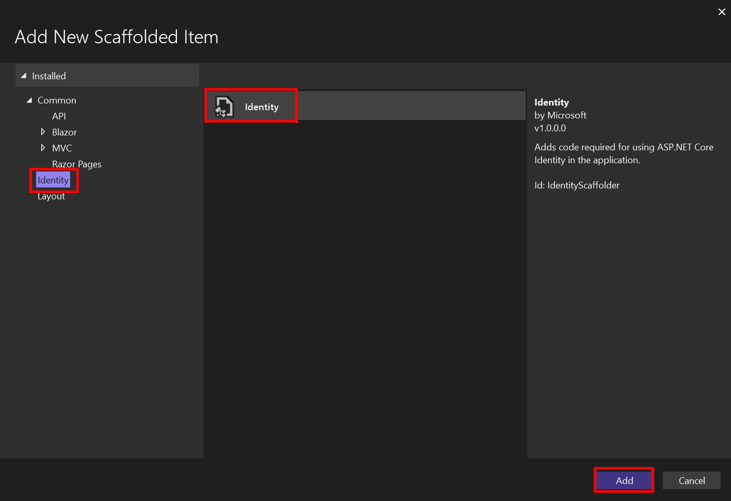
In the dialod, check Register and check Login. Choose your existing ApplicationDbContext.
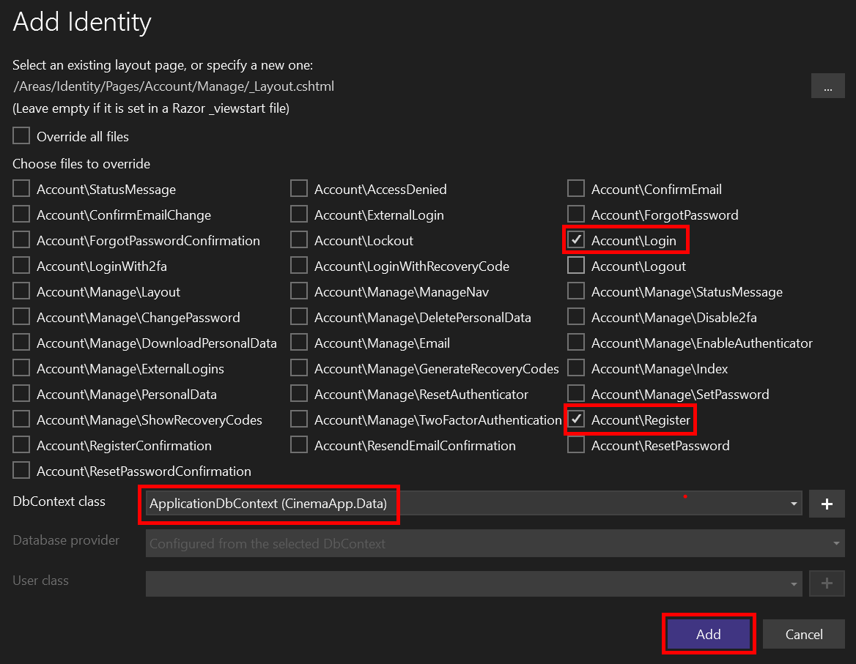
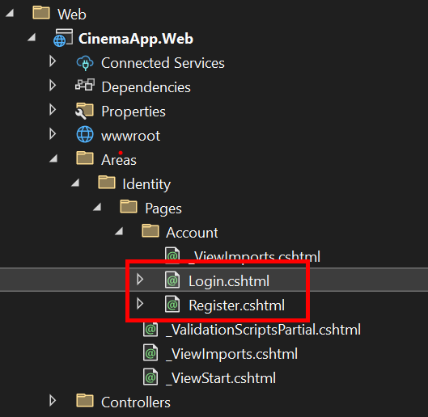
Open each of the scaffolded .cshtml files and remove unwanted sections:
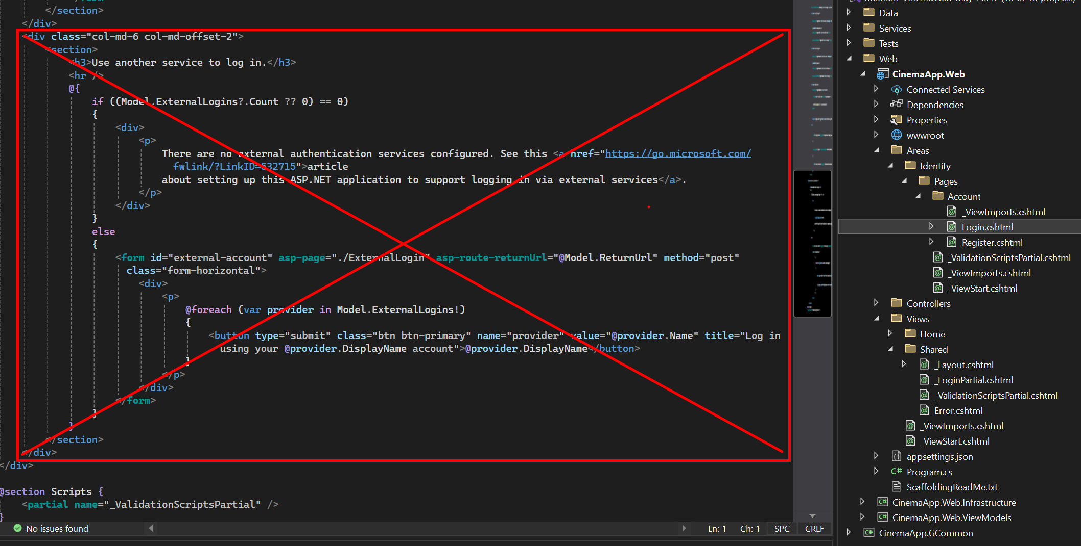
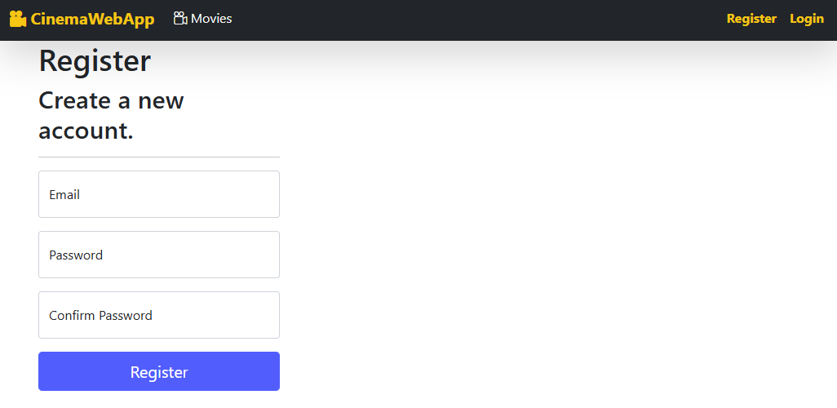
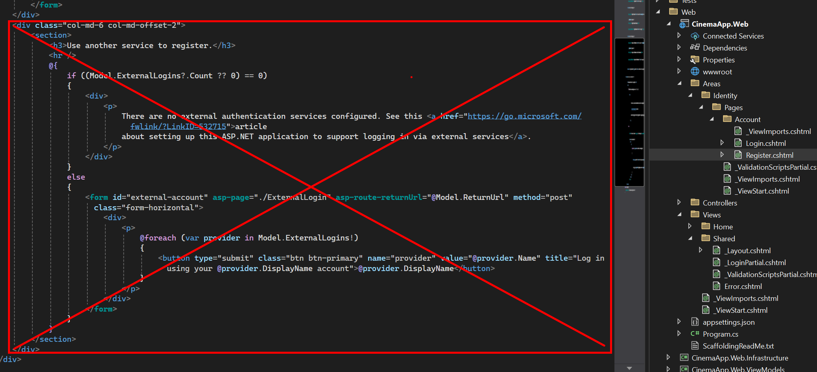
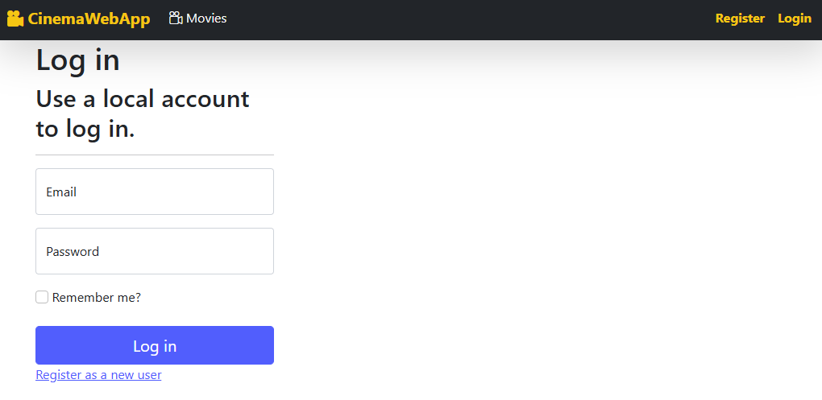

Creating a Custom Home Page
The default home page of a new ASP.NET Core MVC project is generic and not suitable for our CinemaApp. In this section, we will replace it with a custom welcoming home page and apply a background image to give the app a strong visual identity right from the start.

Add a Background Image
Create a new folder in wwwroot
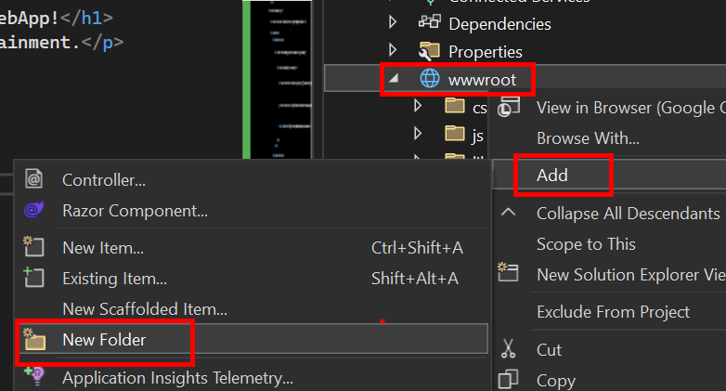
Add your chosen background image (e.g., some-pic-bg.jpg) into the images folde
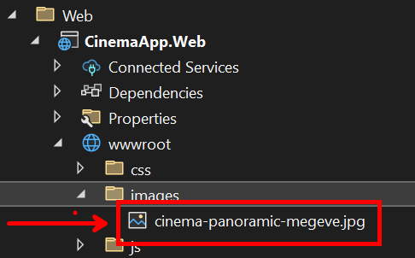

Create Custom Home View
Replace the content of:
Views → Home → Index.cshtml
with the following example code:

Result
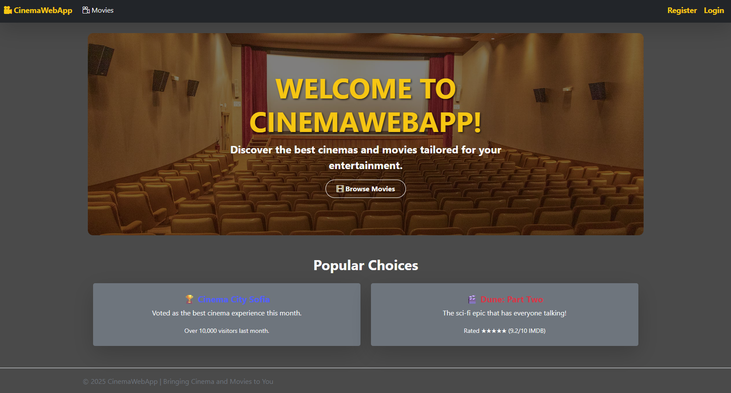

Creating the Movie Model
Now that our layout, Identity system, and home page are in place, we can begin developing application features. We’ll start by creating the first model: Movie
This model will store information about each movie in our cinema system and will be used to perform CRUD operations (Create, Read, Update, Delete) later.

Create the Model Class
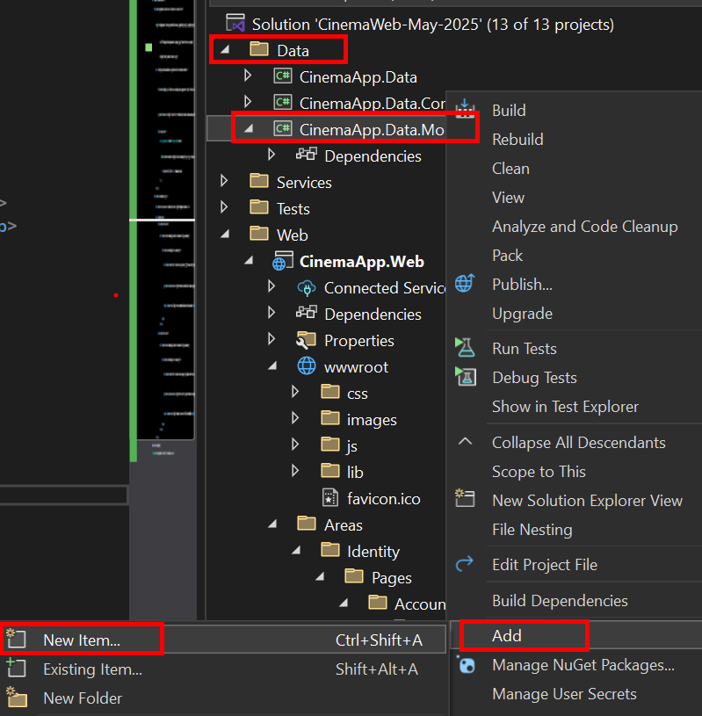
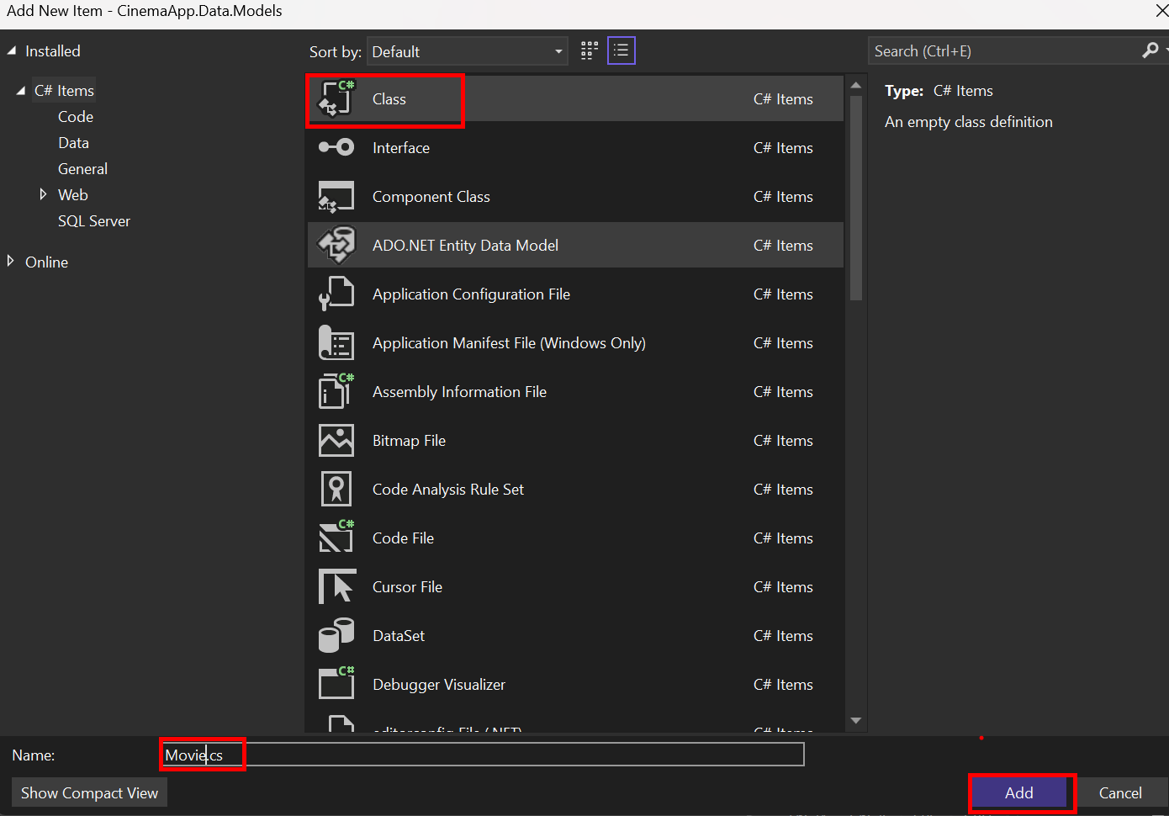

Define the Properties
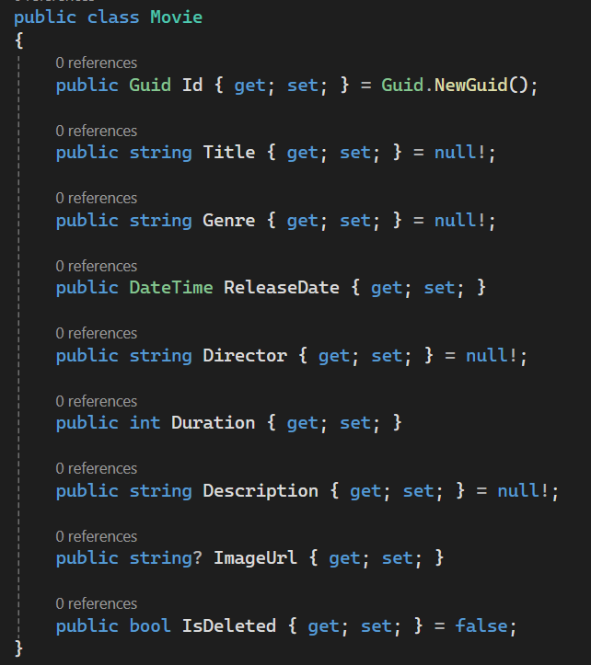

Model Validation
Now that we’ve defined the Movie model and its properties, it’s important to ensure that the data users submit is valid before it's saved to the database.

Defining Validation Constants
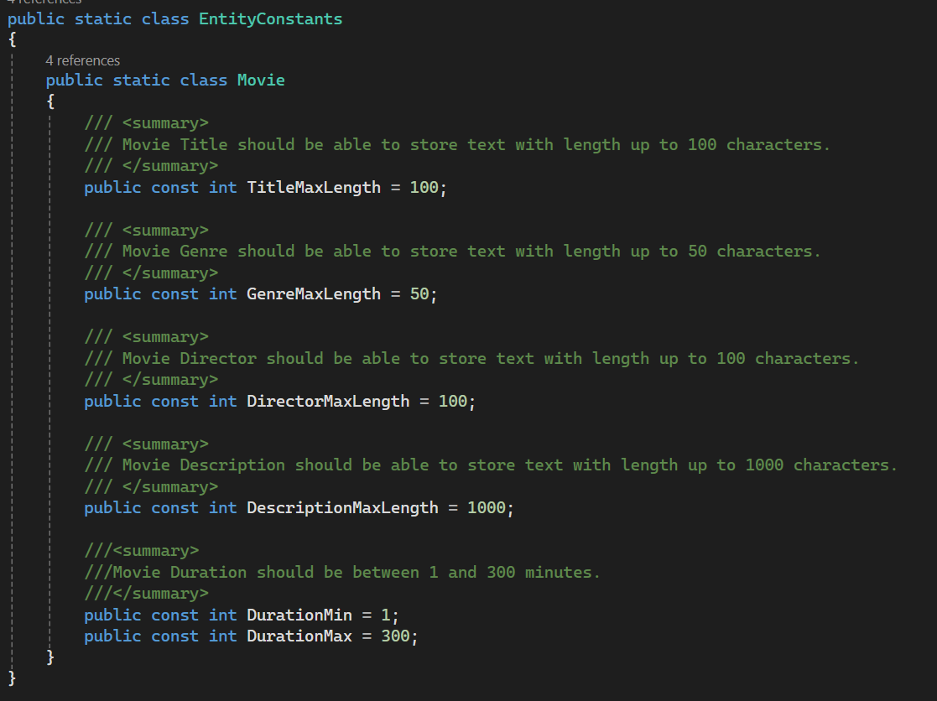
Before applying validation to our model properties, we’ve created a special helper class called EntityConstants. This class is located in the CinemaApp.Data.Common project and is used to hold all the length limits and value constraints for our entities — starting with Movie.

Applying Validation with Data Annotations
ASP.NET Core provides built-in Data Annotations to help us validate our models.
These annotations ensure, for example:
- required fields are not left empty
- string lengths are within range
- values like ratings are within valid numeric ranges
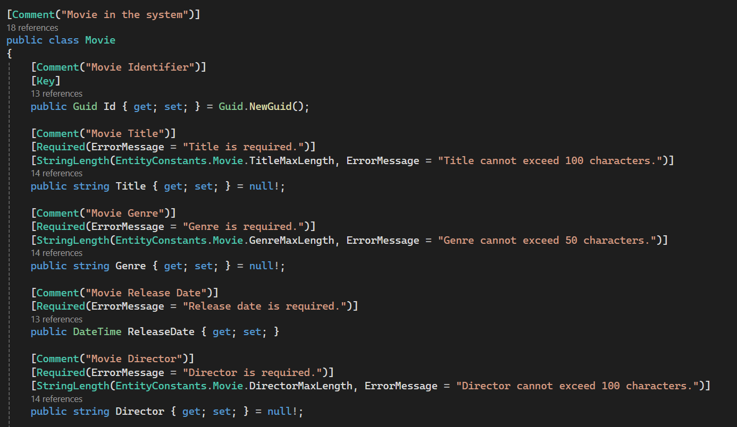

Fluent API Configuration
While we’ve already added validation using Data Annotations, ASP.NET Core and EF Core also allow us to configure the model using the Fluent API. This approach is useful when you want to keep your entity classes clean or need more advanced configuration
We'll create a separate configuration class to apply Fluent API rules:
- Create MovieConfiguration
- Implement the IEntityTypeConfiguration<Movie> interface
- Register Configuration in OnModelCreating
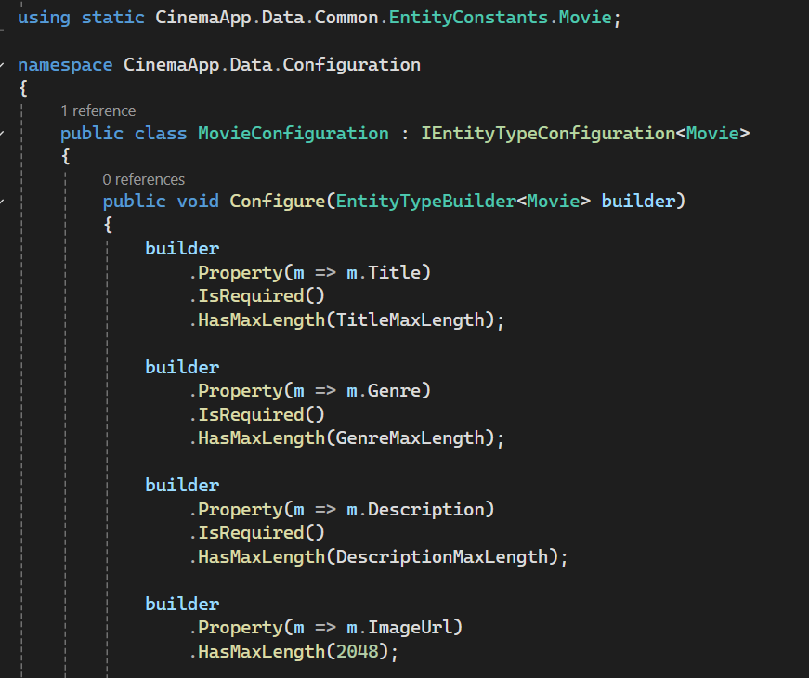

Do You Need Both Data Annotations and Fluent API?
In our project, we demonstrated both Data Annotations and Fluent API to show the two most common ways to apply validation.
However, you do not need to use both at the same time for the same property.
- Data Annotations if you prefer adding rules directly on the model
- Fluent API if you want to keep models clean and apply configuration separately
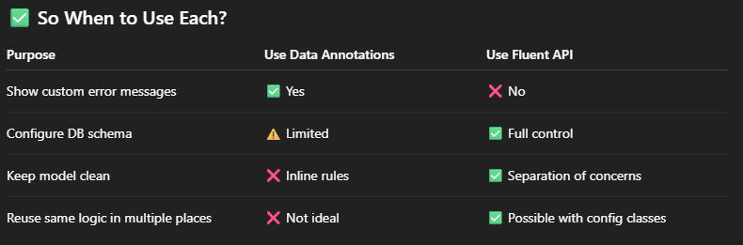

Connecting the Movie Model to the Database
Now that we’ve created the Movie model, we need to tell Entity Framework Core to include it in the database. We do this by registering the model in the application’s DbContext and creating a new migration.

Create a DbSet<Movie> Movies
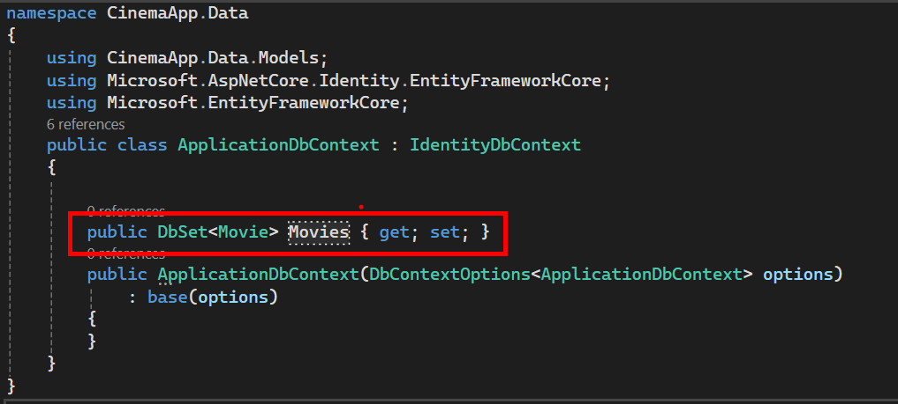

Register Configuration in DbContext - Applying All Configurations Automatically
In our CinemaAppDbContext class, we’ve added this line inside the OnModelCreating method:
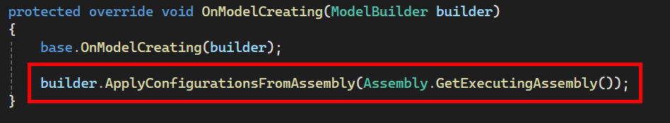
This line tells Entity Framework Core to automatically apply all configuration classes that implement IEntityTypeConfiguration<T> — like our MovieConfiguration

Create a New Migration
- Open the Package Manager Console in Visual Studio
  - Tools → NuGet Package Manager → Package Manager Console
- Make sure the CinemaApp.Data project is selected as the default project, then run:
  - Add-Migration AddMovieTable
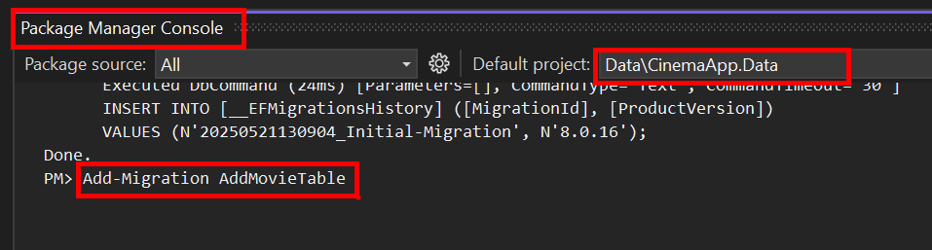

Apply the New Migration
- Still in the Package Manager Console, run:
  - Update-Database
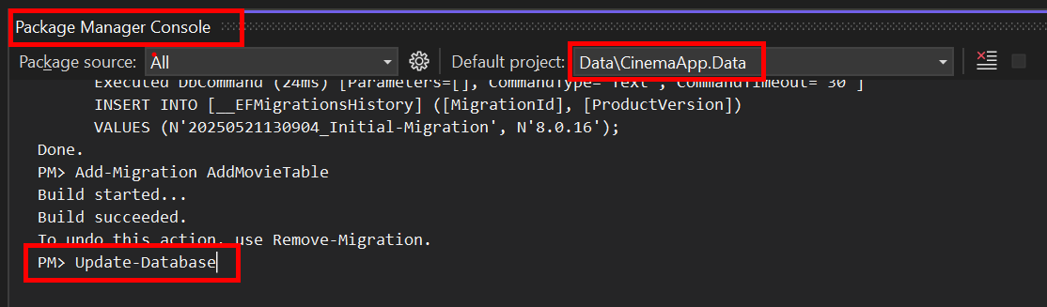

Verifying the Movie Table in SQL Server
After applying the migration, Entity Framework Core creates the necessary table(s) in the connected SQL Server database. In this step, we will verify that the Movies table exists and contains the correct columns.
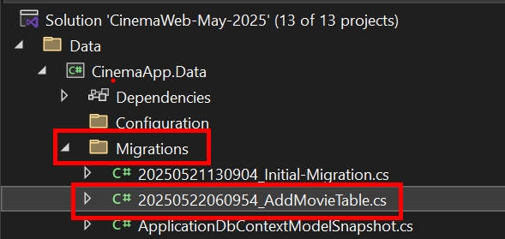
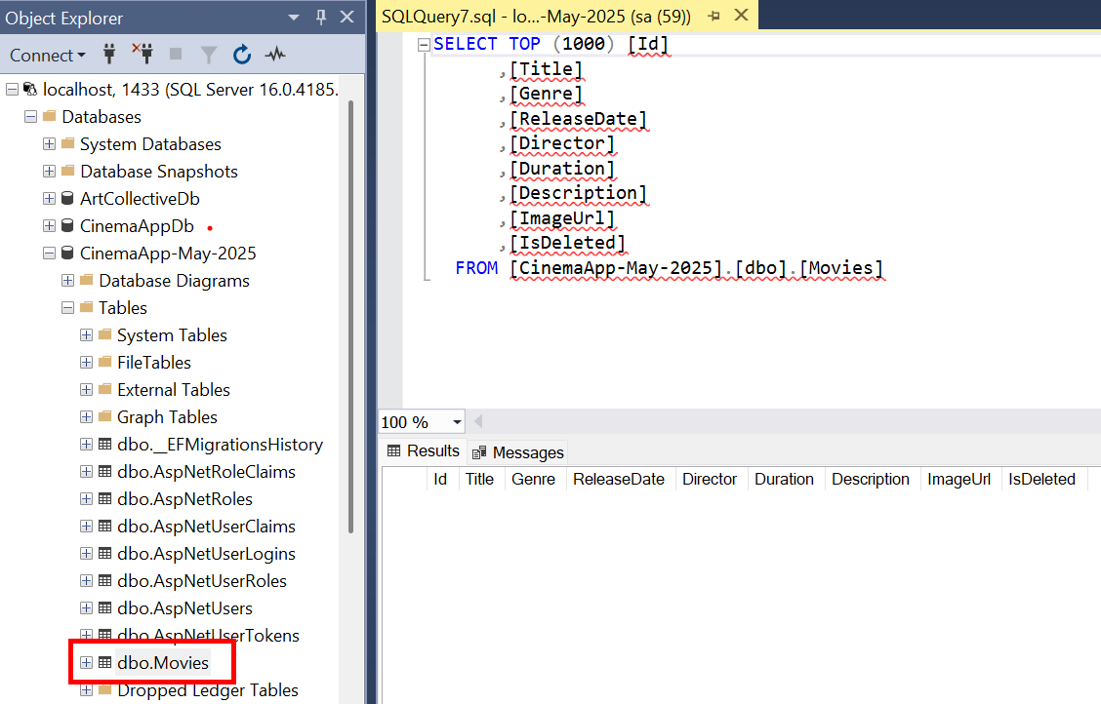

Seeding the Database with Movies
Before we build the UI to manage movies, let’s add some initial movie records to the database. This helps us test the layout and functionality with real data.

Seeding Movies Using MoviesConfiguration
- Create the Configuration File
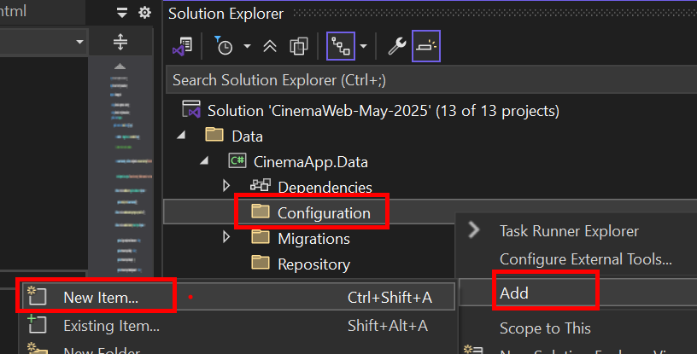
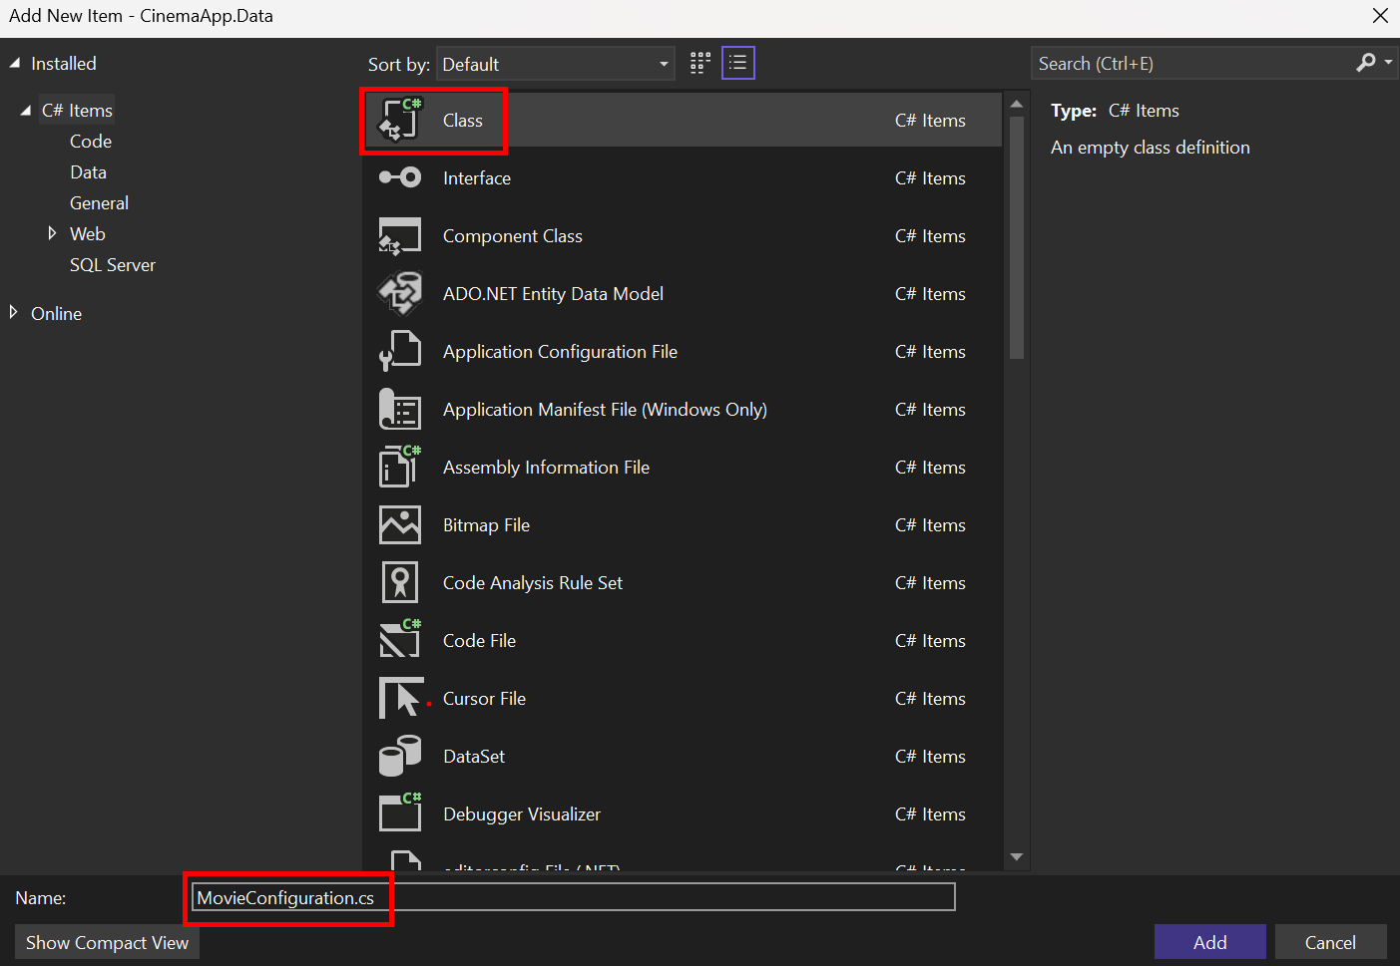
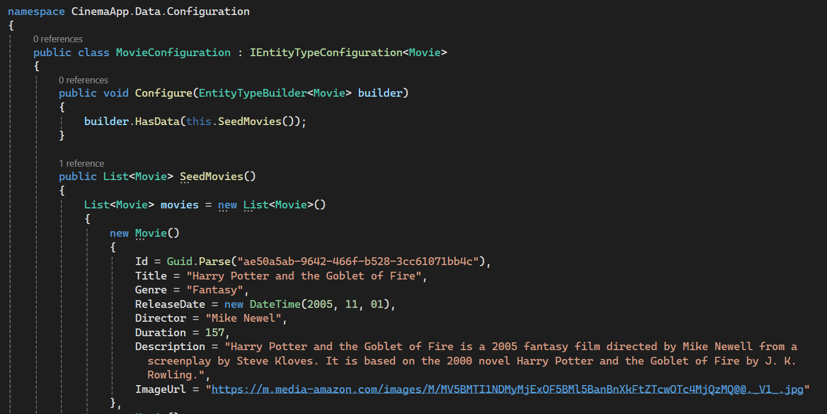

Create and Apply the Migration
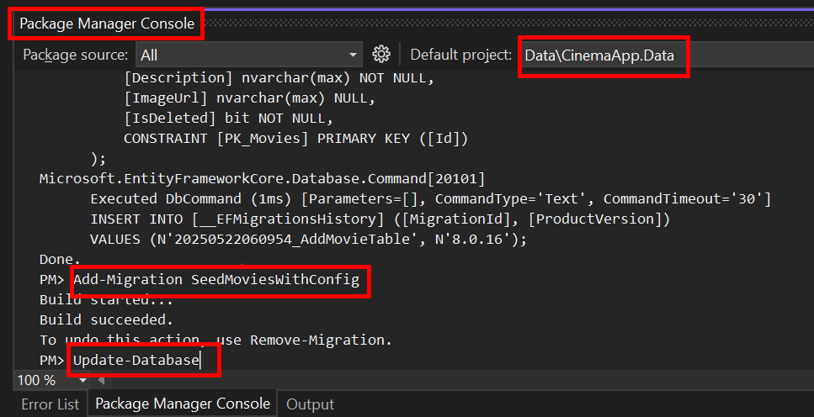

Verify the Data
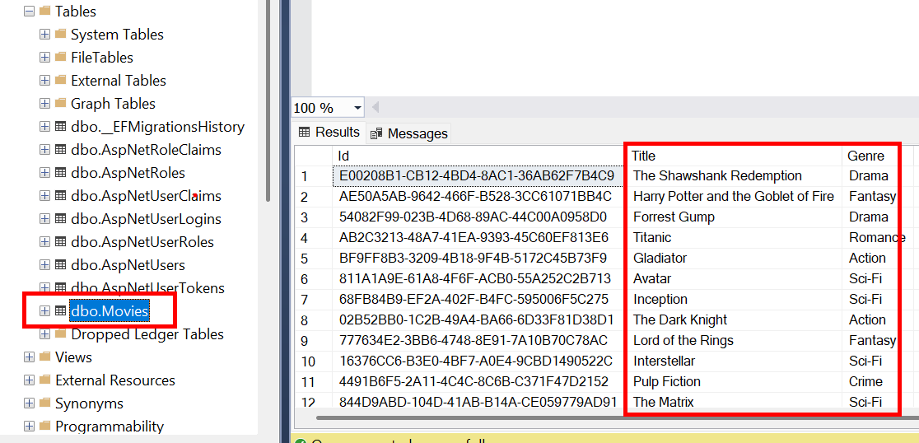

Creating the MovieController and Index View
We’re now ready to display the list of movies stored in the database. In this section, we’ll create a controller and implement the Index action to fetch all movies and show them in a simple table.

Create the Controller
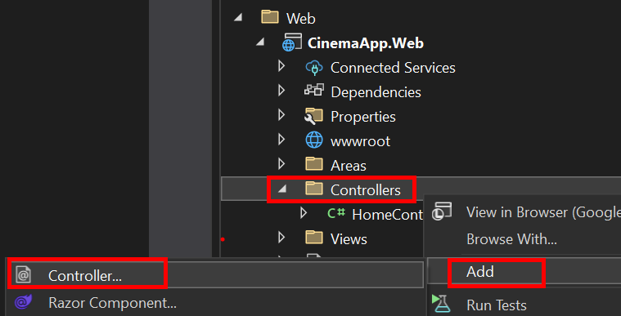
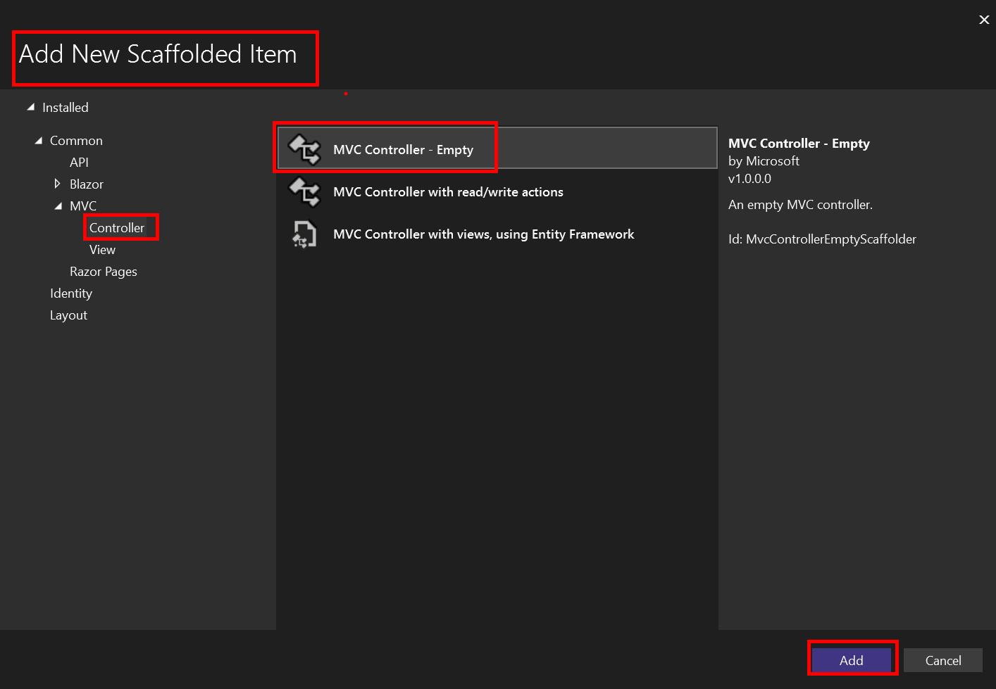
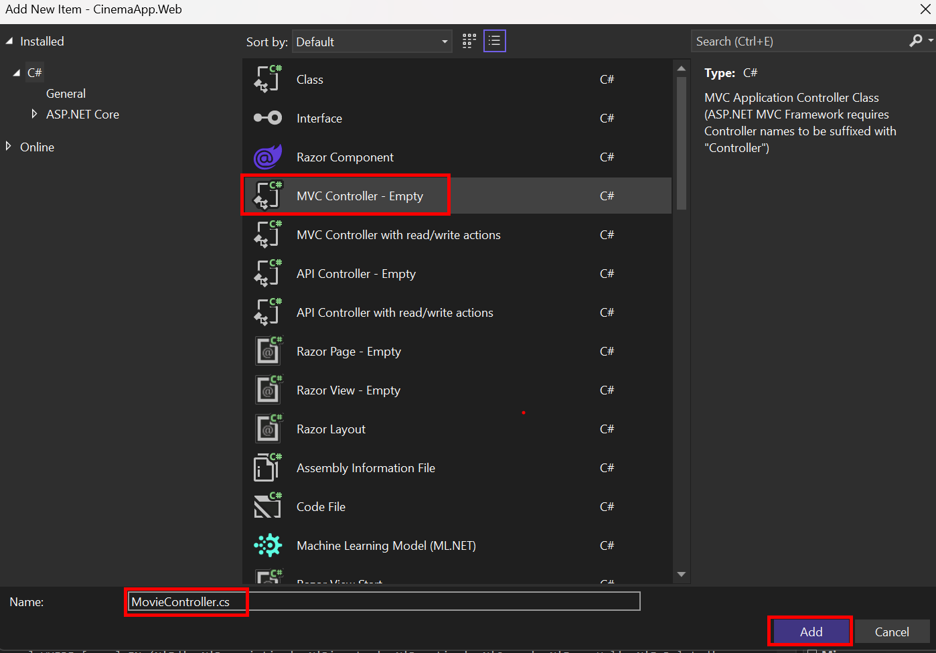
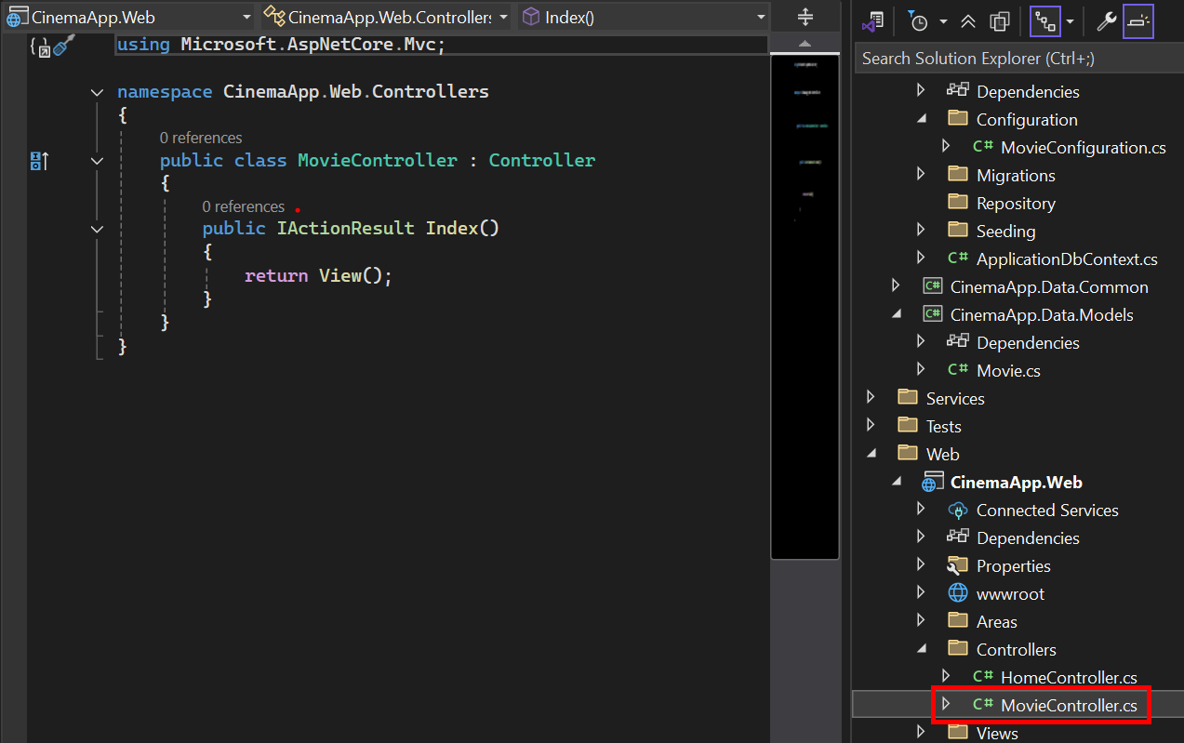

Add Dependencies and Constructor
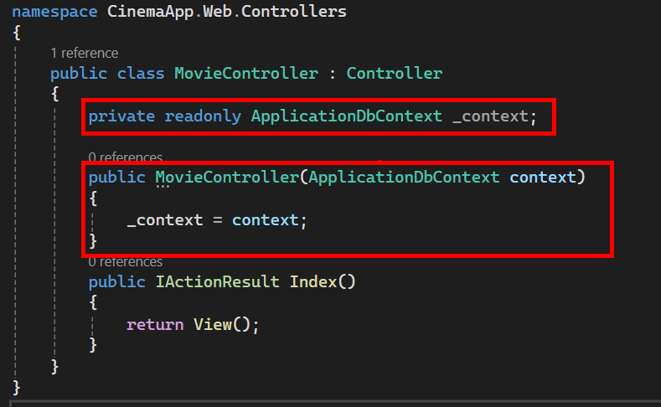

Creating the Movie View Folder and Index View
ASP.NET Core MVC follows naming conventions to connect controllers and views. If a controller is named MovieController and you have an action named Index(), the framework will look for a Razor View at:
- Views → Movie → Index.cshtml
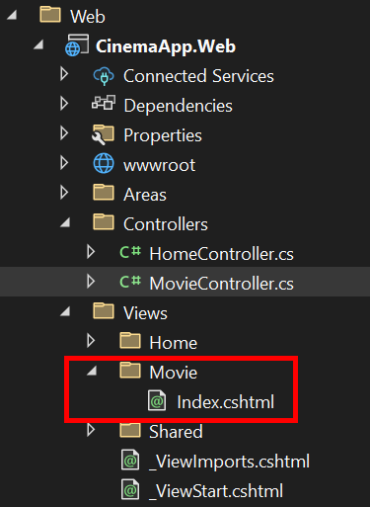

Add the Index View
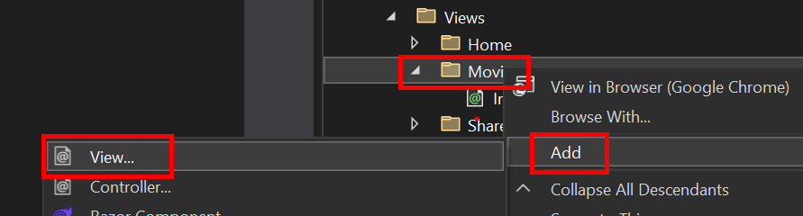
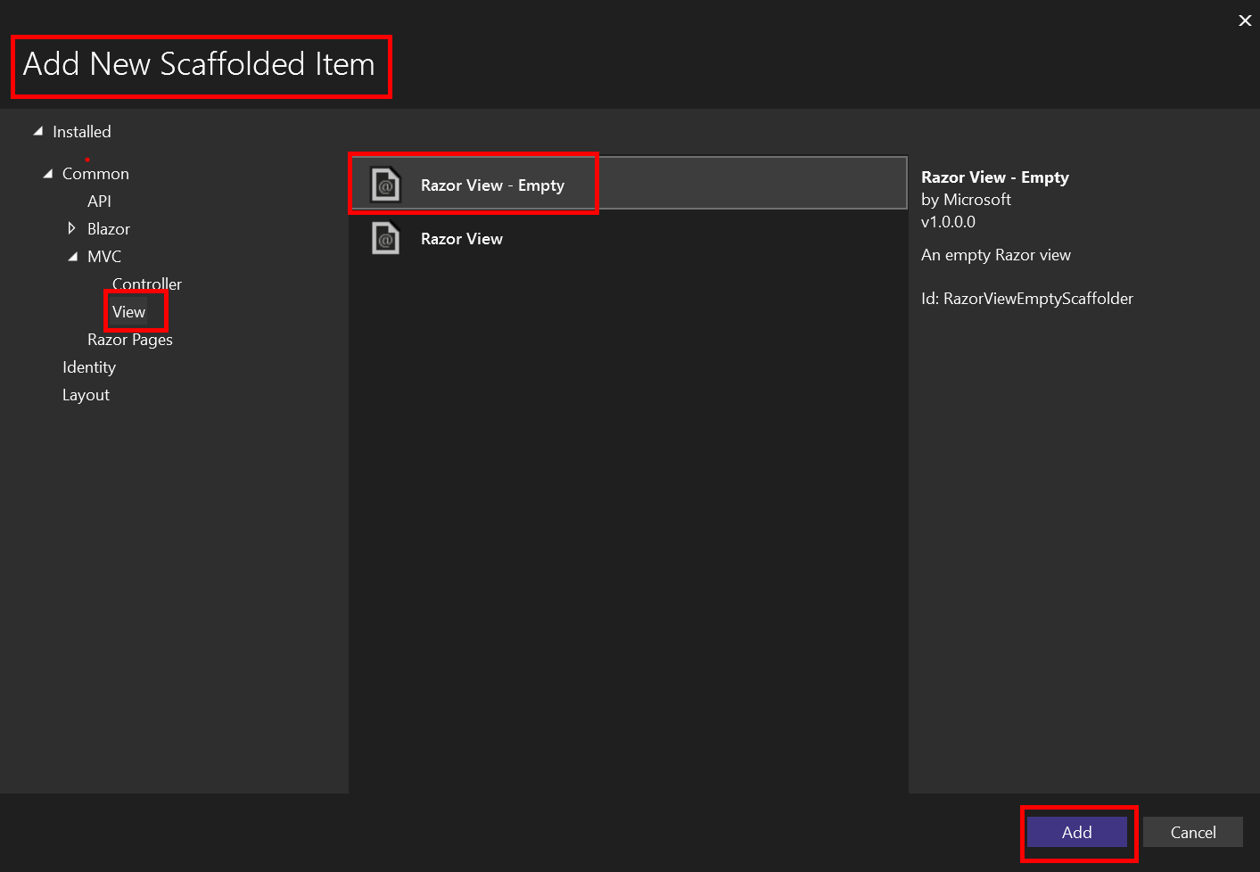
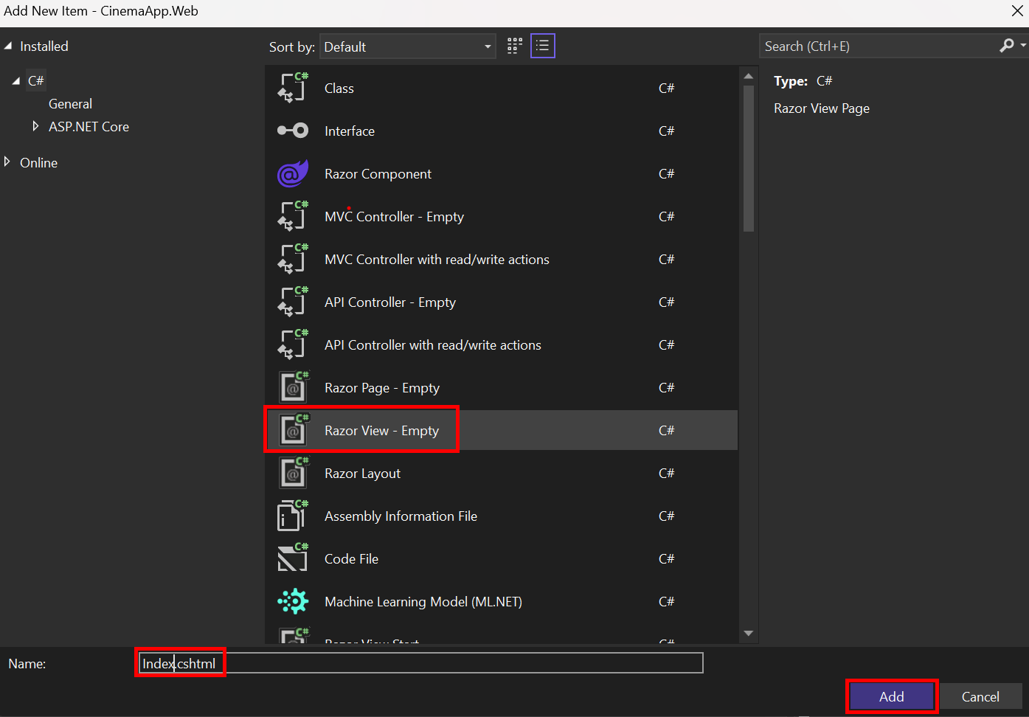

Using a ViewModel for the Movie Index Page
To display only the required movie information in the view (e.g., title, genre, director, release date), we will create a special class called a ViewModel.
This separates our presentation layer (what the view needs) from the data layer (the full Movie entity)
- Create the ViewModel
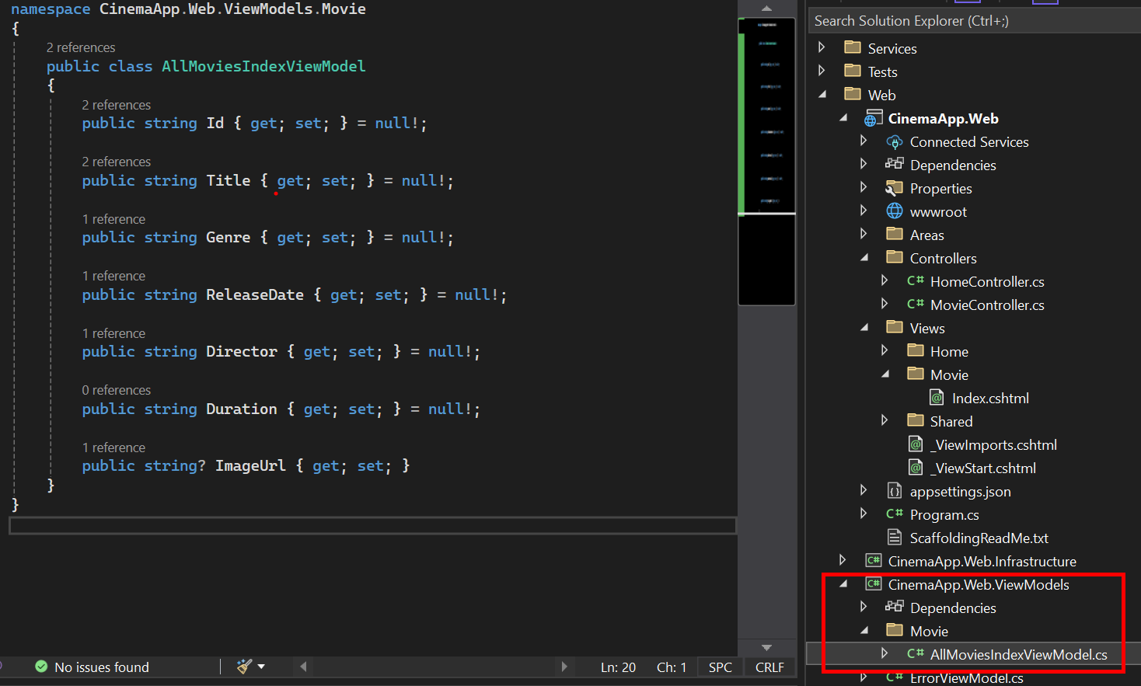

Adjust the Index Action in MovieController
Update the Index action to project data into the view model:
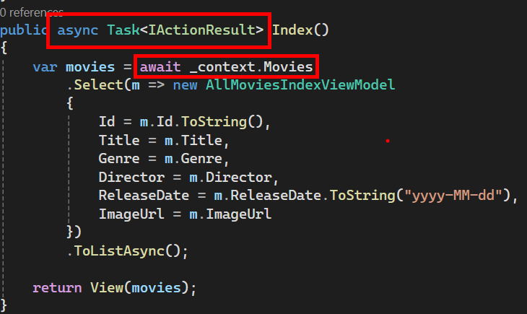

Final Result
You should now see a fully styled and responsive movie list page that displays all movies from your database.
