Creacion Repositorio - PARTE 1
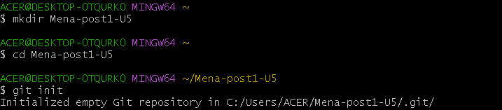
Creacion Rutas
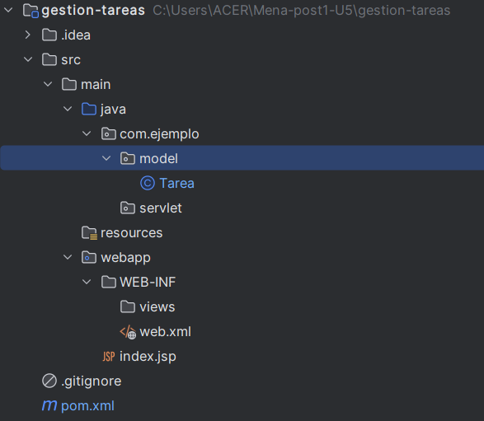

#1 Commit
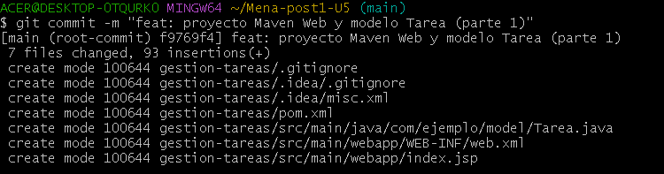

Creacion Ruta
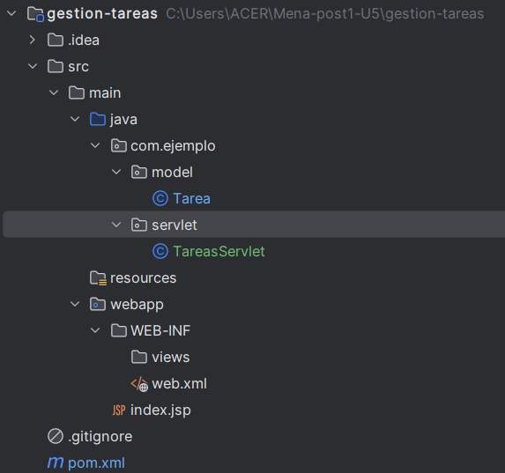

Clean
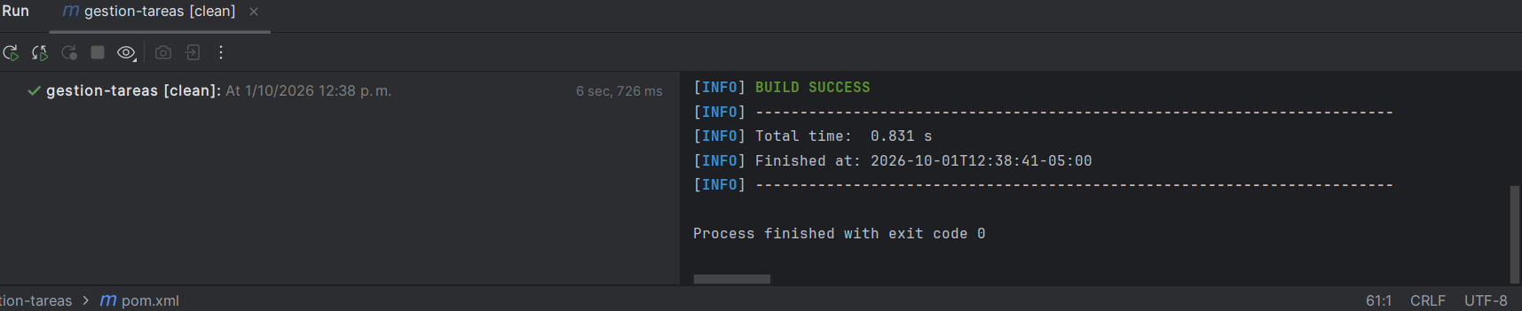
Package
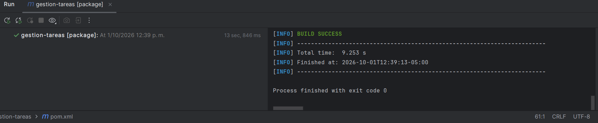

#2 Commit
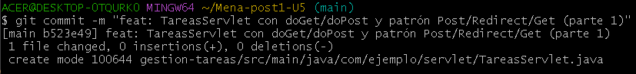

Creacion Ruta
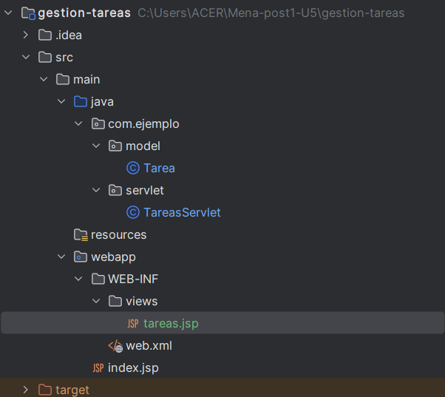

Despliegue
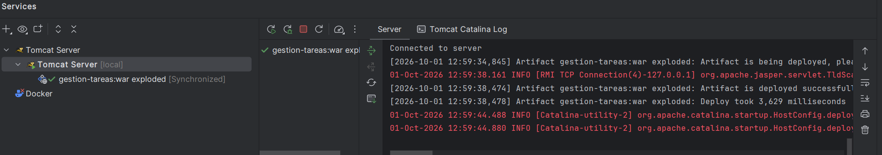
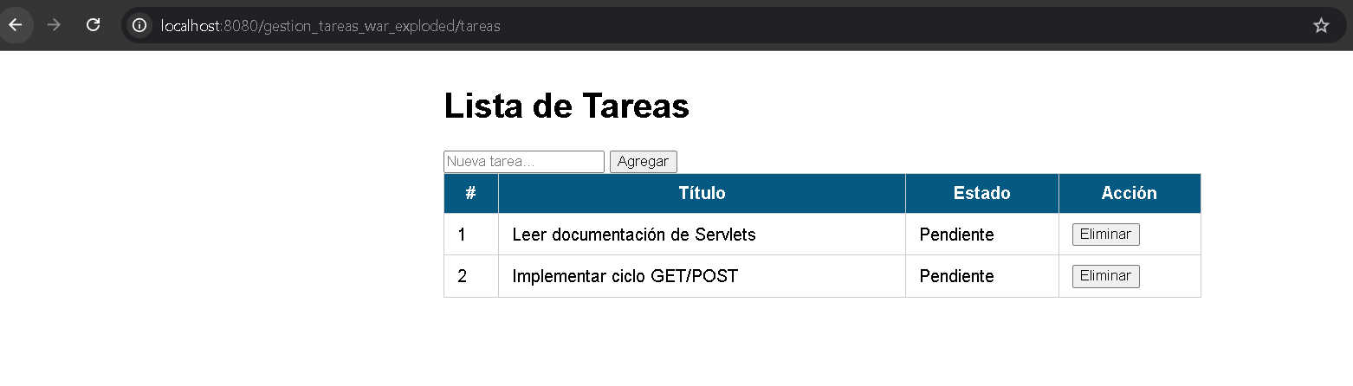

#3 Commit
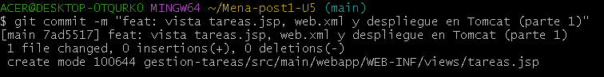
Git remote and Git push
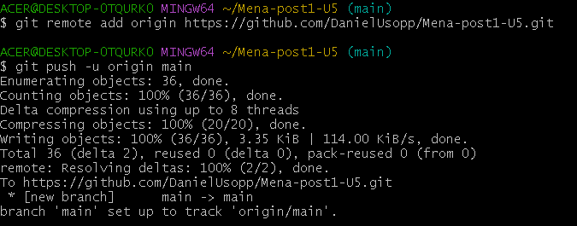

- PARTE 2
#1 Commit
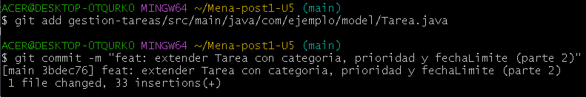
#2 Commit
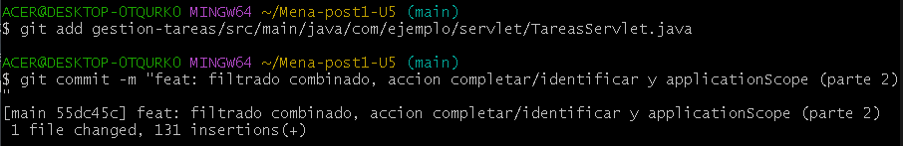
#3 Commit
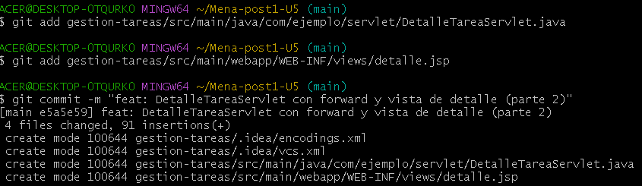

#4 Commit
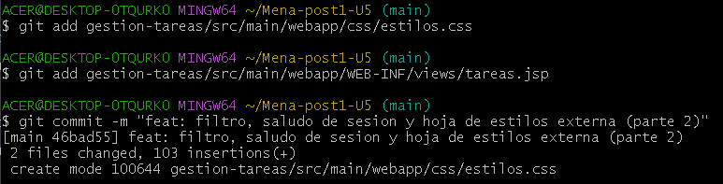
#5 Commit
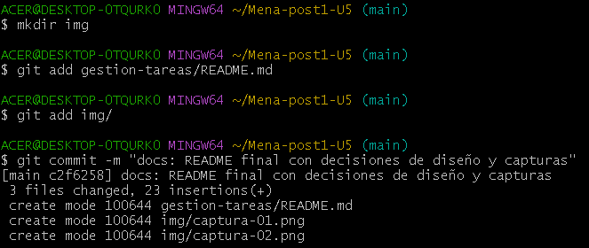
Git push
