Creacion Repositorio - PARTE 1
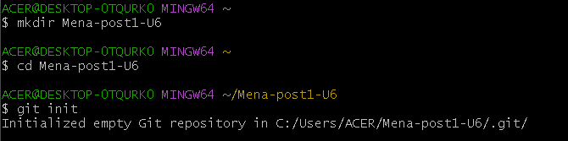
Creacion Ruta
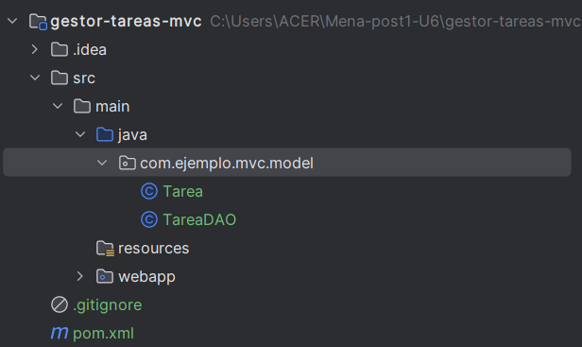
Clean
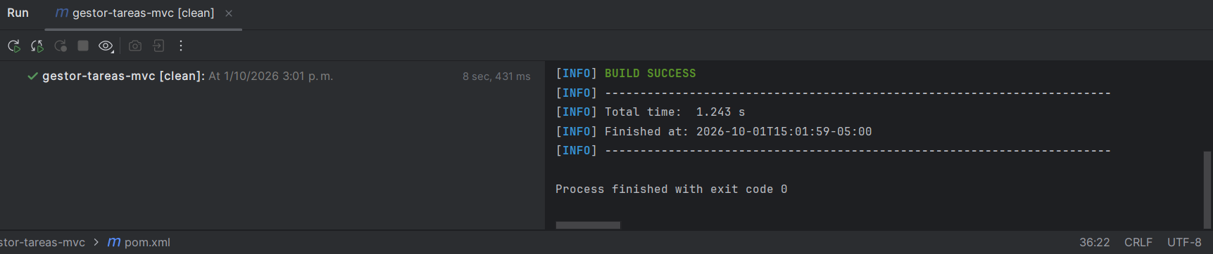
Package
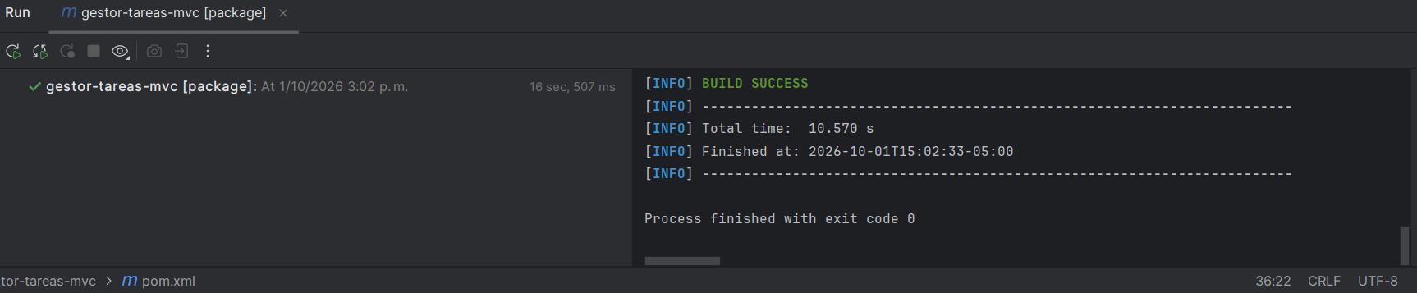

#1 Commit
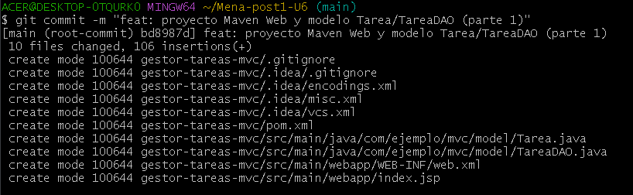
#2 Commit
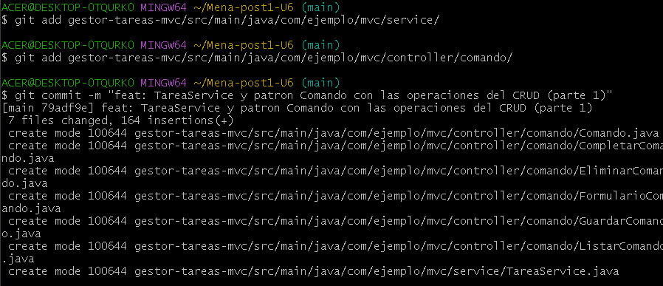
#3 Commit
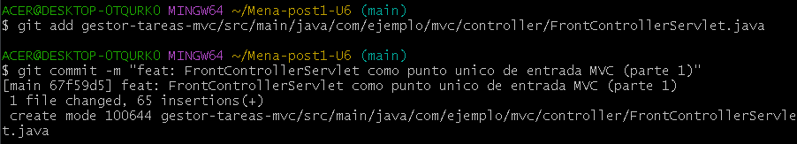
#4 Commit
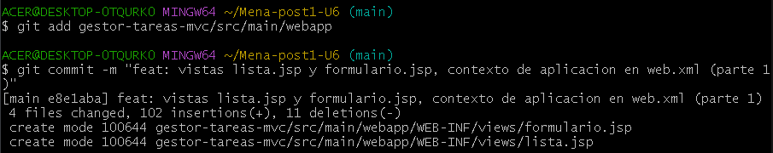

Git push
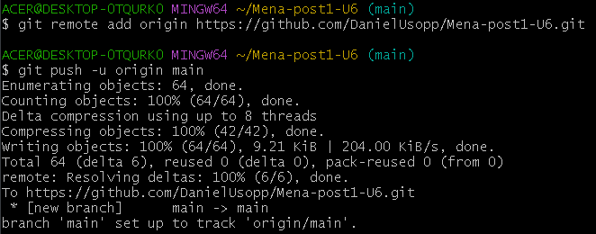

PARTE 2
#1 Commit
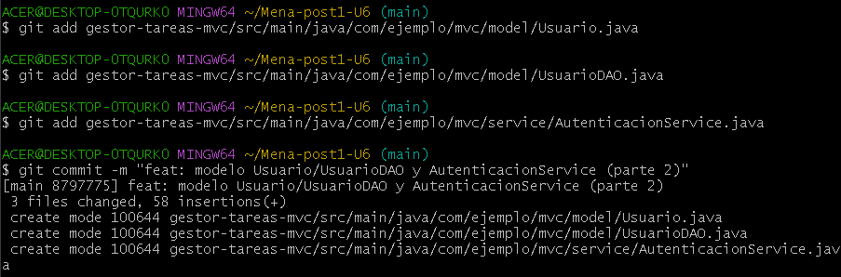
#2 Commit
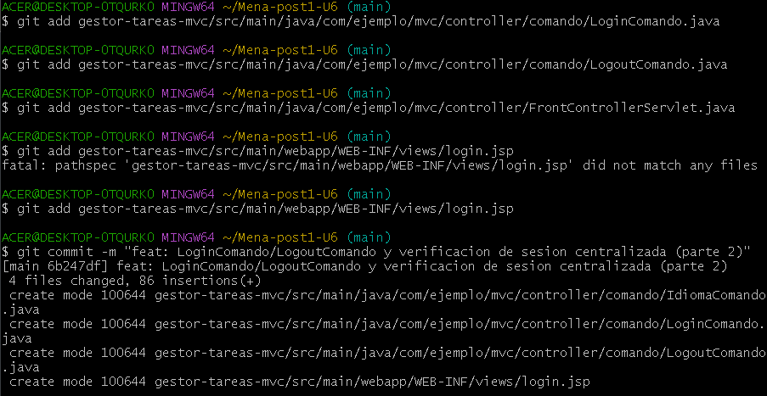
#3 Commit
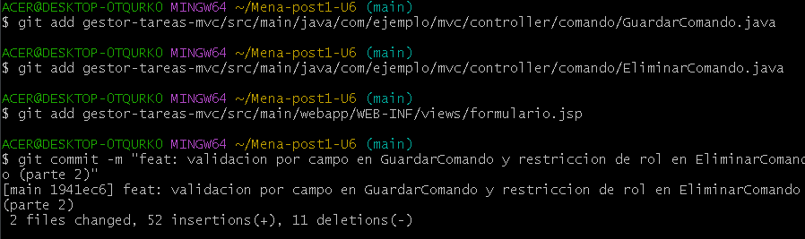
#4 Commit
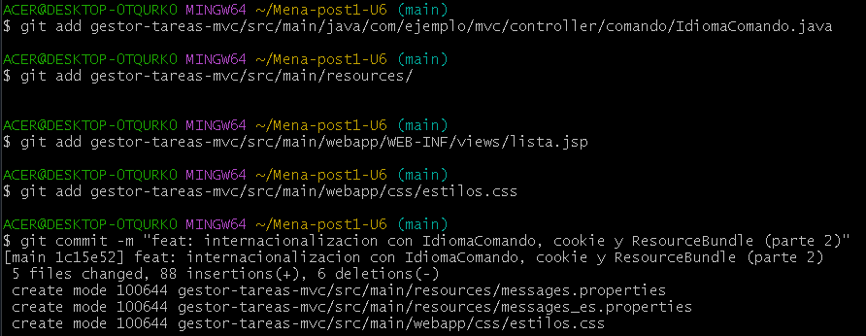
#5 Commit
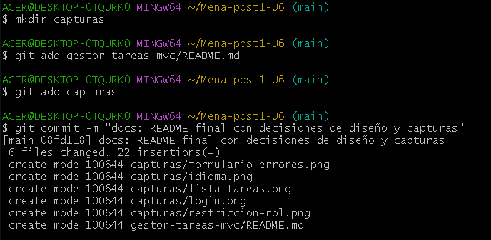
Git push
