Peter Simpson

Abstract
Understand how to build your own Alpaca device using the ASCOM C# template.
C# Alpaca Template Guide


Contents
Introduction 2
Getting started 2
Installing the template generator 2
Removing the Template Generator 2
The ASCOM Library 3
Template help and build options 3
Creating your Alpaca device 3
Project structure 4
Optimal implementation order and testing 4
How to add a new device 5
Implementing the hardware interface 6
How to view Alpaca protocol messages 6
How to use a serial port to communicate with hardware 6
How to use TCP/IP to communicate with hardware 8
How to add a new persisted configuration setting 8
How to add a configurable setting to the web setup UI. 9
How to configure security 9
Appendix 1 - Project structure 10
Appendix 2 – Example Razor setup page 12
Appendix 3 – Installing and using WireShark 14
Installing Wireshark and Setting Privileges on a Raspberry Pi 14
Checking the Wireshark Installation on the Raspberry Pi 14
Installing WireShark on Windows 16
Checking the Wireshark Installation on Windows 18
Setting up a Test & Learning Environment 18
Appendix 4 – Document Change History 20
Version 1 20
Version 2 – October 2025 20
Version 3 – January 2026 20
Version 4 – September 2026 20

Introduction to the C# Alpaca Template

Introduction
The ASCOM C# Alpaca template creates an Alpaca device using Microsoft ASP.NET and Blazor technologies. The generated Alpaca device provides supports Alpaca discovery out-of-the box, making substantial use of the ASCOM.Alpaca.Razor NuGet package to keep device implementation small and enable new features to be added in future.
Initially the template implements a safety monitor device, but you can easily configure the template to serve any ASCOM device type. Furthermore, you can serve multiple devices of the same device type as well as multiple devices of different device types.
We use the “Blazor Server” model rather than “Blazor WebAssembly (WASM)” because this provides a simple model with a single executable running on the host device from which communications to the hardware can be managed

Getting started
The template is created from the command line using a dotnet new command, but before this will work you need to install the NuGet package containing the template.

Installing the template generator
If you have installed an earlier template version, uninstall it first as described below.
To install the template:
- Download the latest template: https://www.nuget.org/packages/ASCOM.Alpaca.Templates
- Start a command prompt in the folder where you downloaded the package.
- Install the template: dotnet new install .\ASCOM.Alpaca.Templates.x.y.z.nupkg where x, y and z are the version numbers from the downloaded file. Include any release candidate text that follows the z parameter.
On completion you should see a message similar to this:
The following template packages will be installed:
D:\Downloads\ascom.alpaca.templates.0.5.0-alpha04.nupkg

Success: ASCOM.Alpaca.Templates::0.5.0-alpha04 installed the following templates:
Template Name Short Name Language Tags
------------------ ---------- -------- ----
ASCOM Alpaca Razor alpacacs [C#] Web

Removing the Template Generator
If no longer required, the template can be removed as follows:
- Start a command prompt
- Uninstall the template: dotnet new uninstall ascom.alpaca.templates
On completion you should see a message similar to this:
Success: ASCOM.Alpaca.Templates::0.5.0-alpha04 was uninstalled.

The ASCOM Library
The ASCOM Library makes it easier to add features to the device you will create from the Alpaca Device template. The Library provides a variety of capabilities in its ASCOM.Tools.Utilities class, which is based on the ASCOM Platform’s Util class, these will prove useful in many projects.
If you are already familiar with Platform components, you should find yourself at home with the Library components. The interface implementations are exactly as defined in the ASCOM Master Interfaces document but several enums have different names in the Library to improve source code clarity. The Library enums are functionally equivalent to their Platform counterparts and their values have a 1:1 mapping to the enums defined in the Master Interfaces document.
Further information on Library capabilities and enum name changes is available through these links:
- Library Capabilities
- Library Enums
- Side of pier and pointing state
Alpaca client authors will find several useful utilities for discovering Alpaca devices and connecting to them in the ASCOM.Alpaca.Components class.
If you are authoring your own Alpaca device from scratch, you will find the ASCOM.Alpaca.Device class can handle the heavy lifting of creating a reliable discovery responder.
The ASCOM Library is distributed as a set of NuGet packages, just search for ASCOM in your development tool’s NuGet UI and select the components you need.

Template help and build options
A summary of use and options is shown by the command: dotnet new alpacacs -h
Note: alpacacs is an abbreviation that avoids the need to type ASCOM.Alpaca.Templates
The help text includes details of options such as driver id and server name that can be set from the command line when the Alpaca device is generated from the template.
The following options can be set from the command line when the template is generated:
- -n <devicename> - The name of the solution/project that will be generated
- -o <outputfolder> - The folder in which the project will be generated (defaults to device name)
- -dr <driverid> - Name of the file used to store configuration information
- -m <manufacturer> - Your name or company
- -p <port> - The IP port on which the Alpaca device will start
- -s <servername> - A friendly name for the server
Note: Use double quotes around parameter values that contain spaces.

Creating your Alpaca device
The Alpaca device is created with a command similar to:
- dotnet new alpacacs -n DeviceName -dr DeviceName.Alpaca -m "Your name" -p 34567 -s "YourName's Alpaca Server" -o C:\Documents\DeviceName
The project can then be opened in Visual Studio (2022 or later) or an editor of your choice.

Project structure
The project structure looks like this (see Appendix 1 - Project structure for a description of each file):
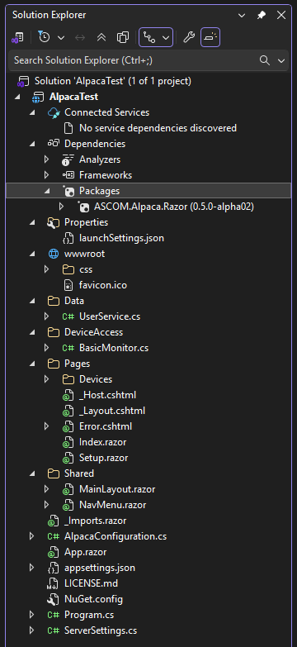

Optimal implementation order and testing
To aid developers, ASCOM publishes the Conform Universal tool that exercises each API member independently and reports on conformance with the relevant interface standard. You can download Conform Universal from this page: https://ascom-standards.org/AlpacaDeveloper/Index.htm . Conform is a robust tool designed to operate in the development environment where devices may be partially implemented or exhibit bugs.
The best approach to creating your Alpaca device to is to implement in the following order:
- Establish connectivity to your device
  - Get the low-level routines for communicating with your device operating robustly, including establishing and tearing down the physical link.
  - Implement the Connected, Connect, Disconnect and Connecting members
- Implement read-only members
  - These appear as properties in the device class you added. Many are straightforward to implement and will enable you to get experience in working with the template.
- Implement functional members
  - These appear as methods and usually implement more complex functionality.

How to add a new device
  - New devices are added as classes to the DeviceAccess folder and then the configuration in program.cs is updated to load the new class when the device starts. In this example a telescope device is added, which implements ASCOM interface ITelescopeV4.
  - Add a new class to the DeviceAccess folder with an appropriate name e.g. TelescopeDevice1
- Add a using statement:
  - using ASCOM.Common.DeviceInterfaces;
- Add a reference to the latest ascom interface to the class statement:
  - public class TelescopeDevice1 : ITelescopeV4
- Right click on the interface statement and use the Quick Action to implement the interface
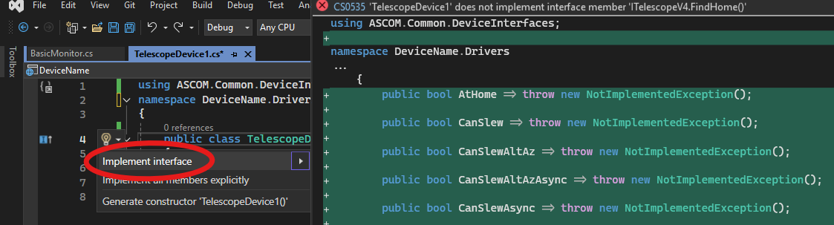
- Add an entry in Program.cs, under the LoadSafetyMonitor line, to load the telescope class when the Alpaca device starts:
  - DeviceManager.LoadTelescope(0, new DeviceAccess.TelescopeDevice1(), "My Alpaca telescope", ServerSettings.GetDeviceUniqueId("Telescope", 0));
  - Parameter 1 is the Alpaca device number that will be used in the URL to access the device e.g. http://localhost:12345/api/v1/telescope/0/name
  - Parameter 2 is the class that controls this device
  - Parameter 3 is the name of the device as it will appear through the discovery API.
  - Parameter 4 is a unique ID for this device. We recommend using the GetUniqueDeviceId function to return a consistent GUID.
  - The template provides Setup GUI pages for all device 0 devices of all ASCOM device types. This means that you only need to add a Setup page to the Pages/Devices folder if you are supporting 2 or more devices of the same device type.
- You can now compile and run your code. A console application will start (the Razor server application) together with a browser interface to the Alpaca device’s management configuration URL. You will see configuration for the Alpaca device itself and for the configured devices:
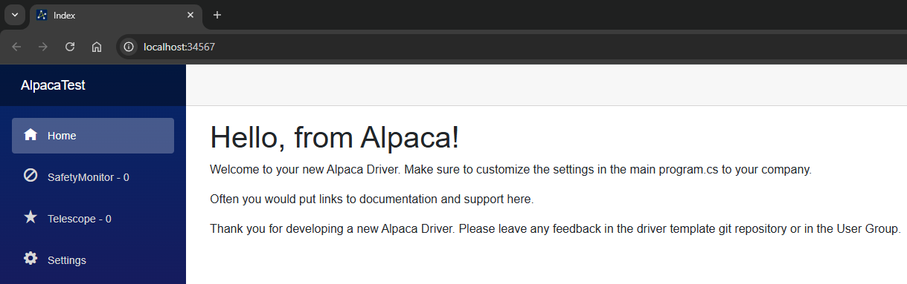
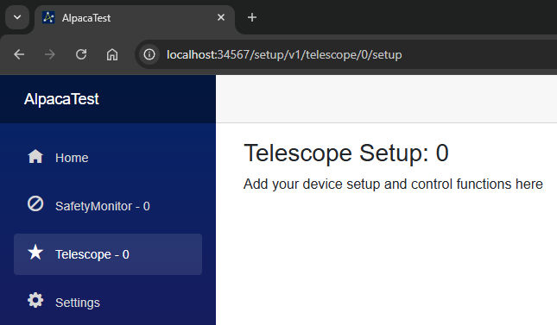

Implementing the connection management members
ASCOM devices have historically used the synchronous Connected property to change the device’s connection state. With Platform 7 we introduced asynchronous connection through the Connect(), Disconnect() and Connecting members, where Connect() and Disconnect() are short lived initiators and Connecting is the completion variable that indicates whether the operation:
- is still running Connecting returns true.
- has completed successfully Connecting returns false.
- failed to complete Connecting throws an exception describing what happened.
Boilerplate code for handling the four connection members is available in the example safety monitor device that is provided in the template. We recommend that you cut and paste this code into your new device to replace the same named members created when the interface was implemented.
The device’s communication code only needs to be implemented once each in the Connect() and Disconnect() methods because the Connected Set property uses Connect(), Disconnect() and Connecting under the hood. The places to add your code in Connect() and Disconnect() are marked with TODO: Add your device connection code here. comments.

Implementing the hardware interface
Due to the wide variety of physical communication channels available, this section is necessarily high-level.
A good approach is to implement the physical hardware communication inside a static class, located in the DeviceAccess folder, and to call this as needed from the Connect() and Disconnect() members.
If hardware responses are expected to take more than 1 second, implement the communications round-trip asynchronously e.g. by using the asynchronous methods in the .NET HttpClient class or by using async await to handle text transmission and reception through the SerialPort class.

How to view Alpaca protocol messages
The Alpaca protocol uses an HTTP/REST implementation and network messages between clients and devices can be viewed with WireShark as described in Appendix 3 – Installing and using WireShark.

How to use a serial port to communicate with hardware
If your device is attached to a real serial port or a virtual port exposed through USB hardware, you will need to add Microsoft’s System.IO.Ports NuGet package to your project. After this you can communicate with using the SerialPort component.
The following basic program shows how to list available COM ports and send text to the COM port.
using System.IO.Ports;

namespace ComTest
{
internal class Program
{
static void Main(string[] args)
{
try
{
// Get a list of available serial ports
string[] portNames = SerialPort.GetPortNames();

if (portNames.Length == 0)
{
Console.WriteLine("No serial ports found.");
return;
}

foreach (string portName in portNames)
{
Console.WriteLine($"Found serial port: {portName}");
}

// Select the first available port and connect at 9600 baud
SerialPort sp = new SerialPort(portNames[0], 9600);
sp.Open();

// Write some arbitrary text to the port
for (int i = 0; i < 10; i++)
{
Console.WriteLine($"Writing to {portNames[0]}, Cycle: {i}");
sp.WriteLine("Arbitrary text sent to the COM port".ToString());
Thread.Sleep(1000); // Wait for 1 second
}
}
catch (Exception ex)
{
Console.WriteLine($"Exception: {ex.Message}\r\n{ex}");
}
}
}
}
This program should be created as a .NET 8 or later project and published to your target of choice e.g. Windows or Linux or ARM.
Serial ports on Windows are usually named COMx where x is an integer from 1 upwards. On Linux they have a variety of names e.g. /dev/ttyUSB0 and /dev/ttys0. If you receive a permissions exception when running the program above on Linux you may need to add your user to the dialup group:
- Add the user to the dialup group: sudo gpasswd --add ${USER} dialout
- Change the user’s group to the dialup group: newgrp dialout

How to use TCP/IP to communicate with hardware
The following is a basic example of how to use the .NET HttpClient component to retrieve a response from an HTTP server, in this example, the OmniSimulator running on the local device:
using System;
using System.Net.Http;
using System.Threading.Tasks;

class Program
{
static async Task Main()
{
using HttpClient client = new HttpClient();

try
{
string url = "http://localhost:32323/setup"; // Target URL
HttpResponseMessage response = await client.GetAsync(url);

response.EnsureSuccessStatusCode(); // Throws if not 2xx

string responseBody = await response.Content.ReadAsStringAsync();
Console.WriteLine($"Response received:\r\n{responseBody}");
}
catch (HttpRequestException e)
{
Console.WriteLine($"Request error: {e.Message}");
}
}
}

How to add a new persisted configuration setting
Configuration settings are defined as properties in the ServerSettings class and are automatically saved when you write to the property. Setting values are persisted to a file stored as follows:
- Windows: C:\Users\%USERNAME%\.ASCOM\Alpaca\{Program.DriverId}
- Linux: $HOME/.config/ascom/alpaca/{Program.DriverId}
This is an example of implementing a boolean value, other types are implemented similarly:
/// <summary>
/// Gets or sets a value indicating whether authentication is enabled.
/// </summary>
/// <remarks>The value is retrieved from or stored in the application profile settings.</remarks>
internal static bool UseAuth
{
get
{
// Retrieve the value. Return false if the value has not yet been set
if (bool.TryParse(Profile.GetValue("UseAuth", false.ToString()), out bool result))
{
return result;
}

// Return false if the stored value cannot be parsed to a boolean value
return false;
}
set
{
// Persist the value to the backing file
Profile.WriteValue("UseAuth", value.ToString());
}
}

See the ServerSettings.cs file for examples of how to implement string, boolean, integer and enum types.

How to add a configurable setting to the web setup UI.
The template’s web pages use the Razor markup language to create UI elements; an example page is shown in Appendix 2 – Example Razor setup page. This shows how to create string, boolean and integer input fields and to retrieve and store values using the ServerSettings class.
Successful compilation of this page requires that you have added three properties (ExampleBool, ExampleInt and ExampleString) to the ServerSettings class following the template in section How to add a new persisted configuration setting.

How to configure security
NOTE: We highly recommended that you never expose an Alpaca device to a hostile environment, particularly not directly to the Internet via a static IP address. Remote access should always be accomplished via a VPN or other similar technology.
The driver template offers several security features including HTTP Basic Auth support via the “Require Authorization” checkbox in the “Security Settings” section on the “Settings” tab. Here you can set a username and password that must be provided by the client.
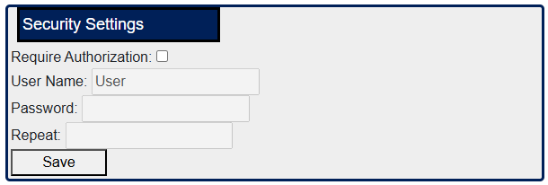
Once enabled, access is allowed only when a correct username and password are provided.
To use more complex access controls, revise the UserService class in the Data folder to implement your desired security mechanic. The default class created by the template supports a single basic auth user whose settings are stored unencrypted in the server settings file.
The template supports both HTTP and HTTPS using self-signed and user supplied certificates through the standard built-in .NET Kestrel server options. If you plan to use SSL, we recommended that you set up a web proxy with an SSL host certificate from a trusted certificate authority.

How to alter the application shutdown timeout
The default timeout is 30 seconds, which can be inconveniently long. The timeout can be changed to a value of your choice e.g. 5 seconds by adding this code after the builder.services lines in program.cs:
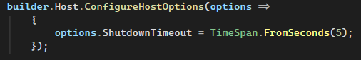

Appendix 1 - Project structure
The broad purposes of files created by the template are:
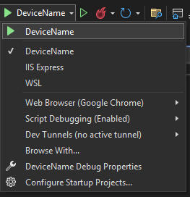
- Packages – Lists NuGet packages used in the project
- launchsettings.json – Configuration for various ways of running the application for testing (stand-alone or as a service running under IIS, which browser to use etc.). Devices built with the template are designed to run stand alone, see opposite, please do not select IIS or WSL.
- wwwroot/CSS – Contains cascading style sheet (CSS) files that format the user interface pages displayed in the browser. You generally don’t need to change these if you retain the default style.
- wwwroot/favicon.ico - The favicon appears in browser tabs.
- Data/UserService – The UserService validates user access. See here for more information.
- DeviceAccess - This folder contains a class for each device available from the Alpaca server. See Implementing the hardware interface for information on how to add further devices.
- Pages/Devices – The Devices folder holds basic configuration pages for all device types
- Pages/_Host.cshtml – HTML page that acts as the host page for the Blazor single page application. You should only need to revise this in advanced scenarios.
- Pages/_Layout.cshtml – HTML page setting out the overall structure of the rendered page including common content e.g. CSS scripts that are available in every page of the application.
- Pages/Error.cshtml – Error page for use in the development environment.
- Pages/Index.razor – Home page for the application
- Pages/Setup.razor – Device’s top-level configuration page
- Shared/MainLayout.razor – Overall layout for common elements of the browser page including the page header, navigation and page content areas. Usually, you won’t need to change this file.
- Shared/NavMenu.razor – This creates the navigation menu including items like device setup and individual configuration pages for all available devices. Usually, you won’t need to change this file.
- _imports.razor – Common Blazor using statements that should be available on all razor pages
- AlpacaConfiguration.cs – Defines configuration values for the Alpaca device itself e.g. IP port, manufacturer name, server version and location that will be loaded from and persisted to permanent storage. Define device specific configuration values in ServerSettings.cs rather than in AlpacaConfiguration.cs.
- App.razor – The root component of the application. Usually, you won’t need to change this file.
- Appsettings.json - The appsettings.json file in ASP.NET Core is a centralized location for storing fixed application configuration settings such as database connection strings, API keys, and other environment-specific values. Usually, you won’t need to change this file.
- License.md – The copyright license file for your device. The MIT license is provided by default.
- NuGet.config – Specifies sources of NuGet updates. By default, this includes the main NuGet repository and the ASCOM MyGet repository that holds updates ahead of public release to NuGet.
- Program.cs – Entry point for the application, see comments in file for further information.
- ServerSettings.cs – Class that defines common server level and device specific configuration values. Contents of this class are loaded automatically when the application starts and persisted by the Save buttons in the setup dialogue.

Appendix 2 – Example Razor setup page
@page "/setup/v1/Telescope/{InstanceID:int}/setup"

<h3>Telescope Setup: @InstanceID</h3>

@* Check whether this is a defined device and if so display the UI *@
@if (ASCOM.Alpaca.DeviceManager.Telescopes.ContainsKey(InstanceID))
{
@* Create a group of configurable values *@
<fieldset style="padding-left:12px">

@* Example text box *@
<label style="margin-top:12px">Example string: </label>
<input type="text" @bind="ExampleString" >
<br />

@* Example check box *@
<label style ="margin-top:12px">Example checkbox:</label>
<input type="checkbox" @bind="ExampleBool">
<br />

@* Example numeric input *@
<label style="margin-top:12px">Example int:</label>
<input type="number" @bind="ExampleInt" min="1" max="65535" style="width:20ch;">
<br />

@* Display a Save button and status label that colours green for success messages *@
@* and red for failure messages *@
<button @onclick="SaveDriverSettings" style="min-width:12ch;margin:12px">Save</button>
<label style="color:@StatusColour;"><b>@Status</b></label>

</fieldset>
}
else
{
@* Not a defined device so create an error message *@
<h3>This device does not exist and cannot be configured</h3>
}

@* Start of C# code *@
@code {

/// <summary>
/// Parameter visible to clients calling this class
/// </summary>
[Parameter]
public int InstanceID { get; set; }

/// <summary>
/// Example boolean setting that defaults to the value retrieved from the ServerSettings class
/// </summary>
private bool ExampleBool { get; set; } = ServerSettings.ExampleBool;

/// <summary>
/// Example integer setting that defaults to the value retrieved from the ServerSettings class
/// </summary>
private int ExampleInt { get; set; } = ServerSettings.ExampleInt;

/// <summary>
/// Example string setting that defaults to the value retrieved from the ServerSettings class
/// </summary>
private string ExampleString { get; set; } = ServerSettings.ExampleString;

/// <summary>
/// Current value of the save status message
/// </summary>
private string Status { get; set; } = "";

/// <summary>
/// Colour of the status message - green for success, red for failure
/// </summary>
private string StatusColour { get; set; } = "green";

/// <summary>
/// Save the driver settings and display a message indicating success or failure
/// </summary>
/// <remarks>
/// Note use of the async modifier to ensure that this method does not block the UI thread
/// and prevent UI updates appearing
/// </remarks>
private async void SaveDriverSettings()
{
try
{
// Save the settings to the ServerSettings class
ServerSettings.ExampleBool = ExampleBool;
ServerSettings.ExampleInt = ExampleInt;
ServerSettings.ExampleString = ExampleString;

// Display a success message
Status = "Driver Settings Saved OK";
StatusColour = "green";

// Notify the application that the UI's Status field has changed so the UI will be updated
StateHasChanged();

// Wait for 2 seconds and then clear the status message.
// Note that this is done asynchronously to ensure the UI remains responsive
await Task.Run(async () =>
{
await Task.Delay(2000);
Status = "";
});
}
catch (Exception ex)
{
Status = $"Settings not saved: {ex.Message}";
StatusColour = "red";
}

// Notify the application that the UI's Status field has changed so the UI will be updated
StateHasChanged();
}
}

Appendix 3 – Installing and using WireShark

Installing Wireshark and Setting Privileges on a Raspberry Pi
To install it on the Pi, you need about 100MB. In a shell
pi@raspberrypi:~ $sudo apt install wireshark
During installation you'll see this
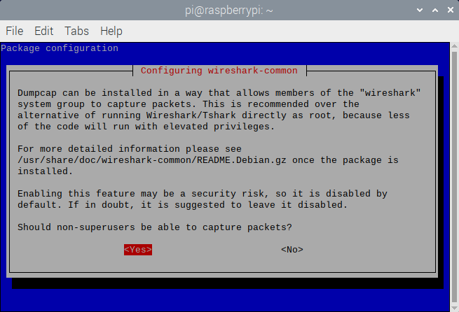
Make sure to answer <Yes> to this so you don't have to start Wireshark with root privs. But there is more, note it says you still need to be a member of the "wireshark" group. Once the installation completes, add yourself (typically you are user "pi"):"
pi@raspberrypi:~ $sudo usermod -a -G wireshark pi
Now log out and back in to join the "wireshark" group. You will find Wireshark in the Berry menu under Internet.
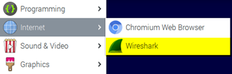

Checking the Wireshark Installation on the Raspberry Pi
Now start Wireshark and be sure you see the network interfaces, indicating that you have successfully allowed non-root capturing and joined the "wireshark" group. You should see this:
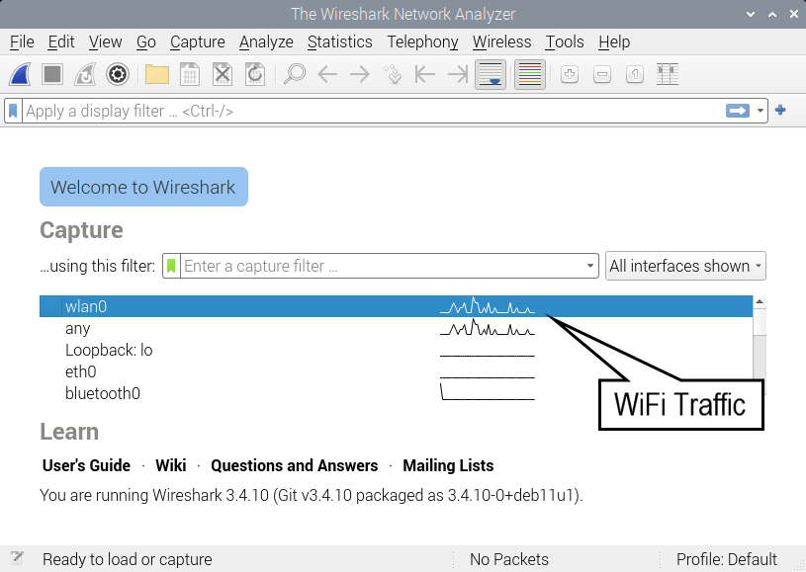
If you see wlan0 and traffic, then you're ready to use Wireshark. If you are on Ethernet, the traffic will be on eth0. Otherwise:
- Did you answer Yes to the non-root capture? You can check by entering this command
pi@raspberrypi:~ $sudo dpkg-reconfigure wireshark-common
which will show the allow non-root dialog that appeared during installation. Answer <Yes>.
- Did you log out and back in after adding yourself to the "wireshark" group?
Go back and repeat the installation steps till you see a Wireshark window with the physical interfaces as shown above.

Installing WireShark on Windows
To install WireShark on Windows, download the latest release from https://www.wireshark.org/ and run the installer.
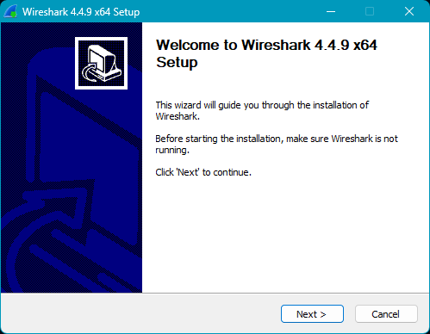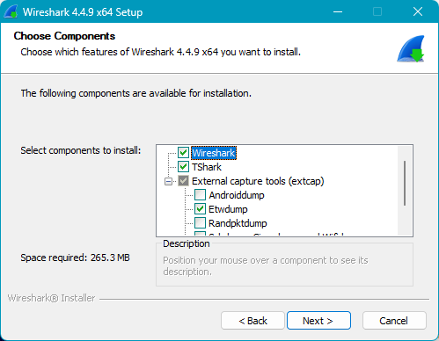
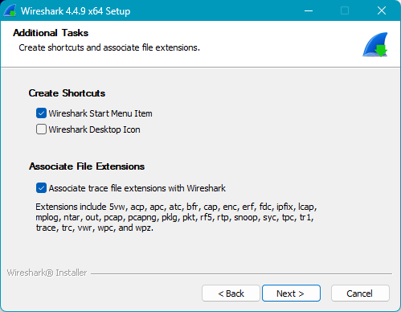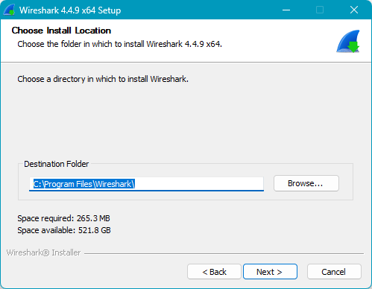
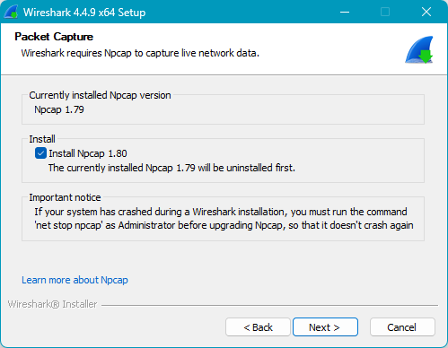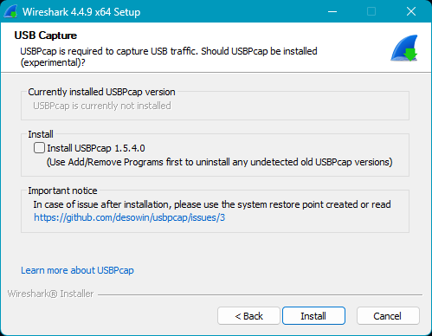
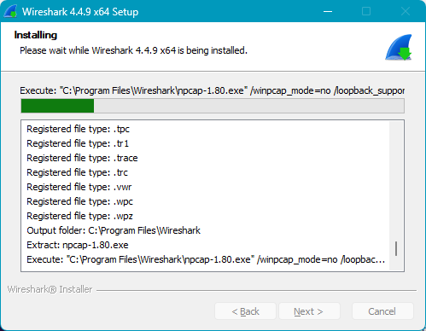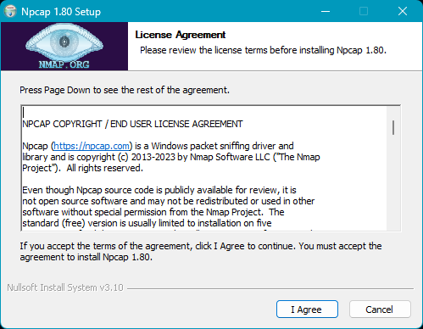
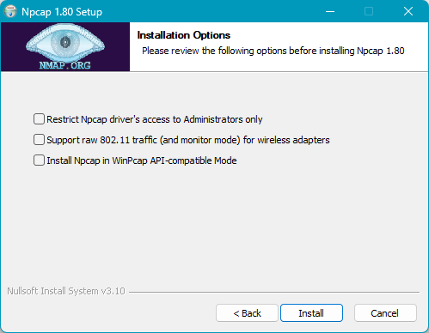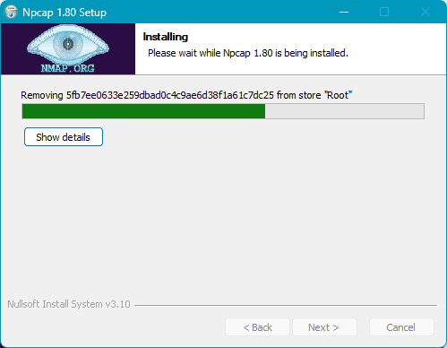
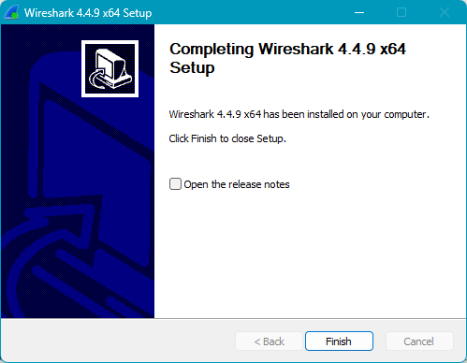

Checking the Wireshark Installation on Windows
Start Wireshark and be sure you see the network interfaces, indicating that you have successfully installed WireShark. You should see something like this:
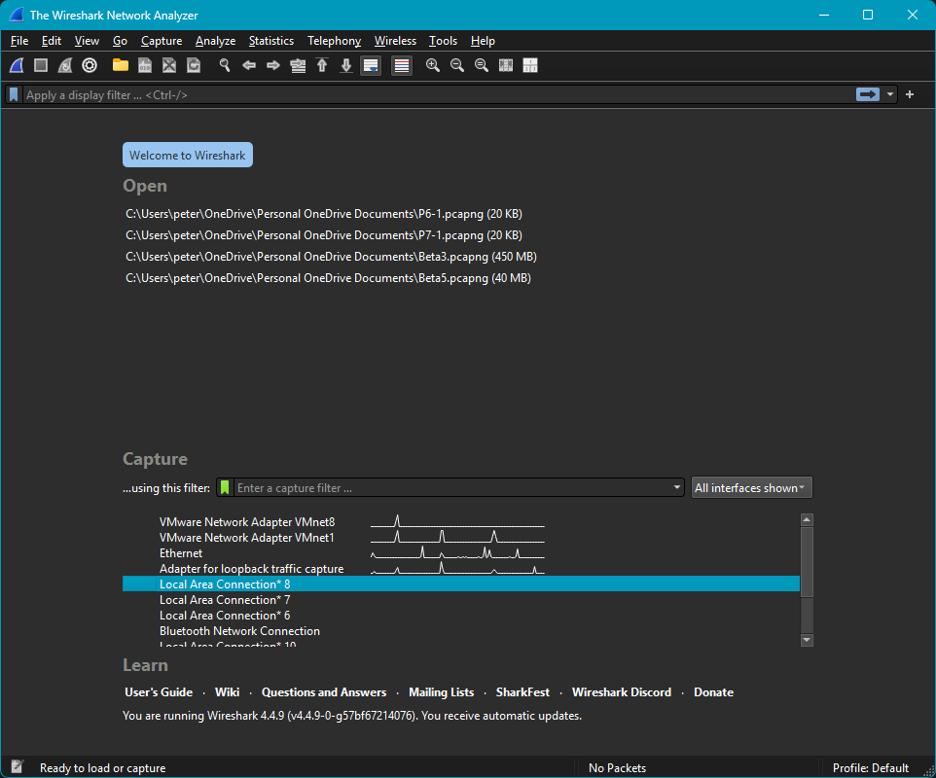

Setting up a Test & Learning Environment
You will need a client application and an Alpaca device for this. A range of clients are available including:
- Windows DeviceHub (via an Alpaca dynamic driver),
- SkySafari Plus or Pro on iOS
- Cartes du Ciel on any supported OS platform
- Conform Universal on any supported OS platform: https://github.com/ASCOMInitiative/ConformU/releases
The OmniSim is the simplest Alpaca device to get going:
- Windows – If you are using Platform 7 the Omni-Simulators are installed with the Platform.
- Windows – If you are using Platform 6 install the latest production Omni-Simulators Windows release from here: https://github.com/ASCOMInitiative/ASCOM.Alpaca.Simulators/releases
- All other OS - Install the latest production Omni-Simulators release for your OS from
here: https://github.com/ASCOMInitiative/ASCOM.Alpaca.Simulators/releases
Once you have an app (anywhere) talking to the simulated telescope on the Pi, you can use Wireshark to see the HTTP/REST traffic between them. Here we use SkySafari Pro on 192.168.0.21, and we're running Wireshark on a Pi that's also running the OmniSimulator, on 192.168.0.42.
Have a look at this packet capture of SkySafari's initial connect to the Telescope. The key to setting this up is the display filter, which limits the display to HTTP and port 32323 (the OmniSim's Alpaca port).
If you make a mistake in the display filter the background will turn reddish. Without the display filter you will see a lot of uninteresting (for our purposes) trash.
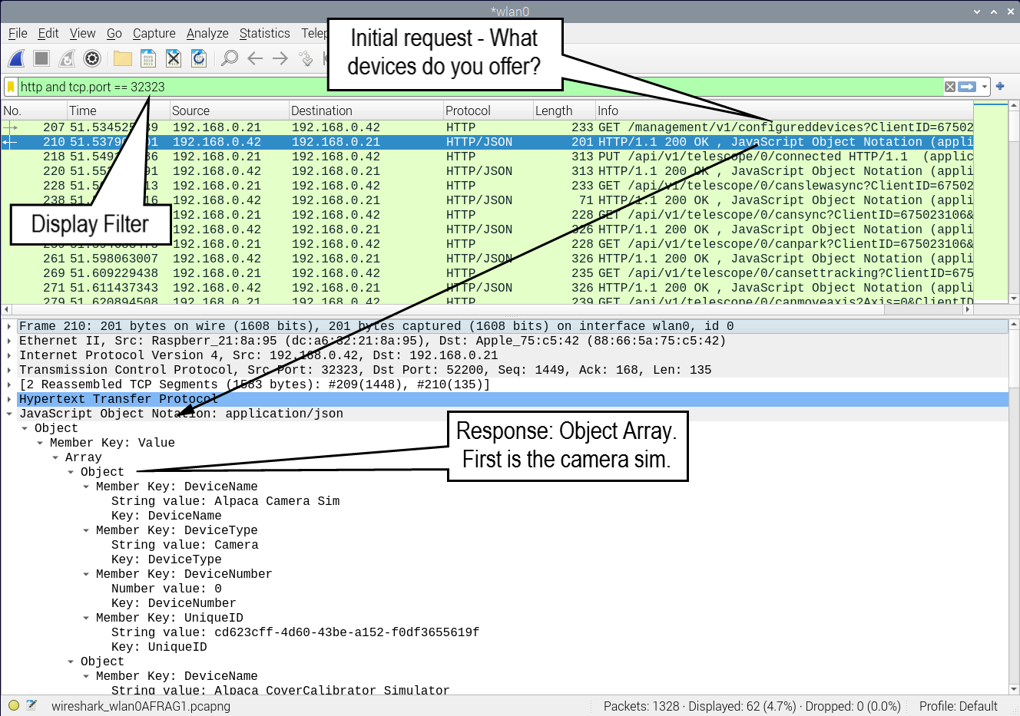
Look at the list of REST transactions. The first gets the list of devices as shown. Next you see a PUT of true to the telescope's connected endpoint, and this succeeds. Then it GETs some capability properties: canslewasync, cansync, canpark, etc.
It's beyond the scope of this document to be a tutorial on Wireshark. There are loads of videos on YouTube covering Wireshark. And there's always the PDF Wireshark User Manual.
More information on the Alpaca API can be found in the Alpaca API Reference document that can be downloaded from here: https://ascom-standards.org/AlpacaDeveloper/Index.htm

Appendix 4 – Document Change History

Version 1
- Original release

Version 2 – October 2025
- Changed the Drivers folder name to DeviceAccess to match the revised template.

Version 3 – January 2026
- Added section on the ASCOM Library and differences versus the Platform components.

Version 4 – September 2026
- Added a section on how to implement Connected / Connect / Disconnect and Connecting.
- Add a “How To” on how to speed up device shut down.
- Updated for latest template release.

