Sentiment Analysis of Movie Reviews
LSTM vs GRU vs BERT: A Comparative Study
Deep Learning for Natural Language Processing
Daniel Wehde & Rami Aabed
April 2026

Table of Contents
Abstract 2
1. Introduction 2
1.1 Objectives 2
2. Dataset 3
2.1 IMDb Large Movie Review Dataset 3
2.2 Data Splits 3
2.3 Text Preprocessing 3
3. Model Architectures 4
3.1 Word Embeddings (LSTM & GRU) 4
3.2 LSTM Classifier 4
3.3 GRU Classifier 5
3.4 BERT Classifier 5
4. Training Process 6
4.1 LSTM and GRU Training 6
4.2 BERT Fine-Tuning 6
4.3 Training Curves 7
5. Results and Evaluation 8
5.1 Evaluation Metrics 8
5.2 Test Set Performance 8
5.3 Confusion Matrix Analysis 9
5.4 Discussion 10
6. Conclusion 11
6.1 Future Work 11
References 12

Abstract
This report presents a comparative study of three deep learning architectures for binary sentiment classification on the IMDb Large Movie Review Dataset. We train and evaluate an LSTM model with learned word embeddings, a GRU model with learned word embeddings, and a fine-tuned BERT (bert-base-uncased) transformer. All models are trained on 22,500 reviews and evaluated on a held-out test set of 25,000 reviews. BERT achieves the highest test accuracy of 91.36% and F1-score of 91.27%, significantly outperforming GRU (82.49%) and LSTM (73.79%). The results demonstrate the clear advantage of pre-trained contextual representations over task-specific recurrent networks for sentiment analysis.

1. Introduction
Sentiment analysis is the task of automatically identifying the emotional polarity of a piece of text, typically classifying it as positive or negative. It is one of the most widely studied problems in Natural Language Processing (NLP) and has practical applications in product review analysis, social media monitoring, and customer feedback processing.
The goal of this project is to build and compare three sentiment classification systems of increasing architectural complexity:
- An LSTM (Long Short-Term Memory) network with learned word embeddings, representing the classical recurrent approach to NLP.
- A GRU (Gated Recurrent Unit) network with learned word embeddings, a streamlined alternative to LSTM.
- A fine-tuned BERT model, representing the state-of-the-art transformer-based approach.
By training all three models on the same dataset and evaluating with identical metrics, we quantify how much improvement each architectural advancement provides, and gain practical insight into the trade-offs between model complexity, training time, and classification performance.

1.1 Objectives
- Implement and train LSTM, GRU, and BERT classifiers for binary sentiment classification.
- Compare model performance using accuracy, precision, recall, and F1-score.
- Analyse training dynamics across architectures using loss and accuracy curves.
- Draw conclusions about the practical trade-offs between recurrent and transformer-based models.

2. Dataset

2.1 IMDb Large Movie Review Dataset
This project uses the IMDb Large Movie Review Dataset, a widely used benchmark for binary sentiment classification. The dataset consists of 50,000 movie reviews collected from the Internet Movie Database (IMDb), split equally into 25,000 training samples and 25,000 test samples. Labels are binary: positive (score >= 7 out of 10) or negative (score <= 4 out of 10). The dataset is perfectly balanced with 12,500 positive and 12,500 negative reviews in each split.

2.2 Data Splits
The dataset is divided into three splits for training, validation, and final testing:
Split | Samples | Class Balance
Training | 22,500 | 50% Pos / 50% Neg
Validation | 2,500 | 50% Pos / 50% Neg
Test | 25,000 | 50% Pos / 50% Neg
Table 1: Dataset splits. The validation set is a 10% stratified sample of the training split.
The validation set is obtained by randomly sampling 10% of the original training set (random seed 42 for reproducibility). The test set is the original held-out IMDb split and is never used during training or model selection.

2.3 Text Preprocessing
For the LSTM and GRU models, reviews are preprocessed with a custom pipeline:
- HTML tags are removed (e.g., <br /> tags common in IMDb reviews).
- Special characters and punctuation are stripped; text is lowercased.
- Sequences are tokenised by whitespace and truncated or padded to a maximum length of 200 tokens.
- A vocabulary of the 20,000 most frequent tokens (minimum frequency 2) is built from the training set only.
For BERT, no manual preprocessing is required. The bert-base-uncased WordPiece tokenizer handles lowercasing, subword tokenisation, and automatically adds the special [CLS] and [SEP] tokens. Sequences are truncated or padded to a maximum length of 256 tokens.

3. Model Architectures

3.1 Word Embeddings (LSTM & GRU)
Both the LSTM and GRU models use a learned embedding layer as their first component. Each token in the vocabulary is mapped to a dense 128-dimensional vector. These embeddings are randomly initialised and updated during backpropagation, allowing the model to learn task-specific representations of the vocabulary.

3.2 LSTM Classifier
The Long Short-Term Memory (LSTM) network is a type of Recurrent Neural Network designed to capture long-range dependencies in sequential data. It uses a gating mechanism composed of three gates (input, forget, output) that control information flow through a cell state, enabling selective memory over long sequences and mitigating the vanishing gradient problem.
The LSTM classifier architecture is as follows:
- Embedding layer: vocabulary size x 128 dimensions.
- Single-layer LSTM with 128 hidden units.
- Dropout (p=0.3) applied to the final hidden state.
- Fully connected linear layer: 128 -> 1 (binary output).
- BCEWithLogitsLoss: sigmoid activation combined with binary cross-entropy.
The last hidden state of the LSTM is used as the sequence representation, which is then passed through dropout and the linear classifier to produce a logit.

3.3 GRU Classifier
The Gated Recurrent Unit (GRU) is a simplified variant of the LSTM. It merges the forget and input gates into a single update gate, and combines the cell state and hidden state. This results in fewer parameters and faster training while still effectively capturing sequential dependencies. The GRU classifier architecture mirrors the LSTM:
- Embedding layer: vocabulary size x 128 dimensions.
- Single-layer GRU with 128 hidden units.
- Dropout (p=0.3) applied to the final hidden state.
- Fully connected linear layer: 128 -> 1 (binary output).

3.4 BERT Classifier
BERT (Bidirectional Encoder Representations from Transformers) is a transformer-based language model pre-trained on large text corpora using masked language modelling (MLM) and next sentence prediction (NSP). Unlike the LSTM and GRU which process text sequentially, BERT uses self-attention to model relationships between all tokens simultaneously, capturing bidirectional context.
We use bert-base-uncased: 12 transformer layers, 12 attention heads, hidden size 768, and approximately 110 million parameters. The model is fine-tuned end-to-end by adding a classification head on top of the [CLS] token output:
- Pre-trained BERT encoder (bert-base-uncased): 110M parameters.
- Dropout (p=0.3) applied to the [CLS] pooled output.
- Fully connected linear layer: 768 -> 1 (binary output).
All BERT parameters are updated during fine-tuning, allowing the model to adapt its pre-trained representations to the sentiment classification task.

4. Training Process

4.1 LSTM and GRU Training
The LSTM and GRU models are trained from scratch using the Adam optimiser with a learning rate of 1e-3. Training runs for up to 5 epochs with early stopping applied if validation loss does not improve for 2 consecutive epochs. The best checkpoint (lowest validation loss) is saved for final evaluation.
Hyperparameter | Value
Embedding dimension | 128
Hidden dimension | 128
Dropout | 0.3
Batch size | 64
Max sequence length | 200 tokens
Vocabulary size | 20,000
Optimiser | Adam (lr = 1e-3)
Loss function | BCEWithLogitsLoss
Max epochs | 5
Early stopping patience | 2 epochs
Table 2: Hyperparameters for LSTM and GRU training.

4.2 BERT Fine-Tuning
Fine-tuning BERT requires a much lower learning rate to avoid catastrophic forgetting of the pre-trained representations. We use the AdamW optimiser at 2e-5, a linear warmup scheduler over the first 10% of training steps, and gradient clipping (max norm = 1.0) to stabilise training.
Hyperparameter | Value
Base model | bert-base-uncased
Dropout | 0.3
Batch size | 16
Max sequence length | 256 tokens
Optimiser | AdamW (lr = 2e-5)
Scheduler | Linear warmup (10% of steps)
Gradient clipping | 1.0
Max epochs | 3
Loss function | BCEWithLogitsLoss
Table 3: Hyperparameters for BERT fine-tuning.

4.3 Training Curves
The figures below show the training and validation loss and accuracy over epochs. BERT converges faster and reaches a lower loss, reflecting its pre-trained representations. The GRU shows notable improvement over LSTM, achieving lower validation loss across epochs.
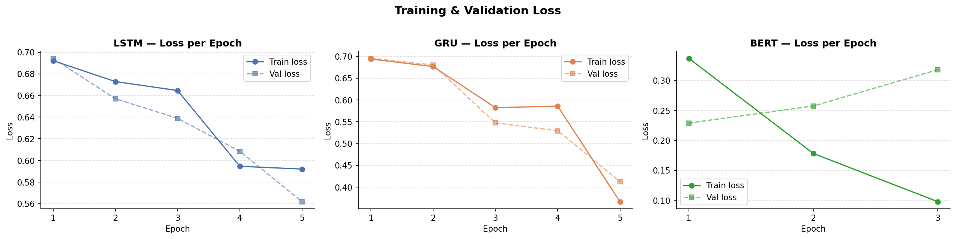
Figure 1: Training and validation loss per epoch for LSTM, GRU, and BERT.
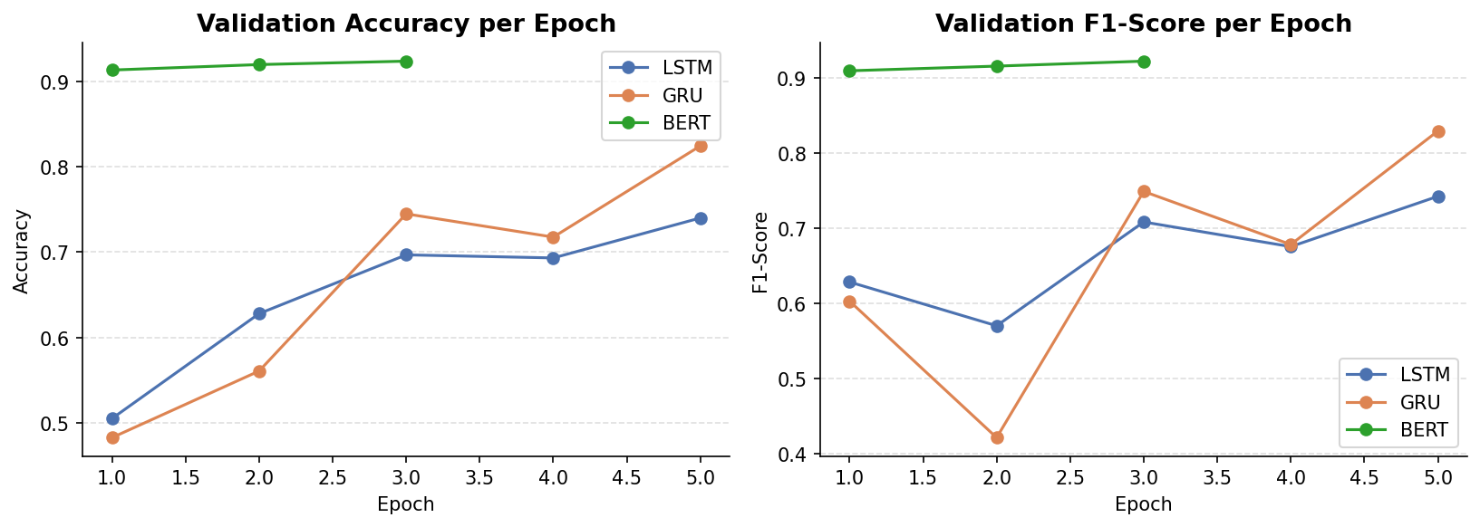
Figure 2: Validation accuracy and F1-score per epoch for all three models.

5. Results and Evaluation

5.1 Evaluation Metrics
All models are evaluated on the held-out test set of 25,000 reviews using four metrics:
- Accuracy: proportion of correctly classified reviews.
- Precision: of all reviews predicted positive, the proportion that are truly positive.
- Recall: of all truly positive reviews, the proportion correctly identified.
- F1-Score: harmonic mean of precision and recall.
Since the test set is perfectly balanced (50% positive, 50% negative), accuracy and F1-score are both meaningful and comparable across models.

5.2 Test Set Performance
Model | Accuracy | Precision | Recall | F1-Score
LSTM | 73.79% | 73.67% | 74.05% | 73.86%
GRU | 82.49% | 80.17% | 86.34% | 83.14%
BERT | 91.36% | 92.20% | 90.35% | 91.27%
Table 4: Test set results for all three models. Best values highlighted in green.
BERT achieves the highest scores across all four metrics. Compared to GRU, BERT improves accuracy by 8.87 percentage points and F1-score by 8.13 points. Compared to LSTM, the gains are 17.57 and 17.41 points respectively. Among the recurrent models, GRU outperforms LSTM by 8.70 percentage points in accuracy despite being simpler.
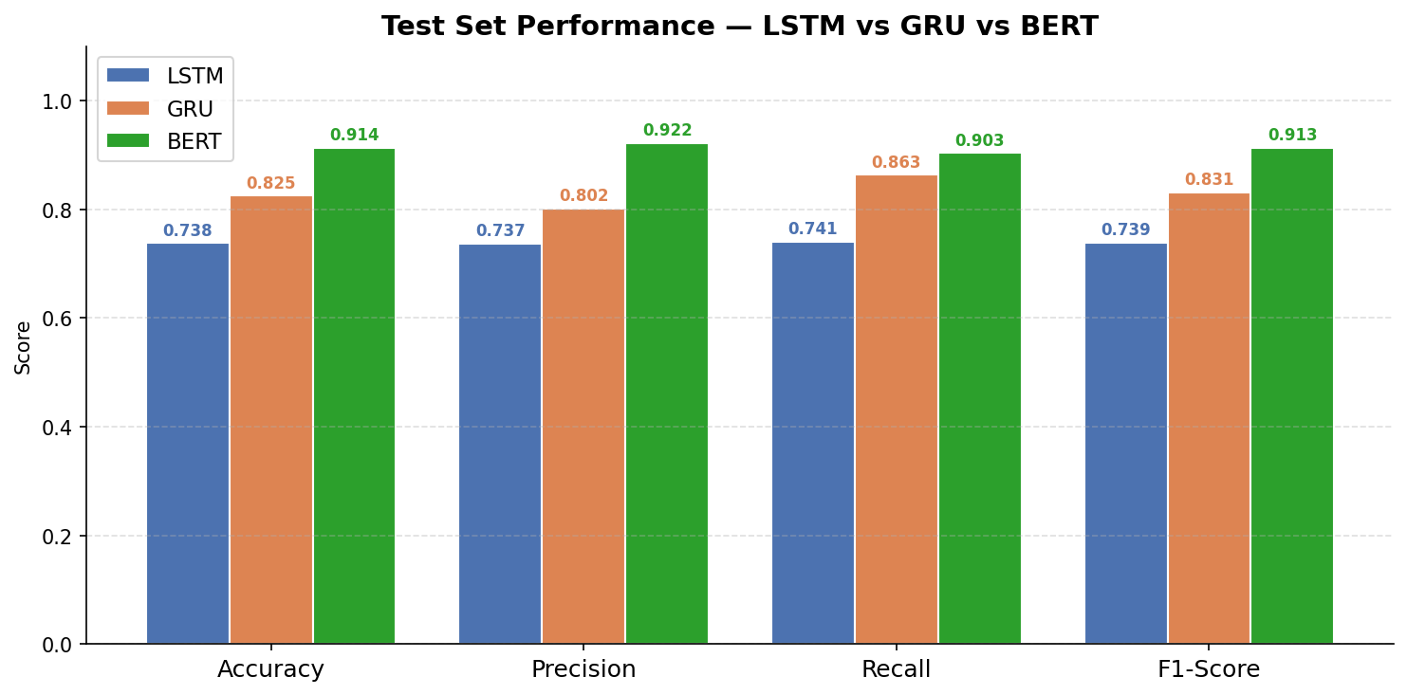
Figure 3: Test set performance comparison across LSTM, GRU, and BERT.

5.3 Confusion Matrix Analysis
The confusion matrices below provide a breakdown of correct and incorrect predictions for each model on the 25,000-sample test set.
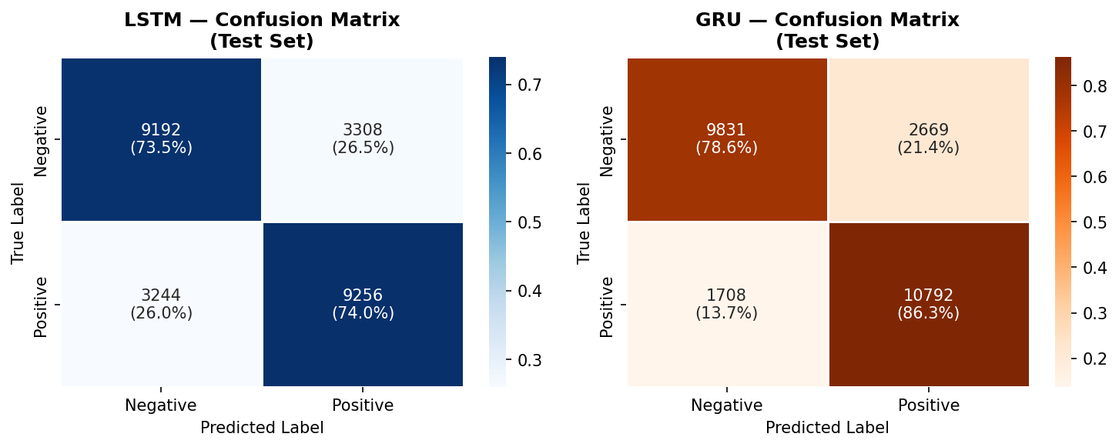
Figure 4: Confusion matrices for LSTM (left) and GRU (right) on the test set.
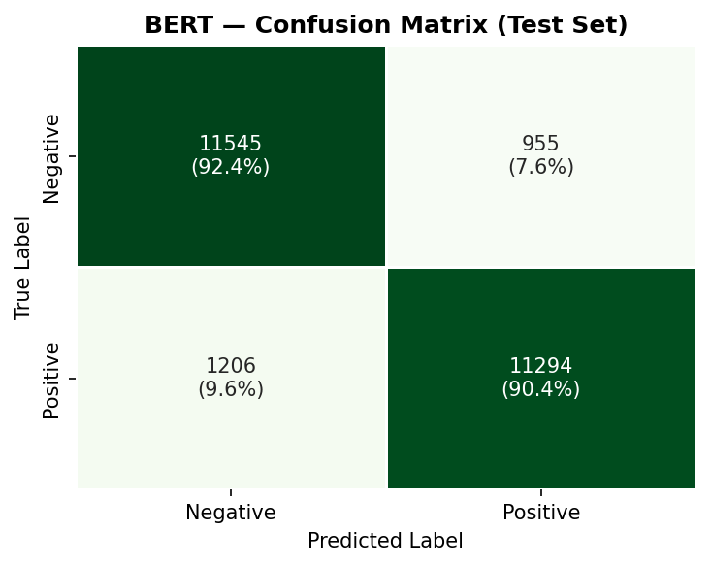
Figure 5: Confusion matrix for BERT on the test set.
The LSTM makes the most errors overall: 3,308 false positives and 3,244 false negatives, indicating roughly symmetric confusion. The GRU reduces total errors substantially but shows a bias toward positive predictions (recall 86.34% vs precision 80.17%), meaning it is more likely to label a negative review as positive than vice versa.
BERT achieves near-balanced error rates: only 955 false positives and 1,206 false negatives, corresponding to error rates of 3.82% and 4.82% respectively. Its slight tendency toward false negatives (lower recall vs precision) is the opposite of the GRU pattern, suggesting BERT is marginally more conservative in predicting positive sentiment.

5.4 Discussion
The results clearly demonstrate the progression of model capability with architectural complexity. The LSTM, while a strong baseline, is limited by its sequential processing and task-specific vocabulary embeddings. It must learn all linguistic patterns from 22,500 training examples alone, with no prior language knowledge.
The GRU closes some of this gap through its more efficient gating mechanism, which converges more reliably on this dataset. Its higher recall suggests it has learned to identify positive signals more aggressively.
BERT's advantage stems from two sources: (1) its pre-training on a massive text corpus provides rich contextual representations capturing linguistic nuance such as negation and sarcasm; and (2) its bidirectional self-attention allows every token to attend to every other token simultaneously, capturing dependencies that a unidirectional RNN may miss. The trade-off is significantly longer training time and higher memory requirements.

6. Conclusion
This project successfully implemented and compared three deep learning architectures for sentiment classification on the IMDb dataset: LSTM (73.79%), GRU (82.49%), and fine-tuned BERT (91.36%). The key findings are:
- BERT significantly outperforms both recurrent models, confirming that pre-trained contextual representations provide a major advantage for NLP classification tasks.
- GRU outperforms LSTM despite being architecturally simpler, showing that fewer but more efficient gating operations are sufficient for this task.
- All three models generalise well: the gap between validation and test accuracy is small for all architectures, indicating no significant overfitting.
- There is a clear trade-off between performance and resource cost: BERT requires roughly 10x more training time and memory than the RNN models.

6.1 Future Work
- Experiment with lighter transformer variants (DistilBERT, RoBERTa) to examine the performance-efficiency trade-off more finely.
- Apply pre-trained static embeddings (GloVe, Word2Vec) to the LSTM and GRU to isolate the contribution of the recurrent architecture from embedding quality.
- Extend to multi-class sentiment (1-5 star ratings) to assess model behaviour beyond binary classification.
- Perform error analysis on misclassified samples to identify linguistic patterns all models struggle with, such as irony and long-range negation.

References
[1] Maas, A. L., et al. (2011). Learning Word Vectors for Sentiment Analysis. ACL 2011.
[2] Hochreiter, S., & Schmidhuber, J. (1997). Long Short-Term Memory. Neural Computation, 9(8), 1735-1780.
[3] Cho, K., et al. (2014). Learning Phrase Representations using RNN Encoder-Decoder for Statistical Machine Translation. EMNLP 2014.
[4] Devlin, J., Chang, M.-W., Lee, K., & Toutanova, K. (2019). BERT: Pre-training of Deep Bidirectional Transformers for Language Understanding. NAACL-HLT 2019.
[5] Vaswani, A., et al. (2017). Attention Is All You Need. NeurIPS 2017.

