**Abalone**

*Filename:* abalone

Sharon enjoys playing this board game called Abalone. It is a two-player game played on a hexagonal board with 61 circular spaces. A space can be occupied by a black piece or a white piece. A piece can only be moved by the player who plays its color. In this problem, Sharon is playing the black color.

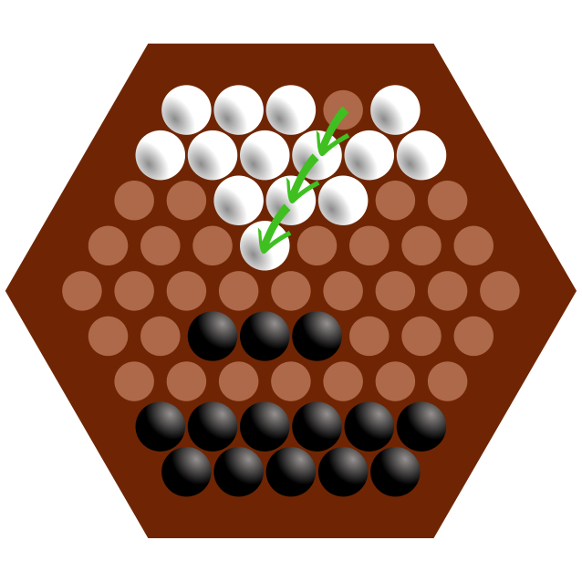

An illustration of the board, and a possible move by the white player.

For each move, a player moves a straight line of one, two, or three pieces of one color one space in any of six directions. A player can push their opponent’s pieces that are in a line to their own if the pushing line has more pieces than the pushed line (three can push one or two, two can push one). Marbles must be pushed into an empty space or off the board. Currently Sharon is in the middle of a game and he began wondering, how many ways can he make a move that pushes a white piece off the board?

**The Problem:**

Given the state of the board during an Abalone game, determine how many moves can be made such that a white piece gets pushed off the board.

**The Input:**

The first line of the input file begins with a single, positive integer, *t*, representing the number of games. For each game, 9 lines follow representing the board, the first having 5 characters, the second having 6, and so on until the 5th line which has 9 characters. Then the 6th line will have 8 characters, the 7th line will have 7, and so on until the 9th line which will have 5 characters. Each character is either “B”, “W”, or “.” depending on whether the space is occupied by a black piece, white piece, or neither respectively. See sample input for an example.

**The Output:**

For each game, output a single line formatted as “Game #i: c” where *c* is an integer representing the number of moves that can be made that will push a white piece off the board.

**(Sample Input and Output on the next page)**

**Sample Input:**

2

..WW.

..BB..

..BB...

...B....

.........

........

.......

......

.....

.....

......

W.....B

W.....W.

.WW..BBBW

WW...B..

....B..

......

.....

**Sample Output:**

Game #1: 3

Game #2: 2

**Notes:** There may be more or less pieces on the board than there are allowed to be in a real Abalone game. In the context of this problem this is not important.

The following are images of the state of the board in the first sample case (left), and the second sample case (right).

