**Rail Fence Attackers**

*Filename:* railfence

We are at war with the fencelings! Fortunately, we have intercepted their attack plans - we just need to decrypt them. The fencelings are true to their name, and they encrypt their messages using a “rail fence” cipher. In this cipher, the text is written diagonally and downwards on successive “rails” of an imaginary fence, then moving up when the bottom rail is reached. When the top rail is reached, the message is written downwards again until the whole text is written out. The message is then read off in rows. For example, if the text was “Hello World” and the number of rails was 3, then the process would look like this:

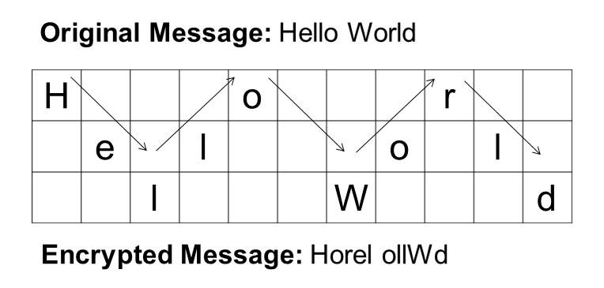

The fencelings have no concept of grammar, so they write their messages using strictly lowercase letters. Given a message written by the fencelings, print the decrypted message.

**The Problem:**

Decrypt a message using the rail fence cipher, and print the decrypted message.

**The Input:**

The first line of the input file begins with a single, positive integer, *t*, representing the number of messages. Then, 2\**t* lines follow, two for each test case. The first of which has two integers 2 ≤ *n*, *k* ≤ 106, representing the length of the message and the number of rails used, respectively. The second line of a test case is a string of *n* lowercase characters representing the message itself.

**The Output:**

For each paper, output a single line saying “Message #i: c” without the quotes, where i is the number of the message and c is the decrypted message, respectively.

**(Sample Input and Output are on the next page)**

**Sample Input:**

2

19 2

wwlatcasxmeiltaktip

10 3

telherisra

**Sample Output:**

Message #1: wewillattackatsixpm

Message #2: threerails