**Trolley Tracks**

*Filename:* trolley

The Minigame Trolley is having its grand opening! It is a brand new trolley that takes its riders to play various minigames. The trolley starts on the left, and at each intersection it can go up or down, depending on the riders’ votes. Each rider has a favorite minigame. If their favorite minigame is reachable, they will vote up or down, depending on the direction of their minigame. If their minigame is unreachable, they will abstain. The votes will be recounted at each intersection, and the trolley will go down if there are more “down” votes than “up” votes, and up otherwise. Finally, when the trolley reaches a minigame (numbered 1 through *n*), it will stop.

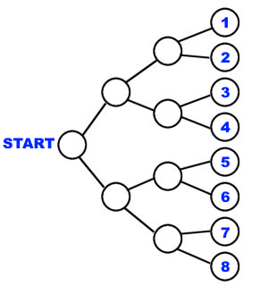

A diagram representing the trolley tracks.

As it is opening night, Pauline the trolley conductor would like to save time by asking the riders what their favorite minigame is at the start. After doing so, she would like to figure out the minigame the trolley will be headed to. This way, the trolley won’t have to stop to recount the votes each time!

**The Problem:**

Given each rider’s intended destination, determine the trolley’s final destination.

**The Input:**

The first line of the input file begins with a single, positive integer, *t*, representing the number of trolleys. For each trolley, two lines follow. The first contains a single integer 1 ≤ *n* ≤ 18, where 2n represents the number of minigames.  The second line consists of an array *a* of 2n integers, where 1 ≤ *a*[*i*] ≤ 109 represents the number of people whose favorite minigame is *i*.

**The Output:**

For each test case, output a single line saying “Trolley #i: c” without the quotes, where i is the trolley number, and c is the minigame that the trolley will reach in the end.

**Sample Input:**

2

3

2 4 2 1 6 4 7 1

1

100 100

**Sample Output:**

Trolley #1: 5

Trolley #2: 1