Model Visualization

Markus Voelter & others,
voelter@acm.org
Version 1.0 for Eclipse 3.5 and TMF Xtext

Introduction
Things that are described graphically are easier to comprehend than textual descriptions, right? What is most important regarding comprehensibility is the alignment of the concepts that need to be conveyed with the abstractions in the language. A well-designed textual notation can go a long way. Of course, for certain kinds of information, a graphical notation is better: relationships between entities, the timing/sequence of events or some kind of signal/data flow. On the contrary, rendering expressions graphically is a dead end. When deciding about a suitable notation, you might want to consider the following two forces: in most (but not all!) tool environments, editors for textual notations (incl. code completion, syntax highlighting and the like) are much easier to build and evolve than really user-friendly and scalable graphical editors. Also, instead of using full-blown graphical editing, you might want to consider textual editing plus graphical visualization (read only, auto-layout, created via transformation). In many cases, this is absolutely good enough.
The model visualization package contains tools for visualization with graphviz and ZEST.

Graphviz
Graphviz is an open source tool that rendes images based on a textual description of a graph. It is quite powerful and widely used. It is available on many platforms. Please download it from www.graphviz.org and install it on your machine.

General Approach
In order to visualize a model, you have to write a model to model transformation from your DSL meta model to the meta model of the input language for Graphviz. The oAW Graphviz support comes with this meta model, it's name is dot. After running the transformation for a given input model, you have to call a code generator (also supplied with the oAW Graphviz integration plugins) that generates the text representation of the dot file. This generator also generates a batch file processdot.bat (and a shell script processdot.sh) that contains calls to the dot.exe renderer to generate the actual GIF images. To make that batch file work, make sure you set the GRAPHVIZ_BIN environment variable to point to the bin directory of your Graphviz installation.

Dot language reference
The metamodel of the dot language is shown in the figure below. The diagram was generated with the Graphviz visualization itself, using the transformation described in the previous section.
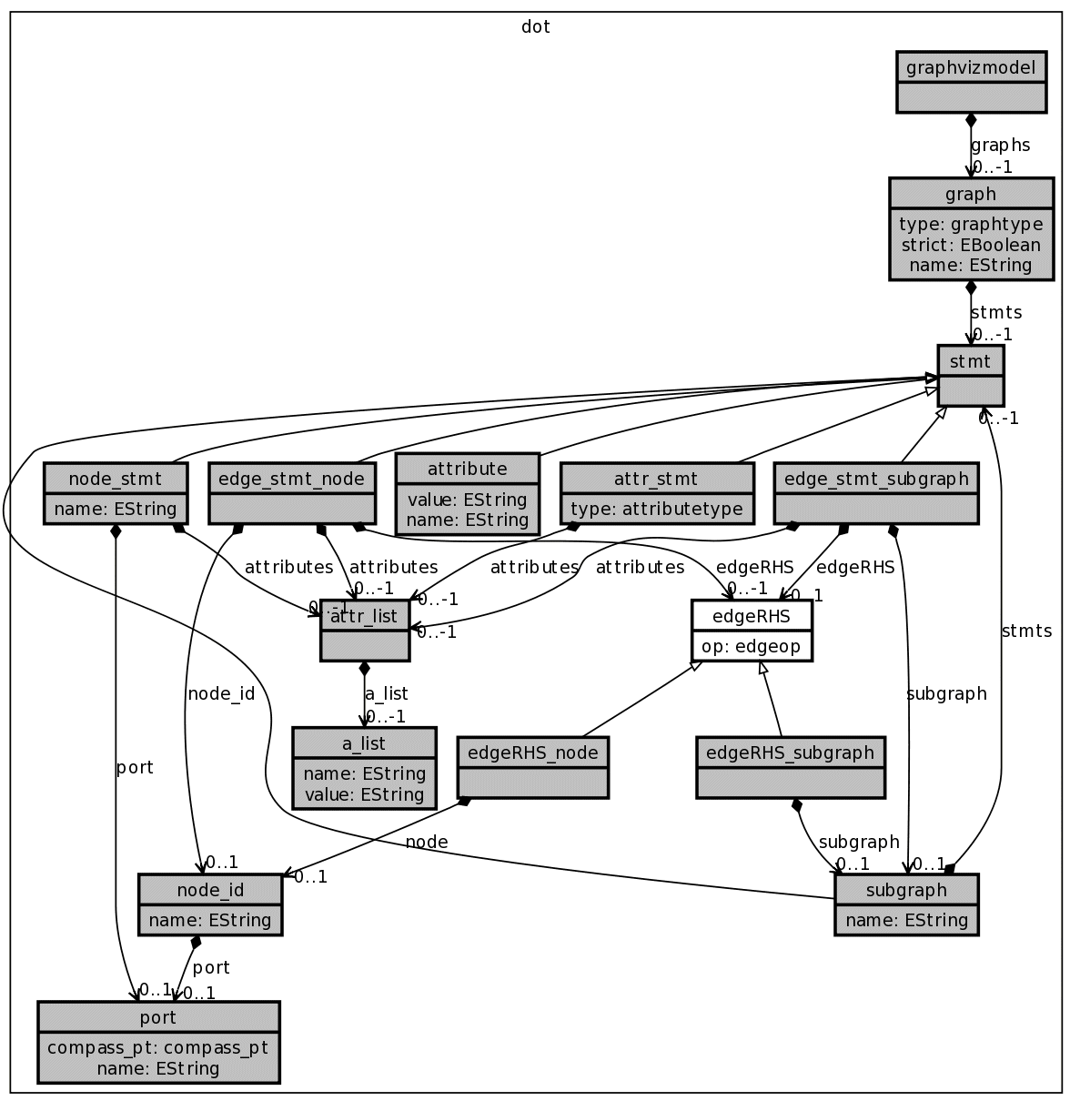

Types
This section describes the types of the dot language. Features are denoted by a qualifier "T", which has the following meaning:
Abbreviation | Meaning
P | Optional property.
P1 | Mandatory property.
R | 0..1 reference.
R1 | 1..1 reference.
R* | 0..* reference.
R+ | 1..* reference.
EP | An extension function with zero or one argument. It can be treated like a property except that the function must called with brackets(). The function can be called on elements of the specified type. The extension is provided by dotlib.
O | An extension function that takes at least one additional argument besides the caller argument. This function behaves like an operation. The extension is provided by dotlib.

dot::graphvizmodel
This is the root element containing graph instances.
T | name | type / arguments | description
R* | graphs | dot::graph | Contained graphs.
O | addGraph | dot::graph | The graph instance to add to the model.
O | addGraphs | Collection[dot::graph] | A collection of graphs to add to the model.

dot::graph
This element represents a named graph instance, Supertype: Eobject
T | name | type / arguments | description
P1 | name | String | The name of the graph.
P1 | type | graphtype | Specifies whether a graph is directed (graphtype::digraph) or undirected (graphtype::graph).
P | strict | EBoolean | A graph may be declared a strict digraph. This forbids the creation of self-arcs and multi-edges.
R* | stmts | dot::stmt | Statements defining this graph.
O | setFont | String | Sets the default font for the graph.
O | addStatement | dot::stmt | Adds a statement to the graph.
O | addStatements | List[dot::stmt] | Adds the given statements to the graph.
EP | filename | String | The filename for the resulting dot file: "<name>.dot"
O | setAttribute | String name  String value | Sets an edge attribute.  The attribute's value.

dot::stmt
This is the base class for statement types.
Supertype: EObject
Subtypes: edge_stmt_node, edge_stmt_subgraph, node_stmt, attribute, attr_stmt, subgraph
Abstract: true

dot::node_stmt
Represents a node in the graph, Supertype: stmt
T | name | type | description
P | name | String | Node name.
R | port | dot::port
R* | attributes | dot::attr_list | Attributes of this element.
O | setStyle | String | Set style property of the node.
O | setFont | String | Sets the font for the node label.
O | setFontSize | String | Sets the font size.
O | setLabel | String | Sets the node label.
O | setLabel | List[String] | Sets the node label which consists of several sections. This helps to create record layouts.
O | setShape | String | Sets the node shape style.
O | setName | String | Sets the node's name.
O | setFillColor | String | Sets the fill color.
O | setAttribute | String name  String value | Sets an edge attribute.  The attribute's value.

dot::edge_stmt_node
This is an edge, Supertype: stmt
T | name | type / arguments | description
R | node_id | node_id | Node identifier.
R* | edgeRHS | dot::edgeRHS
R* | attributes | dot::attr_list | Attributes of this element.
O | setArrowHead | String | Sets the arrow head style.
O | setArrowTail | String | Sets the arrow tail style.
O | setStyle | String | Sets the edge's style property.
O | setWeight | String | Sets the line weight.
O | setColor | String | Sets the line and font color.
O | setFontcolor | String | Sets the font color.
O | setFont | String | Sets the font.
O | setFontSize | String | Sets the font size.
O | setLabel | String | Sets the edge label.
O | setHeadLabel | String | Sets the label for the edge's head.
O | setTailLabel | String | Sets the label for the edge's tail.
O | setLineColor | String | Sets the line color.
O | setAttribute | String name  String value | Sets an edge attribute.  The attribute's value.

dot::attribute
Supertype: stmt
T | name | type | description
P | name | String | Attribute name.
P | value | String | Holds the attribute's value.

dot::attr_stmt
Supertype: stmt
T | name | type | description
P | type | dot::attributetype | Attribute type.
R* | attributes | dot::attr_list | Attributes of this element.

dot::edge_stmt_subgraph
Supertype: stmt
T | name | type | description
R | subgraph | dot::subgraph | The referenced subgraph.
R | edgeRHS | dot::edgeRHS
R* | attributes | dot::attr_list | Attributes of this element.

dot::attr_list
Supertype: EObject
T | name | type | description
R* | a_list | dot::a_list

dot::a_list
Supertype: EObject
T | name | type | description
P | name | String | List name.
P | value | String | The value.

dot::edgeRHS
Represents the target an edge is pointing to.
Supertype: EObject
T | name | type | description
R | op | dot::edgeop | Edge operation.

dot::edgeRHS_node
Supertype: edgeRHS
T | name | type | description
R | node | dot::node_id | Node identifier.

dot::edgeRHS_subgraph
Supertype: edgeRHS
T | name | type | description
R | subgraph | dot::subgraph | A subgraph.

dot::subgraph
Supertype: stmt
T | name | type / arguments | description
P | name | String | The name of the subgraph.
R* | stmts | dot::stmt | Statements defining this graph.
O | setName | String | Sets the subgraph's name.
O | addStatement | dot::stmt | Adds a statement to the subgraph.
O | addStatements | List[dot::stmt] | Adds the given statements to the subgraph.
O | setLabel | String | Sets the subgraph's label.
O | setAttribute | String name  String value | Sets an edge attribute.  The attribute's value.

dot::node_id
Supertype: EObject
T | name | type | description
P | name | String | Node identifier value.
R | port | dot::port | Node port.

dot::port
Supertype: EObject
T | name | type | description
P | name | String | The name of the port.
P | compass_pt | dot::compass_pt | Where the port should be placed at the element.

dot::edgeop
Context: edgeRHS#op
name | description
directed | Directed edge.
undirected | Undirected edge.

dot::graphtype
Context: graph#graphtype
name | description
directed | Directed graph.
undirected | Undirected graph.

dot::attributetype
Context: attr_stmt#type
name | description
graph | Attribute denotes a graph.
node | Attribute denotes a node.
edge | Attribute denotes an edge.

dot::compass_pt
name | description
north | Direction north.
northeast | Direction northeast.
east | Direction east.
southeast | Direction southeast.
south | Direction south.
southwest | Direction southwest.
west | Direction west.
northwest | Direction northwest.

Shapes
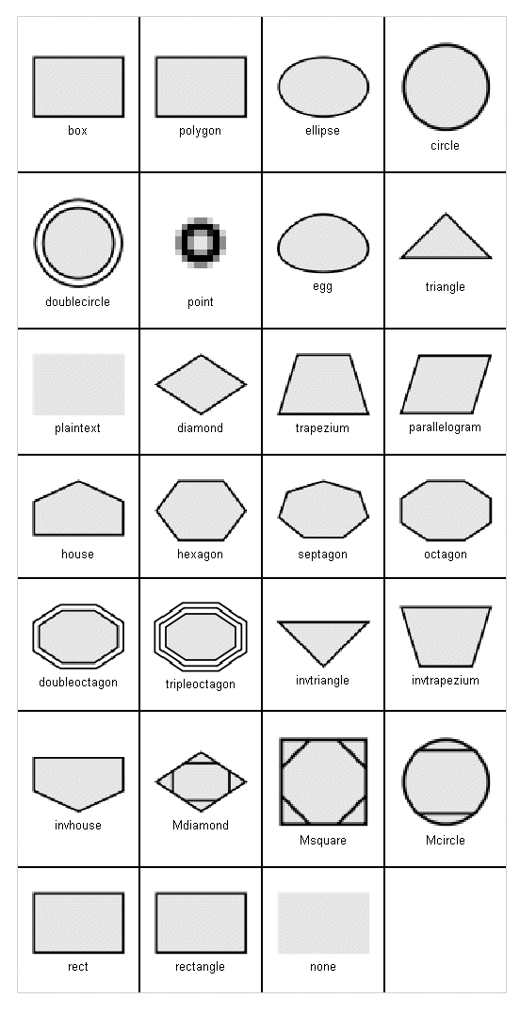

Arrows
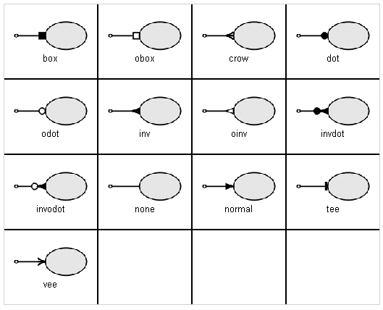

Output formats
Name | Description | Name | Description
bmp | Windows Bitmap Format | canon
dot | DOT | xdot | DOT
dia | Dia format | eps | Encapsulated PostScript
fig | FIG | gtk | GTK canvas
gd  gd2 | GD/GD2 formats | gif | GIF
hpgl | HP-GL/2 | ico | Icon Image File Format
imap  imap_np  cmapx  cmapx_np | Server-side and client-side imagemaps | jpg  jpeg  jpe | JPEG
mif | FrameMaker MIF format | mp | MetaPost
pcl | PCL | pdf | Portable Document Format (PDF)
pic | PIC | plain  plain-ext | Simple text format
png | Portable Network Graphics format | ps | PostScript
ps2 | PostScript for PDF | svg  svgz | Scalable Vector Graphics
tga | Truevision Targa Format (TGA) | tif  tiff | TIFF (Tag Image File Format)
vml  vmlz | Vector Markup Language (VML) | vrml | VRML
vtx | Visual Thought format | wbmp | Wireless BitMap format
xlib | Xlib canvas

Workflow configuration
To invoke the transformation (and subsequently generate the dot text files) you need to write a workflow that calls into the model2dotfile.mwe workflow supplied with the Graphviz integration.

<workflow abstract="true">

<property name="modelFile"/>
<property name="targetDir"/>

<component id="read" class="org.eclipse.emf.mwe.utils.Reader">
<useSingleGlobalResourceSet value="true"/>
<modelSlot value="model"/>
<uri value="${modelFile}"/>
</component>

<cartridge file="org::openarchitectureware::vis::graphviz::model2dotfile.mwe"
targetDir="${targetDir}"
topFunctionCallExpression="ecore2dot::toGraphVizmodel(model)"
inheritAll="true"/>

</workflow>
The model2dotfile.mwe workflow has some configuration parameters described in the table below.
name | description | example
targetDir | Output directory of resulting .dot files and processdot[.bat|.sh] | src-gen
dotTargetDir | Output directory of images produced by Graphviz when calling the generated processdot.[bat|sh] command. | src-gen/images
topFunctionCall-Expression | This is the qualified path to the Xtend function to call to perform the M2M transformation. | ecore2dot::toGraphVizmodel(model)
pathToDotExe | The absolute path to the dot executable, only the directory the executable is contained in. Note that the default will only work on Windows. If the dot executable is already on your system path you can set this property to an empty string.  Default: %GRAPHVIZ_BIN%/ | /usr/local/  graphviz-2.12/bin/
outputFormat | Graphviz output format. Valid options see output formats.  Default: gif

You may want to include the SystemCommand workflow component into your workflow to execute the processing of dot files after their generation.
<!-- Mac/Linux -->
<component class="oaw.util.stdlib.SystemCommand">
<directory value="src-gen"/>
<command value="sh"/>
<arg value="processdot.sh"/>
</component>

<!-- Windows -->
<component class="oaw.util.stdlib.SystemCommand">
<directory value="src-gen"/>
<command value="cmd"/>
<arg value="/c"/>
<arg value="processdot.sh"/>
</component>

Example Transformation
The following is an example transformation, extensively commented. It visualizes meta models (i.e. any .ecore file).
// this is the source meta model - ecore for the example here
import ecore;
// this is the target meta model; dot is the language to
// create graphviz graphs
import dot;

// there's a number of utility functions for working with the
// dot meta model
extension org::openarchitectureware::vis::graphviz::dotlib;

// top level, we create graphvizmodel which contains
// a number of graphs, each eventually resulting in its
// own dot file, and GIF image
create dot::graphvizmodel toGraphVizmodel(EPackage p):
// you can add a number of graphs. Here, we add
// only one.
addGraph( toGraph(p) )
;
// mapping a model element to a graph uses the mapToGraph
// function from dotlib. All those mapping functions need
// to be cached to make sure that if they are called several
// times they are evaluated only once.
cached toGraph(EPackage p):
// creates the actual graph object
p.mapToGraph()
// each graph needs to have a name;
// will result in the filename for the dot
// and gif files for the graph
.setName( "ecoremetamodel" )
// a graph contains statements. Statements
// can be nodes, edges or subgraphs. Here we
// add a subgraph for the package.
.addStatement( p.toSubgraph() )
;
cached toSubgraph( EPackage p ):
// this call maps the package to a subgraph....
p.mapToSubgraph()
// every subgraph MUST have a name - very important!
.setName("ecore")
// this is the label shown in the diagram
.setLabel("ecore")
// again, we cann add statements to graphs:
// nodes, edges and additional subgraphs.
// here we add a node for each class in the EPackage
.addStatements( p.classes().toNode() )
// and then we create an edge for each reference
// of an EClass to another EClass.
.addStatements( p.classes().eReferences.select(r|EClass.isInstance(r.eType)).toRefEdge() )
// finally, we create an edge for the inheritance
// relationships. Note the difference in the coding
// between the implementation for the referneces
// and for the inheritance. The difference is that
// for the reference there's an object (an instance
// of EReference) in the source model. For the in-
// heritance thing, there isn't.
.addStatements( p.classes().addSuperclassEdges() )
;

// create a Node for an EClass
cached toNode( EClass c ):
// this one creates the actual node object
c.mapToNode()
// the record shape is special, it can have
// several "compartments", like the UML class
// symbol. That's what we need here.
.setShape("record")
// sets the label, using the special { and } character
// do define compartments in the record shape.
.setLabel( "{"+c.name+"|"+c.eAttributes.collect(a|a.name+": "+a.eType.name).toString("\\n")+"}" )
// sets the style to bold lines and filled
.setStyle("bold, filled")
// fill color, obviously
.setFillColor("grey")
// and line color.
.setLineColor( "black" )
;

// creates an edge for an EReference
cached toRefEdge( EReference r ):
// creates the actual edge. Parameters
// are source node, target node, and the
// edge node itself
mapToDirectedEdge( r.eContainer, r.eType, r )
// the label on the edge
.setLabel( r.name )
// the label at the target end of the
// line
.setHeadLabel( " "+r.lowerBound.toString() + ".." + r.upperBound.toString() )
// set the arrow head type
.setArrowHead("vee")
// and use a diamond shape at the tail of
// the arrow if it's a containment relaitonship
.setArrowTail( r.containment ? "diamond" : "none" )
;

// this one is used to iterate over all the superclasses
// for a given class. In a very real sense, the only
// reson for this function is to declare a variable
// name for base!
addSuperclassEdges( EClass base ):
// call toSuperclassEdge for all supertypes of
// a given base clas
base.eSuperTypes.toSuperclassEdge( base )
;

// creates a direct edge for an inheritance relationship
cached toSuperclassEdge( EClass super, EClass base ):
// creates the actual edge. Parameters are
// source node, target node and the node for
// the edge itself (here: null)
mapToDirectedEdge( base, super, null )
// sets the arrowhead to be the
// "UML inheritance arrow"
.setArrowHead("empty")
;

// helper function returning all the EClasses
// in an EPackage
classes(EPackage p):
p.eClassifiers.typeSelect(EClass);
You can now run the generated processdot.bat or processdot.sh to render the actual images.

References
This reference cannot cover a complete description of Graphviz and the dot language. So it is recommended to have the respective reference documents by hand to be able to use the full power of this library. See these links for further reading:
- www.graphviz.org, The Graphviz homepage.
- www.graphviz.org/doc/info/lang.html, The DOT language. A definition of the DOT abstract grammar.
- http://www.graphviz.org/doc/info/attrs.html, Node, Edge and Graph Attributes reference.
- Drawing graphs with dot, A user guide for DOT. Recommended reading.
- http://sourceforge.net/projects/eclipsegraphviz, An Eclipse plugin which provides a viewer for DOT graphs.

ZEST
ZEST is a visualization framework implemented on top of GEF. The model visualization project adds the following ingredients:
- a meta model for describing graphs
- a textual language for expressing instances of that meta model
- a generic viewer, that renders instances of the meta model in an Eclipse view

The Meta Model & Language
The textual DSL has been built with oAW Xtext. You can find it in the following projects or plugins, respectively:
org.openarchitectureware.vis.graphmm35
org.openarchitectureware.vis.graphmm35.ui

Manually Written Graph Example
The following is an example of a simple graph built with the language. The meaning of the various constructs should be obvious. More documentation will be added later.
prolog {
iconbasepath "platform:/plugin/de.voelter.zest.example/icons/";
}

graph g1 {
nodes {
s1 label "S1" tooltip "S1 Tooltip" icon "icon1.gif" category "a"
userData
test : text = "This is a test";
test2 : int = "2";
test3 : boolean = "true";
;
s2 label "S2" icon "icon2.gif" category "a";
s3 label "shift click here" source "platform:/resource/de.voelter.zest.example/src/de/voelter/zest/example/test.gmm,100,120";
s4 label "S4" linecolor red category "b";
s5 label "S5" linecolor gray category "b";
s6 label "S6" linecolor darkBlue fillcolor yellow;
s7 label "S7" textcolor green fillcolor blue;
s8 label "S8" textcolor darkBlue;
s9 label "S9" textcolor red;
container sc label "SC"
contained graph scchild {
nodes {
sc1 label "sc1";
sc2 label "sc2";
}
edges {
sc1 -> sc2;
sc1 -> s6;
}
}
;
}

edges {
s1 -- sc label "containeredge";
s1 -- s2 label "Hallo!" tooltip "s1 -> s2"
icon "icon2.gif" color black weight -50;
s2 -- s3 tooltip "s2 -> s3" color cyan weight 0;
s3 -> s1 tooltip "s3 -> s1" color darkGreen weight 50;
s4 -> s5 width 3 style dotted;
s1 -> s4 width 4 style dashDotted;
s1 -> s5 width 2 category "x";
s1 -> s5 width 1 category "y";
s5 -> s6;
}
}

graph g2 {
nodes {
n1 label "n1";
n2 label "n2";
}

edges {
n1 -> n2 label "label";
}
}

Transformation towards the meta model
The typical use case for visualization is not to manually type a graph using the textual DSL. Instead, usually, you will write a model to model transformation that maps your own domain specific language to the graph meta- model. The following is an example of the transformation that visualizes Ecore. As you can see, we actually create two different graphs.
import ecore;
import graphmm35;

extension graphmmlib;

Object top(EPackage p):
toCollection(p);

create GraphCollection toCollection( EPackage p ):
graphs.add( toAssocGraph(p)) ->
graphs.add( toInheritGraph(p));

create Graph toAssocGraph(EPackage p):
setName( "assoc & attr" ) ->
nodes.add( p.toNode("ass") ) ->
nodes.addAll( p.eClassifiers.typeSelect(EClass).toNode("ass") ) ->
edges.addAll( p.eClassifiers.typeSelect(EClass).toEdge("ass") ) ->
edges.addAll( p.eClassifiers.typeSelect(EClass).eReferences.toEdge("ass") ) ->
nodes.addAll( p.eClassifiers.typeSelect(EClass).eAttributes.toNode("ass") ) ->
edges.addAll( p.eClassifiers.typeSelect(EClass).eAttributes.toEdge("ass") );

create Graph toInheritGraph(EPackage p):
setName( "inheritance" ) ->
addLayoutHint( "zestlayout", "tree" ) ->
nodes.add( p.toNode("i") ) ->
nodes.addAll( p.eClassifiers.typeSelect(EClass).toNode("i") ) ->
edges.addAll( p.eClassifiers.typeSelect(EClass).iterateSuperTypes("i") );

iterateSuperTypes(EClass c, Object tkn):
c.eSuperTypes.toInheritanceEdge(c, tkn);

create SimpleDirectedEdge toInheritanceEdge( EClass super,
EClass sub, Object tkn ):
setSource( super.toNode(tkn) ) ->
setTarget( sub.toNode(tkn) );

create SimpleNode toNode( EPackage p, Object tkn ):
setLabel( p.name ) ->
setCategory("package") ->
setFillcolor( ColorEnum::white);

create SimpleNode toNode( EClass cls, Object tkn ):
setLabel( cls.name ) ->
setFillcolor( cls.abstract ? ColorEnum::white : ColorEnum::lightGray );

create SimpleNode toNode( EAttribute attr, Object tkn ):
setCategory( "attributes" ) ->
setLabel( attr.name ) ->
setFillcolor( ColorEnum::lightGreen );

create SimpleDirectedEdge toEdge( EReference ref, Object tkn ):
setLabel( ref.name ) ->
setCategory("associations") ->
setWeight( ref.containment ? 50 : 0 ) ->
setWidth( ref.containment ? 2 : 1 ) ->
setSource( ((EClass)ref.eContainer).toNode(tkn) ) ->
setTarget( ((EClass)ref.eType).toNode(tkn) );

create SimpleDirectedEdge toEdge( EAttribute a, Object tkn ):
setCategory( "attributes" ) ->
setWeight( 100 ) ->
setSource( ((EClass)a.eContainer).toNode(tkn) ) ->
setTarget( a.toNode(tkn) );

create SimpleDirectedEdge toEdge( EClass c, Object tkn ):
setCategory( "package" ) ->
setSource( ((EPackage)c.eContainer).toNode(tkn) ) ->
setTarget( c.toNode(tkn) );

The Viewer
The viewer can be found in the following plug-in: org.openarchitectureware.vis.zest.viewer. Open the view via Window/Show View/openArchitectureWare/Model Visualization.
The generic viewer is able to visualize an instance of the meta model mentioned above. Currently, it is implemented in the following way:
- using the button or the menu entry at the top right side of the view, you run an openArchitectureWare workflow. Alternatively, you can simply drag-and-drop the MWE file to the drop zone on the viewer.
- The workflow can do basically anything, as long as it puts an instance of the above meta model into a workflow slot called graphmodel.
So, the workflow can either just parse a graph defined using the textual language, or it can run a model to model transformation as the one shown above.
The following is a screenshot of the view as it renders the result of the above model transformation.
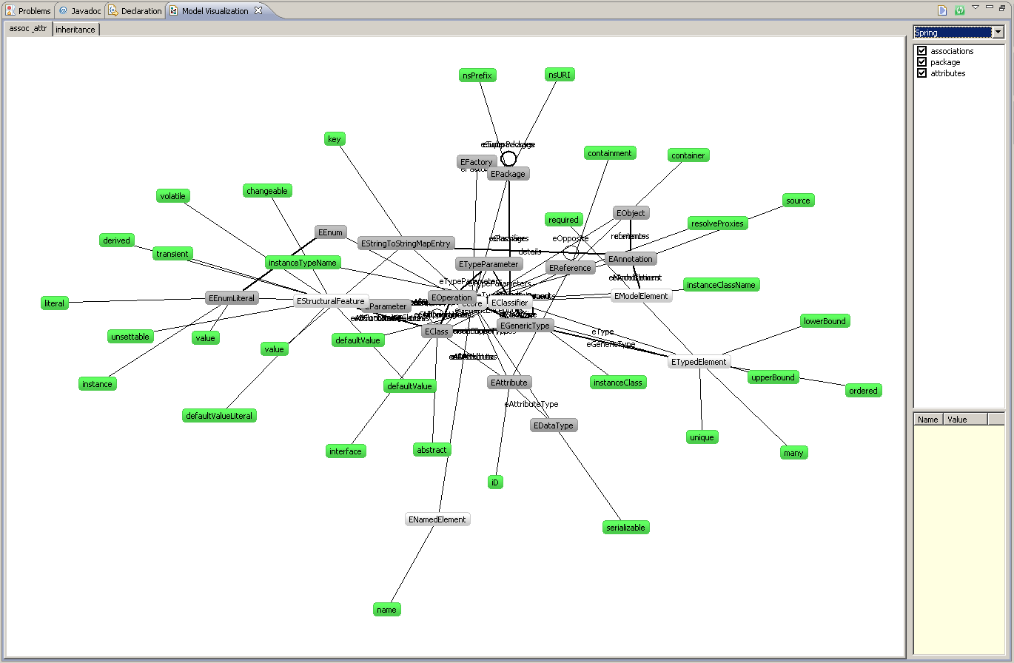
The viewer currently provides the following features:
- changing the layout between the various layouts supported by ZEST
- show several graphs using different tabs
- hiding certain types of elements in the model, based on the categories field in the meta model
- selecting elements as well as related elements
- showing any number of name-value pairs associated with nodes or connections
- if notes contain data in the source field, the viewer can go back to that location in the source code

References back to the model code
You can assign a source location to a node:
create SimpleNode toNode( Entity e ):
setSourceLocation( e.getTMFXtextLocation() ) ->
setLabel( e.name ) ->
setName( e.name );
In the viewer, shift-click on the node to navigate back the code. To make this work, make sure you load the model in the workflow via a platform:/resource URI.
<component class="org.eclipse.xtext.MweReader" uri="platform:/resource/org.xtext.example.mydsl.generator/src/model/MyModel.mydsl">
<register class="org.xtext.example.MyDslStandaloneSetup"/>
</component>

Subgraphs
You can drill-down into subgraphs by right-clicking onto a node and selecting Drill down this Node. This option is available, if
- the node is a ContainerNode as opposed to a SimpleNode
- and the ContainerNode contains a child graph in its containedGraph property.

create ContainerNode toNode( Entity e ):
setSourceLocation( e.getTMFXtextLocation() ) ->
setLabel( e.name ) ->
setName( e.name ) ->
setCategory("component") ->
setFillcolor( ColorEnum::white ) ->
setContainedGraph( e.createPropsGraph() );

create Graph createPropsGraph( Entity e ):
setName( "childgraph_"+e.name ) ->
nodes.addAll( e.simpleProperties().toChildProp() );

create SimpleNode toChildProp( Property p ):
setSourceLocation( p.getTMFXtextLocation() ) ->
setLabel( p.name+": "+p.type.name ) ->
setName( "child_"+p.name );

Compartments
You can create UML-Class-like nodes by using compartment nodes and adding compartments with entries.

create CompartmentNode toNode( Entity e ):
setSourceLocation( e.getTMFXtextLocation() ) ->
setLabel( e.name ) ->
setName( e.name ) ->
setCategory("component") ->
compartments.add( e.createAttrCompartment() );

create Compartment createAttrCompartment( Entity e ):
setName( e.name+"attrcomp" ) ->
setCategory( "properties-compartment" ) ->
entries.addAll( e.simpleProperties().name );

Tips
- Always run your workflow (the one you use for creating the graphmm35 model) in the workspace using Run As -> MWE Workflow because the error reporting in the viewer is not great. Only when it works in the workspace drop it onto the viewer.
- The viewer only works for workflows that are physically located in the workspace directory.
- All nodes need names! Names are not the same as labels. Labels are shown, names are for internal identification. Names must be unique per model.

Future Work
The current state of the ZEST viewer is basically a prototype. To make it really useful, the following improvements should be implemented, and I am looking for people who help with that.
- The layout must be improved, for example by reducing the metaphor of nodes having negative electric charge and connections acting as springs. Using this approach, the layout can be implemented as a numerical simulation of the forces between the nodes.
- To avoid disorientation in a new rendering of the graph, it would be useful to be able to pin down the position of certain nodes. When the graph is rerendered her, those nodes remain exactly that position.
- Currently, the complete graph is rendered. It would be helpful to only render a part of it, and then when selecting a menu entry on a note, expand the graph dynamically. This way, you couldn't explore your way through the graph.
Of course, many more features are possible and useful, if you have suggestions or want to help please let me know: voelter@acm.org

