RQ2 Research Journal
Calibrated confidence, transformation stability and frozen prediction-risk scoring for PCB defect detections.
Journal reconstructed 16 October 2026; revised 20 October 2026. These are documentation dates, not experiment dates. Paths are relative to the TrustPCB root. Result tables use five decimal places unless otherwise stated; exact machine-readable values remain in the recorded CSV/JSON sources. Differences retain their signs and original scale.

Executive summary
RQ2 investigated whether calibrated detector confidence, class consistency and localisation stability could rank incorrect retained predictions more effectively than confidence alone. Probability calibration asks whether predicted correctness probabilities match observed correctness. Error ranking asks whether incorrect predictions receive higher risk scores. Operational referral asks which crops should be sent for human review; that separate question is investigated in RQ3.
The recorded Beta mapping improved final Brier score (0.06376 to 0.06012), NLL (0.22261 to 0.21008) and ten-bin ECE (0.04095 to 0.00833), while raw and calibrated confidence had identical ranking metrics. Equal-weight TrustPCB performed below calibrated confidence on primary development AUROC (0.94732 versus 0.95215) and primary final AUROC (0.94631 versus 0.95306). [RQ2-E20, E41, E42]
A later development search selected weights of 0.89 for calibrated-confidence risk, 0.01 for class-consistency risk and 0.10 for localisation-stability risk. The frozen weighted score reached primary final AUROC 0.95535 and AP 0.98560. Its saved AUROC difference from calibrated confidence was +0.00229, with recorded 95% interval [+0.00136, +0.00325]; the AP difference was +0.00204, interval [+0.00089, +0.00323]. These are small conditional ranking differences, not evidence of improved crop-level referral or factory readiness. [RQ2-E33, E48, E49]
The evidence is within-dataset and incomplete for six upstream stages. The final population was reserved from RQ2 training and development but previously used for RQ1 validation. The original final evaluation also predates the later development weight search; weights were frozen before weighted final evaluation, not before every final-population analysis. Saved intervals condition on the frozen pipeline and do not capture the uncertainty of rebuilding and selecting it.

Research sequence and evidence boundaries
The twelve stages below retain the established research presentation, from partitioning and detector preparation through calibration, stability, development risk comparisons, weighting and two distinct final evaluations. The order organises the methods and evidence; it is not an assertion of execution chronology. artifact_paths.py is infrastructure, not another experiment.
Execution timing is stated only where saved provenance supports it. The original final evaluation records completion on 22 September 2026 UTC; weighted fusion records completion on 23 September; weighted final evaluation records completion on 24 September. Thus Stage 11 executed before Stage 10, although the established presentation is retained. These are provenance timestamps, not Git-date inferences. Development-only selection and the frozen-weight identity are recorded, but an entirely untouched final population throughout all method development cannot be claimed. [RQ2-E07, E40, E54]

How to read the evidence
A — Original saved experimental results available locally. B — Downstream provenance or summaries documenting earlier outcomes or identities. C — Methods defined in source or protocols without complete execution evidence. D — Missing or externally stored artifacts whose current location is unverified. The category applies to a claim: a saved downstream summary is A for its own result but B when used to describe an earlier stage.
The six upstream directories below remain absent in this checkout. DICC is their documented execution context; their present external storage is not verified. A recorded checkpoint hash or fitting parameter identifies what a later run reports using, but does not independently verify the missing original. Reporting figures are later visualisations of A records, not additional experiments. Retired documentation is navigation history, not execution evidence.
Stage or evidence group | Available basis | Completeness boundary
Partition | A: local verification report; C: partition method and YAML [E01–E04]. | Accepted/rejected balance and memberships are recorded.
Detector training | B: selected epoch/checkpoint identity [E07]; C: protocol/source [E05–E06]. | D: runs/rq2/detector_training; checkpoint and training metrics unavailable.
Confidence distribution | B: later retained counts [E10]; C: extraction method [E08–E09]. | D: runs/rq2/confidence_distribution; raw predictions and histograms unavailable.
Raw calibration | B: later target counts [E10]; C: matching/metric definitions [E11–E12]. | D: runs/rq2/calibration_analysis; labelled rows and original calibration metrics unavailable.
Calibrator comparison | B: later Beta identity/input hashes [E07, E40]; C: comparison protocol [E13–E14]. | D: runs/rq2/calibrator_comparison; OOF scores and selection report unavailable.
Final Beta fitting | B: coefficients and fit-artifact hash [E07]; C: fitting method [E15–E16]. | D: runs/rq2/final_calibrator; fit artifact and development fit statistics unavailable.
Transformation stability | B: later signal use and manifest [E07, E19]; C: construction method [E17–E18]. | D: runs/rq2/transformation_stability; development match-level outputs unavailable.
Risk and final analyses | A: saved metrics, intervals, candidates and folds [E20–E56]; B: upstream identities. | Local summaries support reporting. Some row-level files, inference audits and bootstrap replicates remain D.
The exact missing-path list remains in outputs/rq2/manifest.json. Categories B and C do not replace missing category A records. The source register retains all 63 IDs and distinguishes original outputs, downstream provenance, methods, later reporting figures and retired navigation.
Stage navigation: 1 · 2 · 3 · 4 · 5 · 6 · 7 · 8 · 9 · 10 · 11 · 12

1 Train/development partition and rejected v1

Purpose
Separate detector fitting from subsequent development without breaking confirmed similarity groups.

What was done
The similarity-aware 8,207-image RQ1 training pool was partitioned into 7,386 detector-training images and 821 development images. The 2,052-image population previously used for RQ1 validation was reserved from RQ2 training and development. The rejected rare-class-first split was compared with the accepted group-preserving global-balancing approach.

Experimental setup
Seed 24209199; target 821 development images and 7,386 detector-training images. Whole connected components were indivisible. Class image-presence and annotation-count features had equal roles in mean squared deviation from the 10% target. Greedy allocation was followed by deterministic one-for-one component exchanges, capped at 200; source-manifest order was preserved.

Recorded results
Category A: the local verification report, generated 2026-09-19T09:06:59.121870+00:00, records exactly 821 development images, 188 accepted swaps and a local optimum without reaching the swap cap. All source images appear once, no partition overlaps or confirmed-group crossings occur, and the partition procedure did not read reserved final-population images or labels. The accepted maximum class-feature deviation is 0.06711 percentage points.
Table 1. Saved partition verification [RQ2-E01]
Measure | Accepted v2 | Rejected v1
Maximum absolute deviation (pp) | 0.06711 | 29.62264
Mean absolute deviation (pp) | 0.02389 | 9.38869
Mean squared deviation (pp²) | 0.00097 | 181.74108
Recorded source: data/splits/rq2_train_development_split/verification_report.json • class_balance.summary and rejected_split_comparison.class_balance.summary pp = percentage points; pp² = squared percentage points.

Interpretation
The rejected split is an informative negative methodological result: protecting rare classes without global balancing can distort their development representation. The v2 criterion achieved much closer observed balance, but its local optimum is not a proof of global optimality.

Research decision
Recorded outcome: v1 was rejected and the globally balanced v2 memberships were accepted and frozen. The report supports this choice through substantially smaller class-feature deviations while keeping similarity groups intact. The final population retains its RQ1 validation history; it is not an independent external test dataset.

Limitations
The v2 local optimum is not proof of global optimality. Group protection covers confirmed similarities, not board-level independence. RQ1 previously evaluated the final population; its RQ2 holdout role does not make it external or historically untouched.

Next stage
The subsequent detector workflow uses the accepted 7,386/821 training/development memberships.

Supporting evidence
Evidence: RQ2-E02 · RQ2-E03 · RQ2-E01 · RQ2-E04

2 Fresh detector training and checkpoint selection

Purpose
Provide one detector whose development selection is fixed before risk comparison.

What was done
The source and protocol define fresh YOLOv8n training and a selected.pt checkpoint corresponding to the first maximum development mAP50–95, rather than assuming that the framework’s best.pt fitness selects the same epoch. This is category C method evidence; the original local execution outputs are missing.

Experimental setup
The protocol uses seed 24209199, image size 640, batch 32, workers 2, deterministic/AMP enabled and 100 epochs. Training uses 7,386 images with 821 development images; no train-plus-development refit is prescribed. The candidate checkpoint is captured at the matching recorded CSV epoch.

Recorded results
Category B: final-evaluation provenance records selected epoch 72 and checkpoint SHA-256 793992d25ef671c45c820dc1b5a61bca5837af0d3726cd3830b2f2c656a6a85f. Category D: the original detector-training directory and checkpoint are absent locally. No historical detector mAP, training loss or checkpoint-byte validation is inferred from this downstream identity.

Interpretation
Downstream identity supports which detector later stages report using, but does not independently verify an unavailable checkpoint or its full training history.

Research decision
The subsequent frozen evaluation identifies the selected detector. That establishes the reported downstream choice, but the checkpoint-selection decision cannot be independently reconstructed from missing training records. No additional training decision or undocumented approval is inferred.

Limitations
B and C evidence identify the reported checkpoint and method, but D records prevent verifying the checkpoint bytes, training history or selected-epoch metrics. No unavailable training curve is reconstructed.

Next stage
The documented confidence-distribution stage consumes that selected detector on development images.

Supporting evidence
Evidence: RQ2-E05 · RQ2-E06 · RQ2-E07

3 Exploratory confidence distribution

Purpose
Inspect the detector’s confidence range before defining the population for calibration and risk scoring.

What was done
The workflow extracts development predictions at a permissive confidence floor and records confidence distributions. This exploration precedes the fixed retained-prediction threshold used later.

Experimental setup
Development-only prediction settings specify confidence 0.001, NMS IoU 0.7, max_det 300, image size 640, batch 1, device 0, rect=True, augment=False and class-aware NMS. The final retained-reference threshold is 0.01; extraction floor and analysis inclusion are distinct.

Recorded results
Category B: later development summaries record 7,131 retained predictions across 821 images. Category D: the original confidence-distribution directory, raw prediction table and histograms are unavailable locally. Counts below the retained threshold and the historical histogram shape remain unknown.

Interpretation
The permissive extraction floor permits inspection but is not an optimised operating threshold. The absent exploratory outputs prevent a detailed historical distribution narrative.

Research decision
The later pipeline records a fixed raw-confidence inclusion threshold of 0.01. That downstream choice is distinguishable from the exploratory extraction floor of 0.001. Without the exploratory outputs, this journal cannot reconstruct the empirical rationale for choosing 0.01 or claim that it was optimised.

Limitations
Missing exploratory outputs (D) prevent reconstructing confidence-distribution shape or the historical threshold-choice rationale. Later retained counts (B) describe a narrower downstream population.

Next stage
Correctness labelling and calibration use the fixed retained threshold of 0.01.

Supporting evidence
Evidence: RQ2-E08 · RQ2-E09 · RQ2-E10

4 Correctness labelling and raw calibration analysis

Purpose
Define prediction correctness and assess whether confidence represents empirical correctness.

What was done
Predictions with raw confidence at least 0.01 are matched to same-class ground truth in descending raw-confidence order; stable original order resolves score ties. Each prediction claims the highest-IoU unused same-class object, with label-order tie handling. Duplicate and unmatched predictions are incorrect.

Experimental setup
Primary correctness requires IoU ≥0.50. Sensitivity IoU ≥0.75 is independently rematched with a fresh unused-ground-truth set. NLL clips probabilities with epsilon 1e-15 for logarithms; Brier uses unmodified probabilities. ECE uses ten equal-width bins, left-inclusive and final-right-inclusive; empty-bin statistics are undefined. Missed ground-truth objects do not become prediction rows.

Recorded results
Category B: later development records contain 7,131 retained predictions, including 5,618 incorrect under IoU ≥0.50, an incorrect-prediction prevalence of 0.78783. Category D: the original labelled prediction table and raw development calibration metrics are missing. Final-population calibration results do not fill this development evidence gap.

Interpretation
This is conditional correctness among low-threshold retained detections, not object recall or factory defect prevalence. High incorrect-prediction prevalence also creates a high average-precision reference level.
For prediction i, let pᵢ be raw detector confidence and yᵢ=1 denote a correct retained prediction under the stated same-class one-to-one matching rule. The ranking target is eᵢ=1−yᵢ. Brier is the mean of (pᵢ−yᵢ)²; NLL is the negative mean of yᵢ log(pᵢ)+(1−yᵢ) log(1−pᵢ), using the stated logarithm clipping. ECE weights each bin’s absolute mean-confidence/observed-correctness gap by its prediction count. These quantities assess retained-prediction correctness, not the proportion of all objects detected.

Research decision
The recorded downstream pipeline uses the fixed matching, correctness and calibration-metric definitions. These definitions are recoverable from source and protocols (C); the absent development outputs (D) prevent independent verification of the original raw calibration analysis.

Limitations
Methods (C) and downstream counts (B) do not replace missing labelled rows and development calibration scores (D). Missed objects are outside this conditional prediction-row population.

Next stage
The documented calibrator comparison evaluates candidate mappings using development folds.

Supporting evidence
Evidence: RQ2-E11 · RQ2-E12 · RQ2-E10

5 Development calibrator comparison

Purpose
Choose a confidence mapping using held-out development predictions rather than fitting and evaluating on identical rows.

What was done
The method compares Temperature, Platt, Beta and isotonic calibration under five image/group-preserving folds. Out-of-fold prediction-weighted NLL is the primary criterion; paired image-cluster intervals define indistinguishable candidates, followed by Brier and a fixed simplicity order.

Experimental setup
Seed 24209199; all 821 images, including zero-prediction images, remain in fold allocation. Temperature applies sigmoid(logit(p)/T); Platt uses sigmoid(a·logit(p)+c), a≥1e-8; Beta uses sigmoid(a·log(p)−b·log(1−p)+c), a,b≥0. Isotonic uses weighted PAVA with tied-score pooling, linear interpolation and constant extension. Parametric fits use unregularised mean NLL, identity initialisation and L-BFGS-B (maxiter 2000, ftol 1e-12, gtol 1e-8, maxls 50). The saved protocol specifies 10,000 paired image-cluster draws, PCG64 seed 24209199, conditional on fixed out-of-fold predictions; ECE is not a selection criterion.

Recorded results
Category B: later artifacts identify Beta as the approved mapping and record upstream input identities. Category D: the comparison directory, out-of-fold prediction records, per-method metric table and selection report are unavailable. The eventual Beta identity does not reveal the missing comparison scores, margins or review discussion.

Interpretation
Grouped out-of-fold assessment reduces direct fitting optimism. However, selection and interval comparisons are development evidence, and the missing outputs prevent auditing the full historical choice from this checkout. Raw confidence is a benchmark, not a candidate mapping; the documented protocol requires review if no fitted candidate improves its point NLL.

Research decision
The later frozen artifact supports that Beta was carried forward. The protocol defines how selection and explicit approval should occur, but missing original comparison records prevent this journal from reconstructing the full empirical choice or a personal approval history. No absent candidate scores are inferred.

Limitations
Original out-of-fold scores and the selection report are missing (D). Downstream Beta use (B) cannot establish its empirical margin over alternatives or reproduce the historical review.

Next stage
The approved-family identity is carried into the full-development Beta-fitting stage.

Supporting evidence
Evidence: RQ2-E13 · RQ2-E14 · RQ2-E07

6 Frozen full-development Beta mapping

Purpose
Fit the approved mapping once on the full development population and freeze it for downstream use.

What was done
The final-calibrator workflow applies the selected Beta family to all retained development predictions. Subsequent stages consume the fitted mapping rather than fitting on the final population.

Experimental setup
Full development comprises 821 images and 7,131 retained predictions. The downstream provenance records a=0.9671379615387139, b=2.2912177337533874, c=−0.6283462684200526 and ε=1e−15. For q=clip(p, ε, 1−ε), calibrated confidence is p_cal=σ(a log(q)−b log(1−q)+c), with σ(z)=1/(1+exp(−z)) and constrained a,b≥0. These recorded coefficients identify the mapping; they are not a new fit.

Recorded results
Category B: coefficients and the original final-calibrator SHA-256 60b8c9e93559e4297649ee97d2ffe2b9ceff28c80b305f8f932fe7a58f3c2a95 survive in final-evaluation provenance. Category D: the standalone fit artifact, fit statistics and full-development prediction file are not local. The recorded hash is preserved without claiming verification of absent artifact bytes.

Interpretation
Beta maps raw confidence to an estimate of conditional correctness. Its non-decreasing form can improve Brier, NLL and ECE while preserving prediction order; unchanged raw/calibrated AUROC and AP in the saved evaluations are therefore compatible with improved probability calibration. Calibration does not imply improvement in every measure, and order preservation does not itself validate the probabilities.

Research decision
Later use of the frozen Beta coefficients establishes the mapping taken forward. The original fitting and approval records remain missing, so the journal records this downstream decision identity rather than inventing fit diagnostics or a review narrative.

Limitations
The missing original fit artifact and fit summaries (D) prevent an independent fitting audit. Final probability metrics are on another population and must not stand in for development-fit diagnostics.

Next stage
The frozen mapping is consumed with the fixed detector in stability and risk analysis.

Supporting evidence
Evidence: RQ2-E15 · RQ2-E16 · RQ2-E07

7 Transformation based stability

Purpose
Measure whether prediction identity and location remain stable under mild controlled image changes.

What was done
Each crop is independently transformed into 11 views spanning brightness, contrast, blur, rotation and translation. Original reference detections are associated with inverse-mapped transformed detections. Class agreement and localisation overlap are aggregated within families and then equally across available families.

Experimental setup
Brightness factors 0.90/1.10; contrast 0.90/1.10; blur σ=0.6; rotations ±2°; translations ±0.02 of image width or height. Transformations are not composed. Photometric conversion uses float64 clipping and nearest-even uint8 rounding. Geometric processing uses pixel-centre coordinates, inverse bilinear sampling and per-channel median borders; four-corner polygons preserve rotated geometry. References require raw confidence ≥0.01, transformed extraction ≥0.001. References leaving bounds are non-evaluable, not failures. Class-agnostic polygon matching at IoU ≥0.50 first maximises match cardinality and then total IoU; unmatched evaluable references score zero, matched class agreement is binary, localisation uses overlap. Translation’s four views do not receive four times the family weight.
For each evaluable view, class agreement is 1 when the matched detection keeps the reference class and 0 otherwise; localisation uses the matched polygon IoU. An evaluable unmatched reference contributes zero to both. A non-evaluable reference is excluded. Each family score is the sum over evaluable variants divided by their count; the overall signal is the mean over families with evaluable variants. This preserves equal family weight despite differing variant counts. Risks are one minus the respective overall signals.

Recorded results
Categories B/C: downstream risk records, the final transformation manifest and source definitions document the signals used. Category D: the standalone development stability directory and match-level outputs are unavailable. Eleven views per 821 crops imply 9,031 configured development views; this is a protocol count, not an independently verified execution count.

Interpretation
These signals quantify robustness under specified mild perturbations. They do not establish invariance to production conditions, new camera systems or new PCB designs. Excluding non-evaluable geometry prevents out-of-frame truncation from being automatically counted as instability.

Research decision
The later risk analyses show that these fixed stability signals were carried forward. Their method is documented, but the absent match-level development outputs prevent independent reconstruction of every association or a stronger execution claim.

Limitations
Missing development associations (D) limit row-level verification. Stability under the specified perturbations does not establish robustness to new boards, cameras or factory conditions.

Next stage
Primary development risk evaluation compares the frozen signals and their ablations.

Supporting evidence
Evidence: RQ2-E17 · RQ2-E18 · RQ2-E19 · RQ2-E07

8 Primary development risk evaluation and ablations

Purpose
Test whether equal-weight combination improves incorrect-prediction ranking beyond its constituent signals.

What was done
Eight methods compare raw-confidence risk, calibrated-confidence risk, class-consistency risk, localisation-stability risk, three two-signal means and the three-signal equal mean. Higher scores prioritise predictions as potentially incorrect. Composite risk scores are ranking functions; they are not independently calibrated error probabilities.

Experimental setup
Let r=1−raw confidence, c=1−calibrated confidence, k=1−class consistency and l=1−localisation stability. Equal-weight TrustPCB is (c+k+l)/3; the two-signal ablations are (c+k)/2, (c+l)/2 and (k+l)/2. The positive class is an incorrect retained prediction under IoU ≥0.50. AUROC gives half credit to tied pairs; AP uses non-interpolated distinct-score groups, not trapezoidal area. Intervals use 10,000 paired whole-image draws with replacement, PCG64 seed 24209199, 821 images per draw, linear percentile endpoints and no redraw of invalid replicates. Signals remain fixed.

Recorded results
Category A: the saved comparison contains 7,131 predictions, of which 5,618 are incorrect. Equal-weight AUROC is 0.94732 versus calibrated-confidence AUROC 0.95215. The saved paired difference is −0.00483, with recorded 95% interval [−0.00946, −0.00038]. The primary equal-weight hypothesis did not improve on this baseline.
Table 2. Development, primary IoU ≥0.50 [RQ2-E20]
Risk method | AUROC | Average precision
Raw confidence | 0.95215 | 0.98343
Calibrated confidence | 0.95215 | 0.98343
Class consistency | 0.69033 | 0.86871
Localisation stability | 0.87036 | 0.95818
Calibrated + class | 0.94842 | 0.97983
Calibrated + localisation | 0.94996 | 0.98270
Class + localisation | 0.87114 | 0.95637
Equal-weight TrustPCB | 0.94732 | 0.98044
Recorded source: runs/rq2/risk_evaluation/method_metrics.csv • Saved columns: method, auroc, auprc
Table 3. Development paired AUROC: equal-weight versus calibrated [RQ2-E21]
Difference | Lower 95% | Upper 95%
-0.00483 | -0.00946 | -0.00038
Recorded source: runs/rq2/risk_evaluation/pairwise_auroc_differences.csv • Saved columns: observed_delta_auroc, lower_95, upper_95
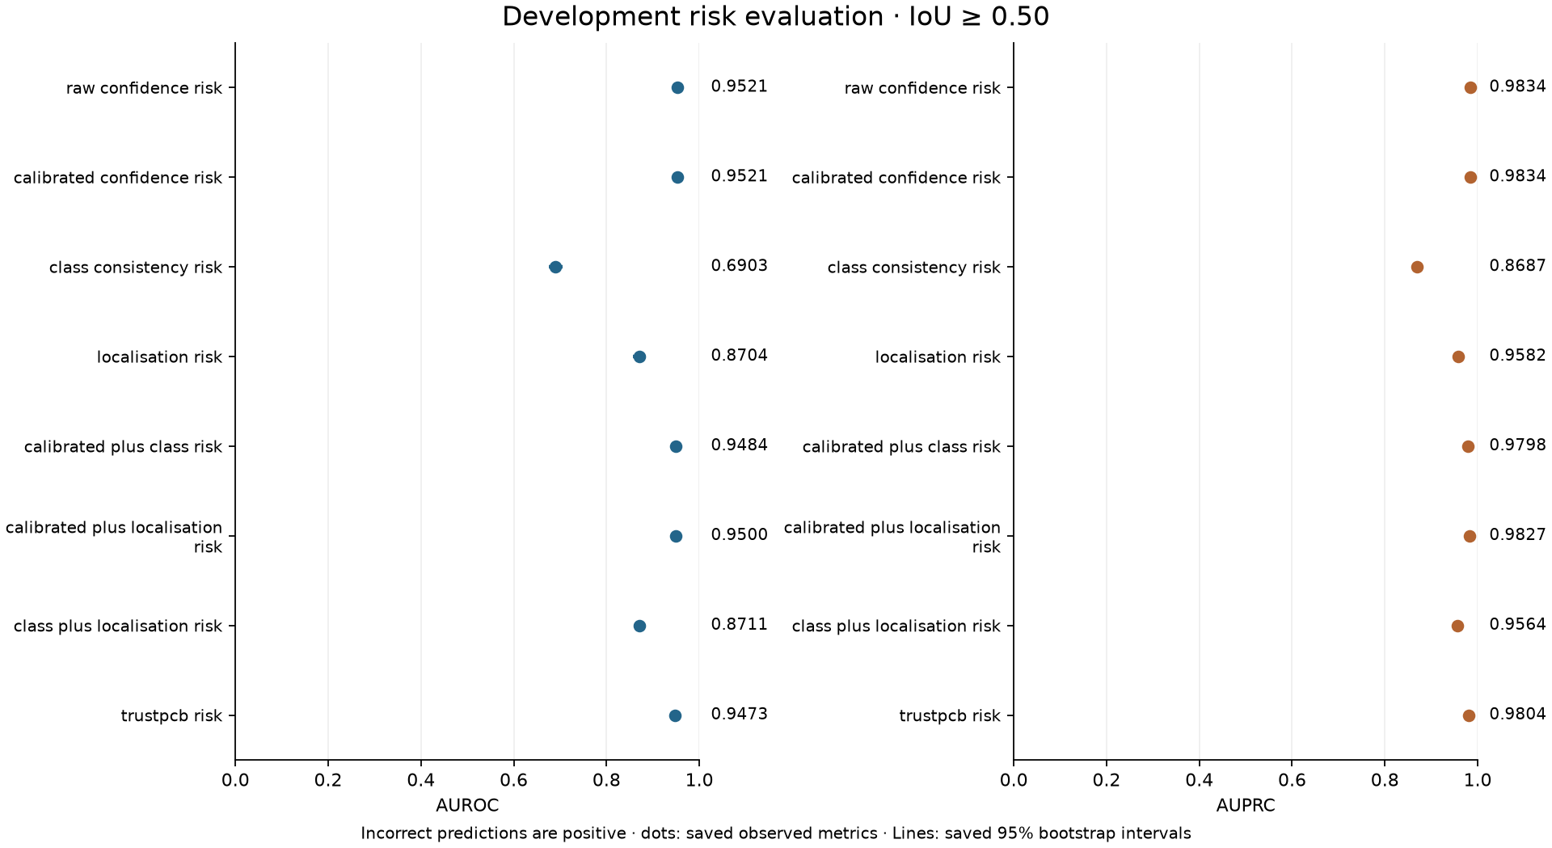
Figure 1. Later visualisation of saved primary development risk metrics. [RQ2-E22]
Saved figure: outputs/rq2/risk_evaluation/figures/method_metrics.png
Original evidence: runs/rq2/risk_evaluation/method_metrics.csv
Calibrated and raw confidence coincide in ranking performance. The equal-weight composite is below them, while class consistency alone is weak. Average precision is interpreted against the high incorrect-prediction prevalence, not against zero.

Interpretation
The negative result is substantive, not an organisation artifact. Adding stability indiscriminately can dilute a strong confidence signal. Development inference remains conditional on mappings fitted and choices explored on this population.

Research decision
The recorded result supports retaining equal weighting as a negative baseline, together with the complete ablations. It provides a rationale for examining a constrained weighting scheme later, but is not relabelled as the subsequent weighted method. No undocumented decision meeting is inferred.

Limitations
This is development evidence conditional on fitted mappings and explored choices. High incorrect-prediction prevalence affects AP; missing raw bootstrap replicates limit independent reconstruction beyond saved summaries.

Next stage
The recorded IoU 0.75 sensitivity analysis checks dependence on the correctness definition without changing the primary protocol.

Supporting evidence
Evidence: RQ2-E23 · RQ2-E24 · RQ2-E10 · RQ2-E25 · RQ2-E26 · RQ2-E27 · RQ2-E28

9 Development IoU 0.75 sensitivity

Purpose
Check dependence of conclusions on the correctness IoU threshold without using that sensitivity to tune weights.

What was done
The same frozen risk scores were evaluated against independently defined IoU ≥0.75 correctness labels. No calibrator refit, risk-formula change or operating-threshold selection was performed.

Experimental setup
The same 7,131 predictions on 821 images use the paired 10,000-draw bootstrap with seed 24209199. IoU ≥0.75 is secondary; IoU ≥0.50 remains primary.

Recorded results
Category A: independently rematched IoU ≥0.75 labels give 6,126 incorrect predictions, prevalence 0.85907, on the same 7,131 retained rows. Calibrated-plus-localisation AUROC is 0.93607 versus confidence 0.93212; equal-weight AUROC is 0.93255. All eight saved methods are retained in Table 4.
Table 4. Development sensitivity only: IoU ≥0.75 [RQ2-E29]
Risk method | AUROC | Average precision
Raw confidence | 0.93212 | 0.98510
Calibrated confidence | 0.93212 | 0.98510
Class consistency | 0.67665 | 0.91063
Localisation stability | 0.88359 | 0.97685
Calibrated + class | 0.93108 | 0.98518
Calibrated + localisation | 0.93607 | 0.98763
Class + localisation | 0.88083 | 0.97510
Equal-weight TrustPCB | 0.93255 | 0.98634
Recorded source: runs/rq2/risk_sensitivity_iou75/method_metrics.csv • Saved columns: method, auroc, auprc

Interpretation
Independent rematching changes the target and incorrect-prediction prevalence, including AP’s reference level. Localisation contributes more favourably under IoU ≥0.75, but these secondary results neither reverse the negative primary finding nor justify choosing the better-looking IoU threshold.

Research decision
The saved sensitivity analysis retained IoU ≥0.50 as primary and performed no tuning. It qualifies the stability interpretation without selecting a new threshold or weight-selection objective.

Limitations
Independent rematching changes the target and prevalence. Cross-IoU AP values cannot be interpreted as the same task improving or deteriorating, and sensitivity is not a tuning set.

Next stage
Weight selection uses primary IoU 0.50 labels only; secondary labels are excluded.

Supporting evidence
Evidence: RQ2-E30 · RQ2-E31 · RQ2-E32

10 Development-selected weighted fusion

Purpose
Test whether a constrained blend can retain useful stability information without the dilution seen in equal weighting.

What was done
The saved candidate table records all 5,151 nonnegative integer-percentage triples summing to 100. Each candidate was assessed on the 821-image, 7,131-prediction development population using five image/group-preserving folds; the component signals were already frozen. Mean fold metrics give the five folds equal weight. No component fitting occurs within these folds.

Experimental setup
Selection maximises mean fold non-interpolated AP for incorrect IoU50 predictions. Candidates within absolute 1e−12 of the maximum enter the AUROC tie-break, using the same absolute tolerance; then the rule minimises exact distance from equal weights and prefers larger confidence, localisation and class weights in that order. Seed 24209199; no nested cross-validation occurred. The selector receives primary-only data: IoU ≥0.75 labels are excluded to keep secondary sensitivity from influencing selection and are considered only after weights are fixed.

Recorded results
Category A: selected weights are calibrated confidence 0.89, class consistency 0.01 and localisation stability 0.10. Mean fold AP is 0.98499 and mean fold AUROC is 0.95395. Candidate records, folds and the selected-weight artifact are local. The frozen weighted score is 0.89c+0.01k+0.10l. Weighted-final provenance verifies the selected-weight identity against commit 74510277056c72114dc421bd900ddb5dfbc91933; this commit is an identity anchor, not an execution-date surrogate.
Table 5. Frozen development-selected weights [RQ2-E33]
Component / measure | Saved value
Class-consistency weight | 0.01
Calibrated-confidence weight | 0.89
Localisation-stability weight | 0.10
Mean fold AP | 0.98499
Mean fold AUROC | 0.95395
Recorded source: runs/rq2/weighted_fusion/selected_weights.json
Table 6. Full-development weighted comparison; descriptive after selection [RQ2-E34]
Risk method | AUROC | Average precision
Calibrated confidence | 0.95215 | 0.98343
Equal-weight TrustPCB | 0.94732 | 0.98044
Selected weighted TrustPCB | 0.95361 | 0.98482
Recorded source: runs/rq2/weighted_fusion/development_metrics.csv • Saved columns: method, auroc, auprc
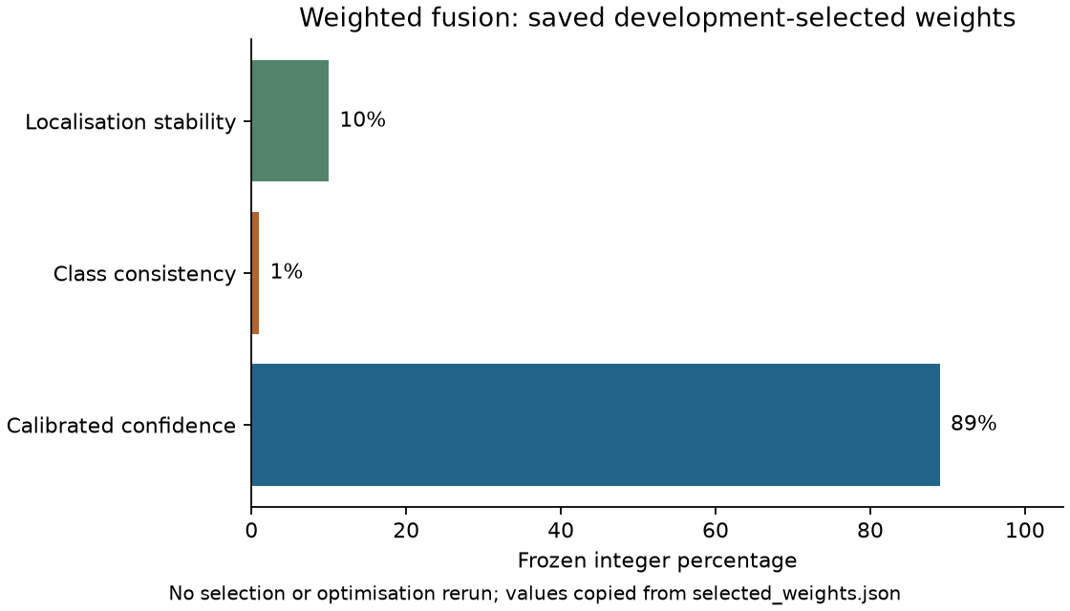
Figure 2. Saved selected fusion weights, rendered later for reporting. [RQ2-E35]
Saved figure: outputs/rq2/weighted_fusion/figures/selected_weights.png
Original evidence: runs/rq2/weighted_fusion/selected_weights.json
Confidence receives 89%, localisation 10% and class consistency 1%. These are frozen empirical choices within the development search, not universal or causal importance coefficients.

Interpretation
The confidence-heavy solution is consistent with the saved ablations. Selection over 5,151 candidates makes development performance post-selection descriptive, not an unbiased generalisation estimate. The coefficients are empirical weights on these defined, correlated signals; they are neither universal feature importance nor causal contributions. The saved original final evaluation preceded this search. Provenance records development-only selection, but the sequence does not establish that all pipeline choices were made before any final-population results existed.

Research decision
The selected 89/1/10 weights were frozen before their weighted final evaluation. Local artifacts and weighted-final provenance record the fixed identity and no reselection. The original equal-weight final evaluation remains a separate, earlier result; no claim is made that these weights predated it.

Limitations
The same development evidence selected and described the weights; no nested evaluation was performed. The original final evaluation already existed, so a claim that all method development preceded any final analysis is unsupported. The records do not establish final-set-driven weight optimisation.

Next stage
The frozen weighted score is subsequently applied to saved final signals in Stage 12. Stage 11 is retained next for comparison with the earlier original final evaluation.

Supporting evidence
Evidence: RQ2-E36 · RQ2-E37 · RQ2-E33 · RQ2-E38 · RQ2-E39 · RQ2-E40

11 Original frozen final evaluation

Purpose
Evaluate calibration and the original eight risk methods on the population held out from RQ2 detector training and development.

What was done
The selected detector and frozen Beta mapping were applied to 2,052 crops; original and transformed predictions supplied the fixed signals. Calibration and primary/sensitivity risk summaries were recorded separately.

Experimental setup
The final population was previously used for RQ1 validation and is not a historically untouched external test. There are 17,840 retained predictions. Original inference uses confidence 0.01; transformed inference uses 0.001, with NMS 0.7, max_det 300, image size 640, batch 1 and device 0. The 11 transformations and frozen Beta parameters are unchanged. Paired bootstrap uses 2,052 image draws per replicate, 10,000 replicates and seed 24209199.

Recorded results
Category A: saved final metrics show lower Beta Brier, NLL and ECE than raw confidence. Ranking AUROC/AP are identical for raw and calibrated confidence. Primary calibrated-confidence AUROC is 0.95306, compared with 0.94631 for equal-weight TrustPCB. The original eight-method primary table remains intact; IoU ≥0.75 summaries are kept separate, with no new weights or referral thresholds selected.
Table 7. Final population: calibration at IoU ≥0.50 [RQ2-E41]
Mapping | Brier | NLL | ECE (10 bins)
Beta | 0.06012 | 0.21008 | 0.00833
Raw | 0.06376 | 0.22261 | 0.04095
Recorded source: runs/rq2/final_evaluation/calibration_metrics.json • metrics; count=17840 each
Table 8. Final population: original eight methods, primary IoU ≥0.50 [RQ2-E42]
Risk method | AUROC | Average precision
Raw confidence | 0.95306 | 0.98357
Calibrated confidence | 0.95306 | 0.98357
Class consistency | 0.67134 | 0.86003
Localisation stability | 0.86877 | 0.95823
Calibrated + class | 0.94654 | 0.97838
Calibrated + localisation | 0.95306 | 0.98452
Class + localisation | 0.86519 | 0.95370
Equal-weight TrustPCB | 0.94631 | 0.98002
Recorded source: runs/rq2/final_evaluation/primary_iou50/method_metrics.csv • Saved columns: method, auroc, auprc
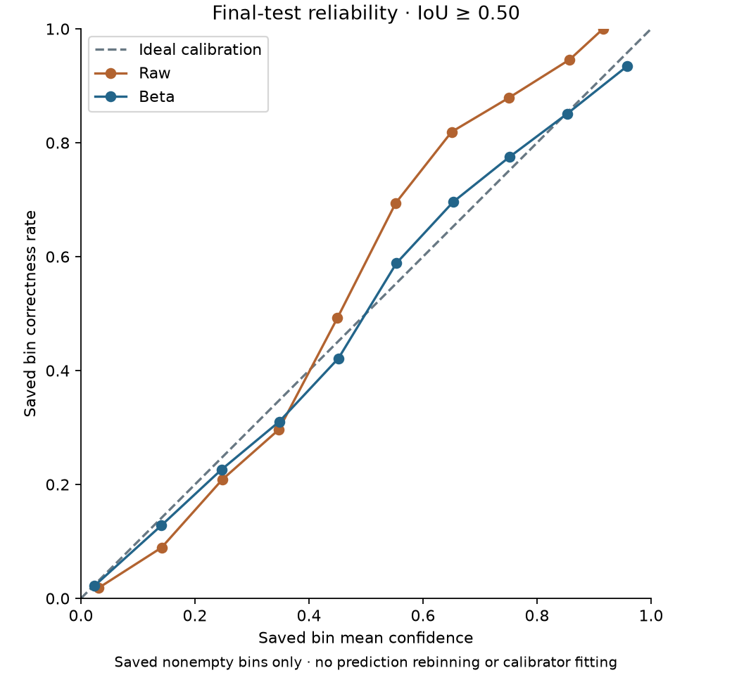
Figure 3. Final reliability curves rendered from saved ten-bin records. [RQ2-E43]
Saved figure: outputs/rq2/final_evaluation/figures/reliability_saved_bins.png
Original evidence: runs/rq2/final_evaluation/calibration_bins.csv
Beta aligns predicted correctness more closely with observed correctness in aggregate. Bin populations differ between mappings; the plot is a saved-bin visualisation, not a new calibration fit or a claim that every bin improves.

Interpretation
Probability calibration improves without an ordering change. Equal-weight failure persists beyond development and should remain visible. Original prediction tables, match-level stability files and inference_audit.json are missing locally; the preserved summaries and provenance cannot independently validate every upstream row.

Research decision
The original frozen evaluation supports improved probability calibration but retains the negative primary equal-weight ranking result. Its saved execution record precedes the later development-selected weight search. It must remain distinct from the subsequent weighted final evaluation.

Limitations
Local summaries and provenance are A/B evidence, but missing original predictions, stability rows and inference audits (D) prevent full row-level validation. Prior RQ1 use limits cross-stage independence; it does not by itself demonstrate RQ2 protocol leakage.

Next stage
Later recorded work selects weights on development only and then applies their frozen identity in the weighted final evaluation.

Supporting evidence
Evidence: RQ2-E44 · RQ2-E45 · RQ2-E07 · RQ2-E46 · RQ2-E47

12 Weighted final evaluation

Purpose
Determine whether the frozen development-selected blend improves ranking on the final retained-prediction population.

What was done
The weighted score was applied to existing final stability evidence. Provenance records no new inference, calibration fitting, transformation processing, weight selection or referral-threshold selection.

Experimental setup
The same 2,052 crops and 17,840 predictions are used, with weights 0.89/0.01/0.10. Primary IoU ≥0.50 and secondary IoU ≥0.75 are separately reported. Paired 10,000 image-cluster replicates preserve within-crop predictions and compare weighted, calibrated and equal-weight scores on shared draws.

Recorded results
Category A: primary weighted AUROC is 0.95535 and AP is 0.98560. Weighted minus calibrated confidence is +0.00229 AUROC (recorded 95% interval [+0.00136, +0.00325]) and +0.00204 AP ([+0.00089, +0.00323]). Table 10 reproduces the saved paired estimates at five decimal places. These small positive differences are conditional on the frozen pipeline.
Secondary IoU ≥0.75 is separately rematched and reported: weighted AUROC is 0.93644 and AP is 0.98609. Weighted-minus-calibrated differences are +0.00200 AUROC (recorded interval [+0.00091, +0.00313]) and +0.00124 AP ([+0.00022, +0.00229]). The final population contains 17,840 retained predictions: 14,037 incorrect under IoU ≥0.50 and 15,261 under IoU ≥0.75. These are different correctness targets, not alternative outcomes used for weight selection. [RQ2-E50, E55, E56]
Table 9. Weighted final comparison, primary IoU ≥0.50 [RQ2-E48]
Risk method | AUROC | Average precision
Calibrated confidence | 0.95306 | 0.98357
Equal-weight TrustPCB | 0.94631 | 0.98002
Weighted TrustPCB | 0.95535 | 0.98560
Recorded source: runs/rq2/weighted_final_evaluation/primary_method_metrics.csv • Saved columns: method, auroc, auprc
Table 10. Primary paired differences: weighted minus calibrated [RQ2-E49]
Measure | Difference | Lower 95% | Upper 95%
AUROC | +0.00229 | +0.00136 | +0.00325
Average precision | +0.00204 | +0.00089 | +0.00323
Recorded source: runs/rq2/weighted_final_evaluation/primary_pairwise_differences.csv • Saved columns: metric, observed_difference, lower_95, upper_95
Table 11. Weighted final sensitivity only, IoU ≥0.75 [RQ2-E50]
Risk method | AUROC | Average precision
Calibrated confidence | 0.93444 | 0.98485
Equal-weight TrustPCB | 0.92919 | 0.98304
Weighted TrustPCB | 0.93644 | 0.98609
Recorded source: runs/rq2/weighted_final_evaluation/sensitivity_iou75_method_metrics.csv • Saved columns: method, auroc, auprc
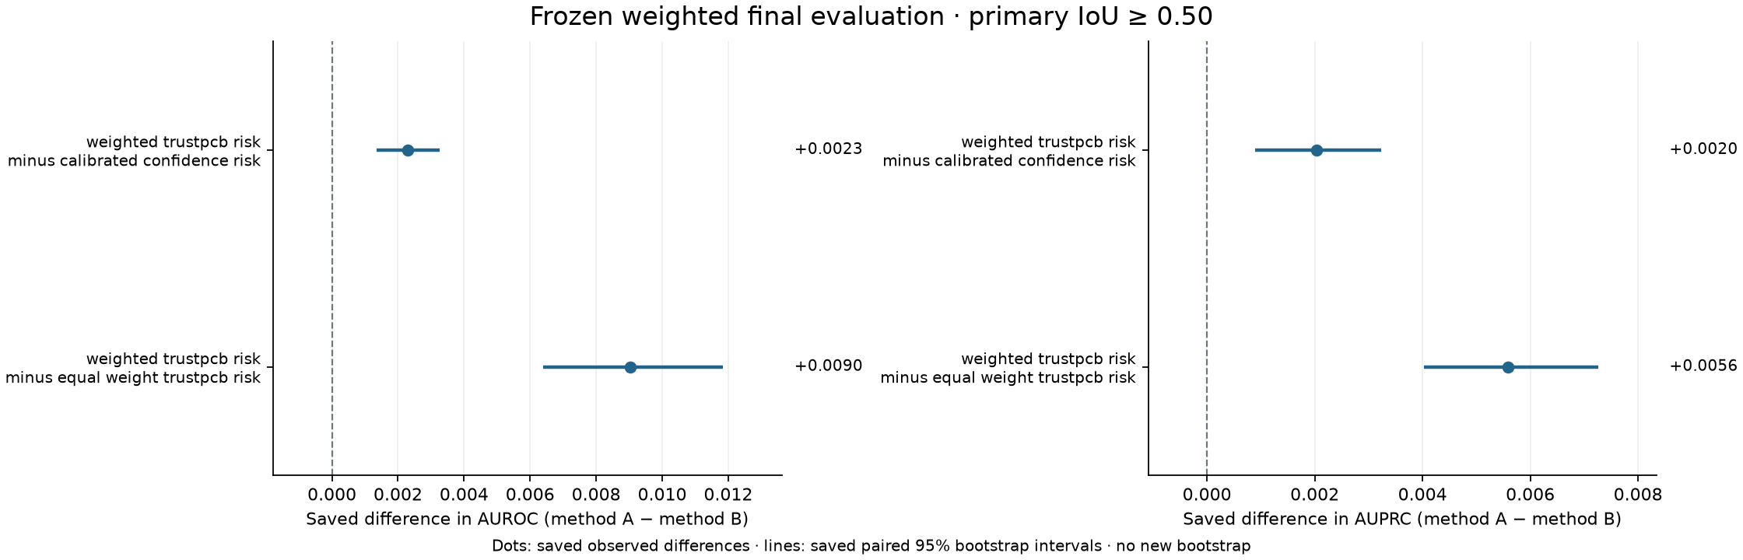
Figure 4. Saved primary weighted-final paired intervals, later rendered. [RQ2-E51]
Saved figure: outputs/rq2/weighted_final_evaluation/figures/primary_pairwise_differences.png
Original evidence: runs/rq2/weighted_final_evaluation/primary_pairwise_differences.csv
Positive weighted-minus-reference differences favour the weighted risk score for both ranking metrics. These intervals are conditional on the frozen detector, mapping and development-selected weights, not uncertainty over refitting the entire pipeline.

Interpretation
The saved paired analysis supports a small positive ranking difference for this frozen weighted score on the stated final population. Its intervals condition on the detector, calibration mapping, transformations, chosen weights and retained predictions. They do not include uncertainty from rebuilding, refitting and selecting the full pipeline. The within-dataset result does not establish external generalisation, improved object-level recall or reduced human-review effort. Prediction-level ranking can differ from crop-level referral usefulness; RQ3 examines that operational question separately.

Research decision
The final evidence supports a modest conditional ranking improvement for the frozen weighted score. It does not erase the negative equal-weight result. The appropriate next analysis is the separate RQ3 assessment of selective review, rather than a deployment or human-effort claim inferred from AUROC/AP.

Limitations
The conditional interval excludes pipeline-selection uncertainty and external-population variation. Ranking benefits do not establish operational referral, missed-object sensitivity or factory readiness. Incomplete upstream evidence remains a reproducibility boundary.

Next stage
RQ3 separately investigates selective human review and its computational and referral trade-offs; no new RQ2 experiment is invented here.

Supporting evidence
Evidence: RQ2-E52 · RQ2-E53 · RQ2-E54 · RQ2-E55 · RQ2-E56

Discussion across experiments
The recorded findings distinguish probability estimation, prediction ranking and operational referral. Beta improved the saved final probability metrics without changing raw/confidence ranking. Equal weighting diluted the strong confidence signal under the primary definition. The later confidence-heavy blend produced modest positive final paired differences. These findings require separate identities for the original and weighted methods, their populations, correctness targets and selection histories.

Limitations and unresolved evidence
Upstream runs/rq2/detector_training, confidence_distribution, calibration_analysis, calibrator_comparison, final_calibrator and transformation_stability are absent locally. They are documented DICC dependencies whose current external locations were not verified. Original checkpoint files, development calibration/OOF metrics and match-level evidence cannot be reconstructed from summaries.
Some final prediction tables, inference audits and bootstrap replicate files are also absent; output summaries, candidate-weight records, selected identities and paired interval tables remain local. The exact missing paths are retained in outputs/rq2/manifest.json. No new distributions, statistical tests or fits were produced for this journal. The final population is held out within RQ2 but previously used in RQ1; conclusions remain within-dataset and conditional on frozen choices.

Overall conclusion
Probability calibration. The recorded Beta mapping improved final Brier, NLL and ECE; it did not improve every measure, because raw and calibrated confidence had identical AUROC/AP.
Equal-weight composite. The original equal-weight combination did not improve primary prediction-error ranking over calibrated confidence. Its negative development and final findings remain part of the RQ2 answer.
Development-selected weighted composite. The frozen confidence-heavy 89/1/10 score showed small positive final AUROC and AP differences under the specified paired analysis. Development results remain post-selection descriptions, and the original final evaluation predates weight selection.
Limitations. The results are within-dataset, conditional on frozen choices and affected by incomplete local upstream evidence. The final population was previously used in RQ1. Saved intervals exclude uncertainty from rebuilding and selecting the complete pipeline. These results do not establish external generalisation, operational human-review usefulness or factory deployment readiness; RQ3 addresses selective review separately.

Reproducibility and navigation
Canonical implementations are under src/trustpcb/rq2/ and corresponding tests under tests/rq2/. Original run and result paths remain authoritative. outputs/rq2/ contains reporting copies and later visualisations; its manifest.json retains historical source/output hashes and the missing-path list. Retired RQ2 README files recover through docs/documentation_archive.json, with destination bookmarks mapped in docs/documentation_inventory.json. The RQ1 notebook archive is not their recovery registry. Missing scientific originals are not silently accepted.
Local workstation checks cover source, synthetic tests and artifact validation. Dataset processing, detector inference, fitting, training, statistical bootstrap and timing experiments belong to the documented DICC workflow and were not performed for this journal. The CPU test count is software validation, not scientific replication.
Archived README material has been integrated into the experiment sections and evidence boundaries above. The following navigation anchors preserve the retired documents’ identities without recreating duplicate guides:
RQ2 research reporting — historical source: outputs/rq2/README.md
RQ2 data partition — historical source: outputs/rq2/data_partition/summaries/README.md
Development risk evaluation · IoU ≥ 0.50 — historical source: outputs/rq2/risk_evaluation/summaries/README.md
Development sensitivity · IoU ≥ 0.75 — historical source: outputs/rq2/risk_sensitivity_iou75/summaries/README.md
Weighted fusion · development selection — historical source: outputs/rq2/weighted_fusion/summaries/README.md
Original final evaluation — historical source: outputs/rq2/final_evaluation/summaries/README.md
Frozen weighted final evaluation — historical source: outputs/rq2/weighted_final_evaluation/summaries/README.md

Supporting evidence register
All 63 evidence identities are retained. A denotes local saved results, B downstream evidence for earlier stages, C method definitions, and D missing originals listed in the completeness summary and reporting manifest. Later figures are identified as derived views of A evidence. Retired navigation is historical documentation, not an experimental result. Exact source hashes remain in docs/research_journal_evidence.json. RQ2 archived README recovery uses docs/documentation_archive.json.
Evidence ID | Source path | Type | Specific role | Evidence status
RQ2-E01 | data/splits/rq2_train_development_split/verification_report.json | JSON | Accepted/rejected split balance, integrity checks and recorded report timestamp. | A
RQ2-E02 | docs/rq2/rq2_data_partition.md | Protocol | Group-preserving allocation and v1/v2 decision rationale. | C
RQ2-E03 | src/trustpcb/rq2/data_partition.py | Python | Partition objective, greedy allocation and deterministic exchanges. | C
RQ2-E04 | configs/datasets/dspcbsd_rq2_train_dev.yaml | YAML | Frozen detector-training and development dataset paths. | C configuration
RQ2-E05 | docs/rq2/rq2_detector_training.md | Protocol | Fresh training and first-maximum checkpoint-selection definition. | C
RQ2-E06 | src/trustpcb/rq2/detector_training.py | Python | Detector workflow and selected.pt capture logic. | C
RQ2-E07 | runs/rq2/final_evaluation/provenance.json | Provenance | Downstream detector/Beta identities; original final execution record. | B upstream; A final record
RQ2-E08 | docs/rq2/rq2_confidence_distribution.md | Protocol | Permissive extraction floor and development confidence exploration. | C
RQ2-E09 | src/trustpcb/rq2/confidence_distribution.py | Python | Confidence extraction and distribution implementation. | C
RQ2-E10 | runs/rq2/risk_evaluation/summary.json | Summary | Primary retained counts and target definitions; earlier-stage counts. | A risk; B upstream
RQ2-E11 | docs/rq2/rq2_calibration_analysis.md | Protocol | Retained-prediction matching and calibration-metric conventions. | C
RQ2-E12 | src/trustpcb/rq2/calibration_analysis.py | Python | Correctness labels, rematching and Brier/NLL/ECE definitions. | C
RQ2-E13 | docs/rq2/rq2_calibrator_comparison.md | Protocol | OOF candidates, selection hierarchy and review requirements. | C
RQ2-E14 | src/trustpcb/rq2/calibrator_comparison.py | Python | Calibration families, grouped comparison and fixed fitting rules. | C
RQ2-E15 | docs/rq2/rq2_final_calibrator.md | Protocol | Approved Beta family and full-development freeze procedure. | C
RQ2-E16 | src/trustpcb/rq2/final_calibrator.py | Python | Full-development Beta fit and frozen mapping consumption. | C
RQ2-E17 | docs/rq2/rq2_transformation_stability.md | Protocol | Perturbations, geometry, matching and family aggregation. | C
RQ2-E18 | src/trustpcb/rq2/transformation_stability.py | Python | Transformation construction and class/localisation signals. | C
RQ2-E19 | runs/rq2/final_evaluation/transformation_manifest.json | Manifest | Final transformation configuration; evidence of later signal use. | A final; B upstream
RQ2-E20 | runs/rq2/risk_evaluation/method_metrics.csv | CSV | All eight primary development AUROC/AP outcomes. | A
RQ2-E21 | runs/rq2/risk_evaluation/pairwise_auroc_differences.csv | CSV | Saved negative equal-weight minus calibrated AUROC interval. | A
RQ2-E22 | outputs/rq2/risk_evaluation/figures/method_metrics.png | Figure | Later plot of saved primary development metrics. | Derived from A
RQ2-E23 | docs/rq2/rq2_risk_evaluation.md | Protocol | Primary risk definitions and paired image-cluster analysis. | C
RQ2-E24 | src/trustpcb/rq2/risk_evaluation.py | Python | Eight risk formulas, ranking metrics and paired bootstrap. | C
RQ2-E25 | runs/rq2/risk_evaluation/bootstrap_summary.json | Summary | Saved bootstrap settings and validity summary. | A
RQ2-E26 | runs/rq2/risk_evaluation/per_class_diagnostics.csv | CSV | Primary development class-specific diagnostics. | A
RQ2-E27 | runs/rq2/risk_evaluation/signal_descriptives.csv | CSV | Recorded development signal distributions. | A
RQ2-E28 | runs/rq2/risk_evaluation/signal_correlations.csv | CSV | Recorded signal correlations; not causal importance. | A
RQ2-E29 | runs/rq2/risk_sensitivity_iou75/method_metrics.csv | CSV | All eight development IoU 0.75 sensitivity outcomes. | A
RQ2-E30 | docs/rq2/rq2_risk_sensitivity.md | Protocol | Sensitivity-only role and exclusion from primary tuning. | C
RQ2-E31 | src/trustpcb/rq2/risk_sensitivity.py | Python | Frozen-score evaluation against secondary correctness labels. | C
RQ2-E32 | runs/rq2/risk_sensitivity_iou75/summary.json | Summary | Secondary target counts, prevalence and no-tuning flags. | A
RQ2-E33 | runs/rq2/weighted_fusion/selected_weights.json | JSON | Frozen 89/1/10 weights, objective and tie-break hierarchy. | A
RQ2-E34 | runs/rq2/weighted_fusion/development_metrics.csv | CSV | Full-development selected-score metrics after selection. | A
RQ2-E35 | outputs/rq2/weighted_fusion/figures/selected_weights.png | Figure | Later visualisation of the saved selected weights. | Derived from A
RQ2-E36 | docs/rq2/rq2_weighted_fusion.md | Protocol | Development-only grid search, folds and selection limits. | C
RQ2-E37 | src/trustpcb/rq2/weighted_fusion.py | Python | Candidate scoring, exact tie-breaks and IoU75 exclusion. | C
RQ2-E38 | runs/rq2/weighted_fusion/candidate_weights.csv | CSV | All 5,151 candidate combinations and fold-level selection metrics. | A
RQ2-E39 | runs/rq2/weighted_fusion/fold_assignments.csv | CSV | Five group-preserving development fold memberships. | A
RQ2-E40 | runs/rq2/weighted_fusion/provenance.json | Provenance | Weight-search execution, development inputs and upstream hashes. | A search; B upstream
RQ2-E41 | runs/rq2/final_evaluation/calibration_metrics.json | JSON | Final raw/Beta Brier, NLL and ten-bin ECE. | A
RQ2-E42 | runs/rq2/final_evaluation/primary_iou50/method_metrics.csv | CSV | Original eight-method final primary AUROC/AP. | A
RQ2-E43 | outputs/rq2/final_evaluation/figures/reliability_saved_bins.png | Figure | Later reliability plot of saved final bin records. | Derived from A
RQ2-E44 | docs/rq2/rq2_final_evaluation.md | Protocol | Original final population, freeze and evaluation boundaries. | C
RQ2-E45 | src/trustpcb/rq2/final_evaluation.py | Python | Final calibration and original risk evaluation definitions. | C
RQ2-E46 | runs/rq2/final_evaluation/calibration_bins.csv | CSV | Saved final calibration bins and mapping-specific populations. | A
RQ2-E47 | runs/rq2/final_evaluation/sensitivity_iou75/method_metrics.csv | CSV | Separate original eight-method final IoU 0.75 outcomes. | A
RQ2-E48 | runs/rq2/weighted_final_evaluation/primary_method_metrics.csv | CSV | Final primary calibrated, equal-weight and weighted comparison. | A
RQ2-E49 | runs/rq2/weighted_final_evaluation/primary_pairwise_differences.csv | CSV | Primary paired AUROC/AP differences and interval endpoints. | A
RQ2-E50 | runs/rq2/weighted_final_evaluation/sensitivity_iou75_method_metrics.csv | CSV | Weighted final sensitivity metrics under IoU 0.75. | A
RQ2-E51 | outputs/rq2/weighted_final_evaluation/figures/primary_pairwise_differences.png | Figure | Later rendering of saved primary paired intervals. | Derived from A
RQ2-E52 | docs/rq2/rq2_weighted_final_evaluation.md | Protocol | Frozen-weight identity and prohibition of final retuning. | C
RQ2-E53 | src/trustpcb/rq2/weighted_final_evaluation.py | Python | Weighted final scoring and paired metric definitions. | C
RQ2-E54 | runs/rq2/weighted_final_evaluation/provenance.json | Provenance | Frozen weight commit/hash, execution time and no-retuning flags. | A execution; B inputs
RQ2-E55 | runs/rq2/weighted_final_evaluation/summary.json | Summary | Final retained counts, target prevalence and paired settings. | A
RQ2-E56 | runs/rq2/weighted_final_evaluation/sensitivity_iou75_pairwise_differences.csv | CSV | Separate IoU 0.75 paired differences and intervals. | A
RQ2-E57 | outputs/rq2/README.md | README | Former RQ2 reporting overview and artifact boundaries. | Retired Git documentation
RQ2-E58 | outputs/rq2/data_partition/summaries/README.md | README | Former partition reporting navigation and completeness. | Retired Git documentation
RQ2-E59 | outputs/rq2/risk_evaluation/summaries/README.md | README | Former primary development reporting navigation. | Retired Git documentation
RQ2-E60 | outputs/rq2/risk_sensitivity_iou75/summaries/README.md | README | Former sensitivity reporting navigation. | Retired Git documentation
RQ2-E61 | outputs/rq2/weighted_fusion/summaries/README.md | README | Former weighted-selection reporting navigation. | Retired Git documentation
RQ2-E62 | outputs/rq2/final_evaluation/summaries/README.md | README | Former original-final reporting navigation and gaps. | Retired Git documentation
RQ2-E63 | outputs/rq2/weighted_final_evaluation/summaries/README.md | README | Former weighted-final reporting navigation and gaps. | Retired Git documentation

