RQ3 Research Journal
Prediction-level selective risk, crop-level review budgets, frozen final thresholds and computational efficiency.
Journal reconstructed 16 October 2026; revised 20 October 2026. These are documentation dates, not experiment dates. Paths are relative to the TrustPCB root. AURC and paired differences use six decimal places; other proportions use five. Workload percentages and runtime summaries use two. Frozen thresholds retain their saved precision, and exact source results remain unchanged.

Executive summary
RQ3 investigated whether frozen prediction-risk scores could support selective automation and useful crop referral at limited review workloads. The analysis has two decision units: predictions retained for automatic processing and whole image crops referred for review. A small improvement in prediction-level risk–coverage area did not translate into consistent crop-level benefits.
Weighted TrustPCB combines calibrated-confidence risk, class-consistency risk and localisation-stability risk with frozen weights 0.89/0.01/0.10. Its development AURC was 0.491615 versus 0.492070 for calibrated confidence. Final AURC was 0.490027 versus 0.490668; the saved weighted-minus-calibrated difference was −0.000641, with 95% paired interval [−0.000884, −0.000395]. Lower AURC is better, but the magnitude is small. [RQ3-E01, E22, E24]
The 5%, 10% and 20% budgets defined thresholds on 821 development crops, which were frozen before application to 2,052 final crops. Final workloads were not forced to those percentages. At the 20% operating point, calibrated confidence referred 377 crops (18.37%) and captured 0.37444 of incorrect predictions; weighted TrustPCB referred 379 (18.47%) and captured 0.30847. Weighted remaining automatic error was worse: 0.76397 versus 0.74962. Some smaller-budget intervals include zero; they do not establish equivalence. [RQ3-E07, E23, E24]
On an NVIDIA A100-SXM4-80GB, five timed repetitions over 821 development crops averaged 7.45 seconds for baseline and 768.41 seconds for TrustPCB. The full TrustPCB pipeline took 103.12 times baseline runtime, a 10,211.67% increase under this implementation. This cost accompanies mixed statistical utility, not demonstrated production readiness. [RQ3-E16, E20]
No human-review intervention or actual correction benefit was measured. Error capture concerns existing incorrect predictions, not missed ground-truth objects. The final population was previously used for RQ1 validation; intervals condition on frozen methods and thresholds, and important RQ2 upstream inputs are unavailable locally. These results do not establish external factory generalisation.

Research sequence and evidence boundaries
Four analysis families retain their historical identities: original development selective review, its supplementary reporting extension, computational efficiency and frozen-threshold final evaluation. Saved UTC provenance places the original analysis at 06:41–06:44 on 5 October 2026, the extension at 10:29–10:32 that day, the benchmark at 01:50–02:55 on 6 October, and final evaluation at 05:40–05:49 on 6 October. These are execution records, not Git-date inferences. [RQ3-E06, E13, E20, E29]
The extension historically added metrics and paired uncertainty using the original development evidence and reproduced draw sequence; it did not create a new model or independent population. Current reporting figures are later renderings of saved outputs. This journal revision only reads those records. Scientific source describes methods; saved outputs and provenance support execution claims. Missing upstream records are distinguished from locally verifiable RQ3 outputs.
Analysis navigation: 1 · 2 · 3 · 4

1 Original development selective review analysis

Purpose
Measure prediction-level selective risk and crop-level error capture under 5%, 10% and 20% nominal review budgets.

What was done
Five methods were evaluated on the frozen RQ2 development population: raw confidence, Beta-calibrated confidence, class consistency, localisation stability and weighted 89/1/10 TrustPCB. The saved provenance records execution from 2026-10-05T06:41:46.078220+00:00 to 2026-10-05T06:44:34.466786+00:00, with no inference or fitting.

Experimental setup
The development population contains 821 crops and 7,131 existing predictions with raw confidence ≥0.01. An incorrect prediction has e = 1 − correct_iou50, based on the saved same-class one-to-one IoU ≥0.50 labels. No correctness rematching or fitting is performed. Higher scores mean greater risk: 1 − raw confidence, 1 − calibrated confidence, 1 − class consistency and 1 − localisation stability. Weighted risk is 0.89(1 − C) + 0.01(1 − Sc) + 0.10(1 − Sl), where C is calibrated confidence, Sc is class consistency and Sl is localisation stability; the frozen integer-percentage implementation is retained. [RQ3-E04, E05]
Prediction coverage is the fraction of source predictions retained for automatic processing. For a retained set S, coverage = |S|/N and selective risk = Σ eᵢ/|S| over i in S. Predictions enter from lowest to highest risk in whole equal-score groups, never by correctness or ID within a tie. AURC = Σⱼ(coverageⱼ − coverageⱼ₋₁) × riskⱼ, the saved right-endpoint step integral. Lower values indicate less error across retained coverages. Risk at zero coverage is undefined. All achievable curve boundaries remain in the original curve CSV. [RQ3-E10]
Each manifest image is one reviewable crop and may contain several predictions. Its score is the maximum prediction risk, so a single high-risk prediction can cause the entire crop to be referred once. This maximum need not rank crops by their number of incorrect predictions; prediction-level and crop-level rankings can therefore differ. Empty crops have undefined exported risk, are never referred, and remain in workload denominators. Neither observed population contained empty crops, but the rule is preserved.
Development budget caps are floor(0.05 × 821) = 41, floor(0.10 × 821) = 82 and floor(0.20 × 821) = 164 crops. For each method, scores are sorted descending and the first excluded score defines the threshold. Referral requires a nonempty crop with risk strictly greater than that value. The whole boundary tie is excluded, giving the largest achievable count within the cap without crop-ID or label tie-breaking. Table 3 preserves the comparison methods’ exact thresholds; all 15 method/budget thresholds remain in the original JSON. [RQ3-E07]
Error capture = incorrect predictions in referred crops / all incorrect predictions. Remaining automatic error = incorrect predictions in non-referred crops / all predictions in non-referred crops. Each crop is counted once for workload, but its predictions contribute individually to these error metrics; crops need not contain equal numbers of errors. Capture is undefined without errors, and automatic error is undefined without automatic predictions. Referral identifies potential review workload; it does not assume that a human corrected the referred predictions.

Recorded results
There are no empty development crops. Weighted AURC is 0.491615 versus calibrated confidence 0.492070. At the same achieved crop counts of 41, 82 and 164, calibrated confidence captures more incorrect predictions at all three budgets (Table 2). Class-consistency boundary ties reduce its achieved counts to 40 and 159 at 5% and 20%. These budget percentages define development operating points, not guaranteed future workloads.
Table 1. Development prediction-level AURC [RQ3-E01]
Method | AURC (lower is better)
Raw confidence | 0.492070
Calibrated confidence | 0.492070
Class consistency | 0.711258
Localisation stability | 0.564651
Weighted TrustPCB | 0.491615
Recorded source: runs/rq3/development_selective_review/aurc.csv • Saved columns: method, aurc
Table 2. Development referral: calibrated versus weighted [RQ3-E02]
Method | Nominal budget % | Achieved crops | Error capture
Calibrated confidence | 5 | 41 | 0.12193
Calibrated confidence | 10 | 82 | 0.23745
Calibrated confidence | 20 | 164 | 0.44162
Weighted TrustPCB | 5 | 41 | 0.10983
Weighted TrustPCB | 10 | 82 | 0.20025
Weighted TrustPCB | 20 | 164 | 0.34336
Recorded source: runs/rq3/development_selective_review/crop_referral_metrics.csv • Saved columns: method, budget_percent, achieved_crops, error_capture
Table 3. Frozen development thresholds: strict risk > value [RQ3-E02]
Method | Nominal budget % | Frozen threshold
Calibrated confidence | 5 | 0.9936295930738688
Calibrated confidence | 10 | 0.9935662080426598
Calibrated confidence | 20 | 0.9933347346162636
Weighted TrustPCB | 5 | 0.9310489886477032
Weighted TrustPCB | 10 | 0.9239604592252796
Weighted TrustPCB | 20 | 0.9186685950307968
Recorded source: runs/rq3/development_selective_review/crop_referral_metrics.csv • Saved columns: method, budget_percent, threshold
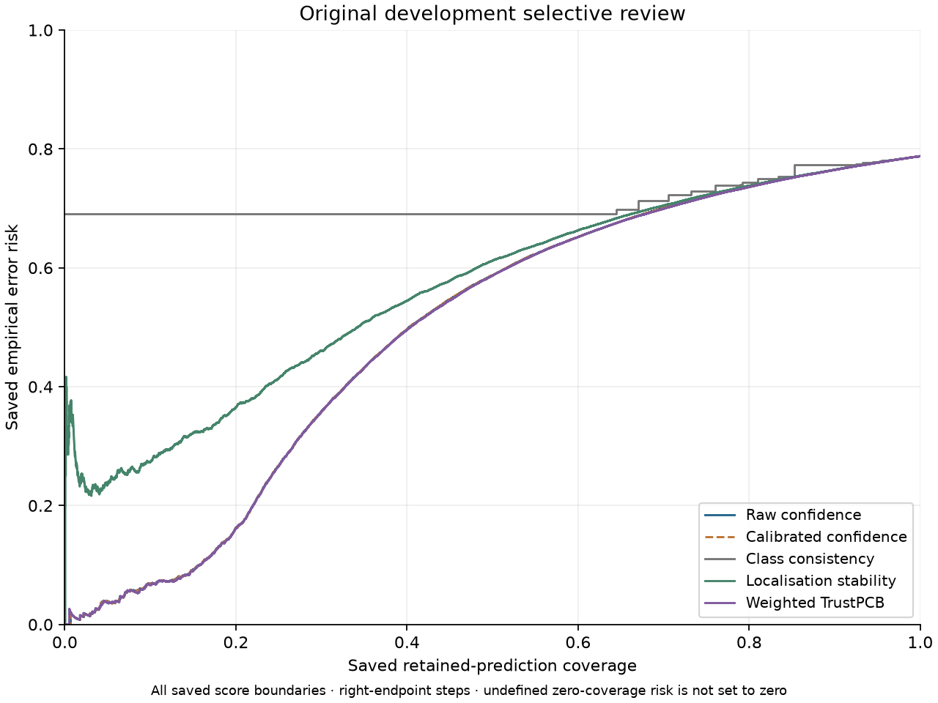
Figure 1. Development risk–coverage curve from saved original curve rows. [RQ3-E03]
Saved figure: outputs/rq3/development_selective_review/figures/prediction_risk_coverage.png
Original evidence: runs/rq3/development_selective_review/prediction_risk_coverage.csv
The curve adds whole equal-score groups. Raw and calibrated confidence overlap because their saved rankings coincide; this does not make calibration and raw confidence identical probability estimates. Weighted and confidence curves are close. AURC averages prediction-level selective risk across coverage, whereas maximum-risk crop referral uses a different ranking and decision unit.

Interpretation
The small prediction-level gain does not ensure useful crop selection. A high maximum risk identifies at least one risky retained prediction, not necessarily many errors in that crop. Error capture measures where existing errors lie, rather than human correction or missed-object recovery. The random reference is the analytic expectation for uniform selection of nonempty crops at each achieved count: expected capture = referred crops / nonempty crops. It is not an executed random-review trial.

Research decision
The saved threshold artifact fixes the development-derived operating points, and final provenance later confirms their unchanged application. The evidence supports carrying these identities forward despite mixed development outcomes; it does not document a new approval meeting or demonstrate that weighted crop referral was superior.

Limitations
Development calibration and weights used this same population, so the results do not independently validate the full selection process. Retained-prediction error excludes missed objects; maximum aggregation and empty-crop rules limit the meaning of workload and capture.

Next stage
The supplementary development extension preserves the original thresholds while adding automatic-error and paired-uncertainty records.

Supporting evidence
Evidence: RQ3-E04 · RQ3-E05 · RQ3-E06 · RQ3-E07 · RQ3-E08 · RQ3-E09 · RQ3-E10

2 Supplementary development reporting extension

Purpose
Expose the error rate left in automatic processing and paired uncertainty that the original summary did not fully present.

What was done
The historical extension added remaining automatic error, absolute reduction and paired weighted-minus-confidence comparisons without replacing the original files or thresholds. It ran from 2026-10-05T10:29:03.190454+00:00 to 2026-10-05T10:32:00.703838+00:00. The original run saved interval summaries rather than replicate arrays, so the extension reproduced the original bootstrap draws and verified their SHA-256. This was a supplementary analysis on the same development evidence; the present journal does not rerun it. [RQ3-E13, E14]

Experimental setup
Remaining automatic error follows the non-referred prediction denominator defined in Stage 1. Absolute error reduction = no-referral error rate − remaining automatic error; it is a probability-point difference, multiplied by 100 only when expressed in percentage points. The saved analysis used 10,000 paired whole-image draws with replacement, PCG64 seed 24209199 and fixed original thresholds. Every prediction from a sampled crop carries its multiplicity, and all methods share the draws. Invalid metrics are omitted without redrawing; 95% intervals use linear 2.5th/97.5th percentiles.
The extension records 14 paired rows: AURC plus two crop outcomes at three budgets, each against raw and calibrated confidence. Those reference comparisons duplicate because their saved rankings and referrals coincide. Differences are weighted minus reference: negative AURC favours weighted, negative error capture favours the reference, and positive remaining automatic error means weighted is worse. The recorded paired difference is computed within each draw, not by subtracting separate interval endpoints.

Recorded results
Weighted-minus-calibrated AURC is −0.000454, with 95% interval [−0.000854, −0.000054]. At 20%, error capture is lower by 0.098256 (interval [−0.173524, −0.022896]), while remaining automatic error is higher by 0.017853 (interval [+0.003897, +0.032156]). At 5% and 10%, intervals for both crop outcomes include zero. Tables 4 and 5 retain all original comparison rows.
Table 4. Supplementary development remaining-error results [RQ3-E11]
Method | Nominal budget % | Referred crops | Error capture | Remaining automatic error
Calibrated confidence | 5 | 41 | 0.12193 | 0.77894
Calibrated confidence | 10 | 82 | 0.23745 | 0.76953
Calibrated confidence | 20 | 164 | 0.44162 | 0.74073
Weighted TrustPCB | 5 | 41 | 0.10983 | 0.78043
Weighted TrustPCB | 10 | 82 | 0.20025 | 0.77173
Weighted TrustPCB | 20 | 164 | 0.34336 | 0.75859
Recorded source: runs/rq3/development_selective_review/reporting_extension/crop_referral_metrics.csv • Saved columns: method, budget_percent, referred_crops, error_capture, remaining_automatic_error_rate
Table 5. Development extension: weighted minus calibrated [RQ3-E12]
Metric / budget | Difference | 95% lower | 95% upper
AURC | -0.000454 | -0.000854 | -0.000054
Error capture / 5% | -0.012104 | -0.067654 | +0.042367
Remaining automatic error / 5% | +0.001495 | -0.004009 | +0.007162
Error capture / 10% | -0.037202 | -0.115135 | +0.038896
Remaining automatic error / 10% | +0.002193 | -0.008887 | +0.013189
Error capture / 20% | -0.098256 | -0.173524 | -0.022896
Remaining automatic error / 20% | +0.017853 | +0.003897 | +0.032156
Recorded source: runs/rq3/development_selective_review/reporting_extension/paired_bootstrap_differences.csv • method_A=weighted_trustpcb_risk, method_B=calibrated_confidence_risk

Interpretation
The paired evidence preserves both the small favourable AURC result and the unfavorable 20% crop outcomes. Development results remain conditional on Beta calibration and weights selected using this population. Intervals do not include uncertainty from rebuilding or selecting the pipeline, and intervals spanning zero do not establish equivalence or absence of an effect.

Research decision
The saved extension preserves the original thresholds and makes the crop-level disadvantage visible alongside AURC. It supplies reporting and uncertainty evidence, not a new operating-point selection or an independent confirmation dataset.

Limitations
This is supplementary development evidence, not another population or a newly fitted method. The frozen-pipeline bootstrap excludes selection uncertainty. Raw/calibrated duplicate comparisons are not independent corroboration.

Next stage
The next recorded family measures implementation cost separately; its timing data do not measure human-review effectiveness.

Supporting evidence
Evidence: RQ3-E05 · RQ3-E13 · RQ3-E14 · RQ3-E15

3 Computational efficiency on the development population

Purpose
Quantify the additional measured cost of the full frozen risk pipeline relative to detector-only processing.

What was done
The benchmark records baseline then TrustPCB over all 821 development crops in each of five repetitions, after 20 untimed warmup crops per pipeline. Provenance records 2026-10-06T01:50:26.962212+00:00 to 2026-10-06T02:55:42.638739+00:00 on NVIDIA A100-SXM4-80GB, CUDA 12.4, torch 2.6.0+cu124 and ultralytics 8.4.117.

Experimental setup
Image size 640, batch 1, device 0, extraction confidence 0.001, reference inclusion 0.01, NMS IoU 0.7 and max_det 300. Baseline performs one detector pass per crop; TrustPCB performs one original plus 11 transformed passes, including empty-reference crops. Wall-clock perf_counter timings synchronise CUDA before/after each repetition. Included work is crop load/decode, preprocessing, inference and postprocessing; TrustPCB also includes transforms, matching, aggregation, Beta application and weighted risk. Model loading/startup, provenance validation, file hashing and output writing are excluded. No prediction cache is used.

Recorded results
Mean runtime per complete 821-crop repetition was 7.45 seconds for baseline and 768.41 seconds for TrustPCB. TrustPCB’s total runtime was 103.12 times baseline, equivalent to a 10,211.67% increase: 100 × (ratio − 1). The ratio already includes the baseline unit; it is not an additional 103-times penalty added to baseline. Throughput was 1.07 versus 110.17 crops/s. Table 6 separates repetition duration, milliseconds per crop and throughput. Sample SD uses ddof = 1 over five repetitions; it is not a confidence interval.
Table 6. Saved runtime on 821 development crops per repetition [RQ3-E16]
Measure / unit | Baseline | TrustPCB
Detector passes per crop | 1 | 12
Mean seconds per 821-crop repetition | 7.45 | 768.41
Sample SD of repetition seconds | 0.02 | 1.72
Mean milliseconds per crop | 9.08 | 935.94
Throughput in crops per second | 110.17 | 1.07
Recorded source: runs/rq3/computational_efficiency/summary.json • pipelines; standard deviation is sample SD across five repetitions
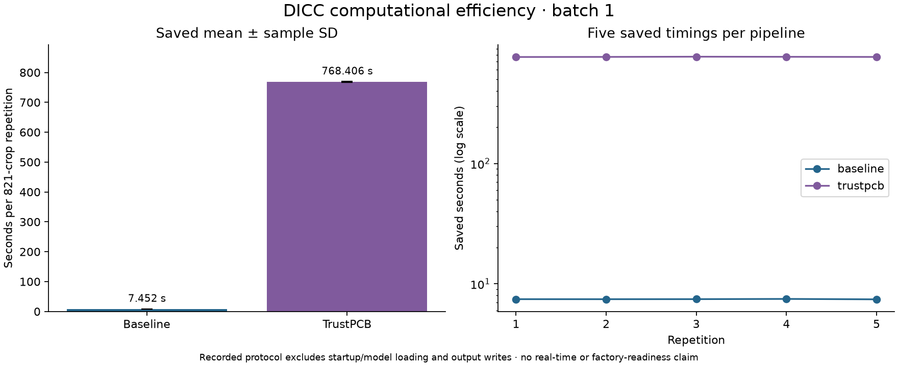
Figure 2. Saved five-repetition runtime summaries, rendered later. [RQ3-E17]
Saved figure: outputs/rq3/computational_efficiency/figures/saved_runtime.png
Original evidence: runs/rq3/computational_efficiency/summary.json; runs/rq3/computational_efficiency/repetition_timings.csv
One baseline detector pass is compared with 12 TrustPCB passes per crop, but the measured runtime ratio is 103.12, not 12. The timed TrustPCB region also includes transformations, matching, aggregation, Beta mapping and weighted-risk processing. The end-to-end ratio cannot be attributed solely to detector inference or decomposed into individual cost shares from this summary.

Interpretation
The sequential batch-one implementation has substantial measured cost on the stated hardware. Warmup, fixed baseline-then-TrustPCB ordering and system effects limit portability of the exact ratio. This benchmark neither measures an optimised parallel implementation nor establishes real-time or production performance. A small prediction-level gain must be assessed alongside the unfavorable referral outcomes and this implementation cost.

Research decision
The recorded benchmark quantifies the cost of the frozen pipeline; it does not justify a deployment claim or document a subsequent optimisation decision. The journal retains the measured implementation as the reference and makes no new timing estimate.

Limitations
Five repetitions describe variability of this hardware and implementation only. The 12-pass count does not predict a 12-fold end-to-end runtime, and no optimised production version was tested.

Next stage
The later final analysis applies the frozen review thresholds to saved final predictions; it performs no new inference or timing benchmark.

Supporting evidence
Evidence: RQ3-E18 · RQ3-E19 · RQ3-E20 · RQ3-E21

4 Final evaluation with frozen development thresholds

Purpose
Test whether selective-review outcomes persist without adapting thresholds to final-test scores or labels.

What was done
The final evaluation uses existing RQ2 final predictions/stability evidence, frozen weights and exact saved original development thresholds. Provenance records execution from 2026-10-06T05:40:48.629038+00:00 to 2026-10-06T05:49:11.257257+00:00; no inference, transformation processing, fitting, calibration, weight selection or benchmark was performed in this analysis.

Experimental setup
The final population comprises 2,052 crops and 17,840 retained predictions. It was held out from RQ2 training and development but previously used for RQ1 validation, so it is not an external or historically untouched test set. No empty crops are recorded. RQ3 uses the primary IoU ≥0.50 correctness labels; stored IoU ≥0.75 columns are checked upstream but are not a separate RQ3 target.
All five methods retain whole prediction-score ties. Crop referral applies risk > saved development threshold, with no final-set top-k selection, quantiles, workload equalisation or new thresholds. The original development JSON, not the reporting extension, is authoritative. Each of 10,000 paired whole-crop draws uses 2,052 crops sampled with replacement, PCG64 seed 24209199 and the same frozen detector, calibration, weights and thresholds. All methods share the draws; undefined replicates are omitted without redraw. [RQ3-E07, E29, E31]

Recorded results
Weighted AURC is 0.490027 versus calibrated confidence 0.490668. The saved difference is −0.000641 with 95% interval [−0.000884, −0.000395], a small advantage for weighted prediction-level selection. Yet weighted error capture is lower at all three nominal budgets. Table 8 adds actual workload percentages from the saved referred counts divided by 2,052; this is presentation arithmetic, not a recalculated experimental result.
At 20%, calibrated confidence refers 377 crops and captures 5,256 incorrect predictions; weighted refers 379 and captures 4,330. Capture is 0.37444 versus 0.30847, and remaining automatic error is 0.74962 versus 0.76397. Weighted-minus-calibrated differences are −0.065969 in capture (−6.60 percentage points) and +0.014354 in remaining error (+1.44 percentage points). Their recorded intervals are entirely negative and positive, respectively (Table 9). The nearly equal workloads make this disadvantage particularly informative.
Table 7. Final prediction-level AURC, IoU ≥0.50 [RQ3-E22]
Method | AURC (lower is better)
Raw confidence | 0.490668
Calibrated confidence | 0.490668
Class consistency | 0.718940
Localisation stability | 0.567111
Weighted TrustPCB | 0.490027
Recorded source: runs/rq3/final_evaluation/aurc.csv • Saved columns: method, aurc
Table 8. Final referrals and achieved workloads at frozen development thresholds [RQ3-E23]
Method | Dev budget % | Final crops | Final workload % | Error capture | Remaining automatic error
Calibrated confidence | 5 | 82 | 4.00 | 0.09318 | 0.77925
Calibrated confidence | 10 | 150 | 7.31 | 0.17418 | 0.77100
Calibrated confidence | 20 | 377 | 18.37 | 0.37444 | 0.74962
Weighted TrustPCB | 5 | 77 | 3.75 | 0.06369 | 0.78391
Weighted TrustPCB | 10 | 181 | 8.82 | 0.16471 | 0.77592
Weighted TrustPCB | 20 | 379 | 18.47 | 0.30847 | 0.76397
Recorded source: runs/rq3/final_evaluation/crop_referral_metrics.csv. Achieved workload (%) = 100 × saved referred_crops / 2,052; rounded to two decimals for this journal. Error measures are proportions, not percentages.
Table 9. Final weighted-minus-calibrated paired comparisons [RQ3-E24]
Metric / budget | Difference | 95% lower | 95% upper
AURC | -0.000641 | -0.000884 | -0.000395
Error capture / 5% | -0.029493 | -0.059828 | +0.000747
Remaining automatic error / 5% | +0.004661 | +0.000968 | +0.008505
Error capture / 10% | -0.009475 | -0.046111 | +0.026370
Remaining automatic error / 10% | +0.004924 | -0.000182 | +0.010310
Error capture / 20% | -0.065969 | -0.107268 | -0.025432
Remaining automatic error / 20% | +0.014354 | +0.006244 | +0.022752
Recorded source: runs/rq3/final_evaluation/paired_bootstrap_differences.csv • method_A=weighted_trustpcb_risk, method_B=calibrated_confidence_risk
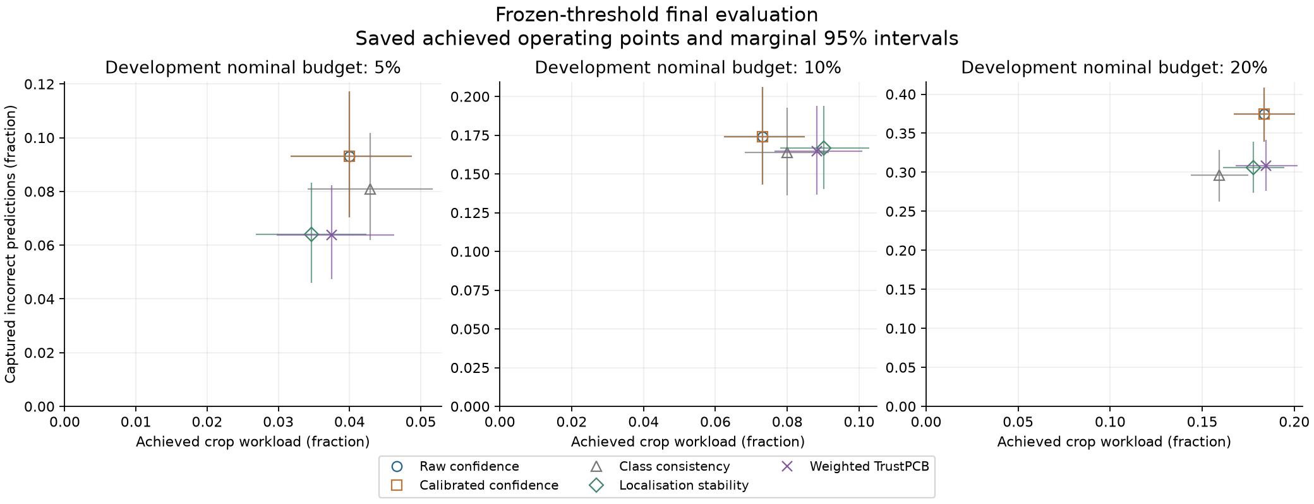
Figure 3. Final achieved crop workload under frozen thresholds. [RQ3-E25]
Saved figure: outputs/rq3/final_evaluation/figures/achieved_referral.png
Original evidence: runs/rq3/final_evaluation/crop_referral_metrics.csv; runs/rq3/final_evaluation/bootstrap_intervals.csv
The 5%, 10% and 20% labels are nominal development budgets. Final calibrated workloads are 4.00%, 7.31% and 18.37%; weighted workloads are 3.75%, 8.82% and 18.47%. At 5% and 10%, interpretation must account for the different achieved workloads. Final scores were not used to equalise counts. Raw and calibrated confidence have identical saved referral outcomes.
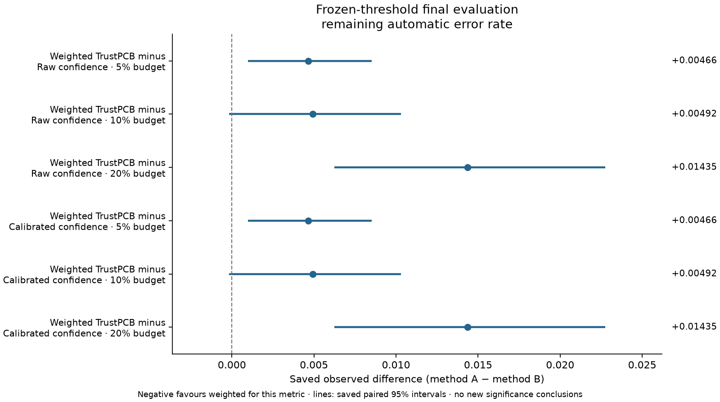
Figure 4. Final paired differences in remaining automatic error. [RQ3-E26]
Saved figure: outputs/rq3/final_evaluation/figures/paired_remaining_automatic_error_rate.png
Original evidence: runs/rq3/final_evaluation/paired_bootstrap_differences.csv
All differences are weighted minus reference. Positive remaining automatic error means worse weighted performance. Its recorded intervals at 5% and 20% are entirely positive; at 10% the interval includes zero. Error-capture intervals include zero at 5% and 10%, but are entirely negative at 20%. Thus not every budget comparison is decisive, and a zero-spanning interval does not establish equivalence. Raw and calibrated comparison rows may duplicate because their saved rankings coincide.

Interpretation
The final evidence separates a small prediction-level advantage from unfavorable crop referral. A maximum score does not encode a crop’s error count, and prediction-level AURC does not measure review benefit. At 20%, nearly equal achieved workloads strengthen the practical relevance of the capture comparison within this dataset. At 5% and 10%, workload differences also matter. No human corrections, missed-object recovery or external factory performance are measured.

Research decision
The saved final protocol kept thresholds and weights fixed. Its results do not support consistent weighted crop-review superiority, despite a small AURC gain. The research conclusion therefore retains the unfavorable referral and runtime findings rather than selecting a new final-set threshold to improve them.

Limitations
Intervals condition on the frozen pipeline and thresholds; they omit refitting and reselection uncertainty. Different achieved workloads complicate some comparisons. Prior RQ1 use and missing upstream inputs limit independence and reproducibility.

Next stage
The recorded RQ3 sequence ends here. Any human-review trial, external validation or implementation optimisation would require new evidence; none is claimed as completed.

Supporting evidence
Evidence: RQ3-E27 · RQ3-E28 · RQ3-E29 · RQ3-E30 · RQ3-E31 · RQ3-E32 · RQ3-E33 · RQ3-E34

Discussion across experiments
Prediction-level selection and crop-level review answer different questions. Weighted TrustPCB gives a small AURC improvement, but maximum-risk aggregation does not consistently prioritise crops containing more errors. Calibrated confidence captures more saved errors at all three recorded development and final operating points. The final 20% comparison is especially informative because workloads are nearly equal. These unfavorable findings and the measured runtime cost are part of the RQ3 answer.

Limitations and unresolved evidence
The final population is within the same dataset and previously served as RQ1 validation. Paired whole-image intervals retain within-crop dependence but condition on frozen detector, calibration, weights and thresholds; they do not cover uncertainty from refitting or reselecting the full pipeline. Intervals spanning zero do not establish equivalence. No additional significance test was introduced for this revision.
Local RQ3 summaries, curves, crop risks, frozen thresholds, intervals and timing records support these results. Important RQ2 checkpoint, development calibration and stability inputs, and original final prediction/stability files remain absent locally. Their recorded provenance hashes identify reported inputs but do not independently verify missing bytes; present DICC/external locations are unverified. No human-review intervention, actual correction outcome, missed-defect recovery or factory-generalisation evidence is available. The missing-path list remains in outputs/rq3/manifest.json.

Overall conclusion
Prediction-level performance. Weighted TrustPCB produced a small improvement in recorded AURC, including the final paired difference of −0.000641. This measures selective risk among existing predictions, not crop-level human-review utility.
Crop-level review. Weighted TrustPCB did not consistently outperform calibrated confidence at frozen referral thresholds. At the final 20% operating point, nearly equal workloads accompany lower weighted error capture and higher remaining automatic error, with paired intervals favouring calibrated confidence. Smaller-budget comparisons include zero-spanning intervals and differing workloads.
Computational efficiency. The measured full pipeline required 103.12 times baseline runtime on the tested A100 and sequential batch-one configuration. This is a 10,211.67% increase, not evidence about an optimised parallel or production implementation.
Limitations. Referral was simulated from saved predictions; no actual human corrections were measured. Missed ground-truth objects are outside retained-prediction error capture. Prior RQ1 use, within-dataset evaluation, frozen-pipeline uncertainty and incomplete upstream evidence preclude claims of external factory generalisation or deployment readiness.

Reproducibility and navigation
Canonical implementations are under src/trustpcb/rq3/ and corresponding tests under tests/rq3/. Original runs remain authoritative. outputs/rq3/ holds reporting copies and later figures, while its manifest retains source/output hashes and references to full original curve and crop-risk files. Retired RQ3 README recovery uses docs/documentation_archive.json, with destination bookmarks mapped in docs/documentation_inventory.json. The RQ1 notebook archive is not the recovery registry for these retired documents. Historical paths below are identities, not current filesystem links.
Local workstation checks cover source, synthetic tests and artifact validation. Dataset processing, detector inference, fitting, training, statistical bootstrap and timing experiments belong to the documented DICC workflow and were not performed for this journal. The CPU test count is software validation, not scientific replication.
Archived README material has been integrated into the experiment sections and evidence boundaries above. The following navigation anchors preserve the retired documents’ identities without recreating duplicate guides:
RQ3 research reporting — historical source: outputs/rq3/README.md
Original development selective review — historical source: outputs/rq3/development_selective_review/summaries/README.md
Development reporting extension — historical source: outputs/rq3/development_selective_review/reporting_extension/summaries/README.md
DICC computational efficiency — historical source: outputs/rq3/computational_efficiency/summaries/README.md
Frozen-threshold final evaluation — historical source: outputs/rq3/final_evaluation/summaries/README.md

Supporting evidence register
All 39 evidence identities are retained. Original results and provenance are distinguished from method definitions, later reporting figures and retired navigation. Exact source hashes and table selections remain in docs/research_journal_evidence.json. RQ3 retired README recovery uses docs/documentation_archive.json. Missing RQ2 upstream inputs are recorded in the reporting manifest; a surviving downstream hash does not verify absent input bytes.
Evidence ID | Source path | Type | Specific role | Evidence status
RQ3-E01 | runs/rq3/development_selective_review/aurc.csv | CSV | Five-method development AURC values. | Original result
RQ3-E02 | runs/rq3/development_selective_review/crop_referral_metrics.csv | CSV | Development referrals, error capture and exact threshold selections. | Original result
RQ3-E03 | outputs/rq3/development_selective_review/figures/prediction_risk_coverage.png | Figure | Later rendering of the full saved development curves. | Reporting visual
RQ3-E04 | docs/rq3/rq3_selective_review.md | Protocol | Prediction/crop definitions, frozen thresholds and extension method. | Method
RQ3-E05 | src/trustpcb/rq3/selective_review.py | Python | Selective-review and extension implementation; not execution proof. | Method
RQ3-E06 | runs/rq3/development_selective_review/provenance.json | Provenance | Original development execution, inputs and output hashes. | Execution record
RQ3-E07 | runs/rq3/development_selective_review/development_thresholds.json | JSON | All 15 original frozen thresholds and strict comparison rule. | Frozen protocol
RQ3-E08 | runs/rq3/development_selective_review/summary.json | Summary | Development counts, target and method definitions. | Original result
RQ3-E09 | runs/rq3/development_selective_review/crop_risks.csv | CSV | All development crops and method-specific maximum risks. | Original result
RQ3-E10 | runs/rq3/development_selective_review/prediction_risk_coverage.csv | CSV | Every achievable development prediction-coverage boundary. | Original result
RQ3-E11 | runs/rq3/development_selective_review/reporting_extension/crop_referral_metrics.csv | CSV | Added development automatic-error and reduction outcomes. | Saved extension
RQ3-E12 | runs/rq3/development_selective_review/reporting_extension/paired_bootstrap_differences.csv | CSV | Development paired AURC, capture and automatic-error differences. | Saved extension
RQ3-E13 | runs/rq3/development_selective_review/reporting_extension/provenance.json | Provenance | Extension execution and original-evidence identities. | Execution record
RQ3-E14 | runs/rq3/development_selective_review/reporting_extension/bootstrap_summary.json | Summary | Shared-draw hash, settings and validity of extension bootstrap. | Bootstrap record
RQ3-E15 | runs/rq3/development_selective_review/reporting_extension/bootstrap_intervals.csv | CSV | Development extension per-method metric intervals. | Bootstrap record
RQ3-E16 | runs/rq3/computational_efficiency/summary.json | JSON | Five-repetition runtime summaries and timing boundaries. | Original benchmark
RQ3-E17 | outputs/rq3/computational_efficiency/figures/saved_runtime.png | Figure | Later plot of saved repetition durations and summaries. | Reporting visual
RQ3-E18 | docs/rq3/rq3_computational_efficiency.md | Protocol | Benchmark hardware settings, warmup and included/excluded work. | Method
RQ3-E19 | src/trustpcb/rq3/computational_efficiency.py | Python | Timing pipeline and synchronisation implementation. | Method
RQ3-E20 | runs/rq3/computational_efficiency/provenance.json | Provenance | Benchmark hardware, versions, timestamps and input identities. | Execution record
RQ3-E21 | runs/rq3/computational_efficiency/repetition_timings.csv | CSV | Individual measured durations for all five repetitions. | Original benchmark
RQ3-E22 | runs/rq3/final_evaluation/aurc.csv | CSV | Five-method final prediction-level AURC. | Original result
RQ3-E23 | runs/rq3/final_evaluation/crop_referral_metrics.csv | CSV | Final counts, workloads, error capture and automatic error. | Original result
RQ3-E24 | runs/rq3/final_evaluation/paired_bootstrap_differences.csv | CSV | Final paired differences and recorded interval bounds. | Bootstrap record
RQ3-E25 | outputs/rq3/final_evaluation/figures/achieved_referral.png | Figure | Later rendering of final achieved workloads and intervals. | Reporting visual
RQ3-E26 | outputs/rq3/final_evaluation/figures/paired_remaining_automatic_error_rate.png | Figure | Later plot of paired automatic-error differences. | Reporting visual
RQ3-E27 | docs/rq3/rq3_final_evaluation.md | Protocol | Final population and unchanged development-threshold rules. | Method
RQ3-E28 | src/trustpcb/rq3/final_evaluation.py | Python | Frozen final selective-review implementation. | Method
RQ3-E29 | runs/rq3/final_evaluation/provenance.json | Provenance | Final execution, exact applied thresholds and upstream hashes. | Execution record
RQ3-E30 | runs/rq3/final_evaluation/summary.json | Summary | Final population, definitions and no-retuning flags. | Original result
RQ3-E31 | runs/rq3/final_evaluation/bootstrap_summary.json | Summary | Final shared-draw identity, settings and paired intervals. | Bootstrap record
RQ3-E32 | runs/rq3/final_evaluation/bootstrap_intervals.csv | CSV | Final per-method metric intervals and validity counts. | Bootstrap record
RQ3-E33 | runs/rq3/final_evaluation/crop_risks.csv | CSV | All final crops and method-specific maximum risks. | Original result
RQ3-E34 | runs/rq3/final_evaluation/prediction_risk_coverage.csv | CSV | Every achievable final prediction-coverage boundary. | Original result
RQ3-E35 | outputs/rq3/README.md | README | Former RQ3 reporting overview and evidence boundaries. | Retired Git document
RQ3-E36 | outputs/rq3/development_selective_review/summaries/README.md | README | Former original development reporting navigation. | Retired Git document
RQ3-E37 | outputs/rq3/development_selective_review/reporting_extension/summaries/README.md | README | Former supplementary extension navigation. | Retired Git document
RQ3-E38 | outputs/rq3/computational_efficiency/summaries/README.md | README | Former benchmark reporting navigation. | Retired Git document
RQ3-E39 | outputs/rq3/final_evaluation/summaries/README.md | README | Former frozen final reporting navigation. | Retired Git document

