RQ1 Research Journal
Dataset integrity, similarity-aware partitioning and controlled YOLOv8n comparison on DsPCBSD+.
Journal reconstructed 16 October 2026; revised 20 October 2026. These are documentation dates, not experiment dates. Repository paths are relative to the TrustPCB root. Tables use consistent display precision; exact machine-readable values remain in the recorded CSV files. Metrics and differences are proportions unless explicitly labelled as percentages or percentage points.

Executive summary
RQ1 investigated the structural integrity of DsPCBSD+, confirmed cross-split near-duplicate relationships, and detector performance after a targeted partition repair. The methodological contribution is a traceable audit and group-preserving split construction that retains all 10,259 images and their annotations.
The audit recorded 20,276 annotations across nine classes and 19 confirmed cross-split pairs. Repair changed 19 image memberships, moving the supplied 8,208/2,051 train/validation split to 8,207/2,052, with no confirmed group crossing the repaired boundary. A slightly favourable single-seed baseline was followed by five matched YOLOv8n seed pairs. Recorded mean differences (similarity-aware minus supplied) were precision +0.011928, recall −0.004962, mAP50 −0.000092 and mAP50–95 +0.000594. [RQ1-E01, E07, E14, E24]
The evidence supports improved partition integrity without establishing a consistent detector-performance gain. Matching seeds improves comparison control, but both training and validation populations changed; the design does not isolate a causal effect of leakage removal. Board-level independence and external generalisation were not established. The historical paired-interval method remains unidentified, so saved intervals are not independently reproduced or validated.

Research sequence and evidence boundaries
Four major stages are reconstructed: dataset audit, similarity-aware split construction, preliminary baseline feasibility/comparison, and matched repeated training. The first three were originally notebook-led. Their current Python workflows are later reconstructions; matched training has its canonical workflow.py implementation. The preliminary two-epoch smoke check is a feasibility run, not an independent performance replicate.
The four-stage sequence below follows the recorded research progression without assigning unsupported execution dates. Current Python source describes methods and dependencies; historical execution claims rest on saved outputs or provenance. Later code reconstruction, reporting visualisations and this journal are separate from the original experiments. Decision records summarise the methodological rationale supported by the saved work; they are not personal reflections or meeting minutes.
Research stages: Dataset audit · Split construction · Preliminary baseline · Matched training

1 Dataset audit and cross-split similarity review

Purpose
Determine whether the supplied image–label pairs were structurally usable and whether near-duplicate crops crossed the train/validation boundary.

What was done
The audit inspected images, YOLO label structure, class frequency and bounding-box size. Exact pixel-duplicate checks were followed by perceptual-hash screening and progressively stricter image-similarity checks. A final contact-sheet review separated confirmed near-duplicates from related but unconfirmed crops.

Experimental setup
DsPCBSD+ contains 10,259 crops and 20,276 annotations across nine classes. The supplied split is 8,208/2,051. The image-size inventory records 10,148 crops at 226 × 226 and 111 at 108 × 108. The historical pHash pipeline used 32 × 32 grayscale DCT processing, a 64-bit non-DC-median convention, batches of 64, and Hamming thresholds 0, 2, 4, 6, 8 and 10. Normalised 128 × 128 images supplied MAE and Pearson comparisons; translation refinement searched ±10 pixels with overlap at least 0.85. Final shortlist criteria included aligned MAE ≤0.015 and Pearson ≥0.985. Manual labels, not these scores alone, determined confirmation.

Recorded results
All label files paired with images and all 20,276 annotations were structurally valid. The 277 nominal boundary-overflow boxes reached only 0.0113 pixels; they were recorded diagnostically rather than silently clipped. Small objects were common: 54.66% of boxes occupied less than 1% of crop area. No exact pixel-duplicate groups were recorded. The funnel narrowed 3,993 pHash candidates to 113 high-similarity candidates and 24 manual-review candidates; 19 pairs were confirmed and five remained related but unconfirmed.
Table 1. Dataset audit and similarity-screening funnel [RQ1-E01]
Recorded measure | Value
Total images | 10,259
Training images | 8,208
Validation images | 2,051
Unreadable images | 0
Images without labels | 0
Total annotations | 20,276
Nominal boundary-overflow boxes | 277
Maximum boundary overflow px | 0.0113
Number of classes | 9
Boxes below 1% crop area percentage | 54.66
pHash screening candidates <=10 | 3,993
Tier-C high-similarity candidates | 113
Final manual-review candidates | 24
High-confidence near-duplicate pairs | 19
Related but non-confirmed pairs | 5
Recorded source: outputs/tables/dataset_audit_summary.csv • Saved columns: metric, value
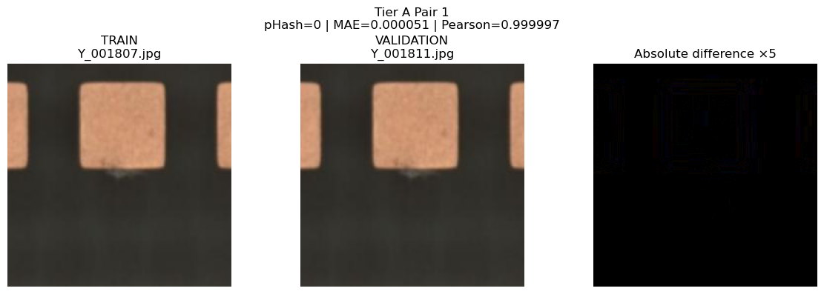
Figure 1. Historical Tier-A pair: training Y_001807.jpg and validation Y_001811.jpg. [RQ1-E02]
Saved figure: outputs/rq1/dataset_audit/figures/notebook01_cell11_output1.png
Original evidence: notebooks/01_dataset_structure_audit.ipynb
The side-by-side crops and five-times absolute-difference panel illustrate a highly similar cross-split pair (displayed pHash=0, MAE=0.000051, Pearson=0.999997). This is preserved notebook output, not a new audit. Displayed unaligned scores differ legitimately from the later aligned-pair table; manual confirmation remains authoritative.

Interpretation
The audit identified a limited but real partition-integrity concern: 19 affected training images and 19 validation images, reported as 0.231% and 0.926% respectively. These fractions describe confirmed relationships under this review procedure; they are not a measured upper bound on all dependence in the dataset. Class imbalance and small-object prevalence contextualise detection difficulty but do not explain individual model errors without additional evidence.

Research decision
The structural audit supported continued use of the dataset, while the 19 confirmed cross-split pairs justified targeted partition repair. This decision follows the recorded audit and subsequent split construction; historical human confirmations remain authoritative and are not replaced by automated thresholds.

Limitations
The review confirms only the recorded near-duplicate set; it does not bound all image dependence or establish board-level separation. Manual confirmations cannot be regenerated from similarity scores alone.

Next step at that time
The next recorded stage constructed whole-group assignments for the 19 confirmed pairs while preserving unaffected memberships.

Supporting evidence
Evidence: RQ1-E01 · RQ1-E03 · RQ1-E04 · RQ1-E05 · RQ1-E06

2 Similarity-aware split construction

Purpose
Repair confirmed cross-split similarity while disturbing the original split and class composition as little as possible.

What was done
Confirmed pair relationships were converted into connected components. All 19 observed components contained two images, one from each supplied partition. Unaffected image memberships were retained. Whole-group assignments were enumerated for the closest feasible train/validation sizes and ranked by class-percentage changes.

Experimental setup
Nine groups assigned to training yield 8,207 training and 2,052 validation images; ten training groups would yield 8,209/2,050. The saved chosen training group IDs are (1, 2, 4, 5, 6, 9, 10, 14, 16); the remaining ten are validation groups. Group IDs are historical identities in the notebook, not inferred from later file ordering. The algorithm preserves whole connected groups and original relative path conventions. No image or annotation content was rewritten.

Recorded results
The notebook records a final PASS: 10,259 images represented once, no overlap, no missing or unexpected images, no confirmed group crossing partitions, and 19 changed assignments. The saved class-composition check found identical class sets within all 19 pairs; one pair differed in annotation count. The recorded mean and maximum percentage changes are shown below at their original displayed precision.
Table 2. Recorded split construction outcomes [RQ1-E07]
Measure | Recorded result
Supplied train / validation | 8,208 / 2,051
Similarity groups / grouped images | 19 / 38
Final train / validation | 8,207 / 2,052
Moved train → validation / reverse | 10 / 9
Confirmed groups crossing final split | 0
Mean class percentage change | 0.0062 percentage points (notebook display)
Largest class percentage change | 0.0177 percentage points (notebook display)
Recorded source: notebooks/02_similarity_aware_split.ipynb • Saved text outputs in Git commit 1937995fb78d979a66e237b7ab7facbe20ca0513

Interpretation
The repair preserves all images and removes the 19 confirmed cross-split relationships. This is a partition-integrity improvement, not proof of improved generalisation. It neither establishes board-level independence nor creates an external test dataset.
Comparison boundary. The supplied partition contains 8,208 training and 2,051 validation images; the similarity-aware partition contains 8,207 and 2,052. Nineteen images changed membership. The detector experiments therefore use different training and validation populations. Matched seeds improve control of random variation, but performance differences cannot be attributed exclusively to leakage removal or to training-set changes. The comparison remains informative about these two recorded partition configurations; it does not isolate an independent causal effect.
Downstream reuse. The 2,052-image similarity-aware validation population was evaluated in RQ1 and later served as the RQ2/RQ3 final evaluation population. Later protocol safeguards concern separation from those stages’ training, development and selection procedures; they do not make this population historically untouched across the project. Cross-stage independence is therefore limited. Reuse alone does not establish a breach of the later protocols.

Research decision
The repaired partition was taken forward for detector comparison because it retained the complete dataset and removed the confirmed crossings with limited membership change. Saved split manifests remain the authoritative identities. The later split_workflow.py and similarity_split.py implement the reconstructed procedure; they are not the original executed notebook.

Limitations
Repair addresses confirmed pair relationships, not every potential dependence. Changing both populations prevents attribution of detector differences exclusively to leakage removal. Original image and annotation content is unchanged.

Next step at that time
The repaired manifests were used alongside the supplied manifests in the preliminary YOLOv8n comparison.

Supporting evidence
Evidence: RQ1-E08 · RQ1-E09 · RQ1-E10 · RQ1-E11 · RQ1-E12 · RQ1-E13

3 Preliminary baseline feasibility and v1 comparison

Purpose
Check that the YOLO workflow operated on the manifests and obtain an initial, explicitly single-seed supplied-versus-repaired comparison.

What was done
A two-epoch smoke run preceded the two 100-epoch v1 runs. The preliminary comparison read saved results.csv records. Current preliminary_baseline.py converts notebook-specific setup, smoke/train invocation and saved-result comparison into explicit functions and CLI operations without claiming those new files executed historically.

Experimental setup
YOLOv8n used pretrained initialisation, seed 24209199, image size 640, batch 32, workers 2, device 0, deterministic and AMP enabled, patience 100 and 100 requested epochs. Dataset YAMLs specify the supplied and similarity-aware manifests. The reported row is the first maximum of saved mAP50–95; precision, recall and both mAP measures all come from that same row. A selected CSV epoch is not automatically the identity of best.pt.

Recorded results
The supplied run selected epoch 76 and the similarity-aware run epoch 81. All four saved preliminary metrics were slightly higher for the repaired split. Table 3 displays the recorded values with five decimal places and signed differences; no metric or interval is recomputed.
Table 3. Preliminary v1 results at each run’s selected epoch [RQ1-E14]
Measure | Supplied | Similarity-aware | Difference
Best epoch | 76 | 81 | —
Precision | 0.81872 | 0.81953 | +0.00081
Recall | 0.79505 | 0.80172 | +0.00667
mAP50 | 0.84516 | 0.84864 | +0.00348
mAP50-95 | 0.50529 | 0.50841 | +0.00312
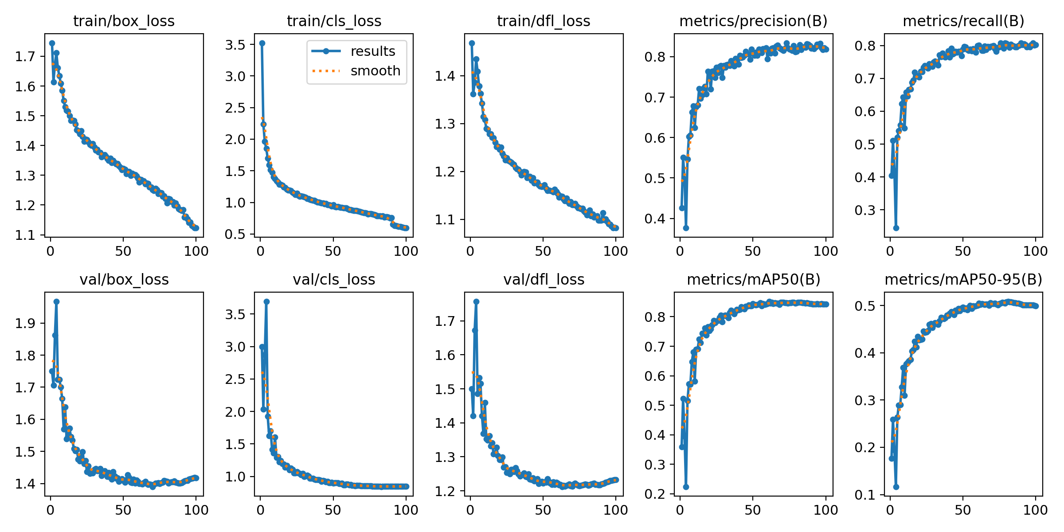
Figure 2. Saved similarity-aware preliminary training curves. [RQ1-E15]
Saved figure: outputs/rq1/preliminary_baseline/figures/v1/similarity_aware/results.png
Original evidence: runs/preliminary_baseline/v1/similarity_aware/results.png
These are original run curves copied into the reporting area. The visible learning trajectory provides context for the selected epoch; it is not an additional replicate and does not justify selecting each metric at a different epoch.

Interpretation
This single-seed comparison is a feasibility and exploratory result. Its modest positive differences cannot establish a repeatable benefit or attribute change solely to leakage removal. It motivated matched repeated training rather than a definitive performance claim.

Research decision
The slightly favourable exploratory result supported proceeding to matched repeated training rather than making a definitive performance claim. The smoke check and two full runs remain separate identities; the repeated comparisons provide the stronger basis for the performance conclusion.

Limitations
One seed cannot establish repeatability. The two runs use different training and validation populations, and selecting a row by mAP50–95 does not identify best.pt automatically.

Next step at that time
The following recorded stage compared five matched seed pairs under a common training and row-selection protocol.

Supporting evidence
Evidence: RQ1-E16 · RQ1-E17 · RQ1-E18 · RQ1-E19 · RQ1-E20 · RQ1-E21 · RQ1-E22

4 Matched repeated detector training

Purpose
Test whether the initial split comparison remained consistent across matched random seeds under a common training and metric-selection protocol.

What was done
Five supplied/similarity-aware pairs were recorded, with supplied then similarity-aware execution for each seed. Portable records contain args.yaml, per-epoch results.csv, provenance and completion receipts. Per-seed and aggregate tables retain run IDs, selected epochs, checkpoints and completion state.

Experimental setup
The seed labels are 24209199, 20260902, 02092026, 12345678 and 20202027. The leading-zero label 02092026 maps to integer 2092026 and must remain distinct from its display spelling. Each run requested 100 epochs under the common YOLOv8n settings. Canonical workflow.py selects the first maximum of saved mAP50–95, accepts completed 100-epoch runs and reports sample SD with ddof=1. Existing pretrained-file identity and per-run provenance are preserved.

Recorded results
All five seed pairs are recorded as complete. The saved mean differences are precision +0.011928, recall −0.004962, mAP50 −0.000092 and mAP50–95 +0.000594. Precision and recall move in opposite directions, and the mean mAP differences are small. Tables 4 and 5 retain the recorded aggregate and paired summaries; they are not new statistical analyses.
Table 4. Matched training: saved aggregate means and sample SD [RQ1-E23]
Split | Measure | Mean | Sample SD
Supplied | precision | 0.814286 | 0.005834
Supplied | recall | 0.801050 | 0.004721
Supplied | mAP@0.50 | 0.846902 | 0.001776
Supplied | mAP@0.50:0.95 | 0.505184 | 0.001034
Similarity-aware | precision | 0.826214 | 0.006000
Similarity-aware | recall | 0.796088 | 0.009522
Similarity-aware | mAP@0.50 | 0.846810 | 0.002693
Similarity-aware | mAP@0.50:0.95 | 0.505778 | 0.002005
Recorded source: results/rq1/aggregate_metrics.csv • Saved columns: split, metric, mean, std Display: six decimals; metrics remain proportions.
Table 5. Paired differences: similarity-aware minus supplied [RQ1-E24]
Measure | Mean difference | Recorded 95% lower | Recorded 95% upper
precision | +0.011928 | -0.002191 | +0.026047
recall | -0.004962 | -0.018108 | +0.008184
mAP@0.50 | -0.000092 | -0.003061 | +0.002877
mAP@0.50:0.95 | +0.000594 | -0.001716 | +0.002904
Interval provenance. These are saved historical interval estimates. The original generating implementation and interval method for paired_differences.csv and paired_summary.csv remain unidentified. Numerical endpoints are reproduced as recorded, with their signs; the intervals have not been independently reproduced or newly validated. Intervals spanning zero do not establish equivalence.
Recorded source: results/rq1/paired_summary.csv • Saved columns: metric, mean_delta, ci95_lower, ci95_upper
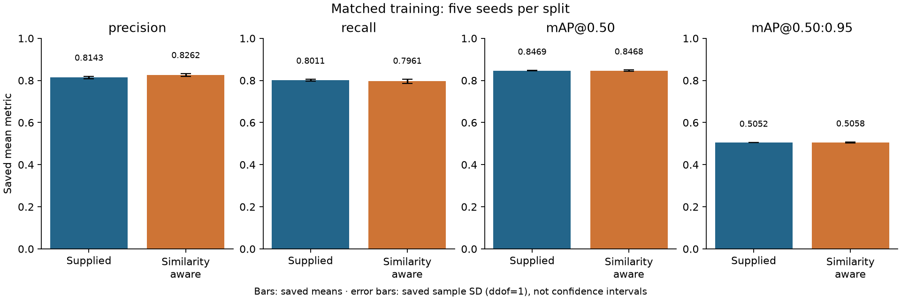
Figure 3. Later reporting visualisation of saved matched-run means and sample SD. [RQ1-E25]
Saved figure: outputs/rq1/matched_training/figures/saved_mean_and_sd.png
Original evidence: results/rq1/aggregate_metrics.csv
The error bars describe between-run sample variability, not confidence intervals. The separate paired-summary intervals have an unresolved producer; this plot neither verifies nor replaces that interval calculation.

Interpretation
Across the five recorded seed pairs, mixed metric directions and small mean mAP differences do not establish a consistent detector-performance improvement. The matched seeds and common settings strengthen control, but the supplied and similarity-aware runs still evaluate different validation populations after training on different memberships. These observations describe the recorded comparison; they do not isolate a causal effect of leakage removal, and they do not establish equivalence.

Research decision
The integrity improvement was retained without claiming a consistent detection gain. The repeated evidence qualifies the favourable single-seed result and supports reporting the mixed finding directly. This methodological conclusion does not depend on treating the unresolved interval calculation as independently verified.

Limitations
Five pairs provide limited replication. Both partition populations differ, and no external or board-independent evaluation is established here. The paired-summary and paired-difference producer and interval method remain unresolved.

Next step at that time
The repaired population subsequently entered the RQ2/RQ3 evaluation design. This records the documented cross-stage transition, not an invented RQ1 experiment or decision date.

Supporting evidence
Evidence: RQ1-E26 · RQ1-E23 · RQ1-E27 · RQ1-E24 · RQ1-E28 · RQ1-E29 · RQ1-E30

Historical execution and Python reconstruction
The first three stages were originally notebook-led. The current audit_workflow.py, split_workflow.py and preliminary_baseline.py are later Python reconstructions, not the exact programs originally executed. Appendix A retains original notebook paths, the immutable Git commit, blob identities and historical checkout hashes. Distinct Git-blob and Windows-checkout hashes reflect recorded newline transformations; reconstructed-code hashes are not substituted for either.
01_dataset_structure_audit became audit_workflow.py with dataset_audit.py kernels; 02_similarity_aware_split became split_workflow.py with similarity_split.py; 03_yolo_baseline became preliminary_baseline.py using workflow.py support. Human A/B review decisions, notebook widget/session state and display-only outputs are preserved as historical records rather than invented automation. reporting.py and archived_sources.py serve reporting and recovery, not detector execution.
Evidence: RQ1-E31 · RQ1-E13 · RQ1-E06

Discussion across experiments
The principal RQ1 contribution is traceable dataset and partition control. A structurally usable dataset contained 19 confirmed cross-boundary near-duplicate relationships. Group-preserving repair changed only 19 memberships and removed those recorded crossings. Preliminary positive differences motivated repeated comparison, whose mixed precision/recall directions and small mAP differences qualify the initial finding.

Limitations and unresolved evidence
Dataset images, large checkpoints and full external run environments were not duplicated or rerun. Local portable records can support reported tables but cannot establish independent replication. Manual near-duplicate labels cannot be regenerated from similarity thresholds alone.
The original producer of paired_differences.csv and paired_summary.csv remains unidentified. Saved interval endpoints are retained faithfully, but their calculation procedure is not independently verified. No interval method is inferred and no interval is recalculated. The historical split percentages retain their notebook display precision. Source identities and reconstructed-code identities remain separate.

Overall conclusion
Dataset and split integrity. Targeted similarity-aware repair removed the 19 confirmed cross-split near-duplicate relationships while preserving all images and original annotations.
Detector performance. Five matched YOLOv8n seed pairs showed mixed precision/recall changes and small mAP differences, without establishing a consistent performance improvement. This conclusion rests on the observed recorded comparisons rather than an independently verified interval analysis.
Limits of the answer. The work does not establish board-level independence, external generalisation or an isolated causal effect of leakage removal. Different training and validation populations limit attribution; later RQ2/RQ3 reuse does not erase RQ1’s earlier evaluation of that population. The unresolved paired-interval provenance precludes claims of newly validated significance or equivalence.

Reproducibility and navigation
Canonical implementations are under src/trustpcb/rq1/; corresponding synthetic and workflow tests are under tests/rq1/. Original run and result paths remain authoritative. outputs/rq1/ contains lightweight reporting copies and saved visualisations grouped into tables/, figures/ and summaries/. Its manifest.json retains historical source and output hashes. Verification must resolve archived documentation and RQ1 notebooks through their recorded Git identities; a missing original is not silently accepted.
Local workstation checks cover source, synthetic tests and artifact validation. Dataset processing, detector inference, fitting, training, statistical bootstrap and timing experiments belong to the documented DICC workflow and were not performed for this journal. The CPU test count is software validation, not scientific replication.
Archived README material has been integrated into the experiment sections and evidence boundaries above. The following navigation anchors preserve the retired documents’ identities without recreating duplicate guides:
RQ1 research reporting — historical source: outputs/rq1/README.md
Dataset audit and similarity-aware split — historical source: outputs/rq1/dataset_audit/summaries/README.md
Preliminary baseline v1 — historical source: outputs/rq1/preliminary_baseline/summaries/README.md
Matched repeated training — historical source: outputs/rq1/matched_training/summaries/README.md
RQ1 Results — historical source: results/rq1/README.md

Appendix A Historical notebook identities
All three notebooks are recoverable from Git commit 1937995fb78d979a66e237b7ab7facbe20ca0513. The table distinguishes Git object IDs, SHA-256 of blob bytes and SHA-256 of the historical Windows checkout. Exact newline transformations remain in docs/rq1/notebook_archive.json [RQ1-E13].
Original source | Recorded historical identities
notebooks/01_dataset_structure_audit.ipynb | Git blob OID  6f07d4f4bd910480340090b0cd9d6b37fffbfb72  Git blob SHA-256  4aa63f3982a29de66a9bf0f75246f8f578254f7235fce836357925fc72e3f4d1  Historical checkout SHA-256  7f7314e90e63f7f684f0f31ee868b3b984e5bd3adb367db91180fdf8703d4815
notebooks/02_similarity_aware_split.ipynb | Git blob OID  27cf3c10721453cb741063dced3bd8cee4a78921  Git blob SHA-256  47a1a1d19295b779cfff67679a454e2dc86b4e44784303b51f8d8491f84edcba  Historical checkout SHA-256  7d90a9c862238c04ceeb7498c8d2e8427ad367d09f7d9893ca198234289c96e0
notebooks/03_yolo_baseline.ipynb | Git blob OID  29087198c86c3fb76b0504197f1f614da642bf58  Git blob SHA-256  98d72120e4213da0edbaca482ea7eb9f9db32d5484d47445a99f1b4f0f98e64b  Historical checkout SHA-256  5ab3c26d2efe3304e6c1264b78f4c30a2024461540b24103ff52a76b008d5bcb
The archived paths above are historical identities, not current filesystem links. Human review outcomes and notebook display/session content remain historical records; later reconstructions do not invent their execution or outcomes.

Appendix B Supporting evidence register
The 36 evidence IDs below resolve the journal’s claims, tables and figures. Local saved evidence is distinguished from later reconstructions, reporting visualisations and archived documentation. Source hashes and exact table selections remain in docs/research_journal_evidence.json; frozen provenance is unchanged. Clickable evidence IDs in the stage summaries lead to these entries.
Evidence ID | Source file | Type | Specific purpose | Status
RQ1-E01 | outputs/tables/dataset_audit_summary.csv | Audit record | Structural checks, counts and screening funnel. | Local original
RQ1-E02 | outputs/rq1/dataset_audit/figures/notebook01_cell11_output1.png | Figure | Historical pair and difference panels; unchanged image. | Local reporting copy
RQ1-E03 | outputs/tables/cross_split_high_confidence_near_duplicates.csv | Pair record | The 19 manually confirmed cross-split relationships. | Local original
RQ1-E04 | src/trustpcb/rq1/dataset_audit.py | Python | Extracted audit kernels; method reconstruction. | Later reconstruction
RQ1-E05 | src/trustpcb/rq1/audit_workflow.py | Python | Notebook 01 workflow and manual-review boundaries. | Later reconstruction
RQ1-E06 | docs/rq1/historical_notebook_notes.md | Notes | Saved notebook observations and non-automated steps. | Later documentation
RQ1-E07 | notebooks/02_similarity_aware_split.ipynb | Notebook | Historical split outputs and class-change displays. | Archived Git
RQ1-E08 | data/splits/similarity_aware_split_manifest.csv | Manifest | Complete repaired image assignments and group identities. | Local original
RQ1-E09 | data/splits/similarity_aware_train.txt | Split list | The 8,207 repaired training memberships. | Local original
RQ1-E10 | data/splits/similarity_aware_val.txt | Split list | The 2,052 repaired validation memberships. | Local original
RQ1-E11 | src/trustpcb/rq1/similarity_split.py | Python | Extracted group assignment and split checks. | Later reconstruction
RQ1-E12 | src/trustpcb/rq1/split_workflow.py | Python | Notebook 02 split workflow and historical conventions. | Later reconstruction
RQ1-E13 | docs/rq1/notebook_archive.json | Archive | Notebook commits, blob and checkout hashes and transforms. | Current registry
RQ1-E14 | outputs/tables/preliminary_baseline_comparison_v1.csv | Result table | Selected preliminary epochs and four metric differences. | Local saved record
RQ1-E15 | outputs/rq1/preliminary_baseline/figures/v1/similarity_aware/results.png | Figure | Original similarity-aware v1 training curves. | Local reporting copy
RQ1-E16 | configs/experiments/yolov8n_preliminary_baseline_v1.yaml | Config | Preliminary model settings and random seed. | Local configuration
RQ1-E17 | configs/datasets/dspcbsd_supplied.yaml | Config | Dataset paths for the supplied partition. | Local configuration
RQ1-E18 | configs/datasets/dspcbsd_similarity_aware.yaml | Config | Dataset paths for the repaired partition. | Local configuration
RQ1-E19 | runs/preliminary_baseline/v1/supplied/results.csv | Run log | Supplied per-epoch metrics; selected epoch 76. | Local original
RQ1-E20 | runs/preliminary_baseline/v1/similarity_aware/results.csv | Run log | Repaired per-epoch metrics; selected epoch 81. | Local original
RQ1-E21 | runs/preliminary_baseline/v1/smoke_test/results.csv | Run log | Two-epoch feasibility check, not a replicate. | Local original
RQ1-E22 | src/trustpcb/rq1/preliminary_baseline.py | Python | Notebook 03 setup, invocation and saved-result reading. | Later reconstruction
RQ1-E23 | results/rq1/aggregate_metrics.csv | Result table | Five-run means and sample SD by split and metric. | Local saved record
RQ1-E24 | results/rq1/paired_summary.csv | Result table | Paired mean deltas and saved intervals; method unresolved. | Local saved record
RQ1-E25 | outputs/rq1/matched_training/figures/saved_mean_and_sd.png | Figure | Means and sample SD rendered from saved aggregates. | Later reporting plot
RQ1-E26 | results/rq1/per_seed_metrics.csv | Result table | Run IDs, selected epochs and completed seed pairs. | Local saved record
RQ1-E27 | results/rq1/paired_differences.csv | Result table | Saved seed-wise differences; historical producer unresolved. | Local saved record
RQ1-E28 | results/rq1/run_records/supplied/seed_24209199/provenance.json | Provenance | Example supplied-run settings and execution identities. | Local original
RQ1-E29 | src/trustpcb/rq1/workflow.py | Python | Canonical matched-run workflow and metric selection. | Current implementation
RQ1-E30 | docs/rq1/rq1_workflow.md | Protocol | Matched-training procedure, records and navigation. | Current documentation
RQ1-E31 | docs/rq1/notebook_extraction.md | Notes | Conversion coverage and reconstructed-code distinctions. | Later documentation
RQ1-E32 | outputs/rq1/README.md | Navigation | Former RQ1 reporting overview and evidence locations. | Retired Git source
RQ1-E33 | outputs/rq1/dataset_audit/summaries/README.md | Navigation | Former audit and split reporting coverage and gaps. | Retired Git source
RQ1-E34 | outputs/rq1/preliminary_baseline/summaries/README.md | Navigation | Former preliminary run identities and available outputs. | Retired Git source
RQ1-E35 | outputs/rq1/matched_training/summaries/README.md | Navigation | Former matched-run reporting and unresolved provenance. | Retired Git source
RQ1-E36 | results/rq1/README.md | Navigation | Former RQ1 result provenance and interpretation cautions. | Retired Git source

