**Dynamic UI System - Tech Brief**

Anita Shah - 10/03/23

| **#** | **Description** | **Author** | **Date** |
| --- | --- | --- | --- |
| 0.1 | Initial revision | AS | 19-Sept-2023 |
| 0.2 | Revision Based On Completed GDD | AS | 09-Oct-2023 |

| **Table of Contents** |
| --- |
| Goals  Dependencies  Requirements  Technical Approach  See Also |

# **Goals**

**Why Is It Important**

UI is crucial for providing an interface between the player and the gameplay mechanics of this game (Clash of Bears). Poor UI will result in frustration, lack of engagement with gameplay mechanics, low visibility, etc. As such UI is crucial to how player’s interact and first perceive the game, making it a key feature that should be used to enhance and engage with our gameplay and design pillars.

**Key Goals**

1. HUD/UI Design that supports gameplay mechanics
2. HUD/UI Design that supports designer iteration
3. Establish proper and desired gameflow
4. Reduced Designer Work With Content Addition
5. Tech Support for Auto Generation of UI elements
6. Single Point Entryways for Wide-Scale Updates

**Qualifications for Success**

| SCREENS | SUPPORTS |
| --- | --- |
| Title Screen | Load/Save/Exit |
| Pause Screen | Save/Exit/Continue |
| Overlay Screen | Resources, Mini-map, Building/Unit Information, Actions |
| Results Screen | Replay/Quit/Proceed |

# 

# **Dependencies**

| **Features** | **Depends** | **Supports** | **Directional** |
| --- | --- | --- | --- |
| Resource Management System | Access to Current Resource Count, Types of Resources | Player Visualization of Resource Inventory | Uni-Directional: Resources to UI |
| Building Management System | Access to Building Actions, Information, Types, etc. | Building Type Selection, Building-Action Selection | Bi-Directional |
| Combat System | Access to Unit Actions, Information, Types, etc. | Unit Type Selection, Unit-Action Selection, Movement Actions, Attack Commands, Enemy Selection | Bi-Directional |
| Camera System | Access to Current World Boundaries for Mini-map Updates, Access to Building and Unit Selection Behavior | Converting Mini-map movement to World Camera Locations | Bi-Directional |

# **Requirements**

1. Start Screen
   1. Mode Support: Initial Mode of Entering into the game in single player
   2. Reload Support: Options to load into previously saved games
   3. Exit Support: Support to close down Unity Game
   4. Inspiration [Warcraft 2 Start Screen and Load Screen]: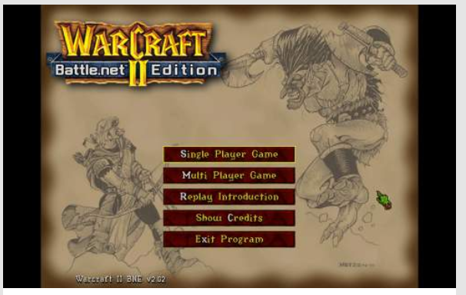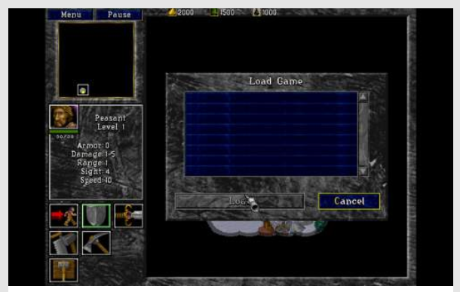
2. Pause Screen
   1. Game State Support: Effectively pauses all gameplay actions without breaking states
   2. Saving Support: Support saving current game state
   3. Continue Support: Exit pause screen, return to gameplay
   4. Exit Support: Return to Title Screen
   5. Inspiration:

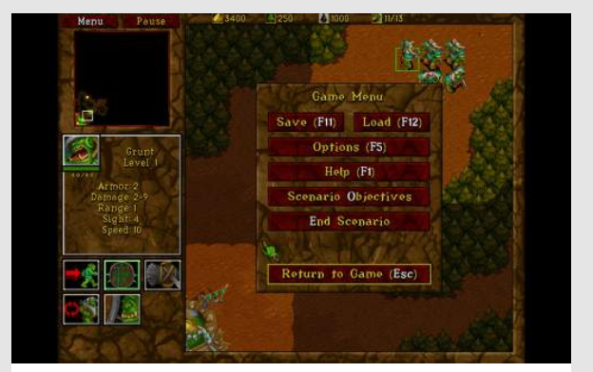

1. Overlay Screen
   1. Mini-Map Support
   2. Building Game State Visibility
      1. Selection State
      2. Building Time
      3. Resource Cost
      4. Resource Availability
      5. Defense and Offense Stats
      6. Possible Actions
   3. Unit Game State Visibility
      1. Selection State
      2. Movement State
      3. Resource Cost
      4. Defense and Offense Stats
      5. Possible Actions
   4. Enemy Selection
      1. To Attack
      2. To Move To
   5. Movement Selection
      1. Where to move units
   6. Inspiration:

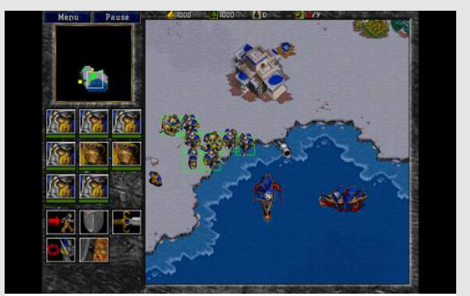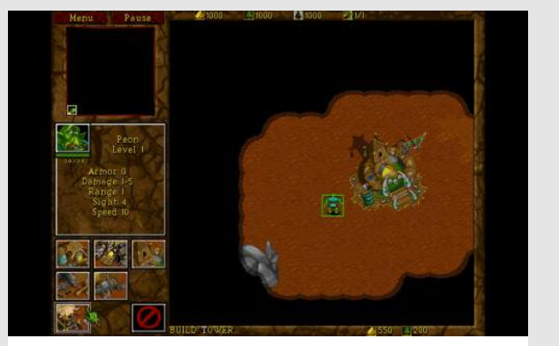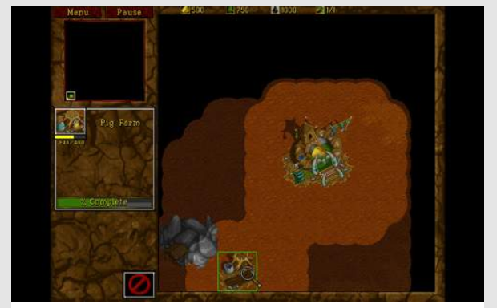

1. Results Screen
   1. Game State Visibility: Support Defeat and Victory Stats
   2. Replay Support
   3. Quit Support
   4. Continue Support
   5. Inspiration:

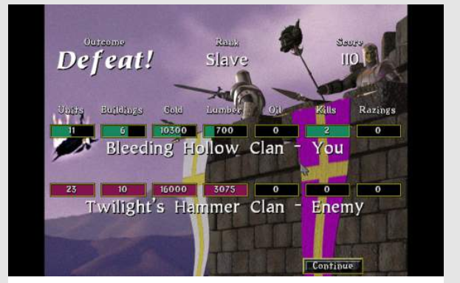

**Technical Approach**

Prototype - Alpha

| **Goals** | **Non-Goals** |
| --- | --- |
| * Fast Iteration For Designers * Unblock Programmers from Working On Key Features * Dynamically Expandable UI Sections with new Prefabs * Establishes Appropriate Gameflow * Overlay Screen | * Polished UI elements * Polished UI placement * Visual Feedback of all gameplay/player intentions * Finalized UI gameflow * Title, Pause, Exit Screen |

Starting Architecture

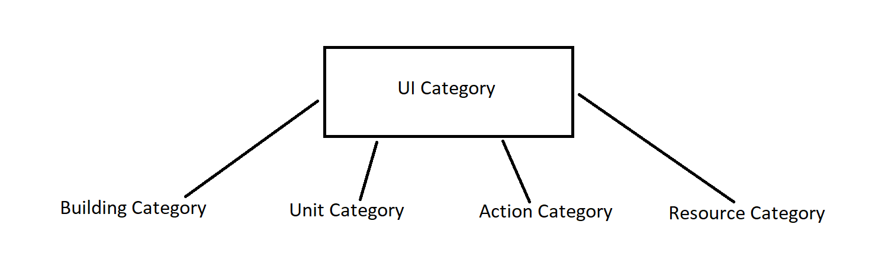

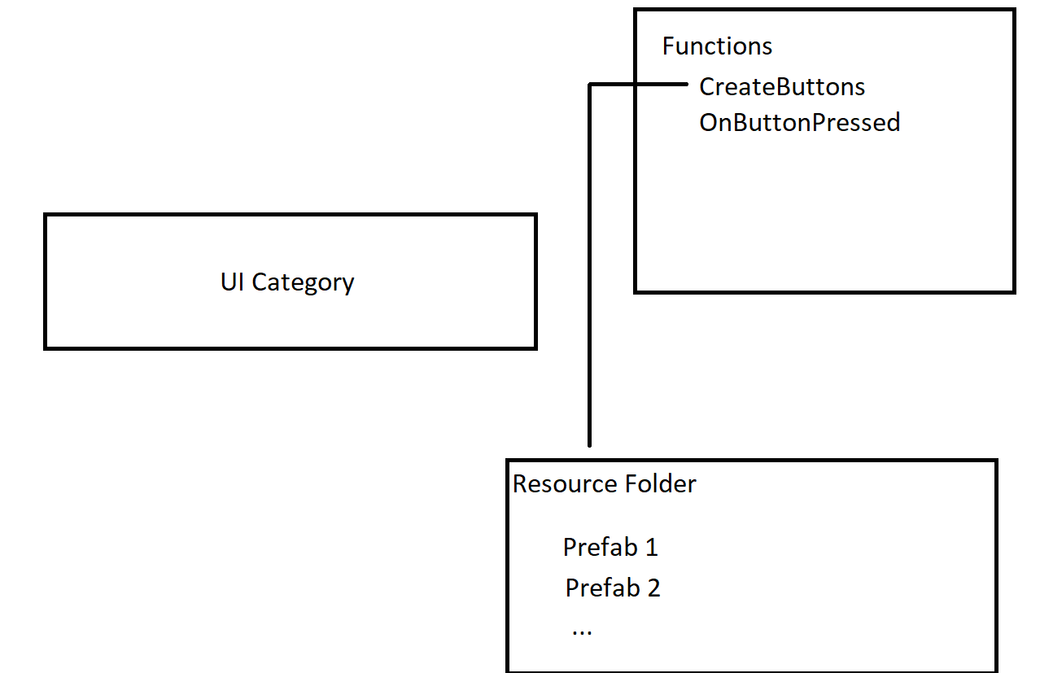

# **See Also**

*(Further reading and reference material as appropriate. Link external web sites, internal docs, etc. with a brief description to explain why it's relevant.)*