Windows Explorer Navigation Pane Configuration

The Windows Explorer Navigation Pane Configuration Tool (WENPCFG) enables you to show or hide the following nodes and their sub nodes in **the navigation pane of Windows Explorer** and also in the **Open- and Save-File-Dialogs** introduced in **Windows 7, Windows 8, Windows Server 2008 R2 and Windows Server 2012**:

* 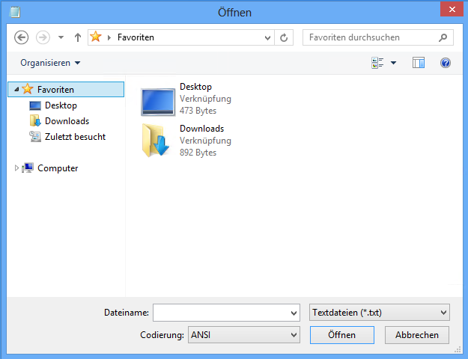Libraries
* Favorites
* Computer
* Network
* Home Group
* User Files
* OneDrive (experimental for Windows 10)
* Quick Access (experimental for Windows 10)

**NOTE:** Changing the configuration of Windows   
Explorer to show or hide any of the above nodes   
affects every user logging on to this computer.   
It is not possible to set this per user. It is a   
machine based configuration.

WENPCFG is a command line application and is   
only intended for **Windows 7, Windows 8, Windows 8.1, Windows 10 and   
Windows Server 2008 R2, Windows Server 2012, Windows Server 2012 R2, Windows Server 10**.   
Running WENPCFG requires **elevated privileges**.

After applying configuration changes you have to restart   
Explorer shell process (not only an explorer window).   
Simply logoff and logon your windows session.

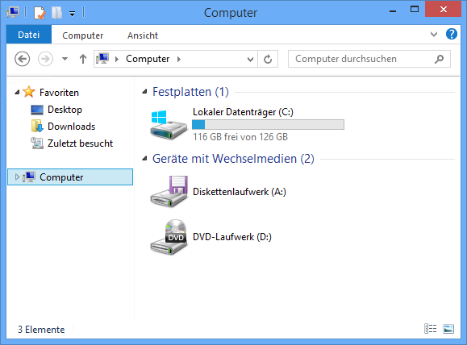

Contents

Usage Information: 3

1. Options: 3
2. Samples: 3
3. System Requirements 4
4. Download WENPCFG 4
5. Author: 4
6. Disclaimer: 5

# Usage Information:

wenpcfg [/option [/option] ... ]

## Options:

|  |  |
| --- | --- |
| **HideLibraries** | Hide libraries icon in the navigation pane of Windows Explorer. |
| **HideFavorites** | Hide favorites icon in the navigation pane of Windows Explorer. |
| **HideNetwork** | Hide network icon in the navigation pane of Windows Explorer. |
| **HideComputer** | Hide computer icon in the navigation pane of Windows Explorer. |
| **HideHomeGroup** | Hide home group icon in the navigation pane of Windows Explorer. |
| **HideUserFiles** | Hide user files icon in the navigation pane of Windows Explorer. |
| **HideOneDrive** | Hide OneDrive icon in the navigation pane of Windows Explorer (Experimental feature for Windows 10). |
| **HideQuickAccess** | Hide quick access icon in the navigation pane of Windows Explorer (Experimental feature for Windows 10). Make sure to also change: [HKEY_CURRENT_USER\SOFTWARE\Microsoft\Windows\CurrentVersion\Explorer\Advanced]  "LaunchTo"=dword:00000001 Otherwise an error is shown. |
| **ShowLibraries** | Show libraries icon in the navigation pane of Windows Explorer. |
| **ShowFavorites** | Show favorites icon in the navigation pane of Windows Explorer. |
| **ShowNetwork** | Show network icon in the navigation pane of Windows Explorer. |
| **ShowComputer** | Show computer icon in the navigation pane of Windows Explorer |
| **ShowHomeGroup** | Show home group icon in the navigation pane of Windows Explorer |
| **ShowUserFiles** | Show user files icon in the navigation pane of Windows Explorer |
| **ShowOneDrive** | Show OneDrive icon in the navigation pane of Windows Explorer. (Experimental feature for Windows 10). |
| **ShowQuickAccess** | Show quick access icon in the navigation pane of Windows Explorer. (Experimental feature for Windows 10). |
| **Logoff** | In order to changes take effect the explorer shell process needs  to be restarted. Specifying the option causes your windows session to logoff immediately. |
| **Reboot** | In order to changes take effect the explorer shell process needs  to be restarted. Specifying the option causes the computer to reboot immediately. |
| **Help** | Displays this usage information. |

## Samples:

Hide libraries and network icon, keep other icons untouched:

wenpcfg /HideLibraries /HideNetwork

Show computer icon, hide network icon and favorites, keep libraries untouched and immediately logoff:

wenpcfg /ShowComputer /HideNetwork /HideFavorites /Logoff

## System Requirements

Supported Operating Systems:

* Windows 7 (32-bit or 64-bit)
* Windows 8 (32-bit or 64-bit)
* Windows 8.1 (32-bit or 64-bit)
* Windows Server 2008 R2 (64-bit)
* Windows Server 2012 (64-bit)
* Windows Server 2012 R2 (64-bit)
* Windows 10 (experimental)

WENPCFG requires .Net Framework 4  
(.Net 4 Client Profile is sufficient)

## Download WENPCFG

<http://www.s-inn.de/download/wenpcfg.zip>

## Author:

Andreas Fleischmann (andreas.fleischmann[at]prianto.com)  
[](http://de.linkedin.com/pub/andreas-fleischmann/14/1ab/ab/) [](https://twitter.com/andif888)

## Disclaimer:

WENPCFG, the application is provided AS IS without warranty of any kind. PRIANTO further disclaims all implied warranties including, without limitation, any implied warranties of merchantability or of fitness for a particular purpose. The entire risk arising out of the use or performance of the application and documentation remains with you. In no event shall PRIANTO, or anyone else involved in the creation, production, or delivery of the application be liable for any damages whatsoever (including, without limitation, damages for loss of business profits, business interruption, loss of business information, or other pecuniary loss) arising out of the use of or inability to use the application or documentation.