Slide 1

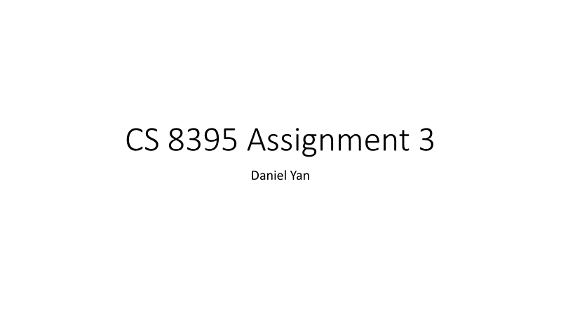

Slide 2

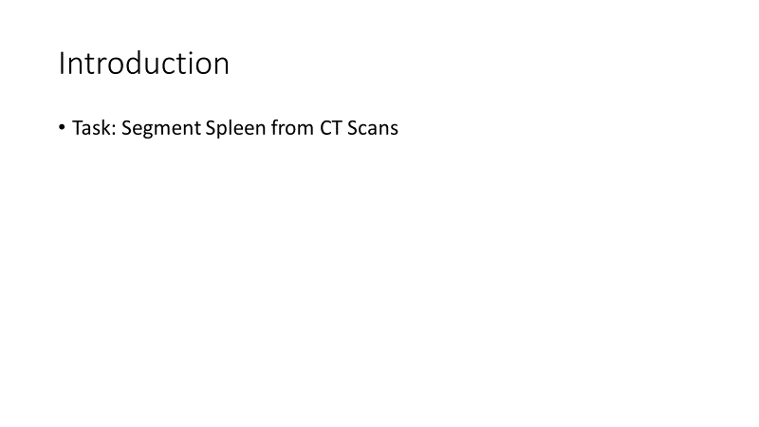

Slide 3

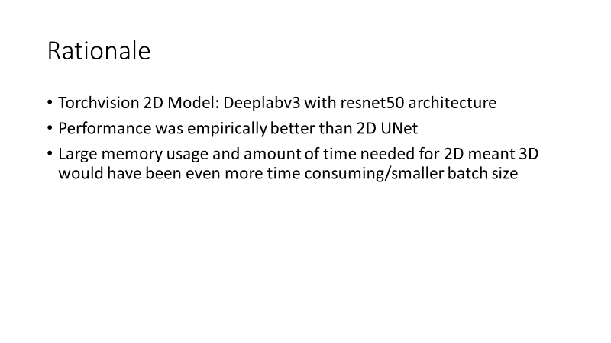

Slide 4

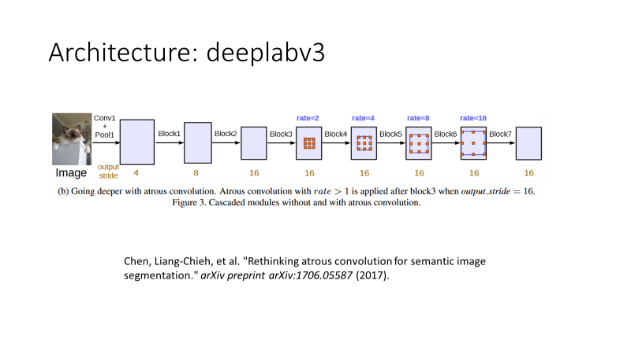

Slide 5

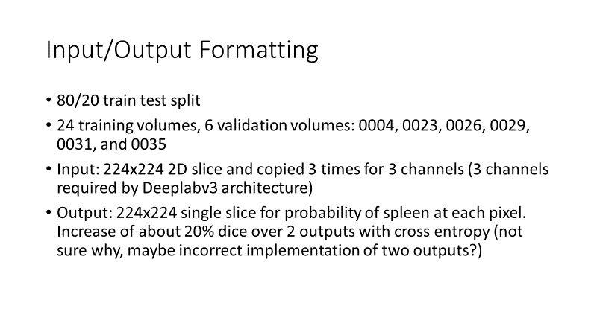

Slide 6

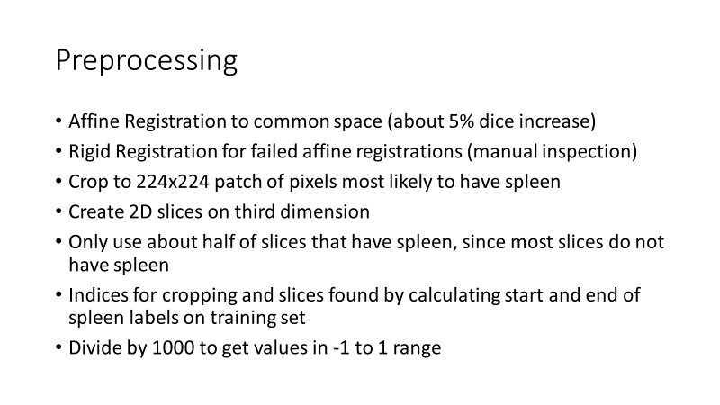

Slide 7

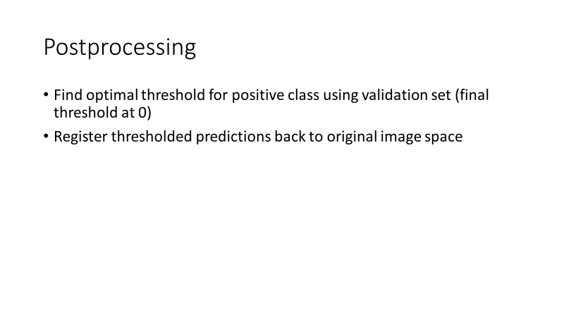

Slide 8

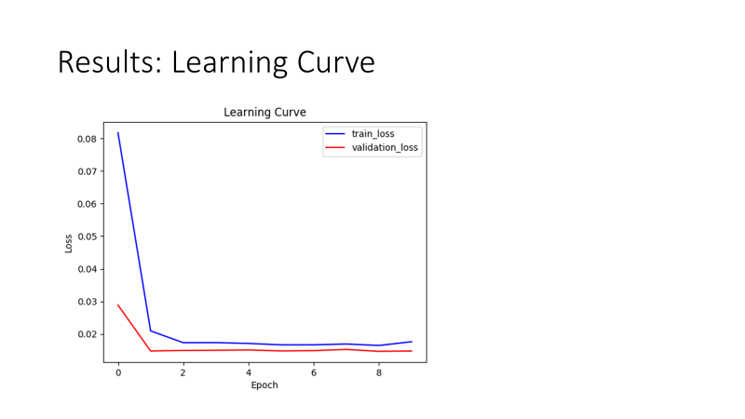

Slide 9

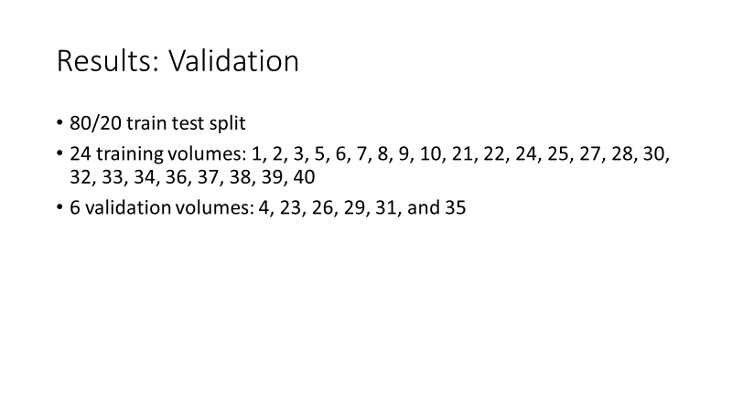

Slide 10

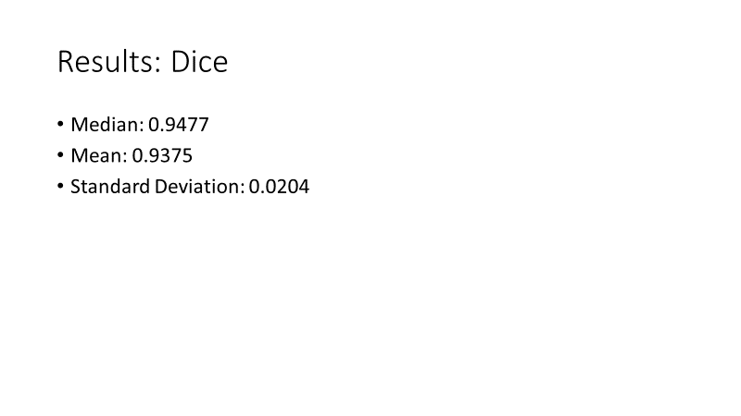

Slide 11

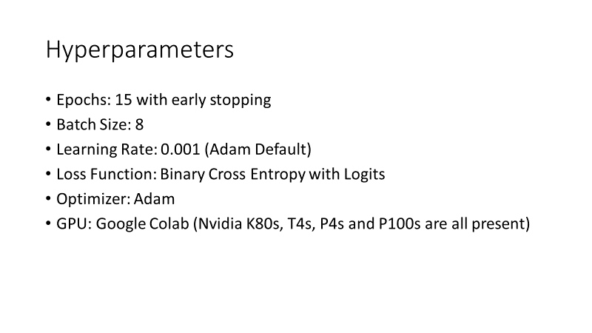

Slide 12

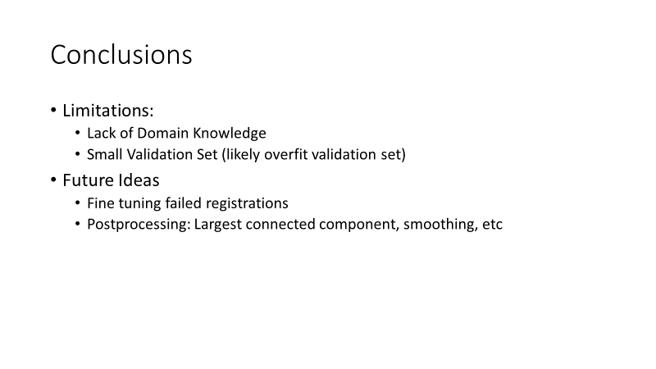

Slide 13

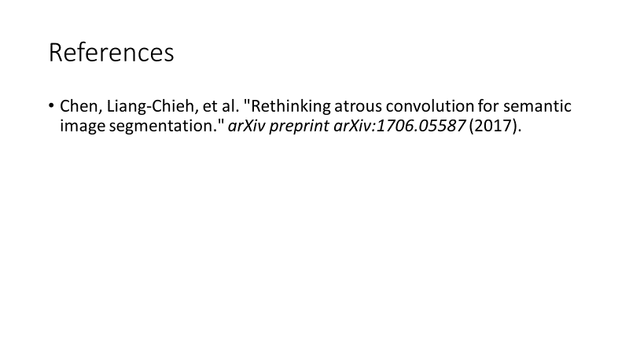

Code

preprocessing:

train_val_split.py

*# Perform 80/20 train-val split first***import** os  
**import** numpy **as** np  
**import** nibabel **as** nib  
**from** sklearn.model_selection **import** train_test_split  
**import** shutil  
  
*# Constants*ORIGINAL_LABELS = **"../../data/Original_Training/label/"**TRAIN_LABELS = **"../../data/Train/label/"**VAL_LABELS = **"../../data/Val/label/"**ORIGINAL_IMG = **"../../data/Original_Training/img/"**TRAIN_IMG = **"../../data/Train/img/"**VAL_IMG = **"../../data/Val/img/"***# Get list of all the volume names*volumes = []  
**for** file_name **in** os.listdir(ORIGINAL_LABELS):  
 volumes.append(file_name[5:])  
  
*# 80/20 train-val split with scikit learn*train, val = train_test_split(volumes, test_size=0.2)  
  
*# Copy image and label to new directories for train and validation***for** volume **in** train:  
 *# Copy image* shutil.copy(ORIGINAL_IMG + **"img"** + volume, TRAIN_IMG + volume)  
 *# Copy label* shutil.copy(ORIGINAL_LABELS + **"label"** + volume, TRAIN_LABELS + volume)  
  
**for** volume **in** val:  
 *# Copy image* shutil.copy(ORIGINAL_IMG + **"img"** + volume, VAL_IMG + volume)  
 *# Copy label* shutil.copy(ORIGINAL_LABELS + **"label"** + volume, VAL_LABELS + volume)

register_affine.py

*# Register all training volumes to 0007.nii.gz with affine registration.***import** ants  
**import** os  
  
*# Constants for path names*FIXED_IMG = **"/content/drive/My Drive/cs8395_deep_learning/assignment3/data/Train/img/0007.nii.gz"**OLD_TRAIN_IMG = **"/content/drive/My Drive/cs8395_deep_learning/assignment3/data/Train/img/"**NEW_TRAIN_IMG = **"/content/drive/My Drive/cs8395_deep_learning/assignment3/data/Train/affine/img_registered_no_resize/"**OLD_TRAIN_LABELS = **"/content/drive/My Drive/cs8395_deep_learning/assignment3/data/Train/label/"**NEW_TRAIN_LABELS = **"/content/drive/My Drive/cs8395_deep_learning/assignment3/data/Train/affine/label_registered_no_resize/"**OLD_VAL_IMG = **"/content/drive/My Drive/cs8395_deep_learning/assignment3/data/Val/img/"**NEW_VAL_IMG = **"/content/drive/My Drive/cs8395_deep_learning/assignment3/data/Val/affine/img_registered_no_resize/"**OLD_VAL_LABELS = **"/content/drive/My Drive/cs8395_deep_learning/assignment3/data/Val/label/"**NEW_VAL_LABELS = **"/content/drive/My Drive/cs8395_deep_learning/assignment3/data/Val/affine/label_registered_no_resize/"***# Read in fixed image*fixed = ants.image_read(FIXED_IMG)  
  
*# Register all the training images***for** file_name **in** os.listdir(OLD_TRAIN_IMG):  
 *# Read in moving image and corresponding label* moving_image = ants.image_read(OLD_TRAIN_IMG + file_name)  
 label = ants.image_read(OLD_TRAIN_LABELS + file_name)  
 *# Calculate transform and apply to image and label. Save transformed image and label.* transform = ants.registration(fixed=fixed , moving=moving_image,  
 type_of_transform=**'AffineFast'** )  
 transformed_image = ants.apply_transforms( fixed=fixed, moving=moving_image,  
 transformlist=transform[**'fwdtransforms'**],  
 interpolator=**'nearestNeighbor'**)  
 transformed_image.to_file(NEW_TRAIN_IMG + file_name)  
 transformed_label = ants.apply_transforms( fixed=fixed, moving=label,  
 transformlist=transform[**'fwdtransforms'**],  
 interpolator=**'nearestNeighbor'**)  
 transformed_label.to_file(NEW_TRAIN_LABELS + file_name)  
  
*# Repeat for the validation images***for** file_name **in** os.listdir(OLD_VAL_IMG):  
 *# Read in moving image and corresponding label* moving_image = ants.image_read(OLD_VAL_IMG + file_name)  
 label = ants.image_read(OLD_VAL_LABELS + file_name)  
 *# Calculate transform and apply to image and label. Save transformed image and label.* transform = ants.registration(fixed=fixed , moving=moving_image,  
 type_of_transform = **'AffineFast'** )  
 transformed_image = ants.apply_transforms( fixed=fixed, moving=moving_image,  
 transformlist=transform[**'fwdtransforms'**],  
 interpolator = **'nearestNeighbor'**)  
 transformed_image.to_file(NEW_VAL_IMG + file_name)  
 transformed_label = ants.apply_transforms( fixed=fixed, moving=label,  
 transformlist=transform[**'fwdtransforms'**],  
 interpolator = **'nearestNeighbor'**)  
 transformed_label.to_file(NEW_VAL_LABELS + file_name)

register_rigid.py

*# Register all training volumes to 0007.nii.gz. No resizing in this version***import** ants  
**import** os  
  
*# Constants for path names*FIXED_IMG = **"/content/drive/My Drive/cs8395_deep_learning/assignment3/data/Train/img/0007.nii.gz"**OLD_TRAIN_IMG = **"/content/drive/My Drive/cs8395_deep_learning/assignment3/data/Train/img/"**NEW_TRAIN_IMG = **"/content/drive/My Drive/cs8395_deep_learning/assignment3/data/Train/rigid/img_register_rigid/"**OLD_TRAIN_LABELS = **"/content/drive/My Drive/cs8395_deep_learning/assignment3/data/Train/label/"**NEW_TRAIN_LABELS = **"/content/drive/My Drive/cs8395_deep_learning/assignment3/data/Train/rigid/label_register_rigid/"**OLD_VAL_IMG = **"/content/drive/My Drive/cs8395_deep_learning/assignment3/data/Val/img/"**NEW_VAL_IMG = **"/content/drive/My Drive/cs8395_deep_learning/assignment3/data/Val/rigid/img_register_rigid/"**OLD_VAL_LABELS = **"/content/drive/My Drive/cs8395_deep_learning/assignment3/data/Val/label/"**NEW_VAL_LABELS = **"/content/drive/My Drive/cs8395_deep_learning/assignment3/data/Val/rigid/label_register_rigid/"***# Read in fixed image.*fixed = ants.image_read(FIXED_IMG)  
  
*# Register all the training images***for** file_name **in** os.listdir(OLD_TRAIN_IMG):  
 *# Read in moving image and corresponding label* moving_image = ants.image_read(OLD_TRAIN_IMG + file_name)  
 label = ants.image_read(OLD_TRAIN_LABELS + file_name)  
 *# Calculate rigid transformation and apply to image and label* transform = ants.registration(fixed=fixed , moving=moving_image,  
 type_of_transform=**'QuickRigid'** )  
 transformed_image = ants.apply_transforms( fixed=fixed, moving=moving_image,  
 transformlist=transform[**'fwdtransforms'**],  
 interpolator=**'nearestNeighbor'**)  
 transformed_image.to_file(NEW_TRAIN_IMG + file_name)  
 transformed_label = ants.apply_transforms( fixed=fixed, moving=label,  
 transformlist=transform[**'fwdtransforms'**],  
 interpolator=**'nearestNeighbor'**)  
 transformed_label.to_file(NEW_TRAIN_LABELS + file_name)  
  
*# Repeat for the validation images***for** file_name **in** os.listdir(OLD_VAL_IMG):  
 *# Read in moving image and corresponding label* moving_image = ants.image_read(OLD_VAL_IMG + file_name)  
 label = ants.image_read(OLD_VAL_LABELS + file_name)  
 *# Calculate rigid transformation and apply to image and label* transform = ants.registration(fixed=fixed , moving=moving_image,  
 type_of_transform = **'QuickRigid'** )  
 transformed_image = ants.apply_transforms( fixed=fixed, moving=moving_image,  
 transformlist=transform[**'fwdtransforms'**],  
 interpolator = **'nearestNeighbor'**)  
 transformed_image.to_file(NEW_VAL_IMG + file_name)  
 transformed_label = ants.apply_transforms( fixed=fixed, moving=label,  
 transformlist=transform[**'fwdtransforms'**],  
 interpolator = **'nearestNeighbor'**)  
 transformed_label.to_file(NEW_VAL_LABELS + file_name)

calc_stats.py

**import** nibabel **as** nib  
**import** numpy **as** np  
**import** os  
**import** matplotlib.pyplot **as** plt  
  
LABELS = **"../../data/Train/affine_fixed/label_registered/"***# Print out statistics for the registered images*print(**"######################################################"**)  
print(**"Statistics For Images at: "**, LABELS)  
print(**"######################################################"**)  
*# Lists for start and end indices of spleen for each image on each axis*min_list_z = []  
max_list_z = []  
min_list_x = []  
max_list_x = []  
min_list_y = []  
max_list_y = []  
**for** file_name **in** os.listdir(LABELS):  
 *# Load the image* image = nib.load(LABELS + file_name)  
 *# Get the array of values* image_data = image.get_fdata()  
  
 *# Filter by 1 values for spleen* spleen_labels = np.where(image_data == 1, 1, 0)  
  
 *# Print out the number of spleen labels* print(file_name, **": "**, np.sum(spleen_labels), **" total spleen labels"**)  
  
 *# Find where spleen starts and ends on z axis* spleen_z = np.sum(spleen_labels, axis=(0, 1))  
 spleen_z = np.where(spleen_z > 0, 1, 0)  
 spleen_z_sum = np.sum(spleen_z)  
 *# Calculate the smallest and largest index with spleen label* spleen_indices = np.nonzero(spleen_z)  
 **if** spleen_z_sum > 0:  
 min_spleen = np.min(spleen_indices[0])  
 max_spleen = np.max(spleen_indices[0])  
 min_list_z.append(min_spleen)  
 max_list_z.append(max_spleen)  
  
 *# Find where spleen starts and ends on x axis* spleen_x = np.sum(spleen_labels, axis=(1, 2))  
 spleen_x = np.where(spleen_x > 0, 1, 0)  
 spleen_x_sum = np.sum(spleen_x)  
 *# Calculate the smallest and largest index with spleen label* spleen_indices = np.nonzero(spleen_x)  
 **if** spleen_x_sum > 0:  
 min_spleen = np.min(spleen_indices[0])  
 max_spleen = np.max(spleen_indices[0])  
 min_list_x.append(min_spleen)  
 max_list_x.append(max_spleen)  
  
 *# Find where spleen starts and ends on y axis* spleen_y = np.sum(spleen_labels, axis=(0, 2))  
 spleen_y = np.where(spleen_y > 0, 1, 0)  
 spleen_y_sum = np.sum(spleen_y)  
 *# Calculate the smallest and largest index with spleen label* spleen_indices = np.nonzero(spleen_y)  
 **if** spleen_x_sum > 0:  
 min_spleen = np.min(spleen_indices[0])  
 max_spleen = np.max(spleen_indices[0])  
 min_list_y.append(min_spleen)  
 max_list_y.append(max_spleen)  
  
*# Print out mean and standard deviation values for start and end of spleen in slices.*print(**"Mean z start slice for spleen: "**, np.mean(np.array(min_list_z)))  
print(**"Std z start slice for spleen: "**, np.std(np.array(min_list_z)))  
print(**"Smallest z start slice for spleen"**, np.min(np.array(min_list_z)))  
print(**"Largest z start slice for spleen"**, np.max(np.array(min_list_z)))  
print(**"Mean z end slice for spleen: "**, np.mean(np.array(max_list_z)))  
print(**"Std z end slice for spleen: "**, np.std(np.array(max_list_z)))  
print(**"Smallest z end slice for spleen"**, np.min(np.array(max_list_z)))  
print(**"Largest z end slice for spleen"**, np.max(np.array(max_list_z)))  
  
print(**"Mean x start slice for spleen: "**, np.mean(np.array(min_list_x)))  
print(**"Std x start slice for spleen: "**, np.std(np.array(min_list_x)))  
print(**"Smallest x start slice for spleen"**, np.min(np.array(min_list_x)))  
print(**"Largest x start slice for spleen"**, np.max(np.array(min_list_x)))  
print(**"Mean x end slice for spleen: "**, np.mean(np.array(max_list_x)))  
print(**"Std x end slice for spleen: "**, np.std(np.array(max_list_x)))  
print(**"Smallest x end slice for spleen"**, np.min(np.array(max_list_x)))  
print(**"Largest x end slice for spleen"**, np.max(np.array(max_list_x)))  
  
print(**"Mean y start slice for spleen: "**, np.mean(np.array(min_list_y)))  
print(**"Std y start slice for spleen: "**, np.std(np.array(min_list_y)))  
print(**"Smallest y start slice for spleen"**, np.min(np.array(min_list_y)))  
print(**"Largest y start slice for spleen"**, np.max(np.array(min_list_y)))  
print(**"Mean y end slice for spleen: "**, np.mean(np.array(max_list_y)))  
print(**"Std y end slice for spleen: "**, np.std(np.array(max_list_y)))  
print(**"Smallest y end slice for spleen"**, np.min(np.array(max_list_y)))  
print(**"Largest y end slice for spleen"**, np.max(np.array(max_list_y)))  
*# Plot the start and end slice distributions for z*plt.hist(np.array(min_list_z), bins=70)  
plt.show()  
plt.close()  
plt.hist(np.array(max_list_z), bins=70)  
plt.show()  
plt.close()  
*# Plot the start and end slice distributions for x*plt.hist(np.array(min_list_x), bins=70)  
plt.show()  
plt.close()  
plt.hist(np.array(max_list_x), bins=70)  
plt.show()  
plt.close()  
*# Plot the start and end slice distributions for y*plt.hist(np.array(min_list_y), bins=70)  
plt.show()  
plt.close()  
plt.hist(np.array(max_list_y), bins=70)  
plt.show()  
plt.close()

2d_slice.py

*# Slice images into 2d slices for 2d networks.  
# Create filtered version of labels with only spleen labels.***import** nibabel **as** nib  
**import** numpy **as** np  
**import** os  
**from** skimage.transform **import** resize  
  
*# Constants for path names*NEW_TRAIN_LABELS_FILTERED = **"../../../data/Train/affine_fixed/label_cropped_filtered/"**OLD_TRAIN_LABELS = **"../../../data/Train/affine_fixed/label_registered/"**NEW_TRAIN_LABELS = **"../../../data/Train/affine_fixed/label_cropped/"**OLD_TRAIN_IMG = **"../../../data/Train/affine_fixed/img_registered/"**NEW_TRAIN_IMG = **"../../../data/Train/affine_fixed/img_cropped/"**NEW_VAL_LABELS_FILTERED = **"../../../data/Val/affine_fixed/label_cropped_filtered/"**OLD_VAL_LABELS = **"../../../data/Val/affine_fixed/label_registered/"**NEW_VAL_LABELS = **"../../../data/Val/affine_fixed/label_cropped/"**OLD_VAL_IMG = **"../../../data/Val/affine_fixed/img_registered/"**NEW_VAL_IMG = **"../../../data/Val/affine_fixed/img_cropped/"***# Start and end indices on z axis to reslice, since most slices do not have spleen*Z_START = 75  
Z_END = 145  
  
*# Start and end indices on x axis to reslice, since most slices do not have spleen*X_START = 288  
X_END = 512  
Y_START = 110  
Y_END = 334  
  
*# First for training set  
# Iterate through all the actual images***for** file_name **in** os.listdir(OLD_TRAIN_IMG):  
 *# Load the image* image = nib.load(OLD_TRAIN_IMG + file_name)  
 *# Get the array of values* image_data = image.get_fdata()  
 *# Fix zero values added by registration* image_data = np.where(image_data == 0.0, -1000, image_data)  
 *# Divide by 1000 to normalize* image_data = image_data / 1000.0  
 *# Iterate through the third dimension to create 2d slices* **for** index **in** range(Z_START, Z_END + 1):  
 *# Check that we have not reached the end of the image* **if** index < image_data.shape[2]:  
 *# Get the current slice* slice = image_data[X_START:X_END, Y_START:Y_END, index]  
 *# Convert to float16* slice = slice.astype(np.float16)  
 *# Save as numpy array. Exclude extension prefix from file name.* np.save(NEW_TRAIN_IMG + file_name[:-7] + **"_"** + str(index), slice)  
  
*# Iterate through the labels  
# Store original and new sum of spleen labels for all training images*old_train_sum = 0  
new_train_sum = 0  
**for** file_name **in** os.listdir(OLD_TRAIN_LABELS):  
 *# Load the image* image = nib.load(OLD_TRAIN_LABELS + file_name)  
 *# Get the array of values* image_data = image.get_fdata()  
 *# Get version of labels with only spleen labels (label 1).* spleen = np.where(image_data == 1, 1, 0)  
 *# Calculate original sum of spleen labels and increment running total* original_spleen_labels = np.sum(spleen)  
 old_train_sum += original_spleen_labels  
 *# Calculate new sum of spleen labels. Start at 0 and add at each slice* new_spleen_labels = 0  
 *# Iterate through the third dimension to create 2d slices* **for** index **in** range(Z_START, Z_END + 1):  
 *# Check that we have not reached the end of the image* **if** index < image_data.shape[2]:  
 *# Get the current slice* slice = image_data[X_START:X_END, Y_START:Y_END, index]  
 *# Convert to uint8* slice = slice.astype(np.uint8)  
 *# Save as numpy array. Exclude extension prefix from file name.* np.save(NEW_TRAIN_LABELS + file_name[:-7] + **"_"** + str(index), slice)  
 *# Save version of labels with only spleen labels (label 1).* spleen_slice = np.where(slice==1, 1, 0)  
 spleen_slice = spleen_slice.astype(np.uint8)  
 np.save(NEW_TRAIN_LABELS_FILTERED + file_name[:-7] + **"_"** + str(index), spleen_slice)  
 *# Increment new sum of spleen labels* new_spleen_labels += np.sum(spleen_slice)  
 *# Increment sum of all spleen labels* new_train_sum += new_spleen_labels  
print(**"Original Training Number of spleen labels: "**, old_train_sum)  
print(**"New Training Number of spleen labels: "**, new_train_sum)  
print(**"Percentage of Training Spleen Labels Retained: "**, new_train_sum / old_train_sum)  
  
print(**"Percentage of Training Labels that is spleen: "**, new_train_sum / (224*224*60*24))  
print(**"Original percentage of Training Labels that is spleen: "**, new_train_sum / (512*512*163*24))  
  
*# Repeat for Validation Set  
# Iterate through all the actual images***for** file_name **in** os.listdir(OLD_VAL_IMG):  
 *# Load the image* image = nib.load(OLD_VAL_IMG + file_name)  
 *# Get the array of values* image_data = image.get_fdata()  
 *# Fix zero values added by registration* image_data = np.where(image_data == 0.0, -1000, image_data)  
 *# Divide by 1000 to normalize* image_data = image_data / 1000.0  
 *# Iterate through the third dimension to create 2d slices* **for** index **in** range(Z_START, Z_END + 1):  
 *# Check that we have not reached the end of the image* **if** index < image_data.shape[2]:  
 *# Get the current slice* slice = image_data[X_START:X_END, Y_START:Y_END, index]  
 *# Convert to float16* slice = slice.astype(np.float16)  
 *# Save as numpy array. Exclude extension prefix from file name.* np.save(NEW_VAL_IMG + file_name[:-7] + **"_"** + str(index), slice)  
  
*# Iterate through the labels  
# Store original and new sum of spleen labels for all validation images*old_val_sum = 0  
new_val_sum = 0  
**for** file_name **in** os.listdir(OLD_VAL_LABELS):  
 *# Load the image* image = nib.load(OLD_VAL_LABELS + file_name)  
 *# Get the array of values* image_data = image.get_fdata()  
 *# Get version of labels with only spleen labels (label 1).* spleen = np.where(image_data == 1, 1, 0)  
 *# Calculate original sum of spleen labels* original_spleen_labels = np.sum(spleen)  
 old_val_sum += original_spleen_labels  
 *# Calculate new sum of spleen labels. Start at 0 and add at each slice* new_spleen_labels = 0  
 *# Iterate through the third dimension to create 2d slices* **for** index **in** range(Z_START, Z_END + 1):  
 *# Check that we have not reached the end of the image* **if** index < image_data.shape[2]:  
 *# Get the current slice* slice = image_data[X_START:X_END, Y_START:Y_END, index]  
 *# Convert to uint8* slice = slice.astype(np.uint8)  
 *# Save as numpy array. Exclude extension prefix from file name.* np.save(NEW_VAL_LABELS + file_name[:-7] + **"_"** + str(index), slice)  
 *# Save version of labels with only spleen labels (label 1).* spleen_slice = np.where(slice==1, 1, 0)  
 spleen_slice = spleen_slice.astype(np.uint8)  
 np.save(NEW_VAL_LABELS_FILTERED + file_name[:-7] + **"_"** + str(index), spleen_slice)  
 *# Increment new sum of spleen labels* new_spleen_labels += np.sum(spleen_slice)  
 *# Update sum of new spleen labels* new_val_sum += new_spleen_labels  
print(**"Original Validation Number of spleen labels: "**, old_val_sum)  
print(**"New Validation Number of spleen labels: "**, new_val_sum)  
print(**"Percentage of Spleen Labels Retained: "**, new_val_sum / old_val_sum)  
print(**"Percentage of Val Labels that is spleen: "**, new_val_sum / (224*224*60*6))  
print(**"Original percentage of Val Labels that is spleen: "**, new_val_sum / (512*512*163*6))

test_preprocessing:

register_affine.py

*# Register all testing volumes to 0007.nii.gz. No resizing in this version***import** ants  
**import** os  
  
*# Constants for path names*FIXED_IMG = **"/content/drive/My Drive/cs8395_deep_learning/assignment3/data/Train/img/0007.nii.gz"**OLD_TEST_IMG = **"/content/drive/My Drive/cs8395_deep_learning/assignment3/data/Testing/img/"**NEW_TEST_IMG = **"/content/drive/My Drive/cs8395_deep_learning/assignment3/data/Testing/img_registered_affine/"***# Load in fixed image*fixed = ants.image_read(FIXED_IMG)  
  
*# Register all the testing images***for** file_name **in** os.listdir(OLD_TEST_IMG):  
 *# Load in moving image* moving_image = ants.image_read(OLD_TEST_IMG + file_name)  
 print(**"Registering "**, file_name)  
 *# Perform registration* transform = ants.registration(fixed=fixed , moving=moving_image,  
 type_of_transform=**'AffineFast'**, random_seed=0)  
 transformed_image = ants.apply_transforms( fixed=fixed, moving=moving_image,  
 transformlist=transform[**'fwdtransforms'**],  
 interpolator=**'nearestNeighbor'**)  
 *# Save transformed image* print(**"Saving "**, file_name)  
 transformed_image.to_file(NEW_TEST_IMG + file_name)

register_rigid.py

*# Register all training volumes to 0007.nii.gz. No resizing in this version***import** ants  
**import** os  
  
*# Constants for path names*FIXED_IMG = **"/content/drive/My Drive/cs8395_deep_learning/assignment3/data/Train/img/0007.nii.gz"**OLD_TEST_IMG = **"/content/drive/My Drive/cs8395_deep_learning/assignment3/data/Testing/img/"**NEW_TEST_IMG = **"/content/drive/My Drive/cs8395_deep_learning/assignment3/data/Testing/img_registered_rigid/"***# Load in fixed image*fixed = ants.image_read(FIXED_IMG)  
  
*# Register all the testing images***for** file_name **in** os.listdir(OLD_TEST_IMG):  
 *# Load in moving image* moving_image = ants.image_read(OLD_TEST_IMG + file_name)  
 print(**"Registering "**, file_name)  
 *# Perform registration* transform = ants.registration(fixed=fixed , moving=moving_image,  
 type_of_transform=**'QuickRigid'**, random_seed=0)  
 transformed_image = ants.apply_transforms( fixed=fixed, moving=moving_image,  
 transformlist=transform[**'fwdtransforms'**],  
 interpolator=**'nearestNeighbor'**)  
 *# Save transformed image* print(**"Saving "**, file_name)  
 transformed_image.to_file(NEW_TEST_IMG + file_name)

train.py

*# Author: Daniel Yan  
# Email: daniel.yan@vanderbilt.edu  
# Description: Train deeplabv3 for segmentation***import** argparse  
**from** matplotlib **import** pyplot **as** plt  
**import** numpy **as** np  
**import** pandas **as** pd  
**import** os  
**import** torch  
**from** torch.utils.data **import** Dataset, DataLoader  
**import** torch.nn **as** nn  
**import** torch.nn.functional **as** F  
**import** torch.optim **as** optim  
**from** torchvision **import** transforms, models  
**from** torch.optim.lr_scheduler **import** StepLR  
**from** skimage **import** io  
  
*# Constants*MODEL_NAME = **"/content/drive/My Drive/cs8395_deep_learning/assignment3/bin/2d_affine_fixed/deeplabv3_bce"**TRAIN_IMG_PATH = **"/content/drive/My Drive/cs8395_deep_learning/assignment3/data/Train/affine_fixed/img_cropped/"**TRAIN_LABEL_PATH = **"/content/drive/My Drive/cs8395_deep_learning/assignment3/data/Train/affine_fixed/label_cropped_filtered/"**VAL_IMG_PATH = **"/content/drive/My Drive/cs8395_deep_learning/assignment3/data/Val/affine_fixed/img_cropped/"**VAL_LABEL_PATH = **"/content/drive/My Drive/cs8395_deep_learning/assignment3/data/Val/affine_fixed/label_cropped_filtered/"***# Define dataset for image and segmentation mask***class** MyDataset(Dataset):  
 **def** __init__(self, image_path, target_path):  
 *# Create a list of all the names of the files to load* self.file_names = list(os.listdir(image_path))  
 *# Create list of images* self.images_list = []  
 self.image_names_list = []  
 **for** file_name **in** self.file_names:  
 *# Load in image using numpy* image = np.load(image_path + file_name)  
 *# Convert to torch tensor* image_tensor = torch.from_numpy(image)  
 *# Insert first dimension for number of channels* image_tensor = torch.unsqueeze(image_tensor, 0)  
 image_tensor_expanded = image_tensor.expand((3, 224, 224))  
 *# Add to list of images.* self.images_list.append(image_tensor_expanded)  
 self.image_names_list.append(image_path + file_name)  
 *# Create list of target segmentations* self.targets_list = []  
 self.target_names_list = []  
 **for** file_name **in** list(os.listdir(image_path)):  
 mask = np.load(target_path + file_name)  
 *# Convert to torch tensor* mask_tensor = torch.from_numpy(mask)  
 *# Add to list of masks.* self.targets_list.append(mask_tensor)  
 self.target_names_list.append(image_path + file_name)  
  
 **def** __getitem__(self, index):  
 **return** self.images_list[index], self.targets_list[index]  
  
 **def** __len__(self):  
 **return** len(self.images_list)  
  
**def** train(model, device, train_loader, optimizer, epoch, train_losses):  
 *# Specify that we are in training phase* model.train()  
 *# Total Train Loss* total_loss = 0  
 *# Iterate through all minibatches.* **for** index, (data, target) **in** enumerate(train_loader):  
 *# Send training data and the training labels to GPU/CPU* data, target = data.to(device, dtype=torch.float32), target.to(device, dtype=torch.float32)  
 *# Zero the gradients carried over from previous step* optimizer.zero_grad()  
 *# Obtain the predictions from forward propagation* output = model(data)[**"out"**]  
 output = torch.squeeze(output, 1)  
 *# Compute the cross entropy for the loss and update total loss.* loss = torch.nn.BCEWithLogitsLoss()(output, target)  
 total_loss += loss.item()  
 *# Perform backward propagation to compute the negative gradient, and  
 # update the gradients with optimizer.step()* loss.backward()  
 optimizer.step()  
  
 *# Update training error and add to accumulation of training loss over time.* train_error = total_loss / len(train_loader)  
 train_losses.append(train_error)  
 *# Print out the epoch and train loss* print(**"############################################################################"**)  
 print(**"Train Epoch: "**, epoch)  
 print(**"############################################################################"**)  
 print(**"Average Training Loss: "**, train_error)  
 **return** train_losses  
  
  
**def** test(model, device, test_loader, test_losses):  
 *# Create dictionary of predictions for different thresholds.  
 # Initialize sums of true positives, true negatives, false positives, and false negatives to 0* threshold_dict = {}  
 **for** threshold **in** [0.001, 0.01, 0.1, 0.25, 0.5]:  
 threshold_dict[str(threshold)] = {}  
 threshold_dict[str(threshold)][**"total_tp"**] = 0  
 threshold_dict[str(threshold)][**"total_tn"**] = 0  
 threshold_dict[str(threshold)][**"total_fp"**] = 0  
 threshold_dict[str(threshold)][**"total_fn"**] = 0  
 *# Specify that we are in evaluation phase* model.eval()  
 *# Set the loss and number of correct instances initially to 0.* test_loss = 0  
 *# No gradient calculation because we are in testing phase.* **with** torch.no_grad():  
 *# For each testing example, we run forward  
 # propagation to calculate the  
 # testing prediction. Update the total loss  
 # and f1 score with counters from above* **for** index, (data, target) **in** enumerate(test_loader):  
 *# Send training data and the training labels to GPU/CPU* data, target = data.to(device, dtype=torch.float32), target.to(device, dtype=torch.float32)  
 *# Obtain the output from the model* output = model(data)[**"out"**]  
 output = torch.squeeze(output, 1)  
 *# Calculate the loss using cross entropy.* loss = torch.nn.BCEWithLogitsLoss()(output, target)  
 *# Increment the total test loss* test_loss += loss.item()  
  
 *# Convert output to numpy array* output = output.cpu().numpy()  
 *# Calculate stats for each threshold* **for** threshold **in** [0.001, 0.01, 0.1, 0.25, 0.5]:  
 *# Filter both the prediction and the target by only class 1 for spleen* pred_filtered = np.where(output > threshold, 1, 0)  
 target_filtered = np.where(target.cpu().numpy() == 1, 1, 0)  
  
 *# Calculate the true positives, false positives, true negatives, and false negatives  
 # and increment total sums* true_positives = float(np.sum(np.where(np.logical_and(pred_filtered == 1, target_filtered == 1), 1, 0)))  
 false_positives = float(np.sum(np.where(np.logical_and(pred_filtered == 1, target_filtered == 0), 1, 0)))  
 true_negatives = float(np.sum(np.where(np.logical_and(pred_filtered == 0, target_filtered == 0), 1, 0)))  
 false_negatives = float(np.sum(np.where(np.logical_and(pred_filtered == 0, target_filtered == 1), 1, 0)))  
 threshold_dict[str(threshold)][**"total_tp"**] += true_positives  
 threshold_dict[str(threshold)][**"total_tn"**] += true_negatives  
 threshold_dict[str(threshold)][**"total_fp"**] += false_positives  
 threshold_dict[str(threshold)][**"total_fn"**] += false_negatives  
  
 *# Calculate precision, recall, and f1 and print out statistics for validation set* print(**"Average Validation Loss: "**, test_loss / len(test_loader))  
 *# Find results for each threshold.* **for** threshold **in** [0.001, 0.01, 0.1, 0.25, 0.5]:  
 print(**"At threshold "**, str(threshold))  
 print(**"Total Validation True Positives: "**, threshold_dict[str(threshold)][**"total_tp"**])  
 print(**"Total Validation True Negatives: "**, threshold_dict[str(threshold)][**"total_tn"**])  
 print(**"Total Validation False Positives: "**, threshold_dict[str(threshold)][**"total_fp"**])  
 print(**"Total Validation False Negatives: "**, threshold_dict[str(threshold)][**"total_fn"**])  
  
 *# Calculate precision and recall and F1* **if** (threshold_dict[str(threshold)][**"total_tp"**] > 0 **and** threshold_dict[str(threshold)][**"total_fp"**]> 0  
 **and** threshold_dict[str(threshold)][**"total_fn"**] > 0):  
 precision = threshold_dict[str(threshold)][**"total_tp"**] / (threshold_dict[str(threshold)][**"total_tp"**]  
 + threshold_dict[str(threshold)][**"total_fp"**])  
 recall = threshold_dict[str(threshold)][**"total_tp"**] / (threshold_dict[str(threshold)][**"total_tp"**] +  
 threshold_dict[str(threshold)][**"total_fn"**])  
 f1 = 2 * precision * recall / (precision + recall)  
 print(**"Precision: "**, precision)  
 print(**"Recall: "**, recall)  
 print(**"F1: "**, f1)  
  
 *# Append test loss to total losses* test_losses.append(test_loss / len(test_loader))  
 **return** test_losses  
  
*# Main structure***def** main():  
 print(**"Entering Main"**)  
 *# Command line arguments for hyperparameters of model/training.* parser = argparse.ArgumentParser(description=**'PyTorch Object Detection'**)  
 parser.add_argument(**'--batch-size'**, type=int, default=8, metavar=**'N'**,  
 help=**'input batch size for training (default: 8)'**)  
 parser.add_argument(**'--test-batch-size'**, type=int, default=8, metavar=**'N'**,  
 help=**'input batch size for testing (default: 8)'**)  
 parser.add_argument(**'--epochs'**, type=int, default=50, metavar=**'N'**,  
 help=**'number of epochs to train (default: 50)'**)  
 parser.add_argument(**'--lr'**, type=float, default=0.001, metavar=**'LR'**,  
 help=**'learning rate (default: 0.001)'**)  
 parser.add_argument(**'--no-cuda'**, action=**'store_true'**, default=**False**,  
 help=**'disables CUDA training'**)  
 parser.add_argument(**'--seed'**, type=int, default=1, metavar=**'S'**,  
 help=**'random seed (default: 1)'**)  
 args = parser.parse_args()  
 *# Command to use gpu depending on command line arguments and if there is a cuda device* use_cuda = **not** args.no_cuda **and** torch.cuda.is_available()  
  
 *# Random seed to use* torch.manual_seed(args.seed)  
  
 *# Set to either use gpu or cpu* device = torch.device(**"cuda" if** use_cuda **else "cpu"**)  
  
 *# GPU keywords.* kwargs = {**'num_workers'**: 1, **'pin_memory'**: **True**} **if** use_cuda **else** {}  
  
 *# Load in the dataset* train_data = MyDataset(image_path=TRAIN_IMG_PATH, target_path=TRAIN_LABEL_PATH)  
 val_data = MyDataset(image_path=VAL_IMG_PATH, target_path=VAL_LABEL_PATH)  
 *# Create data loader for training and validation* train_loader = DataLoader(train_data, batch_size=args.batch_size, shuffle=**True**, num_workers=0, drop_last=**True**)  
 val_loader = DataLoader(val_data, batch_size=args.test_batch_size, shuffle=**False**, num_workers=0)  
 print(**"Finished Loading Data"**)  
  
 *# Send model to gpu* model = models.segmentation.deeplabv3_resnet101(num_classes=1).to(device)  
 *# Specify Adam optimizer* optimizer = optim.Adam(model.parameters(), lr=args.lr)  
  
 *# Store training and validation losses over time* train_losses = []  
 val_losses = []  
  
 *# Create scheduler.* scheduler = StepLR(optimizer, step_size=1)  
  
 *# Store the lowest loss found so far for early stopping* lowest_loss = 1000  
  
 *# Train the model for the set number of epochs* **for** epoch **in** range(1, args.epochs + 1):  
 *# Train and validate for this epoch* train_losses = train(model, device, train_loader, optimizer, epoch, train_losses)  
 val_losses = test(model, device, val_loader, val_losses)  
 scheduler.step()  
 *# Create learning curve* figure, axes = plt.subplots()  
 *# Set axes labels and title* axes.set(xlabel=**"Epoch"**, ylabel=**"Loss"**, title=**"Learning Curve"**)  
 *# Plot the learning curves for training and validation loss* axes.plot(np.array(train_losses), label=**"train_loss"**, c=**"b"**)  
 axes.plot(np.array(val_losses), label=**"validation_loss"**, c=**"r"**)  
 plt.legend()  
 *# Save the figure* plt.savefig(MODEL_NAME + **".png"**)  
 plt.close()  
  
 *# If we find the lowest loss so far, store the model and learning curve* **if** lowest_loss > val_losses[epoch - 1]:  
 *# Update the lowest loss* lowest_loss = val_losses[epoch - 1]  
 print(**"New lowest validation loss: "**, lowest_loss)  
  
 *# Save the model* torch.save(model.state_dict(), MODEL_NAME + **".pt"**)  
  
  
**if** __name__ == **'__main__'**:  
 main()

calc_val_volumes.py

*# Generate predictions for the volumes using the model.***import** nibabel **as** nib  
**import** numpy **as** np  
**import** os  
**import** torch  
**from** torchvision **import** transforms, models  
  
  
VAL_IMG_PATH = **"/content/drive/My Drive/cs8395_deep_learning/assignment3/data/Val/affine_fixed/img_registered/"**SAVE_VOL_PATH = **"/content/drive/My Drive/cs8395_deep_learning/assignment3/results/Val/affine_fixed/prediction_float/"**MODEL_NAME = **"/content/drive/My Drive/cs8395_deep_learning/assignment3/bin/2d_affine_fixed/deeplabv3_bce_resnet50.pt"***# Start and end indices for where to slice on each axis*X_START = 288  
X_END = 512  
Y_START = 110  
Y_END = 334  
Z_START = 75  
Z_END = 145  
  
**def** main():  
 *# Set to either use gpu or cpu* device = torch.device(**"cuda"**)  
  
 *# GPU keywords.* kwargs = {**'num_workers'**: 1, **'pin_memory'**: **True**}  
  
 *# Load in saved model* model = models.segmentation.deeplabv3_resnet50(num_classes=1).to(device)  
 model.load_state_dict(torch.load(MODEL_NAME))  
  
 *# Specify that we are in evaluation phase* model.eval()  
  
 *# No gradient calculation because we are in testing phase.* **with** torch.no_grad():  
 *# Iterate through all validation volumes and calculate predicted segmentations for each one.* **for** file_name **in** os.listdir(VAL_IMG_PATH):  
 print(**"Calculating Predictions for"**, file_name)  
 *# Load the image* image = nib.load(VAL_IMG_PATH + file_name)  
 *# Get the array of values* image_data = image.get_fdata()  
 *# Fix zero values added by registration* image_data = np.where(image_data == 0.0, -1000, image_data)  
 *# Divide by 1000 to normalize* image_data = image_data / 1000.0  
 *# Slice for where the spleen is present* spleen = image_data[X_START:X_END, Y_START:Y_END, Z_START:Z_END]  
 *# Put the z axis on the first dimension since each z slice  
 # represents a separate image in our 2D model* spleen = np.transpose(spleen, (2, 0, 1))  
 *# Convert to torch tensor* spleen_tensor = torch.from_numpy(spleen)  
 *# Insert dimension for number of channels* spleen_tensor = torch.unsqueeze(spleen_tensor, 1)  
 *# Expand to 3 channels for deeplabv3 architecture* spleen_tensor = spleen_tensor.expand((Z_END-Z_START, 3, X_END-X_START, Y_END-Y_START))  
 spleen_tensor = spleen_tensor.to(device, dtype=torch.float32)  
  
 *# Calculate the segmentation output from the model* segmentation = model(spleen_tensor)[**"out"**]  
 *# Take out the dimension for number of channels* segmentation = torch.squeeze(segmentation, 1)  
 *# Convert to numpy array and transpose again* segmentation_np = segmentation.cpu().numpy()  
 segmentation_np = np.transpose(segmentation_np, (1, 2, 0))  
  
 *# Create new numpy array of -10 values and insert in area of predictions* prediction = np.ones(image_data.shape) * -10  
 prediction[X_START:X_END, Y_START:Y_END, Z_START:Z_END] = segmentation_np  
  
 *# Save the prediction to file.* output = nib.Nifti1Image(prediction, image.affine)  
 nib.save(output, SAVE_VOL_PATH + file_name)  
  
**if** __name__ == **'__main__'**:  
 main()

calc_test_volumes.py

*# Generate predictions for the volumes using the model.***import** nibabel **as** nib  
**import** numpy **as** np  
**import** os  
**import** torch  
**from** torchvision **import** models  
  
  
VAL_IMG_PATH = **"/content/drive/My Drive/cs8395_deep_learning/assignment3/data/Testing/img_registered_all/"**SAVE_VOL_PATH = **"/content/drive/My Drive/cs8395_deep_learning/assignment3/results/Testing/prediction_float/"**MODEL_NAME = **"/content/drive/My Drive/cs8395_deep_learning/assignment3/bin/2d_affine_fixed/deeplabv3_bce_resnet50.pt"***# Start and end indices for where to slice on each axis*X_START = 288  
X_END = 512  
Y_START = 110  
Y_END = 334  
Z_START = 75  
Z_END = 145  
  
**def** main():  
 *# Set to either use gpu or cpu* device = torch.device(**"cuda"**)  
  
 *# GPU keywords.* kwargs = {**'num_workers'**: 1, **'pin_memory'**: **True**}  
  
 *# Load in saved model* model = models.segmentation.deeplabv3_resnet50(num_classes=1).to(device)  
 model.load_state_dict(torch.load(MODEL_NAME))  
  
 *# Specify that we are in evaluation phase* model.eval()  
  
 *# No gradient calculation because we are in testing phase.* **with** torch.no_grad():  
 *# Iterate through all validation volumes and calculate predicted segmentations for each one.* **for** file_name **in** os.listdir(VAL_IMG_PATH):  
 print(**"Calculating Predictions for"**, file_name)  
 *# Load the image* image = nib.load(VAL_IMG_PATH + file_name)  
 *# Get the array of values* image_data = image.get_fdata()  
 *# Fix zero values added by registration* image_data = np.where(image_data == 0.0, -1000, image_data)  
 *# Divide by 1000 to normalize* image_data = image_data / 1000.0  
 *# Slice for where the spleen is present* spleen = image_data[X_START:X_END, Y_START:Y_END, Z_START:Z_END]  
 *# Put the z axis on the first dimension since each z slice  
 # represents a separate image in our 2D model* spleen = np.transpose(spleen, (2, 0, 1))  
 *# Convert to torch tensor* spleen_tensor = torch.from_numpy(spleen)  
 *# Insert dimension for number of channels* spleen_tensor = torch.unsqueeze(spleen_tensor, 1)  
 *# Expand to 3 channels for deeplabv3 architecture* spleen_tensor = spleen_tensor.expand((Z_END-Z_START, 3, X_END-X_START, Y_END-Y_START))  
 spleen_tensor = spleen_tensor.to(device, dtype=torch.float32)  
  
 *# Calculate the segmentation output from the model* segmentation = model(spleen_tensor)[**"out"**]  
 *# Take out the dimension for number of channels* segmentation = torch.squeeze(segmentation, 1)  
 *# Convert to numpy array and transpose again* segmentation_np = segmentation.cpu().numpy()  
 segmentation_np = np.transpose(segmentation_np, (1, 2, 0))  
  
 *# Create new numpy array of -10 values for the numpy output,  
 # and insert the predicted area.* prediction = np.ones(image_data.shape) * -10  
 prediction[X_START:X_END, Y_START:Y_END, Z_START:Z_END] = segmentation_np  
  
 *# Save the prediction to file.* output = nib.Nifti1Image(prediction, image.affine)  
 nib.save(output, SAVE_VOL_PATH + file_name)  
  
**if** __name__ == **'__main__'**:  
 main()

postprocessing:

calc_threshold.py

*# Calculate F1 score at different thresholds.***import** nibabel **as** nib  
**import** numpy **as** np  
**import** os  
  
*# Path for the predicted volumes*PREDICTION_PATH = **"../../results/Val/affine_fixed/prediction_float/"***# Path for the actual labels*LABELS_PATH = **"../../data/Val/affine_fixed/label_registered/"***# Path to save the thresholded volumes*THRESHOLD_PATH = **"../../results/Val/affine_fixed/prediction_thresholded/"  
  
def** main():  
 *# Step 1: Find the best threshold for counting a prediction as class 1  
  
 # Best threshold and f1 so far* best_threshold = 0  
 best_f1 = 0  
 *# Iterate through different thresholds to calculate f1 at each threshold* **for** threshold **in** [-0.5, -0.25, -0.1, 0, 0.1, 0.25, 0.5]:  
 *# List of precision, recall, and f1 scores* precision_list = []  
 recall_list = []  
 f1_list = []  
 *# Iterate through all validation volumes and calculate results at different thresholds for each one* **for** file_name **in** os.listdir(PREDICTION_PATH):  
 *# Load in the actual labels* label = nib.load(LABELS_PATH + file_name)  
 label = label.get_fdata()  
 *# Filter for only spleen labels* label = np.where(label == 1, 1, 0)  
  
 *# Load the prediction* image = nib.load(PREDICTION_PATH + file_name)  
 *# Get the array of values* image_data = image.get_fdata()  
 *# Threshold for predictions* prediction = np.where(image_data >= threshold, 1, 0)  
  
 *# Calculate true positives, false positives, and false negatives* tp = np.where(np.logical_and(label == 1, prediction == 1))  
 tp = np.sum(tp)  
 fp = np.where(np.logical_and(label == 0, prediction == 1))  
 fp = np.sum(fp)  
 fn = np.where(np.logical_and(label == 1, prediction == 0))  
 fn = np.sum(fn)  
  
 *# Calculate precision, recall, and f1* precision = tp / (tp + fp)  
 recall = tp / (tp + fn)  
 f1 = 2 * precision * recall / (precision + recall)  
  
 *# Add to list of precision, recall, f1* precision_list.append(precision)  
 recall_list.append(recall)  
 f1_list.append(f1)  
  
 *# Print precision, recall, f1 at the threshold* f1 = np.mean(np.array(f1_list))  
 precision = np.mean(np.array(precision_list))  
 recall = np.mean(np.array(recall_list))  
 print(**"##########################################################################"**)  
 print(**"Threshold: "**, threshold)  
 print(**"##########################################################################"**)  
 print(**"Precision: "**, precision_list)  
 print(**"Precision Mean: "**, precision)  
 print(**"Recall: "**, recall_list)  
 print(**"Recall Mean: "**, recall)  
 print(**"F1: "**, f1_list)  
 print(**"F1 Mean: "**, f1)  
  
 *# Check if this threshold is the best f1 score so far* **if** f1 > best_f1:  
 best_f1 = f1  
 best_threshold = threshold  
  
  
 *# Step 2: Save the predictions at the best threshold* print(**"##########################################################################"**)  
 print(**"Saving the Predictions at the Best Threshold of "**, best_threshold)  
 print(**"##########################################################################"**)  
 *# Iterate through all validation volumes and calculate results at different thresholds for each one* **for** file_name **in** os.listdir(PREDICTION_PATH):  
 *# Load the prediction* image = nib.load(PREDICTION_PATH + file_name)  
 *# Get the array of values* image_data = image.get_fdata()  
 *# Threshold for predictions* prediction = np.where(image_data >= best_threshold, 1, 0)  
 prediction = nib.Nifti1Image(prediction, image.affine)  
 *# Save the prediction* nib.save(prediction, THRESHOLD_PATH + file_name)  
  
**if** __name__ == **'__main__'**:  
 main()

calc_stats.py

*# Calculate statistics back in original space***import** nibabel **as** nib  
**import** numpy **as** np  
**import** os  
  
*# Constants for path names*ACTUAL_LABEL = **"../../data/Val/label/"**PREDICTED_LABEL = **"../../results/Val/affine_fixed/deregistered/"***# List of precision, recall, and f1 scores*precision_list = []  
recall_list = []  
f1_list = []  
  
*# Transform all validation predictions back to original space***for** file_name **in** os.listdir(PREDICTED_LABEL):  
 *# Load in the actual labels* actual = nib.load(ACTUAL_LABEL + file_name)  
 actual = actual.get_fdata()  
 *# Filter for only spleen labels* actual = np.where(actual == 1, 1, 0)  
  
 *# Load in predicted labels* predicted = nib.load(PREDICTED_LABEL + file_name)  
 predicted = predicted.get_fdata()  
  
 *# Calculate true positives, false positives, and false negatives* tp = np.where(np.logical_and(actual == 1, predicted == 1))  
 tp = np.sum(tp)  
 fp = np.where(np.logical_and(actual == 0, predicted == 1))  
 fp = np.sum(fp)  
 fn = np.where(np.logical_and(actual == 1, predicted == 0))  
 fn = np.sum(fn)  
  
 *# Calculate precision, recall, and f1* precision = tp / (tp + fp)  
 recall = tp / (tp + fn)  
 f1 = 2 * precision * recall / (precision + recall)  
  
 *# Add to list of precision, recall, f1* precision_list.append(precision)  
 recall_list.append(recall)  
 f1_list.append(f1)  
  
print(**"Precision: "**, precision_list)  
print(**"Recall: "**, recall_list)  
print(**"F1: "**, f1_list)  
print(**"Mean Precision: "**, np.mean(np.array(precision_list)))  
print(**"Mean Recall: "**, np.mean(np.array(recall_list)))  
print(**"Mean F1: "**, np.mean(np.array(f1_list)))  
print(**"Std F1: "**, np.std(np.array(f1_list)))  
print(**"Median F1: "**, np.median(np.array(f1_list)))

deregister.py

*# Register the labels back to original space***import** ants  
**import** os  
*# Constants for path names*VAL_IMG = **"/content/drive/My Drive/cs8395_deep_learning/assignment3/data/Val/img/"**VAL_IMG_REGISTER = **"/content/drive/My Drive/cs8395_deep_learning/assignment3/data/Val/affine_fixed/img_registered/"**VAL_PREDICTIONS = **"/content/drive/My Drive/cs8395_deep_learning/assignment3/results/Val/affine_fixed/prediction_thresholded/"**NEW_VAL_PREDICTIONS = **"/content/drive/My Drive/cs8395_deep_learning/assignment3/results/Val/affine_fixed/deregistered/"***# Transform all validation predictions back to original space***for** file_name **in** os.listdir(VAL_IMG):  
 print(**"Deregistering: "**, file_name)  
 *# Read in fixed image as the original image and the moving image as the  
 # registered image, as well as the label to transform* fixed = ants.image_read(VAL_IMG + file_name)  
 moving_image = ants.image_read(VAL_IMG_REGISTER + file_name)  
 label = ants.image_read(VAL_PREDICTIONS + file_name)  
 *# Affine register, except for 0004.nii.gz, which was registered with rigid* **if** file_name != **"0004.nii.gz"**:  
 transform = ants.registration(fixed=fixed, moving=moving_image,  
 type_of_transform = **'Affine'**, random_seed=0)  
 **else**:  
 transform = ants.registration(fixed=fixed, moving=moving_image,  
 type_of_transform = **'Rigid'**, random_seed=0)  
 *# Apply transform for label back to original space* deregistered_label = ants.apply_transforms(fixed=fixed, moving=label,  
 transformlist=transform[**'fwdtransforms'**],  
 interpolator=**'nearestNeighbor'**)  
 deregistered_label.to_file(NEW_VAL_PREDICTIONS + file_name)

test_postprocessing

threshold.py

*# Threshold at 0.01, which was the threshold used for validation set.***import** nibabel **as** nib  
**import** numpy **as** np  
**import** os  
  
PREDICTION_PATH = **"../../results/Testing/prediction_float/"***# Path to save the thresholded volumes*THRESHOLD_PATH = **"../../results/Testing/prediction_thresholded/"***# Threshold for prediction of 1 value found with validation set*THRESHOLD = 0  
  
**def** main():  
 *# Iterate through all validation volumes and calculate results at different thresholds for each one* **for** file_name **in** os.listdir(PREDICTION_PATH):  
 *# Load the prediction* image = nib.load(PREDICTION_PATH + file_name)  
 *# Get the array of values* image_data = image.get_fdata()  
 *# Threshold for predictions* prediction = np.where(image_data >= THRESHOLD, 1, 0)  
 prediction = nib.Nifti1Image(prediction, image.affine)  
 *# Save the prediction* nib.save(prediction, THRESHOLD_PATH + file_name)  
  
**if** __name__ == **'__main__'**:  
 main()

deregister.py

*# Register the labels back to original space***import** ants  
**import** os  
*# Constants for path names*VAL_IMG = **"/content/drive/My Drive/cs8395_deep_learning/assignment3/data/Testing/img/"**VAL_IMG_REGISTER = **"/content/drive/My Drive/cs8395_deep_learning/assignment3/data/Testing/img_registered_all/"**VAL_PREDICTIONS = **"/content/drive/My Drive/cs8395_deep_learning/assignment3/results/Testing/prediction_thresholded/"**NEW_VAL_PREDICTIONS = **"/content/drive/My Drive/cs8395_deep_learning/assignment3/results/Testing/prediction_final/"***# Transform all validation predictions back to original space***for** file_name **in** os.listdir(VAL_IMG):  
 *# Read in fixed image as the original image and the moving image as the  
 # registered image, as well as the label to transform* print(**"Deregistering: "**, file_name)  
 fixed = ants.image_read(VAL_IMG + file_name)  
 moving_image = ants.image_read(VAL_IMG_REGISTER + file_name)  
 label = ants.image_read(VAL_PREDICTIONS + file_name)  
 *# Affine register, except for 0066.nii.gz, which was registered with rigid* **if** file_name != **"0066.nii.gz"**:  
 transform = ants.registration(fixed=fixed, moving=moving_image,  
 type_of_transform = **'Affine'**, random_seed=0)  
 **else**:  
 transform = ants.registration(fixed=fixed, moving=moving_image,  
 type_of_transform = **'Rigid'**, random_seed=0)  
 *# Apply transform for label back to original space* deregistered_label = ants.apply_transforms(fixed=fixed, moving=label,  
 transformlist=transform[**'fwdtransforms'**],  
 interpolator=**'nearestNeighbor'**)  
 deregistered_label.to_file(NEW_VAL_PREDICTIONS + file_name)