**测试报告**

基于区块链技术的供应链平台：账户及工作流管理系统

一、 概述 2

1.1项目简介 2

1.2参考资料 2

1.3相关文档 3

二、 目标系统功能需求 3

三、 目标系统其他需求 3

四、 功能测试报告 3

4.1测试环境 3

4.1.1硬件运行环境 3

4.1.2软件运行环境 3

4.2单元测试 3

4.2.1 测试描述 3

4.2.2 用户信息部分 3

登录 3

注册 5

获取用户信息 6

更改密码 7

更改用户信息 8

4.2.3 账户部分 10

充值 10

提款 12

查询余额 13

转账记录 14

4.2.4 合同部分 15

创建合同 15

查看合同 18

合同审批确认 20

核心企业向供应商付款 21

查看所有和当前用户相关的合同 23

4.2.5 融资部分 24

融资申请 24

融资审批 25

发放贷款 27

查看融资 29

查看和当前用户相关的融资申请 31

4.2.6 消息部分 31

查看和当前用户相关的消息 31

设置消息为已读 32

4.3集成测试 33

4.4系统测试 33

五、 性能测试报告 34

六、 其他测试结果 34

6.1 压力测试 34

6.2 安全性测试 34

6.3 可移植性测试 34

七、 不符合项列表 34

八、 测试结果 34

# 概述

## 1.1项目简介

区块链是一种按照时间顺序将数据区块以顺序相连的方式组合成的一种链式数据结构， 并以密码学方式保证的不可篡改和不可伪造的分布式账本。以其去中心化、开放性、自治性、信息不可篡改、匿名性等特性，被广泛运用在金融行业中。

Spring 是一个开源框架，是为了解决企业应用程序开发复杂性而创建的。框架的主要优势之一就是其分层架构，分层架构允许选择使用任意组件，同时为 J2EE 应用程序开发提供集成的框架。

由于整个项目规模较大，由 5 个小组合作完成，我们小组负责实现账户及工作流管理系统模块。该模块是整个系统的中心部分，负责实现对账户信息和工作流的增删改查操作，提供各种接口给前端调用，并使用区块链数据存储模块提供的接口进行数据存储。

## 1.2参考资料

[1]吕云翔，软件工程实用教程，清华大学出版社，2015

[2]吕云翔，刘瀚诚，刘天毅，软件工程项目实训教程，清华大学出版社，2016

[3]Spring MVC 4.2.4.RELEASE 中文文档.

[4]Ian Sommerville著，软件工程（原书第10版），彭鑫等译，机械工业出版社，2018

[5]张海藩，吕云翔，软件工程（第4版），人民邮电出版社，2013

## 1.3相关文档

有关基于区块链技术的供应链平台：账户及工作流管理系统的《需求规格说明书》《软件开发计划书》《软件设计说明书》《用户使用说明书》。

# 目标系统功能需求

参见基于区块链技术的供应链平台：账户及工作流管理系统的《需求规格说明书》

# 目标系统其他需求

参见基于区块链技术的供应链平台：账户及工作流管理系统的《需求规格说明书》

# 功能测试报告

## 4.1测试环境

### 4.1.1服务端硬件运行环境

Intel Xeon CPU E5-2680 v4 @ 2.40GHz, 1核

DDR4 1GB

80GB 硬盘空间

### 4.1.2服务端软件运行环境

Ubuntu 16.04 LTS

jdk-11.0.2

Apache Maven 3.6.1

Apache Tomcat/9.0.20

MySQL 5.7

## 4.2单元测试

### 4.2.1 测试描述

单元测试主要使用白盒测试，对项目的接口方法进行逻辑覆盖。测试分为以下四个部分，共计二十一个接口。用例的测试结果的获取使用Postman工具，直接对WEB API进行测试。

### 4.2.2 用户信息部分

#### 登录

流程图：

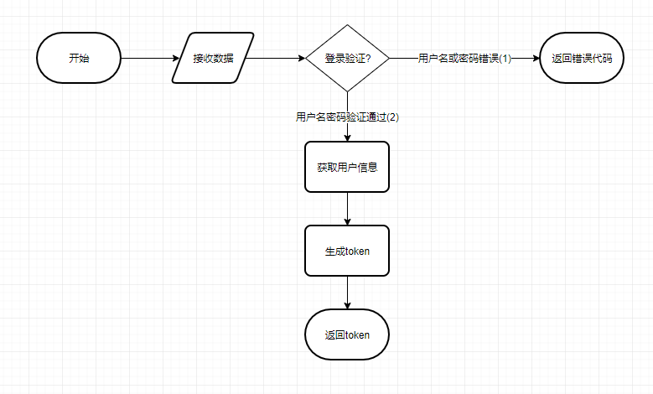

测试用例：

|  |  |  |  |  |
| --- | --- | --- | --- | --- |
| 序号 | 输入数据 | | 预期输出 | 分支覆盖 |
| email | password |
| 1 | test1 | 123456 | {"msg":"Success","data":"T4sUc/8aMvbw6PdvcDwxO4ADtMZVy4Loq7HZ4eNOundJUpodGzS06t1KE68npnNgp9li7CMYiUlZ1IeJkGlpm+gIO9kTvCBlbIaefB4UtRbH+7+JS5c62nRXhSw8JyZM3QcIsx8QMl3nqgNCmCsPoE+UvcBYDVPos6rW0GREbHA=","status": 1} | 2 |
| 2 | test1 | abcdef | {"msg": "用户名或者密码错误","status": 0} | 1 |
| 3 | null | null | {"msg": "用户名或者密码错误","status": 0} | 1 |

测试结果记录：

|  |  |  |  |  |  |
| --- | --- | --- | --- | --- | --- |
| 序号 | 预期结果 | 实际结果 | 测试结果 | 测试人 | 测试时间 |
| 1 | {"msg":"Success","data":"T4sUc/8aMvbw6PdvcDwxO4ADtMZVy4Loq7HZ4eNOundJUpodGzS06t1KE68npnNgp9li7CMYiUlZ1IeJkGlpm+gIO9kTvCBlbIaefB4UtRbH+7+JS5c62nRXhSw8JyZM3QcIsx8QMl3nqgNCmCsPoE+UvcBYDVPos6rW0GREbHA=","status": 1} | {"msg":"Success","data":"T4sUc/8aMvbw6PdvcDwxO4ADtMZVy4Loq7HZ4eNOundJUpodGzS06t1KE68npnNgp9li7CMYiUlZ1IeJkGlpm+gIO9kTvCBlbIaefB4UtRbH+7+JS5c62nRXhSw8JyZM3QcIsx8QMl3nqgNCmCsPoE+UvcBYDVPos6rW0GREbHA=","status": 1} | 通过 | 赵元鹏 | 2019/6/15 |
| 2 | {"msg": "用户名或者密码错误","status": 0} | {"msg": "用户名或者密码错误","status": 0} | 通过 | 赵元鹏 | 2019/6/15 |
| 3 | {"msg": "用户名或者密码错误","status": 0} | {"msg": "用户名或者密码错误","status": 0} | 通过 | 赵元鹏 | 2019/6/15 |

#### 注册

流程图：

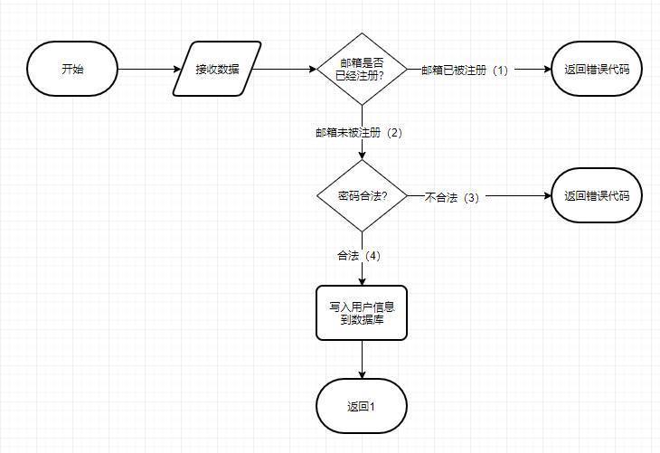

测试用例：

|  |  |  |  |  |  |  |  |
| --- | --- | --- | --- | --- | --- | --- | --- |
| 序号 | 输入数据 | | | | | 预期输出 | 分支覆盖 |
| email | name | password | role | profile |
| 1 | test3 | 中文测试3 | 123456 | CoreBusiness | test profile | {"msg":"Success","status": 1} | 2,4 |
| 2 | test1 | 中文测试4 | 123456 | CoreBusiness | test profile | {"msg": "邮箱已被注册","status": 0} | 1 |
| 3 | test4 | 中文测试5 | null | CoreBusiness | test profile | {"msg": "密码不能为空","status": 0} | 2,3 |
| 4 | test5 | 中文测试6 | 123 | CoreBusiness | test profile | {"msg": "密码长度不能小于6","status": 0} | 2,3 |

测试结果记录：

|  |  |  |  |  |  |
| --- | --- | --- | --- | --- | --- |
| 序号 | 预期结果 | 实际结果 | 测试结果 | 测试人 | 测试时间 |
| 1 | {"msg":"Success","status": 1} | {"msg":"Success","status": 1} | 通过 | 赵元鹏 | 2019/6/15 |
| 2 | {"msg": "邮箱已被注册","status": 0} | {"msg": "邮箱已被注册","status": 0} | 通过 | 赵元鹏 | 2019/6/15 |
| 3 | {"msg": "密码不能为空","status": 0} | {"msg": "密码不能为空","status": 0} | 通过 | 赵元鹏 | 2019/6/15 |
| 4 | {"msg": "密码长度不能小于6","status": 0} | {"msg": "密码长度不能小于6","status": 0} | 通过 | 赵元鹏 | 2019/6/15 |

#### 获取用户信息

流程图：

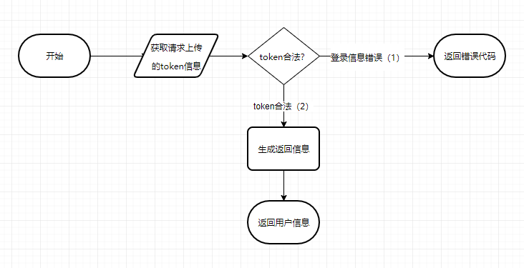

测试用例：

|  |  |  |  |
| --- | --- | --- | --- |
| 序号 | 输入数据 | 预期输出 | 分支覆盖 |
| token |
| 1 | T4sUc/8aMvbw6PdvcDwxO5zOu81DOqcqWj1I88fUfLol3MzThFIkEqqmpaYmECdBoA3CjIxHrGVY6ksLRRgroFwDJ6cU0ZQNXJYku379sflZfrZC/cVim7qAiqFL/1Pg5WjDWVVHCfFUj5SStmcHVEEq9oIUgo+Lp+D8md85YrA= | { "msg": "Success", "user": { "role": "CoreBusiness", "profile": "", "name": "中文测试", "email": "TEST1" }, "status": 1 } | 2 |
| 2 | null | 无效token-500错误 | 1 |

测试结果记录：

|  |  |  |  |  |  |
| --- | --- | --- | --- | --- | --- |
| 序号 | 预期结果 | 实际结果 | 测试结果 | 测试人 | 测试时间 |
| 1 | { "msg": "Success", "user": { "role": "CoreBusiness", "profile": "", "name": "中文测试", "email": "TEST1" }, "status": 1 } | { "msg": "Success", "user": { "role": "CoreBusiness", "profile": "", "name": "中文测试", "email": "TEST1" }, "status": 1 } | 通过 | 赵元鹏 | 2019/6/15 |
| 2 | 无效token-500错误 | 无效token-500错误 | 通过 | 赵元鹏 | 2019/6/15 |

#### 更改密码

流程图：

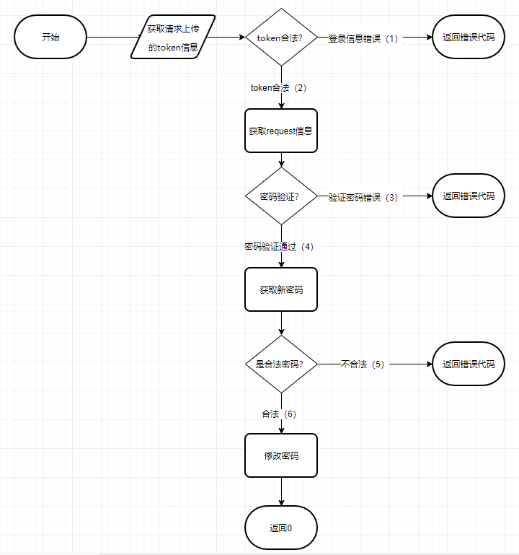

测试用例：

|  |  |  |  |  |  |
| --- | --- | --- | --- | --- | --- |
| 序号 | 输入数据 | | | 预期输出 | 分支覆盖 |
| token | confirmPassword | newPassword |
| 1 | T4sUc/8aMvbw6PdvcDwxO5zOu81DOqcqWj1I88fUfLol3MzThFIkEqqmpaYmECdBoA3CjIxHrGVY6ksLRRgroFwDJ6cU0ZQNXJYku379sflZfrZC/cVim7qAiqFL/1Pg5WjDWVVHCfFUj5SStmcHVEEq9oIUgo+Lp+D8md85YrA= | 123456 | abcdef | {"msg": "Success","status": 1} | 2,4,6 |
| 2 | null | 123456 | abcdef | 无效token-500错误 | 1 |
| 3 | T4sUc/8aMvbw6PdvcDwxO5zOu81DOqcqWj1I88fUfLol3MzThFIkEqqmpaYmECdBoA3CjIxHrGVY6ksLRRgroFwDJ6cU0ZQNXJYku379sflZfrZC/cVim7qAiqFL/1Pg5WjDWVVHCfFUj5SStmcHVEEq9oIUgo+Lp+D8md85YrA= | 987654 | abcdef | {"msg": "验证密码错误","status": 0} | 2,3 |
| 4 | T4sUc/8aMvbw6PdvcDwxO5zOu81DOqcqWj1I88fUfLol3MzThFIkEqqmpaYmECdBoA3CjIxHrGVY6ksLRRgroFwDJ6cU0ZQNXJYku379sflZfrZC/cVim7qAiqFL/1Pg5WjDWVVHCfFUj5SStmcHVEEq9oIUgo+Lp+D8md85YrA= | abcdef | null | {"msg": "密码不能为空","status": 0} | 2,4,5 |

测试结果记录：

|  |  |  |  |  |  |
| --- | --- | --- | --- | --- | --- |
| 序号 | 预期结果 | 实际结果 | 测试结果 | 测试人 | 测试时间 |
| 1 | {"msg": "Success","status": 1} | {"msg": "Success","status": 1} | 通过 | 赵元鹏 | 2019/6/15 |
| 2 | 无效token-500错误 | 无效token-500错误 | 通过 | 赵元鹏 | 2019/6/15 |
| 3 | {"msg": "验证密码错误","status": 0} | {"msg": "验证密码错误","status": 0} | 通过 | 赵元鹏 | 2019/6/15 |
| 4 | {"msg": "密码不能为空","status": 0} | {"msg": "密码不能为空","status": 0} | 通过 | 赵元鹏 | 2019/6/15 |

#### 更改用户信息

流程图：

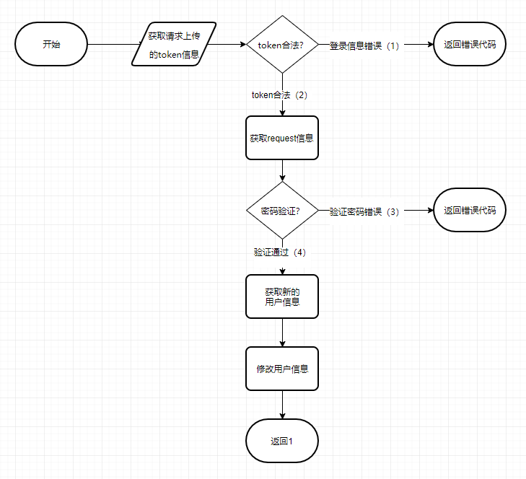

测试用例：

|  |  |  |  |  |  |
| --- | --- | --- | --- | --- | --- |
| 序号 | 输入数据 | | | 预期输出 | 分支覆盖 |
| token | confirmPassword | newUser |
| 1 | T4sUc/8aMvbw6PdvcDwxO5zOu81DOqcqWj1I88fUfLol3MzThFIkEqqmpaYmECdBoA3CjIxHrGVY6ksLRRgroFwDJ6cU0ZQNXJYku379sflZfrZC/cVim7qAiqFL/1Pg5WjDWVVHCfFUj5SStmcHVEEq9oIUgo+Lp+D8md85YrA= | 123456 | {"companyName":"测试一号","profile":"测试专用"} | {"msg":"Success", "status": 1 } | 2,4 |
| 2 | null | 123456 | {"companyName":"测试一号","profile":"测试专用"} | 无效token-500错误 | 1 |
| 3 | T4sUc/8aMvbw6PdvcDwxO5zOu81DOqcqWj1I88fUfLol3MzThFIkEqqmpaYmECdBoA3CjIxHrGVY6ksLRRgroFwDJ6cU0ZQNXJYku379sflZfrZC/cVim7qAiqFL/1Pg5WjDWVVHCfFUj5SStmcHVEEq9oIUgo+Lp+D8md85YrA= | 987654 | {"companyName":"测试一号","profile":"测试专用"} | {"msg":"验证密码错误","status":0} | 2,3 |

测试结果记录：

|  |  |  |  |  |  |
| --- | --- | --- | --- | --- | --- |
| 序号 | 预期结果 | 实际结果 | 测试结果 | 测试人 | 测试时间 |
| 1 | {"msg":"Success", "status": 1 } | {"msg":"Success", "status": 1 } | 通过 | 赵元鹏 | 2019/6/15 |
| 2 | 无效token-500错误 | 无效token-500错误 | 通过 | 赵元鹏 | 2019/6/15 |
| 3 | {"msg":"验证密码错误","status":0} | {"msg":"验证密码错误","status":0} | 通过 | 赵元鹏 | 2019/6/15 |

### 4.2.3 账户部分

#### 充值

流程图：

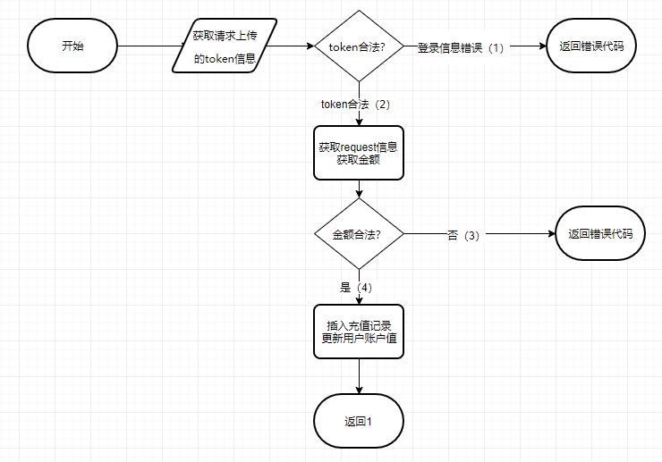

测试用例：

|  |  |  |  |  |
| --- | --- | --- | --- | --- |
| 序号 | 输入数据 | | 预期输出 | 分支覆盖 |
| token | money |
| 1 | T4sUc/8aMvbw6PdvcDwxO5zOu81DOqcqWj1I88fUfLol3MzThFIkEqqmpaYmECdBoA3CjIxHrGVY6ksLRRgroFwDJ6cU0ZQNXJYku379sflZfrZC/cVim7qAiqFL/1Pg5WjDWVVHCfFUj5SStmcHVEEq9oIUgo+Lp+D8md85YrA= | 123456.1 | { "msg": "Success", "status": 1 } | 2,4 |
| 2 | null | 123456.1 | 无效token-500错误 | 1 |
| 3 | T4sUc/8aMvbw6PdvcDwxO5zOu81DOqcqWj1I88fUfLol3MzThFIkEqqmpaYmECdBoA3CjIxHrGVY6ksLRRgroFwDJ6cU0ZQNXJYku379sflZfrZC/cVim7qAiqFL/1Pg5WjDWVVHCfFUj5SStmcHVEEq9oIUgo+Lp+D8md85YrA= | v | {"msg":"Character v is neither a decimal digit number, decimal point, nor \"e\" notation exponential mark.","status":0} | 2,3 |
| 4 | T4sUc/8aMvbw6PdvcDwxO5zOu81DOqcqWj1I88fUfLol3MzThFIkEqqmpaYmECdBoA3CjIxHrGVY6ksLRRgroFwDJ6cU0ZQNXJYku379sflZfrZC/cVim7qAiqFL/1Pg5WjDWVVHCfFUj5SStmcHVEEq9oIUgo+Lp+D8md85YrA= | {"money":"9999999999999999999999999999999999999999999999999999999999999999999999999999999999999999999"} | {"status": 0} | 2,3 |

测试结果记录：

|  |  |  |  |  |  |
| --- | --- | --- | --- | --- | --- |
| 序号 | 预期结果 | 实际结果 | 测试结果 | 测试人 | 测试时间 |
| 1 | { "msg": "Success", "status": 1 } | {"msg":"Success", "status":1} | 通过 | 赵元鹏 | 2019/6/15 |
| 2 | 无效token-500错误 | 无效token-500错误 | 通过 | 赵元鹏 | 2019/6/15 |
| 3 | {"msg":"Character v is neither a decimal digit number, decimal point, nor \"e\" notation exponential mark.","status":0} | {"msg":"Character v is neither a decimal digit number, decimal point, nor \"e\" notation exponential mark.","status":0} | 通过 | 赵元鹏 | 2019/6/15 |
| 4 | {"status": 0} | {"status": 0} | 通过 | 赵元鹏 | 2019/6/15 |

#### 提款

流程图：

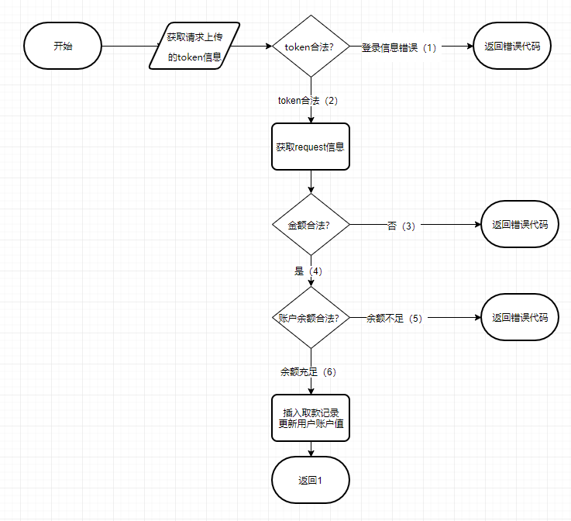

测试用例：

|  |  |  |  |  |
| --- | --- | --- | --- | --- |
| 序号 | 输入数据 | | 预期输出 | 分支覆盖 |
| token | money |
| 1 | T4sUc/8aMvbw6PdvcDwxO5zOu81DOqcqWj1I88fUfLol3MzThFIkEqqmpaYmECdBoA3CjIxHrGVY6ksLRRgroFwDJ6cU0ZQNXJYku379sflZfrZC/cVim7qAiqFL/1Pg5WjDWVVHCfFUj5SStmcHVEEq9oIUgo+Lp+D8md85YrA= | 123456.1 | {"msg":"Success","status":1} | 2,4,6 |
| 2 | null | 123456.1 | 无效token-500错误 | 1 |
| 3 | T4sUc/8aMvbw6PdvcDwxO5zOu81DOqcqWj1I88fUfLol3MzThFIkEqqmpaYmECdBoA3CjIxHrGVY6ksLRRgroFwDJ6cU0ZQNXJYku379sflZfrZC/cVim7qAiqFL/1Pg5WjDWVVHCfFUj5SStmcHVEEq9oIUgo+Lp+D8md85YrA= | v | {"msg":"Character v is neither a decimal digit number, decimal point, nor \"e\" notation exponential mark.","status":0} | 2,3 |
| 4 | T4sUc/8aMvbw6PdvcDwxO5zOu81DOqcqWj1I88fUfLol3MzThFIkEqqmpaYmECdBoA3CjIxHrGVY6ksLRRgroFwDJ6cU0ZQNXJYku379sflZfrZC/cVim7qAiqFL/1Pg5WjDWVVHCfFUj5SStmcHVEEq9oIUgo+Lp+D8md85YrA= | {"money":"9999999999999999999999999999999999999999999999999999999999999999999999999999999999999999999"} | {"msg":"A的账户余额不足","status":0} | 2,4,5 |

测试结果记录：

|  |  |  |  |  |  |
| --- | --- | --- | --- | --- | --- |
| 序号 | 预期结果 | 实际结果 | 测试结果 | 测试人 | 测试时间 |
| 1 | {"msg":"Success","status":1} | { "msg": "Success", "status": 1 } | 通过 | 赵元鹏 | 2019/6/15 |
| 2 | 无效token-500错误 | 无效token-500错误 | 通过 | 赵元鹏 | 2019/6/15 |
| 3 | {"msg":"Character v is neither a decimal digit number, decimal point, nor \"e\" notation exponential mark.","status":0} | { "msg": "Character v is neither a decimal digit number, decimal point, nor \"e\" notation exponential mark.", "status": 0 } | 通过 | 赵元鹏 | 2019/6/15 |
| 4 | {"msg":"A的账户余额不足","status":0} | { "msg": "A的账户余额不足", "status": 0 } | 通过 | 赵元鹏 | 2019/6/15 |

#### 查询余额

流程图：

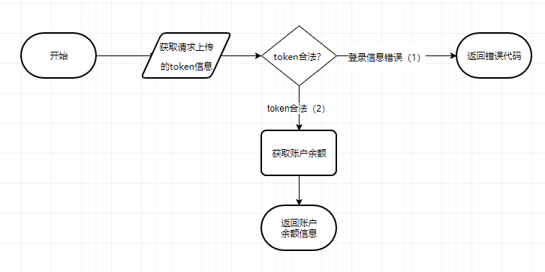

测试用例：

|  |  |  |  |
| --- | --- | --- | --- |
| 序号 | 输入数据 | 预期输出 | 分支覆盖 |
| token |
| 1 | T4sUc/8aMvbw6PdvcDwxO5zOu81DOqcqWj1I88fUfLol3MzThFIkEqqmpaYmECdBoA3CjIxHrGVY6ksLRRgroFwDJ6cU0ZQNXJYku379sflZfrZC/cVim7qAiqFL/1Pg5WjDWVVHCfFUj5SStmcHVEEq9oIUgo+Lp+D8md85YrA= | {"msg":"Success","money":247024.24,"status":1} | 2 |
| 2 | null | 无效token-500错误 | 1 |

测试结果记录：

|  |  |  |  |  |  |
| --- | --- | --- | --- | --- | --- |
| 序号 | 预期结果 | 实际结果 | 测试结果 | 测试人 | 测试时间 |
| 1 | {"msg":"Success","money":247024.24,"status":1} | {"msg":"Success","money":247024.24,"status":1} | 通过 | 赵元鹏 | 2019/6/15 |
| 2 | 无效token-500错误 | 无效token-500错误 | 通过 | 赵元鹏 | 2019/6/15 |

#### 转账记录

流程图：

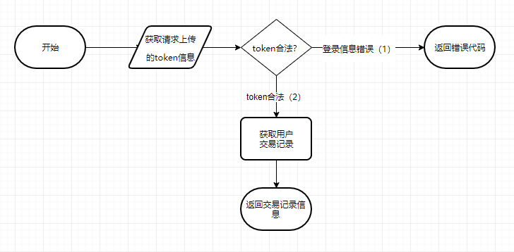

测试用例：

|  |  |  |  |
| --- | --- | --- | --- |
| 序号 | 输入数据 | 预期输出 | 分支覆盖 |
| token |
| 1 | T4sUc/8aMvbw6PdvcDwxOykt1ymolM+4tE0ZNb/xyNMZw3lVApCOyRHgGPhRYZOtS6vkAD7gTtnu3dpzwB1kPfCNNO29MCOSMEkG7tFtAC7oPUuJvzCxH4FZFp0t0ps+Q9vLWn9RqihVl/q5FZA4aG2aYsilmfqbXi+NFT/evyc= | {"msg":"Success","data":[],"status":1} | 2 |
| 2 | null | 无效token-500错误 | 1 |

测试结果记录：

|  |  |  |  |  |  |
| --- | --- | --- | --- | --- | --- |
| 序号 | 预期结果 | 实际结果 | 测试结果 | 测试人 | 测试时间 |
| 1 | {"msg":"Success","data":[],"status":1} | {"msg":"Success","data":[],"status":1} | 通过 | 赵元鹏 | 2019/6/15 |
| 2 | 无效token-500错误 | 无效token-500错误 | 通过 | 赵元鹏 | 2019/6/15 |

### 4.2.4 合同部分

#### 创建合同

流程图：

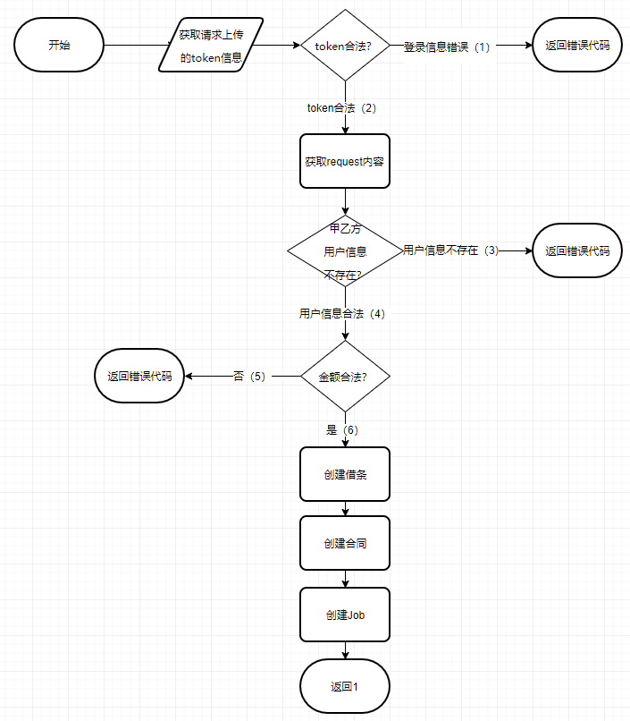

测试用例：

|  |  |  |  |  |  |  |  |
| --- | --- | --- | --- | --- | --- | --- | --- |
| 序号 | 输入数据 | | | | | 预期输出 | 分支覆盖 |
| token | partyA | partyB | terms | credit |
| 1 | T4sUc/8aMvbw6PdvcDwxO3KWMdxQ/aRT/KVyPthPanczOxdeVkW+LJxV9TGqe7P6OKL6GonK/5qQ1K1p4/eFFJwRzTQEaomQUZ6Yc/efymZhSuutOGW1mfauCQPTw4eRaMOMq4PXB8thf0lWlDytcJL/8VclohDiD6wpdA2HqaU= | test2 | test1 | test terms | {"partyA":"test2","partyB":"test1","deadline":7,"money": "123456.78"} | {"msg":"Success","status":1} | 2,4,6 |
| 2 | null | test2 | test1 | test terms | {"partyA":"test2","partyB":"test1","deadline":7,"money": "123456.78"} | 无效token-500错误 | 1 |
| 3 | T4sUc/8aMvbw6PdvcDwxO3KWMdxQ/aRT/KVyPthPanczOxdeVkW+LJxV9TGqe7P6OKL6GonK/5qQ1K1p4/eFFJwRzTQEaomQUZ6Yc/efymZhSuutOGW1mfauCQPTw4eRaMOMq4PXB8thf0lWlDytcJL/8VclohDiD6wpdA2HqaU= | null | null | test terms | {"partyA":"test2","partyB":"test1","deadline":7,"money": "123456.78"} | {"status":0} | 2,3 |
| 4 | T4sUc/8aMvbw6PdvcDwxO3KWMdxQ/aRT/KVyPthPanczOxdeVkW+LJxV9TGqe7P6OKL6GonK/5qQ1K1p4/eFFJwRzTQEaomQUZ6Yc/efymZhSuutOGW1mfauCQPTw4eRaMOMq4PXB8thf0lWlDytcJL/8VclohDiD6wpdA2HqaU= | test2 | test1 | test terms | {"partyA":"test2","partyB":"test1","deadline":7,"money": "v"} | {"msg":"JSONObject[\"money\"] could not be converted to BigDecimal.","status":0} | 2,4,5 |
| 5 | T4sUc/8aMvbw6PdvcDwxO3KWMdxQ/aRT/KVyPthPanczOxdeVkW+LJxV9TGqe7P6OKL6GonK/5qQ1K1p4/eFFJwRzTQEaomQUZ6Yc/efymZhSuutOGW1mfauCQPTw4eRaMOMq4PXB8thf0lWlDytcJL/8VclohDiD6wpdA2HqaU= | test2 | test1 | test terms | {"partyA":"test2","partyB":"test1","deadline":8,"money": "9999999999999999999999999999999999999999999999999999999999999"} | {"status":0} | 2,4,5 |

测试结果记录：

|  |  |  |  |  |  |
| --- | --- | --- | --- | --- | --- |
| 序号 | 预期结果 | 实际结果 | 测试结果 | 测试人 | 测试时间 |
| 1 | {"msg":"Success","status":1} | { "msg": "Success", "agreement": 3, "status": 1 } | 通过 | 赵元鹏 | 2019/6/15 |
| 2 | 无效token-500错误 | 无效token-500错误 | 通过 | 赵元鹏 | 2019/6/15 |
| 3 | {"status":0} | {"status":0} | 通过 | 赵元鹏 | 2019/6/15 |
| 4 | {"msg":"JSONObject[\"money\"] could not be converted to BigDecimal.","status":0} | {"msg":"JSONObject[\"money\"] could not be converted to BigDecimal.","status":0} | 通过 | 赵元鹏 | 2019/6/15 |
| 5 | {"status":0} | {"status":0} | 通过 | 赵元鹏 | 2019/6/15 |

#### 查看合同

流程图：

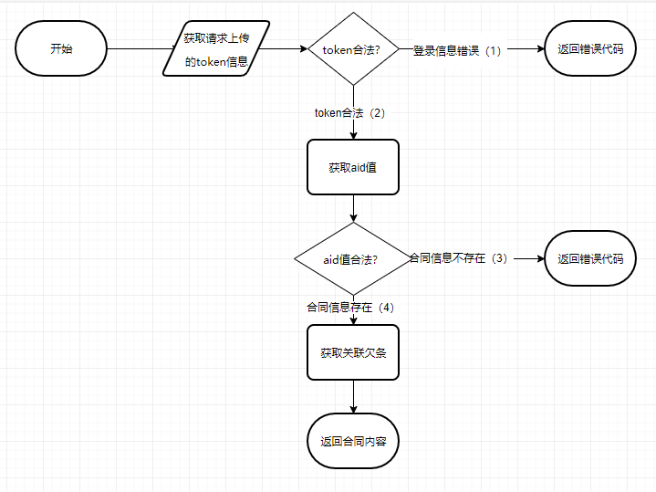

测试用例：

|  |  |  |  |  |
| --- | --- | --- | --- | --- |
| 序号 | 输入数据 | | 预期输出 | 分支覆盖 |
| token | aid |
| 1 | T4sUc/8aMvbw6PdvcDwxO3KWMdxQ/aRT/KVyPthPanczOxdeVkW+LJxV9TGqe7P6OKL6GonK/5qQ1K1p4/eFFJwRzTQEaomQUZ6Yc/efymZhSuutOGW1mfauCQPTw4eRaMOMq4PXB8thf0lWlDytcJL/8VclohDiD6wpdA2HqaU= | 1 | {"msg":"Success","agreement":{"partyA":3,"createTime":"2019-06-10 00:44:52","partyB":2,"credit":{"partyA":3,"money":123456,"createTime":"2019-06-10 00:44:52","partyB":2,"deadline":"2019-06-17 00:44:52","cid":1,"status":0},"aid":1,"cid":1,"status":"init"},"status":1} | 2,4 |
| 2 | null | 1 | 无效token-500错误 | 1 |
| 3 | T4sUc/8aMvbw6PdvcDwxO3KWMdxQ/aRT/KVyPthPanczOxdeVkW+LJxV9TGqe7P6OKL6GonK/5qQ1K1p4/eFFJwRzTQEaomQUZ6Yc/efymZhSuutOGW1mfauCQPTw4eRaMOMq4PXB8thf0lWlDytcJL/8VclohDiD6wpdA2HqaU= | 1000 | { "msg": "id错误", "status": 0 } | 2,3 |
| 4 | T4sUc/8aMvbw6PdvcDwxO3KWMdxQ/aRT/KVyPthPanczOxdeVkW+LJxV9TGqe7P6OKL6GonK/5qQ1K1p4/eFFJwRzTQEaomQUZ6Yc/efymZhSuutOGW1mfauCQPTw4eRaMOMq4PXB8thf0lWlDytcJL/8VclohDiD6wpdA2HqaU= | v | { "status": 0 } | 2,3 |

测试结果记录：

|  |  |  |  |  |  |
| --- | --- | --- | --- | --- | --- |
| 序号 | 预期结果 | 实际结果 | 测试结果 | 测试人 | 测试时间 |
| 1 | {"msg":"Success","agreement":{"partyA":3,"createTime":"2019-06-10 00:44:52","partyB":2,"credit":{"partyA":3,"money":123456,"createTime":"2019-06-10 00:44:52","partyB":2,"deadline":"2019-06-17 00:44:52","cid":1,"status":0},"aid":1,"cid":1,"status":"init"},"status":1} | {"msg":"Success","agreement":{"partyA":3,"createTime":"2019-06-10 00:44:52","partyB":2,"credit":{"partyA":3,"money":123456,"createTime":"2019-06-10 00:44:52","partyB":2,"deadline":"2019-06-17 00:44:52","cid":1,"status":0},"aid":1,"cid":1,"status":"init"},"status":1} | 通过 | 赵元鹏 | 2019/6/15 |
| 2 | 无效token-500错误 | 无效token-500错误 | 通过 | 赵元鹏 | 2019/6/15 |
| 3 | { "msg": "id错误", "status": 0 } | { "msg": "id错误", "status": 0 } | 通过 | 赵元鹏 | 2019/6/15 |
| 4 | {"status":0} | {"status":0} | 通过 | 赵元鹏 | 2019/6/15 |

#### 合同审批确认

流程图：

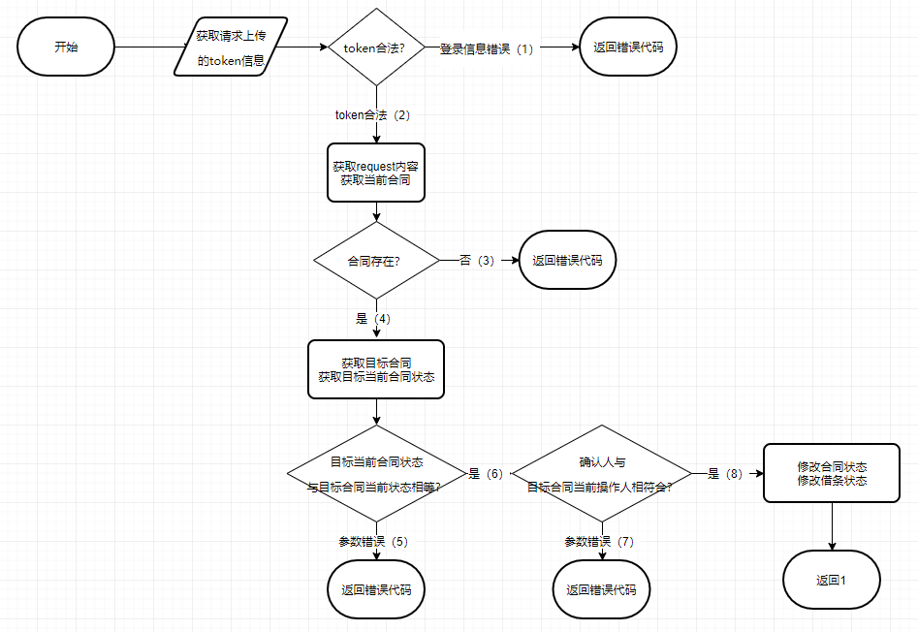

测试用例：

|  |  |  |  |  |  |
| --- | --- | --- | --- | --- | --- |
| 序号 | 输入数据 | | | 预期输出 | 分支覆盖 |
| token | aid | status |
| 1 | T4sUc/8aMvbw6PdvcDwxO3KWMdxQ/aRT/KVyPthPanczOxdeVkW+LJxV9TGqe7P6OKL6GonK/5qQ1K1p4/eFFJwRzTQEaomQUZ6Yc/efymZhSuutOGW1mfauCQPTw4eRaMOMq4PXB8thf0lWlDytcJL/8VclohDiD6wpdA2HqaU= | 1 | 0 | { "msg": "Success", "agreement": 1, "status": 1 } | 2,4,6,8 |
| 2 | null | 2 | 0 | 无效token-500错误 | 1 |
| 3 | T4sUc/8aMvbw6PdvcDwxO3KWMdxQ/aRT/KVyPthPanczOxdeVkW+LJxV9TGqe7P6OKL6GonK/5qQ1K1p4/eFFJwRzTQEaomQUZ6Yc/efymZhSuutOGW1mfauCQPTw4eRaMOMq4PXB8thf0lWlDytcJL/8VclohDiD6wpdA2HqaU= | 100 | 0 | {"msg":"id错误","status":0} | 2,3 |
| 4 | T4sUc/8aMvbw6PdvcDwxO3KWMdxQ/aRT/KVyPthPanczOxdeVkW+LJxV9TGqe7P6OKL6GonK/5qQ1K1p4/eFFJwRzTQEaomQUZ6Yc/efymZhSuutOGW1mfauCQPTw4eRaMOMq4PXB8thf0lWlDytcJL/8VclohDiD6wpdA2HqaU= | 2 | 1 | {"msg":"参数错误","status":0} | 2,4,5 |
| 5 | T4sUc/8aMvbw6PdvcDwxOykt1ymolM+4tE0ZNb/xyNMZw3lVApCOyRHgGPhRYZOtS6vkAD7gTtnu3dpzwB1kPfCNNO29MCOSMEkG7tFtAC7oPUuJvzCxH4FZFp0t0ps+Q9vLWn9RqihVl/q5FZA4aG2aYsilmfqbXi+NFT/evyc= | 3 | 0 | {"msg":"参数错误","status":0} | 2,4,6,7 |
| 6 | T4sUc/8aMvbw6PdvcDwxO3KWMdxQ/aRT/KVyPthPanczOxdeVkW+LJxV9TGqe7P6OKL6GonK/5qQ1K1p4/eFFJwRzTQEaomQUZ6Yc/efymZhSuutOGW1mfauCQPTw4eRaMOMq4PXB8thf0lWlDytcJL/8VclohDiD6wpdA2HqaU= | v | 0 | {"msg":"JSONObject[\"aid\"] is not an int.","status":0} | 2,3 |
| 7 | T4sUc/8aMvbw6PdvcDwxO3KWMdxQ/aRT/KVyPthPanczOxdeVkW+LJxV9TGqe7P6OKL6GonK/5qQ1K1p4/eFFJwRzTQEaomQUZ6Yc/efymZhSuutOGW1mfauCQPTw4eRaMOMq4PXB8thf0lWlDytcJL/8VclohDiD6wpdA2HqaU= | 4 | v | {"msg":"JSONObject[\"status\"] is not an int.","status":0} | 2,4,5 |

测试结果记录：

|  |  |  |  |  |  |
| --- | --- | --- | --- | --- | --- |
| 序号 | 预期结果 | 实际结果 | 测试结果 | 测试人 | 测试时间 |
| 1 | { "msg": "Success", "agreement": 1, "status": 1 } | { "msg": "Success", "agreement": 1, "status": 1 } | 通过 | 赵元鹏 | 2019/6/15 |
| 2 | 无效token-500错误 | 无效token-500错误 | 通过 | 赵元鹏 | 2019/6/15 |
| 3 | {"msg":"id错误","status":0} | {"msg":"id错误","status":0} | 通过 | 赵元鹏 | 2019/6/15 |
| 4 | {"msg":"参数错误","status":0} | {"msg":"参数错误","status":0} | 通过 | 赵元鹏 | 2019/6/15 |
| 5 | {"msg":"参数错误","status":0} | {"msg":"参数错误","status":0} | 通过 | 赵元鹏 | 2019/6/15 |
| 6 | {"msg":"JSONObject[\"aid\"] is not an int.","status":0} | {"msg":"JSONObject[\"aid\"] is not an int.","status":0} | 通过 | 赵元鹏 | 2019/6/15 |
| 7 | {"msg":"JSONObject[\"status\"] is not an int.","status":0} | {"msg":"JSONObject[\"status\"] is not an int.","status":0} | 通过 | 赵元鹏 | 2019/6/15 |

#### 核心企业向供应商付款

流程图：

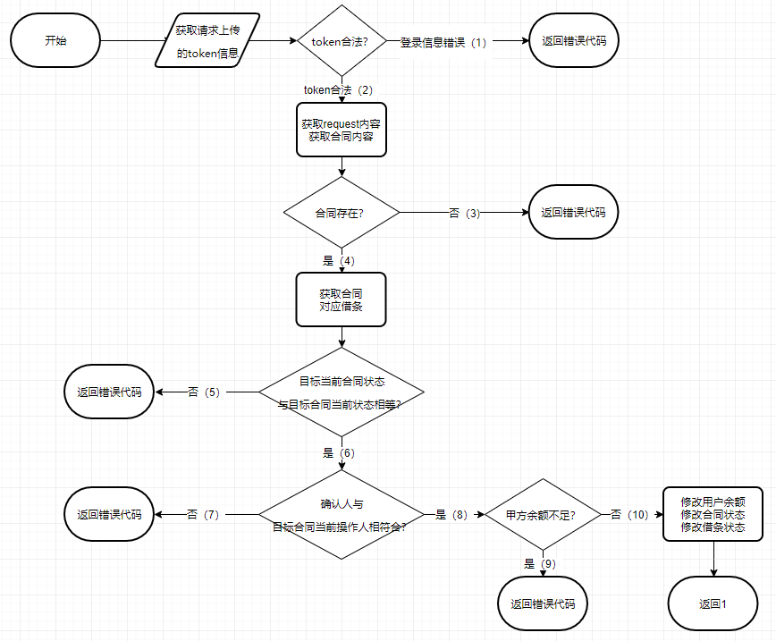

测试用例：

|  |  |  |  |  |  |
| --- | --- | --- | --- | --- | --- |
| 序号 | 输入数据 | | | 预期输出 | 分支覆盖 |
| token | aid | status |
| 1 | T4sUc/8aMvbw6PdvcDwxO9TFy7a+KSYuNzjvwG297j91GlPfCSrNzH29hT4qcFbpFuvJSH781Csq/Ut6Qdr8lQJopDXCP2IkAcwhLMBmd2ybz7+ktVW3dT6yXTvEjEHYB/ngM53W7vnkDgmpk5x3h7sBQqRot8LcaOubcvRY5Ps= | 1 | 3 | {"msg":"Success","status":1} | 2,4,6,8,10 |
| 2 | null | 2 | 3 | 无效token-500错误 | 1 |
| 3 | T4sUc/8aMvbw6PdvcDwxO9TFy7a+KSYuNzjvwG297j91GlPfCSrNzH29hT4qcFbpFuvJSH781Csq/Ut6Qdr8lQJopDXCP2IkAcwhLMBmd2ybz7+ktVW3dT6yXTvEjEHYB/ngM53W7vnkDgmpk5x3h7sBQqRot8LcaOubcvRY5Ps= | 100 | 3 | {"msg":"id错误","status":0} | 2,3 |
| 4 | T4sUc/8aMvbw6PdvcDwxO9TFy7a+KSYuNzjvwG297j91GlPfCSrNzH29hT4qcFbpFuvJSH781Csq/Ut6Qdr8lQJopDXCP2IkAcwhLMBmd2ybz7+ktVW3dT6yXTvEjEHYB/ngM53W7vnkDgmpk5x3h7sBQqRot8LcaOubcvRY5Ps= | 3 | 3 | {"msg":"参数错误","status":0} | 2,4,5 |
| 5 | T4sUc/8aMvbw6PdvcDwxO3KWMdxQ/aRT/KVyPthPanczOxdeVkW+LJxV9TGqe7P6OKL6GonK/5qQ1K1p4/eFFJwRzTQEaomQUZ6Yc/efymZhSuutOGW1mfauCQPTw4eRaMOMq4PXB8thf0lWlDytcJL/8VclohDiD6wpdA2HqaU= | 2 | 3 | {"msg":"参数错误","status":0} | 2,4,6,7 |
| 6 | T4sUc/8aMvbw6PdvcDwxO9TFy7a+KSYuNzjvwG297j91GlPfCSrNzH29hT4qcFbpFuvJSH781Csq/Ut6Qdr8lQJopDXCP2IkAcwhLMBmd2ybz7+ktVW3dT6yXTvEjEHYB/ngM53W7vnkDgmpk5x3h7sBQqRot8LcaOubcvRY5Ps= | 1 | 3 | {"msg":"A的账户余额不足","status":0} | 2,4,6,8,9 |

测试结果记录：

|  |  |  |  |  |  |
| --- | --- | --- | --- | --- | --- |
| 序号 | 预期结果 | 实际结果 | 测试结果 | 测试人 | 测试时间 |
| 1 | {"msg":"Success","status":1} | {"msg":"Success","status":1} | 通过 | 赵元鹏 | 2019/6/15 |
| 2 | 无效token-500错误 | 无效token-500错误 | 通过 | 赵元鹏 | 2019/6/15 |
| 3 | {"msg":"id错误","status":0} | {"msg":"id错误","status":0} | 通过 | 赵元鹏 | 2019/6/15 |
| 4 | {"msg":"参数错误","status":0} | {"msg":"参数错误","status":0} | 通过 | 赵元鹏 | 2019/6/15 |
| 5 | {"msg":"参数错误","status":0} | {"msg":"参数错误","status":0} | 通过 | 赵元鹏 | 2019/6/15 |
| 6 | {"msg":"A的账户余额不足","status":0} | {"msg":"A的账户余额不足","status":0} | 通过 | 赵元鹏 | 2019/6/15 |

#### 查看所有和当前用户相关的合同

流程图：

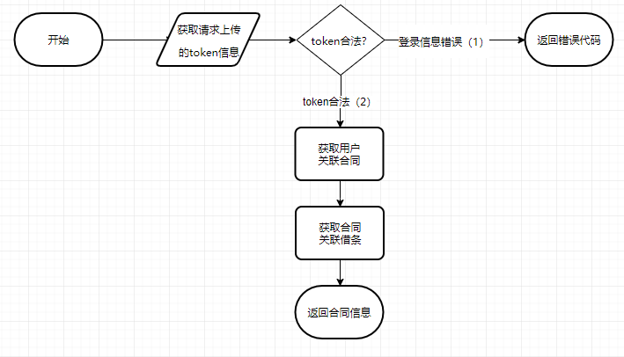

测试用例：

|  |  |  |  |
| --- | --- | --- | --- |
| 序号 | 输入数据 | 预期输出 | 分支覆盖 |
| token |
| 1 | T4sUc/8aMvbw6PdvcDwxO25UVnYZAykcvD8CYtaBCFfkSkpkAOg/NJDISwF+BdImJhYLyXnyUak88+wxMC3PPeDAlyE+gZPG4+eyx9mlo/Kwg5yeucZMke918AOkJRVUZTiCcPfRC/YQfC4C0p3ZSvnsfiUiFQ6Bdv7Gj06Tt4w= | {"msg":"Success","agreements":[],"status":1} | 2 |
| 2 | null | 无效token-500错误 | 1 |

测试结果记录：

|  |  |  |  |  |  |
| --- | --- | --- | --- | --- | --- |
| 序号 | 预期结果 | 实际结果 | 测试结果 | 测试人 | 测试时间 |
| 1 | {"msg":"Success","agreements":[],"status":1} | {"msg":"Success","agreements":[],"status":1} | 通过 | 赵元鹏 | 2019/6/15 |
| 2 | 无效token-500错误 | 无效token-500错误 | 通过 | 赵元鹏 | 2019/6/15 |

### 4.2.5 融资部分

#### 融资申请

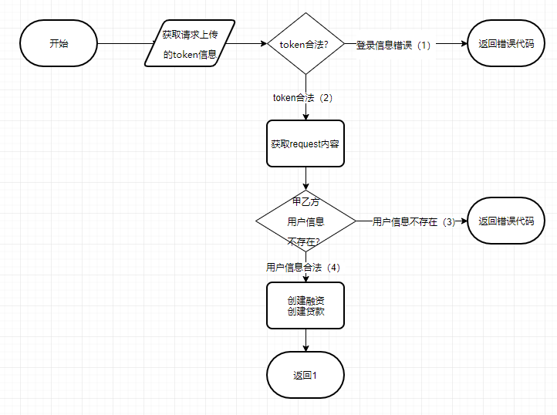

测试用例：

|  |  |  |  |  |  |  |  |  |
| --- | --- | --- | --- | --- | --- | --- | --- | --- |
| 序号 | 输入数据 |  |  |  |  |  | 预期输出 | 分支覆盖 |
|  | token | aid | partyB | partyA | terms | mortgage |  |  |
| 1 | T4sUc/8aMvbw6PdvcDwxO8eJGp35Qt9XSJok0AQhIMsrU2IiO6XDgW1YI0/q1J7AYpVhzG031eZnc7eXeFHOnUR5RpHF9L7FjOZIiyq94swnZmm3UosU+lWEbDqf80bjKGA9Yrh1Dx52xS15FN3ZuopSRDuWSNTR1o3Be+25QNU= | 1 | test1 | test2 | test terms | {"cid":1,"partyA":"test2","partyB":"test1","money": "123456"} | {"msg":"Success","financing":1,"status":1} | 2,4 |
| 2 | null | 1 | test1 | test2 | test terms | {"cid":1,"partyA":"test2","partyB":"test1","money": "123456"} | 无效token-500错误 | 1 |
| 3 | T4sUc/8aMvbw6PdvcDwxO8eJGp35Qt9XSJok0AQhIMsrU2IiO6XDgW1YI0/q1J7AYpVhzG031eZnc7eXeFHOnUR5RpHF9L7FjOZIiyq94swnZmm3UosU+lWEbDqf80bjKGA9Yrh1Dx52xS15FN3ZuopSRDuWSNTR1o3Be+25QNU= | 1 | null | null | test terms | {"cid":1,"partyA":"test2","partyB":"test1","money": "123456"} | {"msg":"用户信息不存在","status":1} | 2,3 |

测试结果记录：

|  |  |  |  |  |  |
| --- | --- | --- | --- | --- | --- |
| 序号 | 预期结果 | 实际结果 | 测试结果 | 测试人 | 测试时间 |
| 1 | {"msg":"Success","financing":1,"status":1} | {"msg":"Success","financing":1,"status":1} | 通过 | 赵元鹏 | 2019/6/15 |
| 2 | 无效token-500错误 | 无效token-500错误 | 通过 | 赵元鹏 | 2019/6/15 |
| 3 | {"msg":"用户信息不存在","status":1} | {"msg":"用户信息不存在","status":1} | 通过 | 赵元鹏 | 2019/6/15 |

#### 融资审批

流程图：

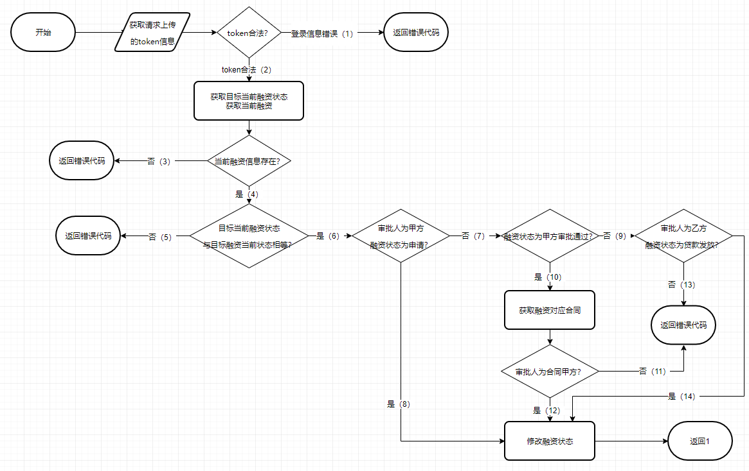

测试用例：

|  |  |  |  |  |  |
| --- | --- | --- | --- | --- | --- |
| 序号 | 输入数据 | | | 预期输出 | 分支覆盖 |
| token | fid | status |
| 1 | T4sUc/8aMvbw6PdvcDwxO9TFy7a+KSYuNzjvwG297j91GlPfCSrNzH29hT4qcFbpFuvJSH781Csq/Ut6Qdr8lQJopDXCP2IkAcwhLMBmd2ybz7+ktVW3dT6yXTvEjEHYB/ngM53W7vnkDgmpk5x3h7sBQqRot8LcaOubcvRY5Ps= | 1 | 0 | {"msg":"Success","financing":1,"status":1} | 2,4,6,8 |
| 2 | null | 1 | 0 | 无效token-500错误 | 1 |
| 3 | T4sUc/8aMvbw6PdvcDwxO9TFy7a+KSYuNzjvwG297j91GlPfCSrNzH29hT4qcFbpFuvJSH781Csq/Ut6Qdr8lQJopDXCP2IkAcwhLMBmd2ybz7+ktVW3dT6yXTvEjEHYB/ngM53W7vnkDgmpk5x3h7sBQqRot8LcaOubcvRY5Ps= | 100 | 0 | { "msg": "id错误", "status": 0 } | 2,3 |
| 4 | T4sUc/8aMvbw6PdvcDwxO9TFy7a+KSYuNzjvwG297j91GlPfCSrNzH29hT4qcFbpFuvJSH781Csq/Ut6Qdr8lQJopDXCP2IkAcwhLMBmd2ybz7+ktVW3dT6yXTvEjEHYB/ngM53W7vnkDgmpk5x3h7sBQqRot8LcaOubcvRY5Ps= | 1 | 2 | {"msg":"参数错误","status":0} | 2,4,5 |
| 5 | T4sUc/8aMvbw6PdvcDwxO9TFy7a+KSYuNzjvwG297j91GlPfCSrNzH29hT4qcFbpFuvJSH781Csq/Ut6Qdr8lQJopDXCP2IkAcwhLMBmd2ybz7+ktVW3dT6yXTvEjEHYB/ngM53W7vnkDgmpk5x3h7sBQqRot8LcaOubcvRY5Ps= | 1 | 1 | {"msg":"Success","status":1} | 2,4,6,7,10,12 |
| 6 | T4sUc/8aMvbw6PdvcDwxO8eJGp35Qt9XSJok0AQhIMsrU2IiO6XDgW1YI0/q1J7AYpVhzG031eZnc7eXeFHOnUR5RpHF9L7FjOZIiyq94swnZmm3UosU+lWEbDqf80bjKGA9Yrh1Dx52xS15FN3ZuopSRDuWSNTR1o3Be+25QNU= | 2 | 1 | {"status":0} | 2,4,6,7,10,11 |
| 7 | T4sUc/8aMvbw6PdvcDwxO9TFy7a+KSYuNzjvwG297j91GlPfCSrNzH29hT4qcFbpFuvJSH781Csq/Ut6Qdr8lQJopDXCP2IkAcwhLMBmd2ybz7+ktVW3dT6yXTvEjEHYB/ngM53W7vnkDgmpk5x3h7sBQqRot8LcaOubcvRY5Ps= | 1 | 3 | {"msg":"参数错误","status":0} | 2,4,6,7,9,13 |
| 8 | T4sUc/8aMvbw6PdvcDwxO8eJGp35Qt9XSJok0AQhIMsrU2IiO6XDgW1YI0/q1J7AYpVhzG031eZnc7eXeFHOnUR5RpHF9L7FjOZIiyq94swnZmm3UosU+lWEbDqf80bjKGA9Yrh1Dx52xS15FN3ZuopSRDuWSNTR1o3Be+25QNU= | 1 | 3 | {"msg":"Success","status":1} | 2,4,6,7,9,14 |

测试结果记录：

|  |  |  |  |  |  |
| --- | --- | --- | --- | --- | --- |
| 序号 | 预期结果 | 实际结果 | 测试结果 | 测试人 | 测试时间 |
| 1 | {"msg":"Success","financing":1,"status":1} | {"msg":"Success","financing":1,"status":1} | 通过 | 赵元鹏 | 2019/6/15 |
| 2 | 无效token-500错误 | 无效token-500错误 | 通过 | 赵元鹏 | 2019/6/15 |
| 3 | { "msg": "id错误", "status": 0 } | { "msg": "id错误", "status": 0 } | 通过 | 赵元鹏 | 2019/6/15 |
| 4 | {"msg":"参数错误","status":0} | {"msg":"参数错误","status":0} | 通过 | 赵元鹏 | 2019/6/15 |
| 5 | {"msg":"Success","status":1} | {"msg":"Success","status":1} | 通过 | 赵元鹏 | 2019/6/15 |
| 6 | {"status":0} | {"status":0} | 通过 | 赵元鹏 | 2019/6/15 |
| 7 | {"msg":"参数错误","status":0} | {"msg":"参数错误","status":0} | 通过 | 赵元鹏 | 2019/6/15 |
| 8 | {"msg":"Success","status":1} | {"msg":"Success","status":1} | 通过 | 赵元鹏 | 2019/6/15 |

#### 发放贷款

流程图：

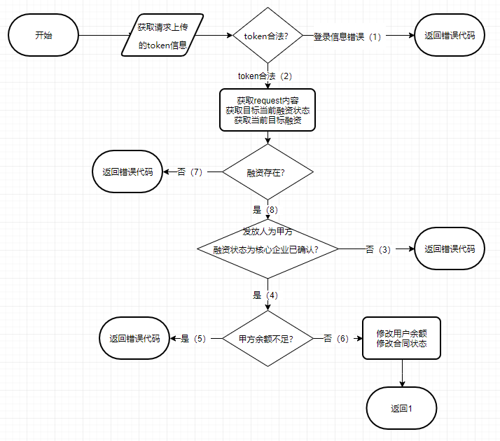

测试用例：

|  |  |  |  |  |  |  |
| --- | --- | --- | --- | --- | --- | --- |
| 序号 | 输入数据 | | | | 预期输出 | 分支覆盖 |
| token | fid | money | status |
| 1 | T4sUc/8aMvbw6PdvcDwxO9TFy7a+KSYuNzjvwG297j91GlPfCSrNzH29hT4qcFbpFuvJSH781Csq/Ut6Qdr8lQJopDXCP2IkAcwhLMBmd2ybz7+ktVW3dT6yXTvEjEHYB/ngM53W7vnkDgmpk5x3h7sBQqRot8LcaOubcvRY5Ps= | 3 | 123456.78 | 2 | {"msg":"Success","status":1} | 2,4,6,8 |
| 2 | null | 2 | 123456.78 | 2 | 无效token-500错误 | 1 |
| 3 | T4sUc/8aMvbw6PdvcDwxO9TFy7a+KSYuNzjvwG297j91GlPfCSrNzH29hT4qcFbpFuvJSH781Csq/Ut6Qdr8lQJopDXCP2IkAcwhLMBmd2ybz7+ktVW3dT6yXTvEjEHYB/ngM53W7vnkDgmpk5x3h7sBQqRot8LcaOubcvRY5Ps= | 100 | 123456.78 | 2 | {"msg":"id错误","status":0} | 2.7 |
| 4 | T4sUc/8aMvbw6PdvcDwxO25UVnYZAykcvD8CYtaBCFfkSkpkAOg/NJDISwF+BdImJhYLyXnyUak88+wxMC3PPeDAlyE+gZPG4+eyx9mlo/Kwg5yeucZMke918AOkJRVUZTiCcPfRC/YQfC4C0p3ZSvnsfiUiFQ6Bdv7Gj06Tt4w= | 2 | 123456.78 | 2 | {"msg":"参数错误","status":0} | 2,8,3 |
| 5 | T4sUc/8aMvbw6PdvcDwxO9TFy7a+KSYuNzjvwG297j91GlPfCSrNzH29hT4qcFbpFuvJSH781Csq/Ut6Qdr8lQJopDXCP2IkAcwhLMBmd2ybz7+ktVW3dT6yXTvEjEHYB/ngM53W7vnkDgmpk5x3h7sBQqRot8LcaOubcvRY5Ps= | 2 | 111111111111111111111111111111111111111111 | 2 | { "msg": "A的账户余额不足", "status": 0 } | 2,8,4,5 |

测试结果记录：

|  |  |  |  |  |  |
| --- | --- | --- | --- | --- | --- |
| 序号 | 预期结果 | 实际结果 | 测试结果 | 测试人 | 测试时间 |
| 1 | {"msg":"Success","status":1} | {"msg":"Success","status":1} | 通过 | 赵元鹏 | 2019/6/15 |
| 2 | 无效token-500错误 | 无效token-500错误 | 通过 | 赵元鹏 | 2019/6/15 |
| 3 | {"msg":"id错误","status":0} | {"msg":"id错误","status":0} | 通过 | 赵元鹏 | 2019/6/15 |
| 4 | {"msg":"参数错误","status":0} | {"msg":"参数错误","status":0} | 通过 | 赵元鹏 | 2019/6/15 |
| 5 | { "msg": "A的账户余额不足", "status": 0 } | { "msg": "A的账户余额不足", "status": 0 } | 通过 | 赵元鹏 | 2019/6/15 |

#### 查看融资

流程图：

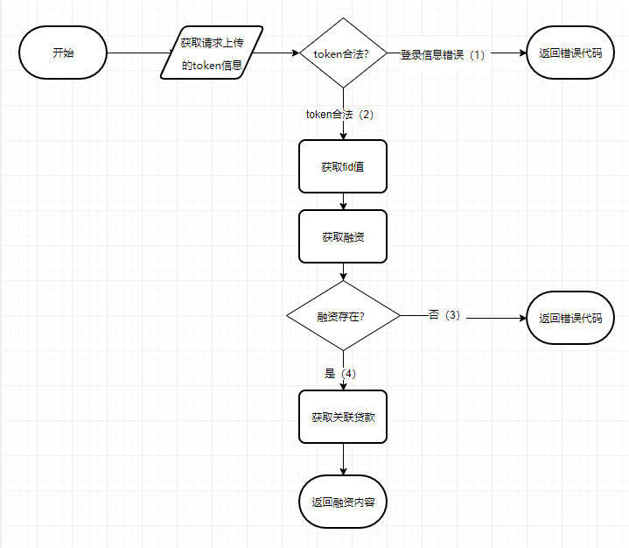

测试用例：

|  |  |  |  |  |
| --- | --- | --- | --- | --- |
| 序号 | 输入数据 | | 预期输出 | 分支覆盖 |
| token | fid |
| 1 | T4sUc/8aMvbw6PdvcDwxO9TFy7a+KSYuNzjvwG297j91GlPfCSrNzH29hT4qcFbpFuvJSH781Csq/Ut6Qdr8lQJopDXCP2IkAcwhLMBmd2ybz7+ktVW3dT6yXTvEjEHYB/ngM53W7vnkDgmpk5x3h7sBQqRot8LcaOubcvRY5Ps= | 1 | {"msg":"Success","financing":{"fid":1,"partyA":3,"mortgage":{"partyA":3,"money":123456,"createTime":"2019-06-16 05:46:27","partyB":2,"mid":1,"cid":1,"status":0},"createTime":"2019-06-16 05:46:27","terms":"","partyB":2,"mid":1,"aid":1,"status":"complete"},"status":1} | 2,4 |
| 2 | null | 1 | 无效token-500错误 | 1 |
| 3 | T4sUc/8aMvbw6PdvcDwxO9TFy7a+KSYuNzjvwG297j91GlPfCSrNzH29hT4qcFbpFuvJSH781Csq/Ut6Qdr8lQJopDXCP2IkAcwhLMBmd2ybz7+ktVW3dT6yXTvEjEHYB/ngM53W7vnkDgmpk5x3h7sBQqRot8LcaOubcvRY5Ps= | 100 | {"msg":"id错误","status":0} | 2,3 |
| 4 | T4sUc/8aMvbw6PdvcDwxO9TFy7a+KSYuNzjvwG297j91GlPfCSrNzH29hT4qcFbpFuvJSH781Csq/Ut6Qdr8lQJopDXCP2IkAcwhLMBmd2ybz7+ktVW3dT6yXTvEjEHYB/ngM53W7vnkDgmpk5x3h7sBQqRot8LcaOubcvRY5Ps= | v | {"status":0} | 2,3 |

测试结果记录：

|  |  |  |  |  |  |
| --- | --- | --- | --- | --- | --- |
| 序号 | 预期结果 | 实际结果 | 测试结果 | 测试人 | 测试时间 |
| 1 | {"msg":"Success","financing":{"fid":1,"partyA":3,"mortgage":{"partyA":3,"money":123456,"createTime":"2019-06-16 05:46:27","partyB":2,"mid":1,"cid":1,"status":0},"createTime":"2019-06-16 05:46:27","terms":"","partyB":2,"mid":1,"aid":1,"status":"complete"},"status":1} | {"msg":"Success","financing":{"fid":1,"partyA":3,"mortgage":{"partyA":3,"money":123456,"createTime":"2019-06-16 05:46:27","partyB":2,"mid":1,"cid":1,"status":0},"createTime":"2019-06-16 05:46:27","terms":"","partyB":2,"mid":1,"aid":1,"status":"complete"},"status":1} | 通过 | 赵元鹏 | 2019/6/15 |
| 2 | 无效token-500错误 | 无效token-500错误 | 通过 | 赵元鹏 | 2019/6/15 |
| 3 | {"msg":"id错误","status":0} | {"msg":"id错误","status":0} | 通过 | 赵元鹏 | 2019/6/15 |
| 4 | {"status":0} | {"msg":"id错误","status":0} | 通过 | 赵元鹏 | 2019/6/15 |

#### 查看和当前用户相关的融资申请

流程图：

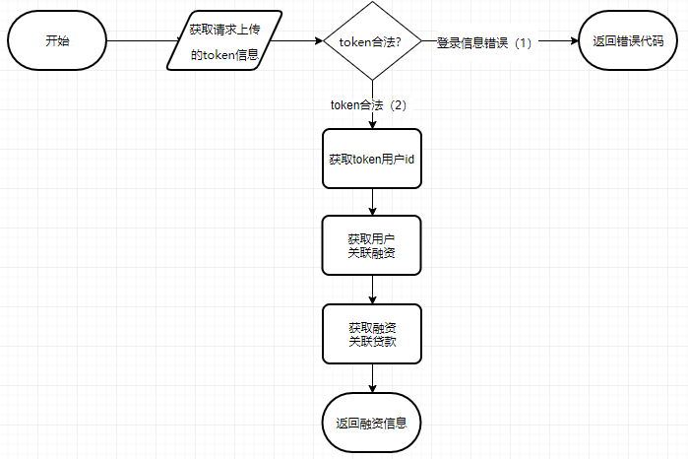

测试用例：

|  |  |  |  |
| --- | --- | --- | --- |
| 序号 | 输入数据 | 预期输出 | 分支覆盖 |
| token |
| 1 | T4sUc/8aMvbw6PdvcDwxO25UVnYZAykcvD8CYtaBCFfkSkpkAOg/NJDISwF+BdImJhYLyXnyUak88+wxMC3PPeDAlyE+gZPG4+eyx9mlo/Kwg5yeucZMke918AOkJRVUZTiCcPfRC/YQfC4C0p3ZSvnsfiUiFQ6Bdv7Gj06Tt4w= | {"msg":"Success","financing":[],"status":1} | 2 |
| 2 | null | 无效token-500错误 | 1 |

测试结果记录：

|  |  |  |  |  |  |
| --- | --- | --- | --- | --- | --- |
| 序号 | 预期结果 | 实际结果 | 测试结果 | 测试人 | 测试时间 |
| 1 | {"msg":"Success","financing":[],"status":1} | {"msg":"Success","financing":[],"status":1} | 通过 | 赵元鹏 | 2019/6/15 |
| 2 | 无效token-500错误 | 无效token-500错误 | 通过 | 赵元鹏 | 2019/6/15 |

### 4.2.6 消息部分

#### 查看和当前用户相关的消息

流程图：

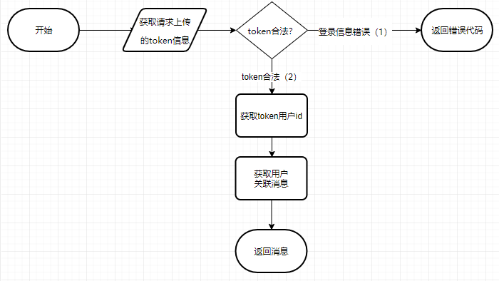

测试用例：

|  |  |  |  |
| --- | --- | --- | --- |
| 序号 | 输入数据 | 预期输出 | 分支覆盖 |
| token |
| 1 | T4sUc/8aMvbw6PdvcDwxO25UVnYZAykcvD8CYtaBCFfkSkpkAOg/NJDISwF+BdImJhYLyXnyUak88+wxMC3PPeDAlyE+gZPG4+eyx9mlo/Kwg5yeucZMke918AOkJRVUZTiCcPfRC/YQfC4C0p3ZSvnsfiUiFQ6Bdv7Gj06Tt4w= | {"msg":"Success","messages":[],"status":1} | 2 |
| 2 | null | 无效token-500错误 | 1 |

测试结果记录：

|  |  |  |  |  |  |
| --- | --- | --- | --- | --- | --- |
| 序号 | 预期结果 | 实际结果 | 测试结果 | 测试人 | 测试时间 |
| 1 | {"msg":"Success","messages":[],"status":1} | {"msg":"Success","messages":[],"status":1} | 通过 | 赵元鹏 | 2019/6/15 |
| 2 | 无效token-500错误 | 无效token-500错误 | 通过 | 赵元鹏 | 2019/6/15 |

#### 设置消息为已读

流程图：

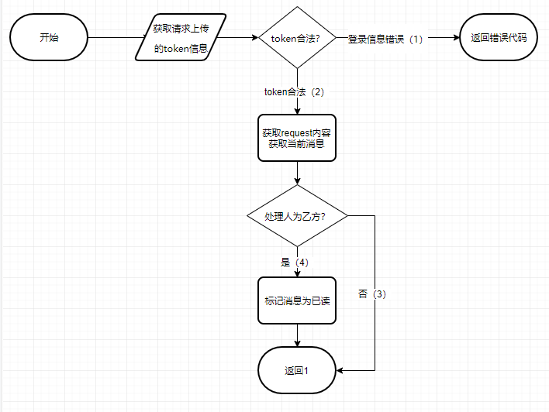

测试用例：

|  |  |  |  |  |
| --- | --- | --- | --- | --- |
| 序号 | 输入数据 | | 预期输出 | 分支覆盖 |
| token | mid |
| 1 | T4sUc/8aMvbw6PdvcDwxO9TFy7a+KSYuNzjvwG297j91GlPfCSrNzH29hT4qcFbpFuvJSH781Csq/Ut6Qdr8lQJopDXCP2IkAcwhLMBmd2ybz7+ktVW3dT6yXTvEjEHYB/ngM53W7vnkDgmpk5x3h7sBQqRot8LcaOubcvRY5Ps= | 1 | {"msg":"Success","status":1} | 2,4 |
| 2 | null | 1 | 无效token-500错误 | 1 |
| 3 | T4sUc/8aMvbw6PdvcDwxO25UVnYZAykcvD8CYtaBCFfkSkpkAOg/NJDISwF+BdImJhYLyXnyUak88+wxMC3PPeDAlyE+gZPG4+eyx9mlo/Kwg5yeucZMke918AOkJRVUZTiCcPfRC/YQfC4C0p3ZSvnsfiUiFQ6Bdv7Gj06Tt4w= | 1 | { "status": 0 } | 2,3 |

测试结果记录：

|  |  |  |  |  |  |
| --- | --- | --- | --- | --- | --- |
| 序号 | 预期结果 | 实际结果 | 测试结果 | 测试人 | 测试时间 |
| 1 | {"msg":"Success","status":1} | {"msg":"Success","status":1} | 通过 | 赵元鹏 | 2019/6/15 |
| 2 | 无效token-500错误 | 无效token-500错误 | 通过 | 赵元鹏 | 2019/6/15 |
| 3 | { "status": 0 } | { "status": 0 } | 通过 | 赵元鹏 | 2019/6/15 |

## 4.3集成测试

集成测试涉及系统五个模块的整合，故不在本报告中阐述。

## 4.4系统测试

集成测试涉及系统五个模块的整合，故不在本报告中阐述。

# 性能测试报告

经过测试，在Postman v7.2.0以及Google Chrome 74.0.3729.169环境下，接口方法的调用均未发生异常。

# 其他测试结果

## 6.1 压力测试

对本系统使用Jmeter 5.1.1进行API抽样压力测试，其统计结果如下所示：

6.1.1 /api/agreement/getAgreementByUser GET方法 查看所有和当前用户相关的合同

测试结果：

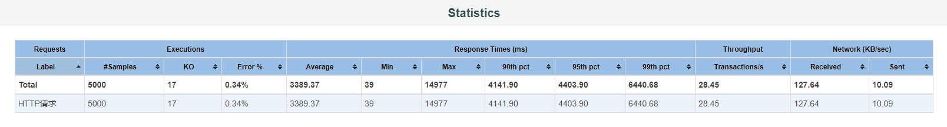

响应时间：

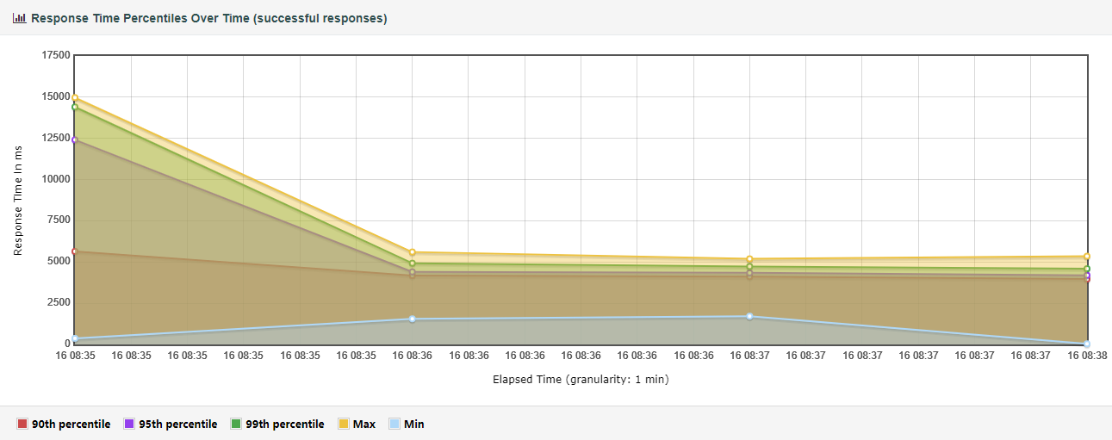

数据交互：

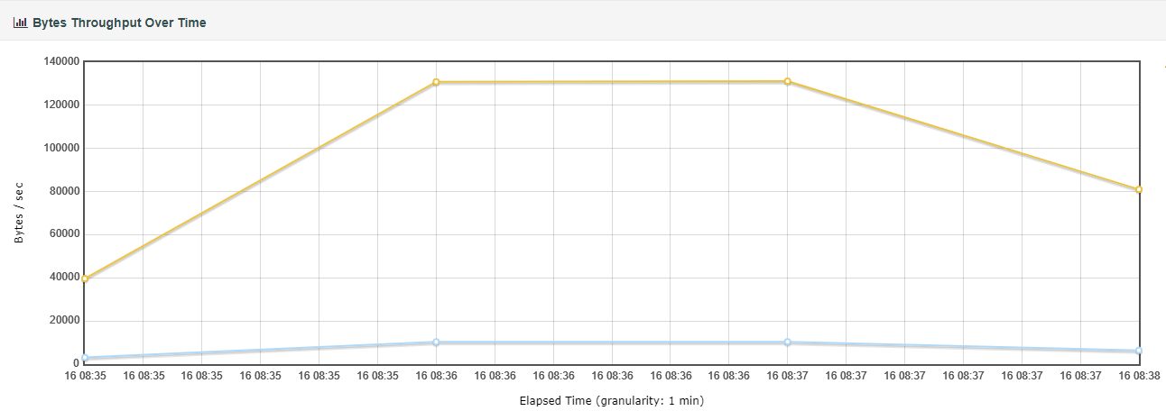

6.1.2 /api/account/recharge POST方法 充值

测试结果：

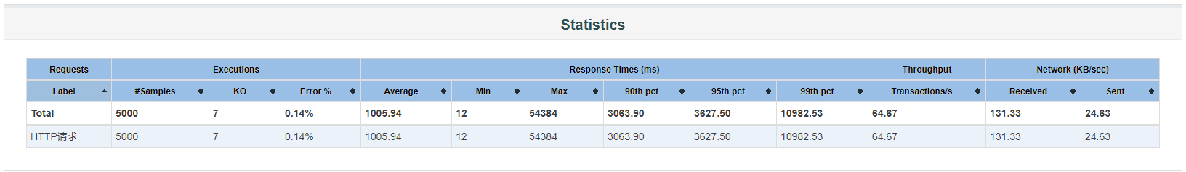

响应时间：

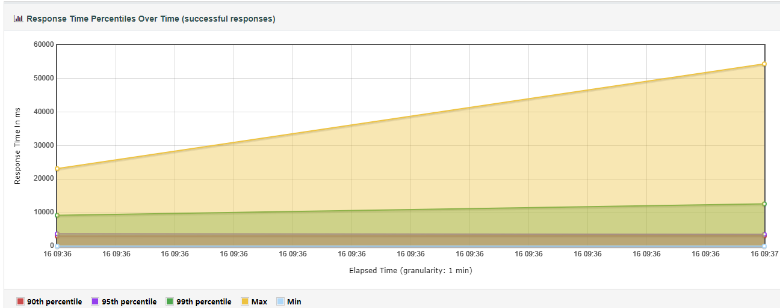

数据交互：

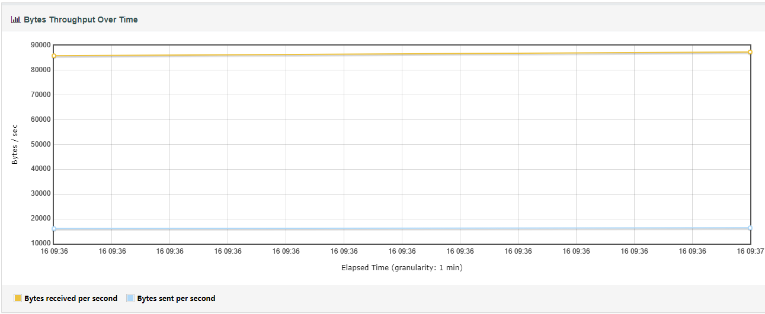

从上述抽样结果可以看出，在100个线程轮询下，系统仍能够维持在复杂数据库处理3000ms以下的响应时间，系统具备一定程度的抗压能力，预计服务器线程池最多可同时容纳约200个查询指令。

## 6.2 安全性测试

系统可防止错误信息、异常修改带来的不良后果：

1. 交易相关的至关重要的信息在区块链中加密存储
2. 信息插入前进行合法性检查
3. token采用AES加密保证传输中的安全性

## 6.3 可移植性测试

经测试，本模块可在配置好必要软件环境的Linux、Windows、MacOS系统下正常运行，对硬件配置要求不高。

# 不符合项列表

无

# 测试结果

测试完成时间：2019-6-16

测试地点：学生公寓

测试环境：多个开发者不同配置的设备

参与测试人员：赵元鹏、马广林

系统强项：稳定性较好，可移植性好，安全性较高

系统弱项：运行效率有待提升

不符合项的统计结果：无

组长签字：陈思言