**Protocol Experiments-3**

**Experiment 6:**

The first experiment lets you understand a well-known program interface between application layer and transport layer called Berkeley Socket I/F. Berkeley Socket I/F has been widely used in network programing for distributed systems. In the homework you need to do the following assignments as a team.

1. You have to study commands specified in Berkeley Socket I/F as shown in the flow diagram Fig. 1 for
   * Using UDP for data transmission between two end points.
   * Using TCP for data transmission between two end points.
2. Explain the process model in network programming for both UDP and TCP using Fig. 2 and explain why the model is used.
3. Google a program that uses UDP or TCP for sending “Hello World” and run the program in two computers. Explain how the program works by using data captured by WireShark, especially about the protocol type, ports and data content in the user datagram. You have to arrange time to show the program running to the teaching assistant.

<https://www.youtube.com/watch?v=lUyaV4haBUE>

**Experiment 7:**

Extend the “Hello World” UDP program to implement a simple Stop-and-Wait protocol (timer can be ignored) on the UDP. You can google YouTube to find video showing how this can be done. Use Wireshark to proof that your program works properly.

<https://www.youtube.com/watch?v=tPzoRLCX-Ps>

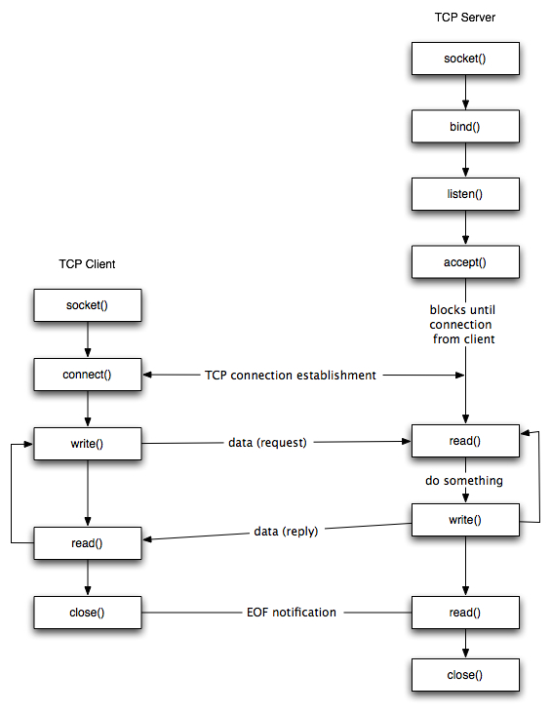

(a) TCP commands calling sequences

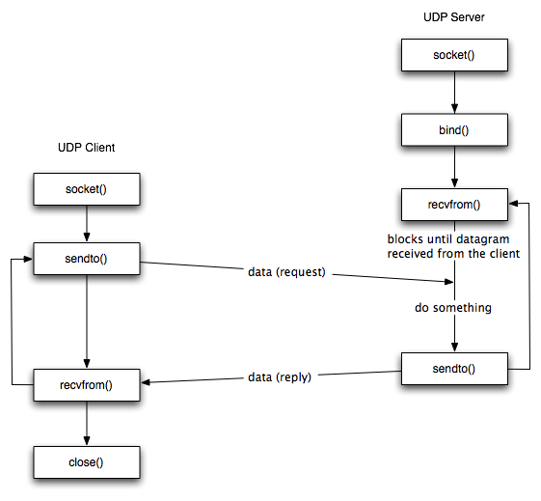

(b) UDP command calling sequence

Fig. 1 Berkeley socket interface commands

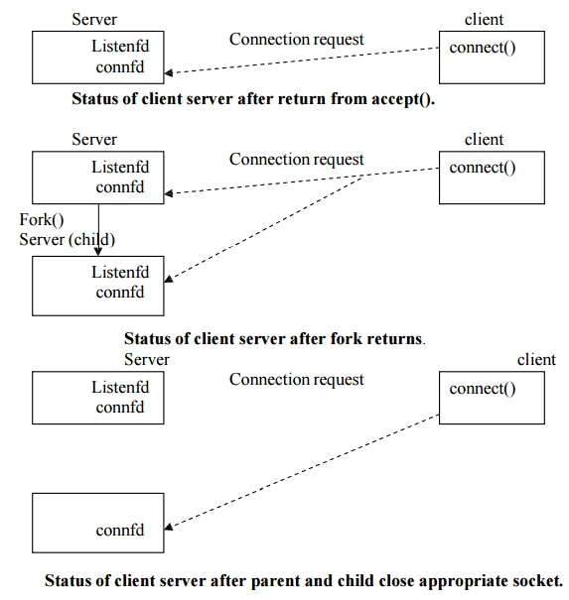

1. Process model in TCP connection setup

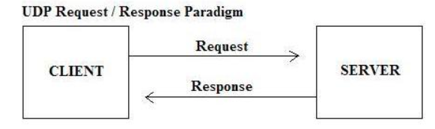

1. UDP process model

Fig. 2 Process model in TCP/UDP