Experimentation Report
Your Name
Your Student No.

Load Factor and Collisions
Modification
In linear.c file:
1. Expand linear_table structure to store collisions and totalSlotChecked:
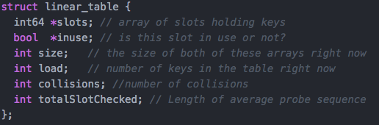
2. Calculate collisions and totalSlotChecked value during inserting keys:
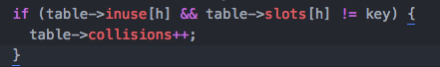
And in increment step loop, increment totalSlotChecked value by 1.
3. The average probe sequence is calcuated in stas function:

Stat Result
No. of slot | No. of keys inserted | Loading factor | No. of collisions | Average probe sequence
1024 | 995 | 97.168% | 483 | 9
2048 | 1983 | 96.826% | 980 | 8
4096 | 2986 | 72.900% | 1051 | 1
4096 | 3982 | 97.217% | 1912 | 11

Conclusion
1. The number of slot is the least 2^n value bigger than number of keys inserted;
2. Given similar loading factor, number of collisions will increase in same step with number of keys, which means:
995 / 483 nearly equal to 1983 / 980 nearly equal to 3982 / 1912;
3. Given similar loading factor, the length of average probe sequence is also similar, which means:
97.168% / 9 nearly equal to 96.826% / 8 nearly equal to 97.127% / 11;
4. Given same number of slot, less load factor leads to less length of average probe sequence.

Keys Per Bucket
Stat Result
4000 insert and 100 lookup test case:
No. of keys | 64 | 128 | 256 | 512 | 1024
No. of Insert | 4000 | 4000 | 4000 | 4000 | 4000
CPU time(s) | 0.011314 | 0.012600 | 0.014279 | 0.019173 | 0.025322

2000 insert and 100 lookup test case:
No. of keys | 64 | 128 | 256 | 512 | 1024
No. of Insert | 2000 | 2000 | 2000 | 2000 | 2000
CPU time(s) | 0.005711 | 0.006526 | 0.007514 | 0.010048 | 0.012179

Conclusion
1. Given same number of keys per bucket, the more cpu time needed will double if double number of keys inserted. And it is reasonable, if three-times number of keys inserted, the cpu time will be triple;
2. Given same number of keys inserted, the bigger number of keys per bucket, the more cpu time needed when insert. The reason should be bigger size of bucket will lead to more time when split bucket and double size the whole table.

