**15_Needham_et_al_2022**

Link: https://onlinelibrary.wiley.com/doi/full/10.1111/gcb.16100

Aim: This study evaluates how demographic diversity (DD) and demographic composition (DC) differ across temperate and tropical forests and how these differences relate to species richness, aboveground biomass (AGB), and carbon residence time.

Files in data folder:

github_demographic_rate_params.RData

Each row corresponds to one species in each site. The demographic parameters were calculated based on a size dependent survival model (Figure 1).

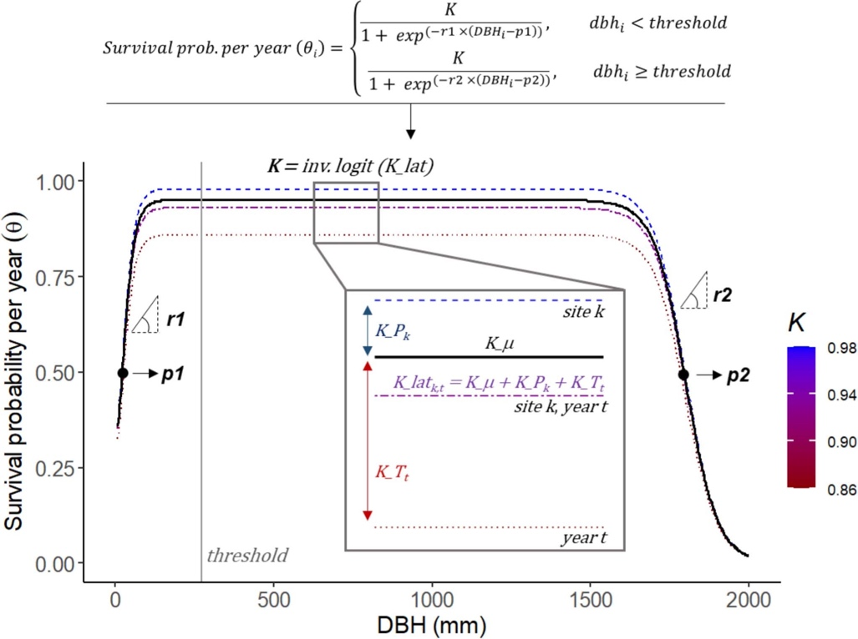

Figure 1. Survival probability per year (theta) for a given species is defined by either one of two similar logistic functions, depending on a tree diameter (DBH) threshold, only changing in the sign of *r* (*r1* > 0, *r2* < 0), yielding two S-shaped logistic function related through their common plateau *K*. detailed information can be found at <https://www.nature.com/articles/s41586-022-04737-7/figures/5> . for the exercise you will only used the estimated parameters described below.

N: number of individuals per species.

K: K is the upper asymptote of the curves and represents maximum survival (MS)

p1: inflection point, i.e., the size at which survival probability is 0.5 below the DBH threshold where the curves meet (defined as c = 0.2 × max (DBH)) (Equation 1 in the paper).

r1: rate parameter that determines the rate of survival increases with size

p2: inflection point, i.e., the size at which survival probability is 0.5 above the DBH threshold where the curves meet (defined as c = 0.2 × max (DBH)) (Equation 1 in the paper).

r2: rate parameter that determines the rate of survival decreases with size

thresh: DBH threshold where the curves meet (defined as c = 0.2 × max (DBH)) (Equation 1 in the paper).

maxsurv: same as K.

surv.sm: survival at 10 cm dbh

alpha1: parameter from the model fit – not needed

alpha2: parameter from the model fit – not needed

beta1: parameter from the model fit – not needed

beta2: parameter from the model fit – not needed

incr.thresh: parameter from the model fit – not needed

ex.slow : growth rate of slow growing trees

ex.fast: growth rate of fast growing trees

logistic.maxsurv: the asymptotic survival over most of the dbh range in logistic form

logistic.surv.sm: survival at 10 cm dbh in logistic form

maxsize: max tree diameter (DBH) from the data in logistic form

For the PCA in the paper, the authors used ex.slow, ex.fast, maxsize, logistic.maxsurv, and logistic.surv.sm.

site_df.RData

Site-level census, geographical and climatic data.

site_sp_rch.RData

Bootstrapped species richness for 19 sites (minus Mudumalai) in the same order as the site.df dataframe.