DANIELA RESENDIZ ALVARADO 19110325

ceti colomos  VISION ARTIFICIAL 7E1

Manual de usuario practica 8

MANUAL DE USUARIO

# EVIDENCIA

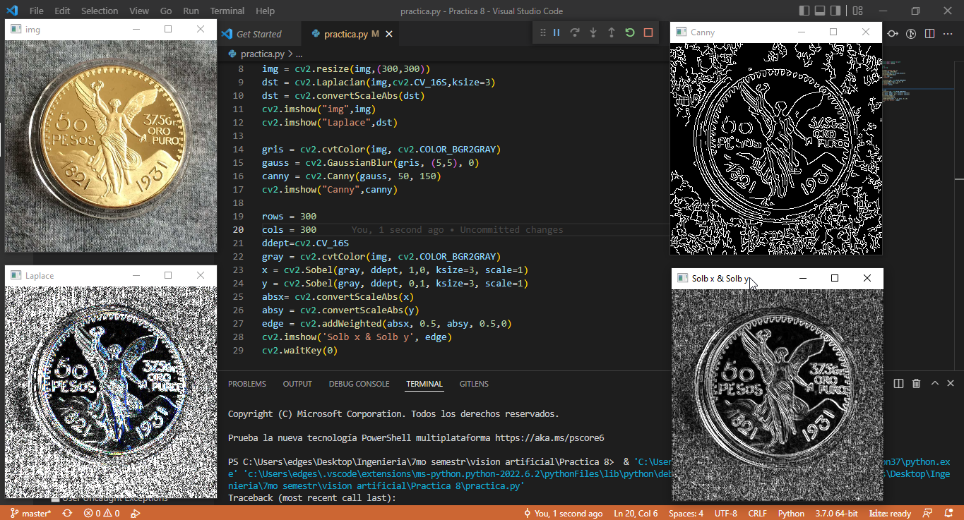

# APP

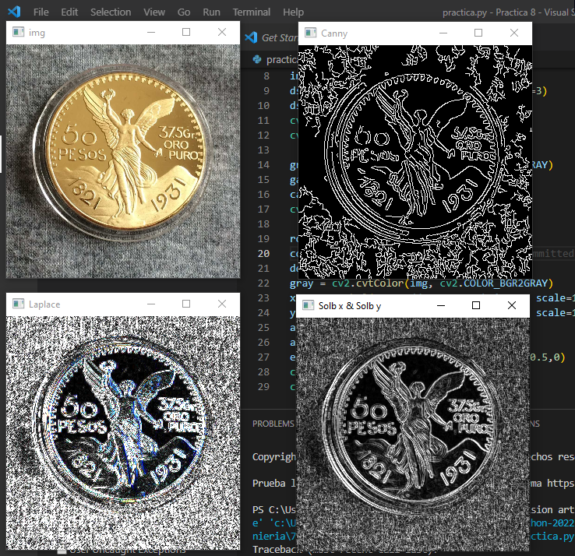

Esta es la vista principal de la aplicación.

# Code:

#Pedro Miguel Elguera Mora 19110148

from matplotlib import pyplot as plt

from matplotlib import pylab

import cv2

import imutils

import numpy as np

img = cv2.imread("moneda.jpg",1)

img = cv2.resize(img,(300,300))

dst = cv2.Laplacian(img,cv2.CV_16S,ksize=3)

dst = cv2.convertScaleAbs(dst)

cv2.imshow("img",img)

cv2.imshow("Laplace",dst)

gris = cv2.cvtColor(img, cv2.COLOR_BGR2GRAY)

gauss = cv2.GaussianBlur(gris, (5,5), 0)

canny = cv2.Canny(gauss, 50, 150)

cv2.imshow("Canny",canny)

rows = 300

cols = 300

ddept=cv2.CV_16S

gray = cv2.cvtColor(img, cv2.COLOR_BGR2GRAY)

x = cv2.Sobel(gray, ddept, 1,0, ksize=3, scale=1)

y = cv2.Sobel(gray, ddept, 0,1, ksize=3, scale=1)

absx= cv2.convertScaleAbs(x)

absy = cv2.convertScaleAbs(y)

edge = cv2.addWeighted(absx, 0.5, absy, 0.5,0)

cv2.imshow('Solb x & Solb y', edge)

cv2.waitKey(0)

# Git:

<https://github.com/PedroElgueraCeti/Practica8_VIsionArtificial.git>