DISEÑO-DHR.R

Usuario

2023-05-18

# DHR  
# ANOVA  
# 18/05/2023  
  
# Experimento ganancia en peso basado en diferentes Dietas  
# Niveles de factor: 4  
  
die1 <- c(2.4, 2.2, 3.4, 1.6)  
die2 <- c(2.2, 1.9, 1.7, 2.1)  
die3 <- c(3.3, 1.3, 2.8, 2.1)  
die4 <- c(1.6, 2.5, 1.4, 2.4)  
  
GP <- c(2.4, 2.2, 3.4, 1.6,2.2, 1.9, 1.7, 2.1, 3.3, 1.3, 2.8, 2.1,1.6, 2.5, 1.4, 2.4)  
Trat <- gl(4,4,16, labels = c("die1", "die2", "die3", "die4"))  
Bloq <-gl(4,4,16, labels = c("Bajo", "Normal", "SP", "Obesidad"))  
Dietas <- data.frame(Trat, GP, Bloq)  
  
boxplot(Dietas$GP~ Dietas$Trat, col="salmon",  
 xlab = "Dietas",   
 ylab= "Ganancia en peso (kg)")

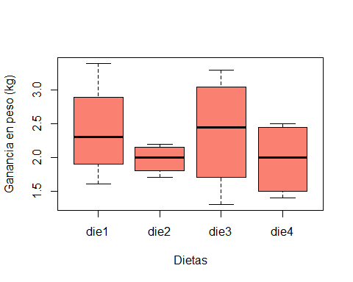

tapply(Dietas$GP, Dietas$Trat, var)

## die1 die2 die3 die4   
## 0.56000000 0.04916667 0.75583333 0.30916667

fligner.test(Dietas$GP, Dietas$Trat)

##   
## Fligner-Killeen test of homogeneity of variances  
##   
## data: Dietas$GP and Dietas$Trat  
## Fligner-Killeen:med chi-squared = 4.6369, df = 3, p-value = 0.2004

bartlett.test(Dietas$GP, Dietas$Trat)

##   
## Bartlett test of homogeneity of variances  
##   
## data: Dietas$GP and Dietas$Trat  
## Bartlett's K-squared = 4.1152, df = 3, p-value = 0.2493

diet.aov <- aov(Dietas$GP ~ Dietas$Trat)  
summary(diet.aov)

## Df Sum Sq Mean Sq F value Pr(>F)  
## Dietas$Trat 3 0.682 0.2273 0.543 0.662  
## Residuals 12 5.022 0.4185

write.table(Dietas, "C:/DANIELA/D_EXPERIMENTAL/Dietas.csv",sep =",")