Software Documentation

Exercises 24.10.2017

Exercise 1.

1. Analyze the video tutorial

This video shows how to create and manage the user interface of your project in Eclipse Dirigible. The target viewers are competent and qualified people who want to learn how to use this functionality.

1. Create a short guide based on this tutorial

How to manage the user interface of your project in Eclipse Dirigible

1. Open **Eclipse Dirigible**
2. In the Workspace Explorer, where your project is, expand the **ScriptingServices** tab, find the entity file you want to create a user interface of. Right-click on it and choose **Generate-> User Interface for Entity Service.**

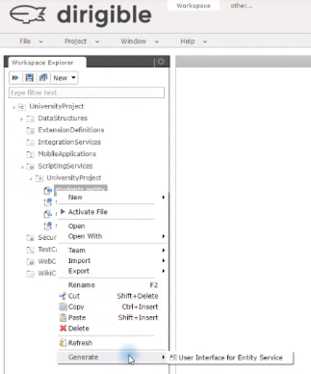

1. An additional window will appear. Select from the available templates **List Entities and click Next.**
2. **Select the columns you want or** you can use the **Select All** button to choose all.
3. On the next page enter a **File name**, click **Next** and then enter a **Page title**. Once you are ready click **Finish** and a file will be generated. You can see the result under the **WebContent** folder.

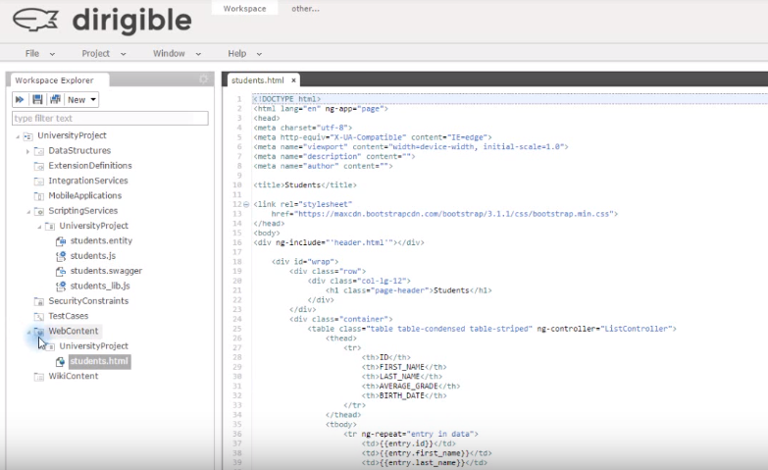

1. Right-click on the **WebContent** folder and choose **New-> User Interface.**
2. In the additional window that appears select **Index Page with Main Menu, Header and Footer.**
3. Click **Next** and choose a **File name**. We recommend you stick with the default name index.html. When you are ready click **Next** again enter a **Page Title** and click **Finish**.
4. Additional files will be generated in the **WebContent** folder.

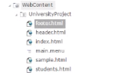

1. Click on the **main.menu** file. Your file should look something like this:

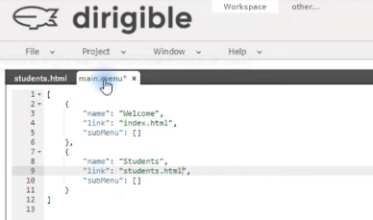

Where “name” and “link” should be replaced with yours.

1. Save your files.
2. If you want to preview your user interface. Click on the **index.html** file and in the **Preview section**, copy the generated link and paste it in your browser.

