## **Level 1 – Basic Introductory Scenario**

For the first level, we created the specified two agents, Peter and Waiter, and we defined the following beliefs, whose names are mostly self-explanatory:

1. Peter:
   1. Has(Food) – starts at False;
   2. Is(Hungry) – starts at 1 and is updated later;
   3. Is(Angry) – starts at False. This belief allows Peter to give bad reviews later on;
   4. CloseFriends(Waiter) – Is always false;
2. Waiter:
   1. Has(Burger) – starts at 1. Goes down to zero once a burger is served to Peter;
   2. Has(Served) – starts at False and is updated to True once Peter has been served a meal;
   3. CanServe(Peter) – starts at False. Signals the Waiter that Peter has ordered and may now be served once the value changes to True;
3. Both:
   1. DialogueState(x);
   2. Has(Floor) – Who has priority to speak;

We then defined the dialogs we wanted between Peter and Waiter, according to the styles **Rude** and **Polite**, and created the possible actions in the WorldModel module:

1. Speak() – These has various subcategories;
2. Serve(Food);
3. Give(BadReview).

Following that, we defined the appraisal rules relating to each action, giving high values of desirability to the events matching the actions of **Serve**, **Speak** with the **Polite** style and **Give,** and giving a low value of desirability to the action **Speak** with the R**ude** style. And, finally, we created the rules to give priority and specify the conditions in which each action could be executed in the emotional decision making model.

## **Level 2 – create your Scenario**

For the second level, we decided to create our own and simpler version of “Auto da Barca do Inferno”. The scenario, which includes 3 characters (the Devil, the Angel and the Player) consists in the player talking his way up to Heaven (or end up in Hell) and for that he must interact with both the Devil and the Angel. We have 4 endings, in which two of them are regulated by social importance and the other two are special endings that only occur following specific paths in the dialogue.

We defined a total of 79 different dialogue states (Figure 1) and used four modules:

1. **Minimum Requirements:** Emotional Appraisal, Emotional Decision Making and WorldModel Modules.
   1. **Emotional Appraisal:** Here we created some appraisal rules, following the styles that we chose (Love, Hate, Disappoint and Approval), and we gave to each style a certain value of praiseworthiness, desirability and desirability for others.
   2. **Emotional Decision Making:** Here we defined rules with conditions to guide, allow or disallow actions. Basically, we created a rule with lower priority that fits almost every action and then we specified rules with higher priorities that represent the progression in the trial of the player (and that have conditions related to having answered the questions of the Devil and/or Angel) and, finally, rules that use the social importance of the player to decide whether he goes to heaven or not.
   3. **WorldModel:** Used to define the actions (in our case we only defined Speak) of each character and to change actors between interactions.
2. **Extra Points:** We chose to use the Social Importance Module to, as it was said before, influence the ending of our game. We defined some rules related to specific states and had them change the perceived social importance of the player. If the player then is perceived in good light (SI > 6) it goes to heaven or not (except for the special endings that bypass this evaluation). We also looped the endings back to the Start state with a Play Again option to increase interaction duration.

## **bonus level – Customize the provided UNITY project to your scenario**

We customized our scenario by:

1. Changing the background to fit the theme of a “ominous port” where the player is judged to then go to Hell or Heaven. This is the same as pictured in the original “Auto da Barca do Inferno”, where there is a boat to Hell and a boat to Heaven.
2. Adding background sound to improve immersion.
3. Guaranteeing that all text lines have the respective voice over.
4. Changing the character models of the devil and angel, we couldn’t exactly find an accurate depiction of them both, so we opted for some nice-looking models, even though they aren’t exactly as one would expect.
5. Finally, we smoothed out the end-states by not displaying them as dialogues (Figure 3)

## ANnexes

Figure 1. Dialogue State Graph for Scenario 2

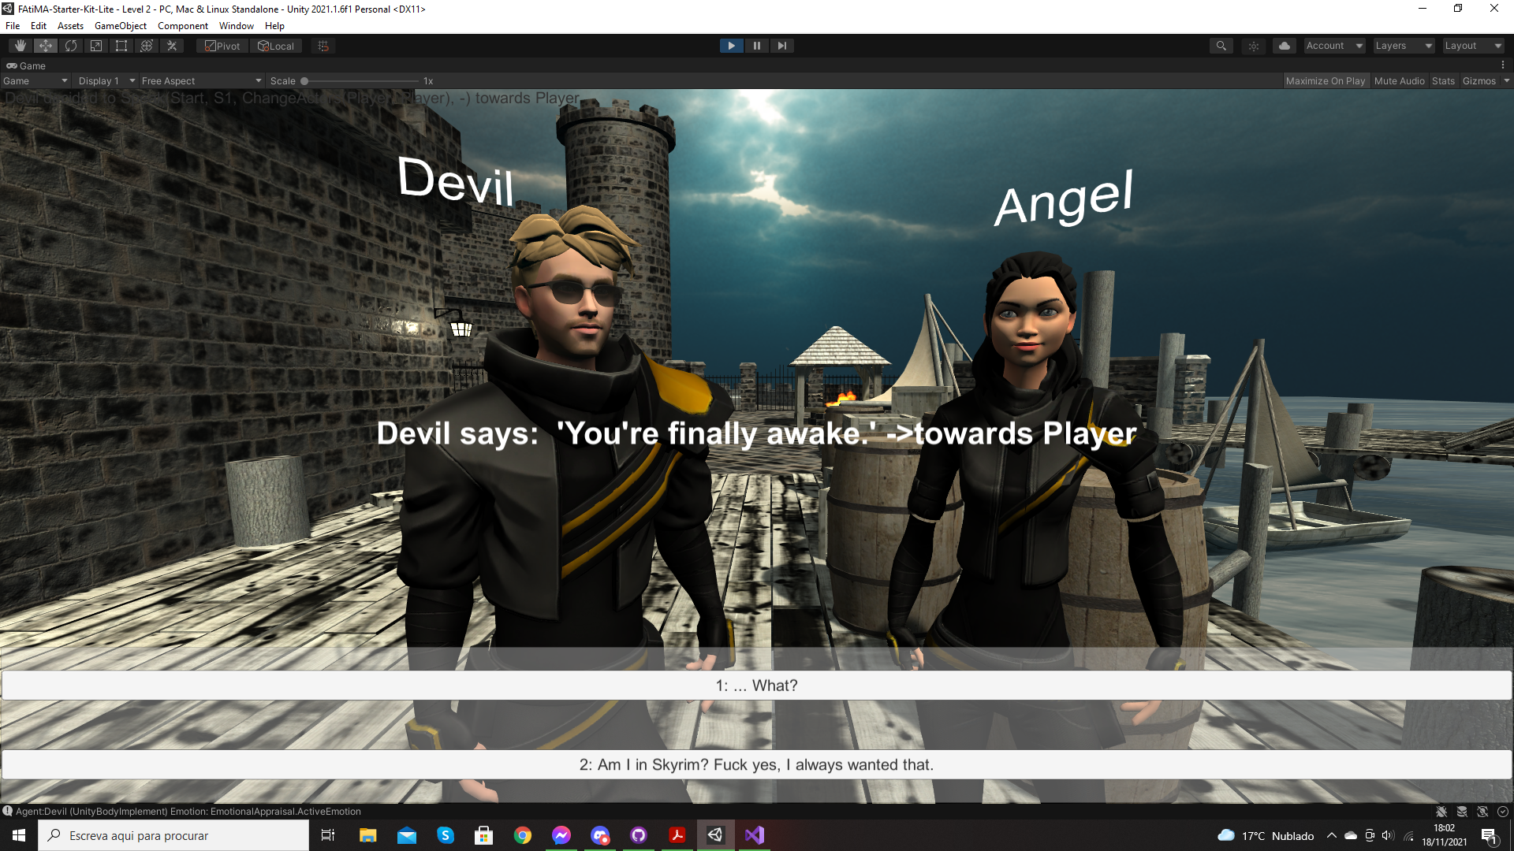

Figure 2. Final Unity look of Scenario 2

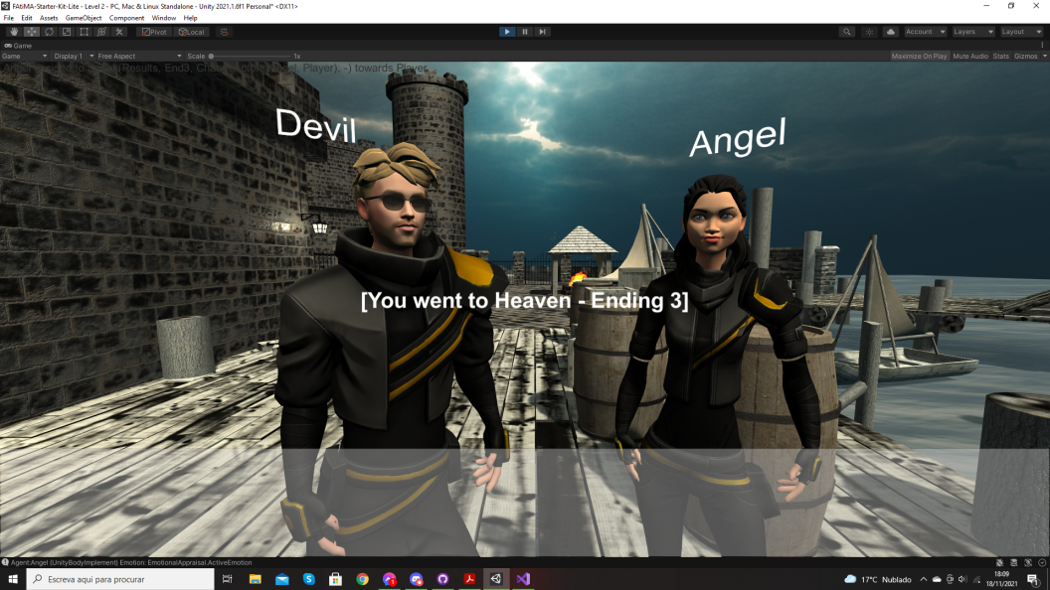

Figure 3. End card's new look