Answer of Q1: the IP address of my computer is 172.20.10.2

Answer of Q2: the value in the upper layer protocol field is ICMP(1)

Answer of Q3: there are 20 bytes in the IP header.

Answer of Q4: payload = total length – header length = 56-20=36 bytes.

Answer of Q5: The fragment offset is 0; the packet has not been fragmented.

Answer of Q6:

Identification, Time to Live, and Header Checksum fields in the IP datagram always change from one datagram to the next within this series of ICMP messages sent by my computer.

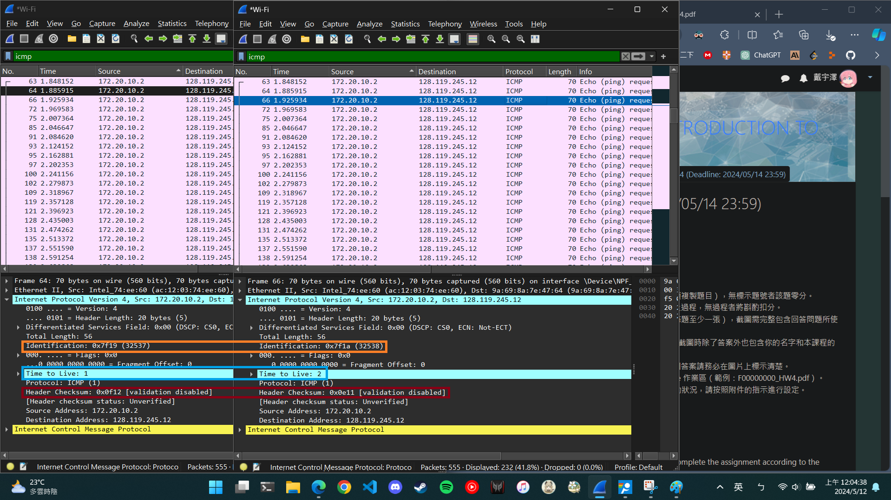

Answer of Q7: Identification: 0x782d(30765); TTL: 64

